The evolving social media strategies of politicians in Malaysia: A critical review

Siti Hara Rashid¹, Kevin Fernandez²

¹Faculty of Business and Economics, University Malaya
²Asia-Europe Institute, University Malaya

Correspondence: Kevin Fernandez (email: kevin@um.edu.my)

Received: 6 October 2023; Accepted: 16 February 2024; Published: 29 February 2024

Abstract

Scholars were optimistic about social media as a tool to reintroduce deliberative democracy. One of the features allows users to express their thoughts and participate in political discussions without being monitored or restricted by the government. It is crucial that politicians also change their communication strategies, including adaptation of social media platforms, to effectively communicate their ideas to their constituents. This study has three objectives. First, it aims to examine the evolution of political strategies used by politicians from conventional media to social media. Second, this study examines the soundbytes that are most popular in the Malaysian context. Third, we seek to understand the perception of ‘media freedom’ amongst politicians and members of the media. Using in-depth interviews with politicians from both sides – the current government and the opposition – this study concludes that Malaysian politicians use social media primarily to portray themselves as people who are loyal to their partners and family, and very religious. Less emphasis is paid on major macro and micro policy debates over social media.

Keywords: Deliberative democracy, media and regime change, social media and politics

Introduction

The traditional media consists of newspapers, magazines, radio and television broadcasts that report events and support politicians' narratives. Especially during election campaigns, politicians appear more often than usual in newspapers and on television to appeal to the public for support. In authoritarian regimes such as Malaysia, the government has traditionally had the power to control and dominate the traditional media through legislation, control over funding and sometimes direct ownership, allowing for almost complete hegemony over the public sphere. The form of control is evident in the implementation of laws such as the Internal Security Act, the Official Secrets Act, the Sedition Act and the Printing Presses and Publications Act (Abbott, MacDonald & Givens, 2013).
Since Malaysia’s independence in 1957, freedom of speech and media has always been elusive. Newspapers such as Utusan Malaysia, Berita Harian, New Straits Times and The Star have been controlled by the government to restrict freedom of speech and media in Malaysia (Samani, Maliki, Rahim,Rahman & Mustaffa, 2015). Freedom House reports that the score for freedom in Malaysia in 2022 is 50% (Freedom House, 2022). According to the report, Malaysia is only considered partially free due to certain restrictions. These limitations include restrictions on the freedom and independence of the media. According to the report, media freedom and independence in Malaysia is relatively low in the run-up to the 2018 general election. One example of media freedom being curtailed was the editor of online news portal MalaysiaKini, Steven Gan, who was found guilty of breaching the Evidence Act 1950. He was also charged with sedition for a comment he made on the court’s decision (Freedom House, 2022).
It is crucial to understand the extent of social media's influence on the course of Malaysian politics. To understand the use of social media by populists, this study will include an analysis of the Instagram accounts of Mahathir Mohamad and Najib Razak, two former prime ministers, and Syed Saddiq, a young politician popular among young voters in Malaysia, to observe the number of engagements and followers they have. Mahathir Mohamad and Najib Tun Razak were chosen because they were both former prime ministers of Malaysia and were elected at a time when social media was popular in Malaysia. Syed Saddiq was a former Minister of Youth and Sports in Malaysia and he was also the former President of MUDA (Malaysian United Democratic Alliance). An in-depth interview with politicians and journalists provided context for our analysis. With this study, we hope to put into perspective the buzzwords that politicians use in conservative societies like Malaysia.
The main aim of this study is to close the knowledge gap about how politicians and political journalists portray themselves on social media in order to gain votes and legitimise themselves as morally ‘good’.

History of media ownership and control in Malaysia

According to Roff (1965) in his book The Origins of Malay Nationalism, the history of the Malay press in Singapore began with the Jawi Peranakan community. Roff (1965) further states that the Jawi Peranakan were indigenous descendants of native Malay women and South Indian Muslim traders. At the end of 1876, the Jawi Peranakan formed an association that set up a printing press to publish a weekly newspaper called Jawi Peranakan. After the birth of the Jawi Peranakan newspaper, other newspapers were also published such as: Fajar, Jajahan Melayu, Jambangan Warta, Khizanah al-Ilmu, Tanjong Penegeri, Pemimpin Warta, Lenkongan Bulan, Bintang Timor and Cahaya Pulau Pinang. Around 1906, Malay journalism began to place its independent reporting in a more religious context. Newspapers like Al Imam were edited in Singapore by Sayyid Shaykh Al Hadi and published by Mohd. Tahir bin Jalaluddin. After Al Imam, other Islamic journals such as Neracha, Tunas Melayu, Majallah al-Islam, Saudara and Al-Ikhwan were also published. Parallel to the rise of Islamic periodicals, the region also saw an upsurge in Malay newspapers. The two main national newspapers in Malaya were Singapore Free Press and Utusan Melayu. Until 1914, Lembaga Melayu, Idaran Zaman and Warta Malaya were some of the main newspapers using the Malay language.
One of the oldest newspapers in Malaysia's history is Utusan Melayu, which was established in 1939. The newspaper was initially funded by donations from the public and was considered an independent and fair newspaper (Steven, 2019). During the Japanese occupation of Singapore (1942-1945), Utusan Malaysia was merged with Warta Malaya and renamed Berita Malai. Berita Malai focused on publishing Japanese propaganda, but after the Japanese occupation, the Berita Malai office came to a standstill. In September 1945, Yusof bin Ishak re-established the office and began distributing newspapers again. As the Malay nationalist movement reached its peak in the 1950s, Utusan Melayu became anti-British and supported the formation of the Federation of Malaya, led by UMNO. As more and more UMNO members bought Utusan Melayu’s shares, Utusan Melayu increasingly came under UMNO’s influence and control (Chia, 2007). In 1957, UMNO realised that it needed to control news coverage and was convinced that an open and free press could harm its political agenda if it openly criticised legitimacy. UMNO began to restrict and control the freedom of the media in 1961 when UMNO decided that it was best to control the reporting itself and take over Utusan Melayu completely. The Utusan Group includes the newspapers Utusan Malaysia, Mingguan Malaysia and Kosmo! as well as magazines such as Wanita, Mangga, Saji, URTV and Mastika. In April 1961, UMNO’s communications chief, Ibrahim Fikri, was appointed manager of Utusan Melayu. This became a highly controversial issue as it marked the beginning of government control over media freedom (Steven Sim, 2019).
Besides newspapers, radio is also a form of traditional media. Radios were first introduced in Malaysia in 1921 when A.L. Birch, an electrical engineer, first brought a radio set to the country. The first radio station was the ZHJ station, which was established by the Penang Wireless Society in 1934. In April 1946, the British established the Singapore Radio Department. Over the years, radios played an important role in announcing social unrest in the country and also became a source of revenue for the government in 1960 through paid commercial advertising (MyGovernment, n.d.).
Three years later, television arrived in the country. In the early days, these two media – radio and television - were under the Ministry of Information. Rangkaian Satu was the first television station, followed by the second station, which was established on 17 November 1969 (RTM, 2021). Television stations were also a rapidly growing industry. Other television channels began to develop, such as the private television channel TV3 in 1984, ntv7 in 1998, followed by 8TV in 2004 and TV9 in 2006. TV3, 8TV, ntv7 and TV9 belonged to the same media group, Media Prima. In addition, Astro, a subscription-based direct-to-home satellite television and radio service, began operations in 1996. On the news front, besides RTM, the government also owned through direct ownership and proxies another news channel TV, including BERNAMA in 1998 (Mustafa, 2005). Media Prima Berhad, the largest media and entertainment conglomerate, is owned by government-affiliated companies such as Permodalan Nasional Berhad (PNB), Kumpulan Wang Persaraan Diperbadankan (KWAP) and Lembaga Tabung Haji (LTH). Media Prima owns newspapers such as New Straits Times, New Sunday Times, Berita Harian, Berita Minggu and Harian Metro. Media Prima also manages television channels such as TV3, 8TV, TV9 and NTV7. The relationship between traditional media and political parties and government-linked companies raises questions about the credibility of news disseminated by traditional mainstream media in Malaysia (Gomez, Mustafa & Yuen, 2018).

Increasing presence of social media in influencing election results in Malaysia

According to Kaplan and Haenlein's (2010) definition, social media are a group of internet-based applications that build on the ideological and technological foundations of Web 2.0 and enable the creation and sharing of user-generated content. Others argue that social media is an online communication tool that connects people through two-way communication (Russo, Watkins, Kelly, & Chan, 2008; Lewis, 2009). Carr and Hayes (2015) noted that the definitions are still too broad and insufficient to use for further analysis. They defined social media as “an Internet-based channel that allows users to opportunistically interact and selectively self-present, either in real-time or asynchronously, with both broad and narrow audiences who derive value from user-generated content and the perception of interaction with others” (p.50).
A survey by Hirschmann (2021), 67% of respondents agreed that social media provides a platform for political debate and discussion on social issues. A study by Nuurrianti (2016) found that the true power of social media effectiveness depends on how users, or in this case politicians, use it to their advantage. Politicians, especially those in the opposition, are free to use these online platforms to share their thoughts with the public. Since social media is an open platform that can be accessed by anyone with an internet connection, they can spread their political ideologies without being hampered by pro-government news outlets (Nuurrianti, 2016). While previous studies have focused on the period leading up to the 2018 elections, this study will extend the analysis to more recent and significant events that have a strong connection to the internet and social media, such as the 14th General Election, the Sheraton Move, the Black Flag Campaign, the Undi18 protests, and the local elections in Johor and Melaka.
Shafizan (2019), investigated the use of Instagram by politicians as a platform communicate during the 14th General Elections. Shafizan Mohamed analysed the use of imagery used by three political figures– -Najib Razak, Mahathir Mohamad and Hadi Awang (leader of Parti Se Islam Malaysia) - to analyse the imagery uploaded on Instagram political communication. He analysed the images posted on their Instagram accounts by dividing them into two categories – public/political stories and personal/private stories. He also analysed the number of posts and followers these political figures had between 15 March and 10 May 2018. In his discussion, he found that of the three political personalities, Najib’s Instagram account was the most interesting as it contained a balanced combination of political and private images. He concluded that Najib effectively used his Instagram account to interact with 165,000 followers. Najib’s online popularity has managed to divert people’s attention from his political scandals and focus more on his personal and approachable nature.
Shafizan (2019) suggested that politicians’ posts should have a good combination of personal and professional posts to have an effective online image and resonate better with the audience. Politicians who have an online presence should adopt a populist approach to be more likeable and accessible to the public.

Research methodology

This section discusses the conceptual framework used to understand and discuss the mindset of policy makers in Malaysia when they: (i) produce material online, (ii) consider the virality of that material, and (iii) understand the target reach of politicians and party media strategists.

Conceptual framework

In this section, the epistemological foundations of this study are explained, beginning with a comparison of the logics of mass media and networked media.

Table 1. Mass media logic and network media logic

 | Mass media logic | Network media logic
Production | Expensive information selection and content generation by professional journalists according to news values. | Inexpensive information selection and content generation by (lay) users according to their individual preferences and attention maximizing.
Distribution | Content selected by expert/professional gatekeepers – based on established news values – distributed to a paying fixed audience of subscribers. | Users are like intermediaries, distributing popular content, sometimes like a chain letter, within networks of like-minded others.
Media usage | Location bound mass audience with limited selective exposure oriented towards passive consumption of information, based on professional selection. | Interest-bound and like-minded peer networks with highly selective exposure oriented towards interaction through practices of updating.
Source: The emergence of network media logic in political communication: A theoretical approach (Klinger & Svensson, 2015).
The logic of mass media is based on professional content production, whereas network media is based on amateur production and “produsage” (Bruns, 2008). This means that the online content producer may have expertise in traditional media, but may not have the technical know-how and resources to produce content for social media. Online content usually has narrative elements and differs from traditional media because the producer wants to stand out to attract viewers.
The logic of virality determines the distribution in social media, in other words, the “network-enhanced word of mouth” or “the process which gives any information item the maximum exposure, relative to the potential audience, over a short duration, distributed by many nodes” (Nahon, Hemsley, Walker & Hussain, 2011, p.1). It is no longer sufficient for information to be transmitted directly from sender to recipient, but it must be passed on from user to user, similar to a chain letter.
Social media platforms may reach a significant number of people who have self-selected themselves as their audience, but they do not reach the broader public (Klinger & Svensson, 2015). Traditional forms of mass media are intended towards mass audiences and the general public. This study aims to understand how politicians use social media platforms and narratives to reach different audiences. Using this conceptual framework, we attempt to analyse how politicians and the media strategists of political parties employ various strategies to (i) produce material, (ii) distribute material and (iii) understand the target reach of politicians in Malaysia.

Research design

The first method used for this research was content analysis. According to Mohajan (2018), “content analysis is a method of analysing written, verbal or visual communication messages” (p.15). Mohajan (2018) also suggested that the framing of media content is also part of content analysis as it allows researcher to study the tone of the news published by the selected newspapers either negative, positive, or neutral. Based on this study, content analysis allows for the collection of data from the Instagram posts of the three selected accounts. The accounts to be analysed are the Instagram accounts of Dato Seri Najib, Tun Mahathir and Syed Saddiq due to their individual popularity and ability to influence the different strata of the Malaysian electorate. We analysed their Instagram posts between 28 March 2018 and 10 May 2018, with data such as number of followers, posts and engagement (likes and comments) to see how many followers and reactions they receive from other social media users.
The second method used was the in-depth interview, which used the method of judgmental and snowball recruitment. The interviews were conducted to find out how politicians from both sides of the spectrum - government and opposition - as well as political journalists perceive the role of social media in politics. The interview was conducted with five people who have extensive experience in covering Malaysian politics. We did not go beyond five interviews because we recognised a saturation point in the interviews. Given the limited resources and the reluctance of politicians and stakeholders to be interviewed on this sensitive topic, we decided that we had enough data to provide a basis for future research.
Previous research on social media and politics has predominantly taken a quantitative approach. In contrast, for this study, the researcher has used a different method of data collection to provide more context for examining the media strategies of politicians and political parties in Malaysia. As the study falls under the social sciences, qualitative research is suitable to understand how people behave, feel and experience their own social reality (Mohajan, 2018).

For the content analysis on Instagram, the number of posts, likes and comments were collected between 28 March 2018 and 10 May 2018 as this was the campaign period for the 14th GE in Malaysia. This period was deliberately chosen because the election campaign officially started on 28 March 2018, after then Prime Minister Najib Razak submitted the Election Commission’s report on the reconstitution of the Dewan Rakyat, until 10 May 2018, the day the election results were to be officially announced. We compared the three Instagram accounts by observing which account was more active and had the most likes and comments during this period (Table 2). The researcher analysed the captions used when posting a photo. The language, hashtag used and context are also important in this research to understand the underlying messages of the photo. When analysing the posts, we also looked at the choice of photos, such as who is in the photo, where the photo was taken and what expressions were chosen.

Table 2. List of Instagram accounts, number of followers, posts, likes and comments of 3 politicians

No. | Username | No. of followers | No. of posts | No. of likes | No. of comments
 | @najib_razak | 972k | 18 | 498,466 | 40,433
 | @chedetofficial | 1.5M | 9 | 1,201,566 | 37,397
 | @syedsaddiq | 1.8M | 60 | 6,406,544 | 36,619

Source: Mahathir Mohamad @chedetofficial, n.d.; Mohd Najib Abdul Razak @najib_razak,n.d.; Syed Saddiq Syed Abdul Rahman @syedsaddiq, n.d.

For the selection of the in-depth interviews, we chose a total of six people who are politicians and political journalists. These key informants were selected on the basis of their experience and merit in the field of media and politics. The list of key informants, their political affiliations and professions are given in Table 3. The interview questions were carefully semi-structured to guide us through the interview process. Based on the course of the interviews, we also asked questions that we considered enriching to the study and that were relevant to the study.

Table 3. List of interviewees, political affiliations and professions

No. | Name | Political Affiliations | Profession
 | Firdaus Azil | n/a | Politics and Current Affairs Journalist at Awani
 | Norman Goh | n/a | Political Analyst, Producer and Former Independent Journalist and Producer of Bicara Minggu Ini Podcasts.
 | Syahredzan Johan | DAP | DAP Social Media Bureau Chairman
 | YB Ahmad Fahmi bin Mohamed Fadzil | PKR | Information Chief and Communications Director of Parti Keadilan Rakyat (PKR)
 | YB Datuk Seri Panglima Abdul Azeez bin Abdul Rahim | BN | High Committee of United Malays National Organisation (UMNO)
6. | YB Tan Sri Dato’ Seri Utama Dr. Rais Yatim | Parti Pribumi Bersatu Malaysia (BERSATU) | President of the Senate, Malaysian Parliament

Interview questions were mainly asked in English, but some interviews were conducted either fully or partially in Malay to help informants fully understand the context. The answers given in Malay were translated into English.
The transcription protocol as suggested by Mergenthaler & Stinson (1992) was followed.
1. Maintain the transcription's naturalness from a morphological standpoint – The main structure of the interviews was maintained with a semi-structured interview protocol prepared before the in-depth interviews.
2. It is important to maintain the natural structure of the transcript. The interviews were structured according to the pre-established protocols to maintain flow.
3. The interview was recorded with prior permission and a verbatim report was produced.
4. The transcript was then digitised for thematic analysis using basic computer skills.
6. The themes were determined according to the conceptual framework Network Media Logic (Klinger & Svensson, 2015).

Findings

Nuurrianti (2016) argues that the actual effectiveness of social media depends on how users, or in this case politicians, use social media to their advantage. Instagram is a social media application for sharing photos and videos that was launched in October 2010 (Blystone, 2022). According to statistics on Monocal, there are about 15,700,000 Instagram users in Malaysia in 2022 (Ahmad, 2022). According to Statista’s statistics on the most followed politicians on Instagram worldwide ( as of June 2020), Narendra Modi (42.9 million followers), Joko Widodo (32.9 million followers), Barack Obama (30.1 million followers) and Donald J. Trump (20.5 million followers) are among the most followed politicians on Instagram (Statista, 2022). In Malaysia, Syed Saddiq (1.8 million followers), Tun Mahathir (1.5 million followers) and Najib Razak (972k followers) are the top politicians on Instagram (StarNgage, 2022). Najib Razak opened his Instagram account (@najib_razak) in January 2013, becoming the first of the other two politicians to have an Instagram account. He was followed by Syed Saddiq (@syedsaddiq) in February 2014 and Tun Mahathir, who created his account (@chedetofficial) in November 2017.
Najib’s first Instagram post was on 19 February 2013 with a casual picture of him smiling. The post has no caption but received 1,548 likes and 434 comments. Figure 1 was posted weeks before the 13th GE, which took place on 5 May 2013.
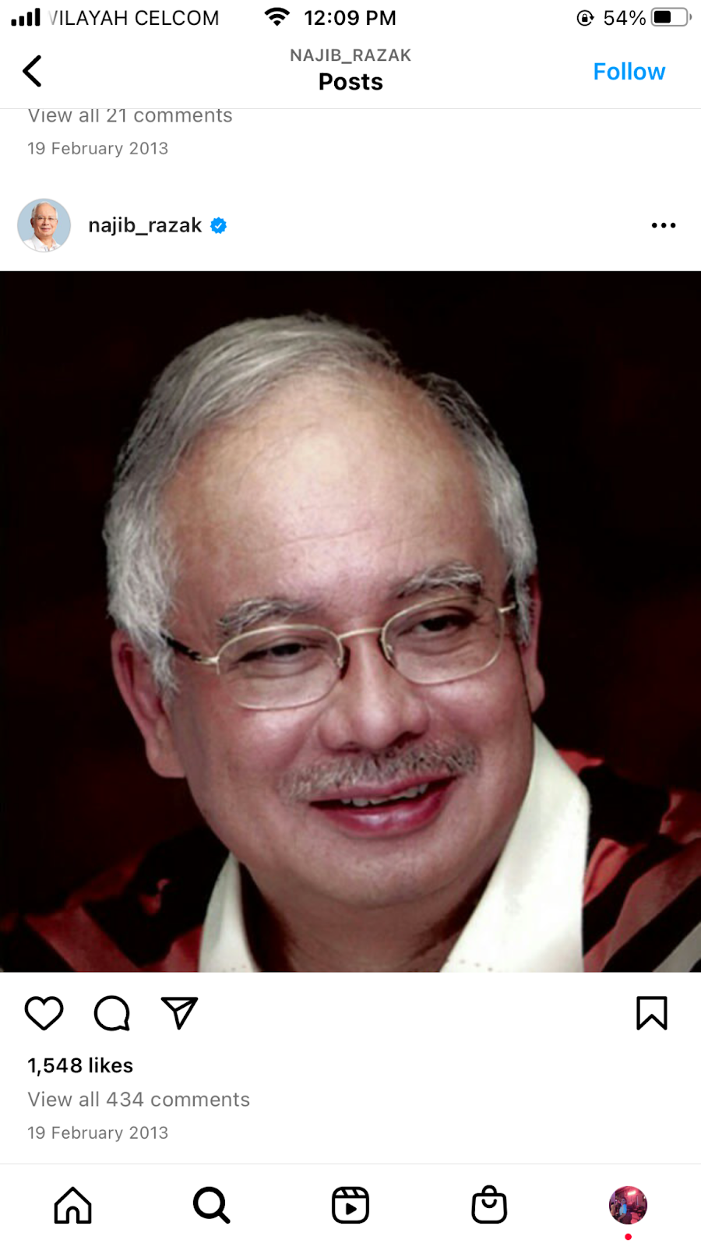
Source: Najib Razak, 2013

Figure 1. Najib's first Instagram post
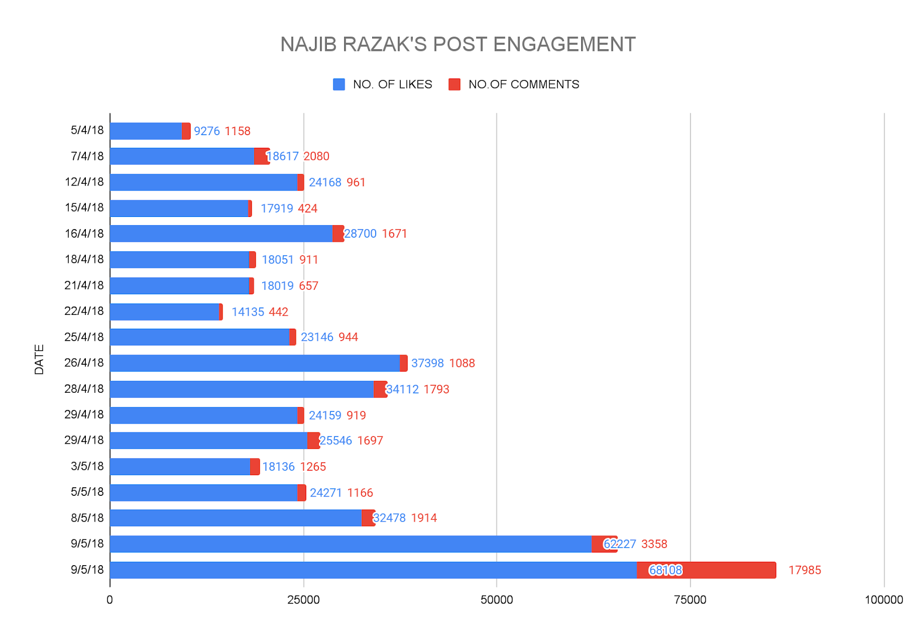
Source: Mohd Najib Abdul Razak @najib_razak, n.d.

Figure 2. Najib's Instagram post engagements

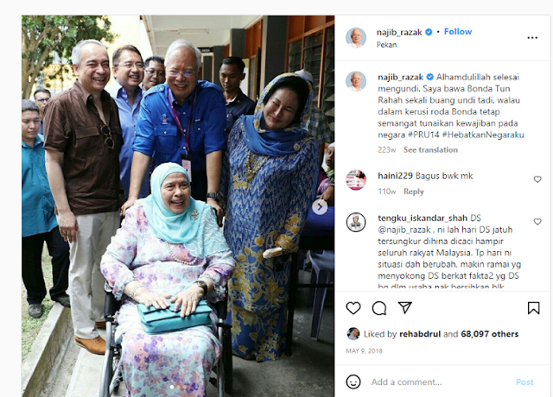

Source: Najib Razak, 2018

Figure 3. Najib's most liked Instagram photo

According to the Instagram analyses, Najib’s post on election day in March 2018, showing him with his mother Tun Hajah Rahah Noah, accompanied by his wife Rosmah Mansor, his brother Nazir Razak and Najib’s supporters, received the most attention on Instagram. Similarly, Mahathir’s postings were also about his family.
Mahathir’s first Instagram post was on the 10th March 2018. It depicted a picture of him with his wife, Tun Dr. Siti Hasmah (Figure 4). The couple has always caught the attention of the people and this post is no exception. The post has 183,830 likes and 6,998 comments with a caption, Hari ini saya mulakan akaun Instagram saya dengan gambar bersama Hasmah. Isteri saya selama 62 tahun yang sentiasa setia bersama saya sejak dulu lagi. (Today I start my Instagram account with a picture with my wife Hasmah. She has been my wife for 65 years and has been faithful to me from the beginning) As doctors, laughter is indeed the best medicine”.
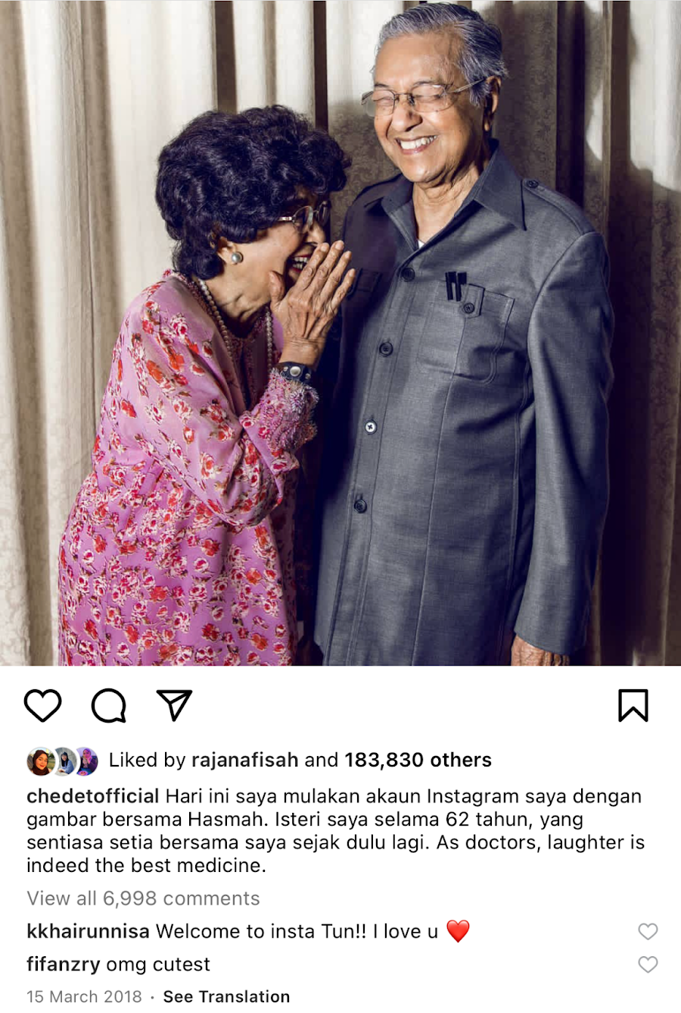

Figure 4. Mahathir's phot with Siti Hasmah

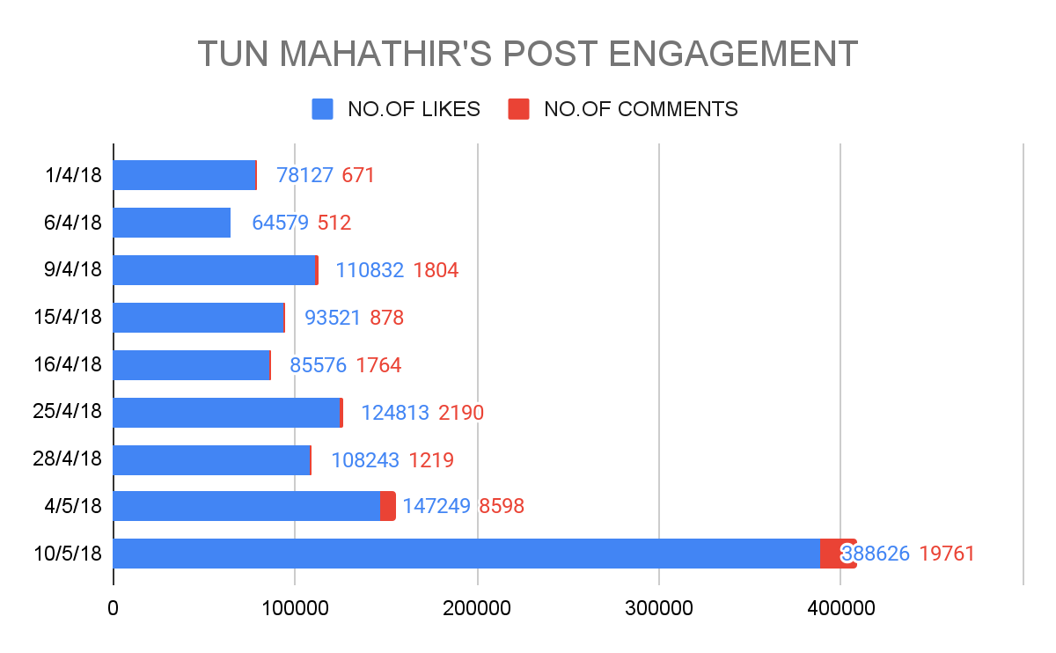
Source: Mahathir Mohamad @chedetofficial, n.d.

Figure 5. Tun Mahathir's post engagements

Similar to Najib’s first Instagram post, this photo was also posted on Tun Mahathir’s Instagram, a few weeks before the 14th GE on 9 May 2018. The 2018 GE was one of the most historic elections in Malaysia, as it was the first time the ruling coalition BN lost a general election. Before the election, Tun Mahathir had formed Parti Pribumi Bersatu Malaysia (PPBM), which led the Pakatan Harapan coalition. Pakatan Harapan won the election, making Tun Mahathir the world's longest serving elected prime minister at 92 years of age (Chin & Welsh, 2019).
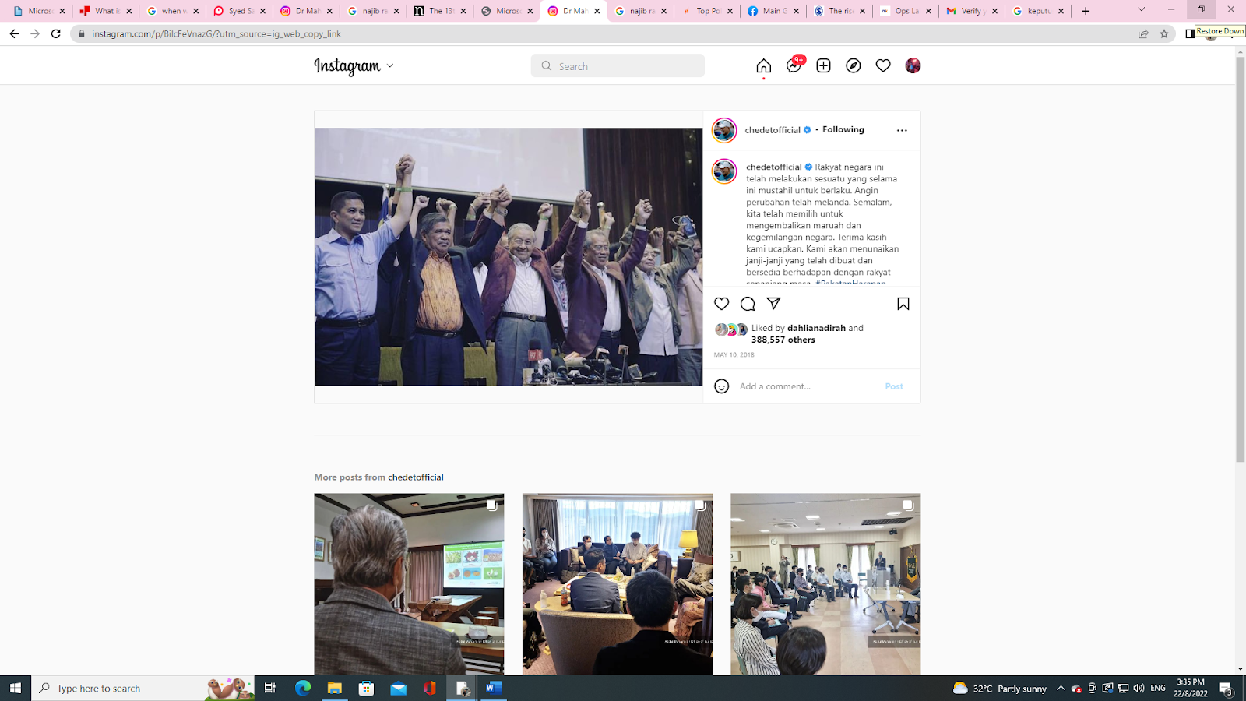
Source: Tun Mahathir, 2018b

Figure 6. Tun Mahathir’s most liked Instagram photo

Syed Saddiq’s first Instagram post was on 8 February 2014. It was a picture of him with his friend during a debate competition when he was still a student at the International Islamic University Malaysia (IIUM). The caption read, “He is a great friend”. The post received 1,994 likes and 301 comments. Before Syed Saddiq entered politics, he was already an aspiring debater and won several awards. He was also a passionate advocate for youth, being invited to events and featured in television and radio interviews (Chow, 2015). When this photo was uploaded, he had not yet joined a political party and had not spoken openly about politics.
Syed Saddiq had 44 Instagram posts from 27 March to 9 May 2018 (Figure 7). Of the 44 posts, he has received 1,189,551 likes and 36,422 comments. Compared to the other two politicians, Syed Saddiq has posted the most posts during this period. Compared to Najib and Tun Mahathir, Syed Saddiq was a new face in politics. By posting on Instagram, he has the opportunity to introduce himself to the public. He is also the youngest of the two, so it can be assumed that he is a more tech-savvy politician who uses social media to his advantage.

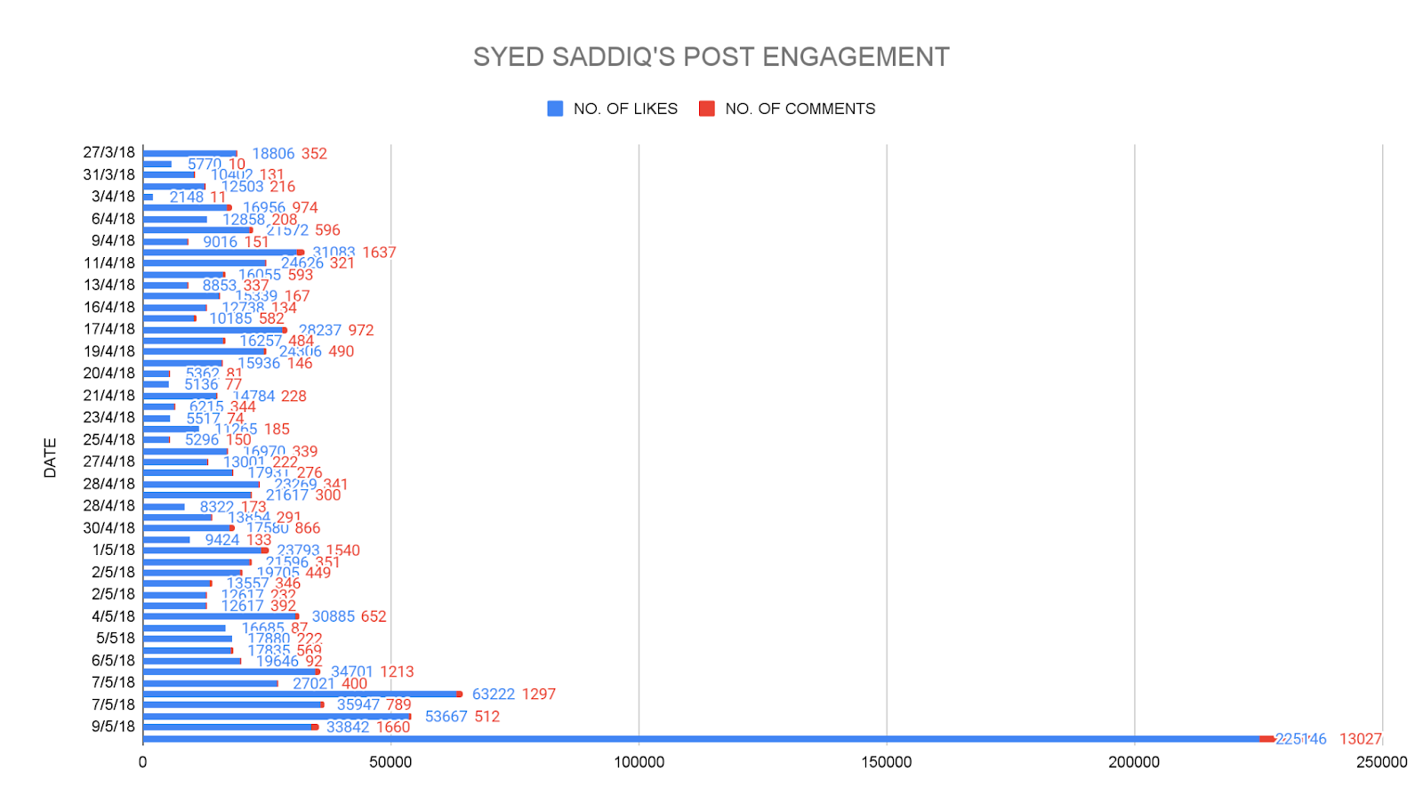
Source: Syed Saddiq, 2018

Figure 7. Syed Saddiq's post engagements photo
The photo with the most likes on Syed Saddiq’s Instagram is one in which he makes a praying hand gesture (Figure 8). The photo shows him praying in a red Malay costume, Baju Melayu Teluk Belanga, which is also a traditional male costume in Johor. With this subtle symbolic message, he wanted to express that he represents the people of Muar, a town in the state of Johor, and emphasise his origin from Johor.

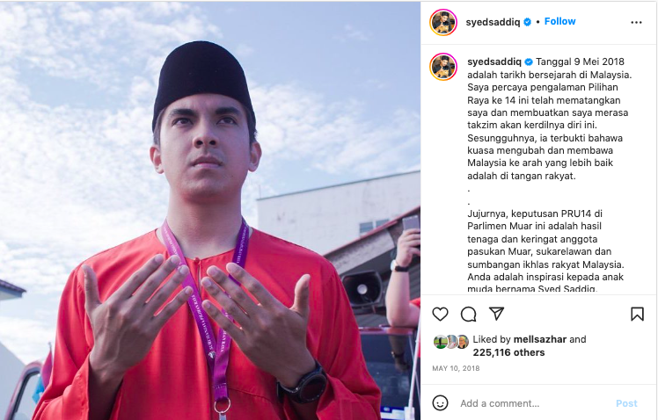

Source: Syed Saddiq, 2018

Figure 8. Syed Saddiq's most liked Instagram photo

Our analysis of the most engaging posts by the most popular politicians on Instagram revealed that the representation of "self" that resonate most with Malaysians are posts depicting family values and piety in the context of Malaysia. It is important that we understand how politicians view the increasing use of social media for political news consumption by Malaysians. In our initial research, we found that Malaysian politicians are less interested in debating important macro-political issues and instead focus more on promoting their loyalty to their partners and their piety. The virality of these social media posts seems to have more traction than political debates.

Analysis and discussions

The debate between liberalising the public sphere or polarizing it, has gained intense scholarly intention (Jibril, Idris & Mohammed, 2022). Even in transitional democracies, the national media are largely in the hands of oligarchs who shape the national political discourse (Madzuki & d'Haenens, 2022). Due to the general interconnectedness of communication, it is difficult for governments to regulate fake news. Fake news is misinformation that is misleading or untrue. Fake news is a subset of disinformation in which untruths are deliberately spread to achieve the goals of the spreaders (Gielow Jacobs, 2022). The regulation of Fake News can also be seen as a means of undermining democracy and the libertarian idea of providing consumers with a wealth of information that enables them to form their opinions freely. Opinions on the curtailment of freedom of expression in Malaysia have been mixed. Syahredzan welcomes the diversity social media offers: The state's role in information distribution has shifted from being the sole provider to now competing with other entities. This change has made social media a hotbed of anti-government sentiments, as seen on platforms like Facebook and Twitter.
As Norman Goh points out, the state also has a responsibility to prevent disinformation that incites hatred and hate speech and sometimes promotes violence against certain vulnerable groups. Syahredzan argues that ‘the state currently has too much power and control in Malaysia, which can lead to abuse’.
As Firdaus mentions, incitement to racial hatred by certain circles should be punishable by the courts: There are comments like “Jangan sampai ada pertumpuhan darah” (I just hope it does not lead to bloodshed). So here we don’t only have contempt of court but we also have a criminal charge, murder threat. Monitoring is necessary for serious issues, but trivial incidents such as making fun of politicians do not require action, as in the case of Fahmi Reza who drew a cartoon of the Prince of Pahang with the Prince's approval does not require such heavy hands. Norman Goh: Legitimate concerns labeled as fake news can result in controlling public responses. Therefore, it is essential to prioritize media literacy and educate the public on safe content sharing regarding political matters.
Firdaus Azil explains why Pakatan Rakyat (PR), the opposition bloc at the time, dominated the alternative media space. By 2008, the opposition had dominated the cyber sphere. Besides MalaysiaKini, we also had Free Malaysia Today and Malaysian Insiders. The opposition used Facebook, blogs but what defeated Tun Abdullah Badawi was the resistance from inside. They were some individuals who started their own blog called Blog House. They are different from other political bloggers in the sense that they were from the finance, media field and so on. UMNO saw this happening and they didn’t want to left out. Although they had the mainstream media but it was not sufficient.
Several factors can be deduced from these interviews. First, Malaysian elected MPs and members of the fourth estate disagree on the parameters of media freedom in Malaysia. Secondly, we have learnt from interviews with senior journalists that UMNO realised that the then opposition PR had captured the space of the alternative media, to which it responded by deploying its own astroturfers (cybertroopers) (Ali, 2020, 9 September). This has led to the rise of populist personalities who prefer to market themselves digitally rather than promote policies that solve the structural problems of our time. Most importantly we also understand from advanced democracies that social media has given rise to populist figures in the US, United Kingdom, Hungary and India. Regional and supranational bodies need to put pressure on social media companies to enforce policies that limit populist narratives by politicians and incorporate bots and algorithms to identify astroturfers on social media. Most importantly, states must include or strengthen civic education and awareness of disinformation and misinformation circulating on social media in schools worldwide. We hope that by teaching political and economic issues in schools, future generations will ask more questions about policies than about the personalities of elected representatives. This is crucial for the protection of democracies worldwide.

Conclusions

This research aimed to place the depiction of politicians' 'self' in context, which assists in their public perception as conforming to societal standards. The research findings revealed that the former opposition party in Malaysia, Pakatan Rakyat (now identified as PH), swiftly adopted new media and social media opportunities in Malaysia. This was a response to the dominance of mainstream media by the previous Barisan Nasional government, particularly UMNO. The rising prominence of new media and social media platforms has led to greater polarization among news audiences, as people have more options to choose their preferred sources. This has resulted in the fragmentation of political discussion spaces. This has led to the growth of online echo chambers, where individuals are exposed only to viewpoints that align with their own beliefs and perspectives. Additionally, there is a rise of misinformation and disinformation that circulate over the internet to influence voters’ perceptions.
The analysis of the legislation on false information (enacted by Barisan National in 2018 and revoked by Pakatan Harapan in 2020) raises questions about categorizing content that incites hatred from materials that fall within the scope of government scrutiny. The research indicates that both older and younger political leaders in Malaysia consistently emphasize religious devotion and the image of being a faithful husband. There is less focus on promoting inclusivity that reflects the diverse ethnic makeup of Malaysian society. Further investigation is needed into the shifts and willingness of current political systems to embrace freedom of speech and public expression. Subsequent studies could also aim to examine how the present administration balances promoting political participation among Malaysians while utilizing legislation to safeguard individuals from hate speech and incitement that may contribute to extremism, particularly among those who are susceptible to such provocations. Another significant limitation of this study was to consider the portrayal of gender roles and self-presentation on social media platforms.

References

Abbott, J., MacDonald, A. W., & Givens, J. W. (2013). New Social Media and (Electronic) Democratization in East and Southeast Asia Malaysia and China Compared. Taiwan Journal of Democracy, 9(2), 105-137.
Ahmad, N. (2022, May 10). Malaysia instagram users statistics 2022. https://www.monocal.com/guide/malaysia-instagram-users-statistics/
Ali, A. J. M. (2020, September 9). Rosmah biayai RM100,000 sebulan pasukan cybertrooper. Berita Harian. https://www.bharian.com.my/berita/kes/2020/09/729516/rosmah-biayai-rm100000-sebulan-pasukan-cybertrooper
Blystone, D. (2022, August 1). What is instagram and why was it successful? https://www.investopedia.com/articles/investing/102615/story-instagram-rise-1-photo0sharing-app.asp
Bruns, A. (2008) Blogs, Wikipedia, Second Life, and Beyond: From Production to Produsage. New York: Peter Lang.
Freedom House. (2022). Freedom In The World 2022. Freedom Hourse. https://freedomhouse.org/country/malaysia/freedom-world/2022
Carr, C. T., & Hayes, R. A. (2015). Social Media: Defining, Developing and Divining. Atlantic Journal of Communication, 23(1), 50. https://doi.org/10.1080/15456870.2015.972282
Chia, J. Y. J. (2007, June 12). Utusan Melayu. Singapore Infopedia. https://eresources.nlb.gov.sg/infopedia/articles/SIP_1088_2007-06-12.html
Chin, J., & Welsh, B. (2019). Special Issue Introduction: The 2018 Malaysian General Election: The Return of Mahathir and the Exit of UMNO. Journal of Current Southeast Asian Affairs, 37(3), 3-8. https://doi.org/10.1177/186810341803700301
Chow, S. (2015, December 7). Saddiq speaks up. R.Age. https://www.rage.com.my/saddiq-speaks-up/
Gomez, J., Mustafa K. Anuar, & Yuen Beng Lee. (2018). Introduction: Democratising Malaysia, Communicating Politics. In Media and Elections: Democrati Transition in Malaysia (pp. xx–xxiii). Strategic Information and Research Development Centre.
Gielow Jacobs, L. (2022). Freedom of Speech and Regulation of Fake News. The American Journal of Comparative Law, 70(Supplement_1), i278-i311.
Hirschmann, R. (2021, November 25). Share of respondents who agreed or disagreed with the following impacts of social media on political participation in Malaysia as of December 2018. Statista. https://www.statista.com/statistics/994189/malaysia-opinions-on-social-media-and-political-participation/
Jibril, A., Idris, S., & Mohammed, A. A. (2022). Discourse Analysis of Online Readers’ Comments on Political Discourse in Nigeria. Journal of Strategic and Global Studies, 5(2), 4.
Kaplan, A., & Haenlein, M. (2010). Users of the world, unite! The Challenges and Opportunities of Social Media. Kelley School of Business, 53, 59–68. https://doi.org/10.1016/j.bushor.2009.09.003
Klinger, U., & Svensson, J. (2015). The emergence of network media logic in political communication: A theoretical approach. New media & society, 17(8), 1241-1257.
Madzuki & d'Haenens, L. (2022). Concentration of media ownership in Indonesia: A setback for viewpoint diversity. International Journal of Communication, 16, 2239-2259.
Mergenthaler, E., and C. H. Stinson. (1992). Psychotherapy transcription standards. Psychotherapy Research, 2(2), 125–42.
Mohajan, H. K. (2018). Qualitative research methodology in social sciences and related subjects. Journal of Economic Development, Environment and People, 7(1), 23–48.
Mustafa, A. K. (2005). Politics and the Media in Malaysia. Kasarinlan: Philippine Journal of Third World Studies, 20(1), 25-47.
MyGovernment. (n.d.). INFO TV. Public Service Delivery and Local Government. https://www.malaysia.gov.my/portal/content/30054
Nahon, K., Hemsley, J., Walker, S., & Hussain, M. (2011). Fifteen minutes of fame: The power of blogs in the lifecycle of viral political information. Policy & Internet, 3(1), 1-28.
Nuurrianti, J. (2016). The effectiveness of social media in assisting opinion leaders to disseminate political ideologies in developing countries: The case of Malaysia. Malaysian Journal of Communication, 32(1), 233–260. https://doi.org/10.17576/ JKMJC-2016-3201-26
Roff, W. (1965). The Origins of Malay Nationalism 1900-1941 [Australian National University]. https://openresearch-repository.anu.edu.au/handle/1885/110691
RTM. (2021, November 16). Background. RTM. https://www.rtm.gov.my/index.php/en/background#:~:text=The%20history%20of%20radio%20in,broadcasting%20through%20300%20meter%20waves.
Russo, A., Watkins, J., Kelly, L., & Chan, S. (2008). Participatory Communication with Social Media. Curator: The Museum Journal, 51, 21–28. https://doi.org/10.1111/j.2151-6952.2008.tb00292.x
Samani, M. C., Maliki, J., Abd. Rahim, M. H., Abd. Rahman, M. P., & Mustaffa, N. (2015). The media agenda of the new and traditional media in Malaysia: Constructing realities. Knowledge for Social Transformation & Development in the 21st Century, 1, 49–55. http://journalarticle.ukm.my/9348/1/048-057_Media_Agenda-HELMI_.pdf
Shafizan, (2019). Instagram and political storytelling among Malaysian politicians during the 14th General Election. Jurnal Komunikasi, 35(3), 353–371. https://doi.org/10.17576/JKMJC-2019-3503-21
StarNgage. (2022). Top politics Instagram influencers in Malaysia in 2022. StarNgage. https://starngage.com/app/pk/influencer/ranking/malaysia/politics
Steven S. (2019, October 10). Mengimbas kembali 80 tahun Utusan Malaysia. MalaysiaKini. https://www.malaysiakini.com/news/495171
Syed Saddiq. (2014, February 9). Syed Saddiq’s First Instagram post. Instagram. https://www.instagram.com/syedsaddiq/
Syed Saddiq. (2018, May 10). Syed Saddiq’s Most Liked Instagram Photo. Instagram. https://www.instagram.com/p/BikHHyXl9D-/?utm_source=ig_web_copy_link
Syed Saddiq Syed Abdul Rahman @syedsaddiq. (n.d.). Instagram Profile. Instagram. https://www.instagram.com/syedsaddiq/?hl=en

