Identification of trends, direction of distribution and spatial pattern of tuberculosis disease (2015-2017) in Penang

Nur Afiqah Ariffin¹, Wan Mohd Muhiyuddin Wan Ibrahim¹, Ruslan Rainis¹, Narimah Samat¹ Mohammad Izzamil Mohd Nasir¹, Siti Masayu Rosliah Abdul Rashid², Azizul Ahmad³, Yaniza Shaira Zakaria⁴

¹Geography Section, School of Humanities, 11800, Universiti Sains Malaysia (USM),
Pulau Pinang, Malaysia
²Geography Section, School of Distance Education, 11800, Universiti Sains Malaysia (USM),
Pulau Pinang, Malaysia
³Centre for Spatially Integrated Digital Humanities (CSIDH), Faculty of Social Sciences and Humanities, Universiti Malaysia Sarawak (UNIMAS), 93400 Kota Samarahan, Sarawak, Malaysia
⁴Institute of Oceanography and Environment (INOS), Universiti Malaysia Terengganu,
21030 Kuala Nerus, Terengganu, Malaysia

Correspondence: Nur Afiqah Ariffin (email: zarika27@gmail.com)

Received: 19 October 2023; Accepted: 9 January 2024; Published: 29 February 2024

Abstract

In Malaysia, the annual tuberculosis (TB) cases exhibit a consistent upward trend, and Penang has experienced a similar increase since 2011. This research aims to analyze the trend, distribution direction, and spatial patterns of TB in Penang from 2015 to 2017, utilizing data from 4,015 TB cases obtained from the TB/Leprosy Unit of the Penang State Department. The study employs three analytical techniques: descriptive analysis, global Moran's I, and central feature with standard deviation ellipse, which measures the trend by calculating standard distances in the X and Y directions to identify the focus and movement of tuberculosis cases.The findings indicate a higher incidence of tuberculosis in males compared to females, with the age group of 45 to 64 years having the highest number of TB patients in Penang. The aging process contributes to weakened immune systems, facilitating tuberculosis development in this age group. The spatial pattern trends for the three study years (2015 to 2017) are scattered, as revealed by the Moran index, indicating a non-dynamic and clustered pattern of TB cases in Penang.The main center of TB case distribution is identified in the George Town subdistrict, situated in the Northeast district, particularly concentrated in urban areas. Rural areas exhibit lower TB cases. The standard deviation ellipse in the north to east direction suggests a potential risk of TB spread, especially to nearby neighborhoods, in the upcoming years.

Keywords: Central feature, directional distribution, Geographic Information System (GIS), Moran's I, spatial analysis, trend analysis, tuberculosis

Introduction

The World Health Organization finds the majority of tuberculosis cases originate in Asia and Africa, with over half located in Asian countries and about a quarter in Africa. Two nations with especially high occurrence rates are China, believed to have between 900,000 to 1.1 million cases, and India, estimated at 2.0 to 2.4 million cases - together making up approximately 38% of worldwide TB infections according to data from WHO (2013) and Sulis et al. (2014). Around 2013, there were nearly 9 million new diagnoses of TB globally, leading to 1.5 million deaths. Of the fatalities, approximately 360,000 were linked to HIV co-infection as reported by WHO (2014a). By 2019, the annual number of fresh TB infections internationally had climbed to an estimated 10 million people as stated by WHO (2020). Malaysia, classed as a country with a moderate disease burden, has experienced annual rises in TB incidence despite local efforts to manage it. Resolving this matter is in line with the country's objective of eradicating TB by 2035. Addressing this aligns with Malaysia's goal to end TB by 2035. Various guidelines have been implemented by the Malaysian Health Ministry to systematically control TB. The National Tuberculosis Control Program (PKTK) began in 1961 coinciding with the BCG vaccine introduction as prevention (Rahman & Mokhtar, 2015). To strengthen PKTK, the ministry is exploring ways to curb spread like bolstering the Directly Observed Therapy Short Course treatment program and launching the Central Tuberculosis Registry in 1973. Manual recording preceded full TBIS implementation in 2012 (Liew et al., 2015). After 61 years of the National TB Control Program, Malaysia has successfully managed TB infections. In the 1960s, around 30,000 people were infected, making TB a major infectious disease before the 1990s. Malaysia's decisive actions led to a significant reduction in incidence and fatalities, as reflected in annual notifications from the 1970s to 1992 (Aziah, 2004). However, from 1992 to 2022, reported cases and mortality gradually increased. The 2022 MOH Annual Report recorded 25,391 cases with 2,572 deaths attributed to TB (see Figure 1: TB incidence cases in Malaysia).

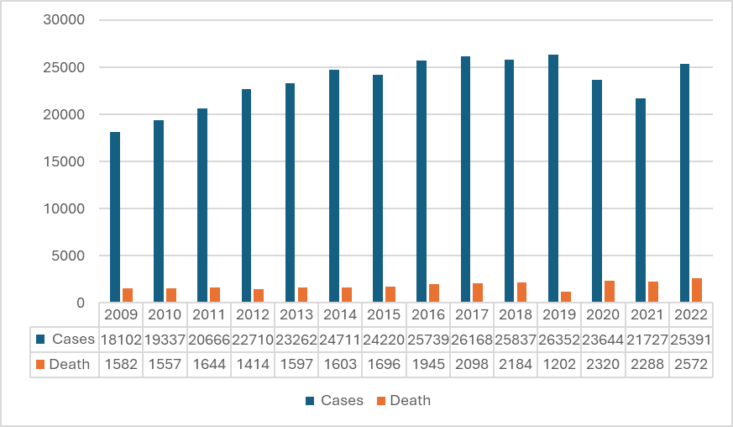

Figure 1. TB cases and death cases

Hence, it is crucial to investigate the challenges faced by the ministry and its agencies during the program's implementation. Identifying these challenges is essential for finding solutions to address the issues, ultimately expediting the process towards achieving the World Health Organization's target of fully eliminating TB by 2050 (WHO, 2014b). This ongoing initiative plays a pivotal role in controlling tuberculosis and ensuring the complete recovery of patients, emphasizing the need for an effective action system, as suggested by Eboy and Hong (2022). A practical action system, such as a surveillance system, provides actionable information for controlling infectious diseases, with GIS software being a well-known tool in current surveillance systems (Azhar Shah et al., 2002). The Geographic Information System (GIS) serves as an electronic asset within the surveillance system, allowing for the exploration and understanding of spatial changes across various domains, including health (Mohd Rosli et al., 2018). GIS facilitates the analysis of health service needs, relationships, and the enhancement of health service quality in specific locations. Compared to manual mapping, GIS provides a swift and straightforward display, offering efficient solutions to spatial problems (Eboy, 2017). Additionally, GIS databases, as highlighted by Ahmad et al. (2011), (2013); Ahmad and Masron (2013); Basiron et al. (2014); Jubit et al. (2023); Marzuki et al. (2023); Mohd Ayob et al. (2013), (2014); Zakaria et al. (2023), store spatial data related to affected areas, enabling the maximization of spatial data for research and decision-making purposes, while also linking spatial data with attribute data. This study aims to employ area-based surveillance for accurately mapping the distribution of TB cases, reinforcing data through epidemiological analysis. Although GIS has not been implemented in Penang, the research focuses on spatially mapping TB incidence and analyzing the spatial patterns of TB occurrences in the region.

Literature review

Airborne tuberculosis and the transmission of the tuberculosis bacterium are intricate processes influenced by four key components: susceptibility to disease, infectiousness, environment, and exposure (CDC USA, 2011). Aerosol droplets, carrying the 'Mycobacterium tuberculosis' germ, have an exceptionally slow settling rate (0.5 mm per second or less), allowing them to be transported over significant distances by air currents, duct systems, or elevator shafts from the source case. Larger particles settle quickly and are either not inhaled by contacts or, if inhaled, get trapped in the mucus of the upper airway. Only droplet nuclei in the size range of 1 to 5 microns reach the terminal air spaces or alveoli, each understood to contain only a few bacteria. The likelihood of a transmission event depends on the infectious particle density and the duration of exposure (Richard et al., 2022). Untreated tuberculosis cases pose a continued risk of infecting others until the patient receives a diagnosis and treatment (Daniel, 2006). Yuen et al. (2015) emphasize that every person exposed to TB germs has a chance of infection, influenced by the individual's immune system or level of immunity. In high-burden countries, undernutrition contributes significantly, with a population-attributable fraction for TB of 27% according to the WHO (Lönnroth et al., 2010; Fox et al., 2015). The determining factors for tuberculosis transmission are categorized into exogenous factors affecting the human body and endogenous factors affecting humans in the environment.
The uneven distribution of TB cases underscores the importance of geographical studies, particularly spatial studies, in the control and prevention strategy. To deepen the understanding of disease transmission, multidisciplinary approaches, including geographical studies based on location, space, and time using geospatial techniques, can be employed. Previous studies utilizing Geographic Information System (GIS) analysis techniques have shown that tuberculosis tends to cluster in specific locations (Munch et al., 2003; Tiwari et al., 2006). GIS mapping in Kathmandu revealed higher TB rates in the Terai region and relatively moderate and low rates in the Hill and Mountain regions (Kakchapati et al., 2014). Souza et al. (2007) observed high TB incidence rates in the neighborhoods of Olinda City in the central and east regions. Understanding the location of tuberculosis clustering is essential for identifying high-risk populations and implementing preventive measures (Wardani et al., 2013). Spatial analysis in China indicated an unbalanced geographical distribution of TB incidence between 2005 and 2015, with a high rate in the west and a low rate in the east (Zhang et al., 2019). Eboy and Hong (2022) found that tuberculosis cases in Mukah predominantly occur in urban areas compared to rural areas, possibly influenced by migrations from areas with tuberculosis (Az Adibah, 2018). Geographic Information Systems (GIS) have transformed data analysis in disease control, particularly in tuberculosis. GIS allows the integration of spatial data with TB-related information, enabling comprehensive spatial analysis to identify patterns and hotspots of TB incidence (Allen, 2016). These clusters identify populations at increased risk due to geographic proximity, indicating recent transmission or reactivation of latent TB infection. Mapping TB cases helps health authorities allocate resources strategically, plan healthcare facilities, and implement targeted interventions in high-risk areas. GIS aids efficient contact tracing by visualizing the geographic movements of TB patients, facilitating the identification of potential new cases. Real-time monitoring and surveillance become possible, enabling timely responses to changing disease patterns (Zhao et al., 2013; Mohd Rosli et al., 2018). GIS also considers environmental factors, contributing to a holistic understanding of TB transmission. Moreover, GIS supports public awareness campaigns through interactive maps, fostering community understanding and engagement. In essence, GIS enhances decision-making processes, offering a multifaceted and spatially informed approach to TB control that improves resource allocation, intervention strategies, and overall effectiveness in mitigating the spread of the disease.

Study methods and location

Study location

The investigation is carried out within Penang, one of the nation's fourteen provinces, and this region is defined by its geographical coordinates: 5° 19' north latitude and 100° 19' longitude. It encounters a mean annual precipitation of 200mm and a temperature range of 28-32 °C. Geographically, Penang, which encompasses 1032 square kilometres, is divided into two major regions. The Island portion encompasses the South West (173 square kilometres) and the North East (119 square kilometres), for a grand total of 292 square kilometres. Seberang Perai, the mainland portion, is additionally subdivided into Seberang Perai Utara (263 square kilometres), Seberang Perai Tengah (236 square kilometres), and Seberang Perai Selatan (241 square kilometres). As shown in Figure 2, Penang comprises 83 subdistricts, of which seven are located in the Northeast, twenty in the Southwest, fifteen in the district opposite North Perai, twenty-two in the Seberang Perai Tengah, and sixteen in the Seberang Perai Selatan. Penang's population experienced a steady increase from 1,526,324 in 2010 to 1,663,000 in 2015 to 1,740,000 in 2017 to 1,760,000 in 2018, with a projected 1,770,000 inhabitants in 2021 (Malaysian Department of Statistics, 2023).
The study location, Penang, was selected based on Ministry of Health data showing it ranked 6th highest in 2013, with an incidence rate of 78.10 per 100,000 population. In 2016, the incidence rate of tuberculosis increased dramatically to 80.56 per 100,000 people, indicating a worrisome rise in the danger of tuberculosis infection for the community. In 2017, the incidence rate decreased slightly to 77.12 per 100,000 people compared to the previous year. Penang was chosen due to the high number of tuberculosis cases, which surpasses 1000 each year. Penang's participation is supported by its dedication to being a Smart and Green State by 2030 through the Inspiring Family project (Portal Penang, 2030). The goal of achieving smart state status is to elevate Penang to global benchmarks through improving public services and keeping the population at the forefront of upcoming advancements. The objective is to provide a smart environment that enhances quality of life across all domains and supports the attainment of sustainable development objectives, particularly in advancing good health and well-being (SDG3). The Penang state administration is confident in its ability to treat tuberculosis efficiently but recognises that this task necessitates dedication from all parties concerned (Anonymous, 2019).
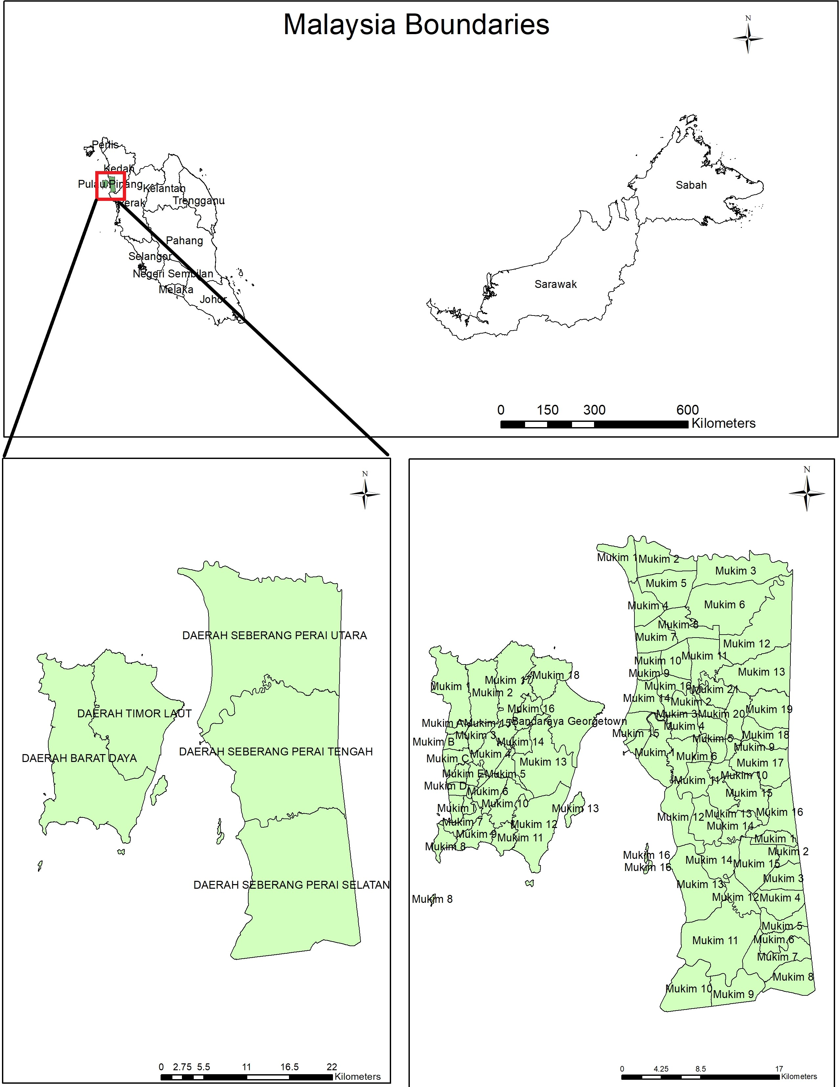

Figure 2. Location map of Penang state and subdistricts in Penang

Data sources

TB case data

This study is exploratory, seeking to examine the link and phenomena related to tuberculosis to gain a more detailed understanding of its distribution and spatial patterns. It utilises a quantitative methodology and depends solely on existing data. The dataset obtained initially relates to tuberculosis patients, with authorization obtained from the Penang State Health Department. Every person diagnosed with tuberculosis is documented in the Tuberculosis Information System (TBIS). The collection contains extensive information about tuberculosis patients, including data like name, address, age, country, and health characteristics. It encompasses all forms of tuberculosis cases, such as pulmonary and extrapulmonary tuberculosis, independent of the patients' treatment status. All cases have been confirmed as tuberculosis patients through interviews performed by health professionals from the National Tuberculosis Control Programme, using the TBIS-10A-1 form. The analysis includes all instances reported between 2015 and 2017, amounting to 1,283 cases in 2015, 1,385 cases in 2016, and 1,347 cases in 2017. The study uses the complete dataset for each year, despite the TB case data being classified into new and recurring cases. The total number of cases over the three-year period is 4,015, and the data collection lasted one year.

Geographic data

The subdistrict and district boundary data were acquired from the Penang Town and Country Planning Department (2019), revealing that Penang is divided into 83 subdistricts or mukims. These mukims are distributed across various districts, including 7 in the Northeast district, 20 in the Southwest district, 15 in the district opposite North Prai, 22 in Seberang Prai Tengah district, and 16 in Seberang Prai Selatan district. Each mukim serves as the minimal area of analysis in this study. The tuberculosis case data, consisting of 6,539 cases with recorded addresses, underwent processing to determine the location of each tuberculosis case. This was achieved using Global Positioning System (GPS) software and Google Maps. The collected data, which included field observations of patient addresses and individual points observed through the Google Maps website, were integrated into a database framework. Geocoding with X and Y coordinates was performed using ArcGIS 10.1 software, showcasing the significance of ESRI's ArcGIS software suite, encompassing ArcMap in facilitating the analysis.

Data analysis

Annual trends and descriptive analysis

From 2015 to 2017, a total of 4,015 tuberculosis cases were documented in Penang, covering various types, including both pulmonary and extrapulmonary tuberculosis. This non-spatial data is categorized based on age, gender, and ethnicity, with age being the only continuous variable. The data, initially acquired in Excel from the Unit TB/Kusta Jabatan Negeri Pulau Pinang, was then transferred and processed using Statistical Package for Social Sciences version 24 (SPSS) software. The analysis performed with SPSS includes descriptive analysis, frequency, and percentage calculations. Descriptive analysis offers insights into the number and percentage of TB cases, encompassing annual trends. To calculate percentages, the frequency is multiplied by 100 and then divided by the total number of patients. For instance, an example calculation for the variable "gender" (male) in the year 2015 is as follows:

68.3% = 876 x 100
1283 …………...(1)

Global Moran's I

An exploratory analysis of TB incidence was conducted using statistical methods. The first method in the exploratory analysis of spatial patterns is autocorrelation analysis. The purpose of autocorrelation analysis is to identify the dependence of the variables, i.e., whether they are random, clustered, or dispersed.

Measuring TB case and directional distribution

Geographical distribution involves assessing the arrangement of certain characteristics within a dataset, allowing for the computation of values representing features like center, density, or orientation (ESRI, 2016). This analysis method encompasses techniques such as determining the location of the central feature and the distribution direction of tuberculosis (TB) cases in the study area. The central feature's location aids in identifying the most central features, such as points or polygons, within the input features. It calculates the distance from each feature's centroid to every other feature's centroid in the dataset, providing insights into the spatial distribution (ESRI, 2016). On the other hand, the Standard Deviation Ellipse serves as a comprehensive approach to measure the trend within a set of points or areas by separately calculating the standard distance in the X and Y directions. These calculations help establish the axis of the ellipse, reflecting the distribution of characteristics. The method involves defining an ellipse as a standard deviation oval, where the standard deviation of the -x coordinate and -y coordinate from the mean center determines the ellipse's axis. The ellipse, with its distinctive orientation characteristics, can illustrate the distribution trend clearly. Moreover, the latitude of the standard deviation can be determined by utilizing location features or positions influenced by attribute values associated with these features (ESRI, 2016).

Result and discussion

Annual trends of tuberculosis incidence from 2015 to 2017

Based on the health indicators report released by the Ministry of Health (Kementerian Kesihatan Malaysia-KKM) for the study years 2015a, 2016, and 2017, tuberculosis cases in Penang exhibited fluctuations. In 2015, the recorded tuberculosis cases increased to 1,283 cases, resulting in an incidence rate of 77.1 per 100,000 population. Subsequently, in 2016, Penang reported 1,385 tuberculosis cases, with an incidence rate of 80.3 per 100,000 population. Moving to 2017, the incidence rate of tuberculosis in Penang stood at 1,347 cases, with an incidence rate of 77.1 per 100,000 population, as illustrated in Figure 3. Population estimates for each year from 2015 to 2017 were derived from the health guidance book for the respective years. These estimates are based on the mid-year population calculated for the period 2011-2017, utilizing the cohort component method that factors in birth, death, and migration components, drawing from the 2010 Population and Housing Census data (Malaysian Department of Statistics, 2017).

Figure 3. Tuberculosis cases and incidence rates in Penang from 2015 to 2017

Descriptive analysis by gender, age group and ethnic group

In 2015, there were a total of 1,283 recorded tuberculosis cases in males, comprising 876 individuals (68.3%), compared to 407 cases in females (31.7%). The following year, 2016, reported 1,385 cases, with males accounting for 936 individuals (67.6%) and females 449 individuals (32.4%). In 2017, 1,347 cases were recorded, and males continued to have a higher prevalence with 900 cases (66.8%) compared to females with 447 cases (33.2%). Generally, males exhibit a higher preference for smoking than females (Kefyalew et al., 2017), as reported by the KKM (2015b), indicating a higher number of male smokers at 38.8% compared to 1.1% for females. This higher prevalence of smoking among males increases their susceptibility to tuberculosis infection compared to females (Aziza et al., 2015; WHO, 2018). Additionally, according to Hudelson (1996), male adults are more likely to be infected with tuberculosis due to their social roles and involvement in economic activities. In summary, these findings suggest that tuberculosis infection is more dominant among males than females.
Age is a frequently studied variable in understanding the demographic profile of tuberculosis cases. For 2015, the age group of 45 to 54 years had the highest number of cases at 255 (19.9%), while the 0 to 14 years age group had the lowest with 18 cases (1.4%). In 2016, the 55 to 64 years age group surpassed the 45 to 54 years group with 275 cases (19.9%), while the 0 to 14 years age group had the lowest with 13 cases (0.9%). In 2017, the 55 to 64 years age group remained the highest with 261 cases (19.4%), and the 0 to 14 years age group was the lowest with 15 cases (1.1%). Overall, the study's three-year results indicated that the 45 to 64 years age group had the highest number of tuberculosis cases in Penang. With advancing age, the weakened immune system facilitates tuberculosis development, particularly when individuals in this age group have other chronic diseases (Yusof, 2017; Eboy & Hong, 2022). This aligns with the WHO's estimation that tuberculosis significantly impacts productive age groups (Iyawoo, 2004; Nissapatorn et al., 2007). Regarding the demographic analysis based on race in 2015, the Malay race had the highest number of cases at 502 (39.1%), while other races (citizens) had the lowest with 9 cases (1.2% of the total). In 2016, Malays again had the highest number with 557 cases (40.2%), while other races (citizens) had the lowest with 12 cases (0.9%). However, in 2017, the Chinese race recorded the highest number with 541 cases (40.2%), and other races (citizens) had the lowest with 13 cases (1.0%). Overall, the study found that Malays and Chinese dominate tuberculosis infections, likely influenced by the population composition in Penang, where Malays constitute the majority, followed by the Chinese. The 2017 population and housing census projections by the Malaysian Department of Statistics revealed 730,600 Malays and 698,000 Chinese (Malaysian Department of Statistics, 2017).

Table 1. Demographic profile of tuberculosis cases according to patient registry records

Variable | 2015 | 2016 | 2017
Variable | (%) | (%) | (%)
Gender
Male | 68.3 | 67.6 | 66.8
Female | 31.7 | 32.4 | 33.2
Age
0 – 14 | 1.4 | 0.9 | 1.1
15 – 24 | 15.8 | 12.5 | 12.6
25 – 34 | 14.6 | 16.6 | 18.3
35 – 44 | 13.7 | 15.4 | 14.2
45-54 | 19.9 | 17 | 18.2
55-64 | 19.2 | 19.9 | 19.4
> 65 | 15.4 | 17.7 | 16.2
Ethnic
Malay | 39.1 | 40.2 | 40
Chinese | 38.2 | 39.4 | 40.2
India | 13.1 | 10.6 | 10.1
Others (Citizens) | 0.7 | 0.9 | 1
Others (Non-Citizens) | 8.9 | 8.9 | 8.8
Source: Unit TB/Kusta, Jabatan Kesihatan Negeri Pulau Pinang, 2019

Measuring TB case distribution and spatial pattern tuberculosis cases

Global autocorrelation

In order to evaluate the spatial distribution of tuberculosis cases in Penang, this study uses spatial autocorrelation using Moran’s index method. Moran’s index measures spatial autocorrelation based on areas that have numerical ratios and interval data (Mohamad Rasidi et al., 2013; Ariffin, 2022). The analysis results from the Moran’s Index for the three years of the study, i.e., 2015 to 2017, show that the incidence of TB cases in Penang is not dynamic, and a clustered pattern is seen for the three years of the study. Moran’s index value for all tuberculosis cases for the three years of the study, from 2015 to 2017, shows a positive autocorrelation with the lowest value in 2017 with an index value of 0.102 and the highest index value of 0.106 in 2015 thus clearly indicating the presence of a clustered distribution of TB cases. Meanwhile, the z-score value was found to be significant by noting the difference between values 2.58 and 2.63. Almost all TB incidence data for three years showed a p-value of 0.01, as shown in Table 2.

Table 2. Global Autocorrelation tuberculosis incidence rate 2015 to 2017 in Penang

Year | Moran’s index | Z Score | P Value | Pattern
2015 | 0.106 | 2.639 | 0.008 | Clustered
2016 | 0.105 | 2.552 | 0.01 | Clustered
2017 | 0.102 | 2.561 | 0.01 | Clustered

Location of central features

The method used to assess the geographical distribution of tuberculosis cases involves calculating values that represent characteristics of tuberculosis cases, such as determining the central location and the latitude of the standard deviation. This approach allows for the observation of changes in the distribution of tuberculosis cases over the three years covered by the study. In general, the spatial pattern trend observed for the three years (2015 to 2017), involving a total of 4,015 cases, is dispersed. The overall distribution of cases is depicted in Figure 4, where the central location of tuberculosis cases for the years 2015 to 2017 is marked by a star symbol within a circle. The colors represent different years, with 2015 represented in red, 2016 in purple, and 2017 in orange.

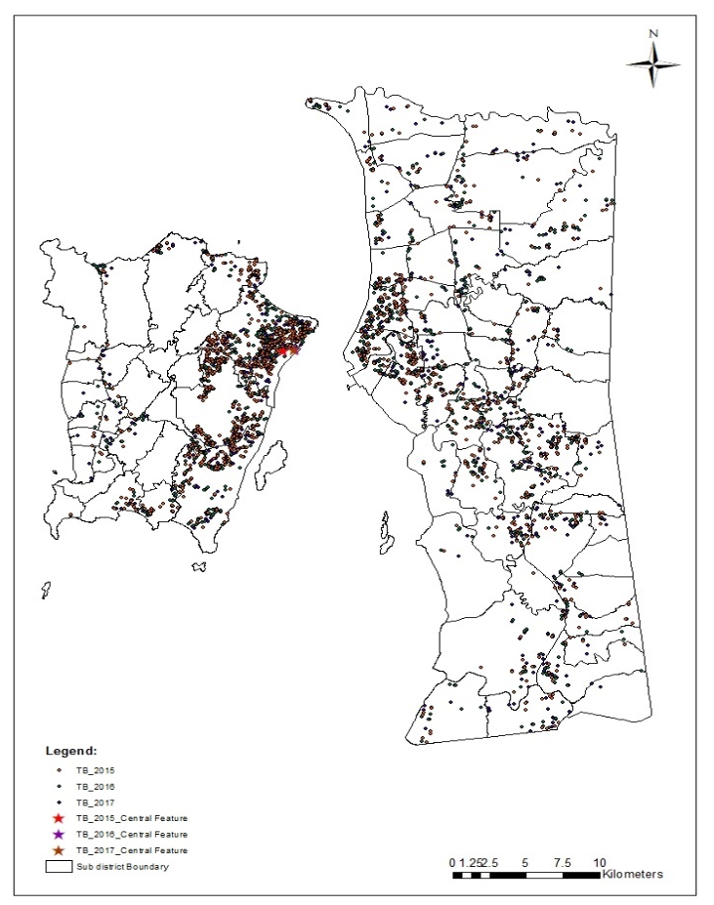
Figure 4. Location of TB case center features from 2015 to 2017

The analysis reveals that the main characteristic center of the distribution of tuberculosis cases in Penang is predominantly located in the subdistrict of George Town City, situated in the Northeast district. This observation suggests that urban areas exhibit a high concentration of TB cases, while rural areas experience lower incidences. The areas with a higher number of recorded cases are associated with densely populated urban centers. This correlation is supported by Abdullah et al., (2016), who noted that population growth tends to concentrate in urban communities, leading to increased population density. Similar findings were reported in a study conducted in Kuala Lumpur by Rajab et al., (2020), where the districts with the highest number of TB cases were identified as Bukit Bintang and Batu in 2013. Additionally, Eboy & Hong (2022) discovered that the mean center of tuberculosis cases is situated in the suburban area of Mukah, with a higher prevalence in urban compared to rural areas. This shift in the center's location is attributed to economic development in urban areas, prompting rural residents to relocate in search of better income opportunities (Kalang & Eboy, 2020). Consequently, urban areas become densely populated, increasing the likelihood of infectious disease transmission, such as tuberculosis.

Directional distribution

The directional direction of the degree of rotation of the longitude of the standard deviation depends on the spread of TB case points because it occurs in different locations with different values of the degree of rotation, as shown in Table 4. The analysis results illustrate the longitude of the standard deviation for each year of the study, presented in a spherical format. Concerning the direction of the central axis of the standard deviation longitude, the distribution of TB cases from 2015 to 2017 tends to be oriented towards the North and East, with degrees of rotation in 2015 (116.20°), 2016 (116.36°), and 2017 (123.36°). The latitude of the standard deviation exhibited changes, inclining more significantly, particularly in 2017 (123.36°), as depicted in Figure 5.
The spatial distribution of TB cases reveals a correlation with spatial factors, particularly location and land use. Notably, the standard deviation in longitude directions tends to concentrate in the North to East areas, encompassing urban locations like Tanjung Bungah, Tanjong Tokong, Tanjong Pinang, Bukit Bendera, Ayer Hitam, George Town, Jelutong, Glugor, Butterworth, Prai, and Bukit Mertajam. This concentration in urban areas, including industrial, residential, commercial, mixed development, and institutional zones, coupled with dense infrastructure like roads and public services, increases the likelihood of TB spread. This observation is supported by Abdul Rasam's findings in 2018. Furthermore, the analysis indicates a shifting center of TB cases from 2015 to 2017, primarily within the George Town subdistrict, serving as a hub for human settlements and activities. In this subdistrict, residential and institutional areas, as well as community facilities like government offices, schools, and places of worship, contribute to the directional distribution. Commuting patterns, driven by high housing costs and home loan expenses, particularly among government and private sector workers traveling between the mainland and the island, are evident. Notably, rising housing prices have redirected home purchases to areas such as Seberang Perai or Kulim, fostering migration from city to city areas in the Seberang Perai region. Economic opportunities, improved quality of life, and well-developed infrastructure further motivate residents to live in smaller towns or suburban areas while working in major urban centers, as highlighted by Ginkel (2010) and Samat et al. (2012).

Table 4. Distance value X and Y

Year | XStdDist | YStdDist | Rotation degree value
2015 | 13164.2266 | 10946.29542 | 116.203816
2016 | 13115.43218 | 11051.31187 | 116.809432
2017 | 13903.60651 | 11191.35206 | 123.367024

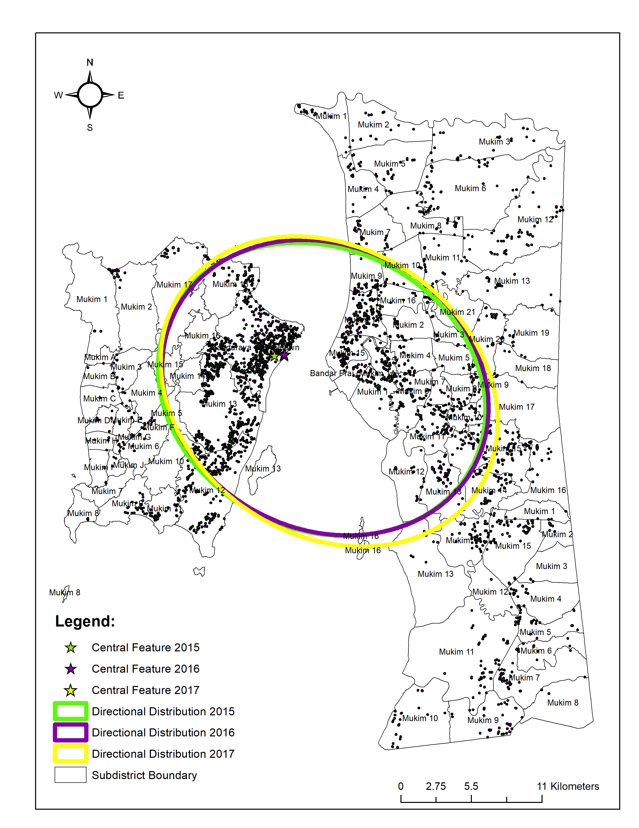
Figure 5. Directional Distribution of TB cases from 2015 to 2017

Moreover, the influx of immigrants or foreign workers, especially those without vaccination, significantly influences the risk of tuberculosis infection in the local community. This assertion is supported by detailed statistical analysis presented in this study. In 2015, there were 114 reported cases of TB among foreign nationals, constituting 8.9 percent of all TB cases that year. Among these cases, 84 individuals did not receive a vaccination injection, while 30 received the vaccination. Similarly, in 2016, 123 cases (8.9 percent of total TB cases) were reported, with 96 individuals not receiving vaccinations and only 27 receiving them. In 2017, 118 cases (8.8 percent of total TB cases) were reported, with 67 individuals not receiving vaccinations and 51 receiving them among foreign nationals (Unit TB/Kusta, Jabatan Kesihatan Negeri Pulau Pinang, 2019). The availability of job opportunities in authorized sectors such as manufacturing, construction, agriculture, plantation, and services attracts foreign workers to Penang, impacting tuberculosis cases. Occupational factors, particularly those in the manufacturing sector and roles as factory or farm operators, significantly contribute to TB cases due to the less conducive and often unhealthy working environments (Chen et al., 2017; Abdul Rasam et al., 2017; Eboy & Hong, 2022). Farm owners tend to hire foreign workers due to lower wages (Norsi’ee et al., 2014). Moreover, the rising number of foreign workers is associated with an increase in tuberculosis cases, attributed to the generally low awareness of tuberculosis symptoms among foreign workers, as noted by Az Adibah (2018). In conclusion, the successful utilization of GIS in evaluating the spatial clustering of TB cases at the subdistrict level in Penang has revealed a directional distribution in subdistricts with human movement and migration activities. This suggests that social determinants of TB disease play a significant role in contributing to high transmission rates. The findings from this study offer crucial insights for understanding the detailed spatial pattern of TB occurrences, which is essential for targeted TB interventions. This significance is particularly vital in developing countries, where efficient resource prioritization is essential for maximizing the impact on disease control in areas with the greatest need.

Conclusion

In summary, this study identified a variation in tuberculosis cases across the entire mukim area over the three-year duration. The spatial aggregation in 2017 highlighted significant differences in TB incidence rates between subdistricts, emphasizing the need for public health initiatives to address these variations and achieve health equity. The study observed a higher prevalence of TB infection in males and individuals aged 45 to 64 years, with Malays and Chinese populations being predominantly affected. Moran's Index analysis for the years 2015 to 2017 revealed a non-dynamic pattern and clustered distribution of TB cases in Penang. The autocorrelation values indicated a clustered pattern, with the lowest value in 2017 (0.102) and the highest in 2015 (0.106). The primary center of TB distribution was identified in George Town City, suggesting a concentration of cases in urban areas with high population density. The directional distribution of TB cases also showed a correlation with spatial factors, specifically location and land use, with a higher standard deviation in the North to East direction. Urban areas such as Tanjung Bungah, Tanjong Tokong, Tanjong Pinang, Bukit Bendera, Ayer Hitam, George Town, Jelutong, Glugor, Butterworth, Prai, and Bukit Mertajam were identified as having a potential influence on TB spread due to human movement, migration, and the impact of immigrants or foreign workers.
The study suggests a likelihood of increased TB spread in the coming years, particularly to neighboring areas, emphasizing the need for further in-depth investigations. The mapping technique employed in the study provides a convenient way to visualize disease patterns over time and space, aiding in targeted prevention and control measures through screening and contact tracing. However, the study has limitations, including its ecological design, a relatively short study period, and the exclusion of certain risk factors associated with TB incidence due to data unavailability.

Acknowledgement

This study is retrospective and has obtained ethical approval from the National Medical Research Register (NMRR) with registration numbers (NMRR-14-998-21596) and (NMRR-19-447-46398). This study is also part of the Long Term Grant Scheme (LRGS): Evaluation of National TB Prevention and Control Program towards Achieving Millennium Development Goals (MDG) (203.PSK.6722006)

Reference

Abdul Rasam, A., Shariff, N. M., Dony, J. J., & Makeswaran, P. (2017). Mapping risk areas of tuberculosis using knowledge-driven GIS model in Shah Alam, Malaysia. Pertanika Journal of Social Science and Humanities, 25(S), 135-144.
Abdul Rasam, A., Shariff, N. M., Dony, J. J., & Misni, A. (2018). Socio-Environmental Factors and Tuberculosis: An Exploratory Spatial Analysis in Peninsular Malaysia. International Journal of Engineering & Technology, 7(3.11), 187.
Abdullah, M. S., Ismail, M. M., & Noor, M. M. (2016). Kesepaduan sosial dan kejiranan di kawasan rukun tetangga. Jurnal Kinabalu, 19, 53-75.
Ahmad, A., & Masron, T. (2013). Aplikasi Sistem Maklumat Geografi (GIS) dalam menganggar keluasan petempatan awal di Tapak Arkeologi Lembah Lenggong, Hulu Perak, Perak, Malaysia. Jurnal Perspektif: Jurnal Sains Sosial dan Kemanusiaan, 5(1), 19–38.
Ahmad, A., Masron, T., Osman, M. A., Mohammed, B., & Marzuki, A. (2011). Initial studies on Web Based Tourism Decision Support System (WBTDSS) case study: Langkawi Island, Kedah. In Azizi Bahuddin (Ed.), Proceedings of 2nd Regional Conference on Tourism Research: Venturing into New Tourism Research (pp. 344–359). Sustainable Tourism Research Cluster (STRC), Universiti Sains Malaysia.
Ahmad, A., Mohd Ayob, N., & Abdul Majid, A. (2013). Regional Carrying Capacity (RCC) Issues Langkawi Islands, Kedah. In B. Mohamed & A. Bahauddin (Eds.), Proceedings of International Conference on Tourism Development: Building the Future of Tourism, Penang, Malaysia, 4 & 5 February 2013 (p. 487). Sustainable Tourism Research Cluster, Universiti Sains Malaysia.
Allen, D. W. (2016). GIS tutorial 2: Spatial analysis workbook. ESRI Press.
Anonymous. (2019, April 6). Pulau Pinang optimis penyakit tibi dapat di banteras. Berita Harian, Retrieved from https;//www.bharian.com.my
Ariffin, N. A. (2022). Pemodelan ruang masa penyakit tuberkulosis di Pulau Pinang [Doctoral dissertation, Universiti Sains Malaysia].
Azhar Shah, S., Mohd. Nor, M. I., Harman Shah, A. H., & Aris, T. (2002). Penggunaan aplikasi GIS dalam penyakit Tuberkulosis di Cheras, Kuala Lumpur, Malaysia. Malaysian Journal of Public Health Medicine, 2(2), 15-26.
Aziah, A. M. (2004). Tuberculosis in Malaysia: Combating the old nemesis. The Medical Journal of Malaysia, 59(1), 1-3.
Aziza, R., Sanae, H., Hatim, K., & Bourkadi, J. E. (2015). Pulmonary tuberculosis specificities in smoker. Egyptian Society of Chext Disease and Tuberculosis, 64(4), 929-932.
Basiron, N. F. Z., Ahmad, A., & Masron, T. (2014). Spatial analysis of international tourist movement to Langkawi for 2010 and 2011. 4th International Conference on Tourism Research (4ICTR), SHS Web of Conferences, 12(01066), 1-8.
CDC USA. (2011). Recommendations for use of an isoniazid-rifapentine regimen with direct observation to treat latent Mycobacterium Tuberculosis Infection. Morbidity and Mortality Weekly Report (MMWR), 60(48), 1650–1653.
Chen, Y. Y., Chang, J. R., Wu, C. D., Yeh, Y. P., Yang, S. J., Hsu, C. H., Lin, M. C., Tsai, C. F., Lin, M. S., Su, I. J., & Dou, H. Y. (2017). Combining molecular typing and spatial pattern analysis to identify areas of high tuberculosis transmission in a moderate-incidence county in Taiwan. Scientific Reports, 7(1), 5394.
Daniel, T. M. (2006). The history of tuberculosis. Respiratory Medicine, 100(11), 1862-1870.
Eboy, O. V. (2017). Tourism mapping: An overview of cartography and the use of GIS. BIMP-EAGA Journal for Sustainable Tourism Development, 6(1), 61-67.
Eboy, O., & Hong, K. S. (2022). Pengenalpastian corak taburan penyakit tuberkulosis menggunakan Sistem Maklumat Geografi (GIS) di Mukah, Sarawak. Malaysian Journal of Social Sciences and Humanities (MJSSH), 7(1), 192-203.
ESRI (2016). An overview of the measuring geographic distribution toolset. Retrieved from http://pro.arcgis.com/en/pro-app/tool-reference/spatial-statistics/an-overview-of-the-measuring-geographic-distributions-toolset.htm.
Fox, G. J., Lee, R. S., Lucas, M., Khan, F. A., Proulx, J., Hornby, K., Jung, S., Benedetti, A., Behr, M. A., & Menzies, D. (2015). Inadequate diet is associated with acquiring mycobacterium tuberculosis infection in an inuit community: A case-control study. Annals of the American Thoracic Society, 12(8), 1153-1162.
Ginkel, V. H. (2010, May 17). Sustainable urban futures: Challenges and opportunities, [Paper Presented]. School of Humanities, Universiti Sains Malaysia, Penang.
Hudelson, P. (1996). Gender differentials in tuberculosis: The role of socioeconomic and cultural factors. Tubercle and Lung Disease: The Official Journal of The International Union Against Tuberculosis and Lung Disease, 77(5), 391-400.
Iyawoo, K. (2004). Tuberculosis in Malaysia: Problems and prospect of treatment and control. Tuberculosis (Edinburgh, Scotland), 84(1-2), 4-7.
Jubit, N., Masron, T., Puyok, A., & Ahmad, A. (2023). Geographic distribution of voter turnout, ethnic turnout and vote choices in Johor State election. Geografia-Malaysian Journal of Society and Space, 19(4), 64–76.
Kakchapati, S., Choonpradub, C., & Lim, A. (2014). Spatial and temporal variations in tuberculosis incidence, Nepal. The Southeast Asian Journal of Tropical Medicine and Public Health, 45(1), 95-102.
Kalang, L.A., & Eboy, O. Valentine. (2020). Penentuan corak densiti jenayah di kawasan tumpuan sekolah-sekolah menengah dalam bandar Kota Kinabalu menggunakan aplikasi GIS: Determination of criminal density patterns in high school focus areas within the city center using the GIS application. Jurnal Kinabalu, 26(2), 197-215.
Kementerian Kesihatan Malaysia (KKM). (2015a). Annual Report KKM 2015. https://www.moh.gov.my/moh/resources/Penerbitan/Penerbitan%20Utama/ANNUAL%20REPORT/Annual_Report_MoH_2015_compressed.pdf
Kementerian Kesihatan Malaysia (KKM). (2015b). Report on Smoking Stutus Among Malaysian Adults.
Kementerian Kesihatan Malaysia (KKM). (2016). Annual Report KKM 2016. https://www.moh.gov.my/moh/resources/Penerbitan/Penerbitan%20Utama/ANNUAL%20REPORT/Annual_Report_MoH_2016_compressed.pdf
Kementerian Kesihatan Malaysia (KKM). (2017). Annual Report KKM 2017. https://www.moh.gov.my/moh/resources/Penerbitan/Penerbitan%20Utama/ANNUAL%20REPORT/Annual_Report_MoH_2017_compressed.pdf
Liew, S. M., Khoo, E. M., Ho, B. K., Lee, Y. K., Mimi, O., Fazlina, M. Y., Asmah, R., Lee, W. K., Harmy, M. Y., Chinna, K., & Jiloris, F. D. (2015). Tuberculosis in Malaysia: Predictors of treatment outcomes in a national registry. The International Journal of Tuberculosis and Lung Disease: The Official Journal of The International Union Against Tuberculosis And Lung Disease, 19(7), 764–771.
Lönnroth, K., Castro, K. G., Chakaya, J. M., Ls, C., Floyd, K., Glaziou, P., & Raviglione, M. (2010). Tuberculosis control and elimination 2010–50: cure, care, and social development. Lancet (London, England), 375(9728), 1814–1829.
Malaysian Department of Statistics. (2017). Annual Report Department of Statistics Malaysia.
Malaysian Department of Statistics. (2023). Annual Report Department of Statistics Malaysia. https://www.mycensus.gov.my/index.php/ms/125-newsletter-infographics/1638-scdp-pulau-pinang
Marzuki, A., Bagheri, M., Ahmad, A., Masron, T., & Akhir, M. F. (2023). Establishing a GIS-SMCDA model of sustainable eco-tourism development in Pahang, Malaysia. Episodes: Journal of International Geoscience, 46(3), 375–387.
Mohamad Rasidi, M. N., Sahani, M., Othman, H., Hod, R., Idrus, S., Mohd Ali, Z., Er, A. C., & Rosli, M. H. (2013). Aplikasi Sistem Maklumat Geografi untuk pemetaan reruang-masa: Suatu kajian kes denggi di daerah Seremban, Negeri Sembilan, Malaysia. Sains Malaysiana, 42, 1073-1080.
Mohd Ayob, N., Ahmad, A., & Mohamed, B. (2013). Spatial Distributions of Tourist in Langkawi Island. Proceedings of International Conference on Tourism Development, 301–309. https://www.semanticscholar.org/paper/Spatial-distributions-of-tourist-in-Langkawi-Ayob-Ahmad/e8063d2ba8ad3d20d02af9a82be22069c56c11ed
Mohd Ayob, N., Masron, T., & Ahmad, A. (2014). Taburan ciri-ciri sosio-demografi pelancong domestik mengikut lokasi di Pulau Langkawi. International Journal of Environment, Society and Space, 2(2), 35–49.
Mohd Rosli, N., Azhar Shah., S., & Mahmood, M. I. (2018). Gegraphical Information System (GIS) application in tuberculosis spatial clustering studies: A systematic review. Malaysian Journal of Public Health Medicine, 18(1),70-80.
Munch, Z., Van Lill, S. W., Booysen, C. N., Zietsman, H. L., Enarson, D. A., & Beyers, N. (2003). Tuberculosis transmission patterns in a high-incidence area: A spatial analysis. The International Journal of Tuberculosis and Lung Disease, 7(3), 271-277.
Nissapatorn, V., Lim, Y. A. L., Ibrahim, J., Chin, H. M., & Ilyana, Mz., Nonaziah, Mz., Hasifah, A. S., & Kuppusamy, I. (2007). Tuberculosis in Malaysia: A Continuing Surge. The Southeast Asian Journal of Tropical Medicine and Public Health, 38(supp 1), 231-239.
Portal Penang. (2030). Penang2030. https://penang2030.com/
Rajab N. A, Hashim, N., & Abdul Rasam A. R. (2020). Spatial Mapping and Analysis of Tuberculosis Cases in Kuala Lumpur, Malaysia. 2020 IEEE 10th International Conference on System Engineering and Technology (ICSET), Shah Alam, Malaysia, pp. 38-43. doi: 10.1109/ICSET51301.2020.9265385
Richard Long, Maziar Divangahi & Kevin Schwartzman (2022). Chapter 2: Transmission and pathogenesis of tuberculosis. Canadian Journal of Respiratory, Critical Care, and Sleep Medicine, 6(sup1), 22-32.
Samat, N., Ghazali, S., Hasni, R., El Hadary, Y. A., & Hassan, F. (2012). Tekanan pembangunan di Seberang Perai Tengah,Pulau Pinang: Satu analisis terhadap peluangdan cabaran kepada masyarakat tempatan: Development pressures in Seberang Perai Tengah,Penang: An analysis on opportunities and challenges to the local communities. Perspektif: Jurnal Sains Sosial dan Kemanusiaan, 4(2), 84-97.
Souza, W. V., Carvalho, M. S., De Fátima Pessoa Militão De Albuquerque, M., Barcellos, C. C., & Ximenes, R. A. A. (2007). Tuberculosis in intra-urban settings: A Bayesian approach. Tropical Medicine & International Health, 12(3), 323–330.
Sulis, G., Roggi, A., Matteelli, A., & Raviglione, M. C. (2014). Tuberculosis: Epidemiology and control. Mediterranean Journal of Hematology and Infectious Diseases, 6(1), e2014070.
Tiwari, N., Adhikari, C. M., Tewari, A., & Kandpal, V. (2006). Investigation of geospatial hotspots for the occurrence of tuberculosis in Almora District, India, using GIS and spatial scan statistic. International Journal of Health Geographics, 5(1), 33.
Unit TB/Kusta, Jabatan Kesihatan Negeri Pulau Pinang. (2019). Cawangan TB/KUSTA. https://jknpenang.moh.gov.my/jknpenang/index.php/bahagian-kesihatan-awam/85-unit-
Wardani, D. W. S. R., Lazuardi, L., Mahendradhata, Y., & Kusnanto, H. (2013). Pentingnya analisis cluster berbasis spasial dalam penanggulangan tuberkulosis di Indonesia. Kesmas: National Public Health Journal, 8(4), 147-151.
World Health Organisation (WHO). (2018). Smoking and tuberculosis: A dangerous combination. http://www.euro.who.int/en/health-topics/communicable-diseases/tuberculosis/news/news/2018/3/smoking-and-tuberculosis-a-dangerous-combination2014
World Health Organisation (WHO). (2020) Global Tuberculosis Report 2020.
World Health Organization (WHO) (2013). Global Tuberculosis Report 2013.
World Health Organization (WHO) (2014a) 7 Million Deaths Annually Linked to Air Pollution. http://www.who.int/phe/health_topics/outdoorair/databases/en/
World Health Organization. (2014b). WHO targets elimination of TB n over 30 countries. http://www.who.int/mediacentre/news/releases/2014/tb-elimination/en/
Yuen, C. M., Amanullah, F., Dharmadhikari, A., Nardell, E. A., Seddon, J. A., Vasilyeva, I., Zhao, Y., Keshavjee, S., & Becerra, M. C. (2015). Turning off the tap: Stopping tuberculosis transmission through active case-finding and prompt effective treatment. Lancet (London, England), 386(10010), 2334-2343.
Yusof, H. U. N. B. (2017). Kepentingan rawatan TIBI terhadap kesihatan. http://www.myhealth.gov.my/kepentingan-rawatan-tibi-terhadap-kesihatan/
Zakaria, Y. S., Ahmad, A., Said, M. Z., Epa, A. E., Ariffin, N. A., M Muslim, A., Akhir, M. F., & Hussin, R. (2023). GIS and oil spill tracking model in forecasting potential oil spill-affected areas along Terengganu and Pahang coastal area. Planning Malaysia: Journal of the Malaysian Institute of Planners, 21(4), 250-264.
Zhang, Y., Li, M., Wu, S. S., Jiang, H., Zhang, J., Wang, S., Ma, W., Li, Q., Ma, Y., Liu, Y., Feng, W., Amsalu, E., Li, X., Wang, W., Li, W., & Guo, X. (2019). Spatial distribution of tuberculosis and its association with meteorological factors in Mainland China. BMC Infectious Diseases, 19(379), 1-7.
Zhao, F., Cheng, S., He, G., Huang, F., Zhang, H., Xu, B., Murimwa, T. C., Cheng, J., Hu, D., & Wang, L. (2013). Space-time clustering characteristics of tuberculosis in China, 2005-2011. PLoS ONE, 8(12), e83605.

