Malaysia and ASEAN-5 e-commerce research: Bibliometric analysis and sustainable development

Khoong Tai Wai¹, Chong Kok Fei², Ooi Pey Theng², Kumara Adji Kusuma⁴, Khor Siak Kim¹

¹ Faculty of Accountancy, Finance and Business,
Tunku Abdul Rahman University of Management and Technology
² Faculty of Human Ecology, Universiti Putra Malaysia
³ Sekolah Jenis Kebangsaan (C) On Pong 2
⁴ Universitas Muhammadiyah Sidoarjo

Correspondence: Khoong Tai Wai (email: khoongtw@tarc.edu.my)

Received: 3 November 2023; Accepted: 26 November 2024; Published: 14 February 2025

Abstract

E-commerce has proven its contribution to the global growth both pre- and post-pandemic, particular in Malaysia and ASEAN-5 countries. E-commerce extends beyond the online shopping, and forms new transactions model. The understanding of e-commerce trends within ASEAN-5 countries is essential to characterize digital economy development that impact global trade, digital divide bridging, and contribute to sustainable development. Hence, the objective of this study is to conduct bibliometric analysis on the Scopus indexed documents between ASEAN-5 countries. This study analysis utilized VOSviewer software to examine the distribution of bibliometric maps. The data was acquired from the Scopus database, whereby data filtering pertaining with the e-commerce terms contained in the title, keyword, and abstract areas. The documents published between 2013 and 2022 were chosen to capture the latest circumstances. During the studied period, Indonesia has the highest documents and items. Within the period, ASEAN-5 showed an increase trend of publication. ASEAN-5 showed various of the top five keywords occurrences, however similarity in sales term. The dataset items are further categorized into clusters. ASEAN-5 demonstrated association of theories in the documents except Philippines. The majority of the countries utilized consumer behavior theories, except Singapore focus mathematics concept. Besides, the sustainable development term frequently occurred within ASEAN-5, particularly Malaysia and Thailand, but not in Philippines. In addition, e-government term plays key research for Thailand and Philippines. The study finding provides a valuable insight for future study in the ASEAN-5 countries e-commerce by identifying key terms, significant publications, and collaborative networks. Researchers can build on this finding to explore specific study areas, consists of theories adopted, sustainable development, and e-government.

Keywords: ASEAN-5, bibliometric, e-commerce, Scopus, sustainable development, VOSviewer

Introduction

E-commerce extends beyond online shopping and involves innovative transaction business models, within business-to-business (B2B), business-to-consumer (B2C), and consumer-to-consumer (C2C). For example, Lazada and Alibaba B2B platforms have transformed how micro, small and medium-sized enterprises (MSME) penetrate global markets. Besides, Shopee and Tokopedia B2C platforms have increased consumer convenience by reshaping the consumer experience through live-streaming and digital payments integration. Facebook Marketplace C2C platforms has encouraged and empowered individual in the digital economy participation. This is due to the internet technology which provided a pivotal innovation of the modern age, thus dramatic impact on business practices. The widespread adoption of information and communication technologies (ICT) have resulted in an expansion of e-commerce within the global B2B activities (Hadasik & Kubiczek, 2022). With the internet growth, individual now engage in the global economy such as price comparison among different geographical regions such as how demand affects pricing, and identify potential substitute options (Acharya et al., 2023). Subsequently, the customers gain a distinct advantage. This is because the extensive level of market openness enables individual to conveniently compare offerings across multiple websites. When customers discover discrepancies in particular in pricing content or services, they are inclined to swiftly transition back to traditional options (Elhan-Kayalar et al., 2022). Therefore, from a business perspective, the presence of a physical store is not seen significant (Hadasik & Kubiczek, 2022).
Moreover, the post COVID-19 pandemic has demonstrated e-commerce to be a significant driver of global economic growth. The pandemic catalyst for the rapid e-commerce expansion due to movement restrictions, and social distancing measures factors. During the pandemic, the ASEAN-5 region experienced unprecedented growth trends in online transactions, particularly retail, healthcare, and education industry shifting to digital operation modes. In 2022, the Southeast Asian countries e-commerce revenue reached $99.5 billion. Within ASEAN-5, Indonesia taking the lead make up 52% of the total, followed by Thailand (14.4%), the Philippines (11.5%), Malaysia (8.7%), and Singapore (4%).
However, the bibliometric analysis in e-commerce research, particularly in Scopus Scholar-indexed journals, is understudied. The use of VOSviewer for mapping analysis enable to assess term the quantity and present condition. Hence, this study utilized bibliometric analysis to analyses Scopus indexed e-commerce study. This study is expected to assist researchers discover e-commerce research subject matter. It is valuable to understand the correlation of e-commerce study to other fields. In addition, it provides a recent e-commerce development in the post-pandemic environment.

Literature review

The discipline of e-commerce denotes the conduct of business transactions through electronic platforms. It utilizes electronic media and the internet as a means of conducting economic exchange of goods and services transactions. At the organizational level, e-commerce adopts internet-based technological solutions (Acharya et al., 2023), such as electronic data interchange. The exploitation of website platform as a trading platform has facilitates direct exchanges between the seller and buyer. The platform employs a wireless purchase cart or a buy basket as a mechanism for allowing payment via debit card, credit card, or electronic fund transfer. As such, e-commerce is commonly associated with internet, payment processing services, analytics, and social media aspects (Kim & Kim, 2022; Fu & Saad, 2023; Khoa & Huynh, 2023; Marjuti et al., 2023).
During COVID-19, multiple studies have been undertaken (Beckers et al., 2021; Giotopoulos et al., 2022; Elhan-Kayalar et al., 2022; Hasbi et al., 2022; Hadasik & Kubiczek, 2022). While conventional research concentrated on large-scale organizations (Han et al., 2022), the COVID-19 period emphasis on global digital applications aspect by retail enterprise (Beckers et al., 2021; Giotopoulos et al., 2022; Shang et al., 2023), and household behavior (Al Amin et al., 2022; Gruntkowski & Martinez, 2022; Jasinska-Bilizczak, 2022; Chen et al., 2023; Khoong et al., 2023). Besides, studies also associate it with strategic planning (Hadasik & Kubiczek, 2022). As comparison, the current e-commerce sector has undergone significant advancements. E-commerce has experienced notable shift towards decentralized operations, incorporation of artificial intelligence (AI) technology, and services offering such as the application of the goods and services tax and short-term financing (Luisa, 2020; Lin et al., 2021; Kang et al., 2022; Zhang, 2023; Jha et al., 2023; Goti et al., 2023).
In view of the important of e-commerce, there was some review of literature study of e-commerce being done. However, the studies limit industries to supply chain (Mashalah et al., 2022), sustainability (Cordes & Marinova, 2023), consumer behavior (Chen et al., 2023), and AI (Goti et al., 2023). In term of geographical distribution, few studies focus within the Association of Southeast Asian Nations (ASEAN) countries (Elhan-Kayalar et al., 2022; Ridhwan et al., 2023). However, several key gaps literature remain within ASEAN-5 e-commerce. Majority of the studies concentrated on the economics, technological, and market aspects, but limit study that integrates sustainable development aspects. Besides, few provide countries comparative analysis, and focuses on individual countries. In addition, only a few existing e-commerce bibliometric studies have addressed the sustainability developing role especially in ASEAN context.
VOSViewer is a software tool developed with the objective of creating, building, and visualizing bibliometric maps (Vlase & Landesmaki, 2023). VOSViewer includes a range of functions, including a text-mining capability that allows for the development and visualization of relationships between citations in scholarly articles. The integration of mapping systems, search features, and browsing functionality enables the visual depiction of published maps (Bukar et al., 2023; Zyoud et al., 2023; Khoong et al., 2024). VOSviewer supports the extraction analysis, an approach utilized to simplify large datasets by studying the bibliometric information linked to a particular paper. Bibliometrics provides a thorough analysis of the conceptual framework and evolving trends within a specific area of study (Vlase & Landesmaki, 2023).

Method and study area

Preferred Reporting Items for Systematic reviews and Meta-Analyses (PRISMA) procedure was utilised for data collection, whereby includes the identification, screening, eligibility, and included stages. The Scopus database was selected due to the significance target of academics for quality publications and international acknowledgment. Besides, the Scopus database is international citation level revealed the largest researched indexed abstract and citation database. All Scopus databases articles are high quality audited yearly based on the four quality measurements, consisting of CiteScore, h-index, SCImago Journal Rank, and Source Normalised Impact per Paper. All Scopus database articles indexed and fulfilled the criteria for article type and relevance research themes for this research were kept in a file for VOSviewer analysis utilization.
In this research, the themes “e commerce” OR “electronic commerce” articles were exclusively selected. The data retrieval process engaging the title, keyword, and abstract criteria to search for information pertaining to the e-commerce. The papers employed in this study consist of publications between the year 2013 to 2022. A duration of 10 years is sufficient to capture the latest trends, and reflects COVID-19 environment. This timeframe also highlights the influence of pandemic and related policy shift on influenced research directions and output quantity. Data were retrieved on 4 April 2023. There is no language filter applied. The data were filter by country to retrieve each ASEAN-5 country. From the database filtering process, Indonesia (1,422 records) has the highest record documents, followed by Malaysia (931 records), Singapore (529 records), Thailand (341 records), and Philippines (157 records).
All retrieved articles were stored in the *.csv file format. After, VOSviewer tools utilised to represent visually, and examine bibliometric maps trends. The data mapping process began by extracting articles from database sources that had been previously selected. The data mapping included three categories, namely network mapping, density mapping, and visualisation overlay. VOSviewer is designed to create and display bibliometric networks, in which the networks may involve article journals, researchers, or personal articles. This often constructed based on citations, bibliographic data, or co-authorship. VOSviewer is suitable for huge literature research quantities analysis, and for visually representing data trends (Perianes-Rodriguez et al., 2016). This analysis done by co-citation and keyword-based approaches. Subsequently, network visualised that demonstrates the associations between numerous terms. VOSviewer adopts a multi-stage visualise bibliometric networks procedure, consists of data collection, data import input and preparation, network creation development, and visualisation. To create the bibliometric map, the keyword frequency determines a minimum frequency of five occurrences from the prepared database. Furthermore, the study adopted a filtering process to determine the terms that would be integrated into the VOSviewer network mapping visualisation.

Results and discussion

Based on the data shown, the number of researches on e-commerce demonstrate increase trend for ASEAN-5 countries (Figure 1). In term of the highest publication, Malaysia had the most publication from year 2013 until 2016. However, Indonesia overtook the highest publication since 2017 until 2022. Indonesia and Philippines demonstrated more than 10-times fold increase within the period. Besides, more than 90 percent of the documents were related to articles and conference paper (Table 1), and mostly related to computer science, engineering, business, and management and accounting subjects.

Figure 1. Types of e-commerce documents between ASEAN-5

Table 1. Comparison document types between ASEAN-5

Type of documents | Indonesia | Malaysia | Singapore | Thailand | Philippines
Article | 460 (32.3%) | 509 (54.7%) | 251 (47.4%) | 135 (39.6%) | 35 (22.3%)
Conference paper | 925 (65.0%) | 346 (37.2%) | 236 (44.6%) | 186 (54.5%) | 118 (75.2%)
Book chapter | 22 (1.5%) | 41 (4.4%) | 33 (6.2%) | 16 (4.7%) | 2 (1.3%)
Review | 12 (0.8%) | 30 (3.2%) | 4 (0.8%) | 3 (0.9%) | 1 (0.6%)
Book | 1 (0.1%) | 2 (0.02%) | 3 (0.6%) | 1 (0.3%) | 0 (0.0%)
Data Paper | 0 (0.0%) | 1 (0.1%) | 0 (0.0%) | 0 (0.0%) | 0 (0.0%)
Editorial | 0 (0.0%) | 1 (0.1%) | 1 (0.2%) | 0 (0.0%) | 0 (0.0%)
Retracted | 1 (0.1%) | 1 (0.1%) | 0 (0.0%) | 0 (0.0%) | 0 (0.0%)
Erratum | 1 (0.1%) | 0 (0.0%) | 0 (0.0%) | 0 (0.0%) | 0 (0.0%)
Note | 0 (0.0%) | 0 (0.0%) | 1 (0.2%) | 0 (0.0%) | 1 (0.6%)
Source: Scopus database

Based on the minimum number of occurrences of five keywords setting, Indonesia had the highest total of items of 437, follow by Malaysia (227 items), Singapore (157 items), Thailand (90 items), and Philippines (36 items) relating to the e-commerce area. Even though the top five keywords by occurrences among ASEAN-5 showed various dimensions, however similarity of the sales keywords emerged in all ASEAN-5 (Table 2). For Indonesia, the top five keywords associated with the sales surveys, meanwhile Malaysia associated with websites survey, Singapore associated to cost information systems, Thailand associated with sales websites, and Philippines associate to student eLearning. ASEAN-5 showed various of the top five keywords occurrences, however similarity in sales term (Figure 2). The dataset items further categorized into distinct clusters, based on the color for visualization (Table 3 to Table 11).

Table 2. Top five keywords between ASEAN-5

Country | Indonesia | Malaysia | Singapore | Thailand | Philippines
First keyword  (TO/TLS) | E-commerce (885/4,509) | E-commerce (478/1,721) | E-commerce (226/768) | E-commerce (200/595) | E-commerce (126/321)
Second keyword (TO/TLS) | Sales (267/2,013) | Commerce (135/621) | Commerce (210/784) | Commerce (76/239) | E-learning (56/167)
Third keyword  (TO/TLS) | Commerce (231/1,394) | Sales  (94/589) | Sales  (67/293) | Sales  (48/224) | Students (37/113)
Fourth keyword  (TO/TLS) | Indonesia (205/1,286) | Websites (75/391) | Costs (44/211) | Thailand (42/122) | Sales (22/68)
Fifth keyword  (TO/TLS) | Surveys  (137/1,169) | Surveys  (54/339) | Information systems (35/142) | Websites  (37/162) | Surveys  (17/60)
Total cluster groups | 7 | 8 | 8 | 7 | 4
Source: Scopus database

The finding shows Indonesia has overtaken Malaysia in research output since 2017. This is driven by several factors. The rapid digital transformation initiatives involve the 100 Smart Cities Program and the rise of major e-commerce Tokopedia and Bukalapak platform, has contributed to increased research interest. In addition, authorities research and development support and global collaboration, has encouraged a dynamic research community. On another hand, Malaysia shows a steady output trend may indicate a shift in priorities study toward emerging areas such as Fintech and blockchain.
Besides, the types of documents published highlight research dissemination strategies. Philippines and Indonesia and the rely heavily on conference papers. This reliance suggests a preference for faster findings dissemination, and common in emerging research groups. Nevertheless, while conference papers provide immediate visibility, however it typically absence of journal articles academic long-term impact. On another hand, Malaysia and Singapore produce a higher proportion of journal articles reflecting the focus on peer-reviewed study that contributes more significantly global e-commerce academic discourse. Then, the limited contributions to book chapters and review articles across ASEAN-5 countries underscore a gap in synthesizing consolidating study findings. The lack of reviews obstructs comprehensive analysis, and trend-gap identification. These finding expose different academic strategies within ASEAN-5, where Philippines and Indonesia emphasize quantity rapid dissemination, meanwhile Malaysia and Singapore prioritize quality scholarly impact.

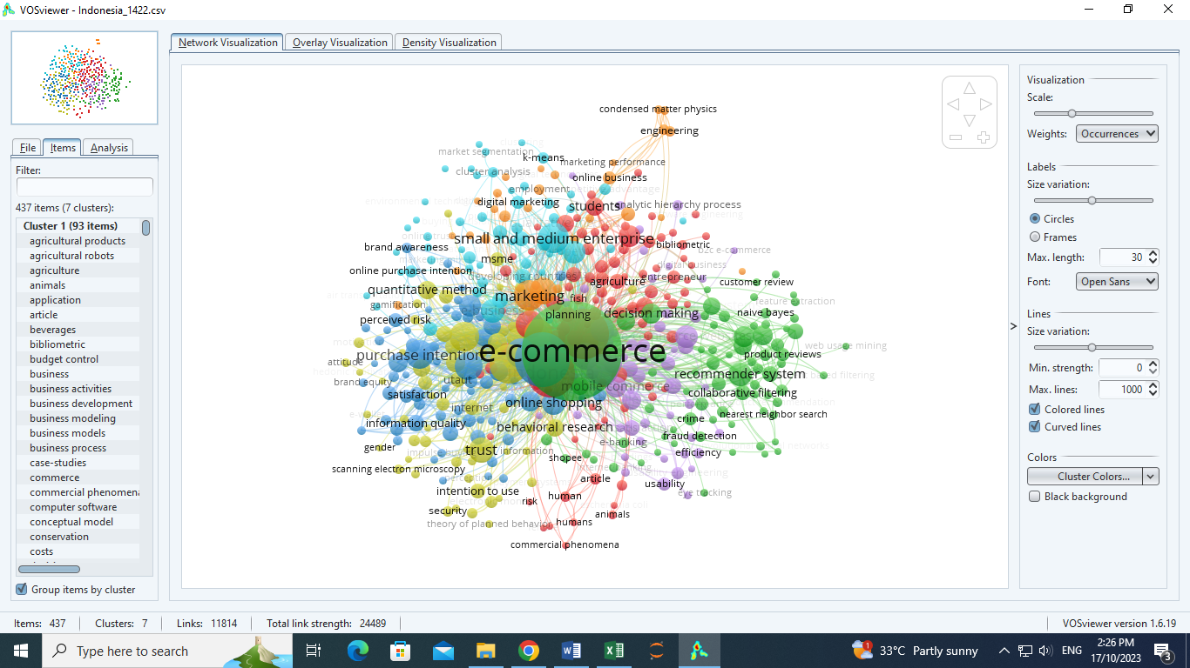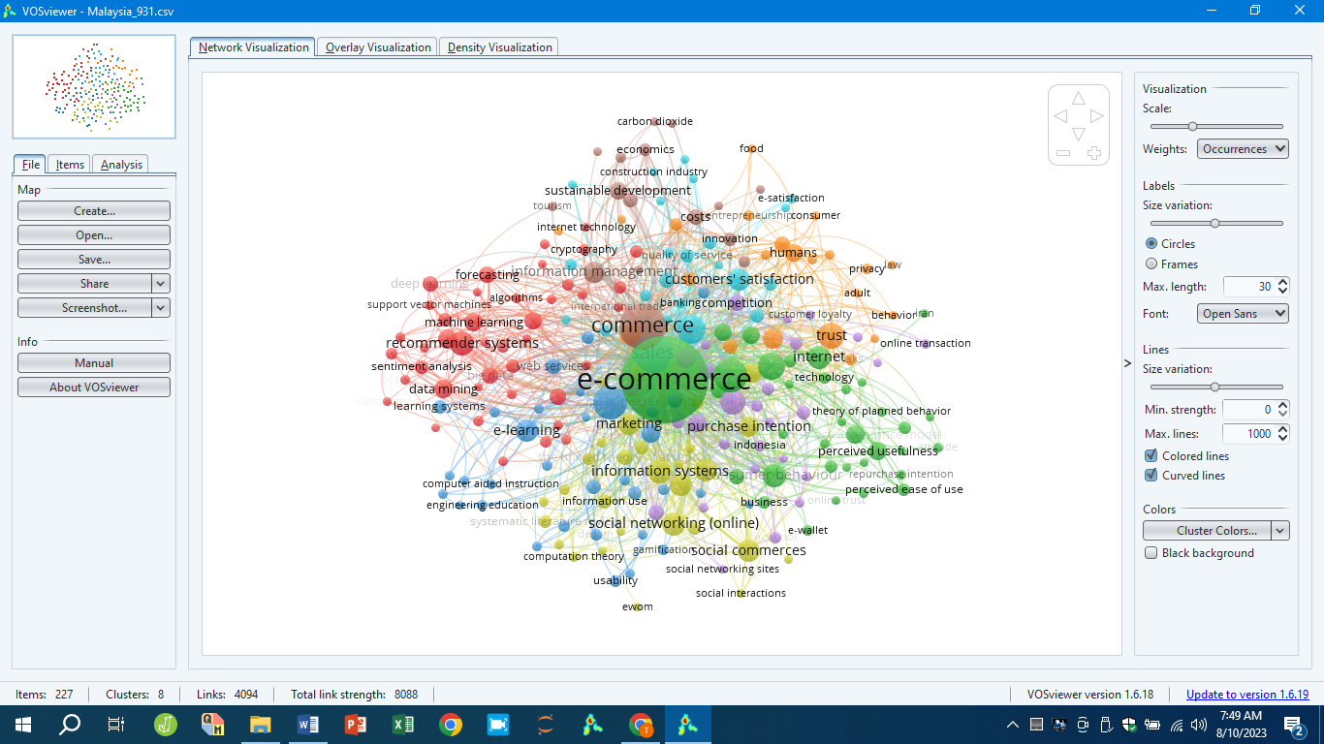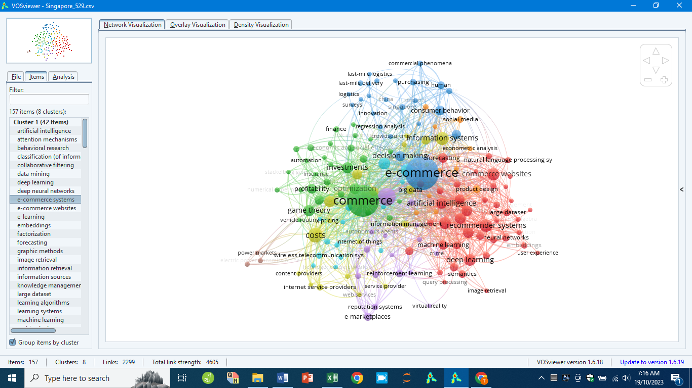
a) Indonesia b) Malaysia c) Singapore

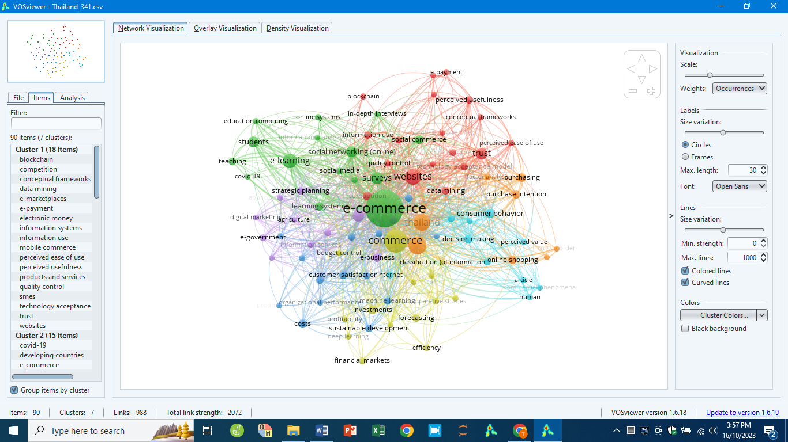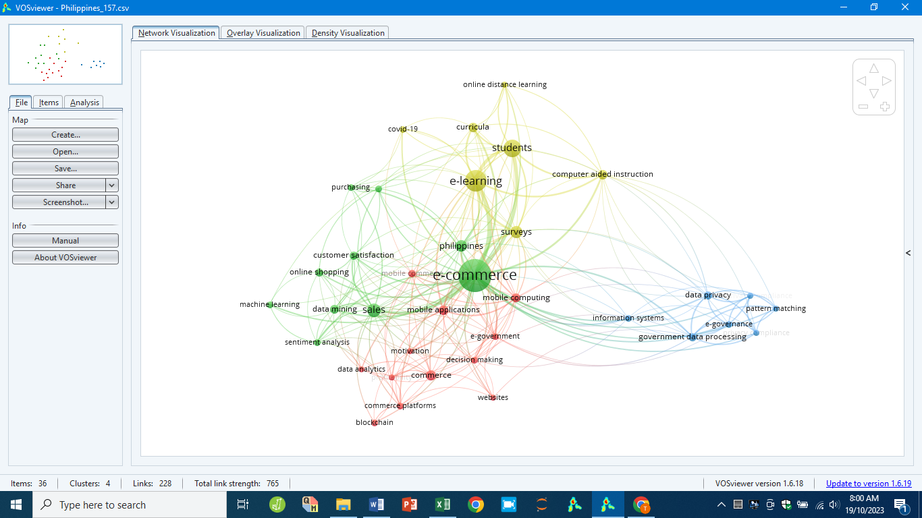
d) Thailand e) Philippines

Figure 2. Network visualization of e-commerce for ASEAN-5

Table 3. Cluster e-commerce terms group for Indonesia (437 items)

Cluster | Terms | Total items | Colour | Links | Total links strength | Occurrences
1 | Commerce | 93 | Red | 349 | 1,394 | 231
2 | E-commerce | 74 | Green | 433 | 4,509 | 885
3 | Sales | 67 | Dark blue | 366 | 2,013 | 267
4 | Surveys | 61 | Yellow | 286 | 1,169 | 137
5 | Websites | 58 | Purple | 207 | 619 | 90
6 | Small and Medium Entreprise (SME) | 55 | Light blue | 180 | 458 | 84
7 | Marketing | 29 | Orange | 239 | 607 | 85

Table 4. Cluster group associated terms for Indonesia

Cluster | Terms | Within cluster associated terms | Non-within cluster associated terms
1 | Commerce | Information management, e-learning, agriculture, qualitative method, costs, e-government, etc | Marketing, SME, SEM, website, purchase intention, etc
2 | E-commerce | Recommender system, decision making, collaborative filtering, mobile banking, eye tracking, etc | Website, marketing, online shopping, SME, behavioral research, trust etc
3 | Sales | Purchase intention, e-service quality, perceived risk, brand awareness, information quality, etc | Behavioral research, mobile commerce, website, quality control, competition, SME, etc
4 | Surveys | SEM, trust, behavioral research, quantitative method, economic and social effects, etc | Online shopping, purchase intention, marketing, developing countries, e-learning, competition, etc
5 | Websites | Mobile commerce, product design, web design, user interfaces, information use, etc | SME, competition, purchasing, website quality, behavioral research, information management, etc
6 | Small and Medium Entreprise (SME) | Competition, developing countries, e-business, e-commerce adoption, etc | SEM, TAM, website, decision making, e-marketplace, qualitative method, etc
7 | Marketing | Social networking (online), social media | SME, social media, qualitative method, information management, website, etc

Table 5. Cluster e-commerce terms group for Malaysia (227 items)

Cluster | Terms | Total items | Colour | Links | Total links strength | Occurrences
1 | Recommender systems | 42 | Red | 53 | 138 | 37
2 | E-commerce | 34 | Green | 224 | 1,721 | 478
3 | Websites | 33 | Dark blue | 139 | 391 | 75
4 | Social networking (online) | 29 | Yellow | 95 | 218 | 34
5 | Small and Medium Enterprises | 28 | Purple | 56 | 145 | 40
6 | Sales | 23 | Light blue | 166 | 589 | 94
7 | Trust | 22 | Orange | 76 | 197 | 45
8 | Commerce | 16 | Brown | 173 | 621 | 135

Table 6. Cluster group associated terms for Malaysia

Cluster | Terms | Within cluster associated terms | Non-within cluster associated terms
1 | Recommender systems | Data mining, deep learning, forecasting, collaborative filtering, ontology, etc | Commerce, sales, websites, purchase intention, consumer behaviour, article, etc
2 | E-commerce | Online shopping, consumer behaviour, internet, Technology Acceptance Model (TAM), Covid-19, etc | Sales, surveys, websites, Unified Theory of Acceptance and Use of Technology (UTAUT), trust, information management, etc
3 | Websites | E-learning, website design, engineering education, web services, user interfaces, gamification, etc | Behavioral research, data mining, decision making, trust, B2C, etc
4 | Social networking (online) | Mobile commerce, information systems, social media, social commerce, economic and social effects, etc | Behavioral research, Facebook, trust, digital marketing, consumer behaviour, etc
5 | Small and Medium Enterprises | e-business, research, literature review, competition, cloud computing, etc | Sales, surveys, Covid-19, business performance, structural equation modelling (SEM), etc
6 | Sales | Surveys, customers’ satisfaction, neural networks, quality of service, e-banking, product design, etc | Recommender systems, websites, sustainable development, trust, information management, etc
7 | Trust | Privacy, behaviour, risks, SEM, security, human, etc | Online transaction, TAM, social media, computer crime, online shopping, etc
8 | Commerce | Information management, sustainable development, e-procurement, innovation, costs, investment, etc | Machine learning, artificial intelligence (AI), forecasting, trust, SEM, TAM, e-learning, etc

Table 7. Cluster e-commerce terms group for Singapore (157 items)

Cluster | Terms | Total items | Colour | Links | Total links strength | Occurrences
1 | Recommender systems | 42 | Red | 64 | 162 | 34
2 | Commerce | 29 | Green | 139 | 784 | 210
3 | E-commerce | 24 | Dark blue | 139 | 768 | 226
4 | Costs | 19 | Yellow | 72 | 211 | 44
5 | Sales | 16 | Purple | 95 | 293 | 67
6 | Social networking (online) | 14 | Light blue | 69 | 151 | 30
7 | Product design | 10 | Orange | 27 | 49 | 12
8 | Electric power transmission networks | 3 | Brown | 12 | 26 | 6

Table 8. Cluster group associated terms for Singapore

Cluster | Terms | Within cluster associated terms | Non-within cluster associated terms
1 | Recommender systems | E-commerce websites, state-of-art, deep learning, AI, data-mining, etc | E-commerce, big data, decision making, multi agent systems, information management, etc
2 | Commerce | Investments, profitability, game theory, stackelberg games, numerical experiments, economic and social effects, stochastic models, optimization, etc | Virtual reality, reinforcement learning, deep learning, consumer behavior, costs, etc
3 | E-commerce | Online shopping, consumer behavior, crowdsourcing, sustainability, innovation, etc | Product design, AI, deep learning, sales, VR, investments, game theory, etc
4 | Costs |  | Competition, economics, internet, big data, IoT, incentive mechanism, etc
5 | Sales | Crime, e-marketplaces, reputation systems, distributed computer systems, autonomous agents, etc | Recommender systems, AI, social media, forecasting, optimization, costs, game theory, etc
6 | Social networking (online) | Marketing, clustering algorithms, influence maximizations, algorithms, approximation algorithms, etc | Costs, sales, investments, risk assessments, social media, forecasting, recommender systems, data mining, etc
7 | Product design | Economic analysis, empirical analysis | Online shopping, data mining, state of the art, AI, digital storage, etc
8 | Electric power transmission networks | Power markets, energy resources | Commerce, costs, sales

Table 9. Cluster e-commerce terms group for Thailand (90 items)

Cluster | Terms | Total items | Colour | Links | Total links strength | Occurrences
1 | Websites | 18 | Red | 59 | 162 | 37
2 | E-commerce | 15 | Green | 87 | 595 | 200
3 | Planning | 14 | Dark blue | 29 | 46 | 9
4 | Commerce | 14 | Yellow | 77 | 239 | 76
5 | Marketing | 11 | Purple | 44 | 97 | 19
6 | Consumer behavior | 8 | Light blue | 34 | 70 | 13
7 | Sales | 8 | Orange | 65 | 224 | 48

Table 10. Cluster group associated terms for Thailand

Cluster | Terms | Within cluster associated terms | Non-within cluster associated terms
1 | Websites | Trust, TAM, data mining, mobile commerce, competition, information systems, etc | Sales, e-learning, social networking (online), strategic planning, customer satisfaction, machine learning, industrial research, online shopping, consumer behavior, etc
2 | E-commerce | E-learning, social networking (online), surveys, social media, developing countries, etc | Budget control, agriculture, customer satisfaction, decision tress, service quality, online shopping, trust, TAM, etc
3 | Planning | Machine learning, costs, sustainable development, customer satisfactions, supply chain management, etc | E-learning, social networking (online), e-business, decision trees, forecasting, investments, budget control, competition, etc
4 | Commerce | Budget control, decision trees, behavioral research, investments, deep learning, etc | Data mining, trust, blockchain, e-learning, agriculture, business performance, investments, machine learning, consumer behavior, etc
5 | Marketing | Strategic planning, digital marketing, e-government, information services, e-business, etc | Trust, quality control, e-learning, business performance, investments, consumer behavior, recommender systems, etc
6 | Consumer behavior | Service quality, tourism, decision making, consumption behavior, perceived value, etc | Trust, purchasing, perceived usefulness, e-learning, e-business, forecasting, sustainable development, etc
7
8 | Sales | Thailand, online shopping, cross-border e-commerce, purchase intention, purchasing, factor analysis, etc | Trust, data mining, e-learning, agriculture, e-government, sustainable development, forecasting, etc

Table 11. Cluster e-commerce terms group for Philippines (36 items)

Cluster | Terms | Total items | Colour | Links | Total links strength | Occurrences
1 | Mobile computing | 12 | Red | 16 | 42 | 10
2 | E-commerce | 10 | Green | 35 | 321 | 126
3 | Government data processing | 7 | Dark blue | 12 | 42 | 8
4 | E-learning | 7 | Yellow | 20 | 167 | 56

Table 12. Cluster group associated terms for Singapore

Cluster | Terms | Within cluster associated terms | Non-within cluster associated terms
1 | Mobile computing | Mobile application, e-government, decision making, profitability, commerce etc | Information systems, data privacy, e-learning, students, sales, customer satisfaction, etc
2 | E-commerce | Sentiment analysis, machine learning, online shopping, customer satisfaction, purchasing, etc | E-learning, online distance learning, information systems, data privacy, etc
3 | Government data processing | Data privacy, information systems, e-governance, pattern matching, etc | Computer aided instruction, surveys, e-government, decision making, websites, etc
4 | E-learninig | Online distance learning, computer aided instruction, curricula, covid-19, etc | Mobile computing, e-government, data mining, purchasing, machine learning, sentiment analysis, etc

ASEAN-5: E-commerce and theories adopted

Post pandemic seen the ASEAN-5 countries have experience businesses and governments operation transformative shifts. Besides economic growth, e-commerce plays an essential role in addressing social and environmental aspects, which crucial in sustainable development achievement. This study concentrates on three key aspects, consisting of the theories adopted in existing studies, integration sustainable development practices, and e-government role.
One of the interesting finding was the associated theory and model adopted for research, except Philippines. Majority countries utilized consumer behavior theories, while Singapore emphasized on mathematics concept. Indonesia adopted Theory Planned Behavior (TPB), Unified Theory of Acceptance and Use of Technology (UTAUT), and Technology Acceptance Model (TAM) (Figure 3), with TPB was the least adopted but inside the trust cluster (Figure 7), meanwhile UTAUT related to behavioral intention (Figure 8). The most study was TAM, whereby associated with SEM, SME, e-marketplace, perceived usefulness, perceived ease of use, and among others. This association enables development strategic framework. Within the SME, the utilization of SEM analytical technique enhances SME performance within e-marketplaces.

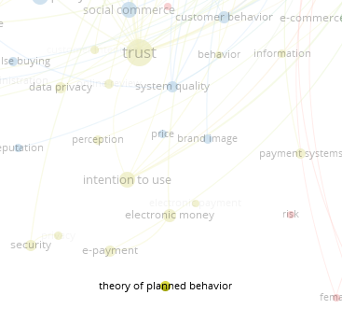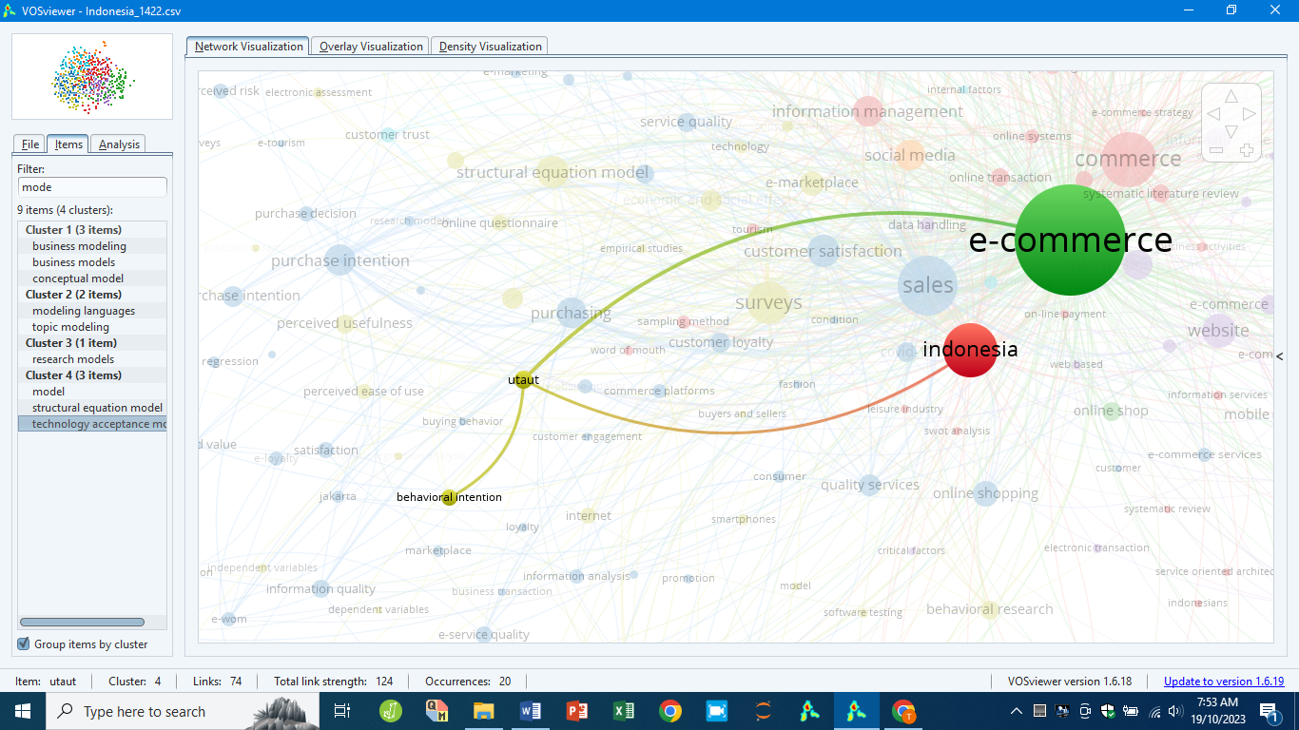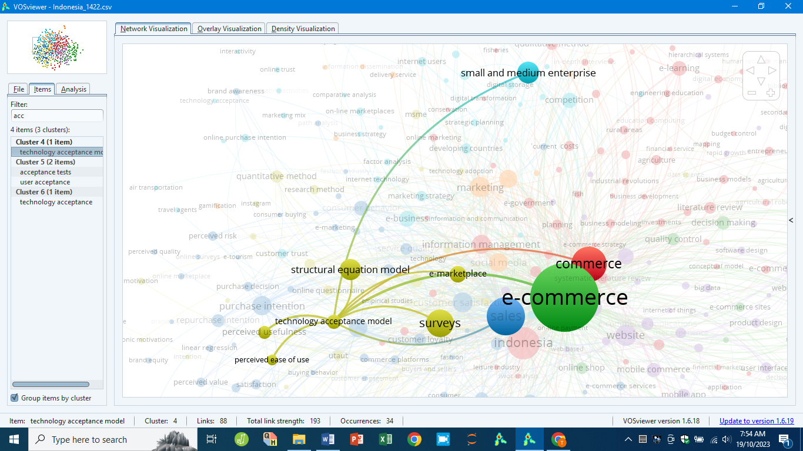
a) TPB b) UTAUT c) TAM

Figure 3. Theories related to e-commerce for Indonesia

Malaysia utilized both consumer behavior and mathematics concept. The past research embedded theories included UTAUT, TAM, and Computation Theory (CT) (Figure 4). UTAUT and CT occurred within the same cluster, and share the same mobile commerce, surveys, e-commerce, facilitating conditions, economics and social effects terms (Figure 4a and Figure 4c). Besides, TAM adopted in consumer behavior, perceived usefulness, perceived ease of use, and trust related articles (Figure 4b). The integration terms promote organization movement in the digital environment, promoting innovation, enhancing consumer satisfaction, and supporting sustainable growth in mobile commerce. The integration leverages the potential of mobile commerce, thus ensuring organization competitiveness in the digital marketplace.

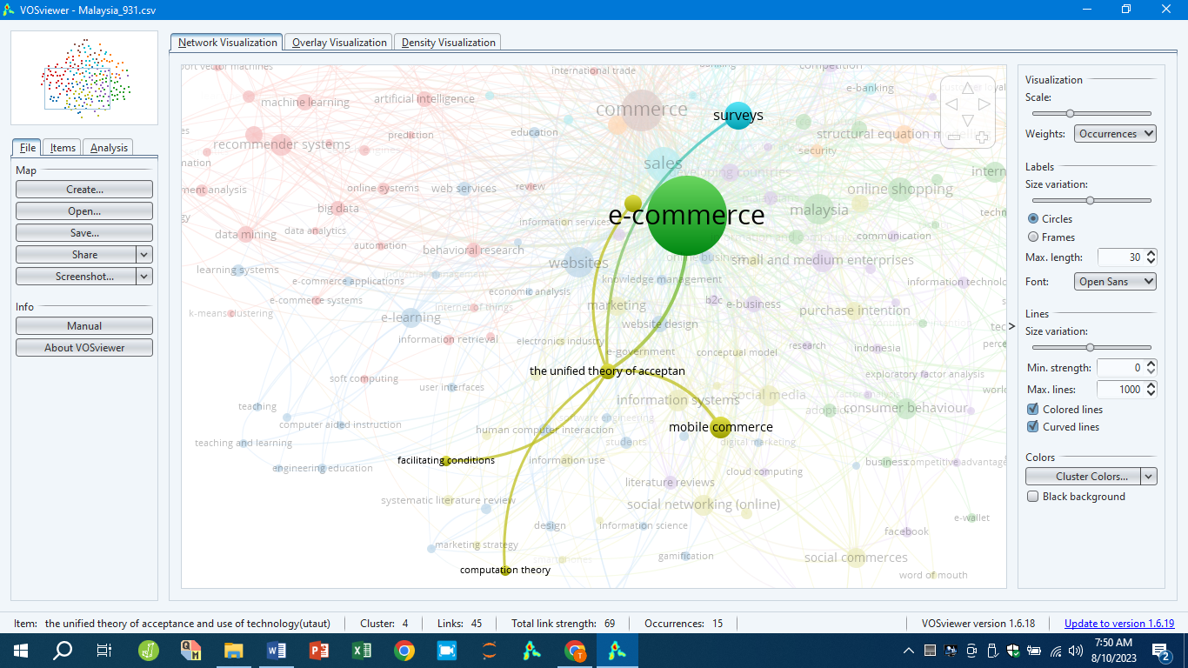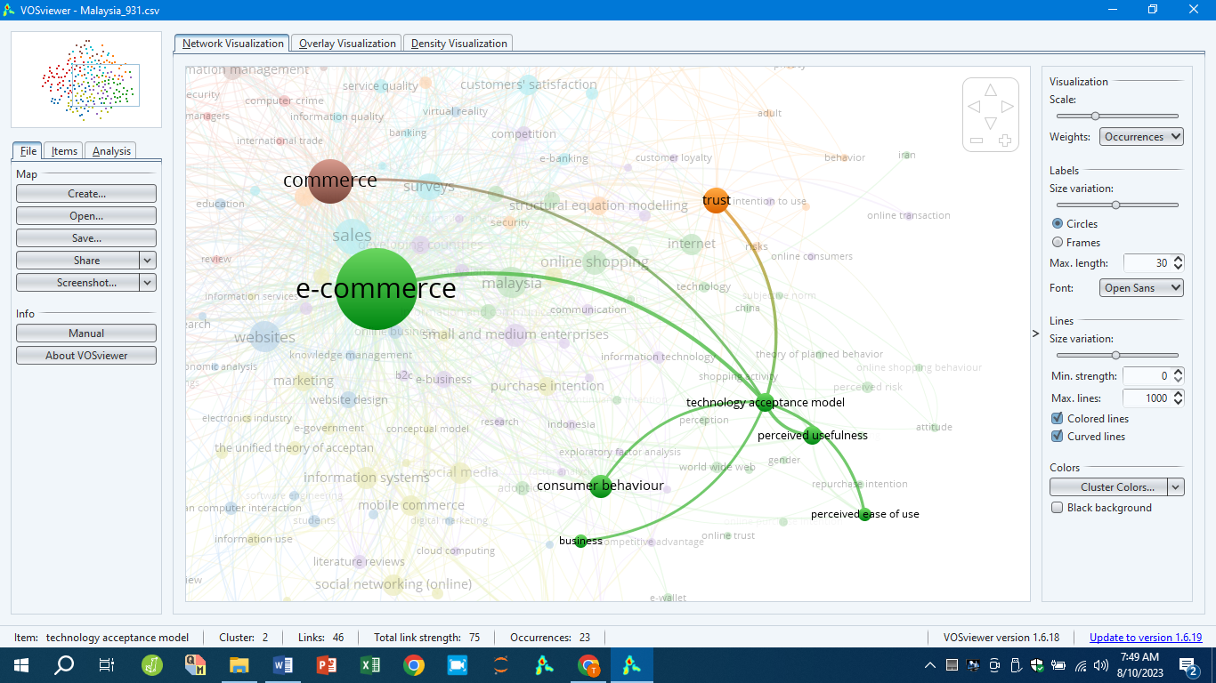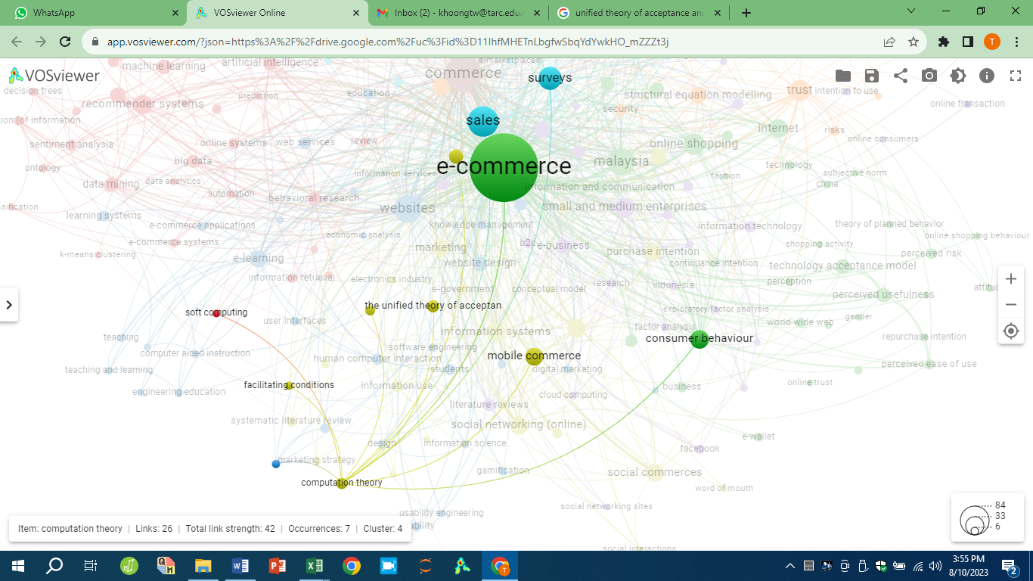
a) UTAUT b) TAM c) CT

Figure 4. Theories related to e-commerce for Malaysia

Singapore adopted CT and Game Theory (GT) (Figure 5), which occurred within the same cluster. Besides, it shares some similar terms such as algorithms, AI, iterative methods, competition, risk management, and among others. The technology adoption enables organisation enhance operational efficiency, and decision-making within a competitive landscape. The integration discussed serves as the fundamental basis for a business strategic and data-oriented approach.

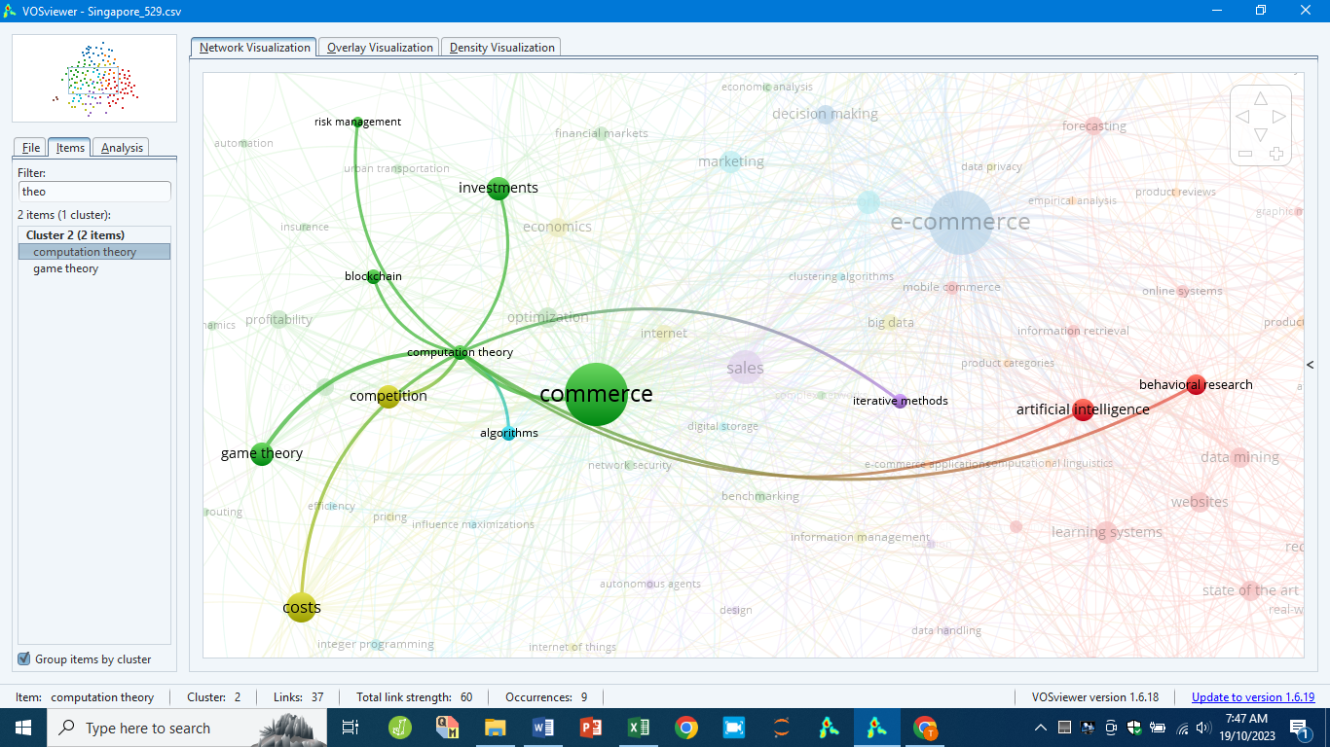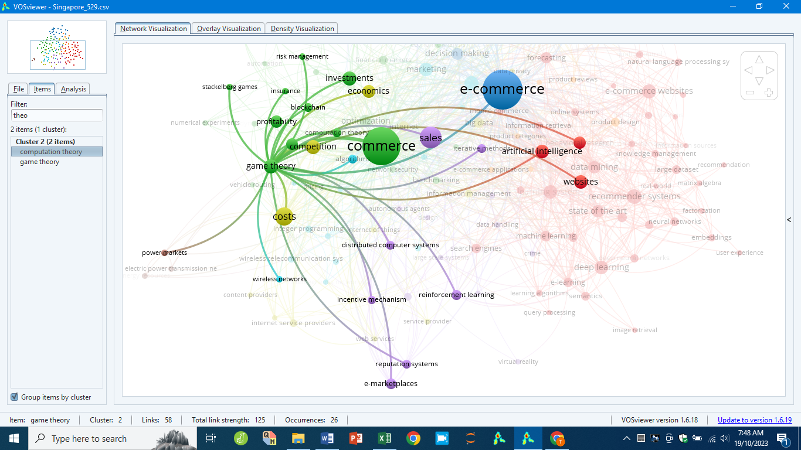
a) CT b) GT

Figure 5. Theories related to e-commerce for Singapore

For Thailand, TAM was the widely use theory in articles (Figure 6), whereby related to trust, mobile commerce, websites, service quality, AI, quality of service, and among others.

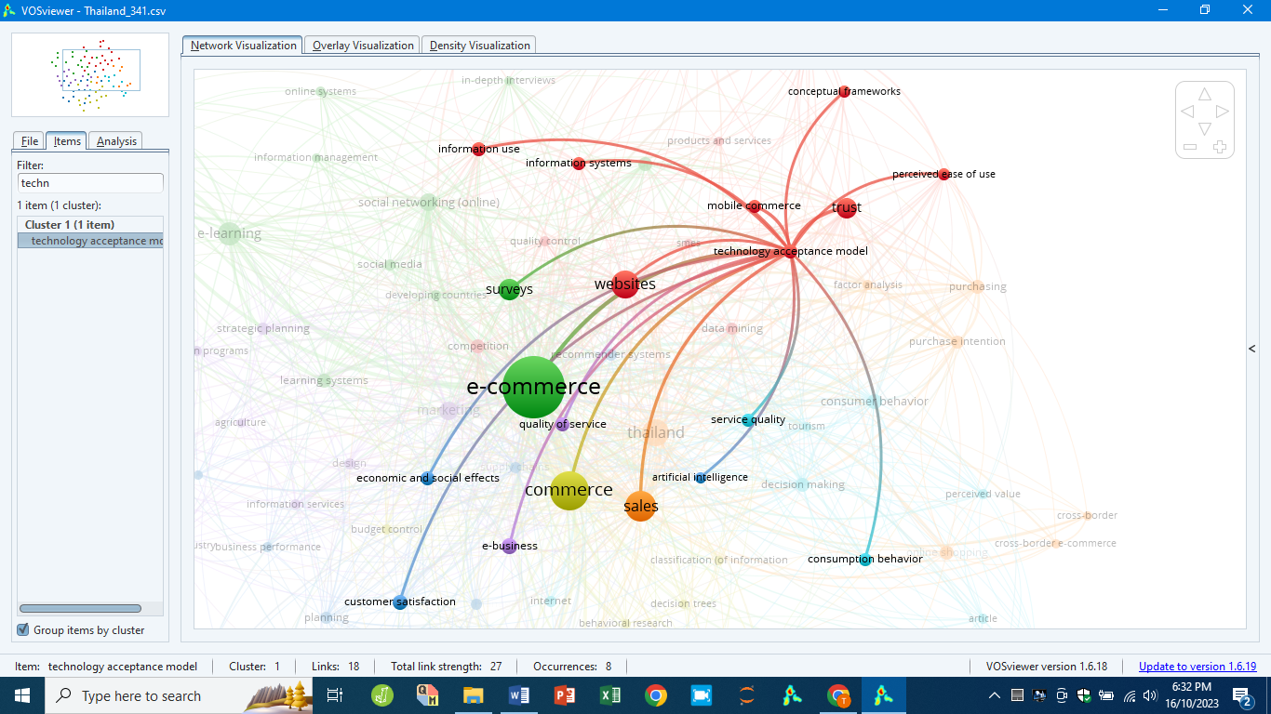

Figure 6. Theories related to e-commerce for Thailand

ASEAN-5: E-commerce and sustainable development

ASEAN-5 countries except Philippines, supported United Nation Sustainable Development Goals 2030 (SDG2030) initiative, although in the different pathway. Malaysia and Thailand were the most concern of the sustainable development. For Indonesia, sustainable development is general highlighted, whereby related to common terms such as sales, commerce, e-commerce, as well as planning (Figure 7a). For Malaysia, sustainable development associated with carbon dioxide, economics, regional planning, costs, innovation, information management, and commerce (Figure 7b). Malaysia adopted multifaceted character such as innovation, economics and environment aspects. The non-within cluster terms includes e-learning, quality of service, customer satisfaction, surveys, sales, decision making, as well as economics and social effects, and among others. This association possible form a framework for optimizing educational experiences to driving positive outcomes.

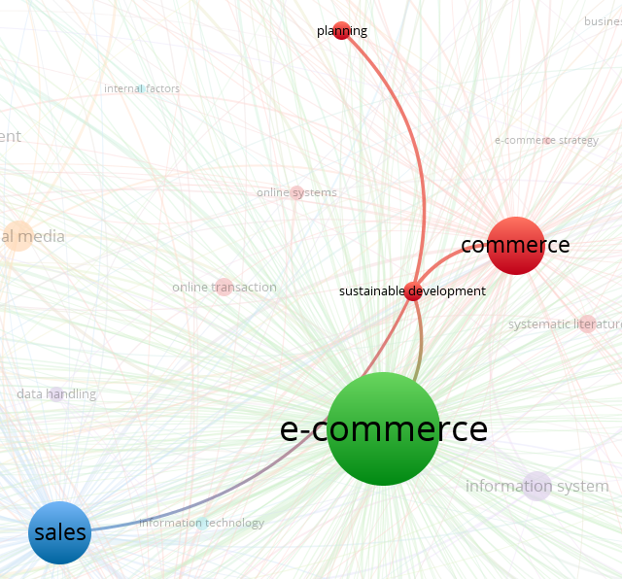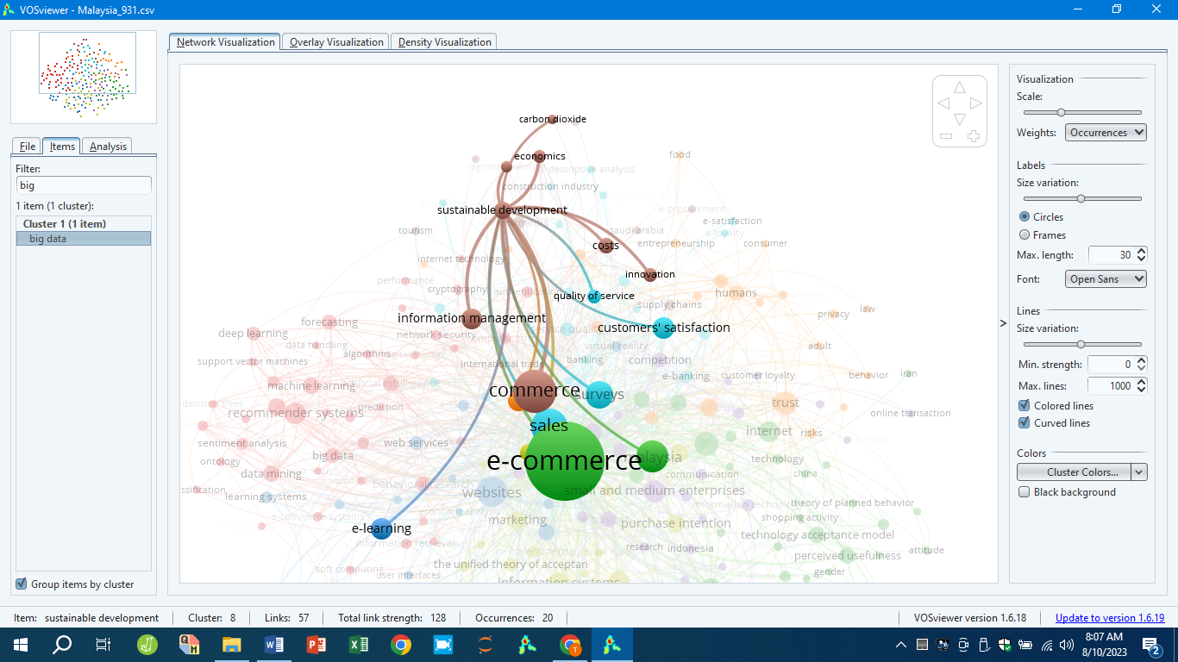
a) Indonesia b) Malaysia

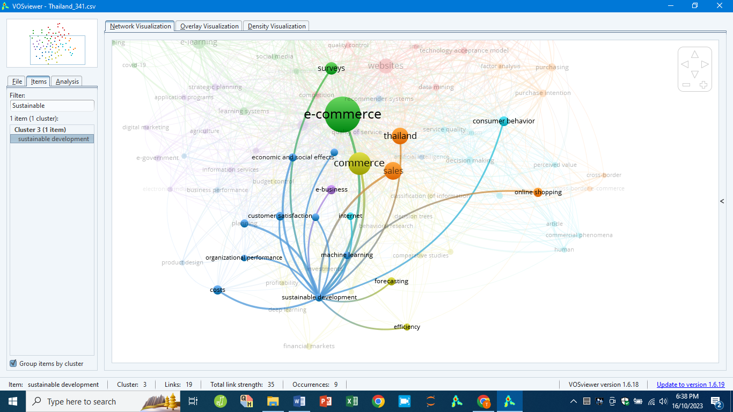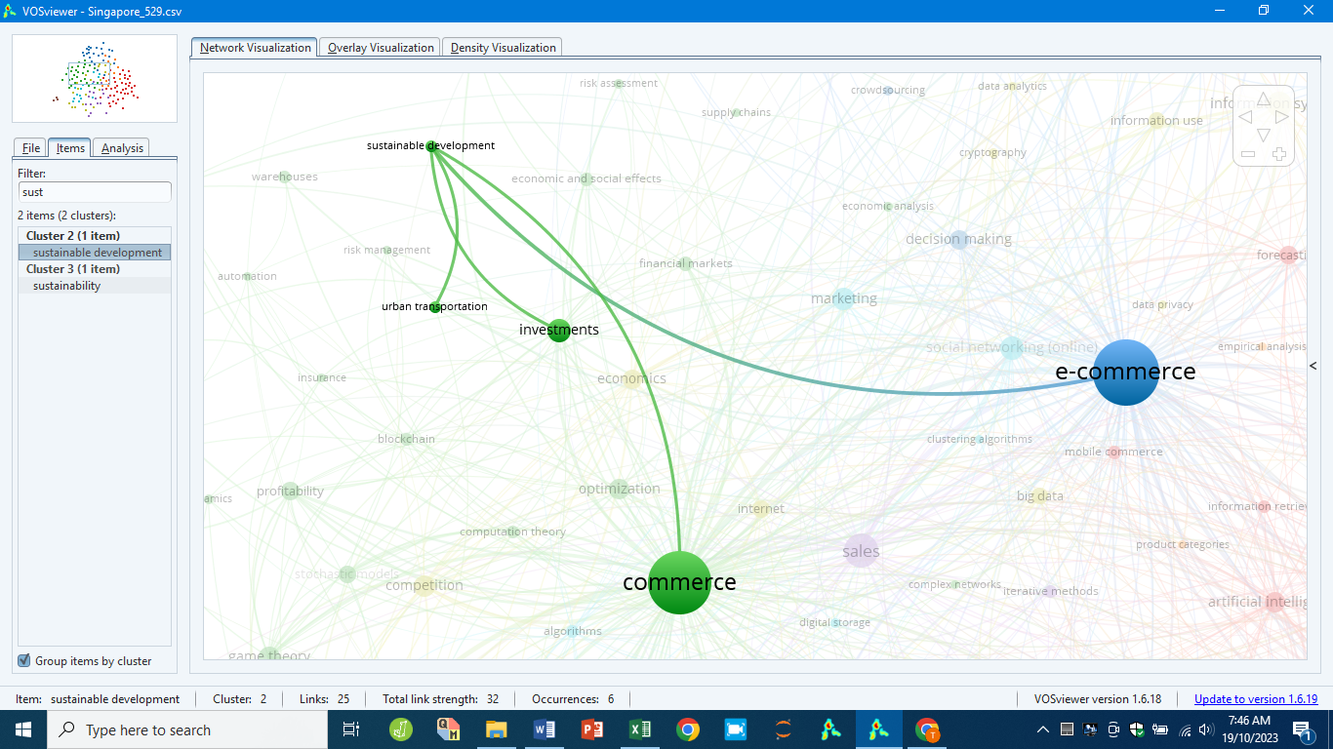
c) Thailand d) Singapore

Figure 7. Sustainable development related to e-commerce for ASEAN-5

For Thailand related to costs, organizational performance, machine learning, customer satisfaction, planning, economics and social effect, as well as supply chains management (Figure 4c). Besides, the non-within cluster terms associated with sales, online shopping, consumer behavior, forecasting, e-business, commerce, efficiency, and among others. This integration has provided eco-conscious among consumers, and fosters environmentally responsible business practices. For Singapore, sustainable development is briefly discussed and only related to urban transportation, investment, e-commerce, and commerce (Figure 7d).

ASEAN-5: E-commerce and e-government

E-government initiatives shape ASEAN-5 e-commerce and sustainable development landscape efforts. These create digital transformation by encouraging policy frameworks, infrastructure, and trust. For example, the Indonesia National Digital Transformation Framework provided a seamless integration of public services with digital platforms. This has streamlined administrative processes and enhanced online marketplaces accessibility and reliability. Besides, the Malaysia Digital Economy Blueprint concentrate in e-government as a driver for expanding digital trade and economic growth inclusion, in which align on high-quality academic contributions. Besides, the intercepts between e-government and e-commerce are evident in efforts to promote sustainability. The digital platforms developed enable data collection and analysis to optimize logistics, reduce waste, and promote environmentally friendly practices. The Thailand Smart Cities initiative has involved digital commerce as part of its broader goals. In addition, e-government initiatives improve trust and security in e-commerce platforms. Data privacy, cybersecurity, and digital payments policies provide a conducive transactions environment. This interaction ensuring equitable access to underserved groups.
ASEAN-5 government play important roles in e-commerce development, except Singapore (Table 13). The e-government for Indonesia and Malaysia were highlighted with e-commerce. However, e-government is essential for Thailand and Philippines. For Thailand, governments utilizing digital industry to improve their service offerings. Digital marketing tactics play a crucial role in the promotion of e-government services, and urban regions agriculture. The online platforms serve as intermediaries, in which connected farmers with markets through information and agricultural products. The process includes the formulation of strategic plans, and implementation of user-friendly application programs to meet the specific needs. Through customer feedback satisfaction, these enable provision of high-quality services. The integration concepts establish synergy between technology, government, commerce, and agriculture, highlighting the interconnection of various disciplines in the digital age.
For Philippines, e-government initiatives comprising e-governance and government data processing. It demonstrates authority holds a prominent position in the country. The decision-making is guided by a substantial amount of data. With the rise of mobile computing and the proliferation of mobile applications, the provision facilitates citizen engagement with government services and data. Data analysis techniques, such as data mining and sentiment analysis, are utilized to analyze the data gathered. Data mining enable to identify patterns, hence facilitating the decision-making. Sentiment analysis used to evaluate current public sentiment and assist governments in understanding public reaction on policies and services. Furthermore, the incorporates e-learning portals to ensure public access accurate information.

Table 13. E-commerce and e-government

Country | Associate keywords with e-government
Indonesia | E-commerce
Malaysia | E-commerce
Thailand | Electronics industry, digital marketing, agriculture, information services, design, strategic planning, application programs, customer satisfaction, quality of services, etc
Philippines | Decision making, mobile computing, mobile applications, mobile commerce, websites, data analysis, e-governance, government data processing, data mining, sentiment analysis, customer satisfaction, surveys, e-learning, etc

Conclusion

The objective of this study is to conduct a bibliometric analysis on the e-commerce research articles comprised in the Scopus journal. This analysis will involve the utilization of VOSviewer software to examine the distribution of bibliometric maps. The data obtained is the result of filtering based on the keyword e-commerce for ASEAN-5 countries, published between the year 2013 to 2022. The findings the ASEAN-5 countries show variability patterns, but reveal an increasing trend over the 10 years. Indonesia emerged as the leading contributor. Indonesia shift attributed towards digital transformation investment, rapid e-commerce sector expansion, and government initiatives. In contrast, Malaysia focus on high-quality peer-reviewed research. The findings also highlight dissemination strategies within ASEAN-5. Philippines and Indonesia relying heavily on conference papers for quicker dissemination, meanwhile Malaysia and Singapore focus on journal articles reflecting a focus on academic global visibility.
Based on the minimum number of occurrences of five keywords setting, had the highest frequency. The dataset items then categorized into clusters. ASEAN-5 documents employed theories, except Philippines. Majority of associated theories are based on customer behavior, except Singapore emphasis on mathematical concepts. Furthermore, ASEAN-5 nations, except Philippines, demonstrated support for the SDG2030 initiative, although in different manners. Malaysia and Thailand were the most concerned on sustainable development. The governments play significant roles in the development of e-commerce excepts Singapore. Indonesia and Malaysia briefly emphasized e-government initiatives. However, e-government greatest significance for both Thailand and Philippines.
This study serves as a significant resource and a subject of reflection for scholars who are interested in exploring deeper into areas of e-commerce study within ASEAN region. It is crucial to acknowledge that this bibliometric research is limited to scholarly publications exclusively found within the Scopus database. Furthermore, it is recommended to conduct assessments from multiple database such as the Web of Science, Dimensions, and Lens databases. By broadening the range of data sources employed, a more in-depth understanding of the subject matter can be attained.

References

Acharya, N., Sassenberg, A.-M., & Soar, J. (2023). The role of cognitive absorption in recommender system reuse. Sustainability, 15(5), 3896.
Al Amin, M., Arefin, M. S., Hossain, I., Islam, M. R., Sultana, N., & Hossain, M. N. (2022). Evaluating the determinants of customers’ mobile grocery shopping application (MGSA) adoption during COVID-19 pandemic. Journal of Global Marketing, 35(3), 228–247.
Bukar, U. A., Sayeed, M. S., Razak, S. F. A., Yogarayan, S., Amodu, O. A., & Mahmood, R. A. R. (2023). A method for analyzing text using VOSviewer. MethodsX, 11, 102339.
Beckers, J., Weekx, S., Beutels, P., & Verhetsel, A. (2021). COVID-19 and retail: The catalyst for e-commerce in Belgium?. Journal of Retailing and Consumer Services, 62, 102645.
Chen, D. & Wang, C., & Liu, Yi. (2023). How household food shopping behaviors changed during Covid-19 lockdown period: Evidence from Beijing, China. Journal of Retailing and Consumer Services, 75, 103513.
Chen, J., Lan, Y., & Chang, Y. (2023). Consumer behaviour in cross-border e-commerce: Systematic literature review and future research agenda. International Journal of Consumer Studies, 47(6), 2609-2669.
Cordes, D. L., & Marinova, D. (2023). Systematic literature review of the role of e-commerce in providing pathways to sustainability for poverty alleviation in Sub-Saharan Africa. Discover Sustainability, 4, 7.
Elhan-Kayalar, Y., Sawada, Y., & Van Der Meulan Rodgers, Y. (2022). Gender, entrepreneurship, and coping with the COVID-19 pandemic: The case of GoFood merchants in Indonesia. Asia and the Pacific Policy Studies, 9(3), 222-245.
Fu, J., & Saad, N. H. M. (2023). Cross border e-commerce uses blockchain technology to solve payment risks. International Journal on Recent and Innovation Trends in Computing and Communication, 11, 205-215.
Giotopoulos, I., Kontolaimou, A., & Tsakanikas, A. (2022). Digital responses of SMEs to the covid-19 crisis. International Journal of Entrepreneurial Behaviour and Research, 28(7). 1751-1772.
Goti, A. Querejeta-Lomas, L., Almeida, A., de la Puerta, J. G., & López-de-Ipiña, D. (2023). Artificial intelligence in business-to-customer fashion retail: A literature review. Mathematics, 11(13), 2943.
Gruntkowski, L. M., & Martinez, L. F. (2022). Online grocery shopping in Germany: Assessing the impact of COVID-19. Journal of Theoretical and Applied Electronic Commerce Research, 17(3), 984-1002.
Hadasik, B., & Kubiczek, J. (2022). E-commerce market environment formed by the covid-19 pandemic – A strategic analysis. Forum Scientiae Oeconomia, 10(3), 25-52.
Hasbi, I., Syahputra, S., Syarifuddin, S., Wijaksana, T. I., & Farías, P. (2022). The impact of discount appeal of food ordering application on consumer satisfaction in Southeast Asia. Journal of Eastern European and Central Asian Research, 9(6), 978 – 991.
Han, B. R., Sun, T., Chu, L. Y., & Wu, L. (2022). Covid-19 and e-commerce operations: Evidence from Alibaba. Manufacturing and Service Operations Management, 24(3), 1388-1405.
Jasinska-Bilizczak, A. (2022). E-commerce from the customer panel: The phenomenon of the pandemic increase and future challenge. Business, Management and Economics Engineering, 20(1), 139-151.
Jha, G. K., Gaur, M., Ranjan, P., & Thakur, H. K. (2023). A survey on trustworthy model of recommender system. International Journal of System Assurance Engineering and Management, 14, 789–806.
Kang, J., Zeng, Y., Chen, S., & Wang, Y. (2022). E-commerce platform response to major public emergencies-optimal strategies and benefits of e-commerce platform subsidies. Xitong Gongcheng Lilun yu Shijian/System Engineering Theory and Practice, 42(2), 345-367.
Khoa, B. T., & Huynh, T. T. (2023). The influence of social media marketing activities on customer loyalty: A study of e-commerce industry. International Journal of Data and Network Science, 7(1), 175-184.
Khoong, T. W., Phuah, K. T., Ow, M. W., & Lin, K. L. (2023). Aplikasi tingkah laku kewangan: Kajian kes pengeluaran pra-persaraan skim pencen sewaktu pandemik crisis COVID-19. Geografia-Malaysian Journal of Society and Space, 19(2), 181-199.
Khoong, T. W., Baba, M., Kumara, A. K., Chong, K. F., Ow, M. W., & Phuah, K. T. (2024). ASEAN geology bibliometric analysis: A way forward for sustainable development. Bulletin of the Geological Society of Malaysia, 78, 5-16.
Kim, S.-I., & Kim, S.-H. (2022). E‑commerce payment model using blockchain. Journal of Ambient Intelligence and Humanized Computing, 14(10), 14369.
Lin, Z., Shi, R., Stecke, K. E., Xiao, W., & Xu, D. (2021). Selling to a financially constrained E-commerce retailer with bankruptcy cost and tax. Transportation Research Part E: Logistics and Transportation Review, 146, 102180.
Luisa, S. (2020). E-commerce and effective VAT/GST enforcement: Can online platforms play a valuable role? Computer Law & Security Review, 36, 105371.
Marjudi, S., Setik, R., Ahmad, R. M. T. R. L., Hassan, W. A. W., & Kassim, A. A. M. (2023). Utilization of business analytics by SMEs in halal supply chain management transactions. International Journal on Informatics Visualization, 7(2), 407-415.
Mashalah, H. A., Hassini, E., Gunasekaan, A., & Bhatt, D. (2022). The impact of digital transformation on supply chains through e-commerce: Literature review and a conceptual framework. Transportation Research Part E: Logistics and Transportation Review, 165, 102837.
Ridhwan, M. M., Suryahadi, A., Rezki, J. F., & Andariesta, D. T. (2023). The impact of COVID-19 on the labour market and the role of E-commerce development in developing countries: Evidence from Indonesia. Journal of the Asia Pacific Economy, 70, 102376.
Shang, L., Liu, Y., & Xu, P. (2023). The COVID-19 shock and the ownership of store Chain: Evidence from China's express delivery industry. Heliyon, 9(10), e20799.
Vlase, I., & Lähdesmäki, T. (2023). A bibliometric analysis of cultural heritage research in the humanities: The Web of Science as a tool of knowledge management. Humanities and Social Sciences Communications, 10(1), 84.
Zhang, R. (2023). The Application of artificial immune network in e-commerce credit risk assessment. International Journal of Computational Intelligence Systems, 16(1), 155.
Zyoud, S. H., Shakhshir, M., Abushanab, A. S., Koni, A., Shahwan, M., Jairoun, A. A., & Al-Jabi, S. W. (2023). Bibliometric mapping of the landscape and structure of nutrition and depression research: Visualization analysis. Journal of Health, Population and Nutrition, 42(1), 33.

