Spatial and temporal trends of climate change in the Kandy district of Sri Lanka based on precipitation and temperature

Piratheeparajah Nagamuthu, Dhanushika Sivakumar

Department of Geography, University of Jaffna, Jaffna, Sri Lanka

Correspondence: Piratheeparajah Nagamuthu (email: npiratheeparajah@gmail.com)

Received: 4 November 2023; Accepted: 6 May 2024; Published: 31 May 2024

Abstract

Climate change stands as one of the most paramount environmental predicaments in the present world. Recent years have seen an escalation of climate change into a truly global issue. In light of this, our study aims to identify the spatiotemporal patterns of climate change, specifically with regards to temperature and precipitation, in Kandy district throughout the period spanning 1992 to 2022. By critically appraising the contemporaneous situation, the study seeks to provide recommendations aimed at curbing the impact of climate change. Another relevant study was conducted, focusing on secondary data, mainly climatological observations. The current investigation utilised the Sri Lanka Metrology Department's spatial trend data administered through the IDW method on Arc GIS 10.4. On the other hand, the temporal trend data were evaluated using the Mann Kendall trend and Sen's slope estimator methods through MiniTab16. The outcomes of this research have been presented through the processing of imagery and tabulating data, which have been subjected to rigorous statistical analyses. As far as the district of Kandy is concerned, the variability of rainfall and temperature across different areas is undeniable. The district's average temperature lies at 0.516°C, with the average high temperature being 0.606°C and the average low temperature being 0.408°C. Rainfall in Kandy district has intensified to 2604 mm, with the Nawalapitiya rainfall observation station showing an increase in trend to 2763 mm, while the Duck wary Estate rainfall observation station displaying a decreased trend to 996.927 mm. In the monsoon season, the south-westerly monsoon season promotes increased rainfall up to 1905 mm, while the north-easterly monsoon season loses its previously known influence on seasonal rainfall, resulting in only 80.34 mm. Meanwhile, the temperature in Kandy District has intensified by 1.98°C. Given the observed disparities in climate, location, and time, there are numerous challenges in planning for development. Effective mitigation measures are paramount for the amelioration of climate change.

Keywords: Climate change, Kandy district, precipitation, spatial pattern, temperature, temporal trend

Introduction

Initially perceived as a scientific quandary, climate change has morphed into an extensively discussed topic among various factions globally (Adams & Heidarzadeh, 2022). It has transmuted into one of the most pressing ecological issues our world presently encounters. Unprecedented transformations to the global climate system have occurred since the '50s, eliciting floods, droughts, and other forms of natural disasters in numerous states, devastating agriculture and economies profoundly (Hoegh-Guldberg et al., 2018). Climate change inquiries are fundamental to apprehending and envisioning climate change, one of the most influential natural and human-induced occurrences in contemporary society. Unsurprisingly, governments worldwide have taken a keen interest in grappling with this predicament (Jiang & Huang, 2018). Therefore, in light of these ramifications, every individual on the planet must consider climate change an essential issue (Strzepek et al., 2021).
Sri Lanka stands as one of the nations most susceptible to the effects of climate change, as noted by Gunaratne et al. (2021). It's significant to mention that Sri Lanka's geographic locale and dependence have escalated its susceptibility to climate change impacts, as indicated by Alahacoon and Edirisinghe (2021). The precipitation in Sri Lanka emanates from different origins, comprising monsoonal, convectional, and depression activities. In the rainfall schedule of Sri Lanka, four distinctive phases have been delineated. They are:

- First Intermoon (FIM): March to April
- South West Monsoon (SWM): May to September
- Second Intermoon (SIM): October to November
- North-East Monsoon (NEM): December to February

Over 38% of Sri Lanka's entire labor force partakes in agricultural activities. Thus, Sri Lanka faces the highest degree of susceptibleness to climate variations owing to its extensive coastline of approximately 1,340 kilometers and robust standards of living, as evidenced by Somasundaram et al.'s 2020 study. The Central Highlands of Sri Lanka are a vital contributor to the nation's economy. Therefore, in this context, comprehending the region's climate conditions from this research is necessary to plan the district of Kandy's future development. According to Gunaratne et al.'s 2022 study, the number and seriousness of climate-generated calamitous events in Kandy district are surging. Additionally, researchers suggest that climate change may be one of the primary reasons for Kandy district's recent rise in climatically-induced disasters, as highlighted in Jiang & Huang's 2018 study.
Considering the sensitivity of the Kandy district to climate change, and notwithstanding the plethora of studies dedicated to this pressing issue, there remains a paucity of information pertaining to the rainfall trends in this region.

Method and study area

Study area

The selection of the Kandy district as the subject area for this study is illustrated in Figure 1. The district of Kandy, which covers a sprawling area of roughly 1940 square kilometers comprising picturesque mountain ranges and valleys, is situated north of the Divisional Secretary Divisions of Matale district, namely Ukuwela, Rath Thota, Lag Gala, Pallegama, and Wilgamuwa. The eastern border is shared with Mahiyangana Divisional of Badulla district, while the western boundary is bordered by Divisional Secretary Divisions of Kegalle District such as Aranyaka, Bulathkohupitiya, Mawanella, and Rambukkana. In addition, the eastern border is shared with Mawatha Gama and Rideegama Divisional Secretary Divisions in Kurunegala District. Its geographical coordinates lie between North Latitudes 69.56 and 70.29 and East Longitudes 80.25 and 80.00 (District Secretariat, 2022).

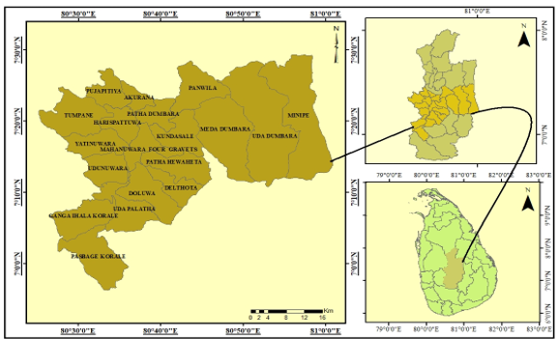

Figure 1. The location of the Kandy district of Sri Lanka

Data

A significant portion of this data is founded on secondary sources. Consequently, secondary data for the research were procured from handpicked meteorological observatories spanning from 1992 to 2022, as provided by the Department of Meteorology in Sri Lanka. Over the course of 30 years, monthly and yearly rainfall information was obtained from selected observatories, including Duck Wary Estate, Handessa Duala gala Katugastota, Kotmale Power Station, and Nawalapitiya, all of which were gathered from the Department of Meteorology in Colombo, in order to scrutinize the climate change inclination within Kandy District. Monthly temperature fluctuations within that time period were also procured, focusing exclusively on the Katugastota observatory. Table 1 and Figure 2 illustrate the geographical distribution of the observation stations for both precipitation and temperature.

Table 1. Geographical distribution of the rain gauge stations in the Kandy district

Stations | Longitudes (East) | Latitude (North) | Elevation (m)
Duck Wary Estate | 816 | 7.35 | 80.78
Handessa Daulagala | 525 | 7.23 | 80.57
Katugastota | 453 | 7.33 | 80.63
Kotmale Power Station | 600 | 7.02 | 80.58
Nawalapitiya | 589 | 7.07 | 80.53
Source: Department of Meteorology, 2023

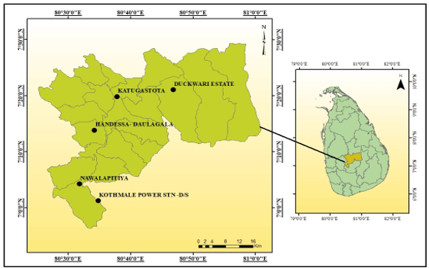

Figure 2. Geographical distribution of the rain gauge stations in the Kandy district

Additional statistical information concerning the investigation was secured from the yearly report, the survey, and the articles. Regrettably, weather observations were unobtainable for certain months, and thus the monthly and annual average techniques were implemented to adjust for the absent information. In particular, the monthly average was calculated without data by evaluating the mean temperature for the corresponding months for the years before and after the deficient year. Furthermore, modifications in temperature and precipitation, along with supplementary data obtained for the investigation's spatial variability, were mapped through the methods of Arc GIS 10.4 and Mini Tab 17 and subsequently subjected to macro analysis. To determine the temporal variability and trends of temperature and precipitation, the Mann-Kendall and Sen's slop estimator methods were utilized and scrutinized.

Methods of analysis

Based on the primary and secondary data garnered for the study, the deviation in temperature and precipitation, as well as the spatial pattern of these factors, have been visualized through the utilization of the inverse distance weighting (IDW) method of spatial interpolation in Geographic Information Technology (Arc GIS 10.4), and were subsequently subjected to a descriptive analysis.
Tests for the identification of significant trends in climatologic time series can be classified as either parametric or non-parametric methods. Parametric trend tests necessitate that data be both independent and normally distributed, whilst non-parametric trend tests only necessitate that the data be independent. In this study, two non-parametric techniques, namely the Mann-Kendall and Sen's slope estimator, were employed to detect trends in meteorological variables.

Man-Kendall's statistics

Mann Kendal Trend analysis is crucial in various fields, particularly in ecology and environmental science, as it helps identify trends and patterns in time-series data. This non-parametric method allows researchers to assess changes in the frequency of events, such as temperature fluctuations or species occurrences, without making assumptions about the underlying distribution of the data. By using Mann Kendal Trend analysis, scientists can better understand long-term trends and make informed decisions for conservation, resource management, and climate change mitigation efforts.
Man-Kendall's statistics S is given by the following formula:

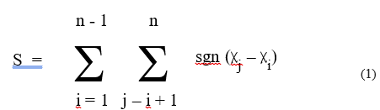

and are the time series, and is the number of data points in the time series. The sign function can be expressed as follows:

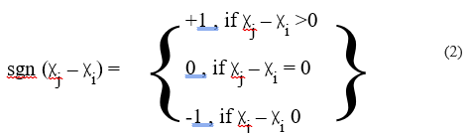

The calculation of the variables in the Man-Kendall experiment is given by the following equation:

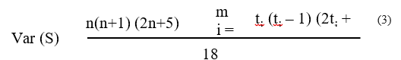

Where it is the number of bonds specified in the sample, then Man-Kendall's statistics are given by the following expressions:

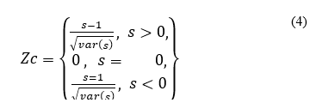
follows the standard normal distribution. A positive value shows a high (upward) tendency, and negative data gives a low (downward) tendency for the period.

Sen’s slope estimator

The Sen's Slope estimator is a crucial tool in analyzing climatic data due to its robustness, simplicity, and ability to handle outliers. It provides a reliable measure of median slope, making it suitable for estimating trends in temperature, precipitation, and other climatic variables. Additionally, the Sen's Slope method is non-parametric, which means it doesn't assume any specific distribution for the data, making it versatile and widely applicable in climatological studies.
The magnitude of a given time trend can be found in Sen's slope estimator (Sen, 1968). The test is widely used to estimate the magnitude of the propensity for rainfall over time. Slope pairs can be calculated for all data using the following equation:
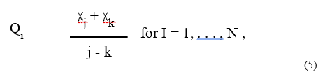

Where is the slope, and are the data values at time, respectively. The mean of the values is encoded as Sen’s slope estimator and is calculated using the following equation:

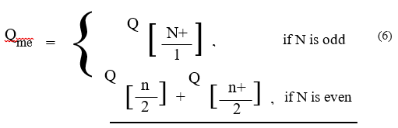

In addition to this, climatic data has also been collected and analyzed from some departments of the study area.

Results and discussion

Spatial pattern of temperature increasing

The temperature trends exhibit spatial variability when analyzing the temperature patterns across the Kandy District over the course of 30 years, from 1992 to 2022. Notably, the maximum temperature has demonstrated an upward trend in the Harispatwa Divisional Secretariat Division, while a downward trend has been witnessed in the Akurana Divisional Secretariat Division (Figure 3).

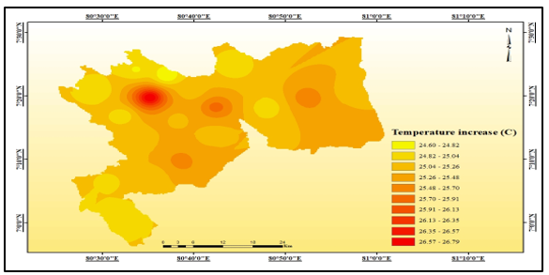

Figure 3. Spatial pattern of temperature increasing in the Kandy district of Sri Lanka

Temporal trend
Upon analyzing the temporal temperature trend in the Kandy district, it can be observed that the monthly temperature oscillates. In January, the average temperature rises to 0.387 °C and in February, the temperature trend further increases to 0.684 °C. Similarly, in the month of March, the average temperature rises to 0.606 °C. April witnesses an increase of 0.303 °C in temperature, resulting in an average temperature rise from 23.8 to 26.5 degrees Celsius between January to April. The primary reason for this trend is the reduced influence of the first inter-seasonal and north-west monsoons in Kandy district. Thus, there is a substantial increase in temperature during this phase.
Subsequently, the average temperature for May rises by 0.2493 °C, and June witnesses a temperature surge of 0.663 °C. In July, the temperature increases by 1.08 °C, and in August, it rises by 0.6 °C. During May to September, the average temperature drops down to 26.0–24.9 degrees Celsius due to the impact of the south-west monsoon. In this period, Kandy district receives abundant rainfall, and the average temperature fluctuates and reduces naturally. The average temperature trend for September is 0.609 °C, whereas it increases to 0.795 °C and 0.378 °C for October and November, respectively. December's average temperature is 0.666 °C, resulting in an average temperature variation between 24.9–25.2 °C during this phase. Additionally, regarding the monthly average trend of Kandy District, the temperature shows a sharp upward surge in July and is the lowest in May among all the months. The average temperature in Kandy district increases to 0.516 °C, and there are increased variations not only in the average temperature but also in the trend of rising and falling temperatures, with the increasing temperature trend up by 0.6060 ° C and the falling temperature trend up by 0.408 °C. Figure 4 illustrates the monthly temperature pattern in Kandy district Sri Lanka. Moreover, the Mann Kendall trend analysis of the temperature indicates the data's pattern. The p-value of the temperature station, Katugastota, is relatively smaller than the significant alba level. Figure 4 illustrate the monthly pattern of temperature changes in the Kandy district of Sri Lanka.
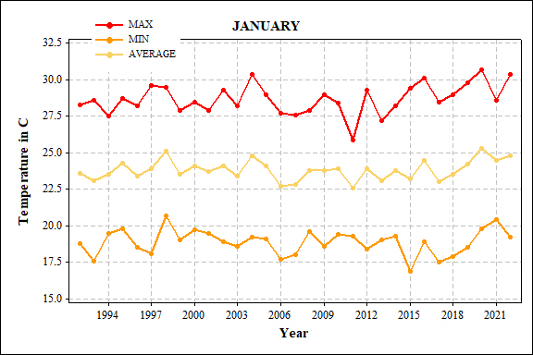
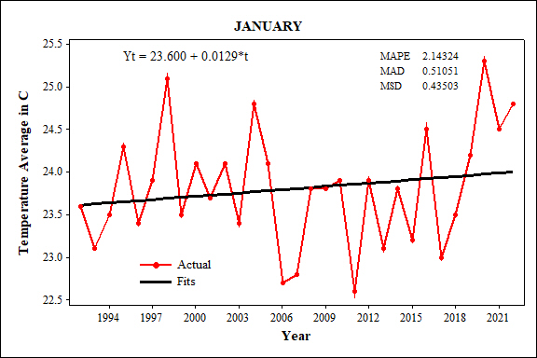
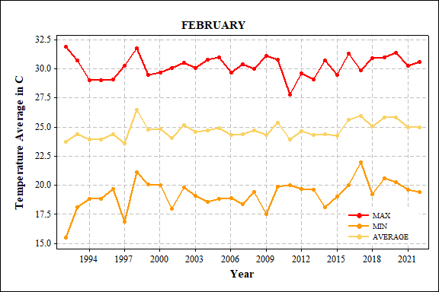
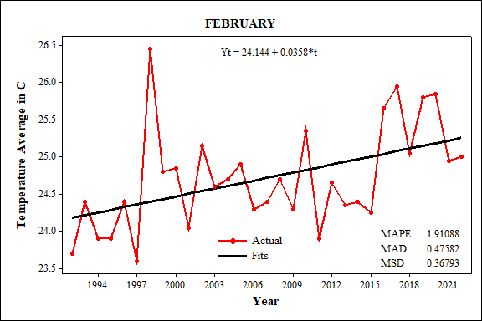
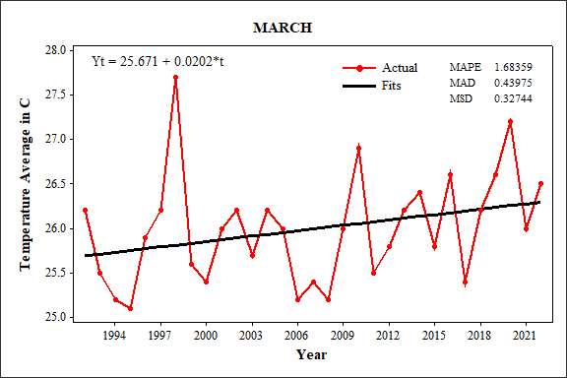
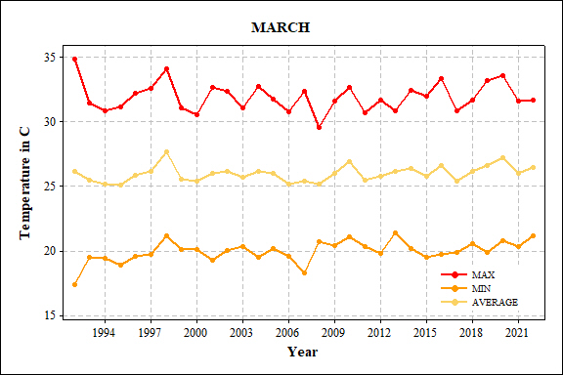
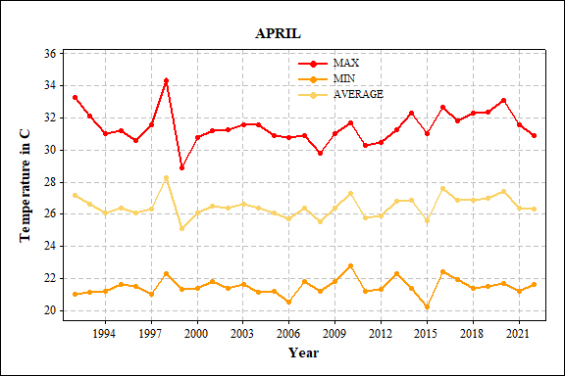
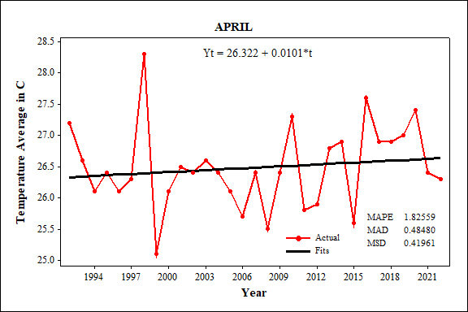
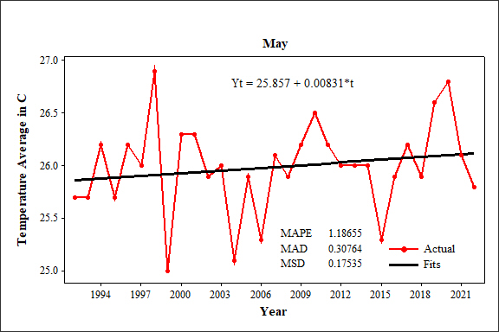
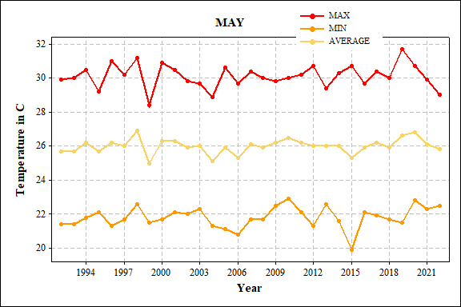
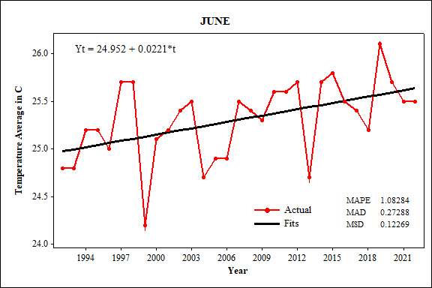
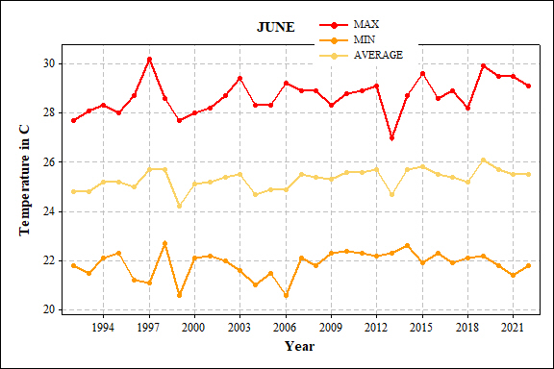
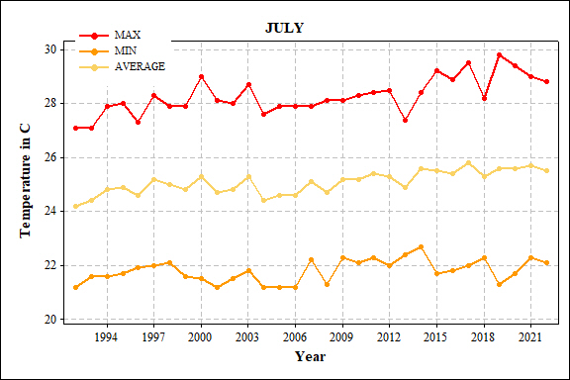
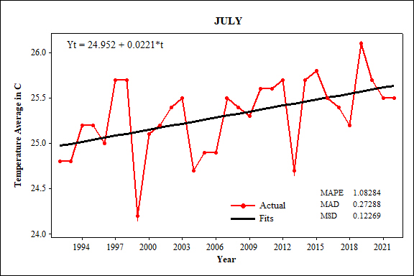
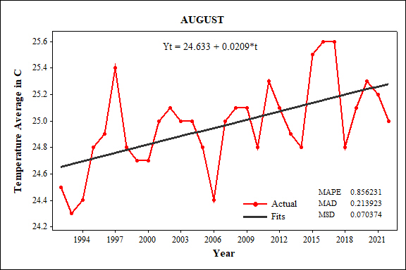
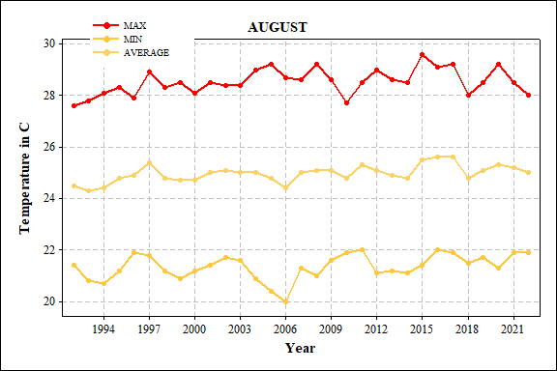
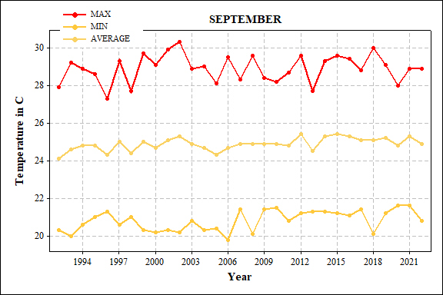
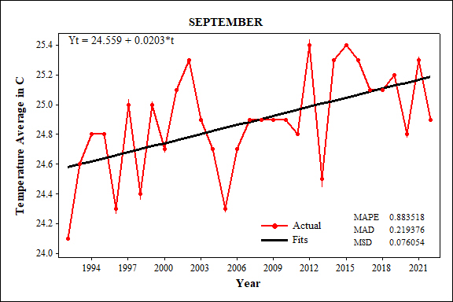
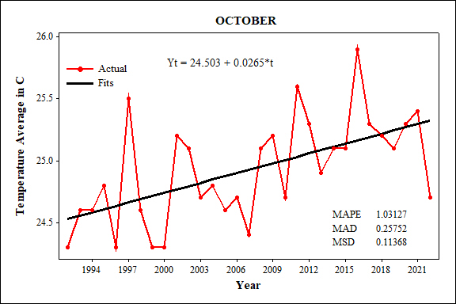
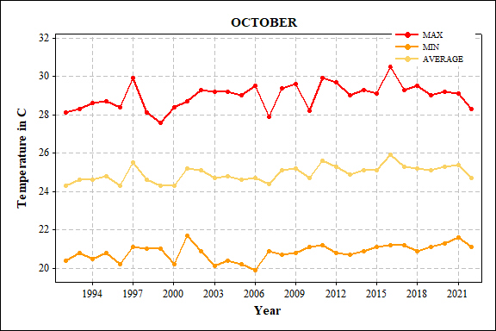
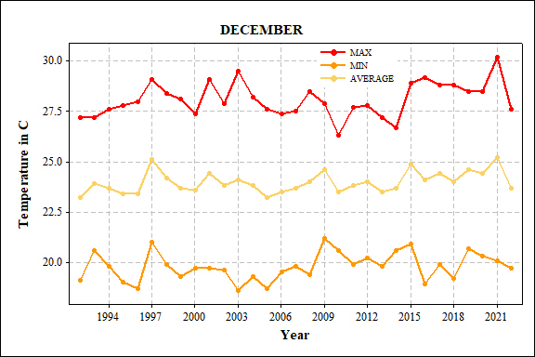
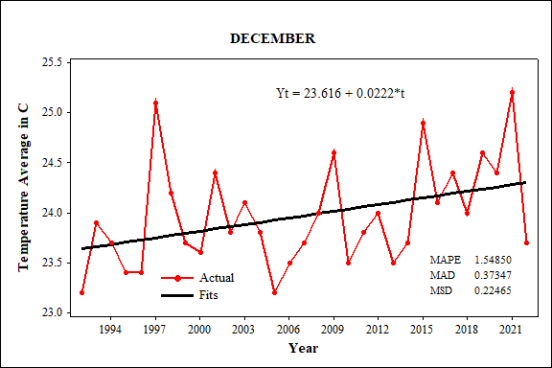
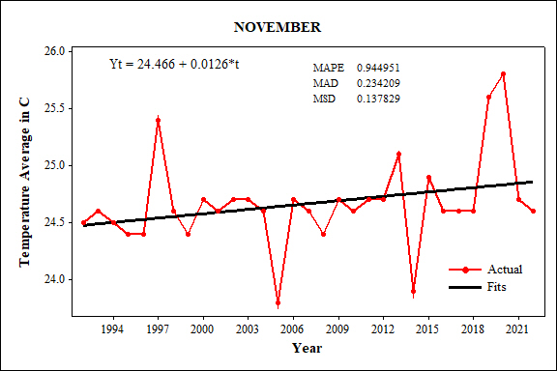
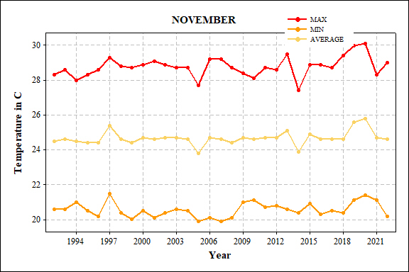

Figure 4. Monthly pattern of temperature increasing in the Kandy district of Sri Lanka from 1992 to 2022

The seasonal temperature fluctuations in the Kandy District of Sri Lanka reveal an ever-rising trend, as evidenced by the FIMS, SIMS, and NEMS temperature indices, which depict an upward trajectory. During the Northeast Monsoon, the temperature in the Kandy District rose by 1.98 °C, and during the Second Inter-Monsoon, it increased by 0.795°C. Consequently, the average temperature in the Kandy District as determined by this study amounts to 25.04°C. The figures appended below visually exemplify the seasonal temperature patterns in the Kandy District of Sri Lanka. Figures 5,6 and 7 elaborating the seasonal temperature increasing in the Kandy district.
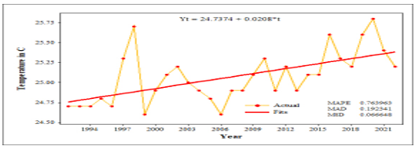

Figure 5. Temperature increasing in the FIMS in the Kandy district

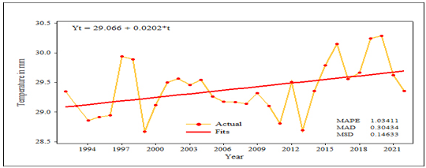

Figure 6. Temperature increasing in the SIMS in the Kandy district

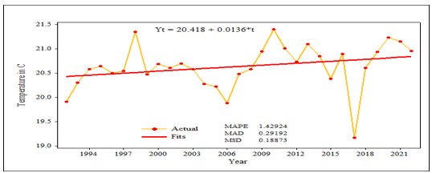

Figure 7. Temperature increasing in the NEMS in the Kandy district

Precipitation trend

- Spatial trend

Although the Kandy District's rainfall pattern is similar, the quantity of precipitation varies across its regions (Figure 8, 9 and 10). The spatial pattern of rainfall in this district is based on a decade-long analysis of rainfall patterns, ranging from 1992 to 2002. It shows that the highest amount of rainfall was recorded in the regions of Peradeniya and Kotmale, while the lowest amount of rainfall was recorded in Duck Wary Estate. From 2002 to 2012, the highest amount of rainfall occurred in Peradeniya and Kanoruwa, while the lowest amount occurred in Duck Wary Estate. In the 2012-2022 period, the Peradeniya region received the highest amount of rainfall, while the Melfort region received the lowest. Scrutinizing the seasonal trend of rainfall, the data collected from various rainfall observation stations reveals that rainfall activity decreases over time. As a consequence, precipitation at the Duck Wary Estate Rainfall Observation Station has declined to 996.927 mm. Figure 12 illustrate the spatial variations of the rainfall changes in the Kandy district.

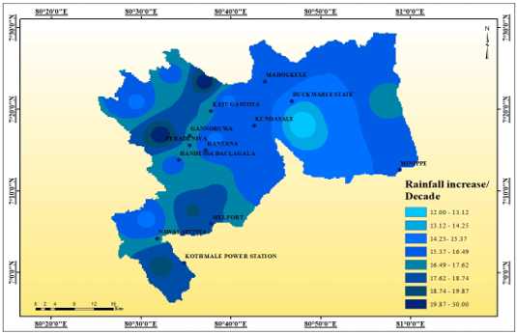

Figure 8. Spatial annual total rainfall changes in Kandy stations per decade from 1992-2002

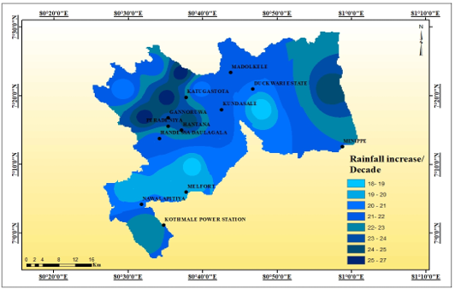

Figure 9. Spatial annual total rainfall changes in Kandy stations per decade from 2002- 2012

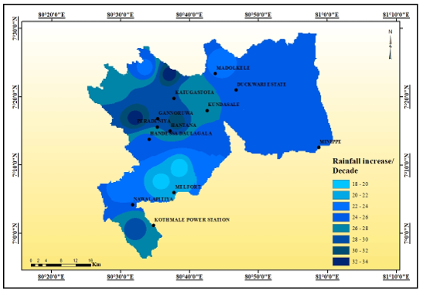

Figure 10. Spatial annual total rainfall changes in Kandy Stations per decade from 2012- 2022

- Temporal trend

The precipitation trend rises at the Handessa Duala gala precipitation observation station to 507 mm, and at the Katugastota precipitation observation station for it to be at 180 mm. The precipitation trend in the Kotmale Power Station rainfall observation station area escalates to 150.6 mm, and further, the precipitation trend for the Nawalapitiya precipitation observation station swells up to 2763 mm (Figure 11 & 12).

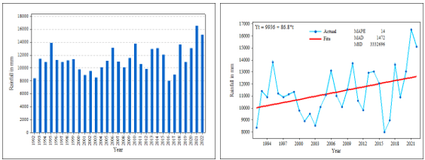

Figure 11. Average annual total rainfall of the Kandy District of Sri Lanka
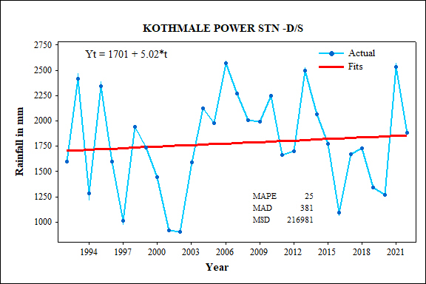
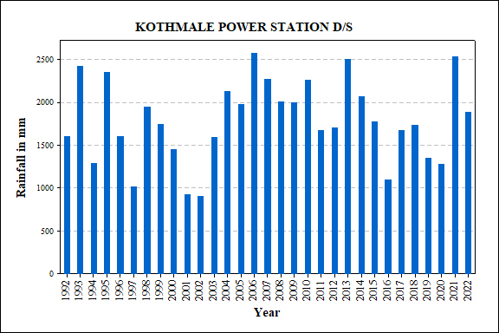
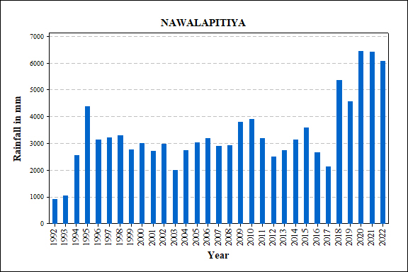
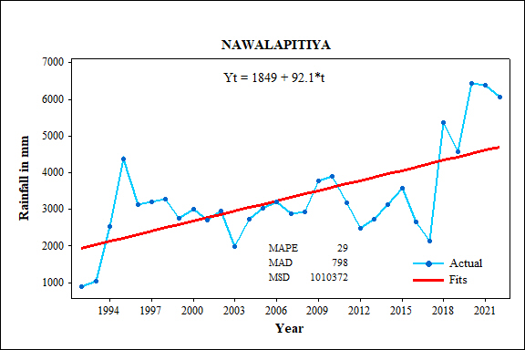
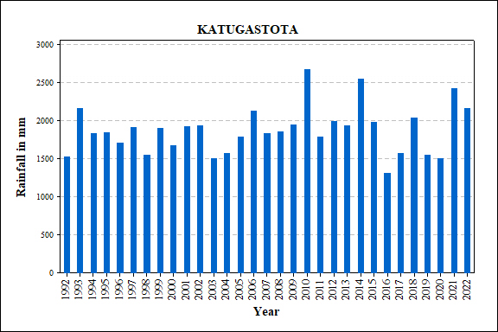
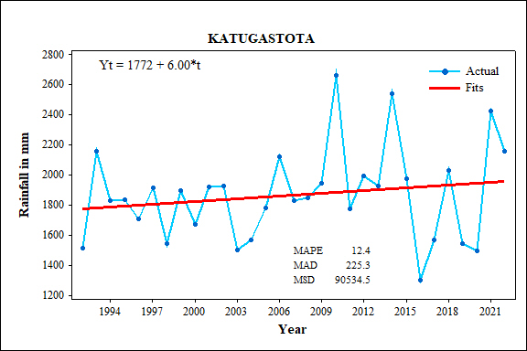
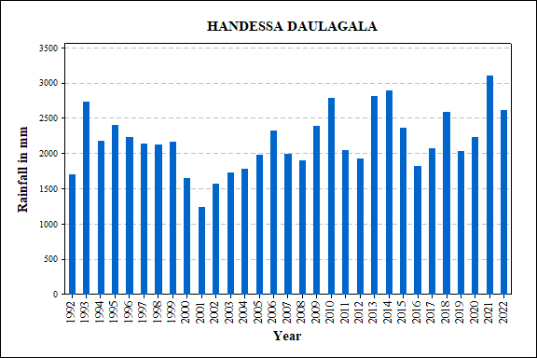
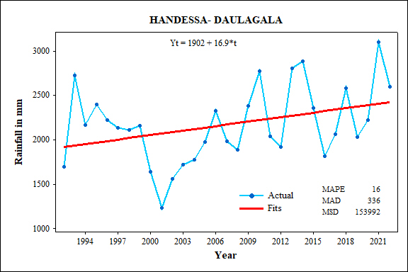
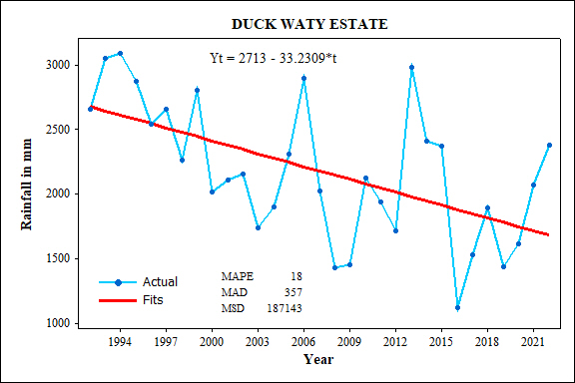
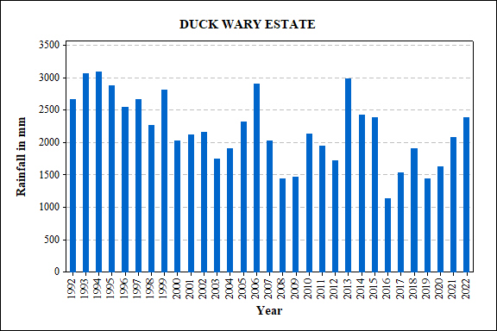
Figure 12. Annual total rainfall pattern of different stations of Kandy district

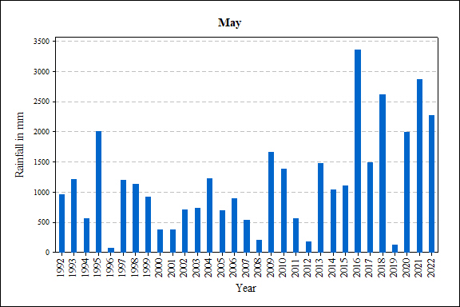
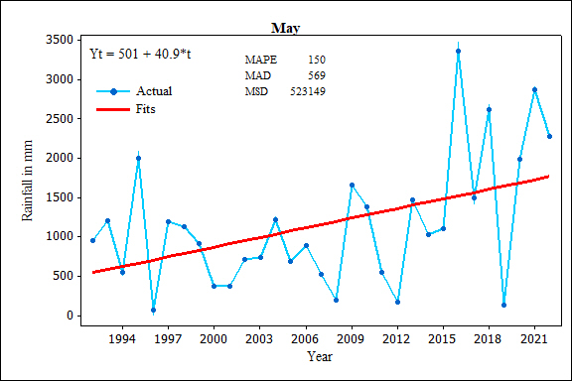
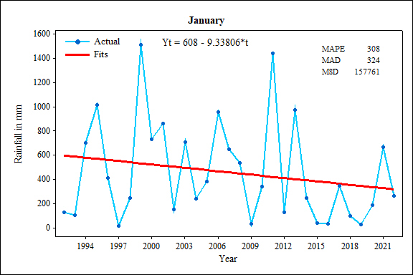
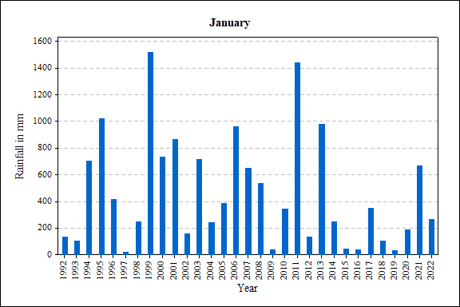
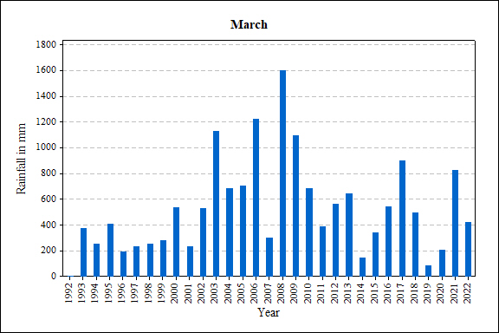
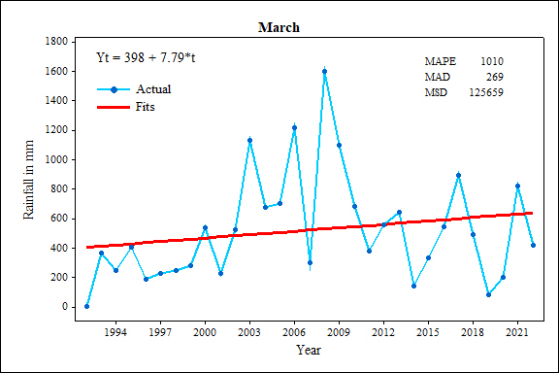
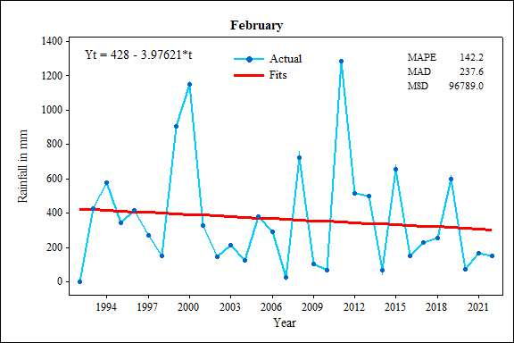
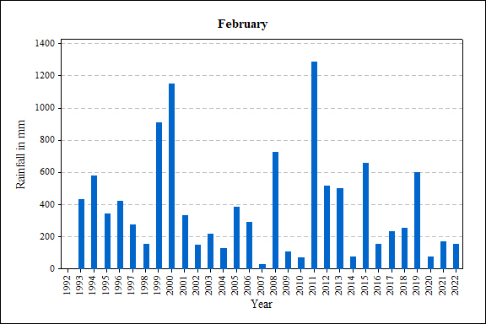
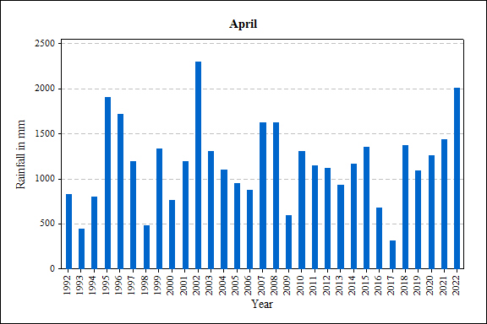
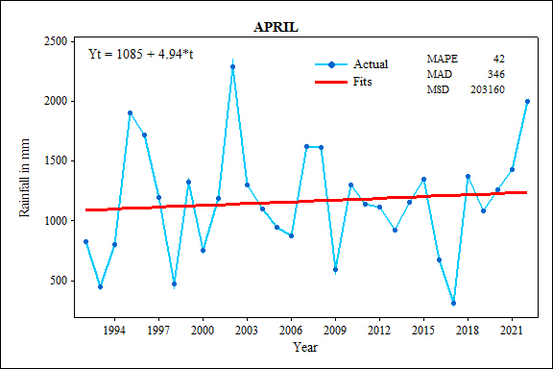
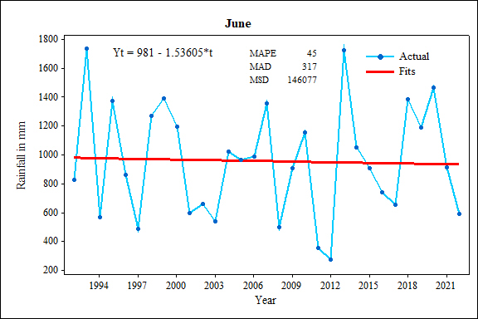
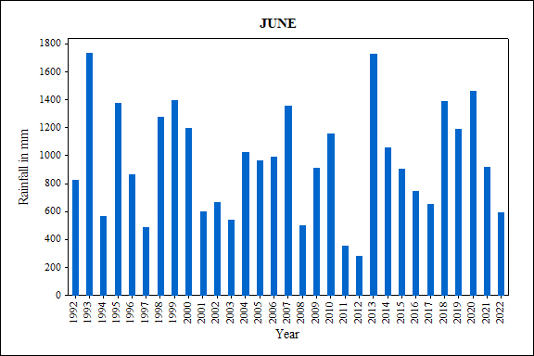
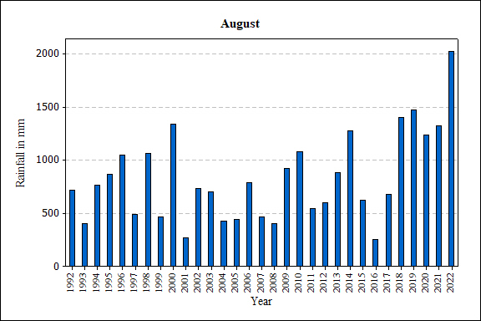
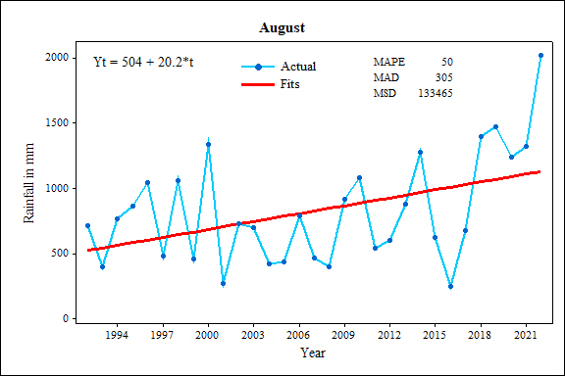
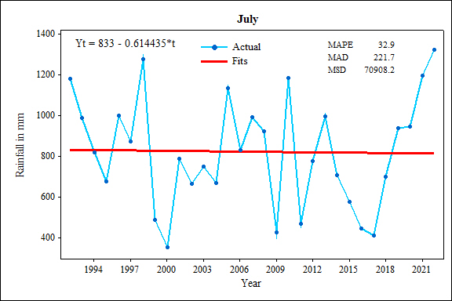
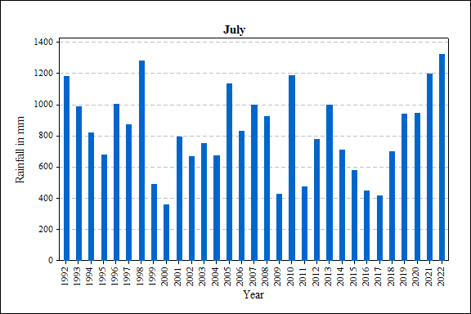
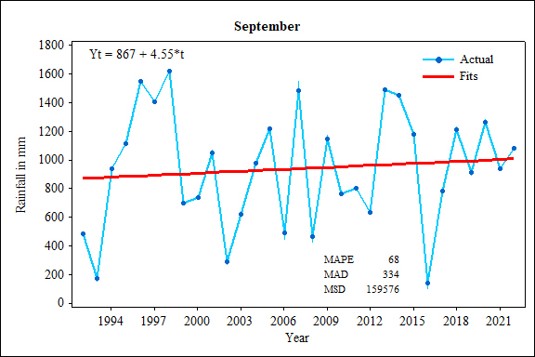
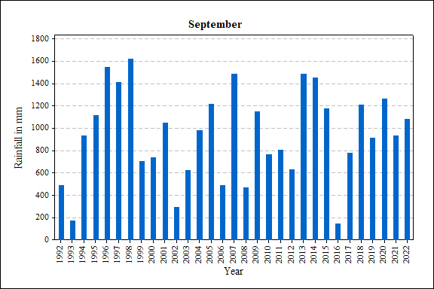
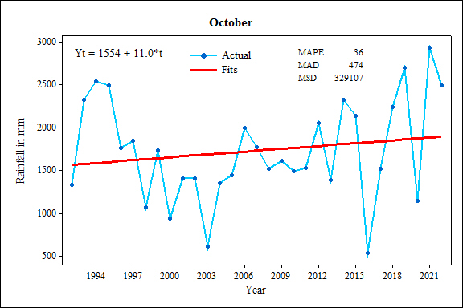
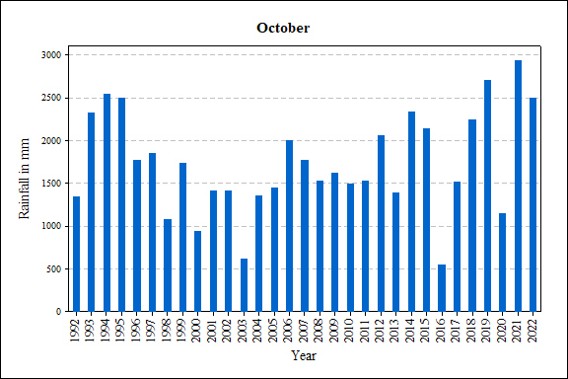
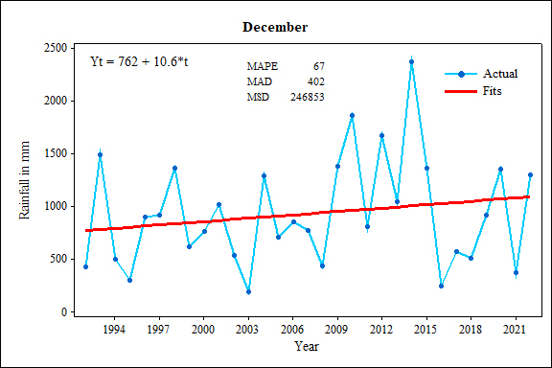
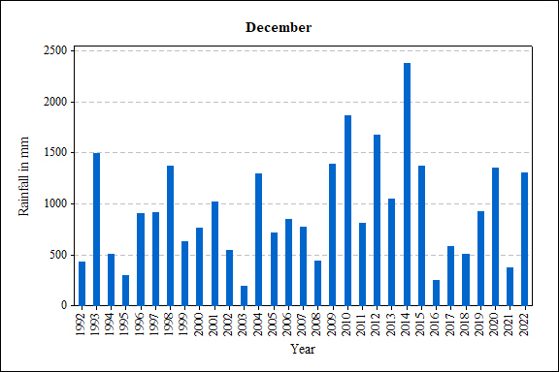
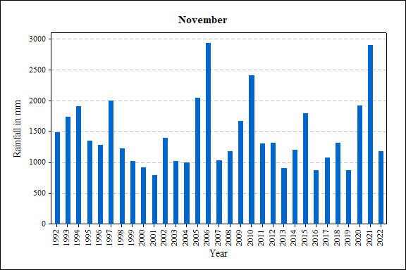
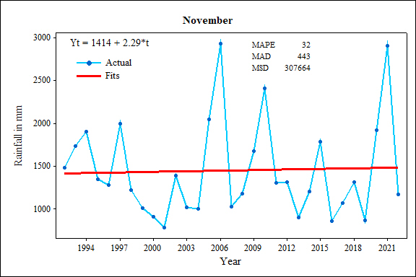

Figure 13. Monthly variations of rainfall in the Kandy district for last thirty years from 1992 to 2022

The trend of precipitation in Kandy district reveals a noticeable decrease in the amount of rain during January and February, settling at 280.141 mm and 119.2863 mm, respectively. However, following this diminishment, the month of March experienced an increase to 233.7 mm, whereas April and May saw the figures rise to 148.2 mm and 1227 mm, respectively. The rainy season was short-lived, for come June, the figures plummeted to a worrisome 46.0815 mm. The following months, July and September, proved to be exceedingly dry, recording merely 18.43305 mm and 136.5 mm, respectively. August, on the other hand, received bountiful rainfall with the figures scaling to 606 mm. Come October and December, the figures witnessed a moderate improvement of 330.0 mm and 318 mm, respectively. Thus, by comprehending the available data, it is safe to infer that the Kandy district experienced a resounding high of 1227 mm rainfall in May, while January remained a relatively dry month with the figures dwindling to 280.1418 mm. Figure 13 illustrate the monthly basis rainfall increasing in the Kandy district of Sri Lanka for the last thirty years from 1992 to 2022 (Figure 13).
The Mann-Kendall trend analysis was implemented on five selected study area stations, namely: Duck Wary Estate, Hadessa Duala Gala, Katugastota, Kotmale Power Station, and Nawalapitiya. The results of the Mann-Kendall trend analysis exhibited a mix of outcomes in terms of rainfall trend for each station in the study area. Nonetheless, most station Mann-Kendall results indicated that the p-values (alba), were below 0.05, thereby denoting a rejection of H0 across the aforementioned stations. Table 2 describe the Mann Kendal analysis of rainfall trend of different rainfall stations of Kandy district and all stations reect the H0.
In Kandy district, rainfall tends to escalate during every season. Notably, the Sen's slope value for each rainy season reveals varying results across the study area stations, consequently causing alterations in rainfall patterns within the area. However, it is reported that Northeast monsoon seasons exhibit a decline in rainfall as compared to other seasons. During the first inter-monsoon season, there was an increment of 381mm of rainfall, with a chance of precipitation at 10 to 30 percent. During the South-west monsoon season, rainfall increased to 1905mm, whereas during the second inter-monsoon season, precipitation rose to 399mm, with rainfall chances of 50 to 80 percent. During the Northeast monsoon season, rainfall dropped to 80.3322mm. Following tables indicating the Mann Kendal trend analysis and Sen’s slope estimation values of the rainfall of various stations of the Kandy district. According to the MK analysis all stations reject the null hypothesis which means that there are trend. Sen’s slope estimation values of all stations and all seasons indicating the rising trend of rainfall in the Kandy district of Sri Lanka. Table 3 illustrating the trend of rainfall of different stations and different season based on the Sen’s slope estimator.

Table 2. Mann Kendal trend analysis results of the varius stations of the Kandy district

Series | P - Value | Alba | Kendall’s tau | Test interpretation
Duck wary Estate | 0.016 | 0.05 | 0.214 | Reject H0
Handessa - Daulagala | 0.037 | 0.05 | 0.211 | Reject H0
Katugastota | 0.007 | 0.05 | 0.265 | Reject H0
Kotmale Power Station D/S | 0.044 | 0.05 | 0.284 | Reject H0
Nawalapitiya | 0.028 | 0.05 | 0.317 | Reject H0

Table 3. Sen’s Slope estimation values for the different seasons of different stations of the Kandy district

Stations | Seasons | Sen’s slope values/ Decade | Trend
Duck wary Estate | FIM | 1.28 | Rising
 | SWM | 1.23 | Rising
 | SIM | 1.82 | Rising
 | NEM | 1.21 | Rising
 | Annual | 2.17 | Rising
Handessa - Daulagala | FIM | 1.28 | Rising
 | SWM | 1.94 | Rising
 | SIM | 1.65 | Rising
 | NEM | 0.98 | Rising
 | Annual | 1.88 | Rising
Katugastota | FIM | 2.17 | Rising
 | SWM | 2.43 | Rising
 | SIM | 1.87 | Rising
 | NEM | 1.16 | Rising
 | Annual | 2.17 | Rising
Kotmale Power Station D/S | FIM | 2.14 | Rising
 | SWM | 1.87 | Rising
 | SIM | 2.07 | Rising
 | NEM | 1.09 | Rising
 | Annual | 1.62 | Rising
Nawalapitiya | FIM | 2.14 | Rising
 | SWM | 1.34 | Rising
 | SIM | 1.67 | Rising
 | NEM | 0.98 | Rising
 | Annual | 2.27 | Rising
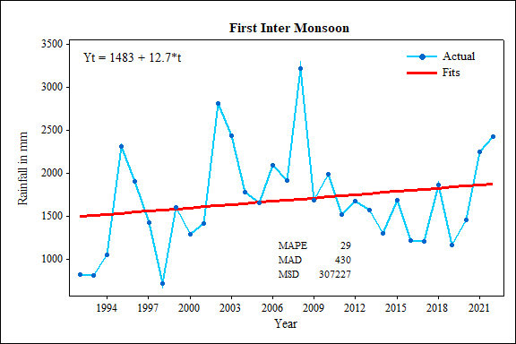
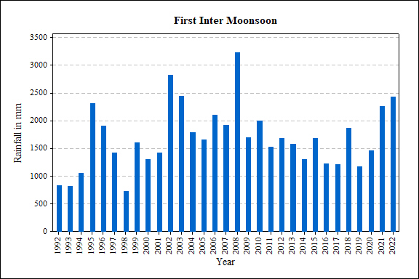
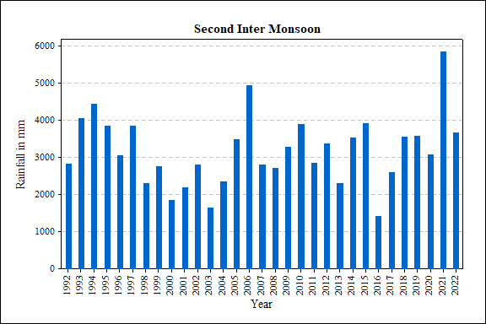
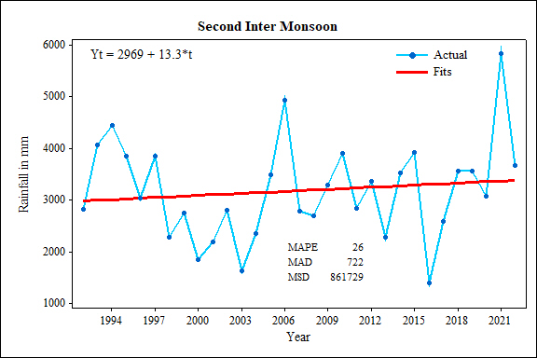
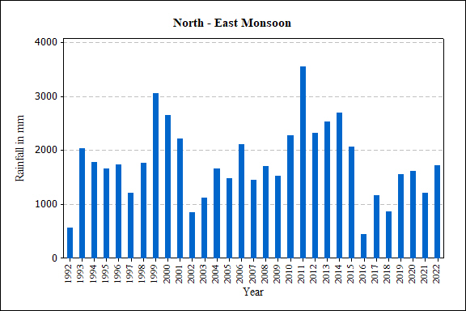
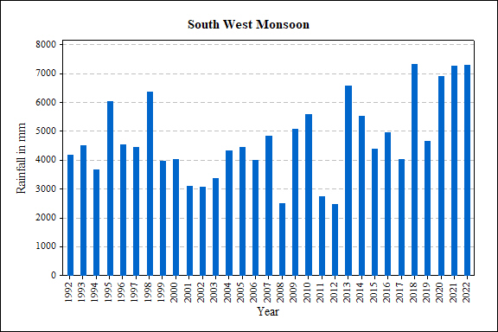
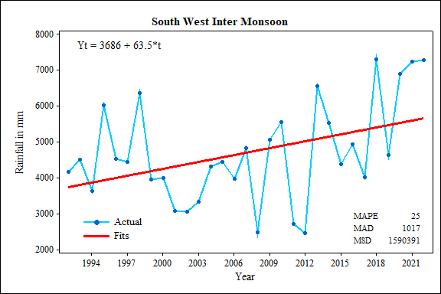
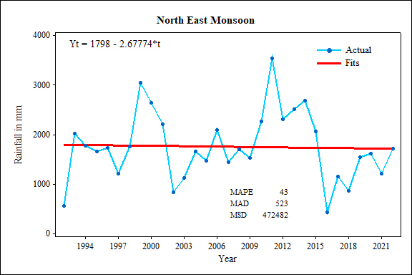

Figures 14. Seasonal pattern of rainfall changes in the Kandy district of Sri Lanka

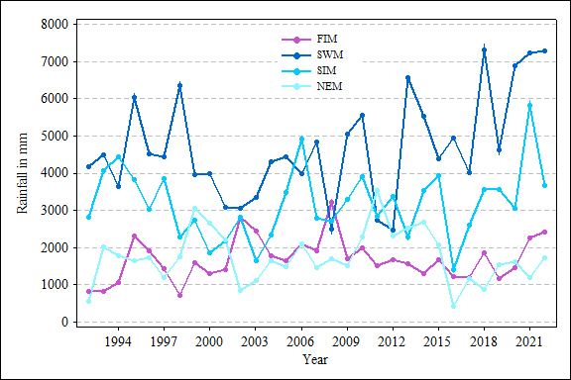
Figure 15. Trend of seasonal rainfall in the Kandy district of Sri Lanka

January, February, and March demonstrate the minimum precipitation in Kandy District, owing to the underwhelming northeast monsoon season and the initial monsoon season (Figure 14 & 15). Subsequently, from the months of April to September, the region experiences tremendous rainfall courtesy of the southwest monsoon. The latter half of the year denotes a surge in rainfall, as exemplified by the monthly culmination of precipitation in October and November, contributing to the overall ascension of the prevailing trend to 2604 mm. From a seasonal standpoint, the southwestern monsoon procures an ever-growing effect, whereas the northeastern season gradually subsides in authority.

Discussion

The findings of the study, concerning the spatial and temporal fluctuations of climate change in Kandy district, pertaining to temperature and precipitation, align with the results obtained by Jayawardene et al. (2005). The research conducted by De Silva and Kawasaki (2018) revealed that the Central Province of Sri Lanka experiences varying annual rainfall, while the annual temperature is declining. This study's results are congruent with the previous one.

Temperature trends

Upon examining the spatial trend of temperature in Kandy district, it has been observed that the average temperature for the 30-year period from 1992 to 2022 stands at 25.04°C. This average temperature varies not only across different regions but also throughout the seasons. Although there is no significant variation in the overall temperature, there are notable disparities in the rise and fall temperatures. Furthermore, seasonal variations in this temperature have also been identified. There are several studies in the varius regions of Sri Lanka showing the same pattern of results in the studies(Rashmika Nawarathna et al., 2023; Sandamali & Chathuranga, 2020; Jayawardene et al., 2020).
Analyzing the seasonal (1992-2022) temperature trend in Kandy district, the highest temperature recorded was 34.9°C in March. Conversely, the lowest temperature of 15.5°C was recorded in February. In Kandy district, the highest temperatures are experienced during the months of March and April, while the lowest temperatures are observed in January and February. However, the annual temperature in certain months of Kandy district is observed to decrease yearly. According to this study, the temperature trend in Kandy district has been identified as increasing in the month of July. The mean temperature throughout January, spanning from 1992 to 2022, is 23.8 degrees Celsius. Nevertheless, the temperature exhibited minimal variation between the periods of 1992-2007 and 2010-2022, experiencing a decline in certain instances. However, the temperature fluctuated between 22.6°C and 25.3°C.
The average temperature recorded in February is 24.7 degrees Celsius, which ascends to 26.0 degrees Celsius in March. It is noteworthy that the average March temperature peaked at 27.7 degrees Celsius in 1998 and was recorded at 27.2 degrees Celsius in 2020. Subsequently, the temperature increased to 26-26.5 degrees in the months of April and May. The primary cause for this temperature rise in the aforementioned months is the diminished influence of the first inter-monsoon and the north monsoon in the Kandy district. Consequently, the temperature naturally escalates in the Kandy district during this period(Senatilleke et al., 2022;Sandamali & Chathuranga, 2020;Jayawardene et al., 2020).
Furthermore, it can be observed that the average temperature declines to 26.0-24.9 degrees Celsius during the period from May to September. This decrease is attributable to the influence of the southern monsoon. For the time span of 1992 to 2022, the mean temperature in May has been documented at 26.0 degrees Celsius. However, in the year 1998, it reached 26.9 degrees Celsius, in 2000, it was 26.3 degrees Celsius, and in 2020, it was 26.8 degrees Celsius. The average temperature observed in the month of June during the aforementioned period was 25.3 degrees Celsius, with a notable 26.1 degrees Celsius recorded in 2019.
The mean temperature recorded in the month of July from 1992 to 2022 was 25.1 degrees Celsius in 2015 and 25.8 degrees Celsius in 2021. The average temperature in September for a span of three decades is 24.9 degrees Celsius, which reached 25.4 degrees Celsius in 2015. Due to the influence of the southwesterly monsoon, which brings rain to the southern and western regions of Sri Lanka during these months, the Kandy district experiences precipitation, thus causing a natural temperature decrease during this period. In the subsequent months from October to December, no significant disparities were observed in the temperature levels. Nevertheless, from 1992 to October-December, a slight decline in temperature can be noticed. The average temperature for October, between 1992 and 2022, is 25.9 degrees Celsius, which will decrease to 24.7 degrees Celsius in 2022. As the month of November approaches, a discernible decline in temperature becomes evident. Over the period spanning from 1992 to 2022, the average temperature stands at 25.8°C. This value is set to decrease to 24.7°C in 2022. Concerning December's temperature, the average for the past 30 years is 25.2°C, projected to drop to 23.7°C in the upcoming year.
The lack of temperature increase during these months can be attributed to the influence of the second inter-seasonal period. The months of October and November bring rainfall to the Kandy district, leading to lower temperatures due to the impact of the second inter monsoon. It is also noteworthy that during this period, Tiran rainfall is notably high in the Kandy district. Several studies indicating the seasonal variations of temperature in the Kandy district and the values of the variation is varies between the researchers(Ehelepola et al., 2018)(Rashmika Nawarathna et al., 2023;Dissanayake et al., 2019;Sandamali & Chathuranga, 2020).
In terms of the climate pattern of the Kandy district, there are significant spatial and temporal variations, particularly in temperature. The temperature in the Kandy district is higher during the North Monsoon season and lower during the second inter-monsoon season. Consequently, based on the temperature analysis results of this study, the average temperature of the Kandy district is recorded at 25.04°C. However, the average temperature of the Kandy district is documented as 26.05°C. (De Silva & Kawasaki, 2018) This implies that the average temperature of the Kandy district is decreasing by 1.01°C compared to the previous 30 years.

Precipitation.

While the overall precipitation in the Kandy district exhibits a consistent pattern, the specific monthly rainfall amounts display fluctuations in increasing and decreasing trends(Meegahakotuwa & Rekha Nianthi, 2023)(Meegahakotuwa & Nianthi, 2018). In the 30-year average precipitation trend of the Kandy district, the highest average precipitation is recorded at the Nawalapitiya Rainfall Observation Station, amounting to 3,322.6 mm, whereas the lowest precipitation is observed at the Kotmale Rainfall Observation Station, totaling 1,781.5 mm. Many researchers pointed out the fluctuations of rainfall trend of the Kandy district, but all researchers agreed that there are changes in the rainfall pattern of Kandy district in every decade.
The decade-long precipitation trends at the Kandy district's rainfall observatories vary regionally. Furthermore, among the selected rainfall observation stations for this study, significant changes in the precipitation trend have been observed at Nawalapitiya and Duckwary Estate stations. Annually, the maximum precipitation is documented at the Nawalapitiya Rainfall Observatory. Conversely, a decreasing precipitation trend can be observed at the Duckwary Estate Observation Station. The rainfall observatory chosen for studying spatial variations in seasonality has experienced the highest precipitation during the second inter-seasonal period. However, the Kandy district receives less precipitation during the monsoon season, differing in spatial extent(Meegahakotuwa & Nianthi, 2018).
The average annual precipitation over the past 30 years is 2,264.86 mm. Although this year's average precipitation varies both spatially and seasonally, it can be inferred that the average precipitation in the Kandy district has increased due to climate change. Based on the available precipitation data from specific stations in the Kandy district annually, monthly, and yearly precipitation is seen with fluctuating trends.
Within the Kandy district's study area, a heightened precipitation level was observed during October and November, surpassing other months within the second inter-seasonal wind season. The region experienced its peak rainfall in October, as per the 30-year rainfall trend. Notably, the Duckwary Estate station recorded 336.3mm, Handessa Daulagala 349.4mm, Katugastota 308.4mm, and Kotmale 292.3mm. The Nawalapitiya Rainfall Observatory registered an impressive 493.2mm. Contrastingly, February witnessed significantly lower rainfall figures: Duckwary Estate at 107.4mm, Handessa Daulagala at 53.3mm, Katugastota at 80.5mm, Kotmale at 56.7mm, and Nawalapitiya Observatory at 61.5mm. An annual fluctuation in precipitation levels is evident within the Kandy district, spanning from 1992 to 2022. The average rainfall for each month is as follows: January, 94mm; February, 75.24mm; March, 108.04mm; April, 240.16mm; May, 246.45mm; June, 217.01mm; August, 8.80mm; September, 169.89mm; October, 355.95mm; November, 298.02mm; and December, 192.05mm.
This analysis conclusively demonstrates that the Kandy district encounters its maximum rainfall during the second monsoon season, specifically in the month of October. However, it is crucial to note that the monthly average rainfall varies across different regions of the rainfall observatories.
Consequently, the alteration in Earth's atmospheric temperature and precipitation serves as the foundation for climate change (Yuan et al., 2017). In this regard, as per the study conducted by Xu et al. (2017), titled "Asian Climate Change under 1.5°C-4°C Warming Targets," Kandy district is subject to climate change. At present, human factors predominantly contribute to climate change more than natural factors (Yan et al., 2021).
By means of this investigation, the annual and monthly temperature fluctuations and the annual and monthly rainfall variations in Kandy district have been identified. This allows for a comprehensive understanding of the trend of change in Kandy district, particularly concerning temperature and precipitation over time. Moreover, it enables accurate forecasting. Spatially, there are disparities in temperature between regions within Kandy district, which significantly impact the local microclimate.
Thus, this study elucidates that by implementing mitigation measures to lessen the consequences of temperature and precipitation changes, which are the primary determinants of various activities, including agriculture, it will be possible to mitigate the impacts of climate change, specifically those related to temperature and precipitation fluctuations. Consequently, sustainable development endeavors can be carried out effectively.

Recommendations

In light of the escalating global concern surrounding climate change, it has become imperative for individuals, organizations, and governments worldwide to address this pressing environmental issue. To combat climate change on a local level, the following recommendations are proposed for the Kandy district:

Foster awareness and education

Cultivating individual awareness is deemed the most effective tactical approach to mitigate climate change. By acknowledging the severity of climate change as a pressing environmental challenge, individuals can adopt practices that reduce their personal contribution to global warming. This collective consciousness trickles down to social, regional, and eventually national awareness, fostering a more comprehensive approach to climate change mitigation.

Implement Sustainable practices

Encouraging eco-friendly practices within the Kandy district can significantly alleviate the impact of climate change. This includes promoting energy efficiency, waste reduction, and the adoption of renewable energy sources. By collectively embracing sustainable practices, the district can effectively contribute to the global efforts in reducing the adverse effects of climate change.

Minimising the utilisation of biofuels

Reducing greenhouse gas emissions is one of the most efficacious strategies for combating climate change. By curtailing the consumption of fossil fuels as much as possible, we can diminish the contribution of greenhouse gases to climate change. A transformation in our lifestyle, employing fossil fuels such as petrol, diesel, coal, and kerosene sparingly for transportation or other necessities, can help reduce our impact on climate change.

Energy conservation

Excessive electricity consumption is considered a significant factor exacerbating climate change, particularly in Sri Lanka where electricity generation relies heavily on petroleum products. This results in the emission of substantial amounts of greenhouse gases during electricity generation using diesel or coal. To mitigate this, we must restrict our electricity usage to decrease greenhouse gas emissions. Contribute to climate change mitigation by using more energy-efficient products in your home or office. Replace conventional light bulbs with energy-saving alternatives to curtail the emission of carbon dioxide. By opting for an incandescent lamp, one can prevent the release of approximately 150 pounds of carbon dioxide molecules annually. Minimising the use of electrical equipment during unnecessary hours and for non-essential purposes is a fundamental factor in increasing greenhouse gas emissions. Consequently, reducing electricity availability in our areas and homes, and subsequently limiting greenhouse gas emissions, can be an effective method to combat climate change.

Promoting public transportation to maximise vehicle usage

With each individual opting for private vehicles for personal travel, we release more greenhouse gases into the environment. We can reduce the amount of greenhouse gases we emit into the atmosphere by using public transport and encouraging its use in all but the most necessary circumstances.

Combating deforestation and promoting new reforestation initiatives

By undertaking afforestation or reforestation projects, we can offset a significant portion of greenhouse gas emissions. Each tree absorbs an average amount of carbon for its own sustenance. By promoting new afforestation and reforestation activities while reducing deforestation, we can limit greenhouse gas emissions and avoid contributing to climate change.

Introduction of Gabon's Tax Legislation on Carbon Emissions

By implementing carbon tax legislation, the discharge of greenhouse gases and, consequently, human involvement in climate change can be minimized. Generally, it is customary to conduct an annual emissions test for each vehicle, in relation to the carbon emissions of the vehicles in our vicinity. However, this function is primarily accessible for procuring a separate road tax permit. On the specific day, i.e., during the emissions test period, the amount of carbon emitted by the vehicles is measured. Based on this, permission is granted to obtain a road tax permit for that year; however, according to most procedures, only on that day will the vehicle be modified to release less carbon and undergo an emissions test. They emit more carbon throughout the day, except for that day. Thus, if a vehicle's carbon emissions exceed the permissible limit through random tests, carbon emissions from vehicles can be regulated by imposing a carbon tax or levying a fine, while simultaneously reducing the contribution of vehicle carbon emissions to climate change.

Promoting material reuse

Reuse, recycling, and other forms of resource conservation are often advocated to mitigate climate change. It encompasses modification and utilization. Consequently, the demand for producing new goods or purchasing new items will decrease. In general, the production of electronics, clothing, and other products requires more energy, which leads to increased energy consumption and, subsequently, higher greenhouse gas emissions. By continually reusing an already produced product, the energy expenditure of producing it anew is reduced. Through this, we can contribute to mitigating climate change.

Utilization of renewable energy sources

Another crucial action to reduce climate change is the adoption of natural energy resources in our homes. In many parts of Sri Lanka, one can observe the situation of harnessing solar energy for domestic needs or selling it to the Sri Lanka Electricity Board. Given Sri Lanka's geography, we have opportunities to utilize solar energy or wind energy throughout the year, enabling us to contribute to climate change mitigation by producing and consuming such eco-friendly, renewable energy sources in our homes and regions. By creating opportunities to generate these renewable energy resources, we can significantly reduce our contribution to climate change by generating electricity for our homes and regions.

Disaster preparedness

Owing to the topography of Kandy district, there exists a heightened risk of catastrophes such as landslides and floods. Consequently, it is imperative to be acquainted with the precautionary measures and act accordingly. Due to the unpredictability of climate change, it is impossible to foresee when and what type of disaster may transpire; thus, a disaster preparedness kit should always be maintained in every household. This kit should be portable in case of unforeseen weather-related catastrophes and functional during emergency situations. This measure can potentially avert disasters.
To mitigate the effects of climate change in our region, we can reduce the use of plastic, adopt environmentally sustainable agricultural practices and animal husbandry, pay greater attention to waste management, and implement eco-friendly technologies.
Climate change has evolved into a pressing global issue with far-reaching consequences. The world is gearing up to confront climate change. It has become one of the most significant natural challenges that every individual, organization, and government worldwide is concerned about. On a global, national, and local scale, various initiatives are being undertaken to alleviate the extent of this climate change or its repercussions. This includes hosting climate change-related conferences, raising awareness, and implementing joint and individual actions by numerous countries. Among the recommendations to lessen the magnitude of climate change and its impacts in the Kandy district, the following can be cited: raising awareness, minimizing the use of fossil fuels, promoting energy conservation, encouraging public transportation, maximizing the utilization of environmentally friendly vehicles, reducing deforestation, and promoting reforestation activities, introducing a carbon tax law, utilizing renewable energy resources, and emphasizing disaster preparedness. Additionally, we can reduce the effects of climate change in our region by curtailing the use of plastic, practicing eco-friendly agriculture and animal management, paying more heed to waste management, and employing green technologies.

Conclusion

The 30-year temperature trend (1992-2022) in Kandy district reveals an average of 25.04°C, with seasonal and regional variations. The highest temperature of 34.9°C was in March, while the lowest of 15.5°C was in February. Kandy district experiences peak temperatures in March and April, and lowest in January and February. Annual temperature decline occurs in specific months. The temperature trend increases in July. January's mean temperature is 23.8°C, with minimal variation between 1992-2007 and 2010-2022. Temperature fluctuates between 22.6°C and 25.3°C. The average temperature rises from 24.7°C in February to 26.0°C in March, with a peak of 27.7°C in 1998 and 27.2°C in 2020. In April and May, it increases to 26-26.5°C due to reduced influence of first inter-monsoon and north monsoon, causing a natural temperature rise in Kandy district during this period.
This analysis reveals a decline in average temperature, ranging from 26.0-24.9°C, between May and September, primarily due to the southern monsoon's influence. The Kandy district experiences rainfall during this period, contributing to the temperature decrease. Over the 1992-2022 period, May's average temperature was 26.0°C, with fluctuations in subsequent months. The southwesterly monsoon causes precipitation in southern and western Sri Lanka, leading to lower temperatures in the Kandy district. From October to December, a slight temperature decline is observed, with average temperatures set to decrease in the coming years. The lack of temperature increase during these months is attributed to the second inter-seasonal period, which brings rainfall to the Kandy district, resulting in lower temperatures. During specific months, the lack of temperature increase is attributed to the second interseasonal period, leading to increased precipitation and lower temperatures in the Kandy district due to the second monsoon. The district experiences significant temperature variations, being higher during the North Monsoon season and lower during the second intermonsoon season.
The Kandy district's general precipitation pattern remains consistent, while specific monthly amounts show fluctuations due to increasing and decreasing trends. Over 30 years, Nawalapitiya station records the highest precipitation, while Kotmale has the lowest. Precipitation trends in the past decade vary regionally, with significant changes at Nawalapitiya and Duckwary Estate stations. The Kandy district experiences less precipitation during the monsoon season. Over 30 years, the average annual precipitation is 2,264.86 mm, and it has increased due to climate change, showing fluctuating trends when examining data from specific stations.
Within the Kandy district, a notable increase in precipitation occurs during October and November, surpassing other months in the second inter-seasonal wind season. The peak rainfall is observed in October, as per a 30-year trend. Significant rainfall amounts were recorded at various stations. However, February experiences lower rainfall. An annual fluctuation in precipitation is evident since 1992 to 2022, with October being the wettest month. The analysis highlights regional variations in rainfall and establishes a link between atmospheric changes and climate change, predominantly influenced by human factors. This study aids in understanding the district's temperature and precipitation trends over time, enabling accurate forecasting and revealing disparities in local microclimates.
Climate change has emerged as a consequential global issue, captivating the attention of people, organizations, and governments worldwide. It has catalyzed efforts at the global, national, and local levels to mitigate its impacts. To subdue the magnitude of climate change in Kandy district, the following measures can be undertaken: investigate the root causes behind the mounting temperatures, particularly the monthly and yearly mean temperature spikes; identify the origins behind the sudden upsurge in rainfall frequency at the Rainfall observation station; establish grounds for the amplified temperature during July versus other months; explore factors encircling upshots in Kandy's precipitation; scrutinize the instigations of decelerating rainfall trends at the Duck Wary Estate rainfall observation station; assess the rationales for intensified rainfall activities during May and south-west monsoon rainfalls; study the causes for the loss of impact of northward migration; and ultimately deduce the etiologies of climate change in the Kandy district. With the discovery of such causes, concomitant mitigation measures tailored to the physical traits of the areas can effectively reduce the incidence of climate change in the respective regions, contributing significantly to minimizing the adversities experienced in Kandy District.

References

Adams, K., & Heidarzadeh, M. (2022). Extratropical cyclone damage to the seawall in Dawlish, UK: Eyewitness accounts, sea level analysis and numerical modeling. Natural Hazards, 116(1), 637–662.
Alahacoon, N., & Edirisinghe, M. (2021a). Satellite-based meteorological and agricultural drought monitoring for agricultural sustainability in Sri Lanka. Sustainability, 13(6), 3427.
Alahacoon, N., & Edirisinghe, M. (2021b). Spatial variability of rainfall trends in sri lanka from 1989 to 2019 as an indication of climate change. ISPRS International Journal of Geoinformation, 10(2), 84.
Ampitiyawatta, A. D., & Guo, S. (2009). Precipitation trends in the Kalu Ganga basin in Sri Lanka. Journal of Agriculture Sciences-Sri Lanka, 4(1), 10-18.
Dasandara, S. P. M., Kulatunga, U., Ingirige, M. J. B., & Fernando, T. (2021). Climate change challenges facing Sri Lanka: A literature review. In Sandanayake, Y. G., Gunatilake, S., & Waidyasekara, K. G. A. S. (eds). Proceedings of the 9th World Construction Symposium, 9-10 July 2021, Sri Lanka.
De Silva, M. M. G. T., & Kawasaki, A. (2018). Socioeconomic vulnerability to disaster risk: A case study of flood and drought impact in a Rural Sri Lankan community. Ecological Economics, 152, 131-140.
Dissanayake, D. M. S. L. B., Morimoto, T., Ranagalage, M., & Murayama, Y. (2019). Land-use/land-cover changes and their impact on surface urban heat islands: A case study of Kandy City, Sri Lanka. Climate, 7(8), 99.
Ehelepola, N. D. B., Ariyaratne, K., & Jayaratne, A. (2018). The association between local meteorological changes and exacerbation of acute wheezing in Kandy, Sri Lanka. Global Health Action, 11(1), 1482998.
Fan, P. Y., Chun, K. P., Mijic, A., Tan, M. L., He, Q., & Yetemen, O. (2021). Quantifying land use heterogeneity on drought conditions for mitigation strategies development in the Dongjiang River Basin, China. Ecological Indicators, 129, 107945.
Gunaratne, M. S., Radin Firdaus, R. B., & Rathnasooriya, S. I. (2021). Climate change and food security in Sri Lanka: Towards food sovereignty. Humanities and Social Sciences Communications, 8(229), 1–14.
Hoegh-Guldberg, O., Jacob, D., Taylor, M., Bindi, M., Brown, S., Camilloni, I., Diedhiou, A., Djalante, R., Ebi, K. L., Engelbrecht, F., Guiot, J., Hijioka, Y., Mehrotra, S., Payne, A., Seneviratne, S. I., Thomas, A., Warren, R., & Zhou, G. (2018). Impacts of 1.5 C global warming on natural and human systems. World Meteorological Organization Technical Document, 175–311.
Jayawardene, H., Sonnadara, D., & Jayewardene, D. (2005). Trends of Rainfall in Sri Lanka over the Last Century. Sri Lankan Journal of Physics, 6(1), 7-17.
Jayawardene, H., Sonnadara, D., Jayewardene, D., Sandamali, K. U. J., Chathuranga, K. A. M., Zubair, L., Yahiya, Z., Agalawatte, P., Lokuhetti, R., Ehelepola, N. D. B., Ariyaratne, K., Dissanayake, W. P., Jayaratne, A., Bandara, P., Abenayake, C. C., Jayasinghe, A. B., Mahanama, P. K. S., Sanjeewani, R. M. S. S. S. S., Manawadu, L., … Carlson, D. (2020). Spatial and temporal variation of land surface temperature (LST) in the Kandy district of Sri Lanka. Global Health Action, 8(1), 1–20.
Jiang, Y., & Huang, J. (2018). Managing water resources for sustainable socioeconomic development; Managing the middle-income transition: Challenges facing the people’s republic of China.
Makubura, R., Meddage, D. P. P., Azamathulla, H. M., Pandey, M., & Rathnayake, U. (2022). A simplified mathematical formulation for Water Quality Index (WQI): A case study in the Kelani River basin, Sri Lanka. Fluids, 7(147), 1-12.
Maury, O., Campling, L., Arrizabalaga, H., Aumont, O., Bopp, L., Merino, G., Squires, D., Cheung, W., Goujon, M., Guivarch, C., Lefort, S., Marsac, F., Monteagudo, P., Murtugudde, R., Österblom, H., Pulvenis, J. F., Ye, Y., & van Ruijven, B. J. (2017). From shared socio-economic pathways (SSPs) to oceanic system pathways (OSPs): Building policy-relevant scenarios for global oceanic ecosystems and fisheries. Global Environmental Change, 45, 203–216.
Meegahakotuwa, U. S., & Nianthi, K. W. G. R. (2018). Variation of annual and seasonal rainfall patterns in Kandy district of Sri Lanka. International Journal of Scientific and Research Publications (IJSRP), 8(9), 725–731.
Naveendrakumar, G., Vithanage, M., Kwon, H. H., Iqbal, M. C. M., Pathmarajah, S., & Obeysekera, J. (2018). Five decadal trends in averages and extremes of rainfall and temperature in Sri Lanka. Advances in Meteorology, 2018, 1-13.
Rashmika Nawarathna, B. N., Nianthi, R., & Subasinghe, S. I. S. (2023). Spatial and temporal variation of land surface temperature (LST) in the Kandy district of Sri Lanka. IOP Conference Series: Earth and Environmental Science, 1266, 012074.
Sandamali, K. U. J., & Chathuranga, K. A. M. (2020). Time series analysis of urban temperature in Kandy city, Sri Lanka with the use of satellite remote sensing. Proceedings of 12th International Research Conference 2019, KDU, General Sir John Kotalawala Defense University.
Senatilleke, U., Gunathilake, M. B., Alyousifi, Y., & Rathnayake, U. (2022). Analysis of recent trends and variability of temperature and relative humidity over Sri Lanka. Mausam, 73(3), 511–524.
Somasundaram, D., Zhang, F., Ediriweera, S., Wang, S., Li, J., & Zhang, B. (2020). Spatial and temporal changes in surface water area of Sri Lanka over 30 years. Remote Sensing, 12(22), 3701.
Wei, X., Jiang, H., Xu, H., Fan, J., Shi, W., & Guo, Q. (2021). Response of sedimentary and pollen records to the 1933 Diexi earthquake on the eastern Tibetan Plateau. Ecological Indicators, 129, 107887.
Yan, Y., Mao, K., Shen, X., Cao, M., Xu, T., Guo, Z., & Bao, Q. (2021). Evaluation of the influence of ENSO on tropical vegetation in a long time series using a new indicator. Ecological Indicators, 129, 107872.
Yuan, Z., Xu, J., Chen, J., Huo, J., Yu, Y., Locher, P., & Xu, B. (2017). Drought assessment and projection under climate change: A case study in the Middle and Lower Jinsha River basin. Advances in Meteorology, 2017.

