Ethnics in coalition: An analysis of stronghold state level party’s performance and trend

Rosmadi Fauzi¹, Zulkanain Abdul Rahman¹, Mohd Muslim Said¹, Muhammad Fathi Marzuki¹, Veronica Sayu Balang¹, Kamaruzaman Jusoff², Mohammad Tawfik Yaakub³, Nisfariza Mohd Noor⁴

¹Universiti Malaya Centre for Democracy and Elections (UMcedel)
Faculty of Arts and Social Sciences, Universiti Malaya, 50603 Kuala Lumpur, Malaysia.
²Deputy Vice Chancellor's Office (Research & Innovation)
Universiti Malaya, 50603 Kuala Lumpur, Malaysia.
³Department of Public Administration, Faculty of Business and Economics,
Universiti Malaya, 50603 Kuala Lumpur, Malaysia.
⁴Department of Geography, Faculty of Arts & Social Sciences,
Universiti Malaya, 50603 Kuala Lumpur, Malaysia.

Correspondence: Rosmadi Fauzi (rosmadifauzi@um.edu.my)

Received: 6 November 2023; Accepted: 16 February 2024; Published: 29 February 2024

Abstract

Pahang was known as Barisan Nasional (BN) stronghold state due to its capabilities to take over the office in Pahang comfortably from the first General Election (GE) until the 13th GE (2013). Despite its triumph, BN Pahang began to lose its tenacity in the 12th GE (2008) and worsened in the 14th GE held in 2018. As a party that consists of three main component parties, namely, United Malays National Organisation (UMNO), Malaysian Chinese Association (MCA), and Malaysian Indian Congress (MIC) needs to devise a new formula and strategy to rebound their position. Therefore, this article was designed to unravel the interrelation between two main keys, ethnicity and alliance formation, to determine the BN resiliency in Pahang. The approach used in this study was a quantitative method using the data obtained from the Election Commission of Malaysia. The data was then tabulated and displayed on a map using the Geographical Information System (GIS). The study found that BN lost their popular vote to the opposing party by only 41.6% compared to 54.8% in the 13th GE. Besides, the number of seats won by BN declined by 39% compared to the 11th GE (2004). Results show that BN needs to form a strong coalition that consists of diversity in terms of ethnicity to win over the office. This study is substantively for parties to win over the electorate’s heart and promote a good democracy in the country.

Keyword: BN, coalition, elections, ethnics, general election, Pahang

Introduction

Politics plays an important role in human life from various perspectives including private life and most importantly society. As for society, politics consists of members who are in the office to shape society economically and socially. The politics in the country that practices democracy shows a dynamic pattern vividly seen throughout the output of the election. This situation is due to the surge in the people’s mindset with the vast explosion of political information (Kemp, 2020; Bakaki et al., 2020), consequently, instilling political literacy which gives them awareness to evaluate the political and election system (Kirby, 2022).
In response, the main actors, politicians meticulously design the political strategies to remain in office. Political strategies have served as a reference point for scholars in the 2000s (König & Wenzelburger, 2014). Politicians considered every aspect of the society to gain trust which will be translated in the ballot. Harteveld et al. (2013), manifested trust as an evaluation approach in the political sciences covering the relation between the subject (the one who trusts) and the object (whom to trust). There are four main dimensions of trust namely commitment, competence, caring, and predictability (Kasperson et al., 1992; Van der Meer, 2010). It has been broadly studied in the field of economics and procedural characteristics (Van der Meer & Hakhverdian, 2017). In an attempt to fill the gap, therefore, there is a need for politicians and scholars to understand the background of the electorate.
The development of trust is rooted in the community itself which is known as the civic community – a voluntary association of citizens that pursue a common interest, hence, generating social trust (Fennema & Tillie, 2001). It is strongly related to ethnicity and the capabilities to defend their rights. In recent years, scholars portrayed the importance of demographic indicators in shaping the voters’ voting behavior which has become a potent force in the political arena (e.g. Branton, 2004; Stroschein, 2011; Aha, 2021). The issue of ethnicity, namely, minorities has been politicized in recent elections, which have emerged as the political actors that made up the minorities as an important part of the electorate (Eelbode et al., 2013). Ng et al. (2021) found that urban development and ethnicity affected the election outcome, with the ethnicity factor being more dominant during Malaysia’s 14th GE (2018). This issue has been used as a strategy in the elections (García Bedolla & Haynie, 2013) and policy decisions related to electoral reform (Bali & Silver, 2006). However, this issue may be diminished over time.
Therefore, there will be a need for politicians to have other alternatives to secure their position. The vulnerability faced in terms of votes will lead to the urge to form a coalition. The coalition is an alliance of factions around grouping parties and experiences change when a party decides to join or leave the dominant alliance (Chambers, 2008). In parliamentary democracies, a party cannot take control of the government without the support of other parties (Bäck, 2008). The formation of an alliance must consider the parties’ ideology, the potential number of votes for minimum winning, side payments, and trust among parties (Bruhn, 2021) for the development of the coalition’s motives due to the differential in terms of political parties’ structure, goals, and values (Druckman, 1996) to achieve the mutual understanding which will determine the durability of the coalition (Luebke, 1980; Winders, 2005).
The interrelation between these two factors in the election shows the need for further study in the different geographical contexts. Therefore, this study was conducted to explore the resilience of a ruling party, Barisan Nasional (BN) due to its resilience to secure their seats in Pahang despite the fall at the federal level. This is substantive for parties to win over the electorate’s heart and trust and implement a good democracy in the country.

Study area

Pahang is the largest state in Peninsular Malaysia with an area of about 35,965 square kilometers (km²) (Department of Survey and Mapping Malaysia, 2011). The state borders the states of Kelantan, Terengganu, and Perak to the north which are separated by the Gunung Tahan Range as well as tropical rainforests. To the south, Pahang borders the state of Johor which is separated by Sungai Endau besides the states of Selangor and Negeri Sembilan to the west. Pahang is divided into 11 administrative districts namely Kuantan, Pekan, Raub, Temerloh, Bentong, Lipis, Jerantut, Cameron Highlands, Maran, Rompin, and Bera. In terms of local government administration, the state has 11 Local Authorities (LAs) of which three are Municipal Council status while the rest are District Councils. The political boundaries of Pahang is divided into 14 parliaments and 42 State Assemblies (Figure 1).

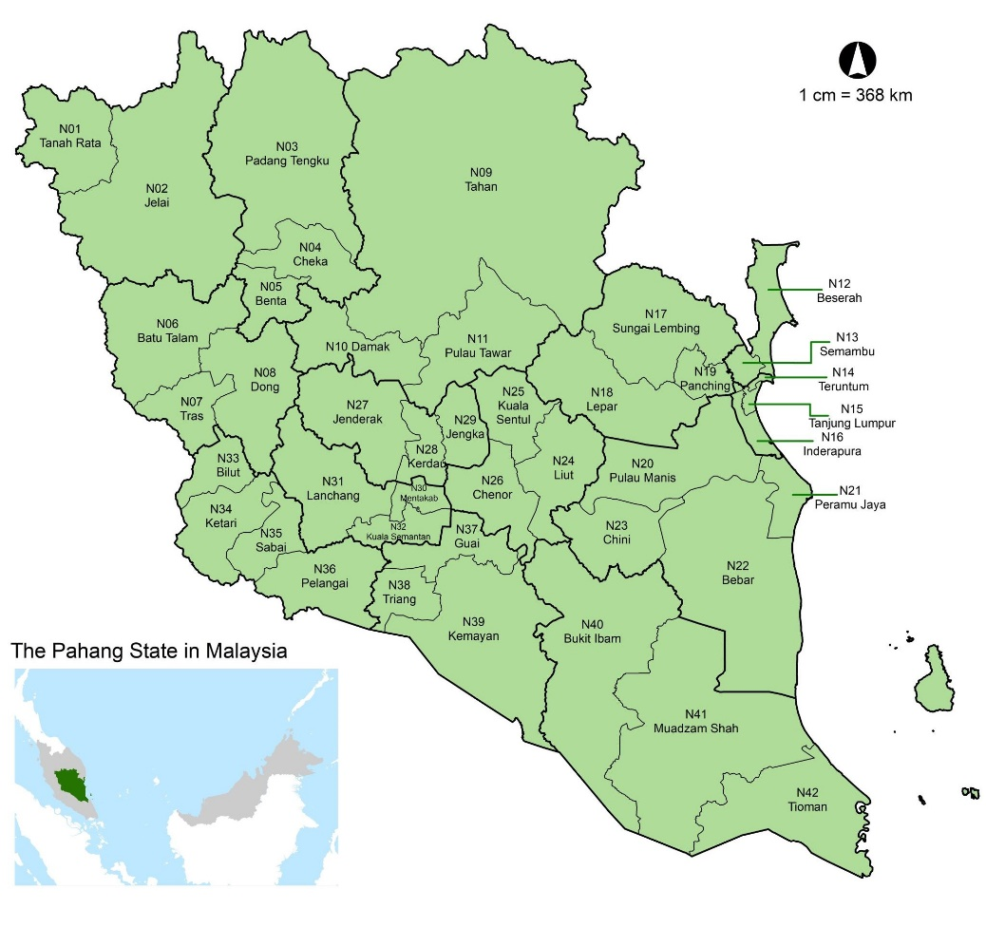

Figure 1. A map of Malaysia shaded in green shows the location of the study.

In 2019, Pahang’s population was estimated at 1.67 million people with a population density of 43 people per km². Bumiputera ethnicity accounts for 80.5% of the entire population, followed by Chinese at 14.8%, Indians at 4.3%, and the other remaining ethnicities at 0.4%. (Department of Statistics Malaysia, 2020). The Bumiputera community consists mostly of farmers and fishermen who live in rural areas. The Chinese community is synonymous with business activities that usually reside in cities throughout Pahang. However, there is also a Chinese community working on farmlands and plantations as well as other agricultural produce in the rural areas. They live in clusters all over the areas of Bentong, Raub, and Temerloh. The gender ratio of the population of Pahang is 113 males per 100 females (Department of Statistics Malaysia, 2020).
Pahang is one of the states that has produced many famous Malays warriors such as Dato' Bahaman, Tok Gajah, Mat Kilau, and Mat Kelubi throughout history. Pahang politics also produced two Prime Ministers of Malaysia, the late Tun Abdul Razak Hussein (Second Prime Minister of Malaysia), and the legacy was continued by his son, Dato' Sri Mohd. Najib Tun Abdul Razak (Sixth Prime Minister of Malaysia). Pahang remained under the administration of BN after various political turmoil in the country. This has made Pahang often known as the BN stronghold state. BN's strength in Pahang is sometimes linked to the presence of numerous Federal Land Development Authority (FELDA) land schemes, which account for a substantial portion of the BN's permanent vote. FELDA is a land development project established by the BN government on July 1st, 1956 under the Land Development Ordinance 1956 for land development and relocation. The majority of FELDA constituencies are in rural areas, with Malay voters dominating. Pahang has three main FELDA territories namely Jengka, Kuantan, and Mempaga with a total land scheme of 114 (FELDA, 2021). This makes Pahang the highest and largest state to own FELDA land schemes in Malaysia. FELDA voters, particularly in Pahang, were inclined to vote for BN ahead of the 14th GE out of loyalty to the party that had made significant contributions. This debt of gratitude has made the relationship between the FELDA and BN communities so strong that BN continues to have the unwavering support of FELDA voters. This sentiment strengthened BN's hegemony in the FELDA area until FELDA was dubbed as the BN fixed deposit area (Yusoff & Halim, 2019; Mahadi et al., 2016).

BN’s performance in Pahang during the 11th GE (2004) until the 14th GE (2018)

Malaysia has conducted 15 series of elections since independence. The 15th GE took place on November 19th, 2022. It was fanciful when BN, the ruling party for 61 years defeated by a coalition of an opposition party, Pakatan Harapan (PH) despite the struggle of disintegration in the 14th GE. PH is a coalition of the Malaysian United Indigenous Party (BERSATU), the Democratic Action Party (DAP), the People's Justice Party (PKR), the National Trust Party (AMANAH), and the pro-PH Sabah Heritage Party (WARISAN) won 121 seats in total, thus, secure their position to form the Federal Government with a simple majority. Meanwhile, BN won merely 79 parliamentary seats and 166 seats and had to relinquish power in seven states namely Kedah, Perak, Terengganu, Negeri Sembilan, Melaka, and Johor. Sabah, which was originally won by BN, also collapsed after six of their state assemblymen switched their support to the Warisan party (Utusan Borneo, 2018) at the State Legislative Assembly (DUN) level.
PH was also ahead of BN in terms of the popular vote achievement. PH received 5,685,252 votes (50.1%), compared to BN's 3,624,921 votes (31.9%) while Malaysian Islamic Party (PAS) had 2,043,159 votes (18.0%) (Malaysia Election Commission, 2020a). As the wave of people's rejection of BN spread across the country, Pahang and Perlis remained with the status quo under the control of BN. BN successfully won 25 of the 42 Pahang State Legislative Assembly (DUN) seats (59.5%). This allows BN to form the state government of Pahang on its own without the need for political cooperation with any other party. Despite its success in forming the state government, the 14th GE (2018) is regarded as a caution signal for BN Pahang. The results of the 14th GE (2018) reflect that the people's rejection of BN was growing stronger as BN lost another five seats that they had won in the 13th GE (2013). For the first time in history, BN lost control of the two-thirds majority of seats in the DUN.
Historically, the trend of decline in the BN state seats has started since the 12th GE (2008). After a landslide victory in the 11th GE (2004) by seizing 41 out of the 42 state assembly seats, BN Pahang began to lose its tenacity in the 12th GE (2008) when it failed to secure the four state constituencies it had won before that. The downward trend worsened in the 13th GE (2013) when BN lost another seven state assembly seats. In the 14th GE (2018), the momentum of the decline continued as BN lost another five state assembly seats, bringing the current total number of State Assembly-dominated to just 25 state constituencies. Since the 11th GE (2004) to the 14th GE (2018), BN has lost 16 state assembly seats. During this period, PAS, DAP, and PKR each performed impressively when they managed to retain the state seats won in each GE while adding to the victories in the state constituencies previously dominated by BN (refer Table 1).

Table 1. Total State Assembly won by each party in four GE terms in the DUN

Party | GE 11  (2004) | Total  + / - | GE 12  (2008) | Total  + / - | GE 13  (2013) | Total  + / - | GE 14  (2018)
BN | 41 | -4 | 37 | -7 | 30 | -5 | 25
PAS | 0 | +2 | 2 | +1 | 3 | +5 | 8
DAP | 1 | +1 | 2 | +5 | 7 | 0 | 7
PKR | 0 | 0 | 0 | +2 | 2 | +2 | 2
Independent | 0 | +1 | 1 | 0 | 0 | 0 | 0
Source: Election Commission of Malaysia, 2004, 2008, 2013, 2018

Based on Figure 2, BN's strength in the 14th GE (2018) is mainly concentrated in the south and partly in the north and central parts of Pahang. BN was defeated by PAS in several state constituencies in the northeast that are neighboring the state of Terengganu which had a strong influence of PAS. The majority of voters in this state legislature come from Terengganu, with Terengganu Malay dialect as the main language of speech. This structural and dynamic situation caused BN's influence to be limited in the region as it was filled by religious organizations and activities dominated by PAS (Noor, 2019). A similar situation occurred in the western state assembly when DAP managed to take control of several state constituencies neighboring Perak. In addition to the grouping of Chinese voters who gravitate towards DAP in the state assembly, neighboring factors also play an important influence. The majority of the Perak State Assembly which is adjacent to Pahang is dominated by the opposing parties, especially the DAP and PKR. Figure 2 shows the change in the pattern of the results in the last GE.

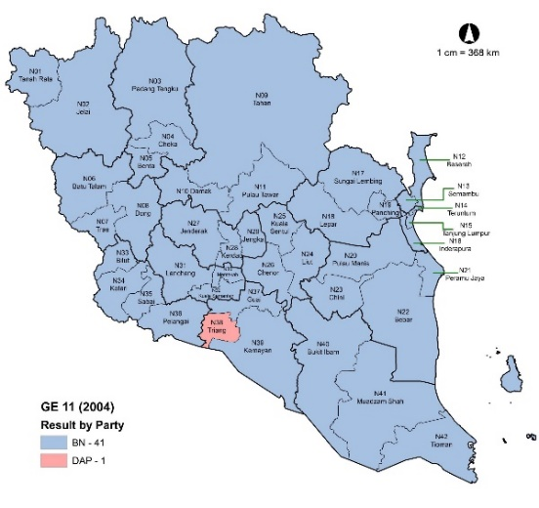  (a) | 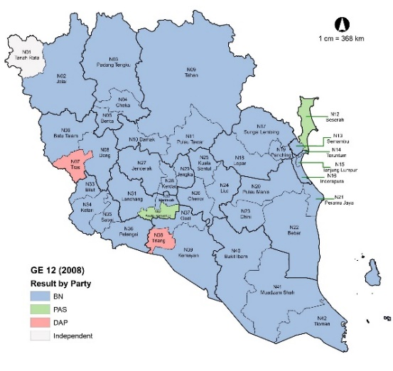  (b)
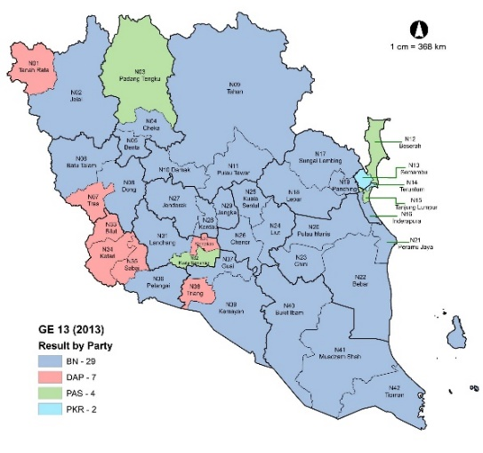  (c) | 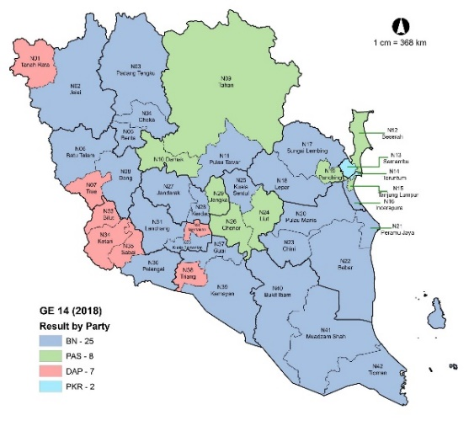  (d)

Results and discussion

BN’s ethnicity-based support

As has been discussed, ethnicity has become a driving force in the political market. It has been used by the main actor in elections to gain support from the electorate. It is delineated as a vehicle of political mobilization (Haokip, 2020) which is activated either in private life or political life (Chandra & Wilkinson, 2008). In politics, ethnicity concerns the collective action by individuals who are not related by immediate personal ties which can be distinguished through institutionalized or non-institutionalized contexts. In the electoral market, ethnicity drives the voter behavior and political party strategy which are associated with each other. This complex relation has caught the scholars’ attention in the study of elections (Barreto et al., 2022) across the nation. For instance, a party is amplified by placing candidates of a particular ethnicity in a constituency where that ethnicity is dominant (McGee, 1962; Ghazali et al., 2011).
In Pahang, the grouping of ethnic-based voters is visible, especially the Malay and Chinese voters. A total of 34 state constituencies were Malay-majority areas (Malay voters exceeded 50%) with 24 of them being supra-majority areas (Malay voters exceeded 75%). A sum of four state constituencies are Chinese-majority areas (Chinese voters are more than 50%) and the remaining four state constituencies are mixed constituencies (each race is below 50%). BN's victory in the 14th GE (2018) was all contributed by the Malay-majority state assembly. BN managed to conquer 25 of the 34 Malay-majority seats (78%). BN's main rival in the Malay-majority state assembly was the PAS party which managed to capture eight seats (22%).
BN and PAS vied fiercely in the eight state assembly seats with a lean majority of victories of under 600 votes. BN won narrowly in four state constituencies namely Cheka (202 votes), Benta (340 votes), Kuala Semantan (474 votes), and Pulau Tawar (587 votes). PAS also narrowly won against BN in four state assembly seats namely Tahan (69 votes), Panching (135 votes), Luit (272 votes), and Chenor (514 votes). BN lost to the PKR’s candidate in the Semambu state constituency where the percentage of Malay voters amounted to 59.6%. BN did not win any seats in the state legislature, which is dominated by Chinese voters, or in the coalition party's state assembly constituencies. The MCA, MIC, and the Malaysian People's Movement Party (Gerakan) representing BN failed to fend off DAP and PKR victories with a large majority in the state assembly except in the Sabai State Assembly. In the Sabai state constituency, BN represented by the MIC candidate lost narrowly to the DAP candidate with a majority of 495 votes (refer Figure 3 and Table 2).

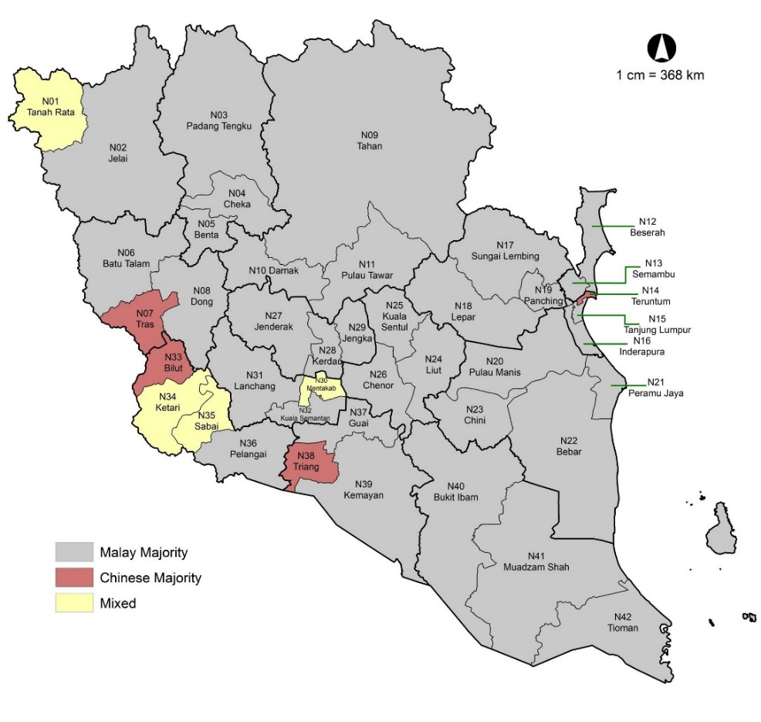

Figure 2. The map of the 14th GE (2018) based on racial composition by DUN.

Table 2. Results of the 14th GE (2018) based on ethnic composition by DUN.

Malay Majority State Assembly  (Malay 98.8 – 58.4%) |  |  | Chinese Majority State Assembly  (Chinese 66.5 – 55.8%) |  |  |  | Mixed State Assembly  (Non any races majority)
DUN | Winning  Party | Majority | DUN | Winning  Party |  | Majority |  | DUN | Winning  Party | Majority
N11 Pulau Tawar | BN | 587 | N38 Triang | DAP | 6,454 |  |  | N01 TanahRata | DAP | 3,589
N29 Jengka | PAS | 1,813 | N07 Tras | DAP | 9,953 |  |  | N34 Ketari | DAP | 3,710
N26 Chenor | PAS | 514 | N14 Teruntum | PKR | 7,725 |  |  | N30 Mentakab | DAP | 5,829
N09 Tahan | PAS | 69 | N33 Bilut | DAP | 3,739 |  |  | N35 Sabai | DAP | 495
N16 Inderapura | BN | 2,165
N03 Padang Tengku | BN | 1,244
N21 Peramu Jaya | BN | 7,182
N20 Pulau Manis | BN | 2,334
N40 Bukit Ibam | BN | 2,478
N23 Chini | BN | 4,622
N25 Kuala Sentul | BN | 2,039
N28 Kerdau | BN | 1,934
N37 Guai | BN | 3,295
N41 Muadzam Shah | BN | 4,840
N42 Tioman | BN | 1,280
N19 Panching | PAS | 135
N17 Sungai Lembing | BN | 1,968
N24 Luit | PAS | 272
N15 Tanjung Lumpur | PAS | 1,339
N32 Kuala Semantan | BN | 474
N08 Dong | BN | 3,832
N18 Lepar | BN | 2,779
N06 Batu Talam | BN | 4,320
N31 Lanchang | BN | 3,725
N12 Beserah | PAS | 1,305
N39 Kemayan | BN | 4,618
N04 Cheka | BN | 202
N36 Pelangai | BN | 2,312
N27 Jenderak | BN | 1,713
N22 Bebar | BN | 5,720
N02 Jelai | BN | 3,507
N05 Benta | BN | 340
N13 Semambu | PKR | 307
N10 Damak | PAS | 1,456
Source: Election Commission of Malaysia, 2018

To gauge the relationship between the votes received by BN and ethnic support, a correlation analysis was carried out. The findings of the research reveal that there is a relationship between the BN’s votes and ethnicity. Malays’ support for BN showed a moderate positive relationship (r = 0.597). Indigenous voters, on the other hand, demonstrated a low positive relationship (r = 0.495). This demonstrates that the more ethnic Malays and Indigenous people in an election constituency, the more votes BN earned. The opposite situation occurred among the Chinese and Indian voters when both formed a significant negative relationship with the BN vote count. Chinese voters’ support for BN showed a strong negative correlation (r = -0.762). The same goes for Indian voters who show a low negative relationship (r = -0.412). This indicates that the greater the concentration of these two ethnic groups in the constituency, the lower the support for BN (refer Table 3).

Table 3. Correlation between BN votes and ethnic composition in the 14th GE (2018) in the Pahang

 | Malay | Chinese | India | Indigenous
Pearson Correlation | 0.597** | -0.762** | -0.412** | 0.495**
Sig. (2-tailed) | 0.00 | 0.00 | 0.00 | 0.00
N | 42 | 42 | 42 | 42
Source: Election Commission of Malaysia, 2018

Political alliance

Combining more than two parties gives an advantage for a political alliance to gain votes to sit in office. Political parties who are thinking of forming a coalition are required to find commonalities and focus on the issues with common ground including sacrificing the preferred policy of each component party to reach an understanding (Knutson, 2018). Besides, a coalition must reach an agreement on the distribution of the office’s benefits (Golder, 2005). It is quite challenging for a party to obtain a suitable ally that meets the requirements of the leadership and grassroots, as experienced by BN to return to the office at the federal and state levels. In the previous election, BN allied with 13 parties and then remained with four parties namely the UMNO, MCA, MIC, and Parti Bersatu Rakyat Sabah (PBRS).
The three most influential parties in the Peninsular have the potential to become BN's partners, namely DAP, PKR, and PAS. The cooperation between BN, DAP, and PKR may be the best solution to restore the support of the Chinese and Indian votes that were previously highly critical of BN. However, this cooperation will certainly face objections from some of the leaders and members of UMNO who are less comfortable with DAP and PKR principles that are led by Dato’ Seri Anwar Ibrahim. The UMNO General Assembly (PAU) 2020 has decided to reject any type of cooperation with DAP, PKR, and BERSATU.
The only solution that can help BN achieve their goals is to strengthen the cooperation with PAS under the roof of Muafakat Nasional (MN) as the agenda to strengthen and empower MN was accepted and approved in PAU 2020. PAS's strength as the second-largest Malay party after UMNO is undeniable. PAS has grassroots members and machinery in almost all corners of the country. In the 14th GE (2018), PAS managed to take control of two East Coast states namely Kelantan and Terengganu managed to win 18 parliamentary seats and 90 state assembly seats despite contesting as the third block (Malaysian Election Commission, 2020b).
BN and PAS formed a coalition in the previous election known as the Alliance party on January 1st, 1973 before being expelled in 1978. PAS's participation in the Alliance government at that time was to strengthen the Malays’ dominance in the country's political market after the outbreak of interracial fights on the May 13th, 1969 tragedy. During the five years of political cooperation, various impacts on the development of Islam in the country were achieved and rejoiced by the Malays. The achievement has boosted the position of the Malays and Islam which were previously openly challenged by non-Malays political parties such as DAP and GERAKAN after the 3rd GE (1969). The BN-PAS political cooperation proved to be extremely beneficial to the BN, particularly UMNO, after its status as the Malays' major party was recovered. Tun Abdul Razak's openness as Prime Minister at that time implemented the proposal put forward by PAS to realise part of their struggle to expand Islamic teachings in Malaysia (Yaakub et al., 2016).
History was once again created after 46 years when UMNO and PAS officially formed a cooperation on September 14th, 2019 after agreeing to sign the Muafakat Nasional Charter which unites the two largest Malays parties. After losing to PH in GE 14 (2018), these two parties' collaboration is back in the spotlight as they were previously in the opposition bloc. In addition, the motivation for forming this alliance was to preserve the rights of Malay-Islamic people. The coalition was quite shaken due to the turmoil in politics at the federal level, yet at the state level, MN showed positive signs. Few programs were held under MN. PAS assemblymen were also allocated funds by the Pahang state government to manage their respective State Assemblies (Utusan Malaysia, 2021). In preparation for the 15th GE, MN Pahang's close cooperation was strengthened with the signing of the Pahang MN agreement. The agreement was signed by the Chairman of the Pahang UMNO Liaison Body, Datuk Seri Wan Rosdy Wan Ismail, and the state PAS Commissioner, Rosli Abdul Jabar. Among the contents of the agreement, UMNO Pahang agreed not to field candidates in the eight state assembly seats that PAS won in the 14th GE (2018). Pahang UMNO also agreed not to cooperate or support any candidate contesting the eight seats, unless the contest was a candidate from PAS (Berita Harian, 2021).
PAS Pahang has agreed not to field candidates in the 25 state assembly seats won by BN in the 14th GE (2018) and will not support any candidate, except BN or UMNO who was selected as a candidate for the seat. For the remaining nine state assembly seats currently held by PH, MN Pahang agreed to discuss the matter further (Berita Harian, 2021). The agreement undoubtedly shows that UMNO and PAS Pahang are ready to form a new political alignment, thus providing a strong rival in the 15th general election. This can be seen through the 14th GE’s outcome. BN Pahang barely survives without the coalition with MN which is illustrated in Table 4 and Figure 4.

Table 4. Simulation of GE results for two-cornered contests (MN vs PH)

DUN | GE 14 (2018) Results |  |  |  | MN Votes  (BN + PAS)  % | 2 Corner Results  (MN vs PH)
DUN | Winning  Party | BN Vote  % | PAS Vote  % | PH Vote  % | MN Votes  (BN + PAS)  % | 2 Corner Results  (MN vs PH)
N01 Tanah Rata | DAP | 26.8 | 3.1 | 45.2 | 29.9 | PH
N02 Jelai | BN | 46.7 | 18.7 | 10.3 | 65.5 | MN
N03 Padang Tengku | BN | 40.5 | 31.6 | 9.3 | 72.1 | MN
N04 Cheka | BN | 27.6 | 26.0 | 23.3 | 53.6 | MN
N05 Benta | BN | 37.7 | 8.5 | 33.8 | 46.2 | MN
N06 Batu Talam | BN | 45.6 | 17.1 | 16.1 | 62.7 | MN
N07 Tras | DAP | 19.7 | 5.2 | 54.2 | 25.0 | PH
N08 Dong | BN | 46.2 | 18.1 | 17.2 | 64.3 | MN
N09 Tahan | PAS | 36.7 | 37.1 | 6.2 | 73.7 | MN
N10 Damak | PAS | 17.5 | 33.6 | 27.8 | 51 | MN
N11 Tawar Island | BN | 36.3 | 33.8 | 8.5 | 70.1 | MN
N12 Beserah | PAS | 22.6 | 31.6 | 28.2 | 54.2 | MN
N13 Semambu | PKR | 19.0 | 24.6 | 39.0 | 43.7 | MN
N14 Teruntum | PKR | 18.2 | 12.3 | 49.4 | 30.5 | PH
N15 Tanjung Lumpur | PAS | 27.3 | 32.6 | 22.4 | 59.9 | MN
N16 Inderapura | BN | 43.4 | 26.5 | 14.1 | 69.9 | MN
N17 Sungai Lembing | BN | 36.9 | 23.6 | 18.2 | 60.5 | MN
N18 Lepar | BN | 37.0 | 20.3 | 21.2 | 57.27 | MN
N19 Panching | PAS | 30.7 | 31.3 | 19.7 | 62 | MN
N20 Manis Island | BN | 40.6 | 29.2 | 10.3 | 69.8 | MN
N21 Peramu Jaya | BN | 47.8 | 25.6 | 8.2 | 73.4 | MN
N22 Bebar | BN | 54.6 | 16.4 | 6.5 | 71 | MN
N23 Chini | BN | 47.2 | 25.4 | 5 | 72.6 | MN
N24 Luit | PAS | 32.3 | 34.5 | 12.9 | 66.8 | MN
N25 Kuala Sentul | BN | 41.5 | 26.2 | 9.7 | 67.7 | MN
N26 Chenor | PAS | 35.8 | 39.1 | 6.7 | 74.8 | MN
N27 Jenderak | BN | 39.9 | 23.7 | 15.3 | 63.5 | MN
N28 Kerdau | BN | 43.9 | 27.7 | 10.8 | 71.6 | MN
N29 Jengka | PAS | 33.6 | 40.9 | 7 | 74.5 | MN
N30 Mentakab | DAP | 17.9 | 18.6 | 41.5 | 36.4 | PH
N31 Lanchang | BN | 37.2 | 20.4 | 21.5 | 57.6 | MN
N32 Kuala Semantan | BN | 30.4 | 28.6 | 23.5 | 58.9 | MN
N33 Bilut | DAP | 26.5 | 10.2 | 46.1 | 36.7 | PH
N34 Ketari | DAP | 26.2 | 13.9 | 42 | 40.1 | PH
N35 Sabai | DAP | 32.4 | 10.9 | 36.5 | 43.3 | MN
N36 Pelangai | BN | 42.3 | 14.2 | 24.2 | 56.5 | MN
N37 Guai | BN | 42.1 | 25.1 | 13.2 | 67.2 | MN
N38 Triang | DAP | 23.7 | 0 | 55.9 | 23.7 | PH
N39 Kemayan | BN | 43.7 | 16.9 | 19.8 | 60.7 | MN
N40 Bukit Ibam | BN | 41.4 | 30.6 | 9.3 | 72 | MN
N41 Muadzam Shah | BN | 44.9 | 21.0 | 13.8 | 65.9 | MN
N42 Tioman | BN | 35.2 | 28.4 | 16 | 63.7 | MN
Source: Election Commission of Malaysia, 2018

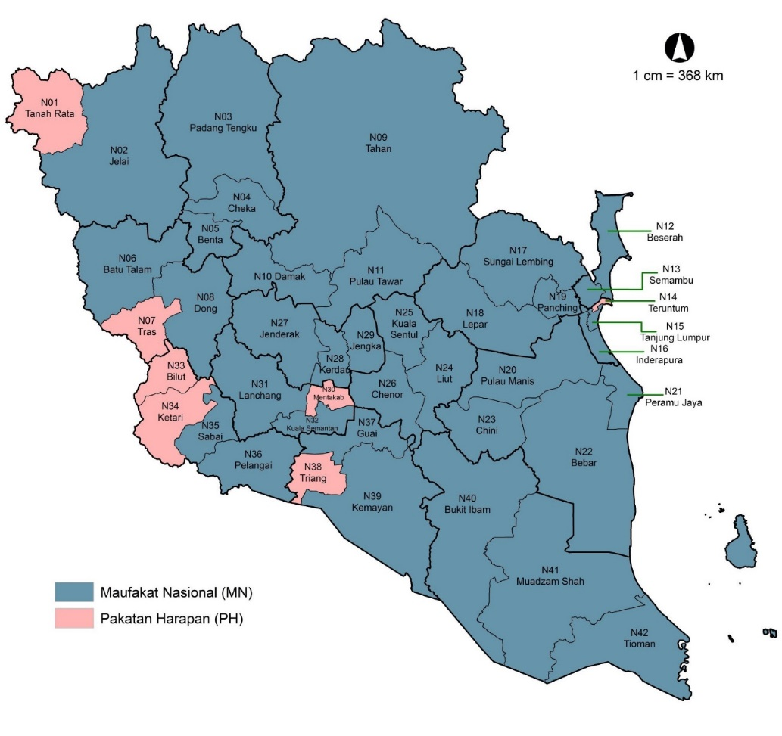

Figure 3. A Map of Simulation GE results for two-cornered contests (MN vs PH)

Previous elections have shown that BN faced a negative swing in terms of their votes and seats in Pahang which might be affected by their performance at the national level. The outcome of the election is based on people’s evaluations and voting behavior, especially when it comes to the distribution of economic prosperity (Johnston & Pattie 1995). Electorate’s dissatisfaction got two-fold either they abstained or turned their vote (Petrarca et al., 2022). The result can vary across constituencies. Our findings found that ethnicity-based support played a significant role for BN to secure their seats in Pahang yet can no longer be considered as a BN fixed deposit area when the support of the vote and the number of state seats that BN wins dwindle in each GE.
According to Gowricharn (2019), ethnicity is pivotal for ethnic competition, power sharing, and the distribution of public goods across ethnic groups. Their membership determines their loyalty and voting behavior. However, votes can be shifted to the opponent parties that promote alternatives in the electoral market which made the electorate experience and witness the fulfillment of public interest transcended entrenched ethnic boundaries (Hasbullah & Korf, 2009).
This was seen as a wake-up call for BN in Pahang to develop new strategies to regain support from the electorate. BN will be unable to ceaselessly depend on ethnic factors to win over the lost seats. Based on the 14th GE results, Pahang showed a higher preference for PAS compared to PH (Hazis, 2020). Therefore, BN must continue and strengthen the alliance with PAS as a coalition party called MN. Surprisingly, the coalition of MN remains ongoing despite the disputes regarding the division of seats in several other states. It is comprehensible for a coalition to have internal issues but then deliberate the issues to reach the organization’s desired outcomes. MN as a ruling party in Pahang should consider and ascertain parties that receive the most vote attention to avoid the occurrence of vulnerability (Bernardi, 2020). By doing so, BN Pahang has the potential to win over the office. This political cooperation is not only for the political benefit of UMNO and PAS alone but far more importantly for the sake of political stability, Malay unity, and the sanctity of Islam in the state and Malaysia.
Last but not least, as a favourable coalition, both parties gain the benefit of forgoing a few crucial portfolios in the government. According to Greene et al. 2021, a coalition that manages to secure the most salient portfolio gives them enough space to control the most salient issues. This will define their success in the upcoming election because the foundation of voters’ support is the ability of a party to raise issues concerning the electorates. The coalition does benefit the major party such as BN Pahang, however, the expansion of the party might be affected. This is because of the junior party participants as they might struggle to pass the electoral thresholds (Klüver & Spoon, 2020).

Conclusion

By leveraging the demographic indication of ethnicity inside the constituency, one can cultivate trust among the people. This superiority in party politics will provide an opportunity to win and seize power. This is amply demonstrated by the results, and history which show that BN must stand with PAS, which is widely supported by Pahang's largest ethnic group, to be in power. On the other hand, the voter has access to a greater variety of political information because of the development of communication technologies. This will affect the election's outcome and offer fresh insights into the electoral market. Parties should therefore devise alternative plans of action to maintain their positions, particularly concerning coalition formation. Researchers should expand the scope of their work in various geographic contexts to enhance the condition of the discipline as it stands today. Also, a thorough poll must be conducted to obtain a more comprehensive perspective from the inhabitants. This will help to promote and achieve the goal of nurturing democracy and national stability.

References

Aha, K. (2021). Resilient incumbents: Ethnic minority political parties and voter accountability. Party Politics, 27(4), pp.680-691. https://doi.org/10.1177/1354068819881125
Bäck, H. (2008). Intra-party politics and coalition formation: Evidence from Swedish local government. Party Politics, 14(1), 71-89. https://doi.org/10.1177/135406880708 1818
Bakaki, Z., Böhmelt, T., & Ward, H. (2020). The triangular relationship between public concern for environmental issues, policy output, and media attention. Environmental Politics, 29(7), 1157-1177.
Bali, V. A., & Silver, B. D. (2006) Politics, race, and American state electoral reforms after election 2000. State Politics & Policy Quarterly, 6(1), 21-48. https://doi.org/10.1177/153244000600600102
Barreto, M. A., Sanchez, G. R., & Walker, H. L. (2022). Battling the Hydra: the disparate impact of voter ID requirements in North Dakota. Journal of Race, Ethnicity, and Politics, 7(1), 119-140. https://doi.org/10.1017/rep.2022.1
Bernardi, L. (2020). From popularity to vulnerability: An application to dynamic representation in coalition governments. Party Politics, 26(4), 459-470. https://doi.org/10.1177/135406881879 0117
Branton, R. P. (2004). Voting in initiative elections: Does the context of racial and ethnic diversity matter?. State Politics & Policy Quarterly, 4(3), 294-317. https://doi.org/10.1177/153244000400400303
Bruhn, K. (2021). When Opposites Attract: Electoral Coalitions and Alliance Politics in Mexico. Mexican Studies/Estudios Mexicanos, 37(3), 451-475. https://doi.org/10.1525/msem.2021.37.3.451
Chambers, P. (2008) Factions, parties and the durability of parliaments, coalitions and cabinets: The case of Thailand (1979-2001). Party Politics, 14(3), 299-323. https://doi.org/10.1177/1354068807088124
Chandra, K., & Wilkinson, S. (2008). Measuring the effect of “ethnicity”. Comparative Political Studies, 41(4-5), 515-563. https://doi.org/10.1177/0010414007313240
Department of Statistics Malaysia. (2020). Newsletter – Pahang. Putrajaya: Department of Statistics Malaysia.
Department of Survey and Mapping Malaysia. (2017). Area for States and Federal Territories in Malaysia. http://www.data.gov.my/data/ms_ MY/dataset/keluasan-malaysia
Druckman, J. N. (1996). Party factionalism and cabinet durability. Party Politics, 2(3), 397-407. https://doi.org/10.1177/1354068896002003006
Eelbode, F., Wauters, B., Celis, K., & Devos, C., (2013). Left, right, left. The influence of party ideology on the political representation of ethnic minorities in Belgium. Politics, Groups, and Identities, 13, 451-467. https://doi.org/10.1080/21565503.2013.816244
Election Commission of Malaysia. (2018). https://mysprsemak.spr.gov.my/semakan/ keputusan/pru/
FELDA. (2021). Plan location. Federal Land Development Board. https://felda.gov.my/peneroka/lokasi-rancangan/Pahang.
Fennema, M., & Tillie, J. (2001). Civic community, political participation and political trust of ethnic groups. In Multikulturelle demokratien im Vergleich (pp. 198-217). https://doi.org/10.1007/978-3-322-85129-1_9
García Bedolla, L., & Haynie, K. L. (2013). The Obama coalition and the future of American politics. Politics, Groups, and Identities, 1(1), 128-133. https://doi.org/10.1080/ 21565503.2012.758593
GE-15: No Clash BN-PAS Pahang State Assembly Seat. April 28, 2021. Berita Harian.
Ghazali, A. S., Othman, M. R., Rahman, Z. A., & Fauzi, R. (2011). Malaysian ethnic politics: A post-12th General Election analysis of non-Malay support for UMNO and PAS. Geografia-Malaysian Journal of Society and Space, 7(2), 518-27.
Golder, S. N. (2005). Pre-electoral coalitions in comparative perspective: A test of existing hypotheses. Electoral studies, 24(4), 643-663. https://doi.org/10.1016/j.electstud. 2005.01.007
Gowricharn, R. (2019). The decline of ethnic voting patterns in plural societies: Evidence from Suriname. Politics, 39(4), 395-410. https://doi.org/10.1177/0263395718782388
Greene, Z., Henceroth, N., & Jensen, C. B. (2021). The cost of coalition compromise: The electoral effects of holding salient portfolios. Party Politics, 27(4), 827-838. https://doi.org/10.1177/1354068820904429
Haokip, T. (2020). Voting behaviour in deeply divided societies: partisanship and ethnic voting in the hills of Manipur. Asian Ethnicity, 23(3), 427-441. https://doi.org/10.1080/14631369.2020.1799750
Harteveld, E., Meer, T. V. D., & Vries, C. E. D. (2013). In Europe we trust? Exploring three logics of trust in the European Union. European Union Politics, 14(4), 542-565. https://doi.org/10.1177/1465116513491018
Hasbullah, S., & Korf, B. (2009). Muslim geographies and the politics of purification in Sri Lanka after the 2004 tsunami. Singapore Journal of Tropical Geography, 30(2), 248-264. https://doi.org/10.1111/j.1467-9493.2009.00370.x
Hazis, F. S. (2020). Elite fragmentation and party splits: Explaining the breakdown of UMNO in Malaysia’s 14th General Election. In F. S. Hazis & M. L. Weiss (Eds.), Towards a New Malaysia?: The 2018 Election and Its Aftermath (pp. 41–60). NUS Press.
Johnston, R. J., & Pattie, C. J. (1995). People, place and the economic theory of voting: the 1992 British General Election. Politics, 15(1), 9-17. https://doi.org/10.1111/j.1467-9256.1995.tb00015.x
Kasperson, R. E., Golding, D., & Tuler, S. (1992). Social distrust as a factor in siting hazardous facilities and communicating risks. Journal of Social Issues, 48(4), 161-187. https://doi.org/10.1111/j.1540-4560.1992.tb01950.x
Kemp, S. (2020). Digital 2020: 3.8 billion people use social media. https://wearesocial.com/blog/2020/01/digital-2020-3-8-billion-people-use-social-media#:~:text=Worldwide%2C%20there%20are%203.80%20billion,%)%20over%20the%20past%20year
Kirby, M. (2022) Modelling the fall and rise in the importance of the environment to the British public: 2006–2019. The British Journal of Politics and International Relations, 25(2), 199-218. https://doi.org/10.1177/13691481221080651
Klüver, H., & Spoon, J. J. (2020). Helping or hurting? How governing as a junior coalition partner influences electoral outcomes. The Journal of Politics, 82(4), 1231-1242.
Knutson, K. (2018). From identity to issue: Policy agenda and framing shifts within long-term coalitions. Politics, Groups, and Identities, 6(2), 281-302. https://doi.org/10.1080/21565503.2016.1208106
König, P. D., & Wenzelburger, G. (2014). Toward a theory of political strategy in policy analysis. Politics & Policy, 42(3), 400-430. https://doi.org/10.1111/polp.12076
Luebke, P. (1980) The Social and Political Bases of a Black Candidate's Coalition: Race, Class, and Ideology in the 1976 North Carolina Primary Election. Politics & Society, 9(2), 239-261. https://doi.org/10.1177/003232928000900204
Mahadi, A, Jali, M. F. M., & Besar, J. A. (2016). Voter behavior and Barisan Nasional success factors: A case study of FELDA Kuala Krau. Geografia-Malaysian Journal of Society and Space, 12(9), 126-137.
Malaysia Election Commission. (2004). General Election results.
Malaysia Election Commission. (2008). General Election results.
Malaysia Election Commission. (2014). General Election results.
Malaysian Election Commission. (2020a). The overall statistics for the 14th GE Parliament.
Malaysian Election Commission. (2020b). GE 14: State Legislative Assembly Decision. Malaysian
McGee, T. G. (1962). The Malayan elections of 1959: A study in electoral geography. Depts. of Geography, University of Singapore and University of Malaya, 1962.
Ng, J. W. J., Rangel, G. J., & Phung, Y. C. (2021). Malaysia’s 14th General Election: dissecting the ‘Malaysian tsunami’—measuring the impacts of ethnicity and urban development on electoral outcomes. Asian Journal of Political Science, 29(1), 42-66.
No political storm between MN in Pahang. (2021, Mac 22). Utusan Malaysia. Available at: https://www.utusan.com.my/berita/2021/03/tiada-badai-politik-antara-mn-di-pahang/
Noor, M. N. M. (2009). The 14th General Election in Pahang: Maintaining status quo through three-cornered fights. Geografia-Malaysian Journal of Society and Space, 15(4), 122-136. https://doi.org/10.17576/geo-2019-1504-09
Petrarca, C. S., Giebler, H., & Weßels, B. (2022). Support for insider parties: The role of political trust in a longitudinal-comparative perspective. Party Politics, 28(2), 329-341. https://doi.org/10.1177/1354068820976920
Six BN assemblymen participate in Sabah's Government Form Heritage. (2018, Mei 12). Utusan Borneo. https://www.utusanborneo.com.my/2018/05/12/enam-adun-bn-sertai-warisan-bentuk-kerajaan-sabah
Stroschein, S. (2011). Demography in ethnic party fragmentation: Hungarian local voting in Romania. Party Politics, 17(2), 189-204. https://doi.org/10.1177/1354068810391161
Van der Meer, T. (2010). In what we trust? A multi-level study into trust in parliament as an evaluation of state characteristics. International review of administrative sciences, 76(3), 517-536. https://doi.org/10.1177/0020852310372450
Van der Meer, T., & Hakhverdian, A. (2017). Political trust as the evaluation of process and performance: A cross-national study of 42 European countries. Political Studies, 65(1), 81-102. https://doi.org/10.1177/0032321715607514
Winders, B. (2005). Maintaining the coalition: Class coalitions and policy trajectories. Politics & Society, 33(3), 387-423. https://doi.org/10.1177/0032329205278461
Yaakub, M. T., Azzis, M. S. A., Nizah, M. A. M., Bakar, A. R. A., & Ibrahim, M. A. (2016). The Dynamics of Malay-Islamic Political Integration: An Analysis of the Umno-Pas Relationship 2010-2015. Paper presented at the Proceedings of the National Image Strengthening Conference 4 (COSNA 4), Universiti Pendidikan Sultan Idris.
Yusoff, M. A, & Halim, S. M. A .A. (2019). FELDA voter behavior in GE-14: Party identification, sociological or rational choice. Akademika, 89(3), 167-182. https://doi.org/10.17576/akad-2019-8903-14

