A geospatial analysis of solar energy potentials: A case study of Kaduna state, Nigeria

Shu’aibu Dabo¹, Narimah Samat¹, Usman Adamu Kibon²

¹Geoinformatic Unit, School of Humaninities, Universiti Sains Malaysia
²Ahmadu Bello University, Zaria, Kaduna State, Nigeria

Correspondence: Shu’aibu Dabo (email: shuaibudabo10@gmail.com)

Received: 7 November 2023; Accepted: 8 July 2024; Published: 29 August 2024

Abstract

Access to clean, sustainable and environmentally friendly energy is a precondition for attaining sustainable development and ensuring climate change mitigation. Renewable energy potentials in Nigeria provides sustained alternative energy sources. In this study, current perspectives of solar energy potentials as a renewable energy option in Nigeria were examined and discussed within the context of Kaduna state. Geospatial techniques were applied to map the solar energy potential sites of the study area using the spatial analysis tools in ArcGIS Pro software 3.0. Results from the study revealed a strong correlation between the ground and satellite measured solar monthly mean daily values of global solar radiation, indicating that Kaduna state has significant potential for harnessing solar energy. The analysis revealed that the maximum insolation values in Kaduna State were recorded between the Months of February, March and January, indicating that the optimum times for harnessing solar energy in the area are the months of February and March. The Pearson correlation coefficient |R| between the observed ground data and the satellite analysis is 0.937, which indicate strong positive correlation the ground and satellite measured solar radiation data, indicating a high evidence of solar energy potentials. This implies that in the absence of one source of radiation data, the other source can reliably serve as alternative. Further analysis revealed that the solar energy potential sites in the state can be classified into areas of high, moderate and low potentials.

Keywords: Climate change environment, potentials, renewable energy, solar energy, sustainable energy

Introduction

Nigeria is endowed with abundance of renewable and non-renewable energy resources, which provide her with immense capacity for socioeconomic development. However, over 80% of the current National energy supply is dependent on fossil fuels and firewood (Akorede et al., 2017). Only about 40% of households in Nigeria are connected to the national electricity grid, majority of which are concentrated in the urban centers. Its per capita electricity consumption has been one of the lowest in Africa (Oladeji, 2014; Akinbami, 2001). The provision of electricity is largely supplemented by private companies or use of individual electricity generators powered with fossil fuel by the few privileged income groups. In addition, over 90% of businesses and companies have private generators leading to high production cost (Omokaro, 2008).
The dependence on these energy sources has adverse negative impacts to global environmental health and sustainability, as they increase greenhouse gas emissions that facilitate global warming and climate change (Sani et al., 2021; Akorede et al., 2017). The threats of climate change on our green planet have become one of the greatest challenges of the twenty-first century (Asumadu-Sarkodie & Owusu, 2016). It has implications for both human and natural systems and could lead to significant changes in resources use, production and economic activity (Raghuvanshi et al., 2007). These grave impacts can still be avoided if efforts are made to transform current energy systems. Renewable energy sources (i.e. solar, wind, hydro, geothermal, biomass) hold the key potential to displace greenhouse gas emissions from fossil fuel-based power generation, thereby mitigating climate change and other negative environmental externalities (Edenhofer et al., 2011).
Solar energy is one of the oldest renewable energy sources in the world and almost all renewable energy sources originate directly or indirectly from the Sun (Ndacheco et al., 2014). Thus, it is seen as a viable solution towards future energy needs, environmental and global challenges (Agbo, 2012). The amount of solar radiation intercepted by the Earth is much higher than annual global energy use. Large-scale availability of solar energy depends on a region’s geographic position, typical weather conditions, and land availability (Johnson, 2004). At present, however, not much effort has been made to harness solar energy potential as a source of renewable energy particularly in developing nations. This is probably mainly due to lack of adequate knowledge of its distribution. Thus, this study aims to utilize a Geographical Information System (GIS) and spatial analysis techniques to map spatial distribution of solar energy potentials in Kaduna State, Nigeria.

Background to the study

Nigeria, having a land mass of about 923,768sq km and located on the equator is within a high sunshine belt where solar radiation is fairly well distributed (Figure 1). The country receives abundant sunshine all year round. The sunshine duration averages 6.5 hours daily with an average flux of 5.55 kWh per square meter per day. This implies that Nigeria receives 4.851x 10 kWh of energy per day from the sun. The solar radiation intensities range from 3.5-7.0 kWh per square meter per day increasing from the South to the North (Ohunakin et al., 2014; Oseni, 2012). This energy source could be available for 26% of the day (9.00am-4.00pm).
Therefore, Nigeria’s location clearly indicates that the potential to generate significant amount of electrical energy from solar energy is very high. Hence, there is an urgent need to optimally harness the renewable energy potentials available in Nigeria. Therefore, this study aimed to scientifically examine the solar energy potential in Kaduna state for sustainable economic development.

Renewable energy sources

Renewable energy sources represent energy resources that occur naturally and repeatedly in an environment and can be harnessed for human benefits. These sources can be replenished or produced immediately through natural processes. Examples of renewable energy systems include solar wind, hydro, geothermal, biomass and biogas (Osueke & Ezugwu, 2011; Raghuvanshi et al., 2007; Akinbami, 2001).
Studies conducted by Oladeji (2014), Oyedepo (2014) and Sambo (2009) confirmed that Nigeria is endowed with abundant renewable energy sources. As shown in Table 1, renewal energy has great potential to solve the established energy problems in the country. Consequently, in promoting the development of renewable energy into the country’s energy supply mix, the government approved the Renewable Energy Master Plan (REMP) prepared by the Energy Commission of Nigeria (ECN) in collaboration with the United Nations Development Programme (UNDP) (ECN, 2005).

Table 1. Renewable energy resources potentials in Nigeria

S/No | Renewable energy resources | Types | Potentials
1 | Hydro energy | Small hydropower | 3,500MW
 |  | Large hydropower | 11,250 MW
2 | Biomass energy | Fuel wood | 11 million hectares of forest and wood land
 |  | Municipal solid waste | 17451000 tons per day
 |  | Animal waste | 211 million assorted animals (285.065 million)
 |  | Energy crops and  Agric Residue | 28.2 (30% of total land)
 |  | Crop reside | 83 million tons/yr
 |  | Saw Dust | 1.8 (million tons)
3 | Solar radiation |  | 3.5-7.0 KW/ m²/day
4 | Wind |  | 2-4 m/s @ 10m height (main land) 285.065 million
Sources: Adapted and modified from Energy Commission of Nigeria, 2003

Solar energy utilization in Africa

Africa is endowed with significant amounts of renewable energy (RE) resources, including solar energy. It receives some of the highest levels of annual radiation globally. Yet, Africa remains the poorest region of the world, in terms of energy access (Quansah, 2016). According to the International Renewable Energy Agency (IRENA, 2021). Africa's solar energy potential puts it ahead of the Americas, Asia, Oceania, Europe and Russia, where Africa owns 60% of the globe's potential for solar power, but only 1.48% of solar generation capacity.
Nigeria being one of the leading developing economies in Africa, where there is an alarming dependence on fossil fuels and firewood (Akorede et al., 2017) and solar energy will remain the most efﬁcient alternative power source than other renewable energy sources because of its availability. The effective harnessing and utilization of its abundant solar radiation, using solar technologies will not only help Nigeria to meet her energy targets, ensure energy sufficiency, but it will also help in stemming the tide of environmental degradation and mitigate climate change (Omojola et al., 2015). At present, however, not much effort has been made to harness solar resources. It is timely to explore the examine the potential of solar energy as one of the main sources of renewal energy.

The concept of geospatial analysis

Geospatial analysis refers to a collection of techniques and tools for geographic analysis and Geographic Information System data processing software engines (Haller, 2010). The modeling of energy resources in GIS method helps to create useful maps with spatial distribution of different energy resources and compare different energy options, including their environmental and economic constraints (Adhikaria & Adhikaria, 2021). Geospatial techniques have the potential for enhancing understanding of spatio-temporal dynamics of energy consumptions, availability and effectiveness of renewable energy resources among others.

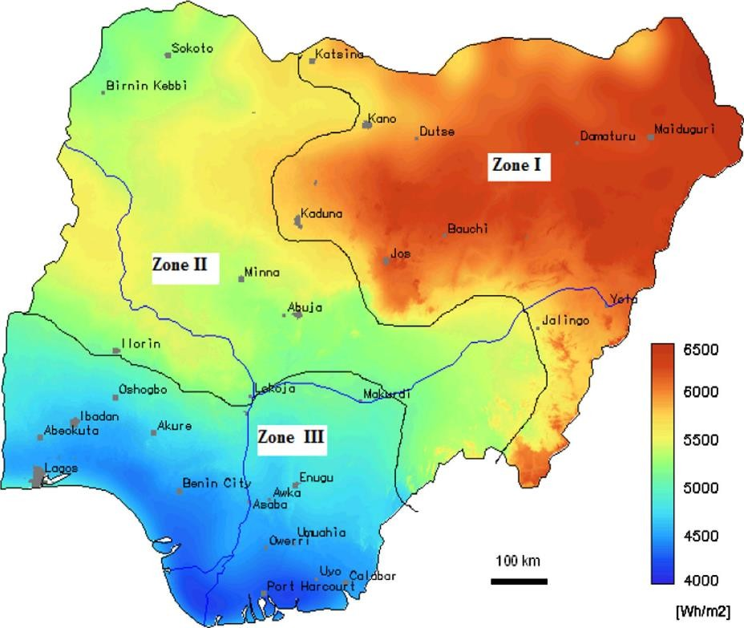
Sources: Adapted from Ohunakin et al., 2014

Figure 1. Solar radiation map of Nigeria

Materials and methods

The study area

Kaduna state is located in north-central Nigeria (Figure 2). It belongs to the Northwest geopolitical regions of the country and located between latitudes 9° 01’ to 11° 34’ north of the Equator and between longitudes 6° 11’ and 8° 49’ east of the Greenwich Meridian. The state has an estimated land area of 42,481 square kilometers (16,594.14 square miles), which makes it the largest in the northwest geopolitical zone and has about 4.7 per cent of the Nigerian land area (NBS, 2009). The study area is delineated into political constituencies of three senatorial districts; each district constitutes of local government areas. There are 23 local government areas in the state with 255 political wards spread across.
Kaduna State is blessed with renewable energy resources, especially solar energy resources, which is attracting investors attention in recent years. Moreover, a 50 MW solar system was launched in 2011 with substantial investment from Snergent Powershare Groups. There also a partnership between Kaduna government and Quaint Global Energy Solutions to finance 50 MW solar power plant in Manchok in the Kaduna State. In 2017, Anjeed Innova Group (AIG) had proposed a plan to embark on Anjeed Kafanchan Solar Project to provide an initial plan of 10 MW which was scaled up to 50 MW in the first phase, and this will be followed by 100 MW in the second phase (Ahmad & Kabuga, 2019). At present, however, the location of those solar energy plants was done without taking into consideration their full potential. Therefore, there is need for a comprehensive and scientific study to identify the potential location of solar energy in Kaduna state, where the proposed approach may give indication on region have highest solar irradiance, including the optimum time for exploitation.

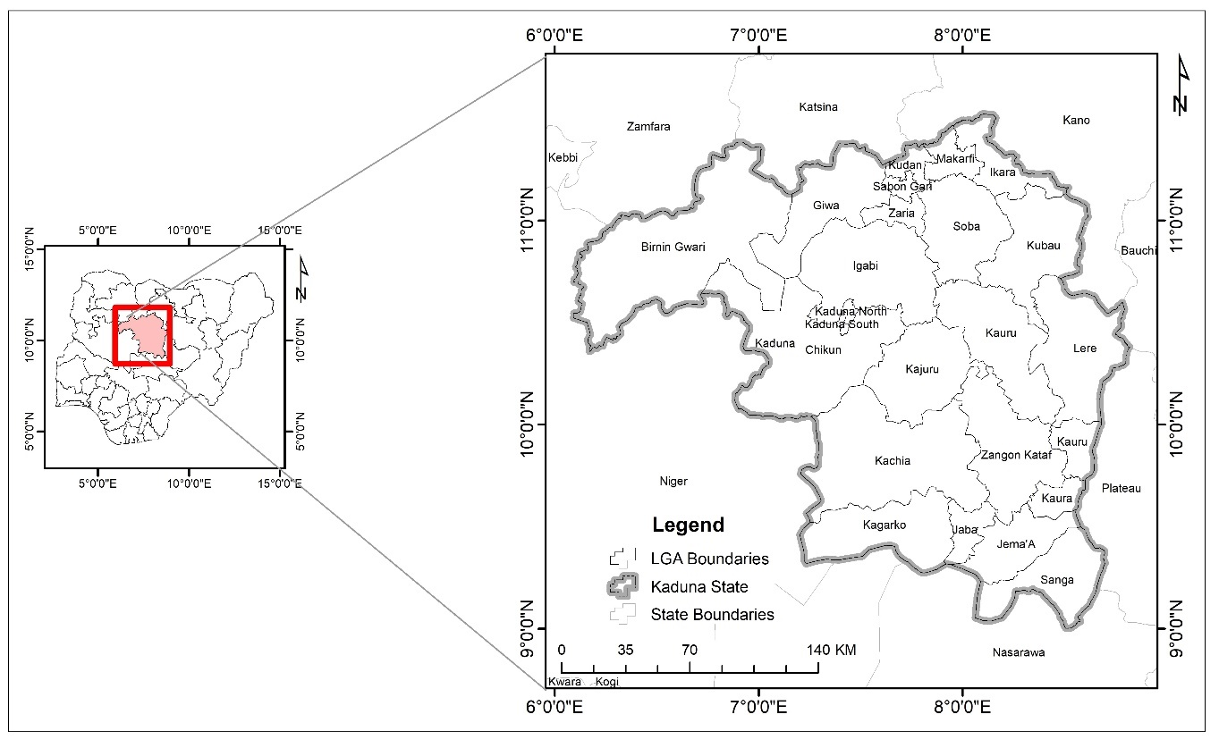
Source: GIS Lab Department of Geography, Ahmadu Bello University, Zaria

Figure 2. Map of Kaduna state

Types and sources of data

The different datasets used for the study includes primary and secondary data which contain both spatial and non-spatial attributes. The data required and their sources are shown in Table 2.

Table 2. Types of data and sources

S/No | Types of data | Source
1 | Administrative map of Nigeria | GRID-3 Nigeria
2 | Reanalysis solar radiation data | Copernicus Climate Data Store
3 | Observed ground measured solar radiation data | Nigerian Metrological Agency (NiMet)
4 | Digital Elevation Model (DEM) | Advanced Land Observation Satellite-1 Phased Array Type L-band Synthetic Aperture Radar ALOS PALSAR) data sets with 12.5m resolution DEM was downloaded from https://vertex.daac.asf.alaska.edu

Methods of data analysis

The data were retrieved from satellites and ground measured solar radiation which were analyzed using geospatial techniques which is shown in Figure 3. This was achieved using the spatial analysis tools in ArcGIS software. Specifically, in order to identify the solar energy potential sites, the map of the study area was used to delineate the Digital Elevation Model (DEM) of the area from Shuttle Radar Topographic Mapper (SRTM) data in ArcGIS environment. Then the maps were georeferenced based on the WGS 1984 Geographic coordinate system. The collected satellites and ground measured solar radiation data when through data cleaning before spatial interpolation. Then, the slope and aspect maps of the area were generated from the DEM, which is followed by reclassification and multicriteria evaluation. Then, the solar radiation map, the DEM, the slope and aspect maps were ranked based on the Analytic Hierarchy Process (AHP). Finally, the solar radiation map, the DEM, the slope and aspect maps were integrated using weighted overlay to produce the map of solar energy potential sites in the study area.

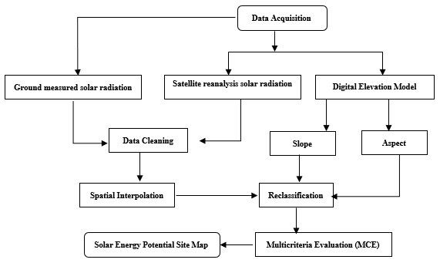

Figure 3. Methods of data analysis

Results and discussion

Ground-measured and satellite monthly mean daily values

The pattern of ground-measured and satellite measured monthly mean daily values of global solar radiation in Kaduna state in Table 3 revealed that based on ground measurement maximum monthly mean solar radiation values were recorded between February, March and April in Kaduna state. This can be attributed to the fact that the months of January, February, and March fall within the period of longer days and shorter nights experienced in the southern hemisphere. A longer day implies longer sunshine hours per day. Correspondingly, the solar radiation measurement results also indicate the insolation values remains high during the month of February March and January in Kaduna state. This can be an element of the increasing sunshine hours observed from the winter solstice in the northern hemisphere. The finding revealed that Kaduna state has significant potential for harnessing solar energy.

Table 3. Ground-measured and satellite monthly mean daily values of Global Solar Radiation (kWh/m2/day) in Kaduna State for 1990-2020

Month | Jan | Feb | Mar | Apr | May | Jun | Jul | Aug | Sep | Oct | Nov | Dec
Ground | 6.72 | 6.95 | 6.78 | 6.13 | 5.32 | 4.83 | 4.57 | 4.68 | 5.40 | 5.92 | 6.03 | 6.02
Satellite | 5.96 | 6.16 | 6.08 | 5.74 | 5.36 | 4.94 | 4.51 | 4.31 | 4.78 | 5.31 | 5.78 | 5.88
Source: NiMet and NASA Power LARC, 2020

Evaluation of ground measured and satellite solar radiation data

- Pearson correlation

Table 4 revealed that the Pearson correlation coefficient |R| between the observed ground data and the satellite reanalysis is 0.937, which indicates strong positive correlation.

Table 4. Results of the Pearson correlation

Correlation matrix (Pearson):
Variables | Ground | Satellite
Ground | 1 | 0.937
Satellite | 0.937 | 1
Values in bold are different from 0 with a significance level alpha=0.05

Evaluation of ground measured and satellite solar radiation data

The graphic presentation of the ground and satellite measured monthly mean daily global solar radiation data in Kaduna state indicates that in comparison of the two values the maximum ground measured solar radiation values was found to be 6.95 kWh/m²/day, while the recorded satellite value was 6.16 kWh/m²/day. Thus, the difference between the ground and satellite measured solar radiation values is very minimal (0.79kWh/m2/day). Similarly, the minimum ground measured solar radiation values was found to be 4.57 kWh/m²/day, compared to the recorded satellite value was 4.31kWh/m² / day. The minimum difference between the ground and satellite measured solar radiation values is 0.26 kWh/m²/day. This finding indicates a strong correlation between the ground and satellite measured solar radiation data, indicating a high evidence of solar energy potentials.

Figure 4. Monthly Mean Daily Values of Global Solar Radiation in Kaduna State (KWhm-² d-1)

The level of correlation between the two sources of radiation is further tested using the scatter plots in Figure 5, the result indicates a strong positive relationship between the two sources of data. This implies that in the absence of one source of radiation data, the other source can reliably serve as an alternative.

Figure 5. Scatter plots showing the level of correlation between the two sources of radiation
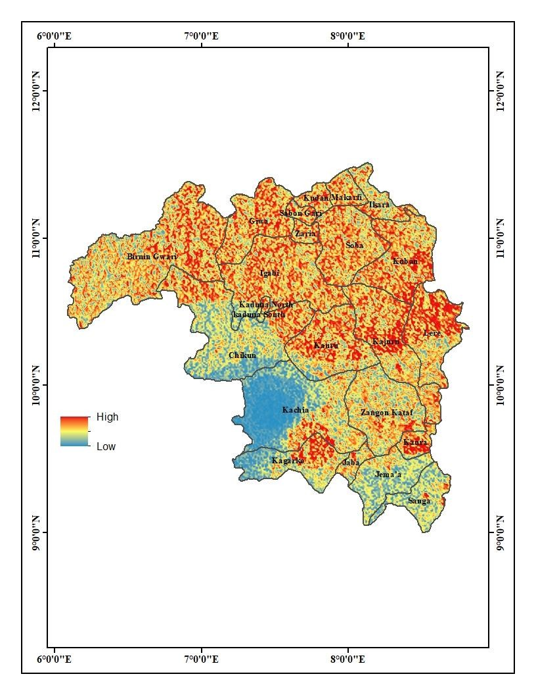
Figure 6. Solar energy potential sites in Kaduna state

Analysis of solar energy potential sites in Kaduna state

Kaduna State solar energy potentials can be classified into three broad areas as indicated in Figure 6. These are areas with high potential, areas with moderate potential and areas with low potential. From Figure 6, the areas of high solar energy potentials incudes Kajuru, Lere, Kudan Zaria, Giwa, Sabon gari, Igabi, Soba, Kaduna north, Makarfi, Birnin gwari and Kaura local government areas of Kaduna state. These areas are the most suitable for harvesting solar energy in the state. The areas with moderate energy potential are: Zangon-Kataf, Chikun, Kaduna south, Ikara, Jama’a, Sanga, Kagarko and chikun local government areas. While the areas with low energy potential are: Kachia, Jaba, Sanga and Jema’a. Generally, the results are an indication that Kaduna state have good potential sites for harnessing solar energy.

Discussion

Solar energy is the cleanest and most abundant renewable energy available in Kaduna State, and in Nigeria at large, which is a tropical nation. The geographic location of Kaduna State means that the area received adequate solar radiation that is suitable for the generation of renewable energy using photovoltaic cells. From the analysis, it was shown that the amount of solar radiation received is influenced by seasons, for example during the rainy season when there is abundant cloud cover, between May and September (Figure 4). This is similar to the findings of Ogunjo et al. (2021), where they found that the monthly mean output power from the solar power systems is affected by seasonal changes for the four locations under study in Nigeria. Additionally, a study by Ndaceko et al. (2014) that with 46,053 km² of land area, Kaduna is among the states with higher solar energy potential since solar energy potential is proportional to the land area.

Conclusion

The study brought to light the potential and opportunities associated with renewable energy sources, particularly climate change mitigation and reduction of environmental and health impacts. Based on the result findings the satellite data and ground measured monthly mean daily values of global solar radiation recorded in Kaduna state showed enormous potential for harnessing solar energy, which can be classified into areas of high, medium and low potentials. The maximum insolation values in Kaduna State were recorded between February, March and January. Therefore, the optimum times for harnessing solar energy in the area are the months of February and March. From the findings, the following recommendations were made that can help promote utilization of solar energy as alternative power sources.

Acknowledgments

Authors wish to sincerely appreciates the tertiary education trust fund, (Tetfund) Nigeria, for providing the required financial support for this publication through the Federal College of Education, Kontagora. In addition, we also extend our appreciations to the Nigerian Metrological Agency (NiMet) and National Aeronautics and Space Administration Surface Meteorology and Solar Energy (NASA SSE) for their support in provisions of all the necessary required materials for the research.

References

Abdelrazik, M. K., Abdelaziz, S. E., & Hassan, M. F. (2022). Climate action: Prospects of solar energy in Africa. Energy Reports, 8, 11363–11377.
Adhikaria, N., & Adhikaria, R. (2021). Analysis of biogas production potential based on livestock dung availability: A case of household biogas plants in Nepal. Biofuels, 13(6), 735-743.
Agbo, E. P., Edet, C. O., Magu, T. O., Njok, A. O., & Ekpo, C. M. (2021). Solar energy: A panacea for the electricity generation crisis in Nigeria. Heliyon, 7(5), e07016.
Ajaelu, H., & Okereke, R. (2020). Assessment of Nigerian renewable energy potentials: Challenges and prospects. PM World Journal, IX(VI), 1-19.
Ajayi, O. O., & Kolawole, A. (2009). Nigeria's energy challenge and power development: The way forward. Journal of Energy & Environment, 20(3), 411-413.
Akinboro F. G., Adejomobi, L. A., & Makindi, V. (2013). Solar energy installation in Nigeria: Observations, prospect, problems and solution. Transnational journal of science and technology, 2(4), 73-84.
Akorede M. F., Ibrahim O., Amuda S. A., Otuoze, A. O., & Olufeagba, B. J. (2017). Current status and outlook of renewable energy development in Nigeria. Nigerian Journal of Technology, 36(1), 196-212.
Ayodele, A. S. (2001). Improving and Sustaining Power (electricity) Supply for Socio- economic Development in Nigeria. http://www.cenbank.org/.
Bamisile, O., Dagbasi M., Babatunde, A., & Ayodele, O. (2017). A review of renewable energy potential in Nigeria; Solar power development over the years. Engineering and Applied Science Research (EASR), 44(4), 242-248.
Energy Commission of Nigeria. (2016). http://www.energy.gov.ng.
Energy Commission of Nigeria and United Nations Development Programme (UNDP). (2003). Renewable Energy Master Plan: Final draft report. http://www.iceednigeria.org.
Internal Energy Agency. (2013). World Energy Outlook 2012. http://www.worldenergyoutlook.org/media/weowebsite/2012/factsheets.pdf
International Renewable Energy Agency (IRENA). (2021). Renewable capacity statistics 2021.
Johanson, T. B., McCormick, K., Neij, L., & Turkenburg, W. (2004). The potentials of renewable energy. Proceedings for the International Conference for Renewable Energies, 1-4 June, Bonn, Germany.
Kabuga, N. A., & Ahmad, A. Y. (2018). Assessing the public perceptions and acceptance of renewable energy technologies in Kaduna metropolis, Nigeria. Nigerian journal of renewable energy, 8(1&2), 67-78.
Mshelia, H. I. (2012). Energy access for all: The role of clean energy in alleviating energy. www.scirp.org.
Mshelia, R. B. (2012). Assessment of renewable energy potentials of the northeast geopolitical region of Nigeria. Renewable energy sources energy policy and energy management, 2(2), 24-38.
Muhammad, U. (2012). Rural solar electrification in Nigeria: Renewable energy potentials and distribution for development. The World Renewable Energy Forum, Colorado, USA.
National Population Commission. (2006). Population census figures of Federal Republic of Nigeria, Abuja.
Ndaceko, U. I., Mukhtar, A., Muhammed, M. A., Bashir, T. S., & Suleiman, F. A. (2014). Solar energy potential in Nigeria. International Journal of Scientific & Engineering Research, 5(10), 594–598.
Ogunjo, S. T., Obafaye, A. A., & Rabiu, A. B. (2021). Solar energy potentials in different climatic zones of Nigeria. IOP Conference Series: Materials Science and Engineering, 1032(1), 012040.
Ohunakin, O. S., Muyiwa, S., Adaramola, M., Oyewola, R., & Fagbenle, O. (2014). Solar energy applications and development in Nigeria: Drivers and barriers. Renewable and Sustainable Energy Reviews, 32, 294–301.
Oladeji, J. T. (2014). Renewable energy as a sure solution to Nigeria’s perennial energy problems: An overview. Researcher,6(4), 45-50.
Olaniyi, O. A., Ojekunie, Z. O., & Amujo, B. T. (2014). Review of climate change and its effect on Nigeria ecosystem. International Journal of African and Asian Studies, 1, 57-65.
Omokaro, O. (2008). Energy development in a fossil fuel economy: The Nigeria experience. The report of a National Dialogue to Promote Renewable Energy and Energy Efficiency in Nigeria (pp. 55).
Omojola, A., Olusola, O. I., & Adekunle, K. C. (2015). A survey of solar energy utilization for sustainable development in Nigeria. Journal of Multidisciplinary Engineering Science and Technology (JMEST), 2(7), 1716-1724.
Owusu P. A., & Asumadu-Sarkodie, S. (2016). A review of renewable energy sources, sustainability issues and climate change mitigation. Cogent Engineering, 3(1), 1167990.
Oyedepo, S. O. (2014). Towards achieving energy for sustainable development in Nigeria. Renewable and Sustainable Energy Reviews, 34, 255-272.
Ozoegwu, C. G. Mgbemene, C. A., & Ozor, P. A. (2017). The status of solar energy integration and policy in Nigeria. Renewable and Sustainable Energy Reviews, 70, 457-471.
Quansaha, D. A., Muyiwa, B. C., Adaramolab S., & Mensa, L. D. (2016). Solar photovoltaics in sub-Saharan Africa – Addressing barriers, unlocking potential. Energy Procedia, 106, 97–110.
Raghuvanshi, S. P., Raghav A. K., & Chandra, A. (2007). Renewable energy resources for climate change mitigation. Indian Institute of Technology Delhi, Hauz Khas, New Delhi, India.
Sambo, A. S. (2005). Renewable energy for rural development: The Nigerian perspective. ISESCO Science and Technology Vision, 1, 12-22.
Sani, H., Aliyu, B. A., & Nuhu, S. R. (2021). Assessing renewable energy practice in Turaki Ali House Kaduna Nigeria. Real estate management and valuation, 29(4), 85-96.

