Exploring determinants of shared bicycle usage in Ningbo: An integration of behavioral theories

Nazatul Faizah Haron¹, Yin Shuang², Siti Rahyla Rahmat², Nadhrah A Kadir², Shankar Karuppayah³

¹Universiti Sultan Zainal Abidin
²School of Social Sciences, Universiti Sains Malaysia
³National Advanced IPv6 Centre (NAV6)

Correspondence: Siti Rahyla Rahmat (email: rahyla@usm.my)

Received: 27 November 2023; Accepted: 26 October 2024; Published: 29 November 2024

Abstract

Most consumers favor shared bicycles for their advantages of convenient use, time-saving, cheap price, and green environmental protection, but most issues exposed in the rapid rise of shared bicycles have gradually reduced the willingness of users to continue using them. The objectives of this study are 1) To identify the willingness of respondents to use shared bikes and 2)To discover corresponding solutions to overcome the obstacles to the healthy development of shared bicycles. This research discovered that the development status of shared bicycles in Ningbo is not optimistic, with prominent problems such as disorderly parking of shared bicycles, chaotic deposit management of shared bicycles, and an imperfect supervision system of shared bicycles. Therefore, based on reasoned action theory, technology acceptance model theory, social influence theory, and innovation diffusion theory, eight factors are proposed to affect the willingness to use shared bicycles. Data on consumers' shared bike riding experience and factors affecting consumers' willingness to use shared bikes were collected through questionnaires. Consequently, the relationship between these factors and consumers' willingness to use shared bicycles is explored through binary logistic regression analysis. From the perspective of consumers, summarizing the development status quo and existing problems of shared bicycles in Ningbo City, as well as providing corresponding solutions, is inevitable. The research suggests that user-friendliness, satisfaction, usefulness, social influence, individual innovativeness, corporate image, and time efficiency positively affect consumers' willingness to use shared bicycles. In contrast, cost efficiency does not significantly impact consumers' willingness to use shared bicycles.

Keywords: Consumer's perspective, consumers' willingness, development status, shared bicycles, social influence, solutions

Introduction

Since the emergence of shared bicycles, the industry scale and number of shared bicycle users have demonstrated explosive growth and achieved great success. According to the China Information and Communication Research Institute's "China Shared Bicycle Industry Development Report (2018)," after the emergence of shared bicycles, the proportion of bicycle travel has doubled. This reaches 11.6%, becoming the three major urban transportation modes parallel to subways and buses (Shen & Bu, 2019).
By the end of 2021, shared bicycles will be used in more than 380 cities in China, with a total of 19.45 million bikes and an average daily usage of about 45.7 million people (Cheng & Yu, 2022). Shared bicycles, commonly referred to as "shared bicycles" or "bike-sharing," are a popular mode of transportation in China. These bicycles can be rented short-term from numerous locations around a city, often through a smartphone application. Remarkably, the number of shared bicycle users exceeds 250 million, and various new brands continue to join the shared bicycle economy. However, due to a series of problems at the level of government, enterprises, and individuals, the development of the bike-share industry has been stalled (Liu & Niu, 2021). With the large-scale rapid expansion, the number of bike-share has been oversupplied, coupled with the lack of a perfect regulatory system. In the past two years, more and more bike-sharing enterprises have closed down (Xu, 2018).
In 2018, the bike-sharing industry ushered in an unprecedented low tide, with industry leaders Mobike and Ofo falling into crisis one after another (Kong & Sun, 2021). In April 2018, Meituan announced its wholly-owned acquisition of Mobike. Recently, it was reported that Meituan would optimize and reorganize Mobike's personnel. Ofo faced the embarrassment of users queuing up to return their deposits online and offline, and several companies sued it (Guo et al., 2017).
In recent years, although the problems faced by shared bicycles have been partially solved, the situation is still not optimistic. The appearance of shared bicycles being damaged or even stolen still exists, and the phenomenon of shared bicycles being parked randomly on the streets is still everywhere. Therefore, it is crucial to study and discuss the status quo of the development of shared bicycles and existing problems and discover corresponding solutions to overcome the obstacles to the healthy development of shared bicycles.

Literature review

The development of shared bikes in China

Nowadays, shared bicycles have been fully integrated into people's daily life. According to the analysis of bike-sharing industry reports in recent years, the number of shared bikes and the scale of users are growing rapidly (Wang & Du, 2023). In 2016, the number of users in China was only 28 million. In 2017, there were 77 shared bike enterprises in China, with a total of 23 million shared bikes put into the market. By the end of 2017, the number of domestic shared bike users reached 221 million, with a half-year growth rate of 108%, and the market scale of shared bike reached 6.43 (converted into Billion Malaysian Ringgit), with a growth rate of 736% (Lv & Gu, 2021).
Due to changing in lifestyle, trend and profit-seeking capital and benefiting from the support of the Internet and modern technology, shared bicycles have been developed rapidly, and the connection between shared bicycle companies and the internet has become increasingly close (Xu, 2018). Because of its economic benefits, green environmental protection, easy to use, by the majority of users but also received strong support from the government (Wang, 2017).
Asnawi et al. (2024) found that urbanization caused a significant decrease in plant cover, increased developed land, and decreased aquatic bodies, with an inverse relationship between Land Surface Temperature (LST) and Normal Variability Index (NDVI). Zainol (2016) examined the Central Area Transit bus service in Georgetown, Penang, Malaysia. The study focused on evaluating Georgetown's tourist transportation service via a complimentary bus service. Results showed that the service benefits both visitors and local residents, but improvements are needed to enhance the user experience. The study by Ling et al. (2016) found that most Mentari Court residents use public transportation for leisure and daily commutes, but issues like accessibility, long travel times, and crime concerns have deterred some from using public transit. Ab Rahman et al. (2021) reveals disparities in bicycle infrastructure in Japan and Malaysia, despite progress made through the Promotion of Bicycle Use Act. However, the study also highlights the ineffectiveness of colored lanes in distinguishing between bicycle and pedestrian lanes.
However, the development of shared bicycles has not been smooth sailing. With the massive investment and use of shared bicycles, a series of problems began to emerge. Notably, shared bikes bring convenience and to some extent bring a nuisance to people's daily lives (Zhang, 2023). Integrating shared bicycles into urban environments has significantly altered daily life, presenting advantages and challenges. On the positive side, shared bicycles enhance urban mobility by providing convenient, cost-effective transportation, especially for short trips. This reduces reliance on motor vehicles and public transport. This shift alleviates traffic congestion and promotes environmental sustainability and public health through increased physical activity. Nevertheless, the dockless nature of many shared bicycle systems has led to disorderly parking and urban clutter, obstructing pedestrian pathways and creating visual pollution. Safety concerns arise from poorly maintained bicycles and the increased interaction between cyclists, pedestrians, and vehicles in areas lacking adequate cycling infrastructure. Additionally, financial issues related to deposit management have eroded user trust. Meanwhile, regulatory challenges highlight the need for more effective governance. Thus, while shared bicycles offer substantial benefits, their integration into daily life necessitates addressing these multifaceted challenges through improved urban planning and regulation.

Issues and solutions of shared bikes

The degree of homogeneity of shared bikes is high. Although there are many brands of shared bikes (Zhang & Wu, 2017), most of them are highly similar, with no apparent differences except in color, name, and logo, which is not conducive to the healthy development of shared bikes (Yang & Zhu, 2020). As a way to cope with this situation, it is believed that shared bike providers should emphasize differentiation, abandon homogeneity, strive for innovation (Wang, 2017), and build the core competitiveness of the brand.
Another problem is the chaotic management of deposits (Liu & Niu, 2021), such as the disorganized handling of user funds by bike-sharing companies. This often results in delayed refunds or unreturned deposits, causing financial uncertainty and discouraging users from continuing with the service. This reduces the number of users and lowers the company's reputation (Guo et al., 2017). Therefore, bike-sharing enterprises should emphasize technological development and innovate deposit management mode. In addition, third-party credit agencies can be introduced (Liu & Niu, 2021).
At present, the shared bicycle business continues to develop. However, the related government and regulatory systems are not yet perfect (Zhang & Wu, 2017), leading to the abnormal development of the shared bicycle industry. Difficulty in refunding OFO deposit. OFO is a shared bike company based in Beijing, China (Liu & Niu, 2021) and the "graveyard" of shared bikes are all problems exposed by poor supervision. The sharing economy has become an "accomplice" to harmful social events. This undoubtedly places higher demands on the regulators (Wang, 2017).
After a large number of shared bicycles flooded into the market, shared bicycles were parked and occupied in public places at will (Guo et al., 2017), affecting people's normal travel (Zhang et al., 2022), damaging the image of the city and unable to provide better convenience for people. The economic benefits brought by the rapid development of shared bikes have also attracted some enterprises to join the ranks of shared bikes (Jiao et al., 2021). Consequently, the entry of too many enterprises has resulted in vicious competition, which undoubtedly aggravates the problems in development.
China's bike-sharing scale achieved tremendous growth in 2017, surging from 0.77 billion ringgit in 2016 to 6.43 billion ringgit, and steadily growing in the following years, with the market scale expanding (Wang, 2017) (Figure 1.0). It is a seven-fold increase from 30 million in 2016. However, the industry leaders Mobike and Ofo had a crisis and Meituan announced its wholly-owned acquisition of Mobike. On the other hand, Ofo faced a downturn when its users queued to ask for the return of their deposits both online and offline (Guo et al, 2017). OFO has also been sued by several companies.

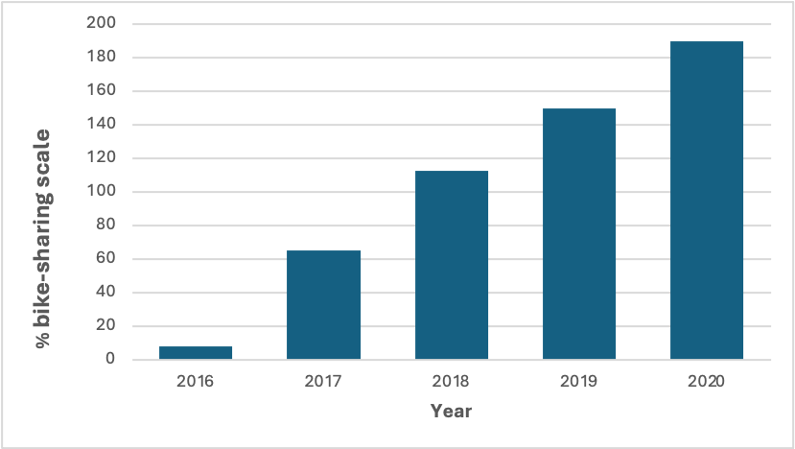

Figure 1. Trend of China's bike-sharing market size

Despite all challenges and issues, it can be depicted that the projection of user penetration in the bike-sharing market in China will be increased approximately 10 % from 2024 to 2029. It shows how the user’s lifestyle and trend in China that preferred shared bikes (Figure 2.0)

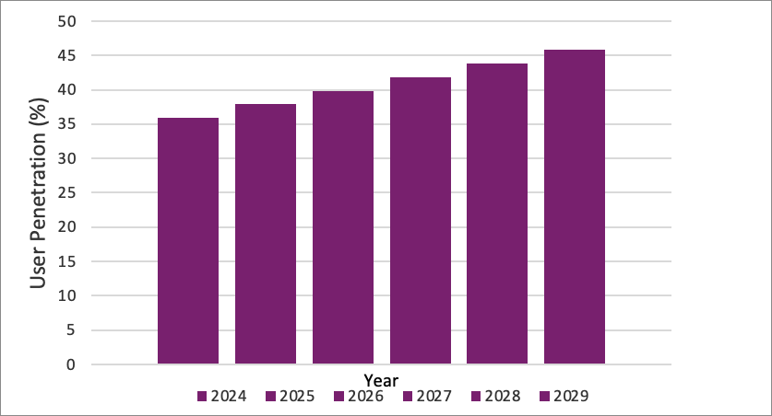

Figure 2. User penetration in bike-sharing market in China (2024-2029)

As more and more enterprises rush into the industry, bike-sharing has started a vicious competition (Jiao et al., 2021). This has led these companies to pour shared bikes into the market without restraint, resulting in oversupply and a large number of shared bikes occupying public space (Zhao & Wang, 2019) and causing traffic jams (Kiziltas & Ayozen, 2022). Faced with this situation, the government should raise the entry threshold of the bike-sharing industry and strengthen supervision (Wang, 2017). Hence, enterprises should improve the level of innovation, develop new technologies and accurately control the number of shared bikes that are put into the market (Wang & Du, 2023).
Due to the absence and backwardness of the bike-sharing supervision system and the imperfection of the relevant legal system (Zhang & Wu, 2017), some law enforcement departments abuse their power or inaction (Tang & Lv, 2021). This greatly damages the legitimate rights and interests of relevant enterprises and consumers. To this end, the government should improve anti-law laws and regulations and establish a complete and sound supervision system for shared bikes to safeguard healthy and sustainable development (Yang, 2022).
Some consumers, lacking moral awareness and the concept of the sharing economy, lock shared bikes privately (Yang, 2022) and even damage or steal shared bikes maliciously (Zhang, 2023). This causes substantial economic losses to bike-sharing enterprises and encourages social injustice. In this situation, the government should strengthen guidance and publicity (Liu & Huang, 2021) and introduce corresponding punishment mechanisms when necessary. Therefore, enterprises should strengthen management, and consumers should strengthen their moral autonomy.
Bike-sharing companies also face the dilemma of a single profit model. Most bike-sharing companies only rely on collecting deposits and usage fees (Zhang, 2023). However, they also face high maintenance and management costs (Zhang & Wu, 2017), putting many companies on the verge of bankruptcy. Hence, to improve the situation, bike-sharing companies should enhance customer stickiness (Li et al., 2020), learn to use online channels for marketing (Liu & Niu, 2021), innovate profit models, and increase additional revenue from shared bikes.
The problem of random parking of shared bicycles is very serious (Guo et al., 2017), often causing traffic jams and even safety accidents. In this regard, government departments should improve the management system of shared bicycles and maintain the order of vehicle parking (Wang & Du, 2023). If necessary, penalties can be imposed on violations, and information on violations of laws and regulations can also be included in personal credit files (Chen & Jing, 2017).

Conceptual framework

This study integrates variables from multiple theoretical frameworks, including the Theory of Reasoned Action (cost and time efficiency) (Yuan et al., 2019), Social Influence Theory (social influence) (Latané, 1981), Technology Acceptance Model (user-friendliness, usefulness, satisfaction) (Huang & Chen, 2017) Innovation Diffusion Theory (individual innovativeness) (Rogers, 1962), and Corporate Social Responsibility (corporate image) (Sheldon, 1923). The goal is to elucidate commuters' experiences with shared bikes and to identify the factors influencing consumers' adoption and usage of shared bike services.

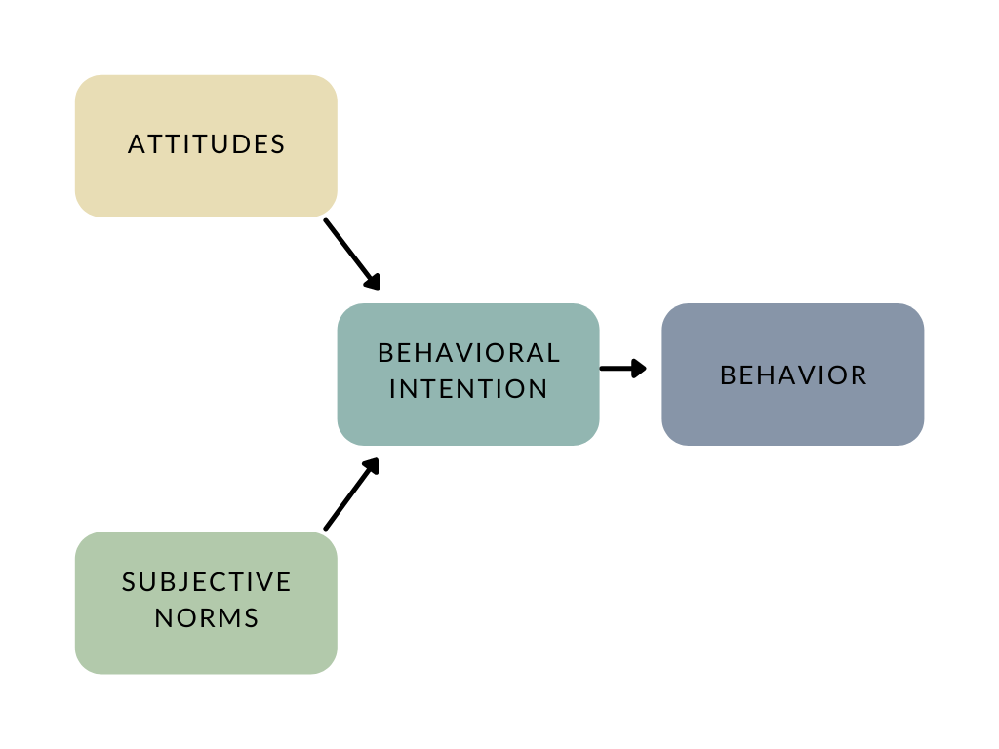
Source: Adapted from Fishbein and Ajzen, 1975

Method and study area

Ningbo has been selected as a study location due to the rapid development of shared bikes in the city and the growing preference among its residents to use shared bicycles for daily travel. However, due to a lack of implementation, and moral and social issues, some shared bicycles have been damaged or stolen. There is also congestion in Ningbo due to disorderly parking of shared bikes. There are also issues related to the deposit management of shared bicycles. It is also found that the high degree of homogeneity of bicycle companies thus lacks innovation. This research is needed to give insightful perceptions of shared bicycle users for sustainable and healthy development.
This study employs a quantitative analysis approach and data was collected through questionnaire surveys. Ningbo shared bike users serve as the primary respondents. The questionnaire targets commuters' experiences with shared bikes and the factors influencing their willingness to use these services. The study utilizes both convenience sampling and snowball sampling techniques. Consequently, the survey was distributed to citizens in Ningbo via the internet using the Questionnaire Star app. The survey link was administered to users who had previously used shared bikes through email, QQ, WeChat, and other social tools, and participants were encouraged to share the link on their social media platforms. Accordingly, a total of 368 responses were collected through this method.
Based on the selection and analysis of the above variables, the logistic regression model is established to investigate the factors affecting consumers' use of shared bikes and study the current situation, problems, and solutions to the development of shared bikes in Ningbo:

$TW = β0+β1CE+β2SI+β3TE+β4UF+β5U+β6II+β7S+β8CI+μi$ (1)

where TW, CE, SI, TE, UF, U, II, S, and CI represent the willingness to use shared bikes, cost efficiency, social influence, time efficiency, user-friendliness, usefulness, individual innovativeness, satisfaction, and corporate image, respectively. Meanwhile, μi is a random disturbance term.

Results and discussion

This research is needed to give insightful perceptions of shared bicycle users for sustainable and healthy development hence understanding users’ willingness towards shared bicycles in Ningbo is crucial. Growing preference among Ningbo’s residents to utilize shared bikes for daily commute will give inputs on how to improvise shared bikes services and the situation in Ningbo. The study objectives are 1)To study the willingness of respondents to use shared bikes 2)To discover corresponding solutions to overcome the obstacles for the healthy development of shared bicycles.

Pilot survey

In order to ensure the effectiveness of this survey questionnaire, this study distributed 46 questionnaires through WeChat and QQ before the full survey began, and all 46 questionnaires were successfully recovered. These questionnaires are all valid as depicted in reliability test. Questions that are hard to understand were adjusted and revised to make it easier to understand.

Reliability analysis

From Table 1, the Cronbach's Alpha value of this questionnaire is 0.929 > 0.7, indicating that the reliability of this questionnaire is relatively high.

Table 1. Reliability test

Cronbach's Alpha | Cronbach's based on normalization terms Alpha | Number of items
0.929 | 0.929 | 21
Source: Own findings
Validity analysis

The results in Table 2 indicate that the Bartlett test has a significant effect (P value is 0.000). The Kaiser-Meyer-Olkin (KMO) coefficient is 0.806, indicating that the concepts or variables involved in the questionnaire measurement have high accuracy and reliability.

Table 2. KMO and Bartlett test

KMO sampling suitability quantity |  | 0.806
Bartlett's test for sphericity | Approximate chi-square | 784.891
Bartlett's test for sphericity | Degrees of freedom | 210
Bartlett's test for sphericity | Significant | 0.000***
Note: ***, **, * represent the significance levels of 1%, 5%, and 10% respectively
Source: Own findings, 2023

Full survey

In order to cover a wider range of respondents, the questionnaire was mainly posted on mainstream Chinese social media platforms such as WeChat and QQ. In this full survey, we distributed a total of 402 questionnaires and successfully recovered 368 valid questionnaires, with an effective recovery rate of 91.54%.

Reliability analysis

Observing Table 3, we can observe that the Cronbach's Alpha value of this questionnaire is 0.928 > 0.7, suggesting that the reliability of this questionnaire is relatively high.

Table 3. Reliability test

Cronbach's Alpha | Cronbach's based on normalization terms Alpha | Number of items
0.928 | 0.932 | 21
Source: Own findings, 2023

Validity analysis

from the results in table 4, it can be observed that the bartlett test has a significant effect (p value is 0.000). the kmo coefficient is 0.915, indicating that the concepts or variables involved in the questionnaire measurement have high accuracy and reliability.

Table 4. KMO and Bartlett test

KMO sampling suitability quantity |  | 0.915
Bartlett's test for sphericity | Approximate chi-square | 5360.307
 | Degrees of freedom | 210
 | Significant | 0.000***
Note: ***, **, * represent the significance levels of 1%, 5% and 10%, respectively
Source: Own findings, 2023
Descriptive analysis

Socio-demographic information: In terms of gender, 53.8% of the respondents are female, 46.2% of the respondents are male. In terms of education level, the highest level of education for most respondents is high school (33.42%) and junior college (29.35%). In terms of jobs, employees (21.74%), employees of state agencies and public institutions (19.57%), and students (19.29%) account for a large proportion. The monthly income of most respondents is between MYR 2501-3750 (34.78%) and MYR 3751-5000 (30.98%).

Table 5. Demographic profile of Ningbo Cyclists

Questions |  | Options | Frequency | Percentage (%)
1. | What is your gender? | Female | 198 | 53.80
 |  | Male | 170 | 46.20
3. | What is your highest level of education? | High School | 123 | 33.42
 |  | Junior college education | 108 | 29.35
 |  | Junior high school | 72 | 19.57
 |  | College or above | 48 | 13.04
 |  | Primary school and below | 17 | 4.62
4. | What is your job? | Staff | 80 | 21.74
 |  | Employees of state agencies and institutions | 72 | 19.57
 |  | Student | 71 | 19.29
 |  | Professional technician | 66 | 17.94
 |  | Other | 54 | 14.67
 |  | Unemployed | 25 | 6.79
5. | What is your monthly income? | 2501-3750 | 128 | 34.78
 |  | 3751-5000 | 114 | 30.98
 |  | More than 5000 | 70 | 19.02
 |  | 1251-2500 | 51 | 13.86
 |  | 0-1250 | 5 | 1.36
7. | What is your main purpose of using your bicycle? | Go to the subway station or bus station | 95 | 25.81
 |  | Commute | 84 | 22.83
 |  | Out for a journey | 66 | 17.93
 |  | Go to school or back home | 51 | 13.86
 |  | Exercise | 39 | 10.60
 |  | Other | 33 | 8.97
8 | How often do you use your bike? | Less than three times a month | 146 | 39.68
 |  | Once or twice a week | 94 | 25.54
 |  | Three or more times a week | 94 | 25.54
 |  | One or more times a day | 34 | 9.24
9 | How long do you use your bike each time? | 5-10 minutes | 100 | 27.17
 |  | 21-30 minutes | 78 | 21.20
 |  | 11-20 minutes | 77 | 20.92
 |  | < 5 minutes | 75 | 20.38
 |  | > 30 minutes | 38 | 10.33
Total |  |  | 368 | 100
Source: Own findings, 2023

Residential area characteristics: In the multiple-choice questions of the questionnaire, 68.48% of the respondents indicated that their residence was not close to a subway or bus station. In comparison, 31.52% of the respondents indicated that their place of residence was close to subway or bus station. 80.44% of the respondents mentioned that they do not live near shopping malls, while 60.87% stated that they do not live near schools or tourist attractions areas. Finally, 38.04% of the respondents mentioned they lived in urban areas, and 61.96% stated they lived in the suburbs. This may indicate a greater demand for shared bicycles in non-public transportation-friendly areas.
Basic situation of shared bicycle use: In terms of the main purpose of using shared bicycles, 25.82% of respondents mainly use them to go to subway stations or bus stations, and 22.83% of respondents use them for commuting. In terms of frequency of use, 39.67% of the respondents stated they used it less than three times a month, 25.54% mentioned they used it once or twice a week, and another 25.54% stated they used it three times a week or more times. In terms of the duration of each use, 27.17% of the respondents mentioned that they used it for 5-10 minutes each time, 21.20% of the respondents stated that it was 21-30 minutes, and 10.33% of the respondents stated that they used it every time more than 30 minutes in length.

Multicollinearity analysis

Among these independent variables, none of the variables had a Variance Inflation Factor (VIF) greater than 10, suggesting that the problem of multicollinearity between these variables is not serious. This is a positive finding, as multicollinearity may lead to inaccurate estimates of regression coefficients, thereby affecting our interpretation of model results.

Table 6. Multicollinearity analysis result

Variable | Unstandardized coefficient |  | Standardized coefficient | t | Sig. | Collinearity statistics
 | B | Standard error | Standardized coefficient | t | Sig. | 1/VIF | VIF
(constant) | -0.807 | 0.051 |  | -15.750 | 0.000
CE | 0.028 | 0.013 | 0.074 | 2.228 | 0.027 | 0.576 | 1.737
SI | 0.053 | 0.012 | 0.146 | 4.422 | 0.000 | 0.580 | 1.724
TE | 0.050 | 0.012 | 0.141 | 4.134 | 0.000 | 0.541 | 1.850
UF | 0.041 | 0.012 | 0.101 | 3.494 | 0.001 | 0.748 | 1.337
U | 0.043 | 0.011 | 0.115 | 3.892 | 0.000 | 0.723 | 1.384
II | 0.149 | 0.014 | 0.433 | 10.771 | 0.000 | 0.391 | 2.561
S | 0.039 | 0.011 | 0.107 | 3.647 | 0.000 | 0.730 | 1.370
CI | 0.028 | 0.014 | 0.076 | 2.091 | 0.037 | 0.482 | 2.076
Note: CE refers to cost efficiency, SI refers to social influence, TE refers to time efficiency, UF refers to user-friendly, U refers to usefulness, II denotes individual innovativeness, S denotes satisfaction, and CI denotes corporate image.
Source: Own findings, 2023
Binary logistic regression

Table 7. Omnibus tests of modal coefficients

 | Chi-square | df | Sig.
Step | 407.330 | 8 | 0.000
Block | 407.330 | 8 | 0.000
Model | 407.330 | 8 | 0.000
Source: Own findings, 2023
As can be observed in Table 8, the P value of the binary logistic regression model used in this study is 0.00 < 0.05, indicating that the model is overall significant and of statistical significance.

Table 8. Binary logistic regression

Variable | B | S.E, | Wals | df | Sig. | Exp (B) | 95% C.I. of EXP(B)
 |  |  |  |  |  |  | lower limit | upper limit
CE | 0.555 | 0.461 | 1.447 | 1 | 0.229 | 1.742 | 0.705 | 4.304
SI | 1.432 | 0.478 | 8.988 | 1 | 0.003 | 4.187 | 1.642 | 10.678
TE | 1.464 | 0.444 | 10.863 | 1 | 0.001 | 4.325 | 1.810 | 10.333
UF | 1.008 | 0.454 | 4.939 | 1 | 0.026 | 2.740 | 1.126 | 6.665
U | 1.297 | 0.492 | 6.937 | 1 | 0.008 | 3.658 | 1.393 | 9.602
II | 1.865 | 0.492 | 14.379 | 1 | 0.000 | 6.456 | 2.462 | 16.927
S | 1.370 | 0.462 | 8.781 | 1 | 0.003 | 3.936 | 1.590 | 9.742
CI | 1.408 | 0.673 | 4.369 | 1 | 0.037 | 4.087 | 1.092 | 15.299
Constant | -31.342 | 6.546 | 22.923 | 1 | 0.000 | 0.000
Note: CE refers to cost efficiency, SI refers to social influence, TE refers to time efficiency, UF refers to user-friendly, U refers to usefulness, II denotes individual innovativeness, S denotes satisfaction, and CI denotes corporate image.
Source: Own findings, 2023

Firstly, we note that the impact of cost efficiency on people's willingness to use shared bikes is insignificant (P = 0.229 > 0.05). Secondly, we noticed that social influence also has a significant positive impact (P = 0.003 < 0.05) on people's willingness to use shared bicycles. The Exp (B) of SI is 4.187, which means that consumers who are socially influenced will be 4.187 times more willing to use shared bicycles than consumers who are not socially influenced.
In addition, time efficiency has a significant positive effect (P = 0.001 < 0.05) on people's willingness to use shared bikes. The Exp (B) of TE is 4.325, which means that compared with people who take a long time to find available shared bicycles, consumers who can find available shared bicycles in a short time will be 4.325 times more willing to use shared bicycles.
At the same time, we noticed that the user-friendly nature of shared bicycles has a significant positive impact (P = 0.026 < 0.05) on the willingness to use shared bicycles. The Exp (B) of UF is 2.74, meaning people's willingness to use user-friendly shared bicycles will be 2.74 times higher than the user-unfriendly shared bicycles.
Besides, we discovered that the usefulness of shared bicycles has a significant positive impact (P = 0.008 < 0.05) on the willingness to use shared bicycles. The Exp (B) of U is 3.658, which means that people's willingness to use practical shared bicycles is 3.658 times higher than the willingness to use impractical shared bicycles.
Furthermore, we discovered a significant positive relationship (P = 0.000 < 0.05) between individual innovativeness and people's willingness to use shared bikes. The Exp (B) of II is 6.456, which means that people with high individual innovativeness are 6.456 times more willing to use shared bicycles than those with low individual innovativeness.
Furthermore, people's satisfaction with shared bicycles is significantly positively (P = 0.003 < 0.05) correlated with their willingness to use shared bicycles. The Exp (B) of S is 3.936, indicating that consumers who are satisfied with shared bicycles are 3.936 times more willing to use shared bicycles than consumers who are dissatisfied with shared bicycles.
Finally, the data suggest that a good company image has a significant positive impact (P = 0.037 < 0.05) on people's willingness to use shared bicycles. The Exp (B) of CI is 4.087, demonstrating that people's willingness to use shared bicycles with a good corporate image is 4.087 times higher than their willingness to use shared bicycles with an average or bad corporate image.

Goodness of fit test

The Hosmer-Lemeshow (HL) goodness of fit test is used to judge the model's goodness of fit. If the p-value is greater than 0.05, the HL test has been passed. Otherwise, it means that the model has not passed the HL test and has poor goodness of fit. The table above indicates that the p-value (1.000) corresponding to the test is greater than 0.05, indicating that this model passed the HL test and the model fit is good.

Table 9. Hosmer and Lemeshow test

Chi-square | df | Sig.
0.188 | 8 | 1.000
Source: Own findings, 2023

Discussion

Findings of this study on social influence are consistent with those of Chen Chuanhong (2018) and Kong Qingmin (2021), who believed that social influence positively affects the willingness to use shared bicycles. Secondly, the usefulness of this study is similar to that of Yuan Xiaofang (2019) yet different from that of Yang Honglin (2019). His research results indicated that the usefulness of shared bicycles has no direct impact on their willingness to use shared bicycles. The finding of this paper on user-friendliness is similar to Huang Guoqing's (2017) view of effort expectation, both of which believed that lowering the threshold for using shared bicycles will encourage more people to use them.
In addition, the results of this study reveal that consumers with strong individual innovation are more willing to use shared bicycles, which supports Chen Chuanhong's (2018) research conclusion on personal innovation behavior. Regarding the impact of the satisfaction of using shared bicycles on the willingness to use shared bicycles, this paper is consistent with the views of Kong Qingmin (2021) and Yuan Xiaofang (2019), both of whom believed that the higher the satisfaction of using shared bicycles, the more willing to use shared bicycles. Furthermore, the results of this study suggested that the image of shared bicycle companies has a positive effect on the willingness to use shared bicycles. This result refuted Kong Qingmin's (2021) previous conclusion, proving that if the shared bicycle company has a good corporate image, people will be more willing to use shared bicycles.
Finally, this study also highlighted that consumers' willingness to use shared bicycles will be stronger if people can find shared bicycles in a shorter time. However, this study discovered that reducing the cost of shared bicycles does not significantly increase the willingness to use shared bicycles. This may be attributed to the fact that the cost of using shared bicycles is not high, and it is not the main obstacle preventing consumers from using shared bicycles.
Data used in this study is limited, which fails to reveal how consumers change from ordinary shared bicycle users to loyal shared bicycle users. In the future, dynamic research data can be collected to study the transformation process of consumers. In the future, we can expand the scope of the study, increase the research period, and conduct multi-scale and dynamic analysis. Furthermore, this research is based on the perspective of consumers. It does not explore the issues related to shared bicycles from the perspective of the government and enterprises, which have certain defects.
Nevertheless, this study still has essential value. This research can be replicated in different urban environments for shared bicycles. Shared bicycles are only a part of the shared economy. Our model can also be extended to research fields such as shared housing and shared charging piles to provide a reference for the development of the shared economy.

Conclusion

In recent years, the shared bicycle industry in Ningbo has developed steadily and achieved certain achievements. At the same time, some shared bicycle companies have blindly launched shared bicycles, which has intensified management costs and industry competition. Notably, the backwardness and absence of government supervision have also led to a series of chaos, and consumers lack the concept of sharing, making the maintenance and operation of shared bicycles difficult. However, generally speaking, the future is bright, yet the road to development is tortuous. Thus, we must believe in the development of shared bicycles in Ningbo.
Some issues and solutions for shared bikes in Ningbo are as follows: To begin with, consumers lack the concept of a sharing economy and lack awareness of sharing, which will lead to privatization of shared bicycles. To deal with it, the government and shared bike companies should strengthen the publicity of the shared economy, advocate the use of shared bicycles, and make the concept of shared economy popular among the people to eliminate the shared bicycle privatization phenomenon. Secondly, some consumers have weak moral awareness, and shared bicycles are often damaged or stolen. Hence, it is inevitable that both morals and ethics should be strengthened.
Furthermore, there is a serious phenomenon of random parking of shared bicycles. This contributes to the increase in management costs of shared bicycle companies but also leads to the occupation of public spaces or obstruction of roads, which leads to traffic congestion and even traffic accidents. In addition, the release and distribution of shared bicycles is unreasonable, which will cause some consumers to face difficulties in renting and returning shared bicycles or no bike available. Hence, a shared bike company should rationally plan and expand the distribution area of shared bicycles and strive to enable consumers to rent and return shared bicycles anytime and anywhere.
Furthermore, the usage threshold of the shared bicycle app is relatively high, and some consumers find it challenging to understand or use it in a short period of time. To deal with that, bike-sharing enterprises should simplify the web page design or apps and rental and return process of the shared bicycle app to ensure that consumers of different ages and education levels can use it conveniently. Moreover, the design of some shared bicycles is unreasonable; the seat cushion is too hard, or the riding is laborious, which reduces the practicality of shared bicycles and consumer satisfaction. Thus, paying attention to shared bike design is a good solution. From the perspective of consumers, they rely on ergonomics knowledge to design comfortable and labor-saving shared bicycles, thereby improving the usefulness and user experience of consumers.
Finally, the poor image of some shared bicycle companies hinders consumers' use of shared bicycles. Hence, shared bicycle companies should take the initiative to undertake social responsibilities and conduct some social welfare or charity activities within their capabilities to establish a good corporate image in the minds of consumers and increase their willingness to use shared bicycles.

References

Ab Rahman, S. A., Mahamod, L. H., Ismail, M. A. H., Wan Mansor, W. M. H., Sharit, S., Zukrey, M. H., Hanafi, M. H., Mohammad Aidid, M. A. K., Asmawi, M. Z., Ponrahono, Z., & Najib, N. N. (2021). Bicycle lane planning: A site appraisal in Fukuoka, Japan. Geografia-Malaysian Journal of Society and Space, 17(3), 76-90.
Asnawi, N. H., Kuok Choy, L., Che Rose, R. A., Widiawaty, M. A., Dede, Moh., & Muhammad, F. N. (2024). Impacts of urban land use and land cover changes on land surface temperature in Kuala Lumpur, Malaysia. Geografia-Malaysian Journal of Society and Space, 20(1), 99-120.
Chen, C., & Li, X. (2018). Research on influencing factors of citizens' willingness to use bike sharing. Journal of Management 11(11), 1601-1610.
Chen, K., & Jing, L. (2017). Cause analysis and countermeasures of bike sharing chaos. Economic and Trade Practice 3(03), 131.
Cheng, S., & Yu, C. (2022). Design thinking and exploration under the development of shared bicycles. Footwear Technology and Design, 15(15), 120-122.
Fishbein, M., & Ajzen, I. (1977). Belief, attitude, intention, and behavior: An introduction to theory and research.
Guo, P., Lin, X., Huang, Y., Tu, S., Bai, X., Yang, Y., & Ye, L. (2017). Bike sharing: Collaborative governance in internet technology and public services. Journal of Public Management 3(03), 1-10.
Huang, G., & Chen, X. (2017). Research on the willingness to use shared bicycles based on situational awareness and UTAUT. Consumer Economy 3(03), 62-68.
Jiao, Z., Xu, M., & Wang, J. (2021). Analysis on problems in the development of bike-sharing industry. Financial Theory and Teaching, 3(03), 98-100.
Kiziltaş, M. A., & Ayözen, Y. (2022). A review of electrical bicycle sharing systems as an innovative application. European Journal of Science and Technology.
Kong, Q., & Sun, Y. (2021). Where is the shared bicycle headed? A study from the perspective of consumers. Journal of Shandong Business and Technology University (05), 107-124.
Li, J., Kang, L., & Ye, X. (2020). Influencing factors of shared bike users' continuing intention to use—Based on the ECM-IS extended model. Journal of Shenyang University (Social Science Edition), 04, 468-475.
Liu, L., & Huang, J. (2021). Problems and countermeasures faced by the in-depth development of shared bicycles. Marketing (30), 167-168.
Ling, O., Leh, H., Iqhwani, N., Hasri, Z., Afiqah, S. N., & Musthafa, M. (2016). Residents’ transportation mode preferences in transit oriented area: A case study of Mentari Court, Petaling Jaya, Malaysia. Geografia-Malaysian Journal of Society and Space, 12(1),49-60.
Liu, Y., & Niu, Z. (2021). Research on urban governance problems caused by shared bicycles. Urban Development Research, 05, 135-140.
Lv, Z., & Gu L. (2021). Research on the development status and governance countermeasures of shared bicycles based on internet of things technology. Journal of Liaoning University of Science and Technology, 05, 67-69.
Shen, L., & Bu, X. (2019). Research on sustainable development of shared bicycles. Price Theory and Practice, 07, 65-68.
Tang, W., & Lv, C. (2021). Game analysis of bike sharing cooperative governance: Action strategy and action dilemma. Statistics and Management, 11, 91-96.
Wang, G. (2017). Systematic Research on the Development of Shared Bicycles. Journal of Chang'an University (Social Science Edition), 02, 30-35.
Wang, X., & Du, X. (2023). Economic analysis of the tragedy of shared bicycle commons. Hebei Enterprise, 06, 18-21.
Xu, Y. (2018). The origin and development of shared bicycles. Think Tank Times, 46, 172-173.
Yang, A. (2022). The current situation, causes and development countermeasures of bike sharing. International Public Relations, 10, 176-178.
Yang, F., & Zhu, J. (2020). Difficulties faced by shared bicycles in the domestic market and development countermeasures. Exhibition Economy, 10, 39-41.
Zainol, R. (2016). Auditing a Central Area Transit (CAT) bus service in a Malaysia’s world heritage site: A case study of Georgetown, Penang. Geografia-Malaysian Journal of Society and Space, 12(5), 61- 3.
Yuan, X., Fang, Y., & Jin, Z. (2019). Research on influencing factors of shared bike users' continuing use intention. Industrial Engineering and Management, 06, 149-156.
Zhang, L., Su, W., Li, Y., & Cao, Y. (2022). Design and implementation of a new type of urban shared bicycle intelligent borrowing and returning system. East China Science and Technology, 07, 91-93.
Zhang, Y. (2023). Analysis of sharing economy business model and development suggestions—taking shared bicycles as an example. Modern Business, 09, 15-18.
Zhang, Z., & Wu, W. (2017). The current situation, problems and development countermeasures of shared bicycles. Modern Business, 15, 162-163.
Zhao, D., & Wang, D. (2019). The research of tripartite collaborative governance on disorderly parking of shared bicycles based on the theory of planned behavior and motivation theories—A case of Beijing, China. Sustainability, 11(19), 5431.

