Geospatial assessment of healthcare distribution and population density in Sri Aman, Sarawak, Malaysia
Luqman Haqim Bismelah, Tarmiji Masron, Azizul Ahmad, Asykal Syakinah Mohd Ali, Daniel Ugih Echoh

Centre for Spatially Integrated Digital Humanities, Faculty of Social Science and Humanities
Universiti Malaysia Sarawak

Correspondence: Tarmiji Masron (email: mtarmiji@unimas.my)

Received: 14 December 2023; Accepted: 15 July 2024; Published: 29 August 2024

Abstract
In Malaysia, particularly in Sarawak, rural areas face significant obstacles in accessing quality healthcare, necessitating oversight and targeted interventions to ensure rural populations receive medical attention comparable to urban areas. Thus, this study focuses on the Sri Aman Division to address healthcare disparities and promote balanced policy implementation in Sarawak. Geographical discrepancy in healthcare access exists within the rural areas, making it difficult for the residents to access healthcare services, particularly if they live in remote areas. This study aims to provide visual definitions of access to healthcare services that has been hampered by the distance between healthcare institutions and rural areas. Hence, the interpretation of distribution and density was conducted with a spatial analysis method. Using the spatial analysis tool, Geographic Information System (GIS), the regions where healthcare services are lacking accessibility can be identified, and the existing data of Sri Aman Land Use will be utilized and explored in the analysis tool. The findings reveal significant disparities in healthcare service distribution, with remote areas suffering from limited access and only being able to support minor ailments. Critical areas requiring urgent interventions were identified, such as those served by Ng. Patoh, Stamang, and Ng. Delok clinics. Large facilities like Sri Aman Health Clinic play a crucial role in serving the largest populations within a 10KM radius. These insights highlight the need for targeted interventions and resource distribution adjustments to reduce healthcare service management risks in Sarawak, including exploring telehealth, innovative delivery models, financial support, policy reforms, and workforce development.

Keywords: Geographic Information System, healthcare distribution, population, spatial analysis

Introduction
Healthcare Distribution in terms of spatial perspective allows researchers, practitioners, policy makers to work on the effort in making sure that everyone has an equal opportunity to access the healthcare services they need, as per represented in the basic needs of human being to sustain life (Xiong et al., 2022). The reason why healthcare access is not the same for everyone is because of limited resources, and wide range of demand throughout entire continent, and scarce in the remote areas of some countries (Strasser et al., 2016). While the number of populations, whether in states, countries or even in the entire world increases, the medical, be it practitioners, instruments and medicines supply had only to be focused on the demand that can offer leverage (Gereffi, 2020). The increasing number of populations does not always buy the privileges of having better access to healthcare. Sometimes a bigger population always had the better chances of obtaining sufficient supply rather than the growing population (Bown, 2020).
According to the Malaysian population policy to direction of 70 million populations which was first introduced in 1982, was suggested by the Prime Minister Tun Dr. Mahathir Mohamed at that time, when he spoke at the UMNO General Assembly in September 1982. He thinks that Malaysia will be more successful with a population of 70 million. This recommendation was then explained and presented again by him in his speech while presenting the review of the Fourth Malaysia Plan Half Term on the 29th. March 1984. This population goal is expected to be achieved within 115 to 120 years (Nuruddin, 2021). In accordance with the latest projections of the 2020 census, with an update of total population for 2022 which is 32.4 million, the Malaysian population is growing with an annual population growth rate of 0.2 percent, with a life expectancy of 74.8 years (DOSM, 2023). According to the population data in Sri Aman Division, Sarawak is 74, 830 in 2010 (DOSM, 2010) and increased to 85, 811 in 2020. The population is generally culturally mixed, with Iban, Malay, and Chinese predominating. The population growth rate of Sarawak from 2000 to 2010 was 1.8%, and 1.1% from 2010 to 2020 (DOSM, 2020).
As the population counts sparsely increasing, the capacity of healthcare facility might be overwhelmed in the future, thus introduce a strain on healthcare infrastructure and its’ resources (Mahendradhata et al., 2021). Medical Certified of Death cases informs how the medical practices may need to be focused on, to prevent further cases to escalate. According to Khaw et al. (2023), the medically certified causes of 3.5 million deaths in Malaysia for the year 2018, include coronary heart disease, which lead the cause of premature mortality among Malaysians (17.7%), followed by lower respiratory infections or pneumonia (9.7%), transport accidents (8.7%), cerebrovascular diseases (stroke) (8.0%), and diabetes mellitus (3.9%). More into health issues, according to principal medically certified cause of death by administrative district Sri Aman (2020), with the total number of cases is 220, ischemic heart diseases (8.6%), Pneumonia (8.2%), Cerebrovascular diseases (7.7%), Hypertensive diseases (5.0%), and Chronic lower respiratory diseases (4.5%). The increasing number of populations will introduce healthcare access challenges, where spatial distribution of the facilities will generate new inequalities among the rural population (Gong et al., 2021).
Healthcare access challenges include geographic, socioeconomic, cultural, and systemic barriers. Additionally, it highlights the impact of healthcare disparities on vulnerable populations Butkus et al., 2020). Access to healthcare can be defined in a variety of ways. In its most attenuate sense, it refers to geographic availability. A far broader definition identifies four dimensions of access: availability, accessibility, affordability, and acceptability (Mahmud & Aljunid, 2018). Some define access as the opportunity to use healthcare, while others draw no distinction between access and use. Inequality in health services is evident not only between countries. Such emergence also exists within countries, in connotation of national averages can obscure lower levels of health coverage among disadvantaged groups of people (Santos et al., 2021). GIS analysis helps to pinpoint areas with poor access, that exceed thresholds including distance travel and geographical based anomalies that prevent societies in the rural from getting adequate healthcare services (Sánchez-Mateos & Pulpón, 2021). Accessibility analysis reveals the disparities that have been the outside view of policymakers, which can redefine how the analysis method performs the ‘miracle’ to mitigate accessibility issues of the remote society (Planey, 2020). The barrier to healthcare accessibility can be overcome in the future by the implementation of policies made in regards considering of spatial related analysis to solve the existing accessibility issues (Khashoggi & Murad, 2020).
In summary, the study will highlight the gap of accessibility to healthcare facilities in Sri Aman Division, using GIS-based analysis and emphasize on land use data around interest. Using GIS to locate the area of which accessibility issues exist in the area, land use data will expose the spatial pattern that describes the population density profile, that had the relationship with land use and its’ influences. The proximity of settlement to the closest healthcare facility will overview the issue of healthcare access, where it is closely connected to population and development programs as it directly impacts the well-being and development of populations. This paper aims to provide a comprehensive understanding of the complexities surrounding healthcare accessibility and inform future interventions and policies to mitigate these issues, to an ambitious result getting on for creating a more conducive access towards the best healthcare services available and implementable in the future. In the next part, the literature review summarizes existing research and identifies gaps this study addresses. Further in detail, methodology will explain the research design and methods use for data visualization. Then, findings will be presented in the results section, also maps and information table are utilized to illustrate key outcomes. In the discussion section, findings are interpreted, discussing their implications, and comparing them with previous arguments and reviews. In the end, the conclusion summarizes the main findings, their significance, limitations, and suggests avenues for future research.

Literature review

Access to health care, services and improving health outcomes

Improving access to healthcare services and improving health outcomes can be a solution to the healthcare access challenges in Malaysia (Chuah et al., 2019). Even so, the ways to improve such matter lies in the state of how the access is being conceptualized. Some of the ways include transportation barriers, which can prevent individuals and families from accessing vital care. Improving transportation infrastructure and providing transportation assistance can help overcome this barrier (Mirza & Hulko, 2022). Also, poor health literacy can be a significant barrier to healthcare access. Improving health literacy can be achieved by providing health education programs and resources (Aljassim & Ostini, 2020). The ability of a person to obtain, process, and understand basic health information and services will reduce the risk of poor health outcomes, as the barrier to access is simply overcome by education on healthcare (Allen-Meares et al., 2020). Efficiency of the existing workforce is also a crucial aspect of improving healthcare access in Malaysia. The healthcare system in Malaysia is facing challenges with insufficient healthcare professionals, inadequate infrastructure, and unsustainable healthcare financing (He & Tang, 2021). Additionally, healthcare organizations can use technology solutions to streamline manual processes, reduce downtime, and address process inefficiencies. By improving the efficiency of the existing workforce, Malaysia can provide better access to healthcare services and improve health outcomes for all its citizens and residents (Lim et al., 2021).
The inadequate rural infrastructure in Sarawak had been a common tiding for decades, due to lack of funding, which caused a few hindrances sets around the remote part of the state (Allred et al., 2022). Basic infrastructures such as clean water pipe, proper road access and communication networks are still hardly available in some rural settlements in the state, mainly the ones that had agriculture and deep forest hunting as main source of living (Manggat et al., 2018). Such facility and infrastructure issues often had to do with lower number of population and remote location of settlement, which led to other accessibility gap between the urban and rural (Tuah et al., 2022). This goes for healthcare facilities and accessibility too, where supply does not meet with the demands due to location and resource allocation in the remote area of Sarawak. The people in the rural would resort to traditional medical practices to combat known health problems (Saliman et al., 2023).

Distribution of healthcare facility

Issues related to the provision of healthcare to the population are a major concern in many places of Sarawak (Panting et al., 2023). Some issues related to the distribution of healthcare services to the population are common issues in rural areas (Pál et al., 2021). The availability of healthcare services is often expressed in terms of the number of people covered in a specified area of interest. Whether or not those individuals can get the proper treatment service, however, depends on how large the population can be in interest for a facility (Bennet et al., 2019). Residents need health services at a specific distance, so it is more appropriate to measure reimbursement based on access, which can be defined by the distance between the population served, a large facility with many beds for a larger group of population is much less expensive than multiple smaller facilities with fewer beds for a scattered population, as cost-effectiveness has been an important issue (Wang, 2020). The public health facilities should have been almost equally distributed due to the density of the population because their role is to support the treatment of individuals living in the area and therefore, the density of health facilities is an important determinant of how a nearby population receives treatments (Yin et al., 2018). However, it is more beneficial to provide health services to a wider population than to a dispersed population. Population demand, health infrastructure and transport links are the main determinants of the spatial availability of health care in each area (Verma & Dash, 2020).

Access to healthcare issues in Malaysia

In conjunction to healthcare facilities access, there are some issues regarding the subject despite availability. The Malaysian Ministry of Health (MOH) is the main provider of health services, and there have been major reorganizations of healthcare services in Malaysia since 1957. However, access concerns still exist in Malaysia, and there are several challenges in healthcare delivery, including equitable healthcare and healthcare financing. Some Malaysians do not have enough access to public healthcare providers despite the government's efforts (Fadzil et al., 2022). People with disabilities in Malaysia, especially in rural face challenges in accessing healthcare services, and the current approach for accessibility adopted in Malaysia is somehow not entirely sufficient (Islam, 2015). The study found inequality in perceived access and inequality in unmet need among rural residents, the latter being associated with educational level, subjective health status and income (Lim et al., 2017). The disparities of population's access to healthcare services are a global health issue, particularly in low and middle-income countries. Rural populations often face challenges in accessing healthcare due to travel distance and availability of services. This issue is also present in Malaysia, where access to health care is limited in less developed areas, especially in the private sector and the disparity in access to health care between coverage and population is also present in rural areas. Nonetheless, geographic disparities in healthcare access, with lower accessibility in areas far from urban centers, often due to imbalanced population and service distribution. (Ab Hamid et al., 2021).
According to Falcon (2019), the lack of accessibility to healthcare facilities is a significant issue in rural areas, leading to differences in healthcare delivery between urban and rural regions. The public healthcare system caters to most of the population but only has 45% of the doctors and 25% of the specialists. This is due to doctors moving to the private sector, resulting in underserved rural populations with younger and less experienced doctors. In rural states like Sabah and Sarawak, the doctor-to-patient ratios are higher compared to the national average. Limited access to quality care and higher rates of undiagnosed cases contribute to health disparities between rural and urban populations. The public healthcare system in Malaysia serves most of the population but lacks in quality and specialist doctors. There is a significant difference in healthcare delivery between urban and rural areas, with rural areas being underserved. The lack of accessibility to healthcare services in Malaysia is a major concern, especially for those who cannot afford private healthcare services. Improving the delivery of primary care services and increasing access to healthcare services can help to prevent and manage chronic diseases such as cardiovascular diseases, diabetes, cancer, respiratory diseases, and mental health disorders. Non-communicable diseases have also created a profile that indicates distance from home to hospital had a significant effect on hypertension, showing people living further from the facilities or town (Biswas & Kabir, 2017).
In the case of Sarawak, some of the earliest healthcare infrastructures across the state were built more than 60 years, while the earliest and first health service had existed since 1910 according to the proper historical record (Yadav, 2017). The issues regarding rural access to healthcare is often being highlight and compared its’ similarities with rural healthcare access from other Third-world countries, that many rural clinics in Sarawak do not have doctors, and some only provide basic medication like paracetamol. The traditional land transport alone already submitted to lead the issues, as only timber road existed and is hard to maintain for local community’s use (Horn et al., 2021). Along with the accessibility issues, shortage of healthcare professionals had also set records within the grounds, with 45.6% of rural clinics in Sarawak not having medical officers (Daud et al., 2022). However, there are solutions that can counter the hustle, such as the "flying doctors" service that provides care to remote areas is limited, with villages only being visited once every 1-3 months (Caballero-Anthony et al., 2022). Another solution suggests initiatives from the government that requires volunteers to be trained in a program that can help with providing basic medical healthcare in remote villages (Bezbaruah et al., 2021).
Geographic Information System (GIS), which is a computer system designed to capture, store, manipulate, analyze, manage, and present all types of geographical data (Masron et al., 2016). It is a tool that can help individuals and organizations better understand spatial patterns and relationships by relating seemingly unrelated data (Masron & Othman, 2015). GIS can be used to compare different types of information, including data about people such as population, income, or education level, and information about the landscape such as the location of streams, different kinds of vegetation, and different kinds of soil. Also, it can be used to map the locations of healthcare facilities and compare them to population data to identify areas where there may be gaps in healthcare accessibility (Wang, 2020). This can help researchers to understand where additional healthcare facilities may be needed or assist researchers to identify areas where healthcare facilities may need to be relocated or expanded. GIS-based analysis allows the researcher to visualize the issue in Sri Aman Division using the specified analytic method, Kernel Density Estimation (KDE) and Buffer technique. To proceed with spatial analysis on the data, this may involve creating maps, calculating distances, and performing network analysis. Spatial analysis for population to visualize its’ association with healthcare accessibility requires the connection to population trend. Population trend determines the perspective of how healthcare accessibility will be needed in every phase.

Kernel Density Estimation to map settlement distribution density

This study utilizes KDE to map settlement distribution density in Sri Aman Division. Settlements studies encompass a broad range of research that seeks to understand the distribution, patterns, and dynamics of human settlements. One of the key methods used in settlements studies is kernel density analysis, which involves the estimation of probability distribution functions to analyze the density and spatial patterns of settlements (Yusliana et al., 2022). Kernel density analysis, as a statistical approach, plays a crucial role in estimating the probability distribution function of settlements in different geographic areas and time periods. This method is widely utilized to analyze spatial patterns in various fields, including housing growth, road accidents, and crime analysis (Neil & Greengrass, 2021). Furthermore, the use of kernel density analysis in settlements studies can provide insights into the changing geographies of point patterns, allowing for a better understanding of the evolving spatial distribution of settlements over time (Dhanaraj & Angadi, 2021). Kernel density analysis is a statistical approach widely used in settlements studies to estimate the probability distribution function and analyze the density and spatial patterns of settlements (McMahon et al., 2021).
To summarize, this paper highlights the issue of healthcare accessibility which can brings the mean of health outcomes improvement in Malaysia, especially the rural areas located in the study area. The gaps exist between urban and rural areas is highlighted for the case of accessibility to the facility, in which the study area has the dynamics of having both urban and rural partition. The distribution of healthcare facilities in Sri Aman Division meant to be shown its’ flaw of egalitarianism, hence promoting the issue. Healthcare accessibility issues in Sri Aman Division will be focusing its’ attention using the elucidated method of GIS analysis. The gaps of accessibility fairness can be the pinnacle of a new meaning towards planned development which aims to employ healthcare conveniently among rural population. The pillar of accessibility lies in how the supply is distributed across the area, which demand can come with heterogeneity in terms of distinct in character. This pattern can be seen in Sri Aman Division, which holds the beauty of multi-cultural, spread across the green sceneries land and other geographical character.

Material and methods
Study area and data
The study focuses on the distribution of healthcare facilities and settlements in Sri Aman district. According to Sri Aman Master Plan (2021), Sri Aman is located 193km from Kuching. Covering a total area of 5,466.25 square kilometers, Sri Aman Division (was known as Simanggang) was one of the first few divisions established during Rajah Brooke's administration (Liu et al., 2014). Throughout its historical significance, it had been a distinct that Sri Aman has faced growth in various aspects including infrastructure and socioeconomic development. The development of the Batang Ai Dam in Lubok Antu District, a sub district of Sri Aman Division, which have been one of the main electrical power supplies of the Sarawak state (Songan, 1992), and its important in eco-tourism activities, playing a much important role on population and cultural entities and activities encouragement (Sheng & Potter, 2023). Throughout the years, Sri Aman Division had grasped the development in number of population and socioeconomically through various environment and natural resources (Sanggin et al., 2015). As development arises, numerous improvements in healthcare and its’ services have jotted along the way, as basic human needs must have honed their way to be accessed by society. However, in the case of accessibility, in some locations may find it difficult for progress. This is due to the state of centralized development that happened throughout the Sri Aman Division, which focuses the development on the main town of Simanggang, due to higher population count and inter-district traveling concentration. Hence, the two individual healthcare facilities that offer good primary, secondary and tertiary healthcare are in Simanggang Town. Sri Aman Division consists of 4 districts and 1 sub district, most part of the land was still covered in ‘green’, whilst a third of the whole Division stands the hills and mountains, where rural population set their settlements. Some of the rural settlements had only to rely on village clinic for primary healthcare services, due to remote area location from the urban area.

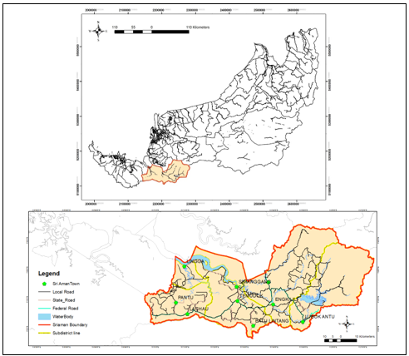

Figure 1. Map of study area
Land use data is an essential component of GIS-based analysis, especially in land use planning and surveying. In this research, we will use land use data of Sri Aman to clarify the function of GIS-based analysis in settlement and healthcare facility planning. The data obtained from the Land and Survey Department, Sarawak, used in this research, is in its latest form. In the case of Sri Aman, we can use GIS to analyze the land use patterns and identify spatial distribution for settlement and healthcare facilities based on factors such as area security, logistics, access to officials and agencies, interference with the local population, and environmental impact. By integrating land use data with other spatial information sources, effective tools can be applied with geospatial analysis capability to support land use planning and decision-making. The other land use data that existed in the area for this study includes residential, commercial, agriculture and vacant land. The land use that exists in the study area had an impact on how accessibility to healthcare facilities has its ‘own impact towards the presence of the existing healthcare facilities. Population and land availability became the focus, along with the other factors that attract social catchment areas. These will be explained via the following map, that shows how locations with the most populated domain in the study area possess the means of incorporating the healthcare facilities.

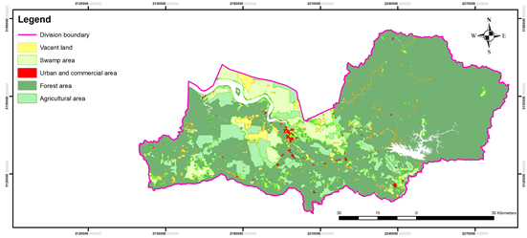

Figure 2. Land use map of study area

GIS analysis tool was used to evaluate the existing locations of healthcare facilities and determine whether they are optimally located to serve the population. Population data is based on settlements such as a village, long house, and small-town housing area. While the healthcare facility included in the data consists of hospital and health clinic that is available in study area. Some of the healthcare facilities were in the rural area and may have fewer healthcare providers overall as compared to the ones in the urban areas, which further issues like limitation in access to the services often come into circumstances.

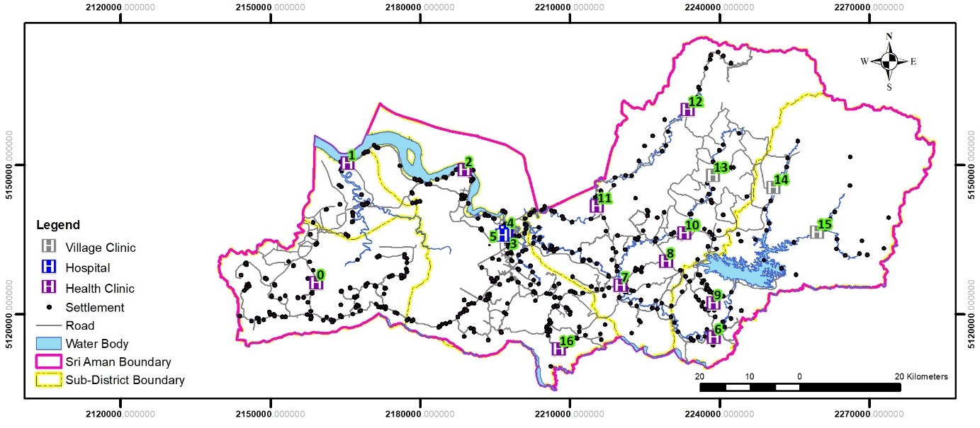

Figure 3. Map of healthcare facility and settlement location in Sri Aman division
Table 1. Healthcare facility in Sri Aman division

ID | Healthcare facility name | ID | Healthcare facility name
0 | Pantu Health Clinic | 9 | Batang Ai Health Clinic
1 | Lingga Health Clinic | 10 | Ng. Kesit Health Clinic
2 | Tg. Bijat Health Clinic | 11 | Skrang Health Clinic
3 | Sri Aman Health Clinic | 12 | Ng. Entalau Health Clinic
4 | Sri Aman Hospital | 13 | Ng. Patoh Village Health Clinic
5 | Sri Aman Hospital 2 | 14 | Stamang Village Health Clinic
6 | Lubok Antu Health Clinic | 15 | Ng. Delok Village Health Clinic
7 | Engkilili Health Clinic | 16 | Batu Lintang Health Clinic
8 | Merindun Health Clinic
Kernel Density Estimation

The population data in this study can provide the density of population in a certain area, hence needed to be displayed via a density estimation to visualize the characteristic of the density itself. In the context of settlement distribution analysis, Kernel Density Estimation, a non-parametric method of a random variable, which in this case, the settlement distribution data, using kernels as weight in estimating the probability density function (Péron, 2019). Kernel density estimation allows the result of data representation in a more accurate perspective, by spreading the data points over a continuous range and allow for the smooth transition in the distinctive of data (Węglarczyk, 2018). The density analysis method can be applied using Geographic Information System technology. By using GIS-based Kernel Density Estimation, we can assess the distribution and clustering characteristics of settlements in relation to healthcare access. Enlisted, 17 healthcare facilities and 672 settlements located across four districts and one sub-district in Sri Aman Division, will be used to conduct the Kernel Density Estimation analysis. This will be used to obtain the indicators of a certain density. Projection of raster is set to 30 by 30 square meter to match the spatial resolution of the data, also produce a smooth wave transition to the mapping of density. This analysis tool is a non-parametric method used to estimate the probability density function of a random variable and can handle multimodal distributions in a particular study area. Hence, Kernel Density Estimation can be used to study the peak and distribution of settlements in Sri Aman Division and helps to assess the availability of healthcare services by estimating the population density. Any form of population density will have an impact on how the distribution of healthcare facility being observed due to its’ location that is different for every group of settlement areas. These locations determine the central point of origin, to which the routes will be displayed from the settlements to the nearest healthcare facility.

Results and discussion
Spatial analysis of healthcare and settlement distribution

The 17 units of healthcare facilities distribution across 4 districts in Sri Aman Division allow the population to gain access to their healthcare services. However, the uneven distribution of the healthcare facilities also provides different quality of healthcare services in different districts.

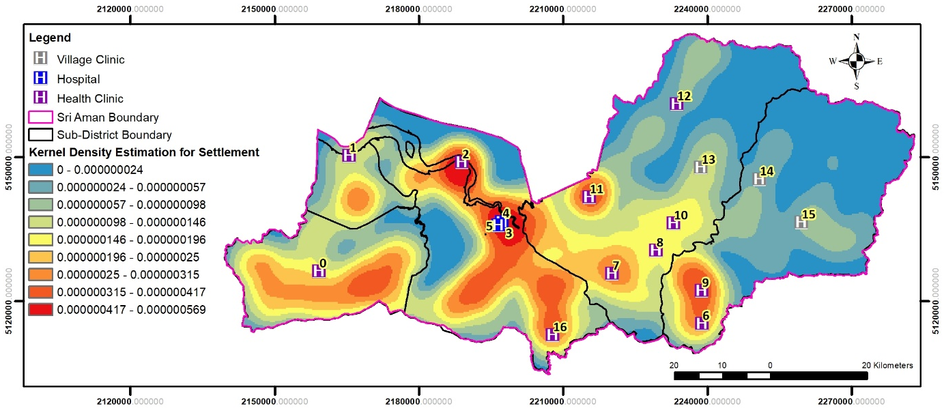

Figure 4. Kernel density estimation of settlement area in Sri Aman division

The nearby clinic primarily caters to light treatment and is equipped with only limited resources and equipment. While it may offer essential medical services for minor ailments and injuries, its capabilities are restricted, making it unsuitable for handling more complex or severe medical conditions. Treatment offered by Village Clinic such as in Ng. Patoh, Stamang and Ng. Delok is limited to only nearby population as it can only support a small number of patients. More to the location of the village clinic, the three small healthcare facilities are in the rural area for the rural population to receive average medical treatment. This limitation often necessitates referrals to larger healthcare facilities with more comprehensive equipment and medical expertise, which can result in delays and inconveniences for patients seeking advanced care. Despite its limitations, these clinics play a crucial role in providing accessible healthcare options, particularly in remote or underserved areas, and can serve as a first point of contact for basic healthcare needs, ensuring that individuals receive some level of medical attention when necessary.
Areas with low healthcare service availability and high population density, also areas with high or low population density comparison and access to healthcare services have been identified. Some areas have no nearby health clinic, like the settlements between Sri Aman and Pantu district boundary. Some settlement areas have insufficient health clinics that might not be able to support the population, like in Lingga, Pantu and Batu Lintang. The location of clinics near the river indicates that it has been around for a long period of time, since the river is primarily the main route before the proper road exists. Clinics in Pantu, Lingga and Batu Lintang would not be able to provide sufficient healthcare to the nearby population since they have only one health clinic per area. In some rural areas, only one health clinic exists to serve the nearby population, mainly the Ng. Entalau Health Clinic, Ng. Patoh Village Health Clinic, Stamang Village Health Clinic and Ng. Delok Village Health Clinic. Clinics which are located near the river, especially in the rural area of Lubok Antu and Engkilili maybe old and have no appropriate medical equipment or professional medical staff in serve. Rare case would be an increased risk of mortality in patients with life-threatening emergencies Hence, these issues will arise when the number of populations area increases.

Distance to nearest healthcare facility

The task to visualize the distribution and proximity for accessing proper treatment from nearby healthcare facilities is performed from the estimated center of high population density area to their nearest healthcare facilities. Using Buffer analysis, the settlement count served by every healthcare facility is identified.

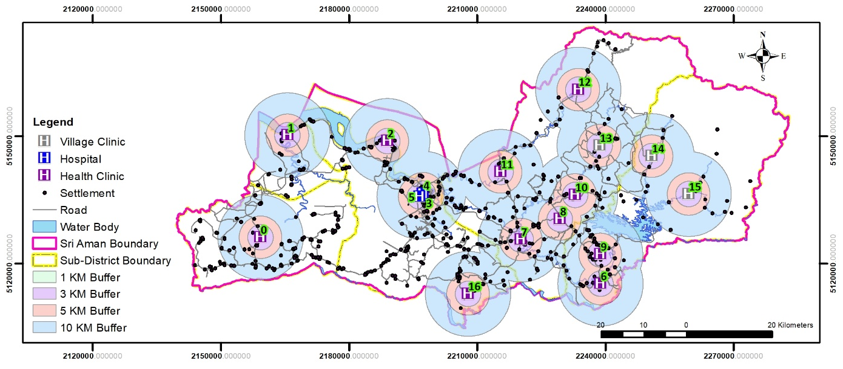

Figure 5. Distance analysis to reach nearest healthcare facility in Sri Aman division

The distance between a specific point in the chosen area of population density to the nearest healthcare facility is determined by the condition of the population. The condition of population in rural area of Sarawak is commonly a grouped settlement. The terrain in Sarawak is often hilly, and the soil is soft, with different function of land for agriculture, so the population density condition is not constantly distributed as it is in the urban area. Thus, different settlement groups have different proximity to nearest healthcare facility.
The map consists of the route from a few settlement points to the nearest healthcare facility in four districts and one sub-district of Sri Aman Division. As concluded from the map, there are differences in the number of settlement group counts in any given area. The settlement group count is due to the variance of settlement profile along the given certain types of land in the district and throughout both the State and Federal roads.

Table 2. Healthcare facility in Sri Aman distance buffer analysis settlement coverage

Healthcare facility | Distance buffer (KM)
Healthcare facility | 1KM | 3KM | 5KM | 10KM
Pantu Health Clinic | 2 | 7 | 12 | 64
Lingga Health Clinic | 1 | 5 | 10 | 28
Tg. Bijat Health Clinic | 11 | 26 | 31 | 50
Sri Aman Health Clinic | 5 | 21 | 44 | 89
Sri Aman Hospital | 5 | 21 | 44 | 89
Sri Aman Hospital 2 | 3 | 21 | 44 | 89
Lubok Antu Health Clinic | 6 | 12 | 19 | 46
Engkilili Health Clinic | 3 | 11 | 24 | 57
Merindun Health Clinic | 6 | 6 | 9 | 39
Batang Ai Health Clinic | 4 | 16 | 28 | 59
Ng. Kesit Health Clinic | 5 | 7 | 11 | 45
Skrang Health Clinic | 17 | 21 | 22 | 41
Ng. Entalau Health Clinic | 1 | 1 | 4 | 11
Ng. Patoh Village Health Clinic | 1 | 5 | 9 | 19
Stamang Village Health Clinic | 1 | 2 | 4 | 10
Ng. Delok Village Health Clinic | 1 | 2 | 4 | 12
Batu Lintang Health Clinic | 7 | 13 | 20 | 39

From the table, Sri Aman Health Clinic and the two hospitals in Simanggang cover the most settlements within all distance buffers together, with 89 settlements within a 10KM radius. While the two hospitals and a health clinic that serve in Simanggang town capable of serving such high number of patients from nearby settlements for the same radius boundary yet deemed as more than stuffiest to cope with the demand for the population. The outermost reach encompasses a vast territory, standing as the healthcare facility that serves a central pillar of the community’s health infrastructure, indicates a substantial reach and influence over the surrounding areas. A concern however, that the village clinics such as Ng. Patoh Village, Stamang Village, and Ng. Delok Village Health Clinic are small healthcare facilities that are located far in the rural areas to serve a very low count of population. While the three small village clinics exist, it may not be sufficing for treatment more than light fever or any skin related health issues, as the clinic is remote from the supplies of equivalent medical resources from the nearest town. For a close range of 3 Kilometers radius, Tg. Bijat and Skrang Health Clinic serve the highest settlement counts, as this means that more people from nearby locations are going to need medical attention while being the single facility in the area. This may also lead to the need for more medical staff and resources.

Distance and response time for emergencies

According to Dr. Nik Ahmad Shaiffudin (2021), A response time of more than 15 minutes for an ambulance is unacceptable. According to Malaysia, the current average ambulance response time is 30 to 40 minutes, in comparison to the international guideline of 7-10 minutes. This is still acceptable for the patient’s condition which is severe. However, results may be different for the patients of serious and critical stages, as time is of the essence. According to the top causes of deaths listed in Malaysia like coronary heart disease and transport accidents, the time of response are unacceptable at all cause. Patients may not be able to survive the critical impact, which may lead to possible massive blood loss, or even the lack of help from nearby personnel, due to lack in health info and training. This would be dangerous for the people in the rural area, in a way such incidents happened. More to the travel profile, patients may not be comfortable as they might find themselves rushed to the hospitals through an uneven road condition in the rural area. This may increase their level of critical as issues like exposed bone cracks may lead to a life-threatening condition when meet with the irregular road journey. There are also issues with the possibilities of multiple incidents occurrence at the same time, and there would not be enough resources to cover the patients. Multiple events may occur from different places, and Ambulance may not be available for each one of them all at once, which will result in the use of personnel transportation, which clearly unsuitable for transporting serious and critical patients.
The next step from this research is to proceed with GIS-based hybrid decision-making approach for another research in future, to identify suitable sites for new healthcare facilities. This approach involves combining other multiple criteria other than population density, such as transportation infrastructure, and healthcare demand, to identify the most suitable sites for new healthcare facilities.

Conclusion
The spatial analysis of healthcare and settlement distribution in the Sri Aman Division reveals a significant disparity in the availability and quality of healthcare services across the four districts. While 17 healthcare facilities provide essential medical services to the population, the uneven distribution, particularly in rural areas, results in varying levels of healthcare access and quality. Clinics in remote areas, such as those in Ng. Patoh, Stamang, and Ng. Delok, are limited in resources and only cater to minor ailments, necessitating referrals to larger, better-equipped facilities for more severe cases. The buffer analysis indicates that facilities like Sri Aman Health Clinic and hospitals in Simanggang serve the largest population within a 10KM radius, highlighting their crucial role in the community’s health infrastructure. However, the small, rural clinics often struggle to meet the healthcare demands of their populations, leading to potential delays and increased risk in emergency situations. Kernel density and buffer analysis have proven effective for examining the spatial distribution density of rural settlements, suggesting that targeted interventions are necessary to address healthcare accessibility needs. Enhancing medical supplies and services in rural areas through telehealth, innovative delivery models, financial support, policy reforms, and workforce development could significantly improve healthcare accessibility and quality in these underserved regions.

References

Ab Hamid, J., Juni, M. H., Manaf, R. A., Ismail, S. N. S., & Lim, P. Y. (2021). Spatial accessibility to primary care in dual public-private health system in Malaysia: A case study in rural Selangor. Research Square, 1-13.
Allen-Meares, P., Lowry, B., Estrella, M. L., & Mansuri, S. (2020). Health literacy barriers in the health care system: Barriers and opportunities for the profession. Health & Social Work, 45(1), 62-64.
Allred, S., Harris, R., Zaman, T., Kulathuramaiyer, N., & Jengan, G. (2022). Cultural Resilience in the Face of globalization: Lessons from the Penan of Borneo. Human Ecology, 50(3), 447-462.
Bennett, K. J., Borders, T. F., Holmes, G. M., Kozhimannil, K. B., & Ziller, E. (2019). What is rural? Challenges and implications of definitions that inadequately encompass rural people and places. Health Affairs, 38(12), 1985-1992.
Bezbaruah, S., Wallace, P., Zakoji, M., Perera, W. L. P., & Kato, M. (2021). Roles of community health workers in advancing health security and resilient health systems: Emerging lessons from the COVID-19 response in the South-East Asia Region. WHO South-East Asia Journal of Public Health, 10(Suppl 1), S41-S48.
Biswas, R. K., & Kabir, E. (2017). Influence of distance between residence and health facilities on non-communicable diseases: An assessment over hypertension and diabetes in Bangladesh. PloS ONE, 12(5), e0177027.
Bown, C. P. (2020). COVID-19: Demand spikes, export restrictions, and quality concerns imperil poor country access to medical supplies. In Baldwin, R., & Evenett, S. J. (eds.) COVID-19 and trade policy: Why turning inward won’t work. CEPR Press.
Butkus, R., Rapp, K., Cooney, T. G., Engel, L. S., & Health and Public Policy Committee of the American College of Physicians. (2020). Envisioning a better US health care system for all: reducing barriers to care and addressing social determinants of health. Annals of internal medicine, 172(2_Supplement), S50-S59.
Caballero-Anthony, M., Cook, A. D., Amul, G. G. H., & Sharma, A. (2022). Health governance and dengue in Southeast Asia (pp. 1-8). S. Rajaratnam School of International Studies.
Chuah, F. L. H., Tan, S. T., Yeo, J., & Legido-Quigley, H. (2019). Health system responses to the health needs of refugees and asylum-seekers in Malaysia: A qualitative study. International Journal of Environmental Research and Public Health, 16(9), 1584.
Daud, F., Abd Ghani, N. F., & Zahid, S. N. A. (2022). Job satisfaction among specialist in Ministry of Health Malaysia and its associated factors. Malaysian Journal of Public Health Medicine, 22(3), 1-8.
Department of Statistics Malaysia. (2010). Number of living quarters and households by state and administrative district 1991, 2000 and 2010.
Department of Statistics Malaysia. (2020). The population of Sri Aman division, Sarawak, Malaysia.
Department of Statistics Malaysia. (2023). The population of Malaysia. https://open.dosm.gov.my/dashboard/population
Dhanaraj, K., & Angadi, D. P. (2021). A GIS based interpretation of the historical evolution of urban settlements in Mangalore City, India. Spatial Information Research, 29, 615-629.
Fadzil, M. M., Wan Puteh, S. E., Aizuddin, A. N., & Ahmed, Z. (2022). Specialists’ dual practice within public hospital setting: Evidence from Malaysia. Healthcare, 10(10), 2097.
Falcon, D. J. (2019). The healthcare gap in rural Malaysia. The New Malaysia, 37, 27-36.
Gereffi, G. (2020). What does the COVID-19 pandemic teach us about global value chains? The case of medical supplies. Journal of International Business Policy, 3(3), 287-301.
Gong, S., Gao, Y., Zhang, F., Mu, L., Kang, C., & Liu, Y. (2021). Evaluating healthcare resource inequality in Beijing, China based on an improved spatial accessibility measurement. Transactions in GIS, 25(3), 1504-1521.
He, A. J., & Tang, V. F. (2021). Integration of health services for the elderly in Asia: A scoping review of Hong Kong, Singapore, Malaysia, Indonesia. Health Policy, 125(3), 351-362.
HIM, N. A. S. B. N. (2021). A study on ambulance response time in three selected hospitals in malaysia: do we really need a dedicated pre hospital paramedic? Malaysian Journal of Emergency Medicine, 5(2).
Hj Nuruddin, N. A. H. (2021). Kajian masa depan mengenai matlamat kependudukan 70 juta dan hubungannya dengan pembangunan umat digital di Malaysia. Journal of Education and Social Sciences, 18(3), 84-90.
Horn, C., Gifford, S. M., & Ting, C. Y. (2021). Informal, essential and embedded: Transport strategies in remote Sarawak. Journal of Transport Geography, 96, 103181.
Islam, M. R. (2015). Rights of the people with disabilities and social exclusion in Malaysia. International Journal of Social Science and Humanity, 5(2), 171-177.
Khashoggi, B. F., & Murad, A. (2020). Issues of healthcare planning and GIS: A review. ISPRS International Journal of Geo-Information, 9(6), 352.
Khaw, W. F., Chan, Y. M., Nasaruddin, N. H., Alias, N., Tan, L., & Ganapathy, S. S. (2023). Malaysian burden of disease: years of life lost due to premature deaths. BMC public health, 23(1), 1383.
Lim, H. M., Teo, C. H., Ng, C. J., Chiew, T. K., Ng, W. L., Abdullah, A., Abdul Hadi, H., Liew, C. S., & Chan, C. S. (2021). An automated patient self-monitoring system to reduce health care system burden during the COVID-19 pandemic in Malaysia: Development and implementation study. JMIR medical informatics, 9(2), e23427.
Lim, K. K., Sivasampu, S., & Mahmud, F. (2017). Equity in access to healthcare in a rural population in Malaysia: A cross‐sectional study. Australian Journal of Rural Health, 25(2), 102-109.
Liu, O. P., Ong, P. H., Selvadurai, S., Radzi, M. M., & Saibeh, B. (2014). The making of Malaysian solidarity: A historical look at education and social cohesion in Sarawak. Geografia-Malaysian Journal of Society and Space, 10(1), 36-48.
Mahendradhata, Y., Andayani, N. L. P. E., Hasri, E. T., Arifi, M. D., Siahaan, R. G. M., Solikha, D. A., & Ali, P. B. (2021). The capacity of the Indonesian healthcare system to respond to COVID-19. Frontiers in public health, 7(9), 649819.
Mahmud, A., & Aljunid, S. M. (2018). Availability and accessibility of subsidized mammogram screening program in Peninsular Malaysia: A preliminary study using travel impedance approach. PLoS One, 13(2), e0191764.
Manggat, I., Zain, R., & Jamaluddin, Z. (2018). The impact of infrastructure development on rural communities: A literature review. International Journal of Academic Research in Business and Social Sciences, 8(1), 637–648.
Masron, T., & Osman, M. A. (2015). Spatial Information in Local Knowledge. Penerbit USM.
Masron, T., Ismail, N., & Marzuki, A. (2016). The conceptual design and application of web-based tourism decision support systems. Theoretical and Empirical Researches in Urban Management, 11(2), 64-75.
McMahon, A., Mihretie, A., Lake, M., Awoke, W., & Wimberly, M C. (2021). Remote sensing of environmental risk factors for malaria in different geographic contexts. International Journal of Health Geographics, 20(28), 1-15.
Mirza, N. A., & Hulko, W. (2022). The complex nature of transportation as a key determinant of health in primary and community care restructuring initiatives in rural Canada. Journal of Aging Studies, 60, 101002.
Neil, E., & Greengrass, E. (2021). Illegal settlement in the Babile Elephant Sanctuary is threatening the resident elephant population. Oryx-The International Journal of Conservation, 56(3), 457-464.
Pál, V., Lados, G., Ilcsikné Makra, Z., Boros, L., Uzzoli, A., & Fabula, S. (2021). Concentration and inequality in the geographic distribution of physicians in the European Union, 2006–2018. Regional Statistics, 11(3), 3-28.
Panting, A. J., Hasim, M. S., & Ninggal, M. T. M. (2023). A qualitative study on health information needs on non-communicable diseases among rural communities in Sarawak, Malaysia. International Journal of Social Policy and Society (IJSPS), 19, 83-100.
Péron, G. (2019). Modified home range kernel density estimators that take environmental interactions into account. Movement ecology, 7, 1-8.
Planey, A. M. (2020). Hearing health care in the United States: A multi-scale spatial & political economic analysis of health care policy and access to audiology services [Doctoral dissertation, University of Illinois at Urbana-Champaign].
Saliman, L., Swee-Kiong, W., Abdullah, M. H., Awang, N. H., & Noor, M. (2023). The impact of Livelihood Asset Accumulation on the Well-being and Psychology of Iban Rural Households in Sarawak. Journal for ReAttach Therapy and Developmental Diversities, 6(9s (2)), 790-800.
Sánchez-Mateos, H. M., & Pulpón, A. R. (2021). Closeness is not accessibility: Isolation and depopulated rural areas in the proximity of metropolitan urban areas, a case-study in inland Spain. European Countryside, 13(2), 410-435.
Sanggin, S. E., Mersat, N. I., Wong, S. K., Suhaidi, S. M., Mohd. Azizul, H. J., & Sarok, A. (2015). Natural resources and indigenous people's livelihood subsistence: a case study of human communities in the headwaters of Engkari river, Sri Aman, Sarawak, Malaysia. Journal of Business and Economics, 7(2), 243-249.
Santos, T. M., Cata-Preta, B. O., Mengistu, T., Victora, C. G., Hogan, D. R., & Barros, A. J. (2021). Assessing the overlap between immunization and other essential health interventions in 92 low-and middle-income countries using household surveys: opportunities for expanding immunization and primary healthcare. EClinicalMedicine, 42, 101196.
Sheng, G. C., & Potter, L. (2023). Transforming Borneo: From land exploitation to Sustainable Development. ISEAS-Yusof Ishak Institute.
Songan, P. (1992). Perceived motivations and deterrents associated with participation of peasants in rural development programs in Sarawak, Malaysia. Cornell University.
Sri Aman Master Plan. (2021). Final report Sri Aman Master Plan 2020-2023.
Strasser, R., Kam, S. M., & Regalado, S. M. (2016). Rural health care access and policy in developing countries. Annual Review of Public Health, 37, 395-412.
Tuah, M. A. E., Tedong, P. A., & Dali, M. M. (2022). The challenges in rural infrastructure planning governance in Sarawak. Planning Malaysia: Journal of the Malaysian Institute of Planners, 20(5), 391-403.
Wan Puteh, S. E., Siwar, C., Zaidi, M. A. S., & Abdul Kadir, H. (2019). Health related quality of life (HRQOL) among low socioeconomic population in Malaysia. BMC Public Health, 19(Suppl 4), 551.
Wang, F. (2020). Why public health needs GIS: A methodological overview. Annals of GIS, 26(1), 1-12.
Węglarczyk, S. (2018). Kernel density estimation and its application. ITM web of conferences, 23, 00037.
Xiong, X., Li, V. J., Huang, B., & Huo, Z. (2022). Equality and social determinants of spatial accessibility, availability, and affordability to primary health care in Hong Kong, a descriptive study from the perspective of spatial analysis. BMC health services research, 22, 1364.
Yadav, H. (2017). The health care system in Malaysia. In Aspalter, C., Pribadi, K. T., & Gauld, R (eds). Health Care Systems in Developing Countries in Asia (pp. 110-130). Routledge.
Yin, C., He, Q., Liu, Y., Chen, W., & Gao, Y. (2018). Inequality of public health and its role in spatial accessibility to medical facilities in China. Applied Geography, 92, 50-62.

