Status and trend of ecosystem services of Madhupur Sal forest in Bangladesh

Soumitra Saha¹, Shaikh Shamim Hasan¹, Md. Enamul Haque¹, Tofayel Ahamed², Shahriar Hasan¹

¹Department of Agricultural Extension & Rural Development,
Bangabandhu Sheikh Mujibur Rahman Agricultural University, Gazipur, Bangladesh
²Department of Agroforestry & Environment,
Bangabandhu Sheikh Mujibur Rahman Agricultural University, Gazipur, Bangladesh

Correspondence: Shaikh Shamim Hasan (email: shamim.aer@bsmrau.edu.bd)

Received: 1 February 2024; Accepted: 16 May 2024; Published: 31 May 2024

Abstract

The Madhupur Sal forest comprises a substantial portion of Bangladesh's Sal Forest area, but deforestation is negatively affecting its overall environment in recent times. This study examines the present status and changing trend of ecosystem services over the years in Madhupur Sal forest. Data were collected from 120 respondents with two focus group discussions through in-person interviews. The major portion of the respondents comprised Garo ethnic people of the area. According to the findings, the respondents identified 20 different ecosystem services where soil erosion prevention, mental peace, and soil fertility maintenance were perceived as top services. Regulating and cultural services existed as the most prominent services of the study area. The forest experienced a massive trend of changes over the last ten years. Most of the respondents (64.80%) observed an increase in the agricultural land area during the period. As reported by most of them (74.50%), the marketplace of the local handicraft industry was getting narrower at a rapid rate while the agricultural land area was increasing at a slower rate (68.60%). All of the services, from provisioning to regulating, exhibited a declining trend, and an extreme trend was observed in case of supporting services, as stated by 95.05% of the respondents. The research findings offer useful baseline information on the ecosystem service research for Bangladesh.

Keywords: Bangladesh, deforestation, ecosystem services, environment, Madhupur, Sal forest

Introduction

Forests are undeniably the most vital for maintaining the earth’s ecological balance and sustainable development across the world (Yasmin et al., 2010; Faruq et al., 2016). They are globally recognized for the economic, social, cultural and ecological benefits offered to the local people (Ahammad et al., 2019a; Hasan et al., 2020a; Islam et al., 2013a). Forests support food security and livelihood in the least developed countries by ensuring nutritive food (Sunderland et al., 2013), medicines, fuelwood, income and employment for rural people (Ahammad et al., 2019a). Aside from direct benefits, they are the provider of indirect benefits that not only include food production but also environmental benefits by regulating air and water, enriching soil and reducing erosion, facilitating crop pollination (Foli et al., 2014; Reed et al., 2017). And these direct and indirect benefits from ecosystems are recognized as “ecosystem services” (MEA, 2005) in the form of provisioning, such as food, fibre, timber, fuel, etc.; supporting, such as primary production, soil formation, nutrients cycling, etc.; cultural, such as spiritual, recreational, cognitive development, or aesthetic experiences, etc.; regulating, such as soil erosion control, soil fertility maintenance, protection from extreme natural events, etc. These services are crucial for sustaining billions of poor people’s livelihoods across the world (Huq et al., 2020; Islam et al., 2022).
Benefits provided by the ecosystem vary according to the type and status of the ecosystems which are important for human well-being (Akber et al., 2018). However, several studies have reported worldwide forest degradation, unsustainable use of ecosystems and land use change which impacted negatively on ecosystem services in recent years (Hasan et al., 2020a; Sohel et al., 2015). MEA (2005) reported that 60% of the world’s ecosystem services have already been degraded due to unsustainable use. Destruction of natural resources, especially forests, has become a severe concern for the rural people of developing countries dependent on these resources for sustenance (Rasul, 2009). Forest cover changes negatively affect the sustainable supply of these ecosystem services (Ahammad et al., 2019b; Hoque et al., 2022).
This paper focuses on the local people’s knowledge of the ecosystem services of the Madhupur Sal forest in Bangladesh. Through people-oriented afforestation projects, the Bangladesh govt plans to preserve and protect forest ecosystems for environmental stability, improved biodiversity, increased employment opportunities, and alleviate poverty for forest-dependent people (Hasan et al., 2017). Local people’s knowledge of ecosystem services helps to evaluate the socio-cultural dimension of ecosystem services (Ahammad et al., 2019a). The Sal forests are tropical moist deciduous forests in Bangladesh (Abdullah et al., 2015). Among them, the Madhupur Sal (Shorea robusta) forest is the third largest, and covers an area of 0.12 million ha which has ecological and economic importance. It is the only forest situated in the flood-free central part of Bangladesh (Faruq et al., 2016) which was rich in flora and fauna in the past. It accommodates a total number of 176 species of plants, including haldu (Haldina cordifolia), kadam (Neolamarckia cadamba), neem (Azadirachta indica), shimul (Bombax ceiba) etc. The prevailing faunal composition includes 140 species of birds, 21 species of mammals (monkeys, deer, and languor), and 29 reptiles (Hossain et al., 2013; Paul et al., 2013).
The Madhupur Sal forest comprises major patches of Sal forests in Bangladesh that delivers economically and environmentally valuable commodities like timber, firewood, fodder, food, etc. (Mondol et al., 2010a). It covers 0.81% of the country's total land and 7.80% of the country’s forest area. Unfortunately, over the recent decades, this forest has been affected by various forms of human disturbances, for instance, deforestation, undue litter collection, and over-exploitation of natural resources (Rahman et al., 2009; Alam et al., 2010). Excessive population triggers this forest’s degradation trend and substantial change in forest cover (Hasan et al., 2018; Muhammed et al., 2008). Therefore, the rich biodiversity of the natural Sal forest has already vanished, causing terrible and permanent environmental loss and making forest resource use unsustainable (Islam et al., 2013b). This forest is native land for ethnic people such as the Garo and Koch since ancient times (Abdullah et al., 2015). However, the ethnic peoples’ land rights and forest access have not been considered, rather, the forest officials tried to eject them from the forest without considering their traditional land rights (Islam & Hyakumura, 2019). These ethnic people's life and livelihood have been severely impacted by the destruction of the natural forest (Saha et al., 2021).
Though several studies explored the social or ecological issues of the Madhupur Sal forest, few researches focused on the socioeconomic and environmental aspects of ecosystem services in that area. Comprehensive studies are needed to identify the available ecosystem services and trends of environmental changes in the forest. Considering the above mentioned facts we undertook the study to assess the land cover changes of the forest area and also to identify the ecosystem services of the study area. We aimed also to assess the perceived changes in the forest condition and ecosystem services. We believe that the findings of the study will be useful in strengthening the ongoing conservation efforts undertaken by the government, various NGOs and rural people.

Methodology

Study location

The research was carried out at the specified areas of Madhupur Upazila (Sub-district) of Tangail district (Figure 1), located in between latitudes 24°47' and 24°31' north and longitudes 90°10' and 89°57' east (Banglapedia, 2015). The study site was chosen purposively for its substantial Sal forest coverage, and a significant number of forest people are dependent on this forest. The Madhupur Sal forest in Tangail district has a total land area of around 46,000 acres; among them, 7,800 acres area have been allotted for rubber production, 1000 acres to the Bangladesh Air Force, 25000 acres have been illegally possessed by people, and 12,200 acres of land is under the control of Forest Department. The remaining patch of Sal forest is mainly found in the Sholakuri and Arankhola unions of Madhupur Upazila (Islam et al., 2013b).

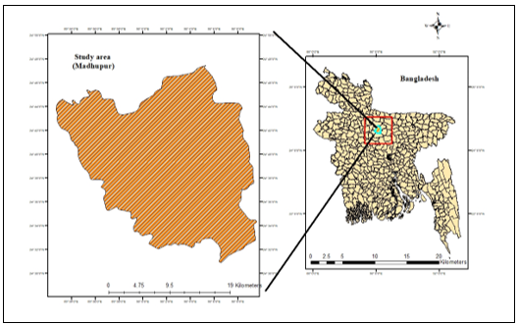

Figure 1. Map of the study area showing Madhupur Upazila

Focus group discussion (FGD)

Two focus group discussions (FGDs) involving 10 and 12 participants were conducted at the Pirgacha and Bhutia villages of Madhupur Upazila for the initial rapid assessment of the ecosystem services. The focus group participants were selected with care, taking into account their dependence on the Sal forest and livelihood strategy. It was made sure that every person engaged keenly in the discussions. During the sessions, well-known and respected members of the community served as moderators.

Data collection

Semi-structured interview schedule was used to facilitate in-person interviews with the respondents to gather data. Questions focused on the available ecosystem services, peoples’ dependency on them, present and past status of the services, and trends of service changes over a certain period.
The present study population consisted of both ethnic and non-ethnic people who were reliant on the Madhupur Sal forest either directly or indirectly. Three villages (Bhutia, Dokhola, and Pirgacha) of Madhupur Upazila were selected randomly. Using a proportionate random selection technique and the following formula, 120 respondents were selected as a sample. Hasan et al. (2010) used a similar formula to select a sample for their study in Bangladesh.

n =$\left(\frac{Z^{2}×σ^{2}× N}{\left(N-1\right)e^{2}+ Z^{2}{.σ}^{2}}\right)$ (1)

Where,
n = Size of the sample
N = Size of the population
e = Acceptable error
σ = Population standard deviation
Z = Standard normal variate at a given confidence level

This study employed land cover data of Bangladesh from 2010 and 2020 with a resolution of 30m. Bangladesh's original land cover map (maps from 2010 and 2020) was acquired from the website www.globallandcover.com. These are China Globe Cover's 30m fine resolution global land cover maps, which have been used in various studies such as Hasan et al. (2020b) and Hasan et al. (2017). The Bangladesh land cover map for each year is derived primarily from the global land cover map. The tiles are for 2010 (N45_20_2010LC030; N45_25_2010LC030; N46_20_2010LC030; N46_25_2010LC030) and for 2000 (N45_20_2000LC030; N45_25_2000LC030; N46_20_2000LC030; N46_25_2000LC030), respectively. The tiles were downloaded from the website and we performed mossaicing and then the entire Bangladesh land cover map was prepared by using ArcGIS 10.5. Originally, the land cover maps have ten major land cover types. These are arable land, forest, grassland, shrubland, wetland, water body, tundra, artificial surface, bare land, glacier and permanent snow. Finally, we extracted the Madhupur upazila land cover map from the Bangladesh land cover with and reclassified into six land use types (Hasan, et al., 2020b; Hasan et al., 2017) with different coding (Table 1) and generalized through a discrete representation scheme after being extracted at 30 m resolution.

Table 1. Rearrangement of land uses of Madhupur

Code | Land use | Description
1 | Agricultural land | Original data include both rice and non-irrigated uplands.
2 | Sal forest | Natural or planted Sal forests with canopy covers greater than 30%; land covered by trees less than 2 m high, with a canopy cover greater than 40%; land covered by trees with canopy cover between 10 to 30%.
3 | Grassland | Lands covered by herbaceous plants with coverage greater than 5% and land mixed rangeland with the coverage of shrub canopies less than 10%.
4 | Water area | Land covered by natural water bodies or land with facilities for irrigation and water reservation, including rivers, canals, and lakes.
5 | Built-up area | Land used for urban and rural settlements, industry and transportation.
6 | Unused land | All other lands.

Data analysis

Prioritization of ecosystem services was done through participatory tools. The participants identified key ecosystems available from the forest through focus group discussions. For prioritization of the ecosystem services, each respondent was asked to express his/her extent of satisfaction by checking against any of the four responses, e.g., very unsatisfied, unsatisfied, satisfied, very satisfied and a score of 1, 2, 3, 4 was assigned, respectively. Some other researches (Suza et al., 2021; Mahamud et al., 2022; Salawat et al., 2013) in Bangladesh followed the same measurement technique to assess response from the respondents. Based on their extent of satisfaction, the ecosystem services were prioritized (Figure 3) utilizing R program. The text size of each ecosystem service shows its priority; the larger the text size, the higher the respondents' priority. A Satisfaction Index (SI) was determined by using the following formula (Uddin et al., 2014):

Satisfaction Index (SI)= VUN×1+UN×2+ SAT×3+VSAT×4 (2)

Where,
VUN = Very Unsatisfied
UN = Unsatisfied
SAT = Satisfied
VSAT = Very Satisfied

A three-point scale consisting of stable (score=1), decreasing (score=2), and increasing (score=3) was used to determine the trend of changes in the Madhupur Sal forest condition and ecosystem services in the last ten years. The overall perceived trend index was used to determine the perception of change trend for the Sal forest condition and different ecosystem services (Oteros-Rozas et al., 2014).

Overall perceived trend = $(\frac{I-D}{I+D+M})$ (3)
Where,
I = frequency of increases;
D =frequency of decreases; and
M =frequency of stability
Again, a four-point scale consisting of no change (score=1), slow (score=2), medium (score=3), and rapid (score=4) was used to determine the rate of changes in the Madhupur Sal forest condition and ecosystem services in the last ten years. Data analysis was carried out using the SPSS/PC + (version 26) program. In accordance with the research questions, qualitative data from interviews were coded and grouped into themes.

Results

Identification of ecosystem services

A total of 20 different ecosystem services were discovered through FGD. Among them, twelve were in provisioning, four in cultural, three in regulating, and one in supporting ecosystem services categories as shown in Figure 2.

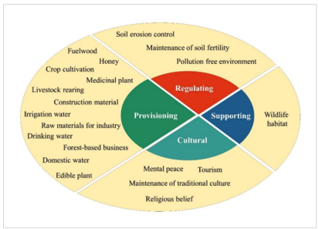

Figure 2. Identified ecosystem services in the study area

The respondents of that area identified these 20 services of their areas which they got from the surrounding ecosystems. Their responses on these issues also made us clear that they did not get equal benefits from these identified ecosystems. Moreover, they also chalked out that the services were decreasing with the advent of time.

Prioritization of identified ecosystem services

Respondents were enquired to express their level of satisfaction with those services. Based on their level of satisfaction, ecosystem services were prioritized as presented in Figure 3. It showed that soil erosion prevention was considered as the most important ecosystem service followed by mental peace (2nd), maintenance of soil fertility (3rd), and tourism (4th). Whereas, irrigation water, drinking water, domestic water, construction material and raw materials for industry services seemed less important to the respondents. These findings revealed that regulating and cultural services were prominent there, and respondents were mostly satisfied with those services.

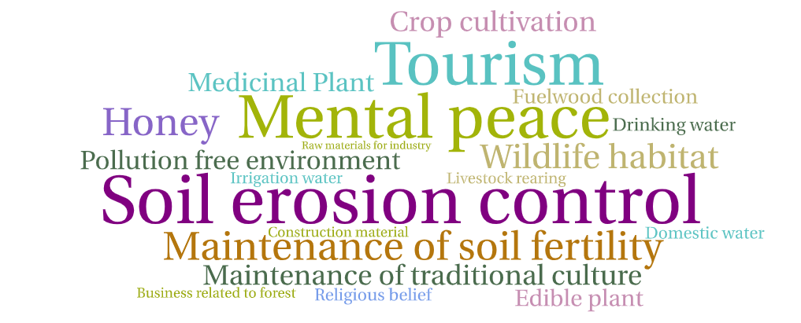

Figure 3. Prioritization of ecosystem services by the forest inhabitants

Most of the respondents found the forest environment as a source of mental peace. The natural beauty of the forest acts as a source of recreation. Despite the lack of a water reservoir in the forest, the use of a water pump for extracting water from ground enhanced fresh water supplies. Though the residents in the remote area suffered from substantial forest loss, they had better access to fuelwood due to their proximity to natural forests. However, in recent years, the local Forest Department restricted access to natural forest, making most of the ecosystem services unavailable to the locals. Madhupur Sal forest is a popular tourist spot; thousands of tourists enjoy its natural charm every year. Most ethnic people considered that tourism operations benefited the overall communication of the Sal forest; however, they rarely engaged in the tourism industry.

Assessment of land cover changes in Madhupur

In Madhupur Upazila, agricultural land, Sal forest, and built-up area are the major land use types (in 2010 and 2020) shown in Figure 4.

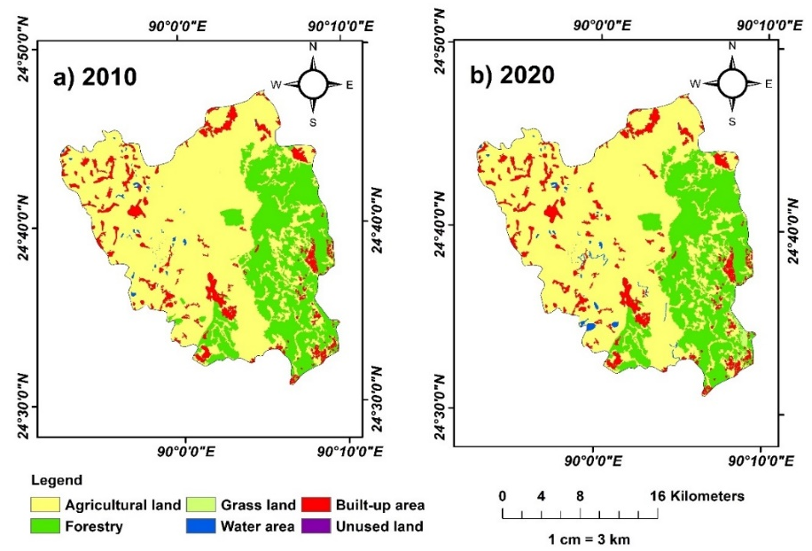

Figure 4. Land cover map of Madhupur Upazila
Table 2. Different land cover type changes

Land cover categories | 2010 |  | 2020
Land cover categories | Area (km²) | % Change | Area (km²) | % Change
Agricultural land | 342.93 | -- | 338.86 | -1.19
Sal forest | 131.82 | -- | 132.37 | 0.42
Grassland | 0.54 | -- | 0.57 | 5.87
Water area | 2.05 | -- | 2.03 | -0.84
Built-up area | 39.56 | -- | 43.07 | 8.88
Unused land | 0.01 | -- | 0.01 | 0.00

It was observed that competition exists among the six land use types, and it mainly showed a decrease in agricultural land and a steep increase in built-up areas (Table 2). Findings from Table 2 and exhibited that from 2010 to 2020, within this time frame agricultural land and water area decreased. While a sharp increase in both built-up area (about 09%) and grasslands (about 6%) was observed, although the total grassland area in Madhupur Upazila was negligible. Meanwhile, data in Table 2 pinpointed a slight increase (0.42%) of Sal forest and a decrease (1.19%) of agricultural land from 2010 to 2020.

Assessment of the previous and current condition of Madhupur Sal forest

Madhupur Sal forest comprises a substantial portion of Bangladesh's Sal forests, but deforestation negatively impacts its overall environment (Hossain et al., 2013). So, the current condition of the Sal forest is not the same as ten years ago. The trend of changes and rate of changes in the Madhupur Sal forest condition in the last ten years have been presented in Figure 5 and 6, respectively.

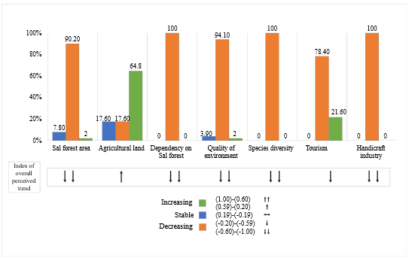

Figure 5. Trend of changes in the Madhupur Sal forest condition in the last ten years

According to Figure 5, cent percent of the respondents (100%) reported a decrease in the conditions related to dependency on the Sal forest, species diversity, and the handicraft industry of the Sal forest area in the last ten years. In contrast, most percentage of the respondents (64.80%) reported an increase in agricultural land in the last ten years. The overall perceived trend index revealed that all the forest conditions except the agricultural land deteriorated in the last ten years. Agricultural land area has increased due to the intrusion of non-forest people into the forest areas. After clearing the forest, they practice banana, pineapple, etc. in monoculture form. Cultivation of these cash crops is becoming popular in the forest areas due to high profit, which extensively depletes forest cover and biodiversity.
According to Figure 6, most percentage of the respondents (68.60%) reported an increase in agricultural land at a slow rate in the last ten years. On the other hand, most percentage of the respondents (74.50%) reported a decrease in the handicraft industry at a rapid rate, dependency on Sal forest at a medium rate (47%), and area of Sal forest at a slower (54.90%) rate, in the last ten years.

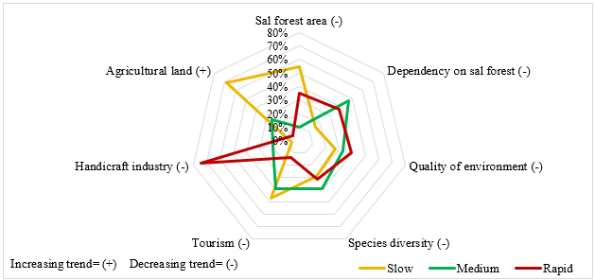

Figure 6. Rate of changes in the Madhupur Sal forest condition in the last ten years

Locals, mostly ethnic people, have mastered making handicrafts like cane baskets and weaving mats. However, Figure 6 illustrated the gloomy condition of the forest area's handicraft industry which declined at a rapid rate in the last ten years. Once, these novelty handicrafts were popular among tourists and were the main clients of these traditional products. However, the respondents of Madhupur Sal forest perceived minimal tourist activities in recent years. As a result, the handicraft industry that grew up in tourism has seen a tremendous drop. The locals, especially ‘Garos,’ had no alternative but to change their traditional occupations to make adequate earnings. They were leaving the forest to pursue urban jobs in government sector and private organizations, garment factories, beauty parlors, and military and police services. In reverse, the agricultural land area increased but at a slower rate as most of the farmland was converted into homesteads due to rapid population growth.

Assessment of the previous and current condition of ecosystem services

The trend of changes in Madhupur Sal forest's ecosystem services in the last ten years has been presented in Figure 7. Considering the overall perceived trend index, all categories of ecosystem services showed a strongest decreasing trend in the last ten years.

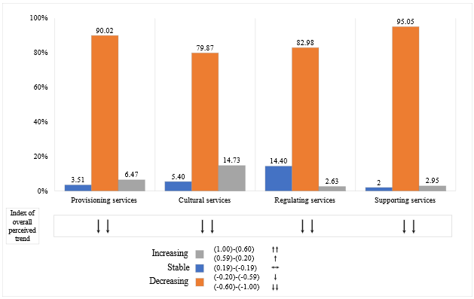

Figure 7. Trend of changes in the ecosystem services of Madhupur Sal forest in the last ten years

Findings from Figure 7 indicated that in the case of supporting services, most of the respondents (95.05%) reported a decreasing trend, followed by provisioning (90.02%) and regulating services (82.98%). The noticeable fact is that the importance and deterioration of provisioning services were highlighted more often by local people than regulating, cultural, and supporting services, which seemed more abstract.

Discussion

The depletion of the Sal Forest coverage was the main reason behind the Sal forest's miserable conditions, which negatively affected its overall environment. The ethnic communities living in the forest were worried about changes in forest cover, especially the loss of natural forest, which had a negative impact on their well-being over time. As per Mia et al. (2012), the Madhupur Sal forest area has been diminishing at a rate of 1-3 percent per year since the 1960s, and it is estimated that if this trend continues, the forest will be entirely destroyed in 50-80 years. According to many studies, such as Hasan et al. (2020b) and Kafy (2017), growing population pressure and rapid urbanization imposed enormous pressure on land cover changes in this forest area. The current study evaluated the present status of this forest condition under human-dominated pressure and its associated ecosystem services.
The study explored that regulating and cultural were the most satisfying services, and soil fertility maintenance was one of the most essential services to the forest people. As per Hasan & Mamun (2015), the Sal forest soil is enriched with a higher amount of nutrients and fungal population due to a reduction in topsoil loss and an enhanced supply of nutrients in the form of leaf litter and biomass from the trees. However, Hasan et al. (2020c) mentioned that local people's forest encroachment had negatively affected soil nutrient status in the Madhupur Sal forest. Through another study in the Chittagong Hill Tracts of Bangladesh Mim et al. (2024) identified that farmers of that area utilized fuel wood which they collected from the surrounding forest area for curing tobacco leaves and thereby deteriorate the environmental condition. Recurrent anthropogenic operations in the Sal forest caused plant nutrient status depletion and reduced stand density. According to Hossain et al. (2010), deforestation in Bangladesh's Sal forests dramatically changed the physico-chemical and microbiological condition of the soil. Mondol et al. (2010b) findings showed that the deforested part of Madhupur Sal forest has now been transformed into an illegal banana, pineapple, and papaya orchard. People indiscriminately use chemical pesticides, fertilizers, and hormones in these gardens, and there are no effective safety nets against these ill practices. Overuse of chemical pesticides and hormones, especially in banana plantations, has resulted in rapid soil erosion and fertility reduction. Plantation of foreign tree species under the guise of "social forestry" is another reason for fertility loss. People transplant seedlings/saplings of Eucalyptus, Acacia, Dalbergia, and other exotic trees in this plantation program, and the leaves of these exotic trees do not decompose, organic matter accumulation in the soil has been reduced significantly, resulting in soil fertility depletion in the Sal forest.
Deteriorating trends of Sal forest posed a major threat to people's livelihoods due to increased time spent in gathering fuels and foods, as well as health hazards linked with the loss of nutrient-rich forest products. These results are similar to the findings of Ehara et al. (2016), which also reported that decreasing forest coverage caused less availability of ecosystem services and locals had to spend more time in deriving forest products. The respondents of Madhupur Sal forest blamed monoculture, unlawful activities and exploitation by the local Forest Department, excessive forest resources consumption, and population growth for deforestation. In accordance with Rahman et al. (2010), the poor living conditions and scarcity of alternative income-generating options of the inhabitants in the Sal forest areas had been utilized by the wood traffickers to involve them in unlawful forest cutting and other doings that were harmful to the forest ecosystem. On the other side, Roy et al. (2014) condemned erroneous policy intervention as the primary cause of forest depletion in the Madhupur Sal forest. In Chittagong Hill Tracts (CHT) of Bangladesh, Ahammad et al. (2019a) discovered that the spread of monoculture trees and commercial tobacco production boosted forest resource exploitation in that area. Like Madhupur Sal forest, Rasul (2009) observed that cash crop cultivation in CHT had high environmental costs, including carbon emissions, soil erosion, and biodiversity loss, which are key social concerns.
According to this study, all categories of ecosystem services in Madhupur forest showed a decreasing trend. Hasan et al. (2020c) observed several factors responsible for this trend. Based on their findings, encroachments of the forest areas by local communities or various other Govt. departments and immigration of non-ethnic people contributed to the extinction of wildlife in this forest. As reported by Paul et al. (2013), the residents of Madhupur were unaware of the importance of forest in terms of economic, social, environmental, and ecological aspects. Their ignorance led to biodiversity loss due to intensive agricultural activities and fuelwood collection. Joshi and Negi (2011) stated in their study that the commercial value of forest products often resulted in forest ecosystem loss. Hossain et al. (2013) identified that the expansion of the Madhupur forest's transportation network contributed significantly to the overexploitation of natural resources, the degradation of biodiversity, and the development of the commercial economy. Road isolates wildlife populations from feeding sites and natural migration routes, limiting breeding opportunities among larger groups. It has made the forest more reachable, allowing anthropogenic disturbances to occur more quickly. All these phenomena caused a significant reduction in supporting services significantly. Furthermore, the growing population burden results in massive pollution in the forest area. All of these acted as driving forces responsible for the loss of ethnic people’s (Garo) tradition, culture, religious belief, and simplistic life.
Loss of environmental quality in the Sal forest was the significant consequence of deforestation; many plant and animal species became extinct, negatively affecting the Madhupur forest's tourism sector. Forest destruction also poses threats to ethnic people’s (Garos) livelihood. With time, their dependency on forest has decreased, as reflected in the study of Islam (2019). Ethnic people were searching for alternative livelihood opportunities. Most of them shifted their traditional professions, ultimately decreasing their dependency on the forest to a greater extent. Meanwhile, Faruq et al. (2016) observed a positive notion regarding Sal forest. Utilizing Landsat satellite imagery, they found that forest area significantly increased from 2010 to 2014 due to the co-management practice of forest jointly by forest-dependent locals and the Forest Department. However, Rahman et al. (2010) and Islam and Sato (2013) mentioned that the hostile relationship between the Forest Department and the locals was a barrier to successful Sal forest management.

Conclusions

Madhupur Sal forest can be regarded as a serene landscape providing various forms of ecosystem services. The present study identified 20 ecosystem services in the forest. Based on the respondents’ opinion, all four services exhibited a decreasing trend, which was severe in supporting services, as opined by 95% of the respondents. The primary causes of this declining trend in services were rapid population rise, deforestation, industrialization, urbanization, and pollution. On the contrary, a significant portion of the respondents (65%) believed that agricultural land increased in the forest area at a slower rate. The respondents' level of dissatisfaction was more on provisioning services, and the satisfaction level was more with the cultural and regulating services. This study's outcomes will have a high potential for portraying present scenarios of various forest ecosystem services. Preliminary assessment of the ecosystem services would help researchers to accomplish a thorough study of the ecosystem services of the area. The results of the study would also be useful for the decision-makers to protect forest biodiversity through sustainable forest management.
However, this research primarily focused on the ecosystem services of Madhupur Sal forest. It would have been better if the services of other Sal forest regions of Bangladesh were explored. This is one of the limitations of this study. Thus, future studies in other Sal forest regions are suggested for better understanding of ecosystem service trend in Bangladesh. Moreover, drivers behind the services degradation were not explored in the present study, which would help to address the service deterioration to a great extent. Therefore, the abovementioned factors are recommended for future ecosystem service researches in Bangladesh.

References

Abdullah, H. M., Golam Mahboob, M., Mezanur Rahman, M., & Ahmed, T. (2015). Monitoring natural Sal forest cover in Modhupur, Bangladesh using temporal Landsat imagery during 1972-2015. International Journal of Environment, 5(1), 1–7.
Ahammad, R., Stacey, N., & Sunderland, T. C. H. (2019a). Use and perceived importance of forest ecosystem services in rural livelihoods of Chittagong Hill Tracts, Bangladesh. Ecosystem Services, 35, 87–98.
Ahammad, R., Stacey, N., Eddy, I. M. S., Tomscha, S. A., & Sunderland, T. C. H. (2019b). Recent trends of forest cover change and ecosystem services in eastern upland region of Bangladesh. Science of the Total Environment, 647, 379–389.
Akber, M. A., Khan, M. W. R., Islam, M. A., Rahman, M. M., & Rahman, M. R. (2018). Impact of land use change on ecosystem services of southwest coastal Bangladesh. Journal of Land Use Science, 13(3), 238–250.
Alam, M., Furukawa, Y., & Harada, K. (2010). Agroforestry as a sustainable landuse option in degraded tropical forests: A study from Bangladesh. Environment, Development and Sustainability, 12, 147–158.
Banglapedia. (2015). Madhupur Upazila. Banglapedia. https://en.banglapedia.org/index.php/Madhupur_Upazila
Ehara, M., Hyakumura, K., Nomura, H., Matsuura, T., Sokh, H., & Leng, C. (2016). Identifying characteristics of households affected by deforestation in their fuelwood and non-timber forest product collections: Case study in Kampong Thom Province, Cambodia. Land Use Policy, 52, 92–102.
Faruq, M. A. A., Zaman, S., & Katoh, M. (2016). Analysis of forest cover changes using Landsat satellite imagery: A case study of the Madhupur Sal forest in Bangladesh. Journal of Forest Planning, 21, 29–38.
Foli, S., Reed, J., Clendenning, J., Petrokofsky, G., Padoch, C., & Sunderland, T. (2014). To what extent does the presence of forests and trees contribute to food production in humid and dry forest landscapes?: A systematic review protocol. Environmental Evidence, 3(15), 1–8.
Hasan, M. K., & Bayeazid Mamun, M. (2015). Influence of different stands of Sal (Shorea robusta C. F. Gaertn.) forest of Bangladesh on soil health. Research in Agriculture, Livestock and Fisheries, 2(1), 17–25.
Hasan, M. K., Huda, N., Akter, R., & Islam, M. T. (2018). Effects of human disturbances on vegetation parameters and soil nutrient status in the Madhupur Sal forest of Bangladesh. Journal of Agriculture and Rural Development, 10(2), 43-55.
Hasan, S. S., Zhen, L., Miah, M. G., Ahmed, T., & Samie, A. (2020a). Impact of land use change on ecosystem services: A review. Environmental Development, 34, 100527.
Hasan, S. S., Sarmin, N. S., & Miah, M. G. (2020b). Assessment of scenario-based land use changes in the Chittagong Hill Tracts of Bangladesh. Environmental Development, 34, 100463.
Hasan, M. K., Islam, M. T., Roshni, N. A., & Hemel, S. A. K. (2020c). Effects of forest encroachment on tree stock parameters and soil nutrient status in the Madhupur Sal (Shorea robusta C.F. Gaertn) forest of Bangladesh. Journal of Agriculture, Food and Environment, 1(2), 35–40.
Hasan, S. S., Ali, M. A., & Khalil, M. I. (2010). Impact of pineapple cultivation on the increased income of pineapple growers. The Agriculturists, 8(2), 50–56.
Hasan, S. S., Deng, X., Li, Z., & Chen, D. (2017). Projections of future land use in Bangladesh under the background of baseline, ecological protection and economic development. Sustainability, 9(4), 505.
Hoque, M. Z., Islam, I., Ahmed, M., Hasan, S.S., & Ahmed Prodhan, F. (2022). Spatio-temporal changes of land use land cover and ecosystem service values in coastal Bangladesh. Egyptian Journal of Remote Sensing and Space Science, 25(1), 173–180.
Hossain, M. N., Rokanuzzaman, M., Rahman, M. A., Bodiuzzaman, M., & Miah, M. A. (2013). Causes of deforestation and conservation of Madhupur Sal forest in Tangail region. Journal of Environmental Science & Natural Resources, 6(2), 109–114.
Hossain, M. Z., Saha, L. M., Aziz, C. B., & Hoque, S. (2010). Effects of deforestation on the properties of soil of Sal forests in Bangladesh. Dhaka University Journal of Biological Sciences, 19(1), 63–72.
Huq, N., Pedroso, R., Bruns, A., Ribbe, L., & Huq, S. (2020). Changing dynamics of livelihood dependence on ecosystem services at temporal and spatial scales: an assessment in the southern wetland areas of Bangladesh. Ecological Indicators, 110, 105855.
Islam, I., Cui, S., Hoque, M. Z., Abdullah, H. M., Tonny, K. F., Ahmed, M., Ferdush, J., Xu, L., & Ding, S. (2022). Dynamics of Tree outside forest land cover development and ecosystem carbon storage change in Eastern coastal zone, Bangladesh. Land, 11(1), 76.
Islam K. K. (2019). Participatory agroforestry for disadvantaged community development: Evidence from Madhupur Sal forests, Bangladesh. Journal of Agroforestry and Environment, 13(1 & 2), 7-12.
Islam, K. K., & Hyakumura, K. (2019). Forestland concession, land rights, and livelihood changes of ethnic minorities: The case of the Madhupur Sal forest, Bangladesh. Forests, 10(3), 288.
Islam, K. K., Rahman, G. M., Fujiwara, T., & Sato, N. (2013a). People’s participation in forest conservation and livelihoods improvement: Experience from a forestry project in Bangladesh. International Journal of Biodiversity Science, Ecosystem Services and Management, 9(1), 30–43.
Islam, K. K., & Sato, N. (2013). Protected Sal forest and livelihoods of ethnic minorities: Experience From Bangladesh. Journal of Sustainable Forestry, 32(4), 412–436.
Islam, M. S., Roy, S., Khanom, S., & Islam, M. (2013b). Deforestation and biodiversity degradation in Madhupur Sal forest at Tangail region. Khulna University Studies, 11(1&2), 219–223.
Joshi, G., & Negi, G. C. S. (2011). Quantification and valuation of forest ecosystem services in the western Himalayan region of India. International Journal of Biodiversity Science, Ecosystem Services and Management, 7(1), 2–11.
Kafy, A. A., Rahman, M. S., & Ferdous, L. (2017). Exploring the association of land cover change and landslides in the Chittagong Hill Tracts (CHT): A remote sensing perspective. International Conference on Disaster Risk Mitigation, 23-24 September, Dhaka, Bangladesh.
Mahamud, T. A., Hasan, S. S., Ghosh, M. K., & Chakma, P. (2022). Assessing farmers’ awareness towards climate change in the middle part of Bangladesh. Geografia-Malaysian Journal of Society and Space, 18(1), 1-14.
MEA. (2005). Ecosystems and Human Well-Being: Synthesis. Island Press.
Mia, M. Y., Hossain, M. U., & Farzana, S. (2012). Prospects and constraints of Madhupur National Park management. Journal of Environment Science and Natural Resources, 5(1), 151–158.
Mim. N. A., Hasan, S. S., Hoque, M. Z., Ahmed, M., & Chakma, P. (2024). Tobacco farmers’ perceptions of unsafe Tobacco cultivation and its effect on health and environment: A case of Chittagong Hill Tracts, Bangladesh. Clean Technologies, 6(2), 586–601.
Mondol, M. A., Wadud, M. A., Hossain, A. K. M. Z., & Rahman, G. M. M. (2010a). Causes, impacts and possible remedial strategies of sal forest encroachment in Madhupur national park range. Journal of Agroforestry and Environment, 4(1), 39–43.
Mondol, M. A., Wadud, M. A., & Rahman, G. M. M. (2010b). Effect of deforestation on physico-chemical characteristics of soil of Bhawal and Madhupur national park range of Sal forest. Journal of Agroforestry and Environment, 5(1), 143–148.
Muhammed, N., Koike, M., Haque, F., & Miah, M. (2008). Quantitative assessment of people-oriented forestry in Bangladesh: A case study in the Tangail forest division. Journal of Environmental Management, 88(1), 83–92.
Oteros-Rozas, E., Martín-López, B., & González, J. (2014). Socio-cultural valuation of ecosystem services in a transhumance social-ecological network. Regional Environmental Change, 14, 1269–1289.
Paul, A. K., Mian, M. M., Khan, M. B., & Islam, M. T. (2013). Study on Biodiversity Conservation Practice in Madhupur Sal Forest, Bangladesh. Journal of Environment Science and Natural Resources, 6(1), 187–193.
Rahman, M. D. M., Nishat, A., & Vacik, H. (2009). Anthropogenic disturbances and plant diversity of the madhupur Sal forests (Shorea robusta C.F. Gaertn) of Bangladesh. International Journal of Biodiversity Science and Management, 5(3), 162–173.
Rahman, M. M., Motiur, M. R., Guogang, Z., & Islam, K. S. (2010). A review of the present threats to tropical moist deciduous Sal (Shorea robusta) forest ecosystem of central Bangladesh. Tropical Conservation Science, 3(1), 90–102.
Rasul, G. (2009). Ecosystem services and agricultural land-use practices: A case study of the Chittagong Hill Tracts of Bangladesh. Sustainability: Science, Practice, and Policy, 5(2), 15–27.
Reed, J., van Vianen, J., Foli, S., Clendenning, J., Yang, K., MacDonald, M., Petrokofsky, G., Padoch, C., & Sunderland, T. (2017). Trees for life: The ecosystem service contribution of trees to food production and livelihoods in the tropics. Forest Policy and Economics, 84, 62–71.
Roy, S., Islam, M. S., & Islam, M. M. (2014). Underlying causes of deforestation and its effects on the environment of Madhupur Sal forest, Bangladesh. Bangladesh Journal of Environmental Science, 27, 162–169.
Saha, S., Shamim Hasan, S., Enamul Haque, M., & Ahamed, T. (2021). Perception based assessment of ecosystem services of Madhupur Sal Forest in Bangladesh. European Journal of Agriculture and Food Sciences, 3(1), 39-44.
Salawat, N., Hasan, S. S., Khan, A. S., Rahman, M. S., Hoque, M. M., & Moonmoon, M. (2013). Study on knowledge and attitude of mushroom growers at selected upazilas of Dhaka. Bangladesh Journal of Mushroom, 7(1), 49-57.
Sohel, M. S. I., Ahmed Mukul, S., & Burkhard, B. (2015). Landscape’s capacities to supply ecosystem services in Bangladesh: A mapping assessment for Lawachara National Park. Ecosystem Services, 12, 128–135.
Sunderland, T., Powell, B., Ickowitz, A., Foli, S., Pinedo-Vasquez, M., Nasi, R., & Padoch, C. (2013). Food security and nutrition: The role of forests. cifor.org. https://www.cifor.org/publications/pdf_files/WPapers/DPSunderland1301.pdf?&utm_source=CIFOR+blog&utm_medium=Further+reading&utm_campaign=Blog+feature&_ga=1.108105414.578506060.1384270572.
Suza, M. K., Hasan, S. S., Ghosh, M. K., Haque, M. E., & Turin, M. Z. (2021). Financial security of farmers through homestead vegetable production in Barishal district, Bangladesh. European Journal of Humanities and Social Sciences, 1(4), 65-71.
Uddin, M. N., Bokelmann, W., & Entsminger, J. S. (2014). Factors affecting farmers’ adaptation strategies to environmental degradation and climate change effects: A farm level study in bangladesh. Climate, 2(4), 223–241.
Yasmin, R., Wadud, M. A., Mondol, M. A., & Sharif, M. O. (2010). Tree diversity in the homestead and cropland areas of Madhupur upazila under Tangail district. Journal of Agroforestry and Environment, 4(1), 89–92.

