The dynamics of land use in the province of Kossi, North-West Burkina Faso

Salifou Sanogo¹, Bienvenue Lawankilea Chantal Noumpoa Karambiri²,
Mahamoudou Badini³, Pawendkisgou Isidore Yanogo⁴

¹Lédéa Bernard Ouedraogo University, Burkina Faso
²Institute of Social Sciences, (INSS/CNRST), Burkina Faso
³Joseph Ki-Zerbo University, Burkina Faso
⁴Norbert Zongo University, Burkina Faso

Correspondence: Salifou Sanogo (email: sanogosalifoua@gmail.com)

Received: 21 February 2024; Accepted: 29 May 2024; Published: 31 May 2024

Abstract

Land use dynamics are a fundamental variable influencing human activities and the environment. Planning agricultural practices and combating environmental degradation must therefore take this into account. The aim of this study is to understand the environmental transformations that occurred between 1999, 2009 and 2019 as a result of land use dynamics. To achieve this, a methodological approach combining digital processing of 30×30 metre resolution LANDSAT TM temporal images of the years 1999, 2009 and 2019 based on object recognition from fieldwork using Geographic Information System (GIS) tools and a literature review was adopted. The results obtained by analysing the time series of LANDSAT TM images showed that: over the three periods, the area of natural vegetation formations such as open and dense vegetation decreased by more than 21%, while anthropogenic formations increased by 24% in the province of Kossi. For example, 87% of respondents said that bushfires and the increase in the area planted with crops were responsible for environmental degradation. Generally speaking, the natural environment in the Kossi has undergone a major transformation, and human activities are responsible for this. The practice of extensive, space-consuming agriculture by the majority (97.23%) of the population, using unsuitable farming techniques, is the source of the decline in natural formations. Bare soil has declined by more than 40%, which shows that people are using techniques to reclaim degraded land.

Key words: Burkina Faso, environmental changes, GIS, human activities, Kossi Province

Introduction

On a global scale, the increase in the number of satellite images acquired and the technological advances made in processing them have made it possible to produce homogeneous land cover inventories that are compatible with other sources of information and to summarise the main spatial dynamics of the earth's surface (Sparfel, 2011). The rational management of natural resources, which is becoming a greater necessity every day, presupposes better knowledge, and if possible precise measurements, of natural resources that are used, usable, degraded or disappearing. Medium-resolution sensors on board satellites have enabled more specific studies and monitoring of vegetation on a terrestrial scale. Applications for medium- and high-resolution sensors include mapping land cover (on a global or regional scale respectively), estimating agricultural yields, monitoring forest fires, monitoring natural disasters (floods, fires, etc.), tracking marine currents, measuring human activity (urbanisation, deforestation, etc.) and studying climate-vegetation interactions. (UVED, 2008 quoted by F. Crutzen, 2017)
Changes in land use and occupation, because of the impact they can have on the environment, should no longer be considered in the short term. In this way, man can act on the environment without the repercussions of his actions being immediately perceptible. It is not uncommon to find that individual or collective actions such as development operations have harmful consequences for the environment 10, 20 or 30 years later (Houet, 2006). As a result, land degradation is a fairly complex environmental issue that affects every country in the world, given the demographic explosion.
Moreover, according to projections, the world's population is set to rise from 7.7 billion in 2019 to 9.7 billion in 2050, and annual global consumption of natural resources (biomass, fossil fuels, metals and minerals, in particular) could more than double by 2060, with the prospect of further damage to the environment as a result of increased production, consumption and waste volumes (FAO, 2022). The West African country of Burkina Faso is no exception. Plant resources are dwindling, while the needs of agriculture and livestock farming are increasing. The forest loses 105,000 hectares of its surface area every year, and 150,000 according to other estimates (MEF, 2010).
Furthermore, changes in the country's land use patterns are dependent on endogenous factors such as the dynamics of extensive (space-consuming) agriculture using unsuitable production techniques, land tenure and exogenous factors such as climate variability and climate change, which are having a negative impact on the country's arable land. In other words, land degradation is closely linked to the dynamics of land use and its evolution over time and space.
Located in the north-west of Burkina Faso, the province of Kossi is an agricultural area where human activities have an impact on land-use units. To find out more, this study and research aims to analyse the dynamics of land use and its evolution between 1999, 2009 and 2019 in the province of Kossi.

Theoretical framework

From a theoretical point of view, this research forms part of the vast field of geography and planning. It uses concepts from geographic information systems, remote sensing and analytical cartography. The spatio-temporal dynamics of land use is a cross-cutting theme that has been addressed by researchers from a variety of backgrounds. The work of Houet (2006), Sparfel (2011), Koumoi et al. (2013), Kpedenou et al. (2016), Djohy et al. (2017), Mballo and Sy (2019), Biga et al. (2020), Nangndi et al. (2021), Kiansi et al. (2021).
In addition, the work of Adama (2015) on the dynamics of rural landscapes and production systems in the commune of Orodara (western Burkina Faso) was analysed over the periods 1992, 2002 and 2014. These results show that the dynamics of land use show an increase in the area under associated crops (49% in 2015). Spatial analysis shows a transformation of the landscape into parks dominated by Anacardium occidentale (cashew) and Mangifera indica (mango). The presence of trees provides ground cover and protects cereal crops against high temperatures (moisture conservation in the undergrowth) and strong winds (windbreak effect). Similarly, investigations by Kiansi et al (2021) into the spatio-temporal dynamics of agrarian spaces in the Pendjari community of communes in north-west Benin show that socio-economic activities and natural conditions influence the dynamics of agrarian space occupation. These authors point to an increase of more than 20% in farmland between 1997 and 2017. The surface area of these areas increased from 33555.13 ha in 1997 to 198128.95 ha in 2017. The rate of conversion of these agrarian units within the Pendjari Community of Communes is 8.88%. This corresponds to an average spatial expansion of just 26.18% over 20 years. The conclusions of the research by Sparfel (2011) show that the use of heterogeneous data to produce information on changes in land use is therefore entirely feasible, provided that a quantitative and qualitative assessment of the quality of the data used and the data produced is carried out.
Furthermore, the work of Bene and Fournier (2014) shows that the very strong demographic pressure in the Kotoudéni terroir has resulted, as elsewhere in Burkina Faso, in a concomitant increase in cultivated land. In 1956, only 20% of the land was farmed, but in 2010, more than half of the land is cultivated. Orchards, which were absent from the village in 1956, already covered a significant area in 1999. They first appeared in the early 1970s, but have grown enormously, especially since 1999, and now cover almost a quarter of the terroir. During our visit to the site, it was clear that arboriculture was continuing to grow at a dizzying pace.
These various studies show that: several approaches to studying land cover dynamics exist and vary according to the scientific disciplines and spatial scales of analysis (Verburg, 2000 quoted by Kpedenou et al. (2016). The aim of this study and research is to analyse the spatial and temporal dynamics of land use in Kossi province, based on the periods 1999, 2009 and 2019. To achieve this, a cartographic approach combined with the use of geographic information systems and remote sensing is useful for analysing the dynamics of land use and its evolution in order to identify development options.

Method and study area

Geographical context

The province of Kossi is located in the north-west of Burkina Faso (Figure 1). It lies between 12° 22' 00'' and 13° 30' 00'' north latitude and between 3° 26' 00'' and 4° 22' 00'' west longitude. In terms of climate, it is part of the Sudano-Sahelian zone, with isohyets ranging from 900 to 600 mm. The rainy season runs from May to September, while the dry season extends from October to April. This climatic position is one of the reasons for the diversification of agricultural production in the province. Cereals and cash crops are grown here. Cereal crops are dominated by millet, sorghum (a staple food), maize and rice, while cash crops include cotton, sesame, watermelon, groundnuts and fonio.
The geological lithology is made up of dolerites, terminal continental and sedimentary cover, which occupy 0.12%, 39.92% and 59.95% of the provincial territory respectively. Resulting from the geological formations of the Kossi province under the effect of erosion, the geomorphological units are subdivided into crystalline, sedimentary and terminal continental formations.

Method

The methodological approach adopted is that of analytical and diachronic cartography based on the use of geographic information systems and remote sensing. Three satellite images were required for this study. These were LANDSAT TM 1999, 2009 and 2019 (Figure 2). The characteristics of these three images are shown in table 1.

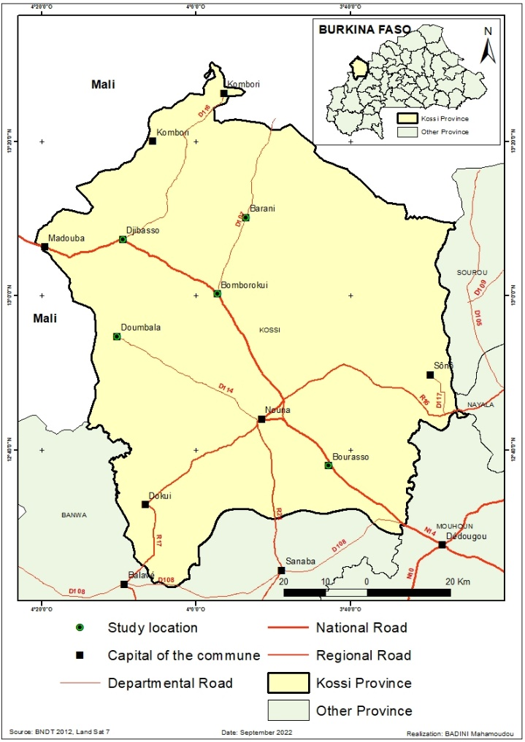

Figure 1. Kossi Province

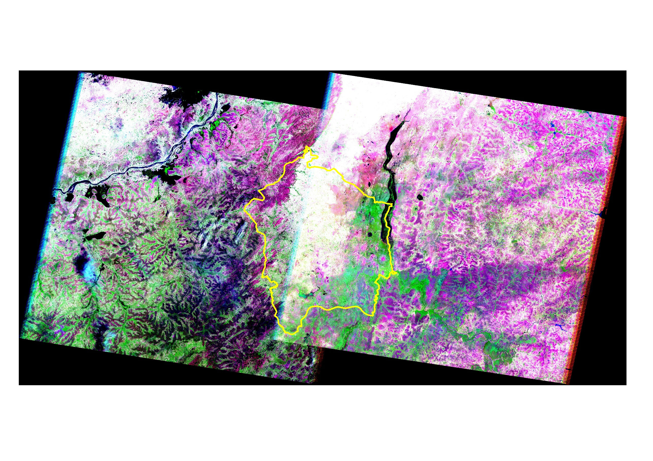
IMAGE LANDSAT TM 2009

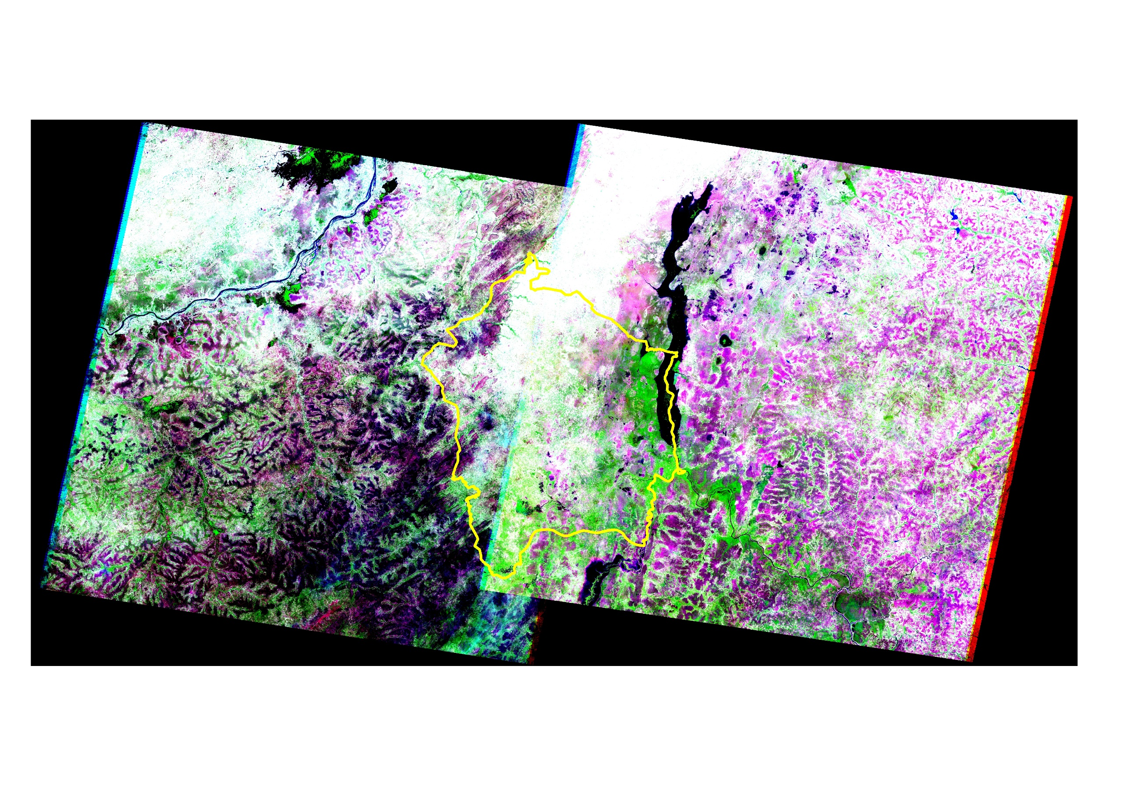
IMAGE LANDSAT TM 1999

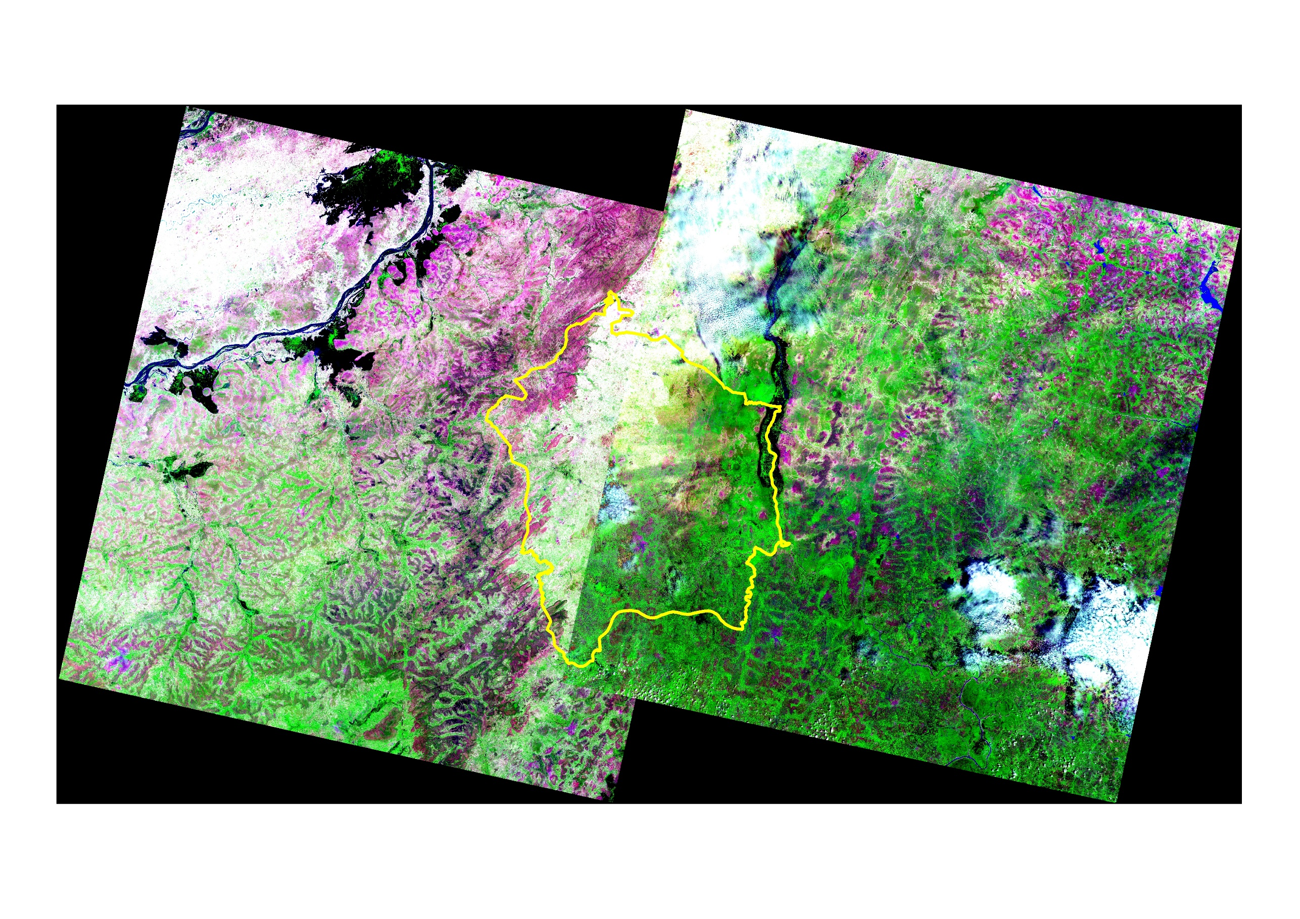
IMAGE LANDSAT TM 2019

Figure 2. LANDSAT TM images 1999, 2009 and 2019
Table 1. Characteristics of the Landsat scenes selected

Path | Row | Acquisition date | Sensor | Mode | Spectral band
 |  |  |  |  | Number of band | Spectral resolution
196 | 51 | 22/10/2000 | LE7 | Multi-spectral | 8 | 30
197 | 51 | 29/10/2000
196 | 51 | 06/10/2009 | LT5 | Multi-spectral | 7 | 30
197 | 51 | 13/10/2009
196 | 51 | 18/10/2019 | OLI | Multi-spectral | 11 | 30
197 | 51 | 26/10/2019
Source: USGS EarthExplorer

These images were processed to generate land use maps using a cartographic approach. We used the image mosaic to merge the two scenes because the study area extends over both images. We also used LANDSAT 8 OLI because it was the best resolution image available in October, replacing an ETM scene whose image quality was not usable at that time. These images date from October 1999, 2009 and 2019. This choice was justified by their availability and quality. In addition, the period chosen made it easier to differentiate between fields and other land-use units. The images were processed using ENVI software. ARCGIS 10.3 software was used to vectorise the various layers and produce the cartographic layout.
Two stages were essential for mapping land use: fieldwork, processing, smoothing and vectorisation of the various land use units. The field trip took place in 2021. It provided the basis for observations and descriptions of the land-use units, as well as GPS measurements of the geographical coordinates used to select the various land-use units. The spatial analysis was completed by surveys of 150 family farmers in the localities of Nouna, Barani, Bomborokui, Bourasso and Djibasso. The choice was made on the basis of the importance of the locality in the process of land-use dynamics and its geographical position. A total of 30 heads of household were surveyed in these localities. These surveys enabled us to get people's views on the dynamics of land use in the study area.

Landsat TM image processing stages:
(i) Pre-processing: this was carried out in two stages: geometric correction and choice of colour composition;
(ii) Geometric correction: for the processing results to be consistent, the images from the different decades must be superimposable;
(iii) Choice of colour composition: the colour composition chosen for image processing was 5/4/3.
(iv) Image processing: the method used for image processing is supervised classification. The classification algorithm used is Maximum Likelihood.

This method is based on a priori knowledge of the area studied. The classes and their spectral characteristics are defined before classification on the basis of training sites which are representative samples of the classes: post-processing; smoothing and vectorisation.

Results

Figure 2 shows the Dynamics of land occupation and use in Kossi province in 1999, 2009 and 2019.

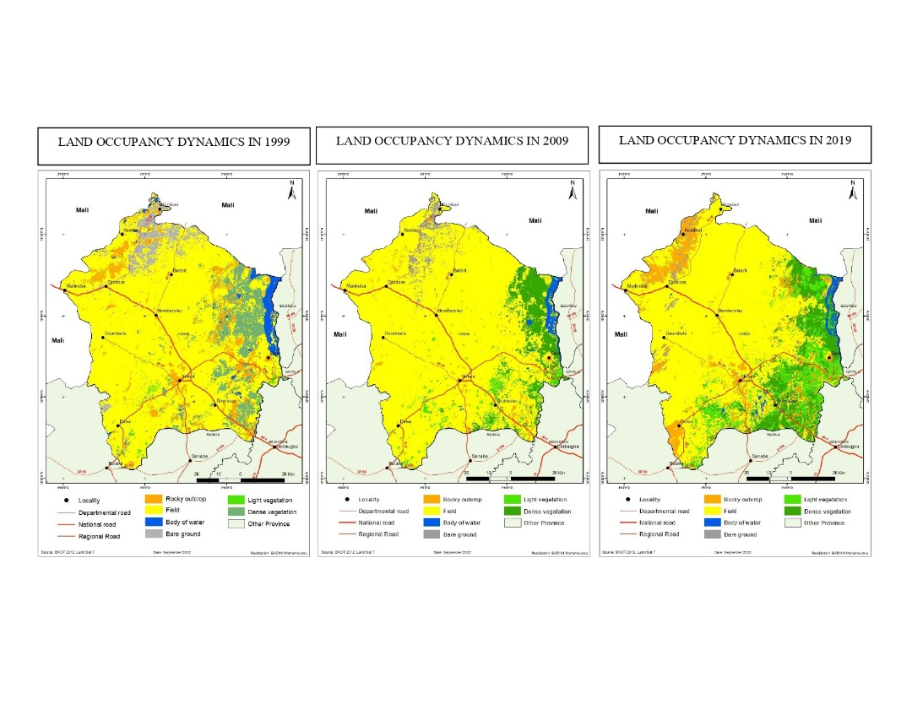
Figure 2. Dynamics of land occupation and use in Kossi province in 1999, 2009 and 2019
Land cover in 1999

In 1999, natural formations (dense, open vegetation) occupied 79,225 ha, or approximately 10.70% of the province's surface area (Figure 2-A). They are concentrated in the north-eastern and south-eastern parts of the province. At that time, human activity for agricultural purposes was very firmly rooted in the province. Fields accounted for 74.11% and were scattered throughout the province. Vegetation barely extended beyond rocky outcrops, which covered 8.30% of the province. Bare soil (4.39%) was found in the north and extreme south-west of Kossi province. Water (2.50%) was located in the flood zone (Figure 3).

Figure 3. Land use units in 1999

Land cover in 2009

Calculations based on the 2009 land cover map show that fields occupied 84.48% (Figure 2-B) of the provincial area. They were scattered throughout the study area. Natural formations (dense, open vegetation) accounted for more than 10% and were concentrated in the central-eastern and extreme south-eastern parts of the province. Water (1.35%) was located in the central-eastern part of the province and in the flood zone. Bare soil (2.19%) was located in the north of the province in the Kombori region. Rock outcrops (1.52%) were scattered throughout the study area (Figure 4).

Figure 4. Land use units in 2009
Land use in 2019

In 2019, natural formations accounted for 20.5% (Figure 2-C) and were located in the south-east, central-east and north-east of the study area. The fields (67.66%) were spread throughout the province. Bare ground (1.04%) was located in the north-west of the Kossi. Rocky outcrops (9.38%) were concentrated in the north-west of the province, while water occupied only 1.42% of the provincial surface area (Figure 5).

Figure 5. Land use units in 2019

Changes in land use

Changes in land use from 1999 to 2009

A review of the period from 1999 to 2009 shows that natural formations (light, dense vegetation) declined by 21.33%, as they are the most heavily exploited for agricultural purposes. Over the same period, man-made formations (fields) increased by 14%. The province of Kossi is a potentially agricultural area, with cereal, fruit and cash crops. The water level also fell by more than 45%, reflecting the intensity of rice-growing activities in the area. Rocky outcrops and bare soil have declined by 81% and 50% respectively.

Changes in land use from 2009 to 2019

The balance sheet for the period 2009 to 2019 shows that natural formations increased by 19.15% at the expense of man-made formations. According to 87.10% of those surveyed in the field, fallow fields accounted for 37.10% of agricultural land during the same period. This situation has led to an increase in natural formations. Anthropogenic activities are the main causes of the degradation of the vegetation cover in Kossi province, following fieldwork carried out with local people. The practice of extensive, space-consuming agriculture by the majority (97.23%) of the population, using unsuitable farming techniques, is the source of the decline in natural formations. Bare soil has declined by more than 40%, reflecting the fact that people are using techniques to reclaim degraded land. Indeed, 78.27% of respondents practise these methods. These land reclamation methods are based on depositing organic manure (family farmers put two handfuls of organic manure, generally animal excrement, in the basins as soon as the rains begin, i.e. in May. Attracted by the organic manure, termites dig galleries in the basins. The water from the first rains creates very deep pockets of moisture in the troughs that resist evaporation), stone cordons (this consists of judiciously aligning the stones across the field following the contour lines. The principle of stone cordons is to slow down the speed of groundwater run-off, to infiltrate as much of this water as possible into the soil, and to evacuate excess water), and agroforestry.

Changes in land use from 1999 to 2019

The balance sheet for the period 1999 to 2019 shows an increase in man-made formations (fields) of more than 24%, while natural formations have declined by 21%. In fact, the practice of vegetation fires (87% of respondents) and the increase in the area sown (77.77% of respondents believe they increased the size of their fields during the analysis period) are the source of the decrease in vegetation cover in the area, as shown in Tables 2, 3 and 4 respectively of the confusion matrices for the classification of the LANDSAT TM 1999, 2009 and 2019 images.

Table 2. Confusion matrix for the classification of the LANDSAT TM 1999 image

Occupancy units | Lake | Field | Rocky outcrop | Bare ground | Dense vegetation | Light vegetation | a | b
Lake | 108.00 | 0.00 | 0.00 | 0.00 | 1.00 | 0.00 | 1.82 | 98.18
Field | 1.00 | 109.00 | 2.00 | 0.00 | 1.00 | 2.00 | 0.91 | 99.09
Rocky outcrop | 1.00 | 0.00 | 89.00 | 5.00 | 2.00 | 0.00 | 21.93 | 78.07
Bare ground | 0.00 | 0.00 | 23.00 | 126.00 | 0.00 | 0.00 | 3.82 | 96.18
Dense vegetation | 0.00 | 1.00 | 0.00 | 0.00 | 131.00 | 3.00 | 4.38 | 95.62
Light vegetation | 0,00 | 0.00 | 0.00 | 0.00 | 2.00 | 130.00 | 3.70 | 96.30
Total | 110.00 | 110.00 | 114.00 | 131.00 | 137.00 | 135.00 | - | 93.91
c | 0.92 | 5.22 | 8.25 | 15.44 | 2.96 | 1.52 | - | -
a : Error of omission (%) ; b : Overall accuracy (%) ; c : Commission error (%)

Table 3. Confusion matrix for LANDSAT TM 2009 image classification

Occupancy units | Lake | Field | Rocky  outcrop | Bare ground | Dense vegetation | Light vegetation | a | b
Lake | 143.00 | 0.00 | 1.00 | 5.00 | 2.00 | 3.00 | 2.05 | 97.95
Field | 0.00 | 111.00 | 1.00 | 0.00 | 0.00 | 0.00 | 0.00 | 100.00
Rocky outcrop | 0.00 | 0.00 | 112.00 | 0.00 | 0.00 | 0.00 | 1.75 | 98.25
Bare ground | 3.00 | 0.00 | 0.00 | 102.00 | 0.00 | 0.00 | 4.67 | 95.33
Dense vegetation | 0.00 | 0.00 | 0.00 | 0.00 | 135.00 | 0.00 | 1.46 | 98.54
Light vegetation | 0.00 | 0.00 | 0.00 | 0.00 | 0.00 | 108.00 | 2.70 | 97.30
Total | 146.00 | 111.00 | 112.00 | 107.00 | 137.00 | 111.00 | - | 97.90
c | 7.14 | 0.89 | 0.00 | 2.86 | 0.00 | 0.00 | - | -
a : Error of omission (%) ; b : Overall accuracy (%) ; c : Commission error (%)

Table 4. Confusion matrix for LANDSAT TM 2019 image classification

Occupancy units | Lake | Field | Rocky  outcrop | Bare ground | Dense vegetation | Light vegetation | a | b
Lake | 011.00 | 0.00 | 0.00 | 0.00 | 0.00 | 0.00 | 0.00 | 100.00
Field | 0.00 | 860.00 | 0.00 | 0.00 | 0.00 | 0.00 | 0.00 | 100.00
Rocky outcrop | 0.00 | 0.00 | 837.00 | 0.00 | 0.00 | 0.00 | 0.00 | 100.00
Bare ground | 0.00 | 0.00 | 0.00 | 574.00 | 0.00 | 0.00 | 0.00 | 100.00
Dense vegetation | 0.00 | 0.00 | 0.00 | 0.00 | 026.00 | 0.00 | 0.00 | 100.00
Light vegetation | 0.00 | 0.00 | 0.00 | 0.00 | 0.00 | 641.00 | - | 100.00
Total | 011.00 | 860.00 | 837.00 | 574.00 | 026.00 | 641.00 | - | 100.00
c | 0.00 | 0.00 | 0.00 | 0.00 | 0.00 | 0.00 | - | -
a : Error of omission (%) ; b : Overall accuracy (%) ; c : Commission error (%)

In satellite image analysis, confusion matrices remain a reliable method for checking the accuracy of a classification. They are based on a comparison between the training sites selected and classified by the user and the same training areas reclassified by the image processing software, i.e. after final classification. These comparisons are expressed in percentages. Above 60%, the classification is considered acceptable, and between 70% and 80% the classification is good. Above this level, the classification is extremely reliable. Tables 2, 3 and 4 show that errors of omission and commission are negligible. The classification accuracy is around 93.91%, 97.90% and 100% respectively for the 1999, 2009 and 2019 images (Figure 2). This corresponds to a reliable level of classification.

Discussion

An examination of land-use dynamics (1999, 2009 and 2019) in the province of Kossi in north-west Burkina Faso shows a decline in natural formations (light, dense vegetation) in favour of anthropogenic formations (fields). Between 1999 and 2019, i.e. in 20 years, natural formations declined by 21%. These results are similar to those obtained by Kouya (2010) in south-west Togo, Adjonou et al. (2010) in Togo, Koumoi et al. (2013) in central Togo, Adama (2015) in western Burkina Faso, Kpedenou et al. (2016) in south-eastern Togo, Djohy et al. (2017) in northern Benin, and Nangndi et al. (2021) in Chad.
The work of Millogo et al. (2017) in the Bam province of Burkina Faso, based on the use of aerial photographs, also produced results similar to ours. Interpretation of these aerial photographs from 1982, 1995 and 2008 revealed four land-use units. These are cultivated areas, open savannahs, mounds and bare areas. The authors also show an increase in the surface area of fields to the detriment of natural formations. The results of this research show that the decline in natural formations is mainly due to agro-sylvopastoral activities in the study area.
The diversification of agricultural production with the cultivation of several crops and the practice of various forms of livestock rearing (Sanogo, 2017) are sources of land degradation and, by extension, the decline in plant formations. According to Stoeffler (2009) 'diversification therefore responds to this uncertain world in which farmers produce. First of all, rainfall is uncertain, and affects the different crops and plots unevenly: if, one year, there is not enough water for rice, there may be plenty for millet; conversely, water may flood the millet field but be at an ideal level for rice. There are many types of damage that cannot be anticipated: too much water (25% of plots having suffered damage), not enough water (8%), invasion by weeds (40%), parasites, worms or diseases (17%), attacks by wild (1%) or domestic (2%) animals, etc. The hazards do not only concern rainfall and other sources of crop damage: supply of inputs, including essential ones such as seeds, marketing conditions, starting with prices, but also family problems affecting production, such as death or illness".
These results are shared by Djohy et al (2017). These authors show that plant formations decreased from 173600 ha in 1990 to 165853 ha in 2000 and 141169 ha in 2010, i.e. a regression of 32431 ha (6.75%) between 1990 and 2010, while anthropogenic activities increased their surface area from 61131 ha in 1990 to 68745 ha in 2000 and 92496 ha in 2010, i.e. 14.10%. This decline in plant formations is particularly critical. Wooded savannahs and forests are being destroyed to create arable land, particularly for cotton growing. This destruction of plant cover leads to soil degradation.
The results of this research also showed that the water level had shrunk by more than 45%, reflecting the intensity of rice-growing activities in the locality. Rice production in the province of Kossi is based on water management by local stakeholders. In other words, this spatial management of water enables the players in the rice sector to produce enough to feed the local population and to export surplus production to the rest of the country. T. Houet (2006) agrees. He shows that spatial management of water requires action on a local scale, both in terms of allocating land use and maintaining, restoring or even rehabilitating landscape structures. The success of these actions presupposes a concerted vision of the territories by the various players and managers involved.
The investigations carried out in this study showed that bare soil had been reduced by more than 40%, testifying to the use of techniques to reclaim degraded land by local people. Indeed, 78.27% of those surveyed were using these methods. These restoration techniques have contributed to the practice of agricultural activities on the restored land. For example, T. Leménager et al (2014) report that in the community savannah in the north-east of Limpopo province, South Africa, environmental degradation, resulting from the uncontrolled extraction of natural resources (firewood, medicinal plants, grazing) exacerbated by poverty, has reached record levels, endangering the national park, an emblem of global biodiversity conservation. To remedy this situation, the authors report that in 2004, the local non-governmental organisation (NGO) Africa's Rural Initiatives for Sustainable Environments (ARISE) launched a Restoration of Natural Capital (RNC) operation with the aim of enabling these communities to obtain a whole range of goods and services (fertile soil, regulation of water flow, water purification, etc.) and to adopt new methods of land management.
All in all, the province of Kossi is witnessing a decline in natural formations (degradation of the plant cover) in favour of anthropised formations characterised by an increase in the number of plots of cultivated land. It would therefore be desirable for local stakeholders to put in place a local agreement to ensure the sustainable and equitable use of natural resources in Kossi province.

Conclusion

Investigations into the dynamics of land use in the province of Kossi, in north-west Burkina Faso, over the periods 1999, 2009 and 2019, using satellite images, reveal the existence of six land use units (rocky outcrops, fields, bodies of water, bare soil, light vegetation, dense vegetation). Diachronic analysis shows a regressive trend from natural formations to man-made formations. In the space of 20 years, natural formations have lost 21% of their surface area. At the same time, man-made formations have increased in area by more than 24% over the 20 years of diachronic study. This increase is due to agro-sylvo-pastoral activity, which consumes space and consequently destroys vegetation.
In addition, the cartographic approach combined with the use of geographic information systems and remote sensing has shown that satellite images are essential for characterising and analysing the environmental dynamics of the Kossi province. It would be wise for the public authorities to take these aspects of land-use dynamics into account in their development programmes, in order to improve the living and working conditions of the local population.

References

Adama, K. (2015). Rural landscape dynamics and production systems in the rural commune of Orodara (Western Burkina Faso) [Master dissertation, Paris 1 Panthéon-Sorbonne University].
Adjonou, K., Djiwa, O., Kombate, Y., Kokutse, A.D., & Kokou, K. (2010). Study of the spatial dynamics and structure of relict dense dry forests in Togo: Implications for the sustainable management of protected areas. International Journal of Biological and Chemical Sciences 4(1), 168-183.
Bene, A., & Fournier, A. (2014). Natural vegetation and land use in Burkina Faso (West Africa). Five decades of change in one part of the country s m. Gwenaëlle FABRE, Anne FOURNIER, Lamine SANOGO. Crossed scientific perspectives on global change and development- Language, environment, culture: proceedings of the Ouagadougou International Colloquium (8-10 March 2012), Sciencesconf.org, <hal-00939898>, 143-164.
Biga, I., Amani, A., Soumana, I., Bachir, M., & Mahamane, A. (2020). Spatio-temporal dynamics of land use in the communes of Torodi, Gothèye and Tagazar in the Tillabéry region of Niger. International Journal of Biological and Chemical Sciences, 14(3), 949-965.
Crutzen, F. (2017). Multi-sensor approach for remote sensing mapping of woody resources in Wallonia: application to the commune of Paliseul. [Master dissertation, University of Liège]. MatheO (Master Thesis Online). http://hdl.handle.net/2268.2/2964.
Djohy, G. L., Totin Vodounon, H. S., & Kinzo, N. E. (2017). Dynamics of land use and changes in agricultural land in the commune of Sinende in northern Benin. Noteb CBRST Lett Human Soc Sci, 9, 101–121
FAO (Food and Agriculture Organization). (2022). The State of the World's Forests 2022. Forest solutions for a green recovery and inclusive, resilient and sustainable economies. Rome, FAO.
Heymann, Y. (1978). Inventories of natural resources using satellite remote sensing. SFER Rural economics. Journal of the French Rural Economy Society. 127, Ecology and society, Part Two, 31-34.
Houet, T. (2006). Land use and water management: prospective modelling in a fragmented agricultural landscape (Case study of the Blavet watershed) [Doctoral dissertation, Rennes 2 University].
Koumoi, Z., Alassane, A., Djangbedja, M., Boukpessi, T., & Kouya, A. E. (2013). Spatio temporal dynamics of land use in central Togo. Geography journal of LARDYMES (Research Laboratory on the Dynamics of Environments and Societies), 10, 163-172.
Kouya, A.M. (2010). Environmental change and biodiversity loss in the Akposso mountain environment (south-west Togo) [Doctoral dissertation, University of Lomé].
Kpedenou, K. D., Ahe, P., & Boukpessi, T. (2016). Spatial and temporal dynamics of land use/occupation in south-east Togo: mapping using spatial remote sensing. Geography journal of LARDYMES (Research Laboratory on the Dynamics of Environments and Societies), 16, 131-143.
Leménager, T., Bougnoux, N., Roques, N., & Martin, C. (2016). Demographic dynamics, environmental degradation and ecological restoration: challenges and opportunities. Research report, AFD - French Development Agency, 2014, HAL Id: hal-01252072 https://hal.archives-ouvertes.fr/hal-01252072.
Mballo, I., & Sy, O. (2019). Spatio-temporal dynamics of agrarian landscapes in Upper Casamance (Senegal). Geographic Space and Moroccan Society, 30, 39-56.
Millogo, B., Nikiema, A. B., Koulibaly, B., & Zombre, N. P. (2017). Analysis of changes in land use based on aerial photographs of the locality of Loaga in the province of Bam, Burkina Faso. International Journal of Biological and Chemical Sciences, 11(5), 2133-2143.
MEF (Ministry of Economy and Finance). (2010). Burkina Faso National Spatial Development Plan. Report N04 Cartographic atlas. Burkina Faso.
Nangndi, B., Avana Tientcheu, M. L., Etchike Dong, A. B., Wouokoue Taffo, J. B., Delanot Tanougong, A., & Fonkou, T. (2021). Spatio-temporal dynamics of land use in the Sudano-Guinean zones of Chad: the case of the Larmanaye ecological landscape. Journal of Applied Biosciences, 160, 16536-16552.
Sanogo, S. (2017). Social and economic dimension of sesame (Sesamum indicum L.) cultivation in Kossi, north-west Burkina Faso [Doctoral dissertation, Université Ouaga 1 Profesor Joseph Ki-Zerbo].
Sparfel, L. (2011). Study of land use changes in the coastal zone using heterogeneous data: application to the Brest region [Doctoral dissertation, University of Bretagne Occidentale].
Stoeffler, Q. (2009). In the land of failing markets: how do farmers react to price signals? Interactions between production factors and marketing conditions in Nouna, Burkina Faso.[Master dissertation, Sciences-Po].
Tchankadéhoun Kiansi, M., Kouta, S., Mazo, I., Arouna, O., Thomas, O., & Toko Imorou, I. (2021). Spatio-temporal dynamics of agrarian spaces in the Pendjari community of communes in north-west Benin. IJPSAT International Journal of Progressive Sciences and Technologies, 25(2), 98-108.

