Application of the Chinese Dunhuang algae well pattern in contemporary architecture design: A review paper

Liu Hui, Liza Marziana Binti Mohammad Noh, Haslinda Abd. Razak

College of Creative Art, University Teknologi MARA

Correspondence: Liu Hui (email: 2021591745@student.uitm.edu.my)

Received: 11 May 2024; Accepted: 30 July 2024; Published: 29 August 2024

Abstract

This study aims to deeply analyze the symbolic meaning of the caisson patterns in the Mogao Grottoes in Dunhuang, China, and explore their innovative application potential in modern architectural design. As a unique carrier of culture and art aesthetics of Han and Tang dynasties, Dunhuang caisson pattern provides a valuable source of inspiration for modern architectural design with its rich symbolic elements and profound cultural connotation. This study uses the comprehensive research method of literature review, pattern semiotics and visual linguistics to systematically identify and deeply interpret the Dunhuang caisson patterns, revealing their profound integration with Han and Tang culture and artistic aesthetics. It is found that the symbolic elements of Dunhuang caisson pattern can be divided into two categories: natural elements and geometric elements. These elements not only have unique cultural connotations, but also inspire innovation in modern architectural design. The typical application cases of Dunhuang caisson pattern in modern architectural modeling design are collected, and the design effect is analyzed and evaluated in detail. The display of these cases provides a new way of thinking and practice for the integration of caisson pattern and contemporary aesthetics. The ultimate meaning of this study is to emphasize, protect and promote the Chinese Dunhuang caisson patterns. Through in-depth analysis, it can inject more cultural elements and innovative vitality into modern architectural design, and provide practical insights and new sources of inspiration for architectural project designers, which will help promote the innovative application and development of cultural heritage in contemporary society.

Keywords: Dunhuang algae well pattern, innovative design, modern architecture, traditional motif

Introduction

The Dunhuang caisson pattern in China refers to a decorative pattern found in the murals of the Dunhuang Mogao Grottoes, typically appearing at the ceilings inside caves. It presents various forms of patterns, including flowers, animals, and geometric shapes, and is considered an outstanding representation of ancient Chinese mural art (Cao, 2022). The history of Dunhuang caisson patterns can be traced back to the 4th century AD, originating during the Han and Tang dynasties as a product of Buddhist art. It represents a fusion of Buddhist culture, religious beliefs, and artistic aesthetics, constituting a precious component of China's ancient cultural heritage. Its significance lies not only in being one of the representative works of ancient Chinese mural art but also as a treasure in the history of world cultural and artistic heritage (Wang, 2022). Dunhuang caisson patterns not only showcase the essence of Chinese traditional culture and outstanding artistry but also reflect cultural exchanges and integration between China and regions such as Central Asia and India. They possess high historical, cultural, and artistic value, earning recognition as a crucial part of the "Eastern Art Treasury" (Li, 2022).
Furthermore, Dunhuang caisson patterns have significant implications and influences on the field of modern architectural design. The rich and diverse pattern symbols presented by these patterns can provide designers with inspiration for decorative design styles representing traditional Chinese architectural aesthetics (Cai, 2016). They help extract unique cultural connotations and artistic values from fundamental pattern elements. Therefore, studying the symbolic and cultural significance of Dunhuang caisson patterns and their application in modern architectural decorative design holds both theoretical and practical importance (Dang, 2017).
Despite the profound historical and cultural significance of Dunhuang caisson patterns, their application in contemporary architectural design remains underexplored. This study aims to bridge this gap by analyzing the symbolic meaning of these patterns and exploring their potential applications in modern architectural environments.
The research question in this study is: How can the symbolic meanings of Dunhuang caisson patterns be identified and applied innovatively in contemporary architectural decorative design? By addressing this question, the study aims to derive individual representative meanings of caisson pattern symbols, reconstruct their symbolic meanings, and deeply analyze the application of pattern semiotics theory in the research of pattern styling art, providing new ideas and methods for the inheritance and application of traditional Chinese patterns.

Literature review

The study of Dunhuang caisson patterns, particularly those found in the Mogao Grottoes, provides valuable insights into traditional Chinese art and its contemporary applications. These patterns, known for their intricate designs and vibrant color palettes, have been a focal point of scholarly research, revealing their unique artistic features and symbolic meanings. The following review synthesizes existing literature on the historical background, symbolic interpretation, and modern applications of Dunhuang caisson patterns, while also addressing ongoing challenges in their contemporary usage.
Dunhuang patterns, particularly caisson patterns, showcase beautiful elements and a vibrant color palette, creating a strong visual impact. Scholars in China have intensively researched these patterns in the 20th century, conducting detailed classification, identification, and analysis. This research has unveiled the unique artistic features and symbolic meanings of these patterns, demonstrating the specific symbolic significance of different pattern elements within the broader context of traditional Chinese art and culture (Li, 2022). Early studies by Zhao (2008) and Wang (1989) provided foundational classifications of caisson patterns, highlighting their evolution from the Han to Tang dynasties and their integration of Buddhist motifs.
Semiotics, the study of symbols and their meanings, plays a crucial role in interpreting Dunhuang caisson patterns. Scholars widely apply semiotic theories to delve into the symbols within these patterns, unraveling their symbolic meanings for a better understanding and appreciation of these artistic works. Semiotic theories also help reveal hidden symbols and meanings in artworks. Through a detailed analysis and interpretation of the symbols, a deeper layer of meaning is often discovered. In Dunhuang caisson patterns, different symbols hold specific meanings and historical-cultural backgrounds, conveying unique cultural and religious messages through their symbolic language (Jiang, 2022). Recent advancements in semiotic analysis by Chen (2015) and Liu (2018) have further detailed the religious and philosophical underpinnings of these patterns, linking them to broader cultural narratives.
The patterns of Dunhuang caisson patterns find extensive application in various fields of modern design, including architectural decoration, fashion design, jewelry design, and graphic design. In architectural decoration, Dunhuang caisson patterns are commonly used on ceilings, walls, and floors, serving as decorative elements (Dong & Shi, 2020). Designers extract and redesign the main pattern elements to create a unique style, contributing to both the preservation of traditional culture and its reinterpretation. In fashion design, designers innovate by modifying the original patterns, applying them to clothing made of different materials, showcasing a harmonious blend of traditional pattern culture and contemporary design. In jewelry design, Dunhuang caisson patterns serve as distinctive design elements, abstracted and simplified for application on necklaces, bracelets, and earrings, resulting in unique decorative effects. In graphic design, these patterns, along with their colors, are rearranged and applied to covers, posters, and brochures, reflecting the cultural richness of traditional Chinese art (Zhao, 2022). Notable case studies include the work of Zhou (2016) in architectural integration and the fashion collections by Dong & Shi (2020), which illustrate the versatility and modern appeal of these traditional motifs.
Despite the widespread application of Dunhuang caisson patterns in modern design, some challenges persist. Formally, there is a tendency towards excessive traditionalism, relying too heavily on the established forms of traditional elements, limiting the innovation of patterns (Guo, 2022). Stylistically, the application of Dunhuang caisson patterns appears scattered, lacking systematic and holistic design, potentially causing visual confusion and weakening spatial perception. Additionally, choices in color and material need to align more closely with modern aesthetic preferences and practical requirements to better suit the trends in contemporary architecture. Addressing these challenges will enhance the artistic charm of Dunhuang caisson patterns in modern architectural design. Scholars such as Yang (2015) and Zhou (2016) have proposed more integrative approaches that balance traditional aesthetics with contemporary design principles, aiming to overcome these challenges.
The comprehensive study of Dunhuang caisson patterns not only enriches our understanding of traditional Chinese art but also provides innovative pathways for their integration into modern design practices. While challenges remain, continued research and creative experimentation promise to enhance the relevance and appeal of these ancient motifs in contemporary settings. This ongoing dialogue between tradition and modernity underscores the enduring significance of Dunhuang caisson patterns in the global design landscape.

Methodology

This study adopts a combined methodology of literature review, semiotics of patterns, and visual linguistics to systematically analyze the symbolic meanings and cultural connotations of Dunhuang caisson ceiling patterns. The images used in the research are sourced from "Dunhuang Caisson Pattern Atlas" (Yang & Jin, 2020, Zhejiang People's Fine Arts Publishing House), as on-site image collection is not feasible due to the need for cultural heritage conservation.
Firstly, through a systematic literature review, a comprehensive understanding of the historical background, artistic features, and modern design applications of Dunhuang caisson ceiling patterns is gained. Based on the theory of semiotics of patterns, the study extracts the primary symbolic elements from the Sui and Tang Dynasties caisson ceiling patterns in the Mogao Grottoes of Dunhuang, categorizing them into natural element symbols and geometric element symbols. Combining historical documents and semiotic theories, the symbolic meanings of each symbol are explained in detail.Simultaneously, utilizing relevant theories from visual linguistics, the study analyzes the visual communication elements such as the composition and form of Dunhuang caisson ceiling patterns, explores their influence and significance in the field of architectural design, and assesses their visual effects and symbolic meanings in modern architectural designs. Moreover, by collecting cases of modern architectural designs in China that apply Dunhuang caisson ceiling patterns, the study conducts detailed analyses and evaluations of these cases, exploring their design effects and cultural connotations, and providing references for future designs.
The methodology of this study combines theoretical research with practical application analysis, delving into the symbolic meanings and design application effects of Dunhuang caisson ceiling patterns through the intersectional application of semiotics of patterns and visual linguistics. By applying these findings to modern architectural styles with unique cultural characteristics, the study contributes to the preservation and promotion of traditional Chinese Dunhuang culture and art, and provides new design concepts and insights for the field of architectural decoration design.

Results and discussion

Identification and symbolic meanings of key patterns

The symbols within Dunhuang caisson patterns carry their unique historical and cultural backgrounds, widely applied and endowed with profound symbolic meanings in Chinese culture. To understand the symbolic significance of these patterns, it is essential to delve into the historical and cultural contexts of these symbols (Feng, 2019). The Dunhuang caisson patterns are rich in symbolic imagery, with each symbol bearing specific cultural connotations. The application of these symbols allows designers to intuitively convey deep-seated information and emotions. Following observation and classification of algae well pattern symbols from the Sui to Tang dynasties in the Dunhuang Mogao Caves, a detailed analysis of individual symbols was conducted. These symbols were then collectively summarized, and associations between different categories were explored. Ultimately, caisson patterns within the defined dynastic boundaries were identified, primarily categorized into two groups: natural element symbols and geometric element symbols. The major symbols within each category represent distinct symbolic meanings, as outlined below:

Table 1. Classification of main identification symbols of natural elements and interpretation of their symbolic meanings

Category | Category subdivide | Symbolic example |  |  | Pattern source | Symbolic meaning
Natural  element | Abiotic  element | Auspicious cloud  pattern |  | 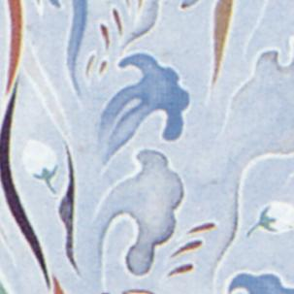 | Cave 407 | Be promoted  to a higher  position  As one  wishes
 |  | Water  streak |  | 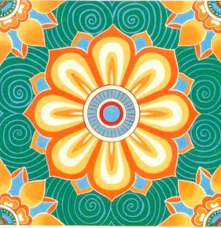 | Cave 386 | Longevity Permanent
 |  | Flame  pattern |  | 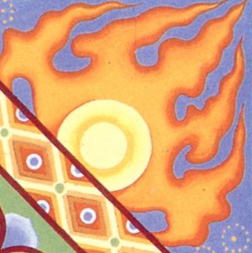 | Cave 398 | Enthusiasm Invigoration
 |  | Jewel  pattern |  | 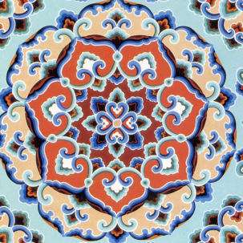 | Cave 355 | Wealth and  rank  Demure
 |  | Vegetal pattern | Lotus design | 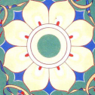 | Cave 293 | Chaste Elegance
 |  | Vegetal pattern | Garnet  pattern | 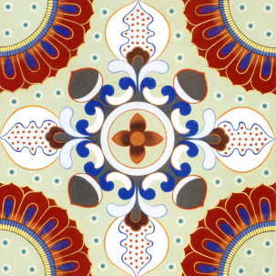 | Cave 373 | Prosperity Happy
 |  | Animal print | Dragon design | 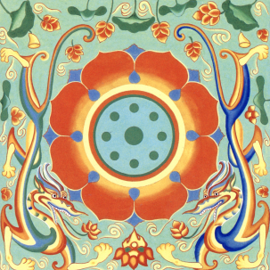 | Cave 392 | Honourable authority
 |  | Animal print | Rabbit design |  | Cave 205 | Propitious harmony
 |  | Animal print | Lion design | 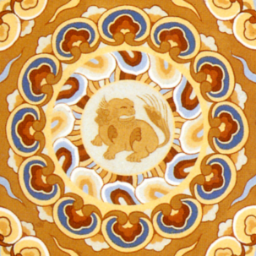 | Cave 85 | Majesty right

Source: The picture is selected from the Dunhuang caisson pattern Atlas, illustrated by Yang Dongmiao and Jin Weidong, 2020

Firstly, the majority of caisson pattern contain some symbols of natural elements, such as plants and auspicious clouds. The symbolic meanings of these elements vary depending on their specific forms and cultural backgrounds.The exploration can start by examining the most frequently occurring plant symbols in caisson pattern.
For example, flowers symbolize life and prosperity. In caisson pattern, floral patterns include lotus patterns, pomegranate flower patterns, vine patterns, and more. The choice and combination of different flower species convey different symbolic meanings.
Lotus holds profound significance in Chinese culture as it grows in mud but remains unstained, often symbolizing purity, nobility, and beauty, signifying elegance and wisdom. In Dunhuang caisson pattern, lotus is typically depicted in full bloom, symbolizing the pursuit of purity and wisdom in spiritual practice. Despite limitations in accessing specific data due to the preservation status of Dunhuang caisson pattern and incomplete research on lotus patterns, existing studies and literature suggest widespread use of lotus patterns in Dunhuang caisson pattern. As a significant cultural symbol, lotus is frequently employed as one of the primary pattern symbols in Dunhuang coffered ceilings, presented either independently or combined with other pattern elements to form intricate designs (As shown in the Table 2).

Table 2. Classification and symbolic meaning interpretation of geometric elements

Lotus pattern | Style | Representative grotto number
 | Eight-petal single-tier large lotus | Cave 392  Cave 401
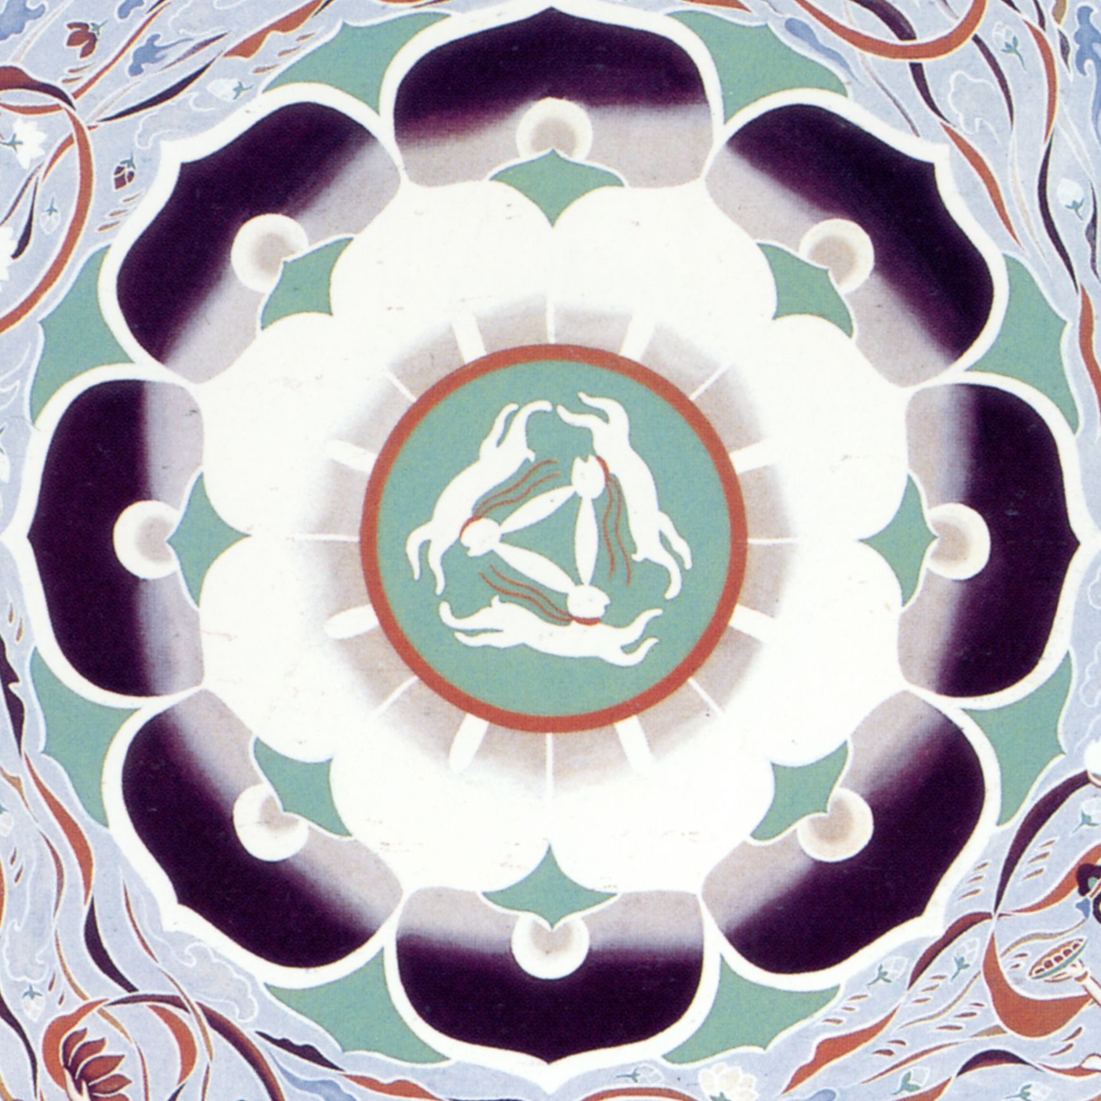 | Eight-petal double-tier large lotus | Cave 390  Cave 407
 | Multi-petal large lotus | Cave 420  Cave 462
 | Intertwined-branch lotus | Cave 390  Cave 397
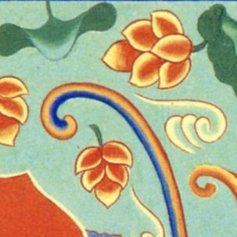 | Individual lotus pattern | Cave 392  Cave 407

Source: The picture is selected from the Dunhuang caisson pattern Atlas, illustrated by Yang Dongmiao and Jin Weidong, 2020
Additionally, in the category of natural elements in Dunhuang caisson pattern, animal patterns, such as dragons, rabbit, and lion, are also common. They carry important symbolic meanings. The "dragon," a crucial totem and symbol in Chinese traditional culture, is prevalent in Dunhuang caisson pattern. The dragon symbolizes power and nobility, representing supreme imperial authority and a myriad of powerful forces. It embodies authority, courage, and wisdom, among other meanings. In caisson pattern, dragons are often depicted flying among clouds or coiling around precious pearls, symbolizing the harmonious aura between heaven, earth, and humanity. The image of "three rabbits sharing one ear" is a representative of animal images in the Dunhuang caisson ceiling.The pattern of "three rabbits with ears" not only shows the spirit and vitality of life, but also signifies auspiciousness and success. The three rabbits echo the idea of three lifetimes, symbolising the cycle of past, present and future lifetimes.
Meanwhile, many abstract geometric shapes appear in the Dunhuang caisson patterns. These geometric patterns are cleverly used in the form of borders or embellishments in the caisson patterns. They not only serve to decorate the main patterns but, based on their stylistic features, also emphasize to varying degrees the symbolism of the central caisson pattern. For example, the three geometric shapes—circle, square, and triangle—each carry distinct meanings. The circle represents perfection, harmony, and eternity; the square signifies stability, balance, and security (Liu & Zuo, 2020); and the diamond-shaped triangles, for instance, represent stability and determination (Wang, 2019) (As shown in the Table 3).

Table 3. Classification and symbolic meaning interpretation of geometric elements

Category | Category subdivide | Symbolic example | Pattern source | Symbolic meaning
Geometric  element | Quadrate | 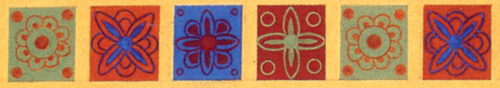 | Cave 393 | Balance  stable
Geometric  element | Roundness | 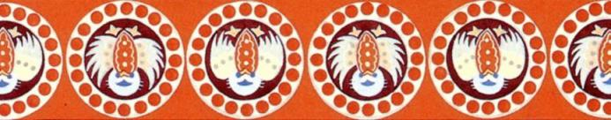 | Cave 401 | Harmony  eternity
Geometric  element | Triangle | 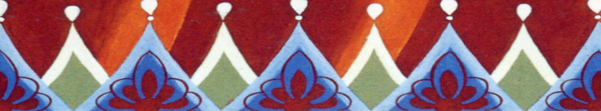 | Cave 393 | Stabilize  firm

Source: The table is drawn by the author himself，The picture is selected from the Dunhuang caisson pattern Atlas, illustrated by Yang Dongmiao and Jin Weidong, 2020

In this regard, these symbols not only serve a decorative purpose in the Dunhuang caisson patterns but also represent specific and rich symbolic meanings. The symbolic meanings of these patterns are closely tied to the historical, religious, and cultural context of that time. A comprehensive understanding and interpretation of these symbols, through a systematic analysis, provide insights into the profound meanings conveyed by the patterns. Simultaneously, this understanding can inspire and guide modern architectural and decorative designs, infusing designs with a richer cultural context and significance. This, in turn, allows users to better comprehend and appreciate the artistic charm of traditional pattern designs when incorporated into contemporary designs. Such improvements aim to popularize the application of traditional pattern designs in the field of architectural decoration, ultimately contributing to the preservation and inheritance of traditional culture.

Interconnection and overall significance construction of pattern symbols

The intricate Dunhuang caisson patterns of the Sui and Tang dynasties reveal a profound interconnectedness among diverse symbols, which collectively shape the overall design and imbue it with layers of rich meaning. This intricate web of symbolism underscores the multifaceted richness of ancient Chinese culture.
At the cultural level, the symbolic correlation construction in these patterns showcases the vast absorption and integration of various cultural elements and beliefs during ancient China. Through the strategic use of symbols, we witness the ancient Chinese people's profound reverence for mythology and legends, reflecting their awe of nature, the universe, and the unknown. These symbols transcend mere artistic representations; they convey the relentless pursuit of values like auspiciousness and harmony, fostering a harmonious balance within a diverse society.
Philosophically, the harmonious coexistence between nature and humanity embodied in these patterns echoes a core concept of ancient Chinese philosophy. Beyond mere aesthetics, the interconnected symbols signify a deeper level of harmony, manifested in people's respect for, adaptation to, and adherence to the natural and cosmic order. This construction also exemplifies the ancient Chinese understanding of moral norms, emphasizing the importance of mutual respect and harmonious relationships with nature, fellow humans, and the universe.
The symbolic interconnectedness in Dunhuang caisson patterns underscores the harmonious beauty that characterizes ancient Chinese aesthetics. This beauty transcends mere visual harmony and exquisite forms; it lies in the profound cultural connotations carried by each symbol. When these symbols are ingeniously combined, they create a unique aesthetic experience that combines formal beauty, visual pleasure, and cultural resonance.
Furthermore, this symbolic interconnectedness offers invaluable insights and inspiration for modern architectural and decorative design. It underscores the idea that design is not merely about form and function but also about the transmission of culture and values. By drawing inspiration from the interconnected symbols in Dunhuang caisson patterns, designers can create contemporary architectural and decorative styles that are deeply rooted in cultural heritage. By incorporating diverse cultural elements and values, designers can go beyond singular pattern designs, fostering a more harmonious and balanced approach to human-nature, society, and self-relationships. Such designs not only cater to visual aesthetics but also touch people's hearts and evoke deeper cultural emotions.
In addition to animal symbols, Dunhuang caisson patterns feature numerous other symbols such as "clouds," "water," and "flowers," each carrying unique symbolic meanings. Clouds symbolize nobility, mystery, and transcendence; water symbolizes life, flow, and change; while flowers symbolize beauty, sacredness, and purity. These symbols also exhibit interrelatedness, seen in combinations like "blending clouds and water" or "blooming flowers bringing prosperity" (as shown in Figure 3). The meanings of these individual elemental symbols, when recombined and constructed, become even more profound and laden with significance.
In the intricate patterns of Dunhuang caisson ceilings, the interconnection of symbols and the construction of overall meaning are vividly demonstrated. Taking the three-rabbit lotus caisson ceiling of Cave 407 (as shown in the Table 4) from the Sui Dynasty as an example, its centerpiece is an eight-petaled lotus flower, symbolizing purity and elegance, while also carrying the meaning of fire prevention. In Buddhist art, it represents the Pure Land. Surrounding the lotus, three rabbits are depicted with their tails connected and ears overlapping, forming a unique pattern known as "three rabbits sharing one ear." This not only adds dynamism to the caisson ceiling but also profoundly embodies the cyclical nature of time and the eternity of life. Encircling the lotus, eight flying gods, hold flowers and dance gracefully, echoing the running rabbits, creating an ethereal atmosphere beyond the mundane world. Furthermore, the caisson ceiling is adorned with border patterns such as lotus and honeysuckle scrolls, as well as pearl-linked bands. These symbols not only enrich the decorative layers of the caisson ceiling but also reflect the exchange and fusion of Chinese and Western cultures. Through the ingenious combination of lotus, three rabbits, flying gods, and border patterns, the entire caisson ceiling constructs a harmonious and profound overall picture, showcasing the ancient Chinese people's aspirations for a better world and the pursuit of eternal life, as well as their open-minded attitude and inclusive spirit towards cultural exchanges between China and the West. This example fully proves the unique artistic value and profound cultural heritage embodied in the interconnection of symbols and the construction of overall meaning in the patterns of Dunhuang caisson ceilings.

Table 4. Artistic interpretation of symbolic integration and overall meaning in the "Three Rabbits Sharing One Ear" caisson ceiling pattern

Caisson ceiling pattern | Local symbols | Symbolic details | Symbolic implications | Overall implications
 | 8-petaled lotus flower |  | Purity  Elegance  Fire Prevention | Symbiosis  Time cycle and life eternal  East meets West
 | 3 rabbits sharing one ear |  | The unending cycle of time  The eternity of life | Symbiosis  Time cycle and life eternal  East meets West
 | 8 Flying Gods |  | Beautiful  Freedom | Symbiosis  Time cycle and life eternal  East meets West
 | Honeysuckle | 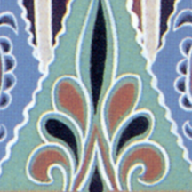 | The Resilience and Perseverance of Life | Symbiosis  Time cycle and life eternal  East meets West

Source: The picture is selected from the Dunhuang caisson pattern Atlas, illustrated by Yang Dongmiao and Jin Weidong, 2020

Application cases of Dunhuang caisson pattern in modern architectural design

Regarding the application of Dunhuang caisson patterns in modern architectural design, in recent years, more and more designers and artists have begun to incorporate Dunhuang caisson patterns into modern architectural design. In the field of architectural decoration, Dunhuang caisson patterns can be applied to building facades, interior decoration, landscape decoration design, and more, creating architectural styles and landscape works with a unique cultural background.
An early and typical artistic design that combines traditional Dunhuang caisson patterns with modern design is the decorative ceiling design by Chang Shana for the banquet hall of the Great Hall of the People in China (as shown in Figures 1 and 2). In 1957, to celebrate the tenth anniversary of the founding of the People's Republic of China, the nation decided to construct buildings such as the Great Hall of the People and the NationalMuseum in Beijing. In this large-scale architectural decoration design, Chang Shana ingeniously and boldly incorporated elements of Dunhuang caisson patterns into the design. When designing the architectural forms of the ceiling of the Great Hall of the People, she used algae well pattern from Dunhuang's Tang Dynasty murals and cleverly selected and recombined plant and geometric pattern elements to create new pattern designs surrounding the chandeliers. Simultaneously integrated with modern architectural decoration materials such as lighting and ventilation, the overall presentation is a dignified and beautifully designed architectural decoration environment. This design scheme immediately received recognition and acclaim from various sectors in the industry and subsequently became a classic example of applying Dunhuang's traditional cultural art to modern architectural decoration.

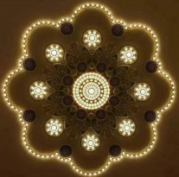

Source: https://baijiahao.baidu.com/s?id=1680038821064099440

Figure 1. Caisson pattern on the top of the Great Hall of the People
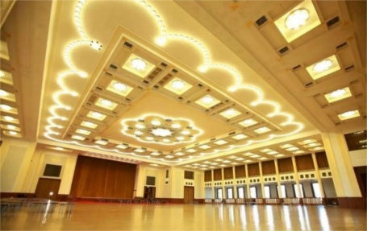
Source: https://baijiahao.baidu.com/s?id=1680038821064099440

Figure 2. Architectural modeling of the ceiling of the Great Hall of the People

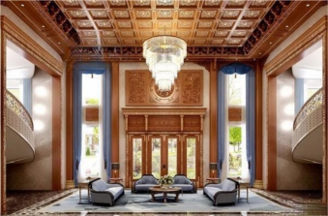

Source: https://www.cnzhengmu.com/news/qiye/32912.html

Figure 3. The application of caisson pattern in the design of Chinese home decoration architecture
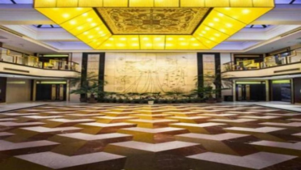

Source: https://www.dunhuangtour.com/cn/dunhuang_picture/19.html

Figure 4. Application of caisson pattern in the architectural design of Dunhuang Hotel Hall

Regarding the application of algae well pattern in modern architectural and decorative design, there is a noteworthy case. This case demonstrates how Dunhuang caisson patterns are cleverly applied in modern home decoration design, creating a strong visual impact. In the decoration design rendering of a traditional Chinese-style villa in the southern region of China (as shown in Figure 3), the use of caisson pattern in the design of high-ceilinged villa interiors is evident. This design accurately and forcefully emphasizes the home decoration style. In a limited space, the designer decorates using caisson pattern featuring completely symmetrical square geometric elements, expanding the sense of space derivation, significantly increasing the spatial perception, and enhancing the visual effect. This design has a considerable visual impact, giving the home decoration work a unique and rich cultural atmosphere.
Moreover, the stylized patterns of Dunhuang’s coffered ceiling designs find applications in the modern decorative design of commercial public spaces. As a significant artistic heritage in Chinese traditional culture, the symbolic and meaningful patterns of Dunhuang's coffered ceiling carry high cultural value, thus generating certain economic value. For instance, in the architectural decorative design at the top of the main hall in the Dunhuang Hotel in China (as shown in Figure 4), designers employed typical pomegranate flower patterns alongside geometric symbols to construct the coffered ceiling pattern. This application effectively and swiftly conveys the traditional cultural atmosphere and specific spiritual and cultural connotations representative of Dunhuang, enhancing the overall building’s cultural taste and ambiance. This grants Dunhuang caisson patterns a distinct cultural identity and robust representativeness within specific commercial architectural spaces.
In summary, the application of Dunhuang caisson patterns in modern design has emerged as a trend. It not only enriches contemporary architectural design styles, enhancing their visual effects with cultural connotations and aesthetic value, but also contributes to the inheritance and promotion of China's unique traditional culture. Field surveys have revealed that these patterns currently possess high visual impact and promising application prospects in contemporary architectural design. Their unique symbols and cultural significance can exert significant market effects, granting traditional patterns extensive prospects and market potential in modern architectural decoration design. However, during the application process, attention should be given to the rationality and cultural adaptability of the meanings conveyed by these pattern symbols, to avoid misunderstandings arising from improper use.

Conclusion

In conclusion, this study, through an analysis of the symbolic meanings of Dunhuang caisson patterns in China and case studies of their application in modern architectural decoration design, has drawn several significant conclusions.
Dunhuang caisson patterns are a form of symbolic art imbued with historical and cultural background. The main symbols carry rich symbolic meanings. When interconnected, these symbols endow the Dunhuang caisson patterns with a complete and even richer symbolic significance. Dunhuang caisson patterns possess extensive practical value in modern architectural decoration design. An in-depth interpretation of the symbols within these patterns allows for the infusion of their cultural and historical significance into modern architectural decoration design, imparting designs with greater cultural depth and value. Simultaneously, this provides modern architectural decoration with fresh creative inspiration and a unique visual impact.Furthermore, based on the collection and review of cases of Dunhuang caisson pattern applications in current architectural decoration design, new design ideas have been summarized. Designers are advised to integrate the symbolic meaning and historical-cultural background of Dunhuang caisson patterns, avoiding simple imitation and superficial application to achieve better design results. This approach expands the application market for traditional pattern styling and allows more people to appreciate and accept it, contributing to preserving a nation's traditional culture.
In summary, this research, through the interpretation of the symbolic meanings of Dunhuang caisson patterns and their exploration in modern architectural decoration design, has unveiled the rich symbolic meaning and value of these patterns. It provides modern architectural decoration designers with new ideas and inspiration, serving as a valuable reference for further exploring the application of Dunhuang caisson pattern styling culture in modern architectural decoration design and for the inheritance and protection of traditional culture.

Acknowledgement

While I have successfully completed this research, I would like to express my sincere thanks to my doctoral supervisors, Dr. haslinda and Dr. Liza. It is their selfless dedication, rigorous academic attitude, and careful guidance that have illuminated my academic path, guided me through countless challenges, and pushed me forward. I would also like to express my special thanks to the reviewers of the Geographic Journal. Their pertinent opinions and valuable suggestions make my research results more complete and perfect, just like a polishing stone. At the same time, there is my classmate Lu Xing, who gave me encouragement and support in the process of research. Here, I would like to express my most sincere thanks to all those who have given me help and support! It is your company and joint efforts that have shaped me into who I am today.

References

Cai, S. H. (2016). Study on Dunhuang caisson pattern and its application in modern design [Doctoral dissertation, Hubei University of Technology].
Cao, J. (2022). Artistic characteristics and application value of caisson decoration symbols in the Sui and Tang dynasties. Yanhuang Geography, 2022(6), 72-74.
Dang, X. (2017). The application of Dunhuang caisson pattern decorative language in modern design [Doctoral dissertation, Ningxia University].
Dong, F. L., & Shi, S. (2020). Application of the Tang Dynasty caisson art in modern clothing design. Fashion Design and Engineering, 2020(2), 1-5.
Feng, G. W. (2019). Study on the application value of Dunhuang caisson pattern in modern design. Western Leather, 41(16), 27-28.
Guo, D. W. (2022). Research on the Redesign of symbolic signs in contemporary Dunhuang caisson pattern - Taking the decoration application of the Great Hall of the people as an example. Design, 35(4), 40-43.
Jiang, X. F. (2022). The application of Dunhuang caisson pattern in modern design. Footwear Technology and Design, 17, 29-31.
Li, C. (2022). Study on the inheritance and development of Dunhuang music and dance art and Chinese traditional culture. Tomorrow's Style: Late, 12, 0021-0024.
Li, C. (2022). Research on the inheritance and development of Dunhuang music and dance art and traditional Chinese culture. Fashion Today: The Second Half, 12, 0021-0024.
Liu, C. M., & Zuo, H. W. (2020). Research and reflection on the application of Dunhuang mural elements in cultural creation. Xinjiang Art (in Chinese), 05, 17- 21.
Li, M. J. (2022). Innovative application of Dunhuang pattern symbols in cultural and creative design. The Work of Nature, 6, 6-8.
Ling, D., Zhang, Q., & Qian, X. (2022). "Otherworldly Space". Shanghai Textile Science and Technology, 2022(7), I0044.
Liu, J. (2014). Application of asymmetric design techniques in Dunhuang mural composition. Big Stage, 2014(7), 15-16.
Lu, H. (2022). Research on the application of traditional patterns in cultural and creative product design. New Silk Road: First Ten Days, 2022(6), 0158-0160.
Wang, C. (2019). The inheritance and innovation of Silk Road patterns in modern design. New West, 12, 102-104.
Wang, G. (1989). Dunhuang pattern research. Northwest Fine Arts, 1989(00), 103-116.
Wang, X. C. (2022). The application and research of Dunhuang auspicious animal pattern in digital illustration design-A case study of the graceful sound [Doctoral dissertation, Anhui University].
Wang, Y. (2017). The influence of color and pattern layout in Dunhuang caisson on painting. Mountains and Seas Classics: Stories (Part 1), 2017(8), 76-76.
Wu, D. (2008). Happy Meeting-The Beauty of Symmetry in Traditional Patterns. Heilongjiang Science and Technology Information, 2008(10), 137-137.
Yang, H. (2015). Application of Symmetry in Traditional Auspicious Patterns in Modern Graphic Design-Taking the Emblem of Shanghai World Expo as an Example. Beauty and Times: Creativity (Part 1), 2015(11), 68-69.
Zhang, J., & Chen, X. (2010). The Evolution of Mogao Grottoes in Dunhuang in the Tang Dynasty Caijing Patterns. Art Grand View, 2010(11), 54-54.
Zhang, L. (2014). Chang Shana and Chinese traditional culture. Journal of Culture &Art Studies, 7(4), 23-28.
Zhang, X., & Dunhuang, M. (2017). An Art Journey About "Cai Well Pattern". Chinese Primary and Secondary School Art, 2017(12), 14-17.
Zhao, H. X. (2022). The application of Dunhuang patterns and nature in modern design -- taking Chang Shana's design works as an example. Beauty and The Times (Part 1), 07, 24-26.
Zhao, S. (2008). The Decoration of the Kingdom of Heaven-One of the Researches on the Decorative Art of Early Dunhuang Grottoes. Decoration, 2008(6), 28-33.
Zhou, F. (2016). Analysis of the application value of Dunhuang caisson pattern in modern design. Popular Literature and Art, 22, 91.

