Dynamics of classified forests in the urban district of Bobo-Dioulasso in Burkina Faso

Valea Françoise¹, Karambiri Bienvenue Lawankilea Chantal Noumpoa², Sanou Korotimi³

¹Joseph KI-ZERBO University, Ouagadougou, Burkina Faso
² National Institute of Sciences and Societies, Burkina Faso
³Norbert ZONGO University, Koudougou, Burkina Faso

Correspondence: Sanou Korotimi (email: sanoukoro77@gmail.com)

Received: 2 June 2024; Accepted: 18 November 2024; Published: 29 November 2024

Abstract

In Burkina Faso, the natural environment is subject to continuous degradation of its forest resources. If the phenomenon is recurrent in rural areas, urban forests are considered to be land reserves that are exposed to exploitation rather than to the preservation of the environment and its biodiversity. To remedy this, Burkina Faso developed a policy for the development of classified forests in 1981, to guarantee balanced exploitation of its forest resources. Such initiatives, combined with the decentralization of power to local authorities over the past three decades, require a closer look at the development of classified forests in the context of climatic variability. The classified forests of Dinderesso and Kua, located in the urban commune of Bobo-Dioulasso, are illustrative cases. The objective of this study is to analyze the factors that contribute to forest degradation and the management practices adopted by stakeholders and community groups. A diachronic study was carried out on the dynamics of plant cover in the classified forests of Dinderesso and Kua in 1988, 2003 and 2018, coupled with an analysis of climatic parameters (1988-2018). The results show that the agricultural production system, the cutting of wood for energy, pastoral practices, and water stress linked to rising temperatures have a negative impact on the development of peri-urban forests. A diachronic analysis of land use units reveals an improvement in forest resources thanks to participatory management by local people, supported by development activities carried out by projects.

Keywords: Burkina Faso, Bobo-Dioulasso, classified forests, degradation, participatory management, Peri-urban

Introduction

With a very fragile ecological environment, Burkina Faso is faced with environmental problems that have become increasingly pronounced since the 1970 drought. Natural ecosystems are thus subject to the dynamics linked of climate change, particularly persistent droughts. The various reports by the Intergovernmental Panel on Climate Change (IPCC, 2007) highlight that the impacts of climate change could have significant consequences for the growth and survival of forest stands. Added to this is the complexity of the various substantial factors in forest degradation. These are essentially the clearings linked to the expansion of farmland, the consumption of wood for energy, and population growth. Furthermore, Africa is the continent where the use of wood as a source of domestic energy will continue to grow over the coming decades (Gueye, 2000). However, one of the objectives of the management of classified areas around urban centers in Burkina Faso is to meet the wood-energy needs of the population. This is the case of the peri-urban classified forests of the city of Bobo-Dioulasso. However, it is imperative to note that the harvesting of forest resources exceeds their capacity for renewal (Dessay, 2006). Therefore, it is necessary for those involved in development to find the right balance between urban development and protecting the resources of classified forest estates around towns. In view of this loss of forest resources, in 1981 Burkina Faso formulated a policy for the development of classified forests to reduce the difficulties associated with forest management. The aim of this policy is to guarantee balanced exploitation of the country's forest resources (Sanou, 2010). But the challenge remains the control of space and the management and protection of the environment. Decentralization is the framework through which this policy is implemented. It gives territorial or local authorities the right to administer themselves freely, to promote grassroots development, and to strengthen local governance. One of the powers and responsibilities transferred from the central government to local authorities is the management of forestry resources. This policy is accompanied by the Schemas Directeurs Amenagement and Urbanisme (SDAU). Bobo-Dioulasso's SDAU aims to harmonise the development of the local.
Despite these measures, the preservation of classified forests in Burkina Faso still faces many difficulties. Those of Dindéresso and Kua in the commune of Bobo-Dioulasso are illustrative given the increasing degradation of their resources. The objective of this research is to determine the factors of degradation of the peri-urban forests of Dindéresso and Kua. A systemic approach combined with geomatics tools has made it possible to take into account all the different geographical elements and the spatio-temporal evolution of forest.

Method and study area

Study area

Located between 11°11' 00'' North longitude and 4°17' 00'' West latitude, Bobo-Dioulasso is the capital of the Hauts Bassins region, Houet province. The classified forests of Dinderesso and Kua are located on the outskirts of the city (Figure 1). The Dinderesso classified forest is located north-west of the city and covers an area of 8,500 ha. It is bounded to the north by national road 09 (RN09) and to the south by regional road 18 (RR18). The Kua classified forest covers an area of 350 ha. It is crossed by the RN1 (Ouagadougou-Bobo-Dioulasso).
The peri-urban nature of the classified forests of Dindéresso and Kua exposes them to accelerated urbanization, which degrades these natural ecosystems, as is the case with the national parks of Banco in Abidjan, Bangr-Wéogo in Ouagadougou, Bangui in the Central African Republic, and their peripheries in recent decades (Gnoumou et al., 2008). The area has benefited from a support project for the participatory management of natural resources in communal forests as part of the cooperation between Burkina Faso and Luxembourg. From 2002 to 2006, the management project focused on the Dinderesso classified area. It was extended from 2006 to 2012 to include the Kua entity in order to improve the resources of these peri-urban forest areas. Currently, these forest formations are undergoing the expansion of the city with its corollaries in real estate needs and employment, all of which rhyme with population growth. For the purposes of the survey in the Dinderesso classified forest, sector 22 of district 7 of the commune and the village of Dinderesso were selected. For the Kua classified forest area, the village of Pala and district 4 (sectors 33) of the same city were selected for the survey. These different localities are in the vicinity of the two forests.

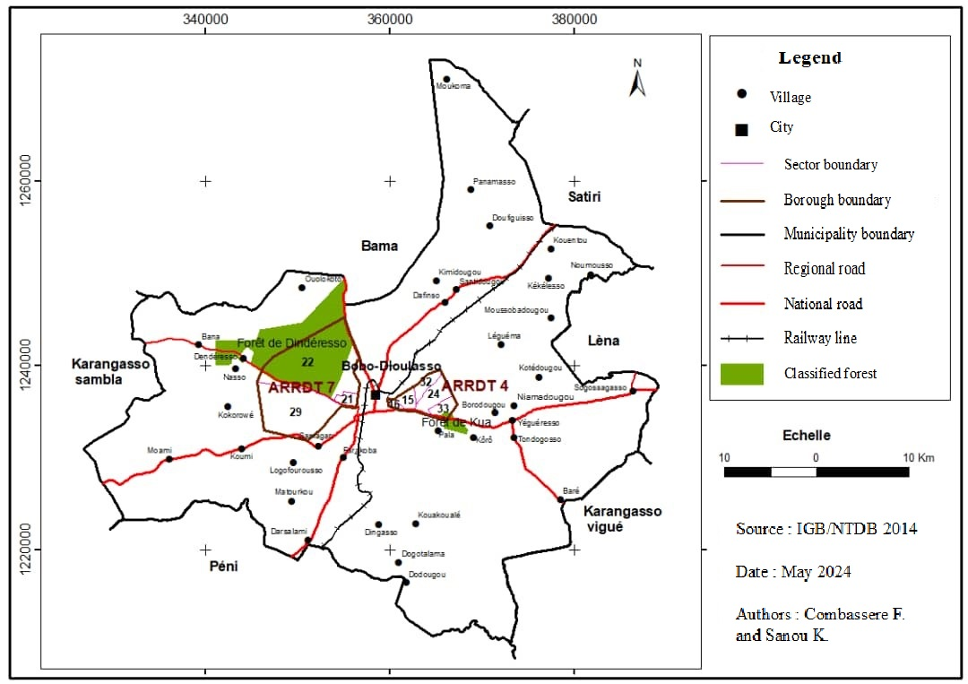

Figure 1. Location of Dinderesso and Kua forests in the commune of Bobo-Dioulasso

Data collection methods

The data required for this study came from a variety of sources. Using Landsat TM and ETM+ satellite images from 1988, 2003, and 2018, a diachronic approach was used thanks to the Geographic Information System (GIS). Indeed, thanks to its ability to store and combine multi-source information, GIS allows for more details on land use patterns and the organization of society, to materialize phenomena and to refine research objectives (Calbérac, 2010; Franchomme, 2010). The National Topographic Database (BNDT) of the Burkina Faso Geographic Institute (IGB) from 2014 was used for map production.
Climatic data was collected on rainfall and temperature, which were collected from Burkina Faso's National Meteorological Agency and cover the period from 1988 to 2018. Socioeconomic data were collected from people living near the two forests through surveys conducted in 2022. Demographic data for the study area were provided by the National Institute of Statistics and Demography (INSD). These are the figures obtained in the latest General Census of Population and Housing (RGPH) for 2019 (INSD, 2020). The open source software GRASS GIS 7 and QGIS 3.10 were used for image processing and mapping. Excel and Sphinx were used for statistical analysis and graphing.

Methods of data processing and analysis

The dynamics of vegetation change require the production of different land use maps for 1988, 2003 and 2018, i.e. three maps per forest based on satellite image processing. Digital image processing involves combining the different image bands and applying colour compositions to each date to better visualise the phenomena. To obtain good results when processing these images, it was essential to combine the bands using remote sensing theories. These are the combination of bands 2-4-5 for Landsat TM (Landsat4 or 5) and the combination of bands 5-4-3 for Landsat ETM + (Landsat 7 or 8). The advantage of this composition is that it allows global treatment of the vegetation due to the low resolution of the satellite images (Landsat has 30 m spatial resolution). The supervised classification algorithm used is the Maximum Likelihood Classifier (MLC) with visual interpretation of the results. Image processing and field surveys allowed us to generate three land cover maps of the forests (specifically Kua and Dindéresso forest) for the periods 1988, 2003, and 2018. Statistical analysis highlighted the transformations that have occurred between the different classes over the different observation periods.
Processing and analysing climatic, socioeconomic and demographic data have enabled us to understand certain spatial changes. For climatic parameters, monthly and annual average data (rainfall and temperature) from 1988 to 2018 have been used to construct the graphs. Trend lines and the Standardized Precipitation Index (SPI) show how climate change is changing and its impact on natural resources (McKee et al., 1993). SPI values above zero indicate surplus years, while those below indicate deficit years compared to the average rainfall (Bergaoui et al., 2001). The demographic dynamics of the area are based on data provided by the INSD and data from surveys of resource persons and the population. Quantitative and qualitative data were collected through individual interviews and focus groups with heads of households in rural areas, urban dwellers living near forests and resource persons (municipal officials and officials from the ministries of the environment, agriculture, and livestock). In all, 150 people were interviewed.

Results and discussion

The analysis is based in part on the state of vegetation and land use in 1988, 2003 and 2018, with climatic, demographic, and socioeconomic factors influencing the appearance of the vegetation cover and consequently the agrarian system. The land-use units identified in Dinderesso and Kua forests during satellite image processing include gallery forest, water bodies, savannahs, heterogeneous and homogeneous forest plantations, agroforestry areas, bare soil, rocky outcrops and fields.

Changes in vegetation coverage in Dinderesso classified forest from 1988 to 2018

In Dinderesso forest, between 1988 and 2003, shrub and treed savannahs were the most dominant units, with irregular evolution, followed by rocky outcrops, fields, and bare ground. Wooded savannah, gallery forest, and lakes are the least important units. Between 2003 and 2018, we note the presence of forest plantations and agroforestry areas that were nonexistent in 1988, and all units have seen a positive change in their initial perimeters with the exception of water bodies, shrub savannahs, and rocky outcrops and fields (Figure 2).

Source: IGB/BNDT, 2014; Landsat ETM 1988, 2003, 2018

Figure 2. Evolution of land use units in Dinderesso forest

These three units have lost areas to agroforestry, gallery forests, heterogeneous and homogeneous forest plantations, tree savannahs, wooded savannahs, grassy savannah, and bare soil. The largest units that have colonized the lakes are the wooded savannah (120.73 ha) and the shrub savannah (136.5 ha) (Figure 3). Rocky outcrops and fields lost surface area to water bodies (141.41 ha) and savannah variants (trees, shrubs, and grass) (1,492.59 ha).
During the period 1988-2018, the units of Dinderesso classified forest have evolved as follows: water bodies, wooded savannahs, and shrub savannahs are the land-use units that have increased in surface area. On the other hand, forest galleries, wooded and grassy savannahs, bare soil, rocky outcrops, and fields are units that have declined. Here, however, the positive trend is seen in the decline in the area of bare soil, rocky outcrops, and fields. The shortage of arable land means that the slightest relaxation of control by the forestry administration almost systematically results in the installation of fields in the Koumbili forest, in the Nahouri region of Burkina Faso (Ilboudo, 2012). N’guessan and al., (2019) also note the development of agricultural areas to the detriment of the classified agro forest Agbo 1 in Côte d’Ivoire.

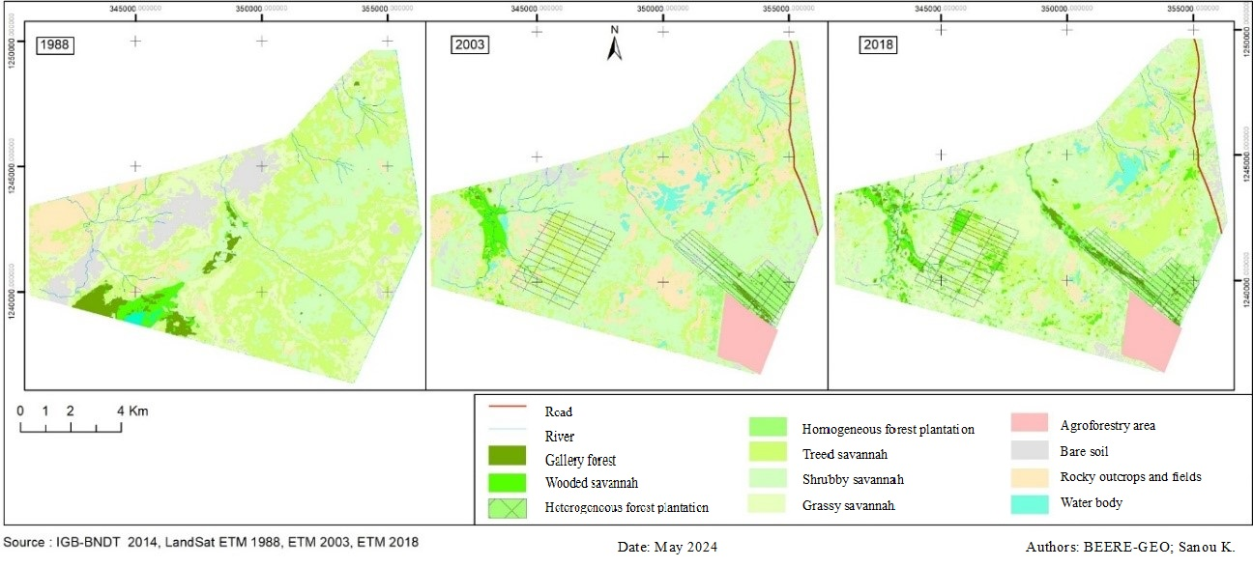

Figure 3. Land use in the Denderesso forest (1988, 2003, 2018).

On the other hand, the land-use units of the Kua classified forest have undergone the same evolutionary trends as the Dinderesso forest. This vegetation is more characterised by shrub savannah, which showed a positive trend between 1988 (35.06%) and 2003 (41.57%), followed by a regression in 2018 (37.67%). Wooded and treed savannah regressed in 2003, while rocky outcrops and fields increased in area. As for bare soil, it gradually declined from 13.48% in 1988 to 8.31% in 2003 and 4.71% in 2018 (Figure 4).

Source: IGB/BNDT, 2014; LandSat ETM 1988, 2003, 2018

Figure 4. Land use in the Kua forest (1988, 2003, 2018)

There has been a positive improvement in the vegetation cover in this forest area, as the surface area of bare soil, rock outcrops and fields has decreased overall between 2003 and 2018 (Figure 5). The situation is quite different in the Pama partial reserve and its outskirts in South-East Burkina Faso, where vegetation has declined in favour of bare soil and rocky outcrops (Soulama and al., 2015).

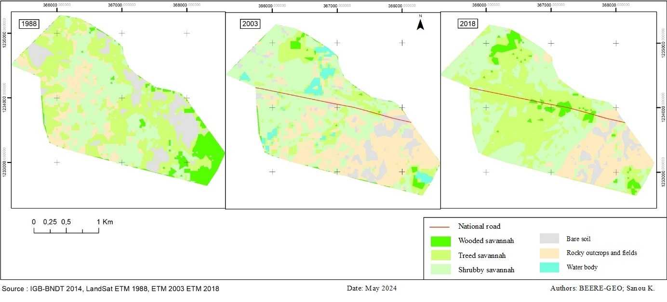

Figure 5. Land use in the Kua forest (1988, 2003, 2018)

The degradation of the Dinderesso and Kua forests is not an isolated case in that all forest formations (forests, savannahs, steppes) are affected throughout Burkina Faso (Kambiré, 2015; Kaboré et al., 2019). Between 1990 and 2010, Burkina Faso lost an average of 59.9 ha of forest formations, a decline of 0.87% per year (LAME, 2011). According to MECV (2007), Burkina Faso is below international standards, which require each country to classify at least 30% of its territory as conservation areas in order to achieve a better socio-ecological balance. However, classified forests near towns such as Dinderesso and Kua are prey to the harmful actions of humans. The factors and sources of anthropogenic and climatic pressure on forest resources in the Bobo-Dioulasso commune are analyzed.

Determinants of vegetation cover dynamics in the Dinderesso and Kua classified forests

Vegetation study necessarily involves an analysis of the climatic elements and the behaviour and perceptions of the people living in the study area.

- Annual variation of rainfall

The development of the natural resources of Dinderesso and Kua classified forests is influenced by the climatic parameters of the Bobo-Dioulasso municipality. Analysis of the average annual rainfall values for the observation series (1988 - 2018) shows a very slight increase in the amount of water falling in the Bobo-Dioulasso area, based on the shape of the trend line (Figure 6). This increase in rainfall, marked by a sawtooth pattern, is confirmed by a positive direction coefficient (1.8225). The very low value of the coefficient of determination (R² = 0.0093) therefore expresses the strong interannual variation in rainfall, with the highest rainfall of 1,320.5 mm recorded in 2018 and the lowest (681.7 mm) in 2017. Irregular rainfall can be unfavourable to vegetation and can therefore lead to the degradation of the Dinderesso and Kua forests, since the more it rains, the denser the natural vegetation (Yan, 2008).

Source: Agency for National Meteorological from Burkina Faso, 2019

Figure 6. Variation in the average annual rainfall in Bobo-Dioulasso (1988-2018)

Calculating the SPI shows that values above zero indicate years with a surplus, and those below zero indicate years with a deficit compared with the average. This reflects interannual variability, which divides the series (1988-2018) into three periods characterised by wet and dry spells (Figure 7).
Source: Agency for National Meteorological from Burkina Faso, 2019

Figure 7. Changes in the Standardised Precipitation Index (SPI)

The first period (1988-1997) was marked by a predominance of episodes of moderate drought. The second period (1998-2007) was punctuated by a succession of dry and wet years. The most recent period, 2008-2018, saw a recovery in rainfall. Overall, there have been sixteen (16) dry years during the 30-year observation period. A year of drought, even an extreme one, can be less dramatic for woody vegetation than a series of two years of moderate drought (Kaboré and al., 2018). Indeed, Sanou and al., (2020) estimate that in Burkina Faso, variations in biomass by province generally follow the annual distribution of rainfall, meaning that plant biomass production is closely proportional to the amount of rainfall. Therefore, we can deduce that the low rainfall recorded between these two periods (1988-1997 and 1998-2007) had a negative impact on the vegetation of the two forests (Dinderesso and Kua). This could explain the appearance of bare soil and rocky outcrops in these forests.

- Temperatures trends

The curves of the annual and monthly temperatures averages of the series show hot and cold months, as well as transition periods (Figure 8). Indeed, high temperatures are observed in the dry season during the months of March, April and May, with maximum temperatures recorded in April (31.1 °C), the hottest month of the year. However, the lowest temperatures are recorded from July to September and from December to January, with the lowest monthly temperature in August (25.4 °C), a month during which the whole country is wet. In general, temperatures are relatively mild from July to January, with the exception of November when temperatures are 27.7 °C or less, February and June are considered transition periods. In general, temperatures are relatively mild from July to January, with the exception of November when temperatures are 27.7 °C. February and June are considered transitional periods.

Temperature °C
Source: Agency for National Meteorological from Burkina Faso, 2019

Figure 8. Trends in average monthly and annual temperatures (1988-2018).

Like rainfall, the irregularity of temperature can be seen in the plot, which justifies an interannual variation in the series. The average annual temperature in 1988 was 27.5 °C, while it is 28.2 °C in 2018. This relatively slight rise of 0.7 °C between 1988 and 2018 in the study area conceals disparities, with maximum values of 28.4°C recorded in 2002, 2005 and 2016. However, the lowest temperature (27 °C) was recorded in 1989. In general, the temperatures in the study area are gradually rising in a similar way to the rest of the country (Doumounia et al., 2020). This increase, which peaked in 2002, 2005 and 2016, is a factor limiting the development of certain plant species (Dipama, 2016) because it could increase water stress in plants. Thermal conditions set the pace for vegetative life, causing water reservoirs to dry up early, destroying crops, reducing soil fertility, and reducing the production of forest resources, and in the long-term forcing living creatures to migrate to other destinations (Sanou et al., 2018).

- Population growth and pressure on land

In Burkina Faso, the urban population represents 26.3% of the total population (RGPH, 2019). This growth is concentrated in the country's two main cities (Ouagadougou and Bobo-Dioulasso), which account for 62.2% of the country's urban population. Bobo-Dioulasso, the main urban centre of the west and south-west region, covers an area of 13,678 hectares. Between 1975 and 2019, the population increased from 291,383 to 983,552 (INSD, 2020). This trend reflects the increase in population density, with an average annual growth rate of 4.69% between 1996 and 2019, doubling in less than 15 years (Figure 9). The urban area accounts for 91.90% of the total population of the municipality, while the population of the adjacent villages accounts for only 8.09% in 2019 (INSD, 2020).

Source: INSD, 2020

Figure 9. Density of population in Bobo-Dioulasso (1985 to 2019).

This high population density has been identified as one of the factors that explain the degradation of natural forest plant formations in the rural commune of Matiacoali and the Bale National Park in western Burkina Faso (Tankoano et al., 2016). The gradual change in density shows the control of the population on the land. This can lead to a strong demographic pressure on the natural resources of the communal territory, especially the forest (Gansaonre et al., 2020; Tiamiyu et al., 2023). The survival of more than 80% of Burkina Faso's population depends on the exploitation of its natural resources, particularly forestry, wildlife, and fisheries (MEDD, 2013). Field surveys reveal that the negative impacts of the agricultural production system, wood fuel harvesting, industrial and artisanal waste, the artificial land development and the proximity and expansion of towns to the detriment of forests are among the factors that exacerbate the pressure on periurban forest resources. In addition, some classified forests are subject to excessive mowing of herbaceous biomass by urban populations, either to feed their own domestic herbivores or to sell to those who keep livestock in permanent stalls. This practice constitutes a permanent threat to the balance of ecosystems in the forest area, particularly the herbaceous stratum (Bouyer, 2011). Sanou (2023) estimates that between 75 and 98% of animal feed in Burkina Faso comes from natural resources. However, people living near the classified forests of Dinderesso and Kua say that wood cutting (41.8%), followed by agriculture (28.4%) and grazing (12.9%) are the main factors in forest degradation (Figure 10). However, 95.6% of those surveyed said they were aware of the forest classification, compared to 4.4% who were unaware of the classification.

Source: Field survey, 2020

Figure 10. Perception of residents of forest degradation factors

- Differentiated governance of the Dinderesso and Kua classified forests

Given the level of degradation of the Dinderesso and Kua classified forests, initiatives for the participatory management of local residents have been launched with the installation of the provincial department of the environment, the green economy and climate change within the forests, and the implementation of the Support for the Participatory Management of Natural Resources (PAGREN) and Participatory Management of the Dinderesso and Kua Forests (PAFDK) projects between 2002 and 2012. To this end, Forest Management Groups (FMG) have been established in the villages that border the two forests. These various GGFs are socioprofessional structures in village, and can unite and even join the national federation of forest management groups in Burkina Faso. Members of the GGF and Village Development Councils (CVD) in the localities concerned have benefited from various training sessions on the organization and sustainable management of forest resources. The project's reforestation campaign, launched in July 2003, surveillance activities, and the participation of local people in the management of the Dinderesso classified forest through the GGF have resulted in forest regreening. In 2010, an agroforestry area and 25 "controlled fields" were established to prevent uncontrolled installation of fields in the forest area and to encourage assisted natural regeneration of units that had been severely degraded (Bahire, 2016). In the Kua classified forest, three GGF from the villages of Pala, Koro, and Borodougou are involved in management. Unlike the GGFs in the Dinderesso forest, those in the Kua forest have not formed a union due to their small numbers. They meet when work needs to be done, in particular for reforestation and firebreaks. However, with the end of the projects, difficulties remain in carrying out the activities. For a long time financed by projects at a rate of 136,000 FCFA per GGF per quarter and 10,000 FCFA per km of runway opened for surveillance and firewall activities, respectively, the GGF have very limited capacity to generate income (1dollar US is equivalent to 675.50 FCFA). The exploitation of green wood and related activities do not generate sufficient resources for their operation. However, the two forests have considerable potential for ecotourism, local crafts, beekeeping, fishing, and small game farming (MECV, 2013).

Conclusion

The environment is under increasing pressure from a number of different development sectors. The dependence of populations on natural resources is linked to strong demographic growth, weak means of subsistence and deteriorating climatic conditions. Periurban forests are under particular pressure because they are close to, or even contiguous to, urban areas, which are constantly expanding. Therefore, sustainable forest management around urban centres is becoming an imperative and a major challenge for national forest policies. However, the slightest resumption of the densification of vegetation cover through the improvement of agroforestry areas, gallery forests, forest plantations, and savannahs, is a collective effort based on participatory management by the local population from Dinderesso and Kua.

References

Bahire, F. X. (2016). Étude diachronique des changements du couvert végétal dans un écosystème forestier par télédétection spatiale et par suivi au sol. « Cas de la Forêt classée péri-urbaine de Dinderesso » [Diachronic study of vegetation cover changes in a forest ecosystem using spatial remote sensing and ground monitoring. “The case of the Dinderesso peri-urban classified forest“]. [Master’s dissertation, Ecole Nationale des Eaux et Forêts].
Bergaoui, M., & Alouini, A. (2001). Characterization of meteorological drought and hydrology: case of Siliana watershed in Tunisia. Secheresse, 12(2), 205-213.
Bouyer, J. (2011). Forest relics of the Banfora cliff : degradation in the vicinity of Bobo-Dioulasso, Burkina Faso.
Calbérac, Y., Delage, A., (2010). Introduction « L’approche spatiale comme moyen de compréhension et d’action sur les sociétés» [Introduction “The spatial approach as a means of understanding and acting on societies”]. Traces. Revue de Sciences humaines.
Dessay, N. (2006). Vegetation and climate dynamics: A remote sensing study of five Brazilian biomes, dense and open rainforest, cerrados, caatinga and campanha gaúcha. [Doctoral dissertation, Human, Economic and Regional Geography, University Paris X Nanterre].
Dipama, J.M. (2016). Pression anthropique et stratégie de préservation des ressources naturelles au Burkina Faso : cas des ressources forestières à Farakoba [Anthropogenic pressure and natural resource preservation strategy in Burkina Faso: The case of forest resources in Farakoba]. Publications Scientifiques, 3(3), 270-287.
Doumounia, A., Zeba, A., Damiba, L., Zougmoré, F., & Nikiéma, M. (2020). Climate variability analysis in the Nouhao Sub-Basin in Eastern Center of Burkina Faso, ed. Larhyss Journal.
Franchomme, M., & Dubois, J. P. (2010). Documenter les zones humides: Vers une meilleure compréhension des paysages du XIXe au XXes [Documenting wetlands: towards a better understanding landscapes of 19th and 20th century].
Gansaonré, R. N., Zoungrana, J-B., & Yanogo, P. I., (2020). Vegetation cover dynamics on periphery of Parc W in Burkina Faso. Belgeo. Revue belge de géographie, 1.
GIEC. (2007). Bilan 2007 des changements climatiques : Rapport de synthèse [Climate Change 2007: Synthesis Report].
Gnoumou, A., Thiombiano, A., Hahn-Hadjali, K., Abadouabou, B., Sarr, M., & Guinko, S. (2008). The Urban Park Bangr-Weoogo : an area for the conservation of diversity floristic in heart city of Ouagadougou, Burkina Faso. Flora et Vegetatio Sudano-Sambesica, 11, 35-48.
Gueye, S. (2000). Study on forest resources and forest plantations in Senegal, Periode, 1992-1999.
Ilboudo, M. (2012). Agricultural colonization and plant cover degradation of Koumbili in Nahouri. [Master’s dissertation, University of Ouagadougou].
INSD (National Institute of Statistics and Demography). (2020). Recensement général de la population et de l’habitat du Burkina Faso.
Kaboré, O., Dipama, J. M., & Sanou, K., (2018). Effects of climate variability on migration and the resilience of agropastoralists in Kabonga 1 and 2 villages (Burkina Faso). Rev. Sc. Env, 15, 251-272.
Kaboré, O., Ouédraogo, B., & Sawadogo, I. (2019). Fragmentation factors and forest management strategies in Burkina Faso. Journal of Applied Biosciences, 13516-13531.
Kambiré, H. (2015). La REDD+ et l’adaptation aux changements climatiques au Burkina Faso [REDD+ and adaptation to climate change in Burkina Faso]. CIFOR, Burkina Faso, 112p.
LAME (Laboratory for mathematical analysis of equations). (2011). Climate modeling, risk assessment and analysis change vulnerability.
Mckee, T. B., Doesken, J., & Kleist, J. (1993). The relationship of drought frequency and duration times scales. American Meteorological Society, 179-184.
MECV (Ministry for the Environment and the Living Environment). (2007). Situation of classified forests in Burkina Faso rehabilitation plan.
MECV (Ministry for the Environment and the Living Environment). (2013). Draft management plan for classified forest the Poa (Koa).
MEDD (Ministry of the Environment and Sustainable Development). (2013). Plan national d’adaptation aux changements climatiques environnement et ressources naturelles [National plan for adaptation to climate change, environment and natural resources].
N’guessan, A. E., Akpa, Y. L., Yao, N. O., & Kassi, J. N. (2019). Cartographie de la dynamique du couvert végétal de la forêt classée d’Agbo 1 Cote d’Ivoire [Mapping the vegetation cover dynamics of Agbo 1 classified forest, Ivory Coast]. Agronomie Africaine, 31(1), 87-99.
Sanou, S. (2010). Etude du niveau d’agression des forêts classées du Kou et de Dinderesso par les déchets de la ville de Bobo-Dioulasso [Study level of aggression the classified forests of Kou and Dinderesso by waste from city of Bobo-Dioulasso].
Sanou, K., Dipama, J. M., & Karambiri, B. L. C. N. (2018). Analysis of land-use dynamics in the Kompienga watershed in Burkina Faso from 1988 to 2016. Rev. Climat and Development LACEEDE, 25, 19-23.
Sanou, K., Rouamba, S., Somé, W., & Somé, Y. S. C., (2020). Approche spatiale du risque climatique dans le secteur de l’élevage à l’échelle du Burkina Faso [Spatial approach to climate risk in the livestock sector in Burkina Faso]. In. Bonnardot, V., & Quenol, H. (eds.). Changement climatique et Territoires (pp. 613-618). Actes du colloque de l’AIC.
Sanou, K. (2023). Livestock production systems, stakeholder vulnerability and the precariousness of natural resources in Burkina Faso. Rev. Climat and Development LACEEDE, 35, 30-40.
Soulama, S., Kadeba, A., Nacoulma, B.M.I., Traore, S., Bachmann, Y., & Thiombiano A. (2015). Impact of anthropogenic activities on vegetation dynamics in Pama partial wildlife reserve and its periphery (southeastern Burkina Faso) in a context of climatic variability. Journal of Applied Biosciences, 87, 8047-8064.
Tankoano, B., Hien, N., Dibi, H. N., Sanon, Z., Akpa, Y. L., Jofack Sokeng, V-C., & Somda, I. (2016). Mapping vegetation cover dynamics of Deux Balé National Park in western Burkina Faso. International Journal of Innovation and Applied Studies, 16(4), 837-846.
Tiamiyu, K., Yaméogo, J., Sanou, K., & Yanogo P. I. (2023). Dynamics of community forests in the Centre-West region of Burkina Faso: the case of rural commune of Siglé. International Journal of Biological and Chemical Sciences,17(1), 63-76.
Yan, B. (2008). Guide pour la description des principaux enjeux écologiques dans les plans régionaux de développement intégré des ressources et du territoire [Guide for description of the main ecological issues in regional plans for integrated development of resources and territory].

