Public perception and acceptance of driverless buses in Yichang, China

Zeng Yi^{1,2}, Mou Leong Tan¹

¹ GeoInformatic Unit, Geography Section, School of Humanities, Universiti Sains Malaysia
² School of Artificial Intelligence, Wuhan Technology and Business University

Correspondence: Mou Leong Tan (email: mouleong@usm.my)

Received: 18 July 2024; Accepted: 22 January 2025; Published: 14 February 2025

Abstract

Previous research on driverless cars has predominantly focused on large cities in developed regions, with limited attention given to the acceptance of driverless buses in small and medium-sized cities. This study conducted a questionnaire survey involving 306 citizens from the Xiling District of Yichang City, analyzing the data using the structural equation model. The research expanded the traditional technology acceptance model by introducing three additional factors influencing public acceptance of driverless buses: perceived risk, perceived value, and perceived usefulness. Additionally, three secondary factors such as social impact, image, and result demonstrability were incorporated into the framework. The findings revealed that 69 participants (22.55%) fully accepted driverless buses, 117 participants (38.24%) were relatively accepting, 111 participants (36.27%) held a neutral stance, and only 9 participants (2.94%) were completely opposed. Young people and highly educated individuals demonstrated greater interest in learning about driverless buses. Social impact and perceived usefulness were identified as having a significant positive influence on public acceptance, while image and result demonstrability positively affected perceived usefulness. In contrast, perceived risk negatively impacted acceptance levels. As Yichang currently lacks driverless bus services, understanding local citizens' perceptions and acceptance is essential before promoting and implementing such services. This study provides valuable insights and a reference framework for the introduction and promotion of driverless buses in the city.

Keywords: Driverless buses, public acceptance, perceived risk, public transport, technology acceptance model

Introduction

According to the world automobile organization, there are more than 1.3 billion vehicles in use in the world, and the number is growing at a rate of nearly 90million every year (Zhan, 2019). Although the emergence of automobiles has greatly saved people's travel time and travel costs, the rapid growth of their number has also brought many problems and challenges to people, of which the three main problems are road traffic accidents, traffic congestion and environmental pollution (Andreasson et al., 2015). Since driverless technology has great potential in promoting a new generation of technological revolution, reducing road traffic accidents, easing traffic congestion and reducing environmental pollution, countries have successively increased investment in the research, development, testing, demonstration and application of driverless technology, and promulgated relevant regulations and standards to promote its development (Van Brummelen et al., 2018). The latest research results of McKinsey Company in 2019 show that by 2030, the market output value related to automatic driving in global cities and regions will reach $1.6 trillion (Baltic et al., 2019). Driverless cars have the potential to enhance the accessibility of mobile services while significantly reducing road fatalities and harmful emissions (Tafidis et al., 2022).

More and more countries begin to study driverless cars. Europe has launched the urban automatic transportation system project, which aims to develop and test urban transportation services. This service is mainly to develop small clean cars and public transport to improve the efficiency of urban transportation (Christie et al., 2016). In 2016, EZ10 small driverless electric vehicle was developed by French EasyMile company; Olli, a driverless bus developed in the United States, can continuously learn and optimize itself through voice interaction with passengers; In China, Ankai driverless bus developed by Ankai Automobile company has realized the functions of automatic lane change and emergency avoidance under automatic driving, and has fully met the requirements of bus trial operation. It can be seen that with the increasing maturity of automatic technology, all countries are competing to develop driverless bus technology in order to promote driverless buses to enter the market and put into use faster. Zhang et al. (2024) proposed an enhanced model for driverless car adoption, incorporating novel factors like perceived interpretability and perceived intelligence. While traditional predictors such as perceived ease of use and perceived usefulness remain significant in building trust, their influence is less pronounced compared to the newer factors.
Driven by the epidemic, driverless cars are applied to daily life faster in China, and its application scenario is also more distinct. However, these scenes are only applicable to driverless low-speed cars. The integration of driverless cars into urban traffic in China remains a challenging task. At each stage of a technology's lifecycle, it is essential to examine and consider the factors influencing its acceptance. Given that user attitudes towards technology significantly impact its adoption and dissemination, it is crucial to study public acceptance prior to the widespread promotion of such technologies. However, the public's lack of familiarity with the driverless technology of vehicles and doubts about its driving safety will affect the public acceptance of driverless cars and delay the application of the new technology (Li, 2017). Salonen's (2019) analysis shows that people's tolerance for accidents caused by driverless cars is lower than that caused by humans. Although the advancements and numerous potential benefits of driverless car technology, public acceptance remains low, with a lack of trust being the most significant barrier to address (Chen et al., 2023; Liu et al., 2023).
The public's lack of familiarity with the driverless technology of vehicles and doubts about its driving safety will affect the acceptance of driverless buses in the public and delay the application of the new technology (Li, 2017). The real consumers of transportation services should be passengers. Understanding passengers is a great challenge facing the whole academia and government. In other words, the public's view of driverless buses is the key to the success of this new mode of transportation. Therefore, the research on the public's acceptance and key influencing factors of driverless buses plays an important role in the rapid application of this technology (Bestepe & Ozkan, 2019). Liu et al. (2020) conducted a scene experiment to examine changes in people's attitudes toward driverless cars before and after experiencing them. The survey revealed that prior to the experiment, 50% of participants were uncertain about their stance on driverless cars. However, after experiencing a ride, approximately 60% developed a positive attitude toward them. This study highlights that firsthand experience can significantly improve people's perception of driverless cars. Bazilinskyy et al. (2015) conducted a survey involving 8862 respondents around the world in 2015 and found that people's attitude towards driverless cars is neutral, respondents in different regions have great differences. However, such evaluation is still limited in China, particularly in developing regions like Yichang.
Research on driverless public transportation vehicles has been limited. This study specifically focuses on the acceptance of driverless buses, a unique form of public transportation, and differs significantly from previous studies in two keyways. First, it includes participants of all age groups. Second, as driverless buses represent one of the most critical urban transportation modes, they carry greater social implications. Consequently, this study innovatively incorporates Social Impact, Image, and Perceived Risk as key factors influencing acceptance. Therefore, this study aims to build an acceptance model for quantifying the public's perception on the driverless buses in Yichang and analyze the key factors affecting the public acceptance of driverless buses in Yichang. Understanding the factors that influence citizens' acceptance of driverless buses can provide valuable insights into public needs. This knowledge can guide the development of driverless bus technologies and products that are better aligned with the expectations and preferences of the public. Provide theoretical reference for the construction of smart city and provide reference for the development of urban transportation during the epidemic. Therefore, it is particularly important to study the public acceptance of driverless buses.

Study area

Yichang is a prefecture level city in Hubei Province, China, a provincial sub central city, a regional central city in the central region approved by the State Council and a member of the urban agglomeration in the middle reaches of the Yangtze River (Figure 1). Yichang has five districts directly under the central government, three counties, three county-level cities and two autonomous regions, with a total area of 21000 square meters. According to the results of the seventh national census of Hubei Province, as of 0:00 on November 1, 2020, the permanent population is 4017607. Registered residence population of 3 million 909 thousand and 400 people, in 2021, the city's GDP reached 502 billion 269 million yuan. Yichang is located in Central China, the southwest of Hubei Province and the boundary between the upper and middle reaches of the Yangtze River. It is known as "the gateway of the Three Gorges" and "the throat of Sichuan and Hubei". Yichang was called Yiling in ancient times, which was named after "the water here and the mountain here and the mausoleum"; In the Qing Dynasty, the meaning of "suitable for prosperity" was changed to "Yichang". Yichang is the starting point of the Three Gorges of the Yangtze River and the location of the Three Gorges Dam and Gezhouba Dam. It is known as the "capital of hydropower in the world"; Yichang is an excellent tourist city in China.
Most previous studies have focused on large cities in developed regions. However, as society evolves, driverless buses are increasingly appearing in small and medium-sized cities. This highlights the need to examine the acceptance of driverless buses in these contexts. Yichang, known as a hub for hydroelectric power in China and a prominent tourist destination, represents an ideal medium-sized city for promoting driverless buses. Consequently, Yichang was selected as the research site for this study.

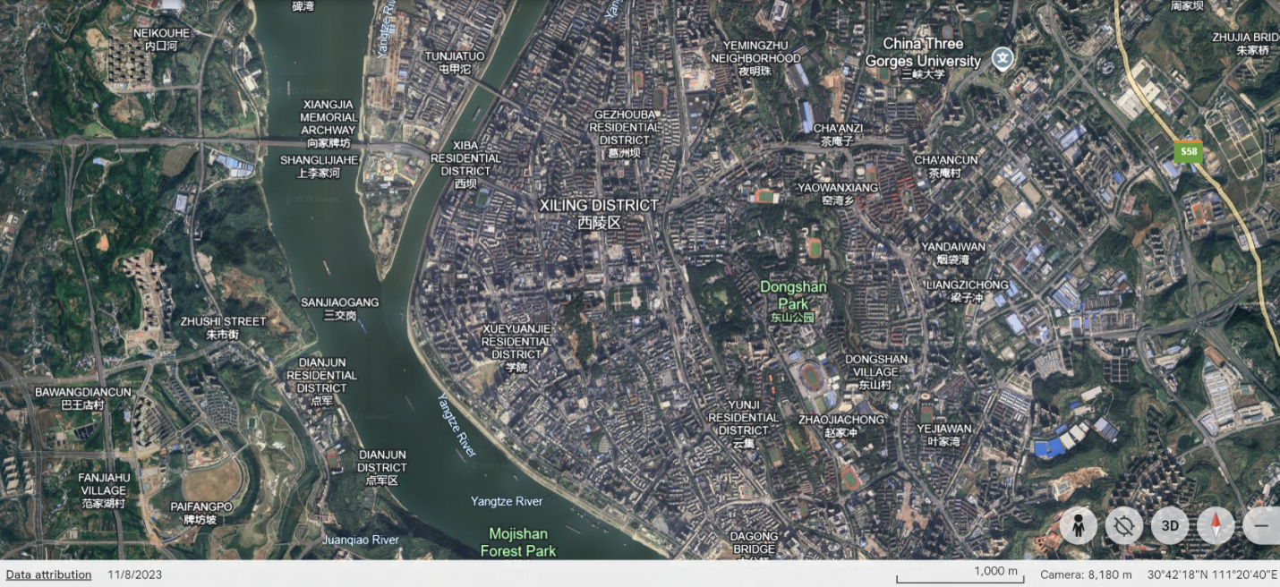
Source: Google Map

Figure 1. Geographical location of Yichang City

Research method

This study adopts a mixed method design to deeply explore the influencing factors of Yichang citizens' social acceptance of driverless buses. Based on TAM2 and the theory of perceived risk, this study constructs the following model. Perceived usefulness, perceived value and perceived risk are the key factors that affect the acceptance of driverless buses. Social impact, image and result demonstrability determine perceived usefulness, perceived value and perceived risk. The preliminary public acceptance model of driverless buses in Yichang is as follows (Figure 2). Structural equation modeling (SEM) is a major linear statistical modeling technique. It analyzes the relationship between variables based on the correlation matrix of variables. This study intends to use structural equation model to quantitatively analyze the influencing factors of Yichang citizens' acceptance of driverless buses, and combine exploratory factor analysis with confirmatory factors to explore the influencing factors of the public's acceptance of driverless buses.

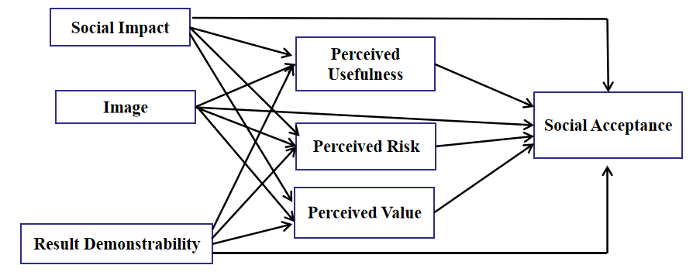

Figure 2. Theoretical framework (based on TAM2 and the theory of perceived risk)
In-depth interview

The sample size of qualitative research should not be too large, because the purpose of qualitative research is to explore potential problems, motives and ideas (Patton, 1990). Compared with quantitative research, the sample size of qualitative research is usually relatively small. But it should not be too small, because it should be able to explain the phenomenon investigated. In the design of hybrid research, the role of qualitative analysis is to study the trend of ideas, behaviors and views. Help quantitative research put forward hypotheses and provide explanations for problems (Creswell & Clark, 2017). The specific sample size needs to be determined according to the different research contents (Creswell, 1998) and at least six by Morse (1994). The final sample size should be the number of participants required to reach saturation (Creswell, 1998; Morse, 1994). In order to determine the influencing factors of driverless bus acceptance, sociologists, information and communication experts and government staff were interviewed in this study. After interviewing 13 people, the influencing factors were determined. After interviewing 15 people, no new influencing factors were found, and the interview content reached saturation.So the final number of interviewees were 15. Among them, there are 5 sociologists or psychologists from the Three Gorges University, 5 experts in information and communication technology, and 5 staff members from the Ministry of transport. Following detailed discussions with experts and data analysis, the specific variables for this study were identified, and the model was adjusted to ensure its alignment with the actual context. Table 1 presents the research hypotheses for the social acceptance model of driverless buses.

Table 1. Research hypothesis of driverless bus social acceptance model. Alternatives in brackets

Number | Research hypothesis
H1 | Perceived usefulness has no (a significant) impact on the social acceptanceof driverless buses in Yichang.
H2 | Perceived value has no (a significant) impact on the social acceptance of driverless buses in Yichang.
H3 | Perceived risk has no (a significant) impact on the social acceptance of driverless buses in Yichang.
H4 | Image has no (a significant) impact on the perceived usefulness of driverless buses in Yichang.
H5 | Image has no (a significant) impact on the perceived value of driverless buses in Yichang.
H6 | Image has no (a significant) impact on the social acceptance of driverless buses in Yichang.
H7 | Image has no (a significant) impact on the perceived risk of driverless buses in Yichang.
H8 | Social impact has no (a significant) impact on the perceived usefulness of driverless buses in Yichang.
H9 | Social impact has no (a significant) impact on the perceived value of driverless buses in Yichang.
H10 | Social impact has no (a significant) impact on the social acceptance of driverless buses in Yichang.
H11 | Social impact has no (a significant) impact on the perceived risk of driverless buses in Yichang.
H12 | Result demonstrability has no (a significant) impact on the perceived usefulness of driverless buses in Yichang.
H13 | Result demonstrability has no (a significant) impact on the perceived value of driverless buses in Yichang.
H14 | Result demonstrability has no (a significant) impact on the social acceptance of driverless buses in Yichang.
H15 | Result demonstrability has no (a significant) impact on the perceived risk of driverless buses in Yichang.

Questionnaire survey

Based on the research hypothesis and theoretical model, a questionnaire was developed and distributed to 350 residents of Yichang City. To ensure probability sampling, the questionnaires were distributed in large shopping centers and supermarkets. The collected valid data were analyzed using SPSS software, leading to modifications in the research model, verification of the hypotheses, and identification of the factors and models influencing public acceptance of smart cities. The study includes both antecedent and outcome variables, comprising a total of seven variables. The test items, totaling 27, were designed based on insights from previous interviews with experts. The measurement table is provided (Table 2).

Table 2. Coding and measurement items

Variable | Code | Measurement item
Perceived  usefulness | PU1 | The number of passengers in driverless buses is small, which can effectively prevent the epidemic.
Perceived  usefulness | PU2 | Driverless buses can reduce traffic accidents caused by human errors.
Perceived  usefulness | PU3 | Driverless buses run more regularly, which can improve the traffic efficiency of the city.
Perceived  usefulness | PU4 | Driverless buses can reduce labor costs and improve the economic benefits of enterprises and society.
Perceived value | PV1 | Driverless buses are attractive to me.
Perceived value | PV2 | Taking the driverless bus makes me feel comfortable.
Perceived value | PV3 | I will look forward to the official use of driverless buses.
Perceived value | PV4 | I have confidence in the promotion and popularization of driverless buses.
Perceived risk | PR1 | I worry that driverless buses cannot adapt to the complex environment of urban traffic.
Perceived risk | PR2 | I am worried about equipment or system failure of driverless buses.
Perceived risk | PR3 | I worry that driverless buses will make my privacy more vulnerable to leakage.
Perceived risk | PR4 | I am worried that the technology of driverless bus is not mature and will cause a lot of traffic accidents.
Image | I1 | Getting information about driverless buses through watching TV ads will affect my attitude towards driverless buses.
Image | I2 | Getting information about driverless buses through government publicity will affect my attitude towards driverless buses.
Image | I3 | Getting information about driverless buses through relevant information released by automobile enterprises will affect my attitude towards driverless buses.
Image | I4 | Getting information about driverless buses through the Internet will affect my attitude towards driverless buses.
Social impact | SI1 | When people around me pay attention to driverless buses, I will also pay attention to them.
Social impact | SI2 | When someone around me takes a driverless bus, I also take a driverless bus.
Social impact | SI3 | When people around me have concerns about driverless buses, I also have concerns about it.
Social impact | SI4 | When people around me think highly of the driverless bus, I will also be interested in it.
Result demonstrability | RD1 | I feel scared when I take a driverless bus for the first time.
Result demonstrability | RD2 | I cannot fully trust the driverless bus for the first time.
Result demonstrability | RD3 | After taking the driverless bus, I will know it better.
Result demonstrability | RD4 | If I feel comfortable after taking the driverless bus, I will often take the driverless bus.
Acceptance | A1 | Your overall view on driverless buses？
Acceptance | A2 | Can you accept driverless buses?
Acceptance | A3 | Do you think driverless buses are beneficial to society?

The questionnaire was designed based on the theoretical model and research hypothesis, and then subsequently distributed to 350 residents of Yichang City. To ensure probability sampling, the questionnaires were administered in large shopping centers and supermarkets. Over several days, 324 questionnaires were collected, of which 18 were incomplete and deemed invalid. Ultimately, 306 valid questionnaires were obtained. The collected data were analyzed using SPSS and Amos software. Initially, the sample data underwent basic quantification. Subsequently, the reliability and validity of the data were assessed. Following this, a structural equation model (SEM) was constructed and refined through a fitting test, and the model's path relationships and hypotheses were analyzed. During the data analysis process, sample characteristics were evaluated using Cronbach's alpha, the KMO test, and Bartlett's test.

Characteristic analysis of samples

This study gathered statistical data on three basic demographic variables: gender, age, and educational background. Descriptive statistics for these variables were generated using SPSS 26.0 software. The detailed results of the statistical analysis for each variable are as follows (Table 3).

Table 3. Analysis of samples

Variable | Category | Frequency | Percent (%)
Gender | Male | 155 | 50.7
Gender | Female | 151 | 49.3
Age | Under 25 | 112 | 36.6
Age | 25 to 35 | 131 | 42.8
Age | 35 to 45 | 30 | 9.8
Age | 45 to 55 | 23 | 7.5
Age | Above 55 | 10 | 3.2
Educational level | High school and below | 47 | 15.4
Educational level | Junior college | 55 | 18
Educational level | Undergraduate | 195 | 63.7
Educational level | Graduate students and above | 9 | 2.9

To ensure more objective sampling results, the questionnaire was distributed with an effort to maintain a 1:1 male-to-female ratio. Participation in the survey was voluntary, and as a result, citizens under the age of 35 showed greater interest in driverless buses and were more willing to complete the questionnaire. In terms of education level, individuals with higher education exhibited a stronger interest in driverless buses, whereas those with lower education levels showed less interest.

Results

Reliability analysis

Based on the results as listed in Table 4, the reliability coefficient for Result Demonstrability is 0.625, which is considered acceptable. To improve the variable's reliability and ensure overall consistency, the RD1 item was removed. The reliability tests show that the coefficients for perceived effectiveness, perceived value, perceived risk, image, social impact, result demonstrability, and acceptance all exceed 0.6, indicating good consistency across the items in the scales. Therefore, the reliability of the questionnaire meets the required standards.

Validity analysis

To extract common factors and ensure the accuracy of the model, this study first conducted exploratory factor analysis, followed by confirmatory factor analysis. The evaluation indicators included the KMO and Bartlett's test, factor loadings, combined reliability, and AVE. As shown in Table 5, the KMO value of the sample data is 0.661, which is greater than 0.6. The significance probability (p-value) is 0.000, which is less than 0.05. These results indicate that the factor analysis for the overall questionnaire is effective and suitable for factor analysis.

Table 4. Analysis of samples

 |  | Cronbach's A | Items | M if D | V if D | TC | CA if D
Perceived  usefulness | PU1 | 0.751 | 4 | 10.89 | 5.408 | 0.502 | 0.725
Perceived  usefulness | PU2 | 0.751 | 4 | 10.77 | 5.644 | 0.57 | 0.681
Perceived  usefulness | PU3 | 0.751 | 4 | 10.72 | 6.066 | 0.503 | 0.717
Perceived  usefulness | PU4 | 0.751 | 4 | 10.53 | 5.542 | 0.627 | 0.651
Perceived  value | PV1 | 0.678 | 4 | 10.73 | 3.898 | 0.517 | 0.573
Perceived  value | PV2 | 0.678 | 4 | 10.85 | 4.1 | 0.474 | 0.603
Perceived  value | PV3 | 0.678 | 4 | 10.67 | 4.472 | 0.427 | 0.633
Perceived  value | PV4 | 0.678 | 4 | 10.81 | 4.323 | 0.425 | 0.635
Perceived  risk | PR1 | 0.652 | 4 | 10.25 | 4.494 | 0.42 | 0.559
Perceived  risk | PR2 | 0.652 | 4 | 10.11 | 3.657 | 0.543 | 0.58
Perceived  risk | PR3 | 0.652 | 4 | 10.25 | 4.533 | 0.417 | 0.645
Perceived  risk | PR4 | 0.652 | 4 | 10.17 | 3.995 | 0.443 | 0.566
Result  demonstrability | RD1 | 0.625 | 4 | 10.05 | 4.139 | 0.117 | 0.641
Result  demonstrability | RD2 | 0.625 | 4 | 10.18 | 3.451 | 0.497 | 0.519
Result  demonstrability | RD3 | 0.625 | 4 | 10.05 | 3.45 | 0.385 | 0.502
Result  demonstrability | RD4 | 0.625 | 4 | 10.08 | 3.495 | 0.393 | 0.515
Image | I1 | 0.696 | 4 | 10.95 | 3.883 | 0.62 | 0.534
Image | I2 | 0.696 | 4 | 10.96 | 5.153 | 0.281 | 0.65
Image | I3 | 0.696 | 4 | 10.96 | 4.779 | 0.401 | 0.679
Image | I4 | 0.696 | 4 | 11.1 | 4.102 | 0.657 | 0.52
Social  impact | SI1 | 0.733 | 4 | 11.41 | 4.748 | 0.419 | 0.729
Social  impact | SI2 | 0.733 | 4 | 11.3 | 4.402 | 0.516 | 0.677
Social  impact | SI3 | 0.733 | 4 | 11.27 | 4.272 | 0.56 | 0.653
Social  impact | SI4 | 0.733 | 4 | 11.3 | 3.714 | 0.608 | 0.62
Acceptance | A1 | 0.79 | 3 | 7.52 | 2.454 | 0.638 | 0.709
Acceptance | A2 | 0.79 | 3 | 7.49 | 2.257 | 0.722 | 0.617
Acceptance | A3 | 0.79 | 3 | 7.56 | 2.372 | 0.546 | 0.784
* In the following table, Mean if Deleted = M if D，Variance if Deleted = V if D，Total Correlation = TC，Cronbach's A if Deleted = CA if D

Table 5. KMO test

KMO of Sampling Adequacy. |  | .661
Bartlett's Test of Sphericity | Approx. Chi-Square | 14725.614
Bartlett's Test of Sphericity | df | 325
Bartlett's Test of Sphericity | Sig. | .000

Table 6 shows that the coefficients set by SPSS are greater than 0.5. Items not displayed indicate that their load on each dimension is less than 0.5, making them invalid and requiring deletion. Additionally, the load of PV1 in two different dimensions exceeds 0.5, which is also considered invalid and needs to be removed. Therefore, the following items should be deleted:

Table 6. Factor analysis (rotated)

 | Component
 | 1 | 2 | 3 | 4 | 5 | 6 | 7
PU1 |  |  | .940
PU2 |  |  | .942
PU3 |  |  | .938
PU4
PV1 |  |  |  |  | .550 |  | .560
PV2 |  |  |  |  |  | .841
PV3
PV4 |  |  |  |  |  | .953
PR1 |  | .953
PR2 |  | .922
PR3 |  | .981
PR4 |  | .904
RD2 |  |  |  |  | .936
RD3 |  |  |  |  | .909
RD4 |  |  |  |  | .935
I1 |  |  | .731
I2 |  |  | .928
I3 |  |  | .916
I4 |  |  | .944
SI1 | .933
SI2 | .868
SI3 | .931
SI4 | .933
A1 |  |  |  |  |  |  | .638
A2 |  |  |  |  |  |  | .769
A3 |  |  |  |  |  |  | .706

Structural Equation Model analysis

The modified structural equation model of the factors influencing driverless bus acceptance, built using Amos 24.0 software, is shown in Figure 3. To assess the fitness between the constructed model and the actual data, this study evaluates the model's fit for public acceptance. Amos 24.0 software is used to estimate the model. After removing the invalid relationship paths, a fitting test is conducted, as presented in Table 7.

Table 7. Fitting degree of modified model

Statistic | Inspection results | Inspection standard
X²/df | 2.971 | ＜3
RMSEA | 0.073 | ＜0.08
NFI | 0.904 | ＞0.9
RFI | 0.911 | ＞0.9
IFI | 0.887 | ＞0.9
CFI | 0.916 | ＞0.9
TLI | 0.905 | ＞0.9

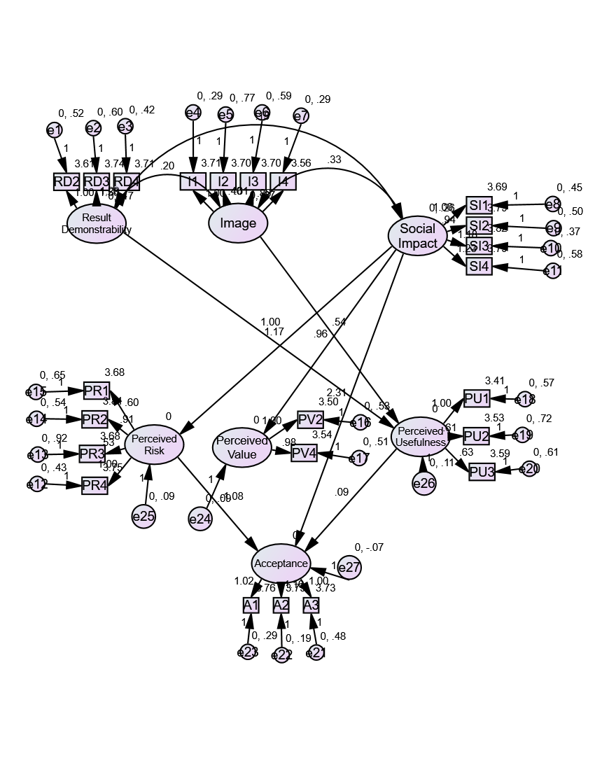
Figure 3. Modified structural equation model
The modified model is constructed based on the hypothesized relationships of the study, which include a total of 15 hypotheses. After removing the invalid relationship paths, the model undergoes another fitting test. Amos 24.0 software is used to examine the path coefficients, as shown in Table 8.

Table 8. Revised path analysis table

Hypothesis |  |  |  | Estimate | S.E. | C.R. | P
H12 | Result demonstrability | ---> | Perceived usefulness | 1 | 0.226 | 4.434 | ***
H4 | Image | ---> | Perceived usefulness | 0.542 | 0.094 | 5.752 | ***
H11 | Social impact | ---> | Perceived risk | 1.167 | 0.128 | 9.147 | ***
H9 | Social impact | ---> | Perceived value | 0.963 | 0.119 | 8.105 | ***
H3 | Perceived risk | ---> | Acceptance | -1.085 | 0.445 | -2.44 | 0.015
H1 | Perceived usefulness | ---> | Acceptance | 0.095 | 0.078 | 1.975 | 0.021
H10 | Social impact | ---> | Acceptance | 2.312 | 0.608 | 3.804 | ***
***0.001 level

Tables 8 and 9 illustrated the corrected values show significant improvement, with all fitting indexes meeting the required standards and each path reaching a significant level. The results indicate that perceived usefulness and social impact have a significant positive effect on the acceptance of driverless buses, while perceived risk has a significant negative effect. There is no significant relationship between perceived value and the acceptance of driverless buses. Although there is no significant relationship between image, result demonstrability, and acceptance, these factors positively influence perceived usefulness and can indirectly impact the acceptance of driverless buses. The final model illustrating the influencing factors of public acceptance of driverless buses in this study is shown in Figure 4.
Table 9. Summary of research hypotheses on social acceptance model of driverless buses

No | Research hypothesis | Result
H1 | Perceived usefulness has a significant positive impact on the social acceptance  of driverless buses in Yichang |  | Yes
H2 | Perceived value has no impact on the social acceptance of driverless buses in Yichang |  | Yes
H3 | Perceived risk has a significant negative impact on the social acceptance of  driverless buses in Yichang |  | Yes
H4 | Image has a significant positive impact on the perceived usefulness of driverless  buses in Yichang |  | Yes
H5 | Image has no impact on the perceived value of driverless buses in Yichang |  | Yes
H6 | Image has no impact on the social acceptance of driverless buses in Yichang |  | Yes
H7 | Image has no impact on the perceived risk of driverless buses in Yichang |  | Yes
H8 | Social impact has no impact on the perceived usefulness of driverless buses in Yichang |  | Yes
H9 | Social impact has a significant positive impact on the perceived value of driverless buses in Yichang |  | Yes
H10 | Social impact has a significant positive impact on the social acceptance of driverless buses in Yichang |  | Yes
H11 | Social impact has a significant negative impact on the perceived risk of driverless buses in Yichang |  | Yes
H12 | Demonstrability has a significant positive impact on the perceived usefulness of driverless buses in Yichang |  | Yes
H13 | Demonstrability has no impact on the perceived value of driverless buses in Yichang |  | Yes
H14 | Demonstrability has no impact on the social acceptance of driverless buses in Yichang. |  | Yes
H15 | Demonstrability has no impact on the perceived risk of driverless buses in Yichang. |  | Yes

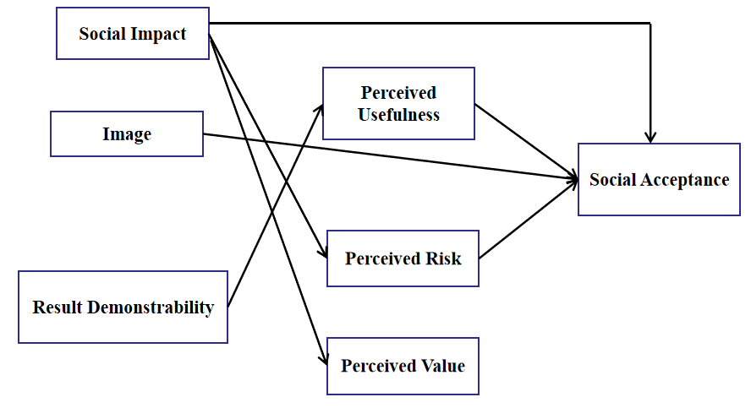
Figure 4. Final model of influencing factors of public acceptance of driverless buses in Yichang

Discussion

Based on previous research and empirical analysis, perceived usefulness has a significant positive effect on the social acceptance of driverless buses in Yichang. Perceived usefulness is a key factor influencing the acceptance of driverless buses. The acceptance of driverless cars, perceived usefulness is influenced by perceived ease of use, which in turn affects acceptance (Wei & Zhong, 2019). This study introduces two innovative variables, image and result demonstrability, and demonstrates that they positively impact perceived usefulness, thereby indirectly influencing the acceptance of driverless buses.
When promoting new technologies, perceived risk is a critical factor influencing public acceptance (Man et al., 2020). If the public perceives that new technology may bring risks, it negatively impacts their attitude toward it, hindering its acceptance. When public evaluation of driverless buses is low, it can obstruct their successful promotion. Therefore, it is essential to prevent negative public emotions and reduce perceived risk. This study shows that perceived risk negatively affects the acceptance of driverless buses. The main concerns include the quality of the equipment, potential safety hazards, and the risk of personal privacy being compromised. To better protect public interests and reduce perceived risk, driverless bus manufacturers can use the findings of this study for improvements. Additionally, the government should thoroughly review driverless buses and share the test results with the public to alleviate concerns. If the review outcomes are positive, they can boost public trust and lower perceived risk.
Currently, the adoption of driverless buses in China is still relatively low, and the public's understanding of them primarily comes from online information and the opinions of others. As a result, social impact becomes a key factor influencing public acceptance of driverless buses. The acceptance of driverless buses, perceived risk negatively affects acceptance, while social impact has a positive effect (Chen et al., 2019). This study further demonstrates that social impact significantly reduces perceived risk. Additionally, social impact positively influences the acceptance of driverless buses. To promote driverless buses in Yichang, a limited number of driverless buses could be introduced for trial operation. This would allow passengers to have a positive experience, influencing those around them and gradually increasing the acceptance of driverless buses.
This study has some limitations. First, the survey participants were somewhat concentrated in a specific area. Second, the influencing factors in the research model are limited. While new factors have been introduced, many other variables could also impact public acceptance of driverless buses. Additionally, the research on the influence of perceived value is not fully explored. Future studies could examine whether there are indirect relationships between perceived value and acceptance from different perspectives. To improve the depth of the research, the following steps could be taken in future studies: (1) expanding the scope of the survey to obtain a more diverse sample and (2) adding new influencing variables to analyze the issue from various angles, potentially leading to new research findings.

Conclusions

Numerous studies have indicated that people in different cities exhibit varying levels of acceptance toward driverless cars. In December 2023, the Ministry of Transport issued safety guidelines for the use of driverless vehicles in public transportation. Currently, there is no research on the acceptance of driverless buses in Yichang. This study helps identify the factors influencing the acceptance of driverless buses among Yichang residents, which can aid in the development of a regulatory framework to facilitate the development and deployment of driverless buses.
Perceived usefulness is a key factor influencing the acceptance of driverless buses (Chen et al., 2020; Xu et al., 2018), and this study reaffirms this finding. Additionally, this research introduces two new variables, image and result demonstrability, and demonstrates that they positively impact perceived usefulness, which in turn can indirectly affect the acceptance of driverless buses.
This study indicates that perceived risk negatively influences the acceptance of driverless buses. Key concerns among the public include the quality of the equipment, potential safety hazards of the technology, and the risk of personal privacy being compromised. Furthermore, the study demonstrates that social impact has a significant negative effect on perceived risk, while social impact itself positively influences the acceptance of driverless buses. Drawing from the technology acceptance model, this research proposes a new acceptance model that can serve as a reference for the development of other technologies in Yichang.

Acknowledgement

The project supported by the Special Fund of Advantageous and Characteristic Disciplines (Group) of Hubei Province.

References

Andreasson, H., Bouguerra, A., Cirillo, M., Dimitrov, D. N., Driankov, D., Karlsson, L., & Stoyanov, T. (2015). Autonomous transport vehicles: Where we are and what is missing. IEEE Robotics & Automation Magazine, 22(1), 64-75.
Baltic, T., Hensley, R., & Salazar, J. (2019). The Trends Transforming Mobility’s Future. The McKinsey Quarterly.
Bazilinskyy, P., Kyriakidis, M., & de Winter, J. (2015). An international crowdsourcing study into people's statements on fully automated driving. Procedia Manufacturing, 3, 2534-2542.
Bestepe, F., & Ozkan, S. (2019). A systematic review on smart city services and IoT-based technologies. Proceedings of the 12th IADIS international conference information systems (pp. 255–259).
Chen, J., Li, R., & Fu, Z. (2019). Passenger acceptance model of driverless bus based on UTAUT. Transportation system engineering and information, 06, 38-44.
Chen, J., Li, R., Gan, M., Fu, Z., & Yuan, F. (2020). Public acceptance of driverless buses in China: An empirical analysis based on an extended UTAUT model. Discrete Dynamics in Nature and Society, 2020(1), 4318182.
Chen, P. (2020). The impact of new coronavirus pneumonia on Xiamen's transportation industry and its countermeasures. Logistics technology, 05, 102-103.
Christie, D., Koymans, A., Chanard, T., Lasgouttes, J. M., & Kaufmann, V. (2016). Pioneering driverless electric vehicles in Europe: The City Automated Transport System (CATS). Transportation Research Procedia, 13, 30-39.
Chen, Y., Khan, S. K., Shiwakoti, N., Stasinopoulos, P., & Aghabayk, K. (2023). Analysis of Australian public acceptance of fully automated vehicles by extending technology acceptance model. Case studies on transport policy, 14, 101072.
Creswell, J. W. (1998). Qualitative Inquiry and Research Design: Choosing Among Five Traditions (p. 403). Sage Publications.
Creswell, J. W., & Clark, V. L. P. (2017). Designing and Conducting Mixed Methods Research. Sage publications.
Li Zhengguang (2017). What are the implications for Chinese auto companies from the bad start of driverless buses in the United States. People's transportation, 12, 64-65.
Li Zhongdong (2017). Is the era of Bus Intelligence coming soon. World culture, 10, 56-59.
Liu, J., Xu, N., Shi, Y., Rahman, M. M., Barnett, T., & Jones, S. (2023). Do first responders trust Connected and Automated Vehicles (CAVs)? A national survey. Transport policy, 140, 85-99.
Liu, P., & Xu, Z. (2020). Public attitude toward self-driving vehicles on public roads: Direct experience changed ambivalent people to be more positive. Technological Forecasting and Social Change, 151, 119827.
Man, S. S., Xiong, W., Chang, F., & Chan, A. H. S. (2020). Critical factors influencing acceptance of automated vehicles by Hong Kong drivers. IEEE Access, 8, 109845-109856.
Patton, M. Q. (1990). Qualitative Evaluation and Research Methods (2nd Edition, p. 532). Sage Publications.
Salonen, A. O., & Haavisto, N. (2019). Towards autonomous transportation. Passengers’ experiences, perceptions and feelings in a driverless shuttle bus in Finland. Sustainability, 11(3), 588.
Tafidis, P., Farah, H., Brijs, T., & Pirdavani, A., (2022). Safety implications of higher levels of automated vehicles: a scoping review. Transport Reviews, 42(2), 245–267.
Van Brummelen, J., O’Brien, M., Gruyer, D., & Najjaran, H. (2018). Autonomous vehicle perception: The technology of today and tomorrow. Transportation Research Part C: Emerging Technologies, 89, 384-406.
Wei X., & Zhong S. (2019). Understanding the acceptance intentions of automated vehicles Based on TAM and Cognitive Theory. China Transportation Review, 41(11), 79-84.
Xu, Z., Zhang, K., Min, H., Wang, Z., Zhao, X., & Liu, P. (2018). What drives people to accept automated vehicles? Findings from a field experiment. Transportation Research Part C: Emerging Technologies, 95, 320-334.
Zhan, Y. (2019). Global auto sales began to slow down after more than a decade of growth. Business Culture, 15, 74-76.
Zhang, T., Li, W., Huang, Q., & Ma, L. (2024). Critical roles of explainability in shaping perception, trust, and acceptance of autonomous vehicles. International Journal of Industrial Ergonomics, 100, 103568.

