Batu Nabau: A rock formation phenomenon in the context of legends and intangible heritage of the Iban people in Sarawak

Gregory Kiyai @ Keai

Visual Arts Program, Faculty of Creative Arts, University of Malaya

Correspondent: Gregory Kiyai @ Keai (email: gregory.kiyai@um.edu.my)

Received: 31 July 2024; Accepted: 20 January 2025; Published: 14 February 2025

Abstract

Batu Nabau, a prominent rock formation in Engkelili, Sri Aman Sarawak, holds significant cultural and mythological importance for the Iban people, believed to be the petrified remains of a giant serpent. Despite its sacred status and symbolic value, detailed documentation and research on Batu Nabau are limited. This study investigates Batu Nabau's role in Iban folklore and its contribution to preserving intangible cultural heritage in Iban identity. Employing qualitative methods, the research utilizes an explanatory approach with data collected from primary and secondary sources, including observations and existing literature. Visual analysis of cultural artifacts and oral traditions reveals Batu Nabau's integral role in the Iban community, reflecting their mythology and identity. The findings highlight Batu Nabau’s function as a cultural memory hub and its influence on Iban rituals and community cohesion. Future studies should aim to thoroughly document and analyze the influence of Batu Nabau on Iban cultural practices, exploring its potential as a key element in heritage conservation and culture preservation. The Batu Nabau research is essential in understanding the Iban identity, especially in how traditional stories, myths, and historical events interact with contemporary views on self and community.

Keywords: Batu Nabau, Iban community, intangible cultural heritage, mythology, rituals

Introduction
Sarawak, often referred to as the Land of the Hornbills, is a state in East Malaysia known for its rich heritage and vibrant cultural assets. The state's diverse population enables it to adapt to global changes while maintaining its cultural and artistic identity. This preservation is reflected in its performing arts, cultural artifacts, local knowledge, languages, and history (Tugang et al., 2022; Gerry & Osup, 2021; Liddy & Wahab, 2021: Salleh et al., 2020; Shaari & Suleiman, 2006).
Oral traditions and expressions are vital for transmitting knowledge, social values, and collective memory, thus preserving culture. They are at risk of disappearing or merging with new cultures due to factors such as mass migration and changes in social environments (Feltault, 2006). These traditions serve as valuable historical resources, especially in regions without written records (West, 1966). Oral transmission often leads to diverse perceptions and narratives, influenced by positive or negative perspectives (UNESCO). Myths and legends can be explored through various research methods (Hassan & Isa, 2014: Liau et al., 2024). Intangible cultural heritage is found all over the world, especially within indigenous communities, and is essential for preserving a community’s history, culture, and values for future generations. In Malaysia, this is particularly significant in light of the National Cultural Policy (Dasar Kebudayaan Kebangsaan), which seeks to foster unity among the country’s multicultural society (Shahidi et al., 2021)
Folklore plays a critical role in explaining the origins of cultural practices while reinforcing social norms related to behavior, morality, and etiquette. It serves as an integral part of tradition, offering insights into the beliefs, values, and experiences of its creators and transmitters. The transmission of culture predominantly occurs through oral traditions, where stories, songs, and beliefs are passed down verbally across generations. Within the realm of indigenous knowledge, this transmission encompasses a diverse array of elements, including cultural rituals, oral histories, legendary tales, musical compositions, mythological narratives, proverbs, and traditional dances. Additionally, it involves societal regulations, local dialects, and classification systems. Collectively, these facets of indigenous wisdom are passed on through successive generations, preserving cultural identity and heritage (Siri et al., 2024).
Research on natural phenomena, such as rock formations within indigenous beliefs, is well-established in the Arts and Humanities. Numerous megalithic studies have been conducted in Peninsular Malaysia, including Negeri Sembilan, Melaka, and Perak, as well as in Sabah in areas like Penampang, Tambunan, and Keningau. The megaliths in Sarawak, especially in the Kelabit highlands, are frequently discussed, with over 540 megalithic sites such as Batu Narit documented (Adnan Jusoh et al., 2018; Sauman et al., 2018; Kong & Eboy, 2021).
The term "megalithic" derives from the Greek words 'Mega' (large) and 'Lith' (stone), referring to the use of large stones by ancient communities, particularly during the Metal Age and afterward. Megalithic cultural remnants often feature monolithic or andesite stones arranged in large formations like menhirs or dolmens. This culture, believed to have originated in the Neolithic era, is known as the Megalithic culture and is considered an authentic local tradition in Southeast Asia, uninfluenced by external sources. Although it began in the Neolithic era, it significantly flourished during the Metal Age (Adnan Jusoh et al., 2018).
The location of Batu Nabau is near Sungai Bukong, approximately 3.2 kilometers from the small town of Engkilili in the Sri Aman district. Engkilili is situated about 56 kilometers from Lubok Antu, 37 kilometers from Bandar Sri Aman, and 210 kilometers from Kuching City. The small town of Engkelili in Sri Aman, Sarawak, is home to a natural treasure: a large rock formation with a significant legend in the local indigenous culture (Borneo Post Online, 2016). Researchers have observed that the local community, as well as people from outside the area, are aware of the rock's existence and regard it as a sacred site. However, it has not been thoroughly documented, and no specific research has been conducted on this site. While the Sri Aman District Council has included visual documentation of the rock on their digital portal, there is no detailed description of it. Batu Nabau, a rock formation that is believed to resemble a serpent in Iban culture, represents more than just a geological phenomenon. It holds deep symbolic meaning in the context of local legends and plays a crucial role in the cultural heritage of the Iban people in Sarawak. This article explores how Batu Nabau is connected to folklore and its significance in preserving the intangible cultural heritage of the Iban community. Figure 1 depicts the locations of these remarkable geological phenomena.
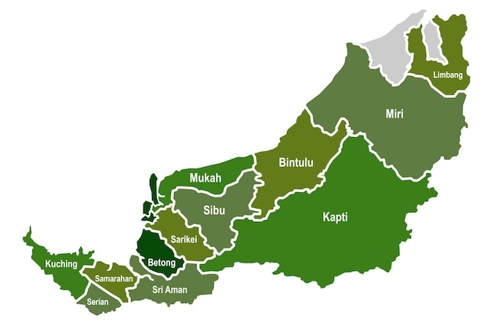
Batu Nabau
Figure 1. Locations of Batu Nabau

Literature review

Nabau is a significant mythology creature in Iban culture. (Janowski, 2019) describes Nabau as an Iban mythological creature known as the 'Water Dragon,' frequently represented by Iban weavers in Pua Kumbu textiles, symbolizing protection, safety, and prosperity. In contrast, (Kiyai, 2022) depicts Nabau as a divine being with a dragon-like head, seven nostrils, scales, and a long, large body.
The forms and artistic expressions related to Nabau beliefs are often showcased in the visual arts of the Iban community, especially in the weaving of pua kumbu. (Drake, 1988), in his study of Iban textile motifs, describes the Nabau as a mythical serpent in Iban folklore. It is frequently depicted with intricate motifs and is revered as a powerful figure. In Iban culture, the spirit helpers of renowned headhunters would sometimes take the form of the Nabau, symbolizing its strength and mystery. These motifs and stories are vital parts of the cultural heritage preserved in artifacts and oral traditions.
According to research by (Rubis, 2023) explores how the Nabau concept serves as a metaphor for the Dayak people's view of Brooke's authority in Sarawak. He clearly discusses how "the Nabau comes to life in the Batang Ai landscapes through these stories and the places it is still believed to dwell. The Nabau was subtly woven into the narratives shared with me by various interlocutors from different Iban communities. The following section delves into how dominant recollections in anthropological literature obscure the extent of colonial violence towards the Dayaks, particularly through the selective use of certain terms to describe the so-called 'plundering.' In this context, the Nabau dream recounted can be seen as part of an Indigenous refusal to challenge dominant narratives and offer an alternative remembering that remains true for the Iban people."(Kiyai, 2022). This reflects white oppression of the indigenous people not only in Sarawak but also in other Southeast Asian countries. In both insular and mainland Southeast Asia, there is a pervasive belief in snake-like water spirits. Specifically, on the mainland, which includes countries such as Vietnam, Laos, Cambodia, Thailand, and Myanmar, these water beings, often referred to as naga, are not only widely revered but are also prominently featured in temple iconography and religious practices (Janowski, 2019)

Research objective

- To identify legends within the oral traditions of the Iban community regarding the Batu Nabau.
- To understand the cultural and artistic manifestations of the Iban community in relation to the Batu Nabau,
- To assess the intangible heritage context through the cultural processes of the Iban community and the phenomenon of rock formation in Batu Nabau.

Methodology

This study is a preliminary investigation utilizing qualitative methods through an explanatory research approach. The aim is to elucidate why or how certain phenomena previously studied occur (Bhattacherjee, 2012). This aligns well with the study's hypothesis that the Iban community tends to associate their beliefs with natural elements, such as rock formations, as representations of extraordinary powers they believe can assist and aid them in their lives. This research focuses on the geological phenomenon of Batu Nabau and its significance to the intangible cultural heritage of the Iban people.
The data collection methods employ two sources: primary and secondary sources through observation and documentation techniques. Secondary data are gathered from past publications such as newspapers and journals. Although specific writings on Batu Nabau are not explicitly mentioned, the researcher attempts to explore from different perspectives such as art, beliefs, and oral traditions. The data analysis method uses visual analysis by examining images included in manuscripts and conducting an analysis through the lens of Iban culture. The researcher's experience growing up in a longhouse aid in examining this study from the cultural and belief perspectives of the Iban community.

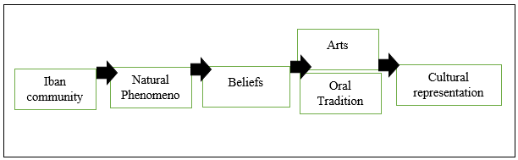
Sources: adapt from Hall, 1989

Figure 2. The process of Iban cultural representation
The data analyzed will be intricately linked to Stuart Hall's Representation Theory (1989), which explores how a community articulates its identity through culture, practices, and everyday habits. At its essence, representation involves the creation of cultural meaning: we assign significance to objects and concepts through the ways we represent them. In this context, language—broadly defined to include more than just written or spoken words—serves as the primary vehicle for this meaning-making process. According to Hall (1989), there is no single, definitive portrayal of people or events within a text; instead, multiple representations exist, each offering a different perspective. Creators of these texts aim to 'fix' a particular meaning or interpretation of the people or events they depict. This notion resonates with our research theme, which delves into how the Iban people utilize natural elements, such as rock formations, to manifest their beliefs and reverence for supernatural forces. The cultural and symbolic meanings behind these practices must be elucidated through a cultural studies lens. This study will investigate how the Iban community employs rocks not merely as physical objects but as potent symbols embedded with profound spiritual significance. For instance, certain rocks may be revered as sacred, intertwined with myths and legends, and epitomizing the Iban's respect for nature and the extraordinary powers they believe reside within these stones. By adopting cultural analysis methodologies, this research aims to unpack the ways these meanings are constructed and represented in the everyday lives of the Iban people (refer to fig.2).

Result and finding

The presence of Batu Nabau has attracted the attention of locals due to its distinctive shape compared to other rock formations in Sarawak. Batu Nabau is a long cylindrical rock with a diameter exceeding two meters and a length of nine meters (refer to fig. 3). This formation gives Batu Nabau the appearance of a giant snake, reminiscent of the Nabau legend in Iban folklore. In Southeast Asia, a similar rock formation has been discovered in Naka Cave at Phu Langka National Park, Thailand, although it has a scaly appearance and is coiled.

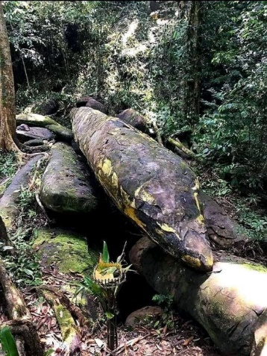
Sources: Bernama Online News, Mustaqim Khairuddin, 2021

Figure 3. Batu Nabau

Visual analysis of Batu Nabau

Through visual observation and analysis, it is evident that the rock formation of Batu Nabau clearly resembles a large serpent emerging with its head from the ground. Visual Analysis I in Figure 4 shows a comparison between the head of Batu Nabau and the head of a python. It is noticeable that the head of Batu Nabau has a tapered and elongated shape similar to that of a python's head (refer fig.4).

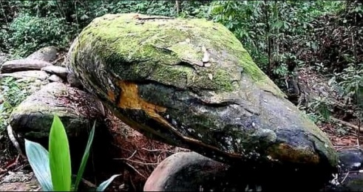 | 
Source: Bernama Online, Mustaqim Khairuddin, 2021 and Jabatan Perhilitan Hutan Malaysia, 2020

Figure 4. Similarities between the head of Batu Nabau and a python

Visual Analysis II explores the body shape of Batu Nabau, which closely resembles the elongated form of a reticulated python. This shape is characteristic of the reticulated python, a species commonly found in tropical rainforests, particularly in Borneo and Southeast Asia. Its scientific name is Malayopython reticulatus (refer fig.5).

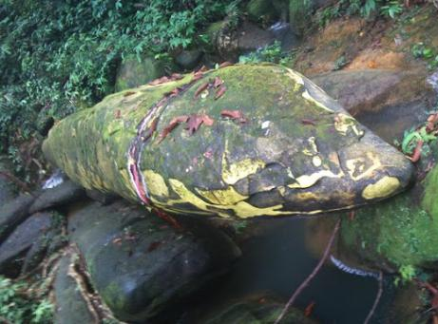 | 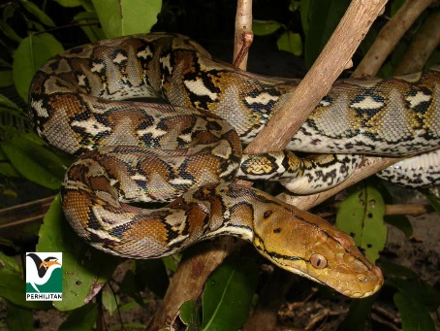
Source: Bernama Online, Mustaqim Khairuddin, 2021 and Jabatan Perhilitan Hutan Malaysia, 2020

Figure 5. Python body

Visual Analysis III explores the coloration of Batu Nabau. Although it is known that the rock has been painted rather than displaying natural hues, this aspect is intriguing for understanding how the local community seeks to imbue the rock with spiritual significance. This effort reflects their intention to connect more deeply with the rock’s symbolic meaning. Figure 6 illustrates that the color scheme of Batu Nabau features dominant shades of black, yellow, white, and green. The green color results from mineral deposits on the rock, and this color scheme has effectively formed patterns or scales resembling those of a reticulated python. Notably, despite being painted over 20 years ago, the paint remains intact and has not faded or worn off, even though the rock has been exposed to harsh environmental conditions (refer fig.6).
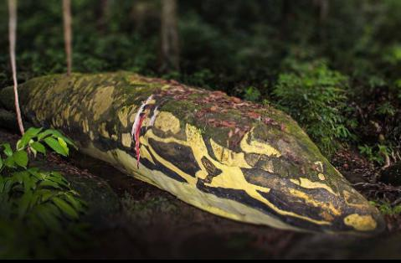
Source: Bernama Online, Mustaqim Khairuddin, 2021

Figure 6. Color texture of Batu Nabau

The legend of Batu Nabau in the local community

A legend refers to a story tied to local tales that are believed to have happened in the past, often linked to extraordinary events or individuals, and has evolved into a cultural identity for the community (Syarifuddin et al., 2017: Setiawan et al., 2023). There are various versions of the legend and stories about the existence and discovery of Batu Nabau in Sarawak.

Version 1

According to Sahih Tukau in the Petronas Gawai (2015) short video titled "The Sacred Serpent." According to the Iban folklore shared by Tukau from a longhouse, the story tells of an old man who transformed into a giant python after his death. He was then venerated as a "Petara" or deity by the Iban people and often appeared in their dreams. During the Gawai festival, villagers would typically avoid drinking tuak, a traditional Iban drink made from yeast and rice, to prevent attracting Nabau. If Nabau became thirsty, he would emerge from his lair, flicking his tongue to drink the tuak. Occasionally, if he drank too much, he would become drunk and coil his body and tail. The Iban believed that Nabau frequently visited them, particularly those related to him. He was known for playing pranks, such as hiding in farmers' baskets to scare them. Consequently, the Iban consider pythons to be sacred and should be protected rather than hunted, to preserve the balance between humans and nature and to honor what might be the spirit of an ancestor.

Version 2

Delves into Borneo Island's history before Western colonization, focusing on the Ngayau (head hunting) practice among tribes. Ngayau involved taking enemy heads as trophies to signify victory and bravery. Local legends recount the Kayau Anak conflict, a revenge-driven war sparked by the intentional killing of a child or relative. In one story, a Tuai Kayau who had committed a murder fled with the victim’s head (Antu Pala) into a dense forest. He crossed Bukit Kana in the Tatau area of Sarawak and continued to Bukong, Engkelili. However, Sungai Bukong was so vast that there was no way to cross it. Desperate for help, he sought aid from the local villagers. Fortunately, a giant snake was crossing the river at that moment. The Tuai Kayau seized the opportunity, leaped onto the snake’s back, and once across, he decapitated the snake and used its body as a barrier to block his pursuers. The snake's carcass eventually turned into stone, taking on the shape of the mythical Nabau-the serpent. Today, this stone is known as 'Batu Nabau' among locals.

Version 3

According to a legend from the Chinese Sarawak community, giant snakes once traveled from Limbang to Engkilili. The most ferocious male snake remained in Limbang, while six others continued to Engkilili. The largest female snake tried to enter a hole but found it too small, so she stayed outside and laid eggs. Over time, these snakes turned into what is now known as Batu Nabau. This legend intertwines with a more recent story from about 20 years ago. A Siamese man from Peninsular Malaysia was brought to the longhouse by local Chinese who were curious about a rock that resembled a snake. Informant, Nyalau reported that the Siamese man had dreamed of the rock and believed it was a real snake deserving of respect. The longhouse residents showed him the rock they called Batu Lintang. Following his visit, the path to their farms saw changes, primarily in the form of religious paraphernalia. The Siamese man claimed his prayers and offerings at the rock had been accepted. Initially, visitors left raw eggs, coins, and spilled milk on the rock, but local believers later put up a sign to stop these practices. The informant, Nyalau noted that the local Chinese who had accompanied the Siamese man painted the rock with yellow stripes, enhancing its resemblance to a snake. As a result, the Ibans began calling the rock Batu Nabau instead of its original name, Batu Lintang.

Batu Nabau's potential in the preservation and conservation of Intangible Cultural Heritage (ICH) for the Iban community in Sarawak

The existence of Batu Nabau has been highlighted in both local and national newspapers, focusing on its uniqueness and the Iban community's legend surrounding the rock's formation. This has been reported in sources such as Suara Sarawak (2023), Utusan TV (2021), Bernama News (2021), and Borneo Post (2016). However, academic research on this subject remains limited, particularly in exploring the history and heritage of Sarawak, especially in relation to the beliefs and cultural practices of its indigenous ethnic groups. For instance, the Iban people hold a deep spiritual belief in Batu Nabau. Batu Nabau has significant potential in preserving and safeguarding the intangible cultural heritage of the Iban community in Sarawak, with the rock’s formation having a lasting impact on their cultural practices.
Firstly, it plays a central role in the belief system of oral stories and legends. The legend of the mythical creature Nabau is deeply rooted in the collective memory of the Iban. The Iban regard Nabau as a powerful incarnation of Petara, reinforcing their daily beliefs in the longhouse. The idea of Nabau as a protector and guardian is expressed through cultural artifacts such as pua kumbu (Iban woven textiles), tikai bebuah (patterned mats), and wooden carvings, designed to immortalize Nabau's image for ritualistic and customary purposes. The ability to create intricate and innovative Nabau motifs is highly esteemed within the Iban social hierarchy. Women skilled in weaving and mat-making sacred motifs like Nabau are highly respected and hold a prestigious social status, as do the men.
Batu Nabau is essential in documenting the cultural history of the Iban through oral traditions passed down from generation to generation. This aspect of ICH illustrates how the Batu Nabau site can serve as a memory hub for the Dayak groups in Borneo, showcasing the richness of their oral history. Indirectly, it helps archive the Iban community's memory and history through stories of Nabau and the warriors who battled it, as recounted in Iban folklore in Jeram Pelagus along the Rajang River, between Belaga and Kapit towns. According to local elders, Nabau appeared in Jeram Pelagus as a human and tried to court a warrior's wife. The warrior discovered Nabau's act, captured him, cut him into seven parts, and threw them into the rapids. Nabau, in his dying breath, cursed the area, vowing to act violently and claim the lives of those passing through Jeram Pelagus. The seven parts of Nabau's body are said to have formed seven rock formations and treacherous rapids now known as Wong Lapoh, Wong Nabau, Wong Batu Kawie, Wong Sukat, Wong Tilan, Wong Batu Naga, and Wong Pantu.
Additionally, Nabau's existence in Iban belief provides knowledge and practices related to the natural world. Major floods or tidal phenomena are linked to Nabau's presence. This traditional understanding helps the Iban relate natural events to the power of sacred beings. Seasonal conditions are crucial for the Iban, who practice hill rice cultivation, as floods and droughts affect their harvest. Rice, apart from being a staple food, is essential in traditional cuisine, such as tuak (rice wine). A plentiful and healthy rice harvest, known as beras baru, symbolizes new life and hope for the Iban community post-harvest. The end of the harvest season, around late May, marks the new year for the Iban, celebrated with the Gawai festival to thank the land god Pulang Gana for the harvest.
Batu Nabau also sustains the practices and rituals of the Miring ceremony. This ritual, inherited from Iban ancestors, involves making requests, seeking blessings, and asking for forgiveness from extraordinary powers believed to be Petara (Deity). Locals believe Batu Nabau has the sacred power to grant prayers of those who bring food offerings and pray to the spirit of the rock. This practice continues today, as locals see Batu Nabau as a symbol connecting them with their ancestors and cultural history, symbolizing the continuity of heritage and cultural identity. The Miring ceremony helps communicate and pass traditional Iban values and beliefs to younger generations, ensuring traditions and cultural heritage are preserved. Additionally, Batu Nabau serves as a focal point that unites the Iban community, strengthening social bonds and collective identity. Communal ceremonies reinforce a sense of togetherness and solidarity within the community.

Conclusion

Batu Nabau is central to preserving the Intangible Cultural Heritage (ICH) of the Iban community in Sarawak by connecting legend, tradition, culture, and Iban identity. The legend of the mythical Nabau, regarded as a powerful protector, is deeply embedded in Iban oral traditions. This legend is immortalized in cultural artifacts such as woven textiles, patterned mats, and wooden carvings, showcasing the community's artistic expression and reverence for their mythology. Batu Nabau serves as a memory hub for the Dayak groups in Borneo, documenting the Iban's cultural history through generational storytelling. It links natural phenomena to traditional beliefs, with seasonal changes and natural events associated with Nabau's presence, impacting agricultural practices and community rituals.
The Miring ceremony, a vital Iban ritual, involves making offerings and prayers to Batu Nabau, maintaining a spiritual connection with their ancestors. This practice ensures the transmission of traditional values and beliefs to younger generations, reinforcing the Iban's cultural identity. Through communal ceremonies at Batu Nabau, the Iban community strengthens their collective identity, social bonds, and sense of solidarity, preserving their rich heritage and cultural continuity. Batu Nabau’s role in Iban culture exemplifies how intangible cultural heritage is maintained and celebrated, connecting the past with the present and future generations.
Batu Nabau, a landmark of considerable cultural and historical importance, necessitates a well-rounded approach to its preservation and conservation. To safeguard its legacy for future generations, it is essential to implement strategies that include thorough documentation, community involvement, effective management guidelines, and collaboration with experts.
- Documentation is a fundamental step in preserving Batu Nabau. This process involves capturing detailed records of the oral histories, traditional practices, and cultural narratives connected to the site. By keeping both physical and digital records, we ensure that these intangible aspects of Batu Nabau are preserved for future research and education. Accurate documentation not only provides a historical reference but also helps maintain the cultural significance of the site.
- Community involvement is crucial in the conservation effort. Local communities have deep-rooted knowledge about Batu Nabau and its cultural context. Engaging these communities in preservation activities ensures that traditional practices and cultural insights are protected and transmitted to future generations. Involving locals fosters a sense of ownership and responsibility, which is essential for the sustainability of conservation efforts. Their active participation enhances the authenticity and success of the preservation initiatives.
- Management guidelines are vital for maintaining the physical condition of Batu Nabau. It is important to develop clear and practical guidelines for the site's management and protection, including regular maintenance schedules, monitoring procedures, and conservation strategies. Effective management helps preserve the site's physical integrity and cultural value. Regular reviews and updates to these guidelines are necessary to address evolving conditions and challenges.
- Collaboration with experts enhances the effectiveness of preservation efforts. Cultural experts, historians, and conservationists offer specialized knowledge and skills crucial for developing and implementing effective preservation strategies with Tun Jugah Foundation, Sarawak Museum Department and National Heritage Department. Their expertise can guide the creation of comprehensive conservation plans, inform best practices, and resolve complex issues related to the site. Collaborative efforts also facilitate the sharing of resources and knowledge, further strengthening the preservation strategy.
In summary, preserving Batu Nabau and its cultural heritage requires a holistic approach that combines thorough documentation, active community involvement, effective management guidelines, and expert collaboration. By integrating these elements, we can ensure that Batu Nabau remains a significant cultural landmark and retains its importance for future generations.

Acknowledgement

All the photos used in this research have already been credited to their respective sources and are intended solely for research and educational purposes. I would like to express our gratitude to the informants, Mr. Nyalau for providing the data used in this study.

Reference

Adnan Jusoh, Y. S. S., & Ramli, R. A. D. Z. (2018). Kebudayaan megalith di Semenanjung Malaysia dari perspektif sosiobudaya dan etnoarkeologi. Jurnal Arkeologi Malaysia, 31(1), 1-18.
Bhattacherjee, A. (2012). Social Science Research: Principles, Methods, and Practices. University of South Florida.
Drake, R. A. (1988). Ibanic textile weaving. Expedition, 30(1), 29.
Feltault, K. (2006). Development folklife: Human security and cultural conservation. Journal of American Folklore, 119(471), 90-110.
Gerry, D. A., & Osup, C. A. (2021). Perubahan fungsi dan seni persembahan kuntau di Kampung Bayur, Balai Ringin, Sarawak: The functional changes and art of kuntau performance in Kampung Bayur, Balai Ringin, Sarawak. KUPAS SENI, 9(1), 16-28.
Hall, S. (1989). Cultural identity and cinematic representation. Framework: The Journal of Cinema and Media, 36, 68-81.
Hassan, F., & Isa, H. M. (2014). Mitos dan legenda sebagai produk pelancongan di Malaysia: Kajian kes Lembah Lenggong. Geografia-Malaysian Journal of Society and Space, 10(5), 168-179.
Hului, P. (2016, July 3). The mysterious ‘Rock Snake of Engkilili’. The Borneo Post. https://www.theborneopost.com/2016/07/03/the-mysterious-rock-snake-of-engkilili/
Janowski, M. (2019). Protective power: The nabau or water dragon among the Iban of Sarawak. Sarawak Museum Journal.
Kiyai, G. (2022). Makhluk mitologi dalam artifak budaya Iban: Pua Kumbu. Jurnal Arkeologi Malaysia, 35(1), 17-30.
Khairuddin, M. (2021, December 16). Batu Nabau di Sarawak. Bernama News. https://www.facebook.com/bernamaofficial/posts/281579394001481/
Kong, S. T., & Eboy, O. V. (2021). Kajian taburan batu megalitik serta penentuan sumbernya di Kampung Tobilung menggunakan analisis GIS. Malaysian Journal of Social Sciences and Humanities (MJSSH), 6(2), 33-52.
Liau, J., Jiton, C., Dugun, D. L., & Ahmad, S. W. (2024). Seni bela diri Dayak Iban: Kajian tentang Kuntau di Sarawak Borneo. Geografia-Malaysian Journal of Society and Space, 20(3), 242-258.
Liddy, M. A., & Wahab, K. A. (2021). Tabu bahasa dalam aktiviti ekonomi masyarakat Iban di Sungai Passai, Sarawak (Language taboo in economic activities of the Iban communities in Sungai Passai, Sarawak). Geografia-Malaysian Journal of Society and Space, 17(2), 375-388.
Petronas Gawai short video: The Sacred Serpent. (2015). YouTube. https://www.youtube.com/watch?v=UMJ9c71uC3s
Rubis, J. (2023). A political ecology of remembering for Dayaks of Sarawak, Malaysian Borneo. ZMO-Studien.
Shahidi, A. H., Shabri, M. S., Aman, R., Ismail, R., & Kechot, A. S. (2021). Kefahaman masyarakat kepulauan terhadap Dasar Kebudayaan Kebangsaan (The archipelago community's understanding of the National Cultural Policy). Geografia-Malaysian Journal of Society and Space, 17(2), 313-326.
Sauman, Y., Jusoh, A., Hasni, M. T., & Ramli, Z. (2018). Penemuan terkini bukti kebudayaan megalitik dan pengebumian tempayan di Sabah. Jurnal Arkeologi Malaysia, 31(2), 1-16.
Salleh, N., Inai, N. N., & Magiman, M. M. (2020). Ritual serarang: Analisis hidangan makanan sebagai simbol komunikasi bukan masyarakat Melanau Likow di Dalat, Sarawak. Jurnal Komunikasi Borneo (JKoB), 8, 118-132.
Setiawan, E., Sukesi, K., Hidayat, K., & Yuliati, Y. (2023). Ecological politics towards the protection of Alas Purwo National Park based on local wisdom. Geografia-Malaysian Journal of Society and Space, 19(4), 119-131.
Shaari, N., & Suleiman, N. (2006). Peranan tekstil di dalam sosial budaya Melayu Sarawak. Kertas kerja, 13-15.
Suara Sarawak. (2023, May 21). Misteri Batu Nabau. Suara Sarawak. https://suarasarawak.my/misteri-batu-nabau/
Siri, H., Naim, H. M., & Ali, A. W. (2024). The Melanau folklore: An analysis of moral values. Geografia-Malaysian Journal of Society and Space, 20(1), 155-173.
Syarifuddin, N., & Mutalib, M. H. A. (2017). Analisis sosiologikal terhadap makna Legenda Monsopiad: Perspektif etnik Kadazandusun (A sociological analysis on the meaning of Monsopiad Legendary: Kadazandusun ethnic perspective). Geografia-Malaysian Journal of Society and Space, 13(3), 42-52.
Tugang, N., Kiyai, G., & Anne, B. (2022). Penganan: Makanan warisan tidak ketara masyarakat Iban di Sarawak (Satu penelitian awal). Journal of Borneo Social Transformation Studies, 8(1), 104-112.
UNESCO. (n.d.). Oral traditions and expressions including language as vehicle of the intangible cultural heritage. UNESCO Headquarters. https://ich.unesco.org/en/oraltraditions-and-expressions-00053
Utusan TV. (2021, February 23). Legenda Batu Nabau – Misteri ular gergasi yang menjadi batu di Sarawak. Utusan TV. https://utusantv.com/2021/02/23/legenda-batu-nabau-misteri-ular-gergasi-yang-menjadi-batu-di-sarawak/
West, F. (1966). Oral tradition. A study in historical methodology by Jan Vansina: H. M. Wright. History and Theory, 5(3), 348–353.

