

Comparative Study Of USLE And RUSLE Model In Predicting Soil Erosion Events Using GIS In Penang Island

Nur Zulaikha Hamizul¹, Haris Abdul Rahim¹, Nor Aizam Adnan¹, Raiz Razali¹, Fazly Amri Mohd² Abdul Aziz Abdul Rahman³

¹Studies of Surveying Science and Geomatics, School of Geomatics Science and Natural Resources, College of Built Environment, Universiti Teknologi MARA (UiTM), 40450 Shah Alam, Selangor, Malaysia
²School of Geomatics Science and Natural Resources, College of Built Environment, Universiti Teknologi MARA (UiTM), 40450 Shah Alam, Selangor, Malaysia
³Institute for Environment and Development (LESTARI), Universiti Kebangsaan Malaysia (UKM)

Correspondence: Haris Abdul Rahim (email: harisrahim@uitm.edu.my)

Received: ; Accepted: ; Published:

Abstract

Soil erosion is a significant environmental concern globally, particularly in tropical regions like Penang Island, Malaysia. This study is to estimate soil erosion using the USLE and RUSLE models in Penang Island, to determine the accuracy and reliability of both models to estimate soil erosion risk and to compare the predictions produced by the RUSLE model with site verification. Key parameters such as rainfall erosivity factor, soil erodibility factor, slope length and steepness factor, vegetation management factor, and supporting conservation practices factor were derived from spatial datasets and incorporated into the models. The research involved the integration of both USLE and RUSLE models with GIS technology to analyse and map soil erosion risk across Penang Island. The results indicate that the RUSLE model is more effective than the USLE model in identifying areas at risk of soil erosion. Hence, the RUSLE model shows more consistent data and generally correlates well with actual site verification results. Overall, the prediction of soil erosion using RUSLE can be accurately compared to the USLE model in GIS. The recommendation of this study provides data collection for model inputs to further improve the accuracy of soil erosion predictions in Penang Island.

Keywords: Soil Erosion, USLE, RUSLE, GIS, land-use, mapping

Introduction
Soil erosion is a worldwide environmental issue that affects both natural ecosystems and agricultural output. Although it is a natural phenomenon, human activities like overgrazing, forest clearing, improper farming techniques can accelerate it. For sustainable land management and effective soil conservation, accurate soil erosion estimation is crucial. Soil erosion is recognized as a factor in the degradation of biodiversity, agricultural productivity, water quality, and aquatic life (Behera et al.2023). Soil erosion is examined from various disciplines and perspectives. This book defines soil erosion as the cumulative result of all processes that dislodge and move soil from its original site over the long term (Asmamaw, L., & Mohammed, A. 2019). Soil erosion is a naturally occurring geomorphic process, although human usage of the soil often results in rates of soil detachment and transport that are several orders of magnitude greater than naturally occurring rates. Researchers have developed numerous methods to estimate soil erosion, including process-based models like the Universal Soil Loss Equation (USLE) and the Revised Universal Soil Loss Equation (RUSLE). The USLE model estimates the typical soil loss resulting from splash, sheet, and rill erosion (Bernama,2023).Created by the United States Department of Agriculture (USDA) in the 1960s, it is used globally (Adnan et al.2021). The USLE has evolved into a valuable tool for predicting soil losses and planning control strategies by integrating GIS-based techniques for calculating factor values on a grid cell basis. Next, The RUSLE includes improvements in estimating the cover-management factor and the topographic factor, designed to overcome the shortcomings of the USLE. However, despite these advancements, there are still debates about the applicability and accuracy of the RUSLE compared to the USLE. Therefore, comparative studies are necessary to evaluate the performance of these two models under different climatic and geographical conditions. Furthermore, Geography Information System (GIS) has developed methodologies and processes for performing soil erosion studies to assess the level of soil erosion in a specific area. The aim of this study is to comparative study of USLE and RUSLE models in predicting soil erosion events using GIS in Penang Island. Soil erosion can be accelerated by intense rainfall and steep slopes, particularly in regions with these characteristics. Rainfall and stormwater activities are primary factors contributing to slope collapse and landslides at many construction sites situated on slopes in Malaysia (Mokhtar, 2006; Rahman & Mapjabil, 2017). Reported approximately 21,000 landslide-prone locations across Malaysia, with 76% of them (16,000 locations) in Peninsular Malaysia, 2,000 in Sarawak, and 3,000 in Sabah (Rahman & Mapjabil, 2017). According to sectoral studies in Malaysia, 88% of 49 documented landslide events occurred on man-made slopes JKR as depicted in Figure 1.
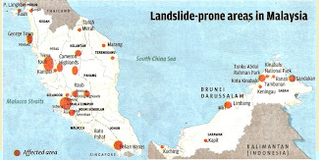
Figure 1. Landslide prone areas in Malaysia (Source: National Slope Master Plan 2009-2023, 2019)
Literature review

One typical environmental issue that poses a harm to the ecology of Penang Island's hills is soil erosion. Events that can affect and pose a risk to people, the environment, and the economy include landslides, flooding, soil erosion, and slope collapse (Ahmad et al., 2013; Ahmad et al., 2020). The slope is particularly vulnerable to erosion and landslides in Malaysia due to the country's abundant rainfall. As a result, was shown in Figure 2.1, soil erosion and slope failure caused a section of the federal road around the island, which runs from Balik Pulau road to Teluk Bahang, to become completely blocked in July 2023. Zairil Khir Johari, the chairman of the Penang Infrastructure and Transportation Committee, stated that slope breakdown was brought on by soil erosion because of a high rainfall distribution during the Public Works Department's (PWD) precursor study of the site (Bernama, 2023). Figure 2. shows the location of the slope failure at FT006 section 46.80 in Balik Pulau, Penang.

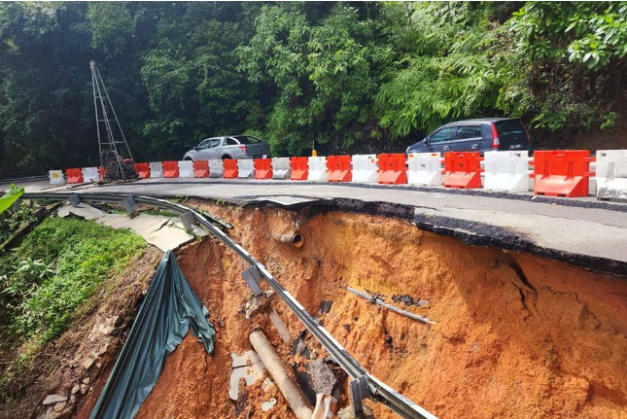
Figure 2. Slope failure at FT006 section 46.80 at Balik Pulau (Bernama,2023)

Sheet erosion refers to the gradual loss of soil in thin layers due to the impact of raindrops and shallow surface movement. It can be challenging to detect unless significant soil deposition nearby has occurred, or the erosion damage is already substantial. During sheet erosion, organic compounds and essential nutrients contained within soil particles are often removed, diminishing soil fertility over time. (Mulvihill, 2021). The most vulnerable soils to sheet erosion are those that have been overgrazed and farmed and have insufficient vegetation to cover and hold the soil. Bare spots, water puddles as soon as it rains, exposed tree roots, discernible grass roots, and exposed subsoil are all signs of sheet erosion. Sheet erosion occurs when minute particles are released from the substrate by rain splash and are then carried away, typically over short distances, by a thin, even layer of water known as sheet flow. Sheet erosion is a phenomenon of modest magnitude because sheet flow transfer often happens over small distances. As opposed to a normal sheet flow, a sheet flood has a significantly higher volume and a much lower frequency. The sheet erosion occurring along the Langat River at Kuala Langat is shown in Figure 3.

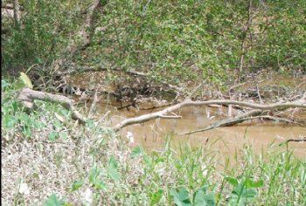
Figure 3. Sheet erosion along Langat River at Kuala Langat (Abidin et al., 2017)

Rill erosion is a form of erosion that creates shallow, curved, parallel channels in the soil. These channels, initially small, are referred to as microrills. Over time, with repeated water flow, they can enlarge and deepen, depending on the frequency and volume of water passing through them (Rollo & Dunn, 2022). Rill erosion is most noticeable on hillsides, where it manifests as a group of parallel, perhaps convergent channels that range in depth from 0.3 to 3.9 inches. These channels are formed as runoff water concentrates and flows down a slope. The distinctive flow pattern of rill erosion suggests that water moves in predictable, if disjointed, parallel channels.
Moreover, rills happen when the capacity of surface runoff to separate soil particles outweighs the soil's resistance to a force applied perpendicular to its surface. Erosion begins when water breaks up soil particles and moves them down the slope. Rills can occur on any surface and are closely tied to the steepness of the hillside slope. Not all surfaces are suitable for the creation of rills, and steep slopes are necessary because gravity limits the water's capacity to produce the perfect conditions needed for rills to form. Because the strength of the water is controlled by gravity, the sexual atmosphere required to create rills is exclusive to steep slopes and cannot occur on any other surface (Rollo & Dunn, 2022). Figure 2.3 shows the rill erosion occurring along Langat River at Hulu Langat.

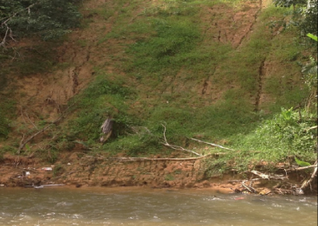
Figure 4. Rill erosion along Langat River at Hulu Langat (Abidin et al., 2017)

Method and study area

This chapter delineates the comprehensive methodology utilized in comparing the RUSLE and USLE models for predicting soil erosion in the study area. The methodology comprises four main sections: data collection, data processing, data analysis, and visualization of the soil erosion risk map. Figure 1 shows research methodology. In the data collection phase, four types of data were gathered: satellite imagery, DEM data, soil maps, and rainfall data. The processing phase involved utilizing NDVI, land use, slope, and flow accumulation data to evaluate relevant factors and calculate average annual soil loss using appropriate formulas. Data analysis included comparing prediction results from both models and conducting on-site verification. Accuracy assessment was integral to this section, focusing on comparing the accuracy of predictions between the USLE and RUSLE models (Figure 5).

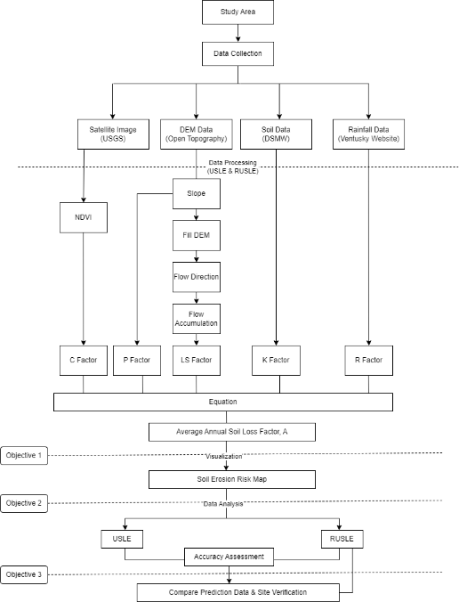
Figure 5. Flowchart of research methodology
Data acquisition

Table 1. Description of the datasets used in this study
Data | Resolution | Year | Source
Landsat 8 | 30m | 2024 | United States Geological Survey (USGS)
DEM data | 90m | 2023 | Open Topography
Soil data | - | 2023 | Digital Soil Map of World (DSMW)
Rainfall data | - | 2023 | Ventusky

The predicted soil erosion of the study area was identified in this research study using ArcGIS 10.8.2 software and using data from remote sensing raster data (images from Landsat 8). The USLE and RUSLE are empirical models used for predicting soil erosion. The USLE and RUSLE is an empirical soil model that was created by Wischmeier and Smith in 1978. Equation (1) was used to calculate the A value.

$$A_{\begin{aligned}\frac{USLE}{RUSLE} \\ \end{aligned}}=R×K×LS×C×P$$ |  | Eq.1

where A is the estimated average soil loss, R is the rainfall erosivity, K is the soil erodibility, LS is slope length and steepness, C is vegetation management and P is supporting conservation practices. The equation of R factor and K factor was the same used for both models, but factor C and LS are using the difference equation. The slope of Penang Island is used to perform the process of the P factor of both models. (Table 2) showed the comparative study of the models used in the study area.

Table 2. Comparative study of the models
Factor | USLE & RUSLE Model
R | 38.5 + 0.35P
K | $$K_{USLE/RUSLE}=f_{csand}×f_{ci-si}×f_{orgC}{×f}_{\begin{aligned}hisand \\ \end{aligned}}$$
 | USLE Model | RUSLE model
LS | $${LS}_{USLE }= {\left(flow accumulation ×\frac{cell value}{22.14}\right)}^{0.4}×{\begin{aligned}\left(\frac{\sin\left(slope \right)}{0.0896}\right) \\ \end{aligned}}^{1.4}$$ | $${LS}_{RUSLE }= {\left(flow accumulation ×\frac{cell value}{\begin{aligned}22.1 \\ \end{aligned}}\right)}^{m} ×(0.065+ 0.045S+0.0065 ×S^{2} )$$
C | $$C_{USLE}=exp\left(\begin{aligned} -α×\frac{NDVI }{ β -NDVI} \\ \end{aligned}\right)$$ | ${ C}_{\begin{aligned}RUSLE \\ \end{aligned}}$= 0.9167$-NDVI×1.1667$

The accuracy of the predicted risk levels from both the USLE and RUSLE models. Then, compared by RUSLE model with actual site verification data. Additional verification evidence was required. Eight locations were selected for on-site verification, representing various areas within the study site and offering a diverse set of conditions for assessing soil erosion risks. The actual soil erosion risk levels at these locations were determined through on-site verification and observations. Penang Island is in Northwest Peninsular Malaysia at latitudes 5°22'11" N and longitudes 100°15'38" E using the WGS84 coordinate system, has an average height of 118 meters above sea level. There are 301.27 km² in the Penang Islands overall, with 126.4 km² in the northeast and 174.87 km2 in the southwest. The Department of Statistics Malaysia (DOSM) states that Penang Islands has one of the highest rates of urbanization, following Kuala Lumpur and Selangor, which have rates as high as 90.8%. Penang Island is also seeing constant economic growth, and because of extensive industrialization, rapid technological advancements, and the greatest rate of urbanization to accommodate population increase, high-risk geohazard zones have been created (Figure 6). For example, the high terrains of Bukit Bendera (738 meters) and Bukit Western (833 meters) in these two places have had multiple landslide incidents in the past few years.

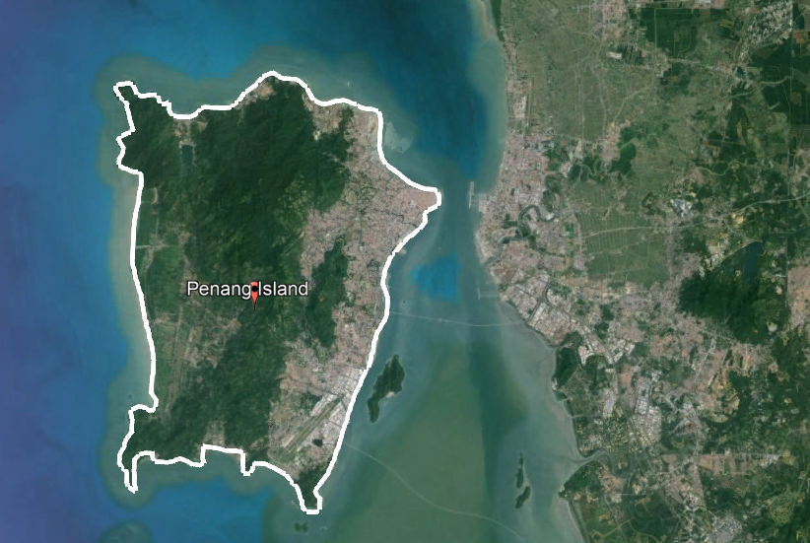
Figure 6. Study area (Google Earth,2024)

Results and Discussion

This chapter describes the concepts of the USLE and RUSLE models along with techniques to estimate the annual average soil loss rate using the USLE and RUSLE equations. In this study, only one software was used to process the data: ArcGIS software.

Rainfall Erosivity Factor

Penang Island is experiencing high rainfall rates that can lead to soil erosion. Increased rainfall, sloping terrain, and insufficient vegetation cover can accelerate the erosion process. This water erosion can damage infrastructure and cause the loss of productive soil and sediment in rivers and oceans. Raindrops, upon hitting the ground, are the primary source of energy for soil separation. In this study, the annual average rainfall data obtained was used to calculate the value of rainfall erosivity (Mg/ha/year). The monthly anomaly precipitation data in 2023 was obtained from six rainfall stations from Ventusky. The spatial interpolation of all data points was conducted using the IDW method. The value of R was calculated based on the formula in Equation (2) that was introduced by Morgan in 1974. where P is mean annual rainfall in mm (2023). R factor map in Figure 7 indicates that the values range between 230.3 and 258.9 mm/ha h year.

R= 38.5+ 0.35P
Eq. 2

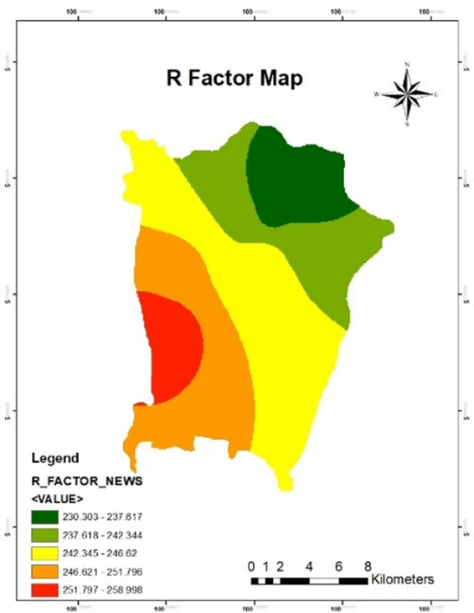
Figure 7. R factor map

Soil Erodibility Factor
There is one predominant soil unit known as Orthic Acrisols (AO). Orthic Acrisols are characterized by a clay-enriched subsoil horizon and are typically found in tropical regions. The K factor depends on four parameters: sand, clay, silt, and organic matter percentages, which determine the soil's susceptibility to erosion. The K factor value was calculated using Williams' (1995) Equations (3) to (7).

$$K_{USLE/RUSLE}=f_{csand}×f_{ci-si}×f_{orgC}{×f}_{\begin{aligned}hisand \\ \end{aligned}}$$  $$f_{csand}=\left(\begin{aligned}0.2+0.3×exp\left[-0.256×m_{s}×\left(1-\frac{m_{silt}}{100}\right)\right] \\ \end{aligned}\right)$$  $$f_{ci-si}={\left(\frac{m_{silt}}{\begin{aligned}m_{c}+m_{silt} \\ \end{aligned}}\right)}^{0.3}$$  $$f_{orgc}=\left(1-\frac{0.25×orgC}{\begin{aligned}orgC+exp\left[3.72-2.95×orgC\right] \\ \end{aligned}} \right)$$  $$f_{hisand}=\left(1-\frac{0.7×\left(\begin{aligned}1-\frac{m_{s}}{100} \\ \end{aligned}\right)}{\left(1-\frac{m_{s}}{100}\right)+exp\left[-5.51+22.9×\left(\begin{aligned}1-\frac{m_{s}}{100} \\ \end{aligned}\right)\right]}\right)$$ | Eq.3  Eq.4  Eq.5  Eq.6  Eq.7

where $K_{USLE/RUSLE}$is the erodibility factor, $m_{s}$ is the % sand, $m_{silt}$ is the % silt, $m_{c}$ is the % clay, and ${Org}_{c}$ is the % organic carbon. The results in Figure 8 show that the values of the K factor are 0.160, indicating a moderate to high susceptibility to erosion.

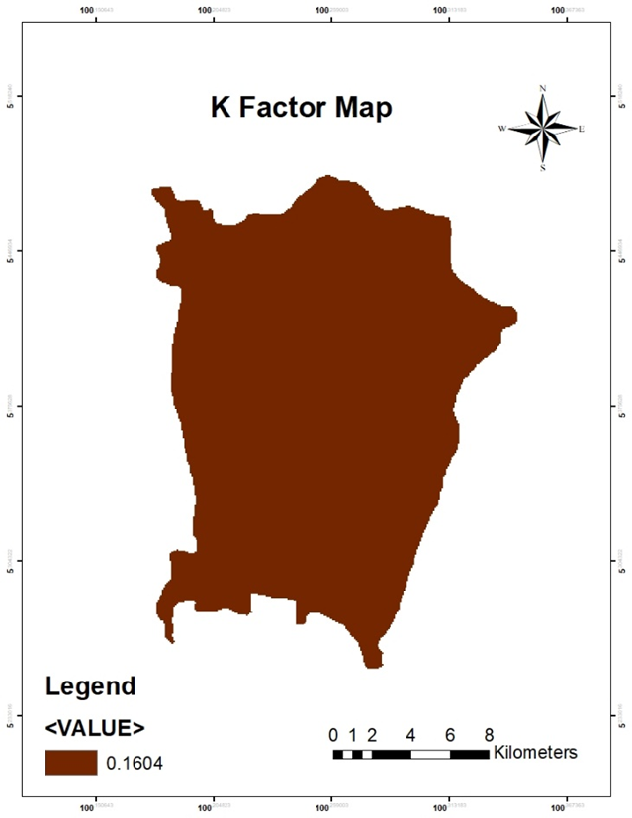
Figure 8. K factor map
Slope Length and Steepness(LS)

The LS factor in both USLE and RUSLE equations reflects the combined effect of slope length and steepness on soil loss. This factor has the greatest influence on soil erosion in the study area. To calculate the LS factor for both models, DEM data was processed to create flow direction, flow accumulation, and slope raster datasets. Flow accumulation was derived from the flow direction, and both flow accumulation and slope raster data were utilized in the LS calculation. Both images show a similar spatial distribution of LS values, with high values concentrated in similar areas. The RUSLE model appears to show more detailed variation within the high LS compared to the USLE model. Equation (8) and Equation (9) for USLE and RUSLE models has been given as:

$${LS}_{USLE }= {\left(flow accumulation ×\frac{cell value}{\begin{aligned}22.14 \\ \end{aligned}}\right)}^{0.4} ×{(sin(slope)/0.0896)}^{1.4}$$  $${LS}_{RUSLE }= {\begin{aligned}\left(flow accumulation ×\frac{cell value}{22.1}\right) \\ \end{aligned}}^{m} ×\left(0.065+ 0.045S+0.0065 ×S^{2} \right)$$ | Eq.8  Eq.9
where S is slope in % and m is parameter related slope class in (Table 3).

Table 3. Value m relative to each class of slope (Mondal et al., 2018)
m value | Slope (%)
0.5 | >5
0.4 | 3-5
0.3 | 1-3
0.2 | <1

The results of the processed DEM and LS factor in the Penang Island area are shown in Figure 9 to Figure 10 for both models. The result of the analysis shows that the high value LS of the USLE model is 1628.69, while the high value LS of the RUSLE model is 302.166.

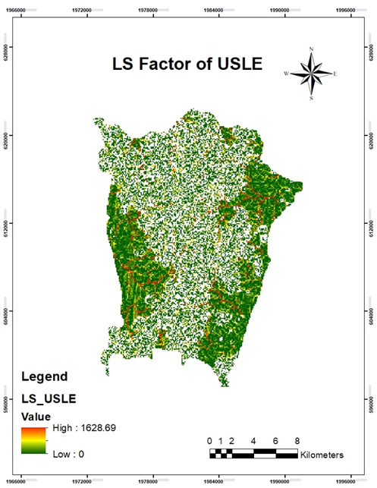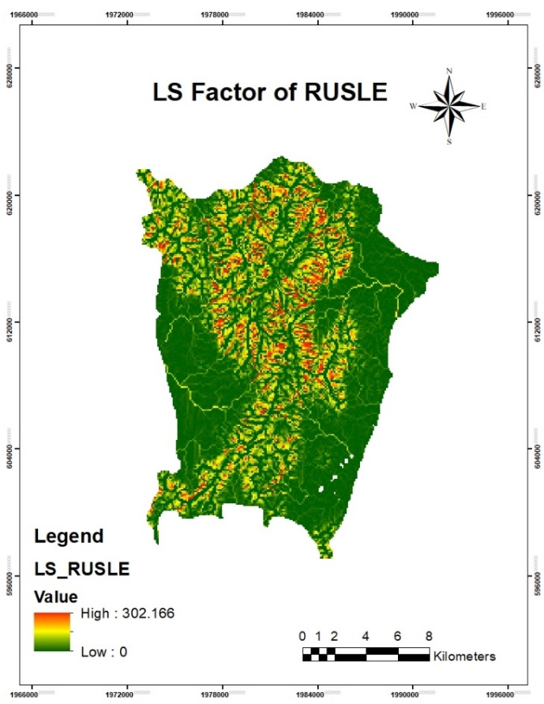
Figure 9. LS factor of USLE & Figure 10. LS factor of RUSLE

Cover and Management (C)
For the NDVI (Normalised Difference Vegetation Index), the effects of available vegetation covering any ground surface, either agricultural practices or not, in reducing soil erosion are numerically represented by the C factor. In this research study, the Landsat 8 images were used in Equation (10) to calculate the NDVI. The NDVI calculation required an appearance of both bands in the Landsat 8 images, as band 4 was associated with red (R) and band 5 with infrared (IRC) [3].

$$NDVI=\left(\begin{aligned}\frac{NDVI -RED }{ NDVI +RED} \\ \end{aligned}\right)$$ | Eq.10

where NIR is near infrared band of the satellite image and R is red band of the satellite image. The NDVI values found in the study area range from −0.12 to +0.53. Figure 11 shows the result of the NDVI.

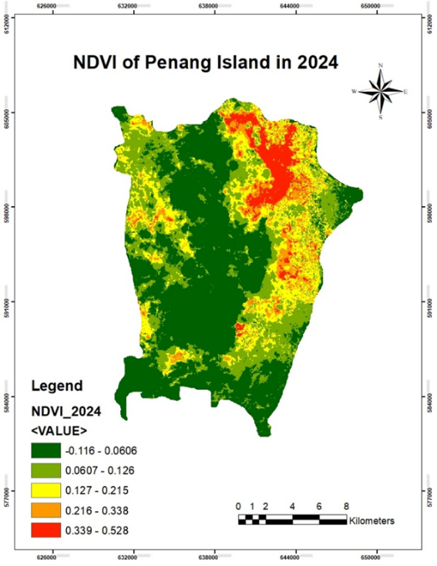
Figure 11. NDVI of Penang Island

As a result, the effect of vegetation cover is included in the C factor in soil erosion. However, the C factor values of the USLE model are calculated here and range from 1 to 1, while the RUSLE model ranges from 0.30 to 1.05. According to the RUSLE model's C factor, a low value of 0.30 is covered with dense vegetation or forested areas, which help in reducing soil erosion. However, the high value of 1.05 has less vegetative cover or more disturbed land, which increases the susceptibility to soil erosion. The NDVI values were used in different regression equation in USLE and RUSLE models. The regression equation of the USLE model was as defined by Vander Knijff, et al., (1999) based on Equation (11) while the Equation (12) used for the RUSLE model.

$$C_{USLE}=exp\left( -α×\frac{NDVI }{\begin{aligned} β -NDVI \\ \end{aligned}}\right)$$  $C_{\begin{aligned}RUSLE \\ \end{aligned}}$= 0.9167$-NDVI×1.1667$ | Eq.11  Eq.12

where alpha and beta were defining the shape of the curve, where $α = 2 and β = 1$. The C factor map for the USLE and RUSLE is depicted in Figure 12 and Figure 13.

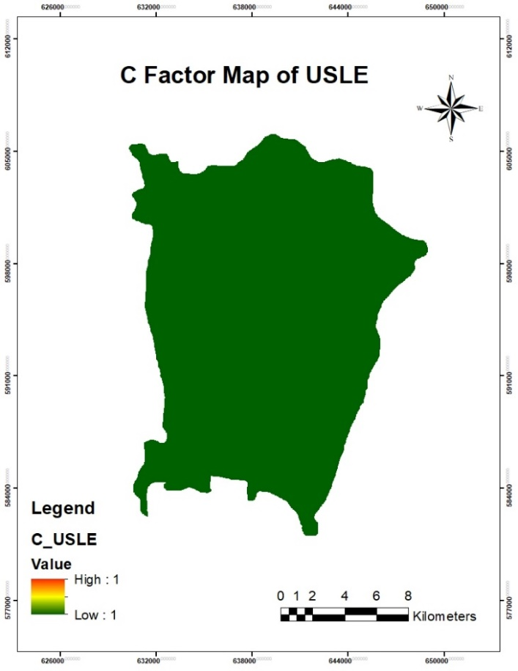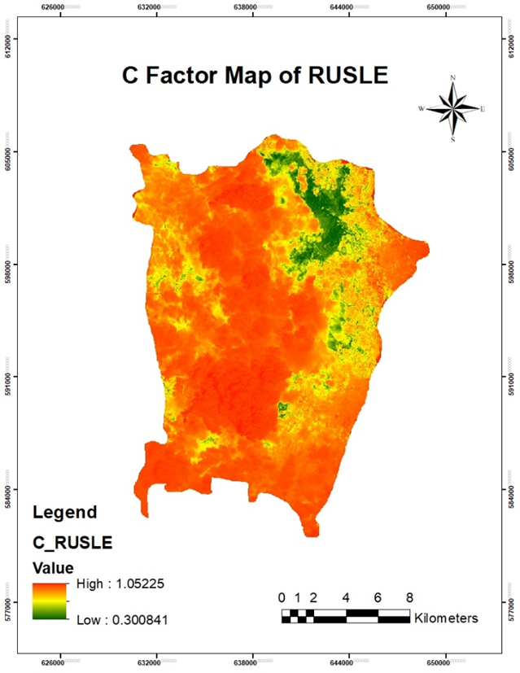
Figure 12. C factor of USLE & Figure 13. C factor of RUSLE

Support Conservation Practices (P)
In this study, the slope of Penang Island is used to perform the process of the P factor of both models. These areas have a P factor close to 1, indicating a higher potential for soil erosion, while values close to 0.55 indicate a lower erosion potential. The concentration of high P factor places indicates that the risk of erosion is higher in these areas due to either ineffective conservation techniques, steeper slopes, or more severe rainfall. Next, low P factor values are indicative of less heavy rainfall, flatter topography, or better land management techniques, all of which lower the risk of erosion. According to Table 4, the P factor was shown to depend on the slope.

Table 4. P factor depending on slope (DOA, 2010)
Slope (%) | Contouring
0.0 - 7.00 | 0.55
7.00 - 11.3 | 0.60
11.3 - 17.6 | 0.80
17.6 - 26.8 | 0.90
26.8 > | 1.00

The P factor map for the USLE and RUSLE is depicted in Figure 14.

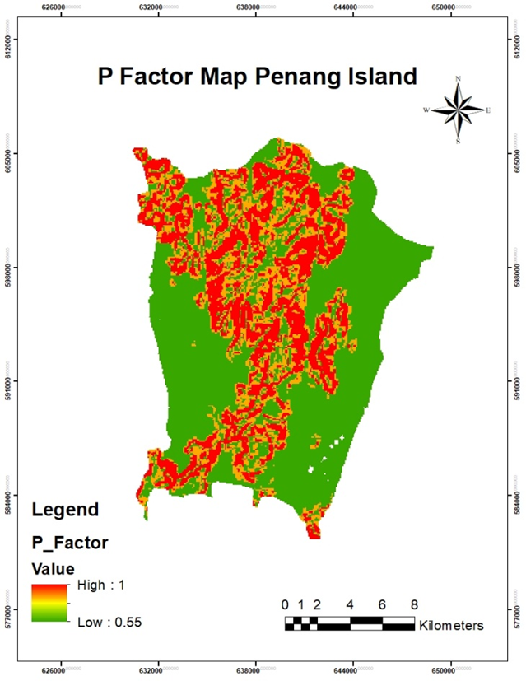
Figure 14. P factor map Penang Island

Soil Erosion Risk Map

The study analysed soil erosion risk maps generated using both the USLE and RUSLE models on Penang Island. The results show that the RUSLE model is more effective than the USLE model in pinpointing areas vulnerable to soil erosion. This difference arises because the soil erosion risk assessments in both models utilize distinct regression equations to calculate the C and LS factors. Then, the results of all five factors were calculated using models based on the Equation (1). Next, the results were reclassified into five classes which were very low risk, low risk, moderate risk, high risk and very high risk. Figure 15 shows the result of the soil erosion risk map of the USLE model, while Figure 16 shows the result of the RUSLE model.

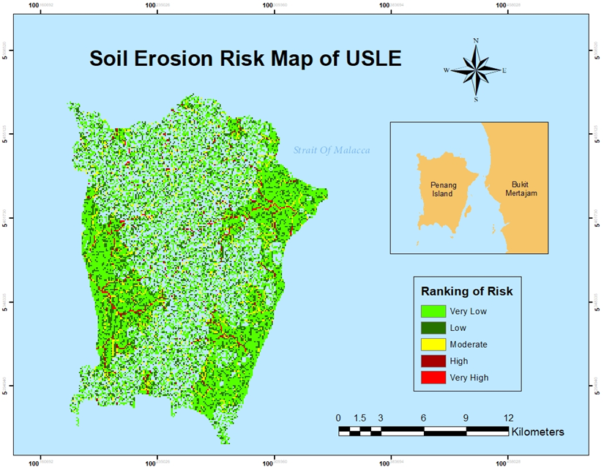
Figure 15. Soil erosion risk of USLE

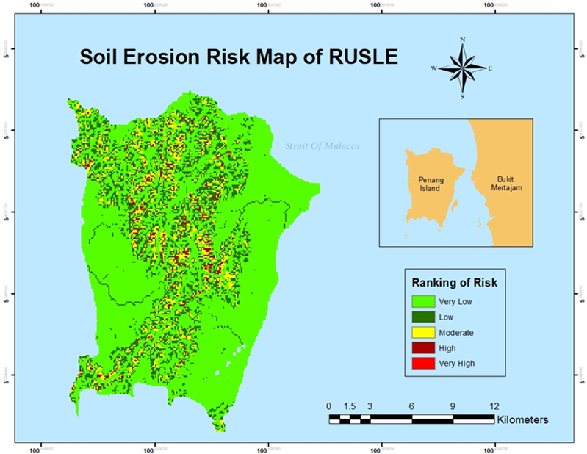
Figure 16. Soil erosion risk of RUSLE

Accuracy and Reliability of Both Models (USLE vs RUSLE)
Table 5 shows the result of compares actual site verification data with the predicted risk levels from the USLE and RUSLE models at various locations. Based on Table 5, the RUSLE model shows more consistent data and generally correlates well with actual site verification results. The USLE model also predicts accurately but lacks data for several locations, suggesting occasional gaps in its reliability for predicting soil erosion. Consequently, the RUSLE model is deemed more reliable and accurate in estimating soil erosion risk compared to the USLE model.

Table 5. Actual site verification data with predicted risk levels from USLE and RUSLE
No | Location | Coordinate |  | Actual Site Verification | Level Risk by USLE | Level Risk by RUSLE
No | Location | Latitude | Longitude | Actual Site Verification | Level Risk by USLE | Level Risk by RUSLE
1 | Jalan Bukit Kukus | 5°21’34.98” | 100°16’29.15” | Medium | No data | Very Low
2 | Jalan Tun Sardon 1 | 5°21’20.16” | 100°16’12.60” | Low | No data | Low
3 | Jalan Tun Sardon 2 | 5°20’59.48” | 100°15’17.81” | Very Low | Low | Very Low
4 | Jalan Tun Sardon 3 | 5°20’52.34” | 100°14’25.73” | Very Low | No data | Very Low
5 | Jalan Balik Pulau  (Kek Lok Si Temple) | 5°24’0.73” | 100°16’26.00” | Medium | High | Medium
6 | Jalan Teluk Bahang 1 | 5°25’24.54" | 100°13’9.18” | Medium | Very low | Medium
7 | Jalan Teluk Bahang 2 | 5°25’23.10" | 100°13’8.51" | Medium | No data | Low
8 | Jalan Teluk Bahang 3 | 5°25’36.50" | 100°13’6.96" | Medium | Medium | Medium

Estimation of Soil Erosion Risk

This section describes the comparisons of the predictions produced by the RUSLE model with site verification. The temperatures range from 31°C to 33°C, which are relatively consistent and typical of a warm climate. There are eight locations taken for location verification with varying risk levels throughout Penang Island. Referring to Table 6 provides detailed information about soil erosion risk at specific locations based on the RUSLE model. Figure 17 shows the map location of verification.

Table 6. Information of site verification and level risk by RUSLE
No | Time (PM) | Temperature | Location | Coordinate |  | Level Risk by RUSLE
 |  |  |  | Latitude | Longitude | Level Risk by RUSLE
1 | 12.36 | $$32°$$ | Jalan Bukit Kukus | 5°21’34.98” | 100°16’29.15” | Very Low
2 | 13.01 | $$32°$$ | Jalan Tun Sardon 1 | 5°21’20.16” | 100°16’12.60” | Low
3 | 13.54 | $$31°$$ | Jalan Tun Sardon 2 | 5°20’59.48” | 100°15’17.81” | Very Low
4 | 14.01 | $$31°$$ | Jalan Tun Sardon 3 | 5°20’52.34” | 100°14’25.73” | Very Low
5 | 13.21 | $$33°$$ | Jalan Balik Pulau  (Kek Lok Si Temple) | 5°24’0.73” | 100°16’26.00” | Medium
6 | 14.46 | $$32°$$ | Jalan Teluk Bahang 1 | 5°25’24.54" | 100°13’9.18” | Medium
7 | 14.50 | $$32°$$ | Jalan Teluk Bahang 2 | 5°25’23.10" | 100°13’8.51" | Low
8 | 14.54 | $$32°$$ | Jalan Teluk Bahang 3 | 5°25’36.50" | 100°13’6.96" | Medium
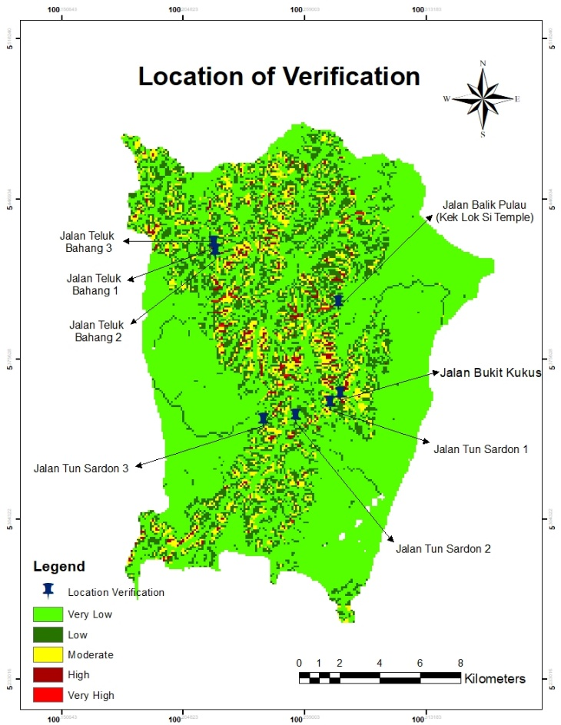
Figure 17. Map of location verification

Conclusion

The comparative study of USLE and RUSLE models in predicting soil erosion events in Penang Island using GIS has provided valuable insights into their efficacy and reliability. The estimating soil erosion of five factors namely R, K, LS, C, P are produced and from the combination of all factors are produced A, soil loss map from the USLE and RUSLE models. The results imply that the RUSLE model is superior to the USLE model in identifying areas prone to soil erosion. This difference arises because the soil erosion risk assessments in both models utilize distinct regression equations to calculate the C and LS factors. RUSLE models have more consistent data and generally align well with actual site verification while USLE model also provides accurate predictions but lacks data for several locations. This indicates that the model is highly reliable and provides accurate predictions of soil erosion. So, the RUSLE model performs much better compared to the USLE model of accuracy and reliability to estimate soil erosion risk. Additionally, site verification of the RUSLE model's predictions affirmed its robustness in estimating soil erosion. The spatial distribution of erosion predicted by the RUSLE model quite matched the observed erosion patterns in the field. This consistency underscores the model’s practical utility for soil erosion assessment and its potential for guiding effective land management practices on Penang Island. Overall, the RUSLE model demonstrated a higher level of accuracy and reliability in predicting soil erosion events compared to the USLE model. The study highlights the significance of employing advanced models such as RUSLE for assessing soil erosion, to aid in sustainable land use planning and soil conservation efforts.

Acknowledgement

Nur Zulaikha Hamizul carried out the research, wrote and revised the article. Haris Abdul Rahim conceptualised the central research idea and provided the theoretical framework. Nor Aizam Adnan and Fazly Amri Mohd designed the research, supervised research progress; Raiz Razali and Abdul Aziz Abdul Rahman anchored the review, revisions and approved the article submission.

References

Journal article

Ahmad, F., Yahaya, A. S., Azmi, M., & Mustaza, N., (2020). Slope Failure Due to Effect of Damrey Typhoon in Penang Island. In Lowland Technology International (Vol. 22, Issue 1).
Benavidez, R., Jackson, B., Maxwell, D., & Norton, K. (2018). A Review of the (Revised) Universal Soil Loss Equation ((R)USLE): With a View to Increasing its Global Applicability and Improving Soil Loss Estimates. Hydrology and Earth System Sciences, 22(11), 6059–6086. https://doi.org/10.5194/hess-22-6059-2018
Franzpc. (2016, December 30). Calculating Normalized Differential Vegetation Index (NDVI). GIS Crack. https://giscrack.com/calculating-normalized-differential-vegegtation-index-ndvi-arcgis/
Han, Fengpeng., Ren, Lulu., Zhang, Xingchang., & Li, Zhanbin. (2016). The WEPP model application in a small watershed in the Loess Plateau. PLoS ONE, 11(3). https://doi.org/10.1371/journal.pone.0148445
Ismail, K. (2021, August 17). Pay Serious Attention to the Occurrence of Landslides Balik Pulau. Utusan Malaysia. https://www.utusan.com.my
Pennock D. (2019). Soil Erosion: The Greatest Challenge for Sustainable Soil Management.
Pradhan, B., Chaudhari, A., Adinarayana, J., & Buchroithner, M., (2012). Soil Erosion Assessment and its Correlation with Landslide Events Using Remote Sensing Data and GIS: A Case Study at Penang Island, Malaysia. Environmental Monitoring and Assessment, 184(2), 715–727. https://doi.org/10.1007/s10661-011-1996-8
Tosic, R., Dragicevic, S., Kostadinov, S., & Dragovic, Nada. (2011). Assessment of Soil Erosion Potential by The USLE Method: Case Study, Republic of SRPSKA-BiH. Fresenius Environmental Bulletin, 20(8).
Vanwalleghem, T., Gómez, J. A., Infante Amate, J., González de Molina, M., Vanderlinden, K., Guzmán, G., Laguna, A., & Giráldez, J. V. (2017). Impact of Historical Land Use and Soil Management Change on Soil Erosion and Agricultural Sustainability during the Anthropocene. In Anthropocene (Vol. 17, pp. 13–29). Elsevier Ltd. https://doi.org/10.1016/j.ancene.2017.01.002
Abidin, R. Zainal., Sulaiman, M. Sofiyan., & Yusoff, Naimah. (2017). Erosion Risk Assessment: A Case Study of the Langat River Bank in Malaysia. International Soil and Water Conservation Research, 5(1), 26–35. https://doi.org/10.1016/j.iswcr.2017.01.002

Adnan, S., Aldefae, A., & Humaish, W. (2021). Soil Erosion and the Influenced Factors: A Review Article. IOP Conference Series: Materials Science and Engineering, 1058(1), 012041. https://doi.org/10.1088/1757-899x/1058/1/012041

Ahmad, F., Yahaya, A. S., Azmi, M., & Mustaza, N. (2020). Slope Failure Due to Effect of Damrey Typhoon in Penang Island. In Lowland Technology International (Vol. 22, Issue 1).

Al-Ani, I., & Hussein, O. (2020). Application of USLE and MUSLE Models for the Assessment of Soil Loss and Sediment Yield in Kuala Kari, Kelantan. IOP Conference Series: Materials Science and Engineering, 870(1). https://doi.org/10.1088/1757-899X/870/1/012090

Altaweel, M. (2017, July 14). Measuring Vegetation from Satellite Imagery with NDVI. GIS LOUNGE. https://www.gislounge.com/measuring-vegetation-satellite-imagery-ndvi/

Asmamaw, L., & Mohammed, A. (2019). Identification of Soil Erosion Hotspot Areas for Sustainable Land Management in the Gerado Catchment, North-Eastern Ethiopia. Remote Sensing Applications: Society and Environment, 13, 306–317. https://doi.org/10.1016/j.rsase.2018.11.010

Benavidez, R., Jackson, B., Maxwell, D., & Norton, K. (2018). A Review of the (Revised) Universal Soil Loss Equation ((R)USLE): With a View to Increasing its Global Applicability and Improving Soil Loss Estimates. Hydrology and Earth System Sciences, 22(11), 6059–6086. https://doi.org/10.5194/hess-22-6059-2018

Bernama. (2023, July 17). The Balik Pulau-Teluk Bahang road are closed following erosion. Astro Awani. https://www.astroawani.com

Behera, D. K., Jamal, S., Ahmad, W. S., Taqi, M., & Kumar, R. (2023). Estimation of Soil Erosion Using RUSLE Model and GIS Tools: A Study of Chilika Lake, Odisha. Journal of the Geological Society of India, 99(3), 406–414. https://doi.org/10.1007/s12594-023-2324-y

Buraka, T., Elias, E., Suryabhagavan, K. V., & Lelago, A. (2024). Assessment of soil erosion risks in response to land-use and land-cover changes in Coka watershed, Southern Ethiopia. Geology, Ecology, and Landscapes, 8(2), 140–153. https://doi.org/10.1080/24749508.2022.2109825

Chadli, K. (2016). Estimation of Soil Loss using Rusle Model for Sebou watershed (Morocco). Modeling Earth Systems and Environment, 2(2). https://doi.org/10.1007/s40808-016-0105-y

DID. (2010). Department of Irrigation and Drainage. Ministry of Natural Resources, Environment and Climate Change. https://www.water.gov.my

Djoukbala, O., Djerbouai, S., Alqadhi, S., Hasbaia, M., Benselama, O., Abdo, H. G., & Mallick, J. (2024). A geospatial approach-based assessment of soil erosion impacts on the dams silting in the semi-arid region. Geomatics, Natural Hazards and Risk, 15(1). https://doi.org/10.1080/19475705.2024.2375543

Farizi, F. A., Ngadisih., Susanto, S., Suryatmojo, H., & Tando, P. K. V. (2019). Assessment of Soil Erosion and Landslides Susceptibility Based on Hydrophysic Soil Properties in Karangkobar Catchment, Banjarnegara, Indonesia. IOP Conference Series: Earth and Environmental Science, 355(1). https://doi.org/10.1088/1755-1315/355/1/012021

Franzpc. (2016, December 30). Calculating Normalized Differential Vegetation Index (NDVI). GIS Crack. https://giscrack.com/calculating-normalized-differential-vegegtation-index-ndvi-arcgis/

Girona-García, A., Vieira, D., Doerr, S., Panagos, P., & Santín, C. (2024). Into the unknown: The role of post-fire soil erosion in the carbon cycle. Global Change Biology, 30(6). https://doi.org/10.1111/gcb.17354

Gao, H., Song, X., Wu, X., Zhang, N., Liang, T., Wang, Z., Yu, X., Duan, C., Han, Z., & Li, S. (2024). Interactive effects of soil erosion and mechanical compaction on soil DOC dynamics and CO2 emissions in sloping arable land. Catena, 238. https://doi.org/10.1016/j.catena.2024.107906

Han, Fengpeng., Ren, Lulu., Zhang, Xingchang., & Li, Zhanbin. (2016). The WEPP model application in a small watershed in the Loess Plateau. PLoS ONE, 11(3). https://doi.org/10.1371/journal.pone.0148445

Ismail, K. (2021, August 17). Pay Serious Attention to the Occurrence of Landslides Balik Pulau. Utusan Malaysia. https://www.utusan.com.my

Ismail, S. (2010). Erosion and Sediment Yield Evaluation in Regards of Erosion Sediment Control Practices (ESCP).

Khosravi, K., Asadzadeh, F., Momtaz, Hamid., Miran, N., & Zare, E. (2022). Digital Mapping of Soil Erodibility Factor in Northwestern Iran Using Machine Learning Models. Environmental Monitoring and Assessment, 194(5). https://doi.org/10.1007/s10661-022-10048-1

Lai, I. (2012, December 11). Cameron Highlands in Terrible Shape due to Land Clearing and Water Pollution. The Star. https://www.thestar.com.my

Lan, X., Liu, Z., Yang, T., Cheng, L., Wang, X., Wei, W., Ge, Y., Chen, X., Lin, K., Zhao, T., Zhang, X., & Zhou, G. (2023). Land-Use Intensity Reversed the Role of Cropland in Ecological Restoration Over the World’s Most Severe Soil Erosion Region. Earth’s Future, 11(6). https://doi.org/10.1029/2022EF003388

Mekonnen, E., Kebede, A., Asfaw, S., & Feyissa, S. (2023). Optimizing Soil Erosion estimates of RUSLE model by analyzing Land use/cover Dynamics in upper Awash River Basin, Central Ethiopia. Geomatics, Natural Hazards and Risk, 14(1). https://doi.org/10.1080/19475705.2023.2257363

Meng, X., Zhu, Y., Yin, M., & Liu, D. (2021). The Impact of land Use and Rainfall Patterns on the Soil Loss of the Hillslope. Scientific Reports, 11(1). https://doi.org/10.1038/s41598-021-95819-5

Mondal, A., Khare, D., & Kundu, S. (2018). A Comparative Study of Soil Erosion Modelling by MMF, USLE and RUSLE. Geocarto International, 33(1), 89–103. https://doi.org/10.1080/10106049.2016.1232313

Moisa, M. B., Babu, A., & Getahun, K. (2023). Integration of geospatial technologies with RUSLE model for analysis of soil erosion in response to land use/land cover dynamics: a case of Jere watershed, Western Ethiopia. Sustainable Water Resources Management, 9(1). https://doi.org/10.1007/s40899-022-00805-y

Mulvihill, K. (2021). Erosion 101: Everything You Need to Know About Soil Erosion. Natural Resources Defense Council.

Najib, S., Rahaman, Z., Geografi, B., Kemanusiaan, P., Sekitar, J., & Kemanusiaan, F. (2016). Land Use Change Analysis of Southwest District, Pulau Pinang. Geography, 4(1), 43–55.

Panagos, P., Ballabio, C., Borrelli, P., Meusburger, K., Klik, A., Rousseva, S., Tadić, M., Michaelides, S., Hrabalíková, M., Olsen, P., Aalto, J., Lakatos, M., Rymszewicz, A., Dumitrescu, A., Beguería, S., & Alewell, C. (2015). Rainfall erosivity in Europe. Science of the Total Environment, 511, 801–814. https://doi.org/10.1016/j.scitotenv.2015.01.008

Pennock D. (2019). Soil Erosion: The Greatest Challenge for Sustainable Soil Management.

Pradhan, B., Chaudhari, A., Adinarayana, J., & Buchroithner, M. (2012). Soil Erosion Assessment and its Correlation with Landslide Events Using Remote Sensing Data and GIS: A Case Study at Penang Island, Malaysia. Environmental Monitoring and Assessment, 184(2), 715–727. https://doi.org/10.1007/s10661-011-1996-8

Quinton, J. N., & Fiener, P. (2024). Soil Erosion on Arable Land: An Unresolved Global Environmental Threat. In Progress in Physical Geography (Vol. 48, Issue 1, pp. 136–161). SAGE Publications Ltd. https://doi.org/10.1177/03091333231216595

Rahaman, Z. A., Kafy, A.- Al, Faisal, A.-A.-, Al Rakib, A., Jahir, D. Md. A., Fattah, Md. A., Kalaivani, S., Rathi, R., Mallik, S., & Rahman, M. T. (2022). Predicting Microscale Land Use/Land Cover Changes Using Cellular Automata Algorithm on the Northwest Coast of Peninsular Malaysia. Earth Systems and Environment, 6(4), 817–835. https://doi.org/10.1007/s41748-022-00318-w

Rahman, H., & Mapjabil, J. (2017). Landslides Disaster in Malaysia: an Overview. Health and the Environment, 8(1), 58–71. https://www.researchgate.net/publication/321096764

Renard, K., Foster., G., A, G., & Porter, J. (1991). RUSLE: Revised Universal Soil Loss Equation. Soil and Water Conservation, 46(1), 30–33.

Rollo, J., & Dunn, T. (2022, May 7). Rill Erosion Definition, Causes and Prevention. Social Science Studies. https://study.com/learn/lesson/rill-erosion

Roslee, R., Bidin, K., Musta, B., & Tahir, S. (2017). Integration of GIS in Estimation of Soil Erosion Rate at Kota Kinabalu Area, Sabah, Malaysia. Advanced Science Letters, 23(2), 1352–1356. https://doi.org/10.1166/asl.2017.8400

Roslee, R., Bidin, K., Musta, B., Tahir, S., Tongkul, F., & Norhisham, M. (2017). GIS Application for Comprehensive Spatial Soil Erosion Analysis with MUSLE Model in Sandakan Town Area, Sabah, Malaysia. Geological Behavior, 1(1), 1–5. https://doi.org/10.26480/gbr.01.2017.01.05

Schroder, L. S., Rasche, L., Jantke, K., Mishra, G., Lange, S., Eschenbach, A., & Schneider, U. A. (2024). Combined effects of climate change and agricultural intensification on soil erosion in uphill shifting cultivation in Northeast India. Land Degradation and Development, 35(2), 670–686. https://doi.org/10.1002/ldr.4944

Sestras, P., Mircea, S., Roșca, S., Bilașco, Ștefan, Sălăgean, T., Dragomir, L. O., Herbei, M. V., Bruma, S., Sabou, C., Marković, R., & Kader, S. (2023). GIS based soil erosion assessment using the USLE model for efficient land management: A case study in an area with diverse pedogeomorphological and bioclimatic characteristics. Notulae Botanicae Horti Agrobotanici Cluj-Napoca, 51(3). https://doi.org/10.15835/nbha51313263

Sidle, R., Jarihani, B., Kaka, S., Koci, J., & Al-Shaibani, A. (2019). Hydrogeomorphic Processes Affecting Dryland Gully Erosion: Implications for Modelling. Progress in Physical Geography, 43(1), 46–64. https://doi.org/10.1177/0309133318819403

Silva, T. P., Bressiani, D., Ebling, É. D., de Deus Júnior, J. C., & Reichert, J. M. (2023). Evaluating Hydrological and Soil Erosion Processes in Different time Scales and Land Uses in Southern Brazilian paired watersheds. Hydrological Sciences Journal, 68(10), 1391–1408. https://doi.org/10.1080/02626667.2023.2217333

Tosic, R., Dragicevic, S., Kostadinov, S., & Dragovic, Nada. (2011). Assessment of Soil Erosion Potential by The USLE Method: Case Study, Republic of SRPSKA-BiH. Fresenius Environmental Bulletin, 20(8).

Turner, B., Meyer, W., & Skole, D. (1994). Global Land-Use/Land-Cover Change: Towards an Integrated Study. Ambio, 23(1), 91–95.

Vanwalleghem, T., Gómez, J. A., Infante Amate, J., González de Molina, M., Vanderlinden, K., Guzmán, G., Laguna, A., & Giráldez, J. V. (2017). Impact of Historical Land Use and Soil Management Change on Soil Erosion and Agricultural Sustainability during the Anthropocene. In Anthropocene (Vol. 17, pp. 13–29). Elsevier Ltd. https://doi.org/10.1016/j.ancene.2017.01.002.

Wicks, J., & Bathurst, J. (1996). SHESED: A Physically Based, Distributed Erosion and Sediemnt Yield Component for the SHE Hydrological Modelling System. Hydrology, 175(1–4), 213–238.

Yadav, M., & Vaishya, R. C. (2022). Comparative Study of RUSLE and USLE Soil Erosion Models using Remote Sensing and GIS for the Ganga River basin in Fatehpur district, Uttar Pradesh, India. Indian Journal of Environmental Protection, 42(12), 0253–7141.

Zhao, L., Zhang, Z., Dong, F., Fu, Y., Hou, L., Liu, J., & Wang, Y. (2023). Research on the Features of Rainfall Regime and Its Influence on Surface Runoff and Soil Erosion in the Small Watershed, the Lower Yellow River. Water (Switzerland), 15(14). https://doi.org/10.3390/w15142651

Zulkafli, S. A., Abd Majid, N., & Rainis, R. (2023). Local Variations of Landslide factors in Pulau Pinang, Malaysia. IOP Conference Series: Earth and Environmental Science, 1167(1). https://doi.org/10.1088/1755-1315/1167/1/012024

