Urban rainfall modelling refined: The crucial impact of Digital Terrain Model resolutions in 3D city models

Syed Ahmad Fadhli Syed Abdul Rahman^{1& 2}, Khairul Nizam Abdul Maulud^{1&3}, Uznir Ujang⁴, Wan Shafrina Wan Mohd Jaafar¹, Lam Kuok Choy^{5,} Sharifah Nurul Ain Syed Mustorpha^{6,7}

¹Earth Observation Centre, Institute of Climate Change (IPI), Universiti Kebangsaan Malaysia
²Department of Survey and Mapping
³Department of Civil Engineering, Faculty of Engineering & Built Environment,
Universiti Kebangsaan Malaysia,
⁴Geo-information, Faculty of Built Environment and Surveying, Universiti Teknologi Malaysia
⁵Geography Program, Center for Research in Development, Social & Environment,
Faculty of Social Sciences & Humanities, Universiti Kebangsaan Malaysia
⁶School of Geomatics Science and Natural Resources, College of Built Environment,
Universiti Teknologi MARA
⁷School of Professional and Continuing Education (SPACE), Universiti Teknologi Malaysia

Correspondence: Khairul Nizam Abdul Maulud (email: knam@ukm.edu.my)

Received: 28 October 2024; Accepted: 2 April 2025; Published: 20 August 2025

Abstract

Urbanization and climate change are exerting increasing pressure on urban infrastructures and ecosystems, necessitating advanced rainfall modelling for sustainable city planning and effective water resource management. Accurate urban rainfall modelling is essential for predicting and mitigating flood risks, optimizing drainage systems, and ensuring the resilience of urban environments to climate variability. One critical yet often overlooked component in this modelling process is the resolution of Digital Terrain Models used within 3D city models. The resolution of DTMs significantly influences the precision of rainfall-runoff simulations, which are vital for predicting urban flooding and managing water resources effectively. This study employs a comparative analysis of high-resolution (0.5 meter LiDAR), medium-resolution (5 meter IFSAR), and low-resolution (30 meter SRTM) DTMs to assess their impact on the modelling of rainfall events in Section 13 of Petaling Jaya urban settings. By focusing on Level of Detail 1 building models, which represent the basic geometry of buildings, and open terrain footprints, which are areas without buildings or dense vegetation, this study assesses water level trends in urban environments, identifying areas with increasing (up trends) or decreasing (down trends) water levels. The findings highlight that the high-resolution DTMs provide the most accurate water depth predictions, essential for precise urban flood modelling. Medium-resolution DTMs offer a balance between detail and computational efficiency, while low-resolution DTMs, despite indicating significant trends, show higher variability and less reliability. This study demonstrates that high-resolution DTMs are critical for developing accurate urban rainfall models, which are essential for sustainable urban development and effective flood management.

Keywords: DTMs, rainfall modelling, 3D city models, raster resolutions, climate change, urban study

Introduction

Urbanization and climate change exert significant pressure on city infrastructures and ecosystems, necessitating advanced approaches to water resource management and planning for extreme weather events and climate change (Ramyar et al., 2021; Agonafir et al., 2023). Accurate urban rainfall modelling is vital for predicting flood risks, optimizing drainage systems, and ensuring the resilience of urban environments to climate variability (Qi et al., 2021). A critical yet often overlooked element in this modelling process is the resolution of Digital Terrain Models (DTMs), which directly influences the accuracy of flood predictions and drainage system designs (Escobar-Silva et al., 2021).
High-resolution DTMs, such as those derived from Light Detection and Ranging (LiDAR), offer unparalleled precision in simulations by capturing fine-scale topographical details (Song and Jung, 2023). However, these models demand substantial computational power and resources. On the other hand, medium-resolution DTMs, like Interferometric Synthetic Aperture Radar (IFSAR), and low-resolution DTMs, such as Shuttle Radar Topography Mission (SRTM), require less computational effort but may omit crucial details, potentially compromising the accuracy of flood risk predictions (Pa’suya et al., 2022).
The choice of DTM resolution has far-reaching implications for urban flood modelling. High-resolution DTMs enable the identification of micro-topographical features, which can significantly influence water flow paths and flood extents (Zhao, 2020). These models are particularly beneficial in densely built urban areas, where even minor topographical variations can impact drainage patterns and flood behaviour. In contrast, while medium and low-resolution DTMs are more computationally efficient, these lower-resolution models may fail to capture critical small-scale features, leading to potential inaccuracies in flood extent and depth predictions (Trepekli et al., 2022). Incorporating DTMs of varying resolutions in urban flood modelling requires a balanced approach, considering both computational constraints and the need for accuracy. The trade-offs between resolution and computational demand are essential for selecting the appropriate DTM for specific urban environments and flood scenarios especially when incorporating with the 3D building models such as Level of Detail 1 (LoD1) building models (Hassan and Abdul Rahman, 2021). LoD1 building models are simplified 3D representations of buildings that capture the basic shape and size of structures without detailed architectural features.
Therefore, this study aims to interpret the impact of different DTM resolutions on urban rainfall modelling by comparing high, medium, and low-resolution DTMs. This study employs LoD building models and also uses the open terrain footprints which refer to areas of land without significant obstructions, such as buildings or dense vegetation. These footprints are used to model natural surface features and are critical for understanding how water flows over unbuilt areas. By focusing on LoD1 building and open terrain footprints, this study assesses water level trends, identifying areas with increasing (up trends) or decreasing (down trends) water levels. The observed water level trends are critical indicators of urban hydrological dynamics. Upward trends in water levels could signal potential flood zones, where the drainage capacity is insufficient to manage rainfall, leading to surface water accumulation. Conversely, downward trends might reflect improved drainage efficiency or areas where water runoff is more effectively managed. By identifying these trends, this study provides valuable insights for urban planners and policymakers to enhance flood resilience and optimize drainage infrastructure.

Study area

This study focuses on Petaling Jaya, a major city in the state of Selangor, Malaysia, and a part of the Greater Kuala Lumpur region. The city (Figure 1) has evolved from a satellite city into a key urban center, playing a vital role in the socio-economic development of Selangor. Known for its strategic location, the city is characterized by rapid urbanization, diverse land uses, and varied building types, making it an ideal case for studying urban hydrological challenges. Section 13 of Petaling Jaya, in particular, has been chosen as the study area due to its active participation in the Smart City initiative led by the Petaling Jaya Municipal Council (MBPJ, 2019). This area spans approximately 259.20 acres and features a mix of residential, commercial, and open terrain, representing typical urban development scenarios that are vulnerable to flooding and water management issues.
The selection of the city and specifically Section 13 is based on several factors (Md Dali et al., 2022): (1) the city’s ongoing urban development projects, which increase impervious surfaces and alter natural drainage patterns; (2) its climate, characterized by heavy rainfall events, posing significant flood risks; and (3) the city’s inclusion in the Smart City framework, which emphasizes the use of advanced technologies and data-driven approaches for urban planning and management. These characteristics provide a robust context for analyzing the effects of different DTM resolutions on urban rainfall modelling, offering insights that are applicable not only to the city but also to other rapidly urbanizing cities in tropical regions facing similar environmental and infrastructural challenges.

(a) | 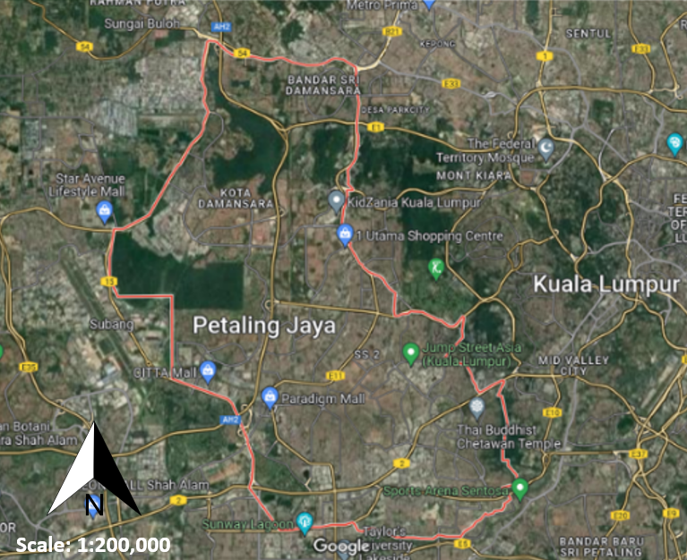 | (b) | 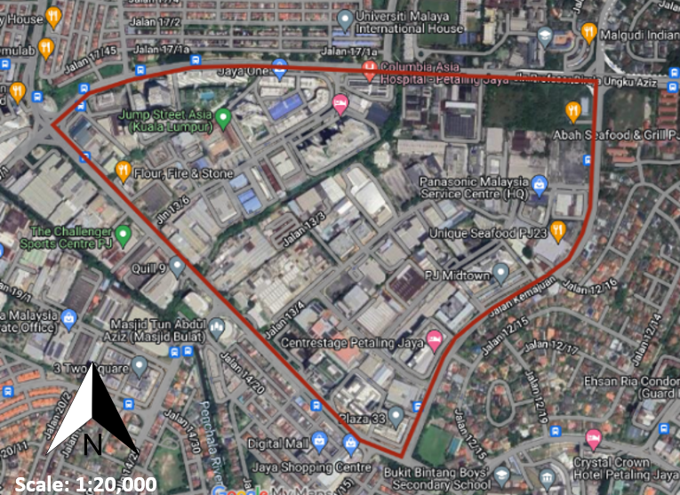

Figure 1. Study area situated in (a) Petaling Jaya and (b) Section 13, Petaling Jaya

Methodology

Related data

This study used three distinct types of DTMs: LiDAR DTM (high resolution: 0.5 meters), IFSAR DTM (medium resolution: 5 meters), and SRTM DTM (low resolution: 30 meters). These DTMs were selected to represent varying levels of detail and computational complexity, catering to different analytical needs. Moreover, the extruded and draped building footprint data (in this case the LoD1) is specific to the urban area being studied, ensuring that the simulations reflect real-world conditions. A 3D city model was developed to incorporate the multidimensional spectrum, including water depth, which integrates the vertical aspects of non-terrain components. This model also facilitates the visualization of the urban area.

Rainfall-runoff simulation process

The rainfall-runoff simulation process began with scenario configuration, where the area of interest (AOI) was defined, and rainfall events were set through time to simulate real-world conditions. The simulation parameters (Table 1) were configured, including infiltration values such as rate and maximum capacity. These parameters were applied to impervious surfaces to focus on the terrain’s capacity to drain water. During height map extraction, content visibility was verified, ensuring all data layers and simulation elements, including the DTM surface and 3D city model, were visible. The simulation was then executed, initializing a new cache where height values were sampled. In the simulated flow phase, water movement calculations were iteratively performed over the height map, with the cache evolving over time. The simulation was stepped through at different moments and played back to observe flow dynamics, while symbology was configured to accurately represent the data. For data results export, the water depth variable was selected, and the number of iterations was set to 10. The AOI was resampled and rotated as necessary to create raster data for further analysis.

Table 1. Simulation parameters were used in this study

No. | Parameters | Input
1. | Rain duration | 60 minutes
2. | Rainfall/hour | 60 mm
3. | Time Step Interval | 6 minutes
4. | Number of Time Steps | 10
5. | Infiltration rate (unit/hour) | Impervious Surface (0)
6. | Maximum infiltration | Impervious Surface (0)

Data analysis techniques

a. Statistical and trend analysis

This study meticulously examined digital terrain models (DTMs) to understand how these models manage rainfall-runoff simulations within urban environments. Specifically, the areas that experienced either increasing water levels (up trends) or decreasing water levels (down trends) were focused on. By comparing these trends across the different DTMs, this study was able to distinguish how resolution affects the identification of high-risk areas.

These trends were categorized based on their values (Table 2):
- Down Trends: These represent areas where water levels are decreasing. The assigned values of -3, -2, and -1 denote the severity of the decline.
- No Significant Trend: When water levels remain stable, are assigned a value of 0. This category helps us identify regions where changes are minimal.
- Up Trends: These areas witness rising water levels. The values of 1, 2, and 3 to capture the magnitude of the increase.

Table 2. The statistical measure used in this study

No. | Trend bins | Trend (z-scores) | Certainty level (p-values)
1. | 3 | Up trend | 99% confidence
2. | 2 | Up trend | 95% confidence
3. | 1 | Up trend | 90% confidence
4. | 0 | No significant trend | No significant trend
5. | -1 | Down trend | 90% confidence
6. | -2 | Down trend | 95% confidence
7. | -3 | Down trend | 99% confidence

To quantify these trends and compare them across different DTMs, this study employed several statistical measures:
- Z-scores: Z-scores allow us to assess how far a data point deviates from the mean. In this study context, Z-scores are used to identify whether a specific area's water level trend is statistically significant.
- P-values: P-values indicate the probability of observing a trend as extreme as the one has measured. Lower p-values suggest stronger evidence for a trend.
- Trend bins: These trend bins provide a visual representation of confidence intervals. It categorizes trends based on their certainty levels.
By analyzing these trends, this study acquires valuable insights into potential flood risk areas. Vigorous statistical methods empower decision-makers to prioritize interventions, adapt infrastructure, and enhance resilience towards climate change. Understanding water level dynamics is pivotal for sustainable urban development and effective flood management.

b. Time series clustering

The clustering analysis was conducted to identify patterns in water depth variations over time. It is used to highlight locations with consistent depth changes (Montero and Vilar, 2015). By employing the Pseudo F-statistic, it can determine the optimal number of clusters for each DTM, and trend statistics were computed to evaluate the direction and significance of water depth trends within each cluster. The simulations were conducted using consistent parameters (Table 3) across all three DTMs:

Table 3. Time series clustering parameters used in this study

No. | Parameters | Input
1. | Distance interval | Approximately 0.3 meters
2. | Time step interval | 6 minutes
3. | Aggregation shape type | Fishnet Grid
4. | Number of time steps | 10
Results and analysis

The comparative analysis of DTMs with different resolutions provided critical insights into how resolution impacts the accuracy and practicality of urban rainfall modelling. The results highlight significant differences in the detection of water depth trends and the computational efficiency required to process these models. The overview of simulation water depth results is shown in Figure 2.

LiDAR DTM
(a) | 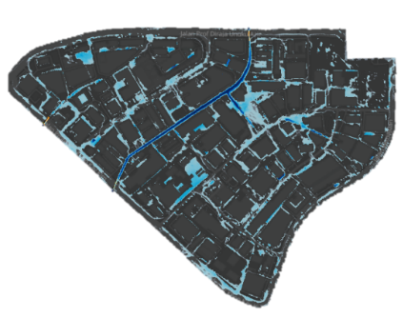 | (b) | 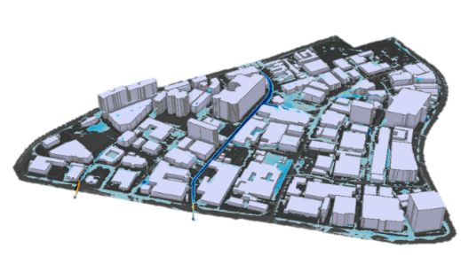
IFSAR DTM
(c) | 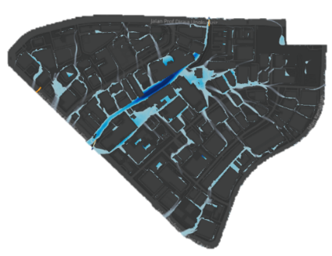 | (d) | 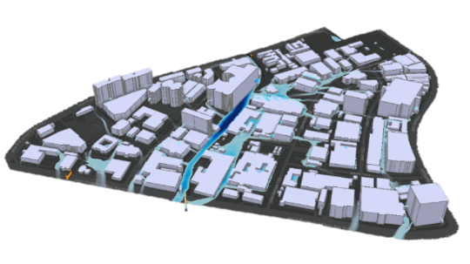
SRTM DTM
(e) | 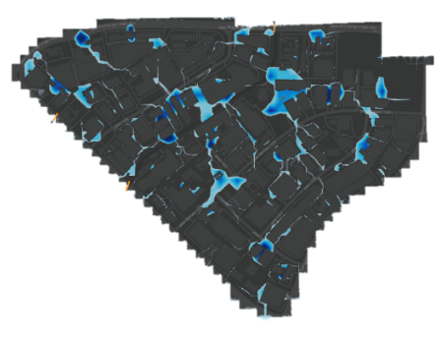 | (f) | 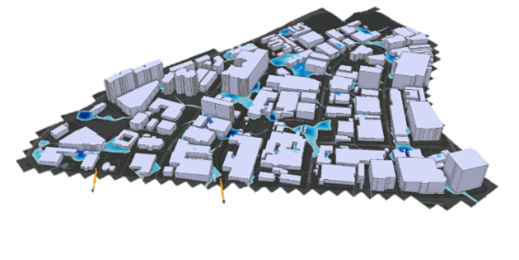
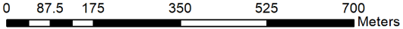
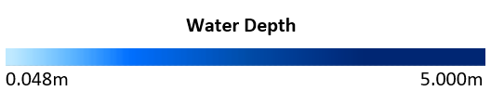

Figure 2. Simulation water depth results, (a) (c) (e) the top view without LoD1 model and (b) (d) (f) with LoD1 model
a. Statistical results

The data from the three datasets provides comprehensive information regarding the water depth trends and related statistics across different DTMs. To conduct a thorough analysis, this study examined the impact of different DTM resolutions on the rainfall-runoff simulation by comparing key statistical parameters such as trend z-scores, p-values, and trend bins. It enables the identification of patterns and differences in water depth predictions based on the various resolutions of the DTMs.

i. Descriptive Statistics
Descriptive statistics indicate that SRTM DTMs exhibit the most pronounced declines in water depth, with higher standard deviations suggesting greater variability compared to LiDAR and IFSAR DTMs. These differences highlight the impact of DTM resolution on water depth predictions.
The mean water depth trends, as indicated by z-scores (which standardize the data to show deviations from the mean) (Table 4), suggest a slight overall decrease. Among the datasets, SRTM DTM exhibits the most pronounced decline. These negative z-scores imply that, on average, water depth is decreasing relative to the mean baseline. Higher standard deviations in IFSAR DTM (2.133) and SRTM DTM (2.260) indicate greater variability in water depth predictions compared to LiDAR DTM (1.889). This increased variability may stem from differences in DTM resolution and terrain characteristics, with lower-resolution datasets like SRTM being more susceptible to errors in complex terrains. Regarding distribution shape, skewness values close to zero indicate symmetric trends for all three datasets (LiDAR DTM: 0.136, IFSAR DTM: 0.323, SRTM DTM: 0.326). Furthermore, the kurtosis values (LiDAR DTM: 2.769, IFSAR DTM: 2.413, SRTM DTM: 2.414) suggest a leptokurtic distribution, meaning heavier tails than a normal distribution. In summary, the water depth trends follow a symmetric distribution with pronounced tails, consistent across the datasets. The SRTM DTM exhibits the most pronounced decline in water depth and the highest variability, likely due to its lower resolution. These findings highlight the importance of DTM resolution in water depth predictions and its impact on data variability.

Table 4. Descriptive statistics results

Metric | LiDAR DTM | IFSAR DTM | SRTM DTM
Mean Water Depth (z-score) | -0.028 | -0.117 | -0.178
Standard deviation | 1.889 | 2.133 | 2.260
Skewness | 0.136 | 0.323 | 0.326
Kurtosis | 2.769 | 2.413 | 2.414

ii. Inferential statistics

Inferential statistics show that SRTM DTMs have the lowest p-values, suggesting stronger evidence for significant water depth trends (Table 5). This emphasizes that even lower-resolution DTMs can detect significant trends, although with less reliability than high-resolution DTMs.

Table 5. Inferential statistics results

Metric | LiDAR DTM | IFSAR DTM | SRTM DTM
Trend p-values | 0.381 | 0.335 | 0.319
Trend bins | -0.018 | -0.036 | -0.059

The p-values serve as a measure of statistical significance for the observed water depth trends. Specifically, the mean p-value for LiDAR DTM is 0.381, indicating some statistical significance, though not extremely strong. For IFSAR DTM, the mean p-value is 0.335, showing a slightly more pronounced significance than LiDAR DTM. The SRTM DTM dataset has a mean p-value of 0.319, standing out with the strongest statistical significance. Lower p-values indicate stronger evidence against the null hypothesis (such as the absence of a trend), suggesting that there is some meaningful trend in water depth across all datasets, with SRTM DTM providing the strongest evidence.
The trend bins represent the average trend magnitude within specific intervals across all DTMs. For LiDAR DTM, the mean trend bin value is approximately -0.018, indicating an overall decreasing trend in water depth. The mean trend bin for IFSAR DTM is about -0.036, reinforcing the downward trend. SRTM DTM shows the largest magnitude of decline in water depth, with a mean trend bin value of -0.059. Collectively, the negative trend bin values align with the z-scores and confirm the consistent downward trend in water depth. In summary, the statistical analyses support the observed trends, with SRTM DTM standing out as the dataset exhibiting the most significant changes in water depth.

iii. Statistical comparative analysis

The resolution of DTMs significantly impacts the outcomes of rainfall-runoff simulations, as evidenced by our comparative analysis of high-resolution (LiDAR DTM), medium-resolution (IFSAR DTM), and low-resolution (SRTM DTM) datasets. High-resolution LiDAR DTM provides the most detailed and accurate water depth trends, exhibiting the least variability and thus offering more consistent and reliable predictions. Medium-resolution IFSAR DTM, while showing increased variability and slightly stronger trend significance, strikes a balance between detail and computational efficiency. Conversely, low-resolution SRTM DTM demonstrates the greatest variability and the strongest trend significance, highlighting the impact of lower resolution on increasing prediction uncertainty and variability.
Higher resolution data, such as LiDAR DTM, yields more consistent and less variable water depth trends. As the resolution decreases with IFSAR DTM and SRTM DTM, variability increases, suggesting that coarser DTMs may introduce more noise and uncertainty into the simulation results. Despite the variability, all DTMs exhibit statistically significant trends, with SRTM DTM presenting the most significant trends. This indicates that even lower-resolution datasets can reveal meaningful patterns, notwithstanding higher variability.
The findings underscore the importance of high-resolution DTMs for precise and consistent water depth trend analysis. High-resolution DTMs, such as LiDAR DTM, are recommended for urban planning and flood risk mitigation to achieve accurate and reliable predictions. While lower-resolution DTMs, such as SRTM DTM, can still be valuable, particularly for larger-scale studies where computational resources are limited, there is a trade-off in precision. Thus, the robustness of the simulation methodology is evident across all resolutions, affirming the utility of each dataset depending on the specific requirements and constraints of the study.

b. Trend analysis results

Trend analysis reveals that high-resolution DTMs detect more localized and accurate changes in water depth, highlighting areas at risk of flooding. In contrast, low-resolution DTMs show broader but less precise trends, which may affect the accuracy of flood risk assessments. Figure 3 shows the water depth trend results of a rainfall-runoff simulation conducted using three types of DTMs. The figures represent the water depth trends within an urban area, highlighting areas of significant up and down trends with varying levels of confidence.

(a) | 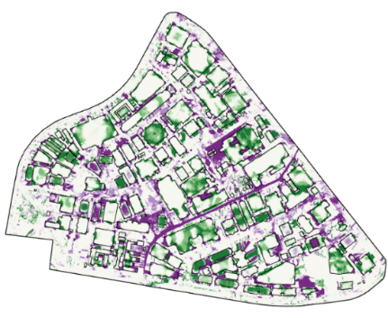 | (b) | 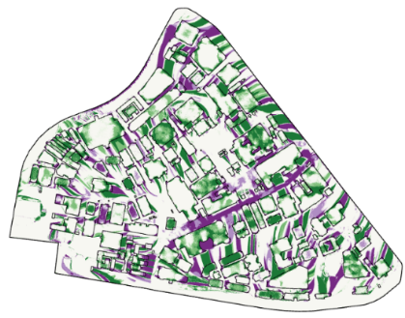
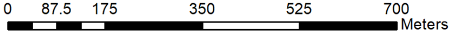
(c) | 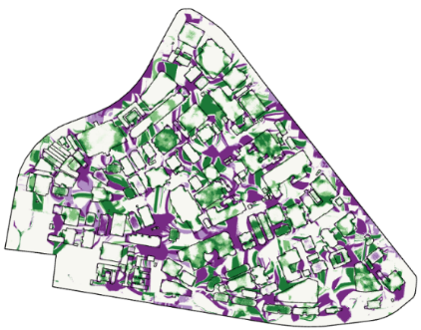 |  | 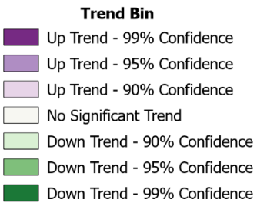

Figure 3. Water depth trend results derived from (a) LiDAR DTM, (b) IFSAR DTM and (c) SRTM DTM

Figure 3(a) illustrates water depth trends derived from the high-resolution LiDAR DTM. Several areas exhibit both up and down trends at high confidence levels (99%, 95%, and 90%). Notably, significant down trends are more prominent, indicating a general decrease in water depth. Also, the high-resolution data accurately identified LoD1 buildings, ensuring precise simulation of structures.
Figure 3(b) shows the water depth trends derived from the medium-resolution IFSAR DTM data. This resolution captures most urban features but lacks the fine detail evident in the high-resolution LiDAR DTM data. The significant water depth trends remain detectable, however, these trends are less detailed, with significant down trends appearing more aggregated. This indicates broader regions of water depth changes rather than the precise delineations observed with LiDAR DTM. While LoD1 building are still identifiable in the IFSAR DTM data, the precision in their delineation is comparatively reduced, highlighting the trade-off between resolution and detail in urban flood modelling.
Figure 3(c) describes the water depth trends utilizing the low-resolution SRTM DTM data. Key observations indicate that the low resolution smoothens many finer urban features, resulting in a more generalized terrain representation. This generalized detail leads to a higher presence of significant upward trends compared to other DTMs. However, these trends are more generalized and less precise, reflecting a broader but less accurate simulation of water depth changes. In addition, the delineation of LoD1 building is less precise, with many small LoD1 buildings potentially being missed or inaccurately represented.

i. Trend comparative analysis

The impact of DTM resolution on detail and precision is evident across the different datasets. LiDAR DTM (0.5 meter resolution) provides the highest level of detail and precision, enabling accurate simulations around small urban features and precise delineation of LoD1 buildings. In contrast, IFSAR DTM (5 meter resolution) strikes a balance between detail and computational efficiency, capturing most urban features but lacks the precision of higher-resolution data. SRTM DTM (30 meter resolution) results in a generalized terrain model that misses finer details, leading to broader and less precise trends.
In terms of trend detection and confidence, higher resolution data (LiDAR DTM) captures a greater number of significant trends at higher confidence levels, particularly down trends. Medium resolution (IFSAR DTM) also captures significant trends but with reduced detail and precision. Lower resolution (SRTM DTM) results in more generalized trends, with a noticeable increase in significant up trends, indicating potential inaccuracies in the simulation.
From an urban planning and flood mitigation perspective, high-resolution DTMs like LiDAR DTM are essential for precise planning and effective flood mitigation efforts, providing accurate and reliable data for decision-making. Medium-resolution DTMs like IFSAR DTM can be valuable in larger-scale studies where computational efficiency is critical, offering a compromise between detail and performance. Low-resolution DTMs like SRTM DTM may be suitable for preliminary studies or large-scale regional analyses but should be supplemented with higher-resolution data for detailed urban planning and flood mitigation efforts.
The analysis of rainfall-runoff simulations with varying DTM resolutions reveals that while high-resolution DTMs, such as LiDAR-derived models, are indispensable for capturing fine-scale variations critical to urban flood management, medium and low-resolution DTMs serve best in preliminary assessments or regional studies where broad trends suffice. Future efforts should focus on balancing resolution, computational demands, and data availability to support scalable and context-specific flood modeling strategies.

c. Time series clustering results

Time series clustering identified distinct patterns in water depth changes across different DTMs. High-resolution DTMs produced more consistent clusters, aligning well with known drainage features, while low-resolution DTMs showed broader, less precise clustering, indicating the importance of resolution in accurately mapping hydrological patterns. The Pseudo F-statistic analysis was conducted to determine the optimal number of clusters within the dataset. The analysis revealed the following values for the Pseudo F-statistic across multiple groups of clusters, from two clusters to ten clusters. Therefore, the optimal number of clusters for each dataset are LiDAR DTM two clusters, IFSAR DTM six clusters and SRTM DTM three clusters, based on the highest Pseudo F-Statistic among ten tested clusters values. It indicates that this number is optimal for maximizing the between-cluster variance while minimizing the within-cluster variance. This method facilitates a more precise and reliable analysis of spatial patterns and trends within the data. The time series clustering results are shown in Figure 4 and Table 6.

(a) | 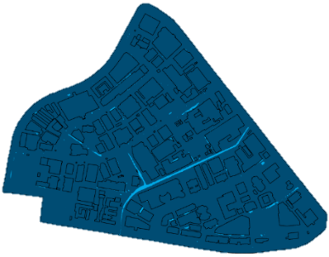 | 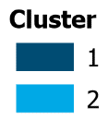 | (b) | 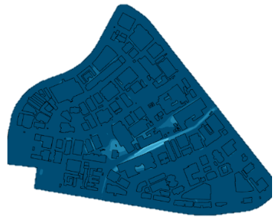 | 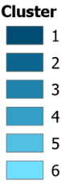
(c) | 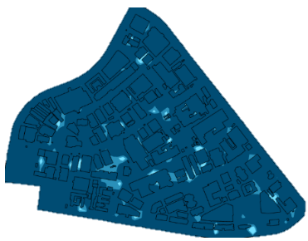 | 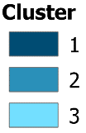 | (d) | 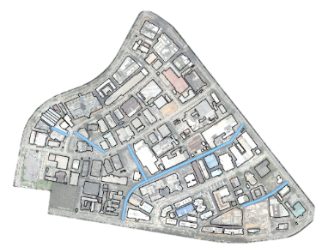 | 

Figure 4. Time series clustering results for (a) LiDAR DTM, (b) IFSAR DTM, (c) SRTM DTM and (d) monsoon drain location in the study area

Table 6. Time series clustering results

DTM Dataset | Cluster | Trend Statistic | p-value | Remarks on Consistency and Reliability
LiDAR | 1 | 3.9355 | 0.0001 | High consistency; robust across broad areas
LiDAR | 2 | 3.9355 | 0.0001 | Strong agreement with ground truth
IFSAR | 1 | 3.5777 | 0.0003 | Variability present; moderate consistency
IFSAR | 2 | 3.0411 | 0.0024 | Localised trends; less robust
IFSAR | 3 | 1.7889 | 0.0736 | Weaker trend; limited reliability
IFSAR | 4 | 3.9355 | 0.0001 | Strong in specific areas
IFSAR | 5 | 3.9355 | 0.0001 | Consistent in small clusters
IFSAR | 6 | 3.3988 | 0.0007 | Very localised significance
SRTM | 1 | 3.9355 | 0.0001 | Widespread increases but poor agreement with ground truth
SRTM | 2 | 3.9355 | 0.0001 | Consistent trend but lacks ground truth alignment
SRTM | 3 | 3.9355 | 0.0001 | Significant localised trends but inconsistent

The clustering analysis of the LiDAR DTM dataset identified two distinct clusters, each representing significant trends in water depth. Cluster 1 dominates most of the study area and indicates substantial increases in water depth, with a trend statistic of 3.9355 and a p-value of 0.0001. Cluster 2 covers smaller areas but also exhibits significant trends, with identical statistical values (trend statistic: 3.9355, p-value: 0.0001). The uniform pattern of water depth increases observed in the LiDAR DTM clustering suggests robust predictions across a broader area when compared to the SRTM DTM dataset. This consistency is attributed to the high-resolution data of LiDAR DTM, which allows for more precise and reliable clustering outcomes. In addition, by comparing the cluster output to the monsoon drain located in the study area (Figure 4(d)), it shows that cluster 2 results are in line with the monsoon drain. It demonstrates that the LiDAR DTM is consistent with the ground truth features in the study area.
The IFSAR DTM dataset revealed six distinct clusters, each characterized by varying degrees of statistically significant trends in water depth. Cluster 1 includes a huge portion of the area with a significant increasing trend (trend statistic: 3.5777, p-value: 0.0003). Cluster 2 includes scattered locations exhibiting a significant trend (trend statistic: 3.0411, p-value: 0.0024). Cluster 3 consists of small patches with a weaker trend (trend statistic: 1.7889, p-value: 0.0736). Cluster 4 covers limited areas with a significant trend (trend statistic: 3.9355, p-value: 0.0001). Cluster 5 represents sparse locations also showing a significant trend (trend statistic: 3.9355, p-value: 0.0001). Finally, Cluster 6 includes extremely limited areas with a significant trend (trend statistic: 3.3988, p-value: 0.0007). The IFSAR DTM analysis demonstrates substantial variability in the spatial distribution of water depth increases, with certain clusters displaying weaker trends. Upon comparing the cluster output with the monsoon drain’s position within the study area (as in Figure 4(d)), it becomes evident that the IFSAR DTM cluster results exhibit partial alignment with the monsoon drain. However, this alignment also reveals inconsistencies between the IFSAR DTM, and the ground truth features in the study area. This variability underscores the importance of considering spatial heterogeneity in water depth trends when utilizing the IFSAR DTM dataset for hydrological studies.
The analysis of the SRTM DTM dataset revealed three distinct clusters, each indicating significant changes in water depth. Cluster 1 includes most of the area and shows substantial increases in water depth, with a trend statistic of 3.9355 and a p-value of 0.0001. Cluster 2 comprises smaller patches within the area, also indicating significant increases in water depth, sharing the same statistical values (trend statistic: 3.9355, p-value: 0.0001). Cluster 3 is limited to extremely specific locations but likewise exhibits significant trends with identical statistical values (trend statistic: 3.9355, p-value: 0.0001). This clustering pattern underscores widespread increases in water depth throughout most of the study area, with further significant localized increases. In the context of our study area, we observed a discrepancy between the cluster output derived from the SRTM DTM and the actual monsoon drain (Figure 4(d)). Specifically, the SRTM DTM results diverged significantly from the ground truth features associated with the monsoon drain. This discrepancy highlights the inaccuracies in the SRTM DTM when compared to reliable reference data within our study region.

i. Comparative analysis of time series clustering for water depth trends using LiDAR, IFSAR, and SRTM DTM datasets

The comparative clustering analysis of the LiDAR, IFSAR, and SRTM DTM datasets provides critical insights into the spatial distribution and trends in water depth across the study area. The high-resolution LiDAR DTM dataset identified two distinct clusters, both exhibiting substantial increases in water depth. Cluster 1, which dominates most of the study area, presents a significant trend statistic of 3.9355 with a p-value of 0.0001. Cluster 2, although covering smaller areas, shares identical statistical values. The uniformity in water depth increases across these clusters suggesting robust predictive capabilities of the LiDAR DTM. The alignment of cluster 2 results with the monsoon drain further validates the consistency of LiDAR DTM with ground truth features, underscoring its reliability for hydrological studies.
In contrast, the IFSAR DTM dataset revealed a more complex clustering pattern with six distinct clusters, each characterized by varying degrees of statistically significant trends. Cluster 1, the most extensive, shows a significant increasing trend (trend statistic: 3.5777, p-value: 0.0003), while clusters 2 through six exhibit varying trends, from significant (cluster 4: trend statistic 3.9355, p-value 0.0001) to weaker trends (cluster 3: trend statistic 1.7889, p-value 0.0736). This variability indicates substantial spatial heterogeneity in water depth trends, suggesting that the IFSAR DTM may be less consistent than the LiDAR DTM. Despite its lower horizontal resolution (5 meter) compared to LiDAR DTM (0.5 meter), IFSAR DTM identifies a higher number of clusters, attributed to its detailed vertical information compensating for its coarser horizontal resolution. While some clusters align partially with the monsoon drain, inconsistencies with ground truth feature reveals limitations in the IFSAR dataset's precision and reliability. Notably, IFSAR DTM identified one cluster with a non-significant trend, highlighting potential inconsistencies and the need for careful interpretation in trend analysis.
The SRTM DTM dataset identified three clusters, all showing significant increases in water depth. Cluster 1, covering most of the area, shares the same trend statistic (3.9355) and p-value (0.0001) as the LiDAR clusters, indicating widespread water depth increases. Clusters 2 and 3, although smaller, exhibit identical statistical values. Despite this, the SRTM DTM results showed significant discrepancies when compared to the actual monsoon drain locations, highlighting inaccuracies and limitations in the dataset when matched against reliable reference data. The SRTM DTM, with its 30 meter resolution, offers the most generalized view, resulting in broader and more homogeneous clustering patterns.
In terms of spatial coverage, both SRTM DTM and LiDAR DTM datasets demonstrate broader and more uniform increases in water depth, whereas the IFSAR DTM dataset exhibits more localized variations. This indicates that while SRTM DTM and LiDAR DTM tend to show general trends over larger areas, IFSAR DTM captures more detailed and varied changes within smaller regions. These findings underscore the importance of considering both horizontal and vertical resolutions when analyzing spatial datasets, as well as the inherent trade-offs between detail and coverage in diverse types of DTMs. Overall, the comparative analysis reveals that the LiDAR DTM provides the most consistent and reliable clustering results, aligning well with ground truth features and demonstrating robust predictive capabilities. The IFSAR DTM, while useful, exhibits significant spatial variability and partial alignment with ground truth, suggesting the need for careful consideration of spatial heterogeneity. The SRTM DTM, despite indicating significant water depth trends, falls short in accuracy when compared to the other datasets, emphasizing the critical need for high-resolution data in hydrological modelling and flood risk assessment.

Conclusion

This study underscores the critical role of DTM resolution in enhancing the precision and efficacy of urban rainfall modelling. Through a comprehensive comparative analysis of high-resolution (LiDAR), medium-resolution (IFSAR), and low-resolution (SRTM) DTMs, this study has delineated the significant impact of DTM resolution on the accuracy of rainfall-runoff simulations. The results indicate that higher resolution DTMs, such as LiDAR, provide more detailed and accurate water depth trends, offering precise simulations essential for effective flood risk mitigation and urban planning. LiDAR DTMs, with their minimal variability and close alignment to ground truth features, are highly reliable for detailed hydrological studies.
Conversely, medium-resolution IFSAR DTMs, while balancing detail and computational efficiency, exhibit significant spatial variations in water depth trends, leading to inconsistencies in flood modeling. This variability necessitates careful consideration when employing IFSAR data for urban flood modelling, as it may introduce inconsistencies. Despite this, IFSAR DTMs remain valuable for larger-scale studies where computational resources are constrained, providing a feasible compromise between detail and performance. The low-resolution SRTM DTMs, though demonstrating significant water depth trends, display the greatest variability and the least precision, highlighting the limitations of lower-resolution data in capturing complex urban features. This generalized representation may lead to broader but less accurate trends, which are less useful for detailed urban planning and flood mitigation efforts.
Our findings encourage the prioritization of high-resolution DTMs in urban rainfall modelling to achieve precise and reliable flood risk predictions. High-resolution DTMs, such as LiDAR, are essential for precise urban flood modelling, providing consistent and reliable data for effective planning. Medium- and low-resolution DTMs, while useful for large-scale analysis, require careful consideration due to potential inaccuracies. Implementing these findings can enhance urban resilience and flood mitigation efforts by improving model precision and optimizing resource allocation. The findings of this study, though focused on Petaling Jaya, have broader relevance to other urban areas in tropical regions with similar conditions. Cities undergoing rapid urbanization and facing heavy rainfall can benefit from these insights. Planners in such regions should consider using high-resolution DTMs, like LiDAR, to improve flood risk assessments and urban drainage planning. This study emphasizes the importance of selecting appropriate DTM resolutions tailored to the specific requirements of urban resilience planning, ensuring that cities are well-prepared to manage and mitigate the impacts of climate change and extreme weather events.

Acknowledgement

The author would like to thank the Earth Observation Centre, Institute of Climate Change, Universiti Kebangsaan Malaysia, for the guidance and the Ministry of Higher Education (MOHE) for supporting this work under the research grant Fundamental Research Grant Scheme (FRGS), grant number FRGS/1/2023/WAB09/UKM/02/2.

References

Agonafir, C., Lakhankar, T., Khanbilvardi, R., Krakauer, N., Radell, D., & Devineni, N. (2023). A review of recent advances in urban flood research. Water Security, 19, 100141.
Escobar-Silva, E. V., Almeida, C. M. D., Silva, G. B. L. D., Bursteinas, I., Rocha Filho, K. L. D., de Oliveira, C. G., Fagundes, M. R., & de Paiva, R. C. D. (2023). Assessing the extent of flood-prone areas in a south american megacity using different high resolution DTMs. Water, 15(6), 19.
Hassan, H., & Abdul Rahman, S. A. F. S. (2021). Integration of aerial photography, airborne LiDAR, and Airborne IFSAR for mapping in Malaysia. IOP Conference Series: Earth and Environmental Science, 767, 012020.
Majlis Bandaraya Petaling Jaya. (2019). Draf Rancangan Kawasan Khas (RKK) Seksyen 13, Petaling Jaya: Pengubahan 1. https://www.mbpj.gov.my/sites/default/files/21122019_draf_rancangan_kawasan_khas_rkk_seksyen_13_petaling_jaya_pengubahan_1.pdf
Md Dali, M., Sharifi, A., & Mohd Adnan, Y. (2022). Envisioning sustainable and resilient Petaling Jaya through low-carbon and smart city framework. In Resilient Smart Cities (pp. 213-238). Springer.
Montero, P., & Vilar, J. A. (2015). TSclust: An R package for time series clustering. Journal of Statistical Software, 62, 1-43.
Pa’suya, F. M., Talib, N., Narashid, R. H., Fauzi, A. A., Mohd, F. A., & Abdullah, M. A. (2022). Quality assessment of TanDEM-X DEM 12m using GNSS-RTK and Airborne IFSAR DEM: A case study of Tuba Island, Langkawi. International Journal of Geoinformatics, 18(5), 87-103.
Qi, W., Ma, C., Xu, H., Chen, Z., Zhao, K., & Han, H. (2021). A review on applications of urban flood models in flood mitigation strategies. Natural Hazards, 108, 31-62
Ramyar, R., Ackerman, A., & Johnston, D. M. (2021). Adapting cities for climate change through urban green infrastructure planning. Cities, 117, 103316
Song, H., & Jung, J. (2023). An object-based ground filtering of airborne LiDAR data for large-area DTM generation. Remote Sensing, 15(16), 4105.
Trepekli, K., Balstrøm, T., Friborg, T., Fog, B., Allotey, A. N., Kofie, R. Y., & Møller-Jensen, L. (2022). UAV-borne, LiDAR-based elevation modelling: A Method for improving local-scale urban flood risk assessment. Natural Hazards, 113(1), 423-451.
Zhao, G. (2020). A Sub-Model Approach for Fast Large-Scale High-Resolution Two-Dimensional Urban Surface Flood Modelling [Doctoral dissertation, University of Copenhagen].

