Linking Western Psychological models and Sundanese Indigenous Wisdom
in the real world

Siti Kulsum¹, M. Solehuddin¹, Eka Sakti Yudha¹, Bella Syakina², M. Edi Armanto³, Ilham Khairi Siregar⁴

¹Faculty of Education, Universitas Pendidikan Indonesia
²Centre for Global Sustainability Studies, Universiti Sains Malaysia
³Faculty of Agriculture, Sriwijaya University
⁴Faculty of Education, Universitas Negeri Gorontalo

Correspondence: Siti Kulsum (email: sitikulsumks@upi.edu)

Received: 30 October 2024; Accepted: 10 August 2025; Published: 20 August 2025

Abstract

This study examines the integration of Western Psychological Well-Being (PWB) models with Sundanese indigenous values, specifically Pancawaluya, a local philosophical framework comprising five principles: Cageur (healthy), Bageur (kind), Bener (truthful), Pinter (intelligent), and Singer (resilient). The aim is to understand how these local values interact with global models of well-being and to construct a culturally relevant conceptual framework for the psychological well-being of the Sundanese people. A mixed-methods approach was employed. Quantitative data were gathered from 150 respondents through an online survey using a structured Google Form, while qualitative insights were obtained from in-depth interviews with 80 of the participants. Respondents were purposively selected from the native Sundanese community across various age groups (15 to over 60 years) and professional backgrounds. The analysis combined descriptive statistics with thematic coding to capture both measurable patterns and deeper cultural meanings. The findings reveal that Sundanese well-being emphasizes harmony, simplicity, and interconnectedness, offering a holistic perspective distinct from the individualistic orientation of Western PWB models such as Ryff’s. The Quadrant Coordinates model shows that Sundanese individuals tend to score high in Bageur (kindness) but face challenges in Pinter (intelligence). This study proposes practical steps to bridge traditional and modern perspectives by incorporating indigenous values into education, digital platforms, community programs, and institutional policies, thus enhancing resilience and psychological growth within the local context.

Keywords: Cultural integration, Pancawaluya, Psychological Well-Being, Sundanese culture

Introduction

The Sundanese people, the second-largest ethnic group in Indonesia, are predominantly located in West Java and Banten. Known for their agrarian lifestyle, communal orientation, and deep spirituality, Sundanese culture emphasizes harmony with nature, others, and the self. These cultural foundations are reflected in a value system called Pancawaluya, consisting of five core principles: Cageur (healthy), Bageur (kind), Bener (truthful), Pinter (intelligent), and Singer (resilient). These values not only represent individual qualities but also reflect collective harmony and interpersonal relationships within the community (Nugraha et al., 2021; Utami, 2021; Durmush et al., 2024).
The concept of psychological well-being (PWB), as commonly measured through Western models, often emphasizes individualistic aspects such as autonomy, environmental mastery, and personal growth (Bastos et al., 2023; Martela & Ryan, 2023). These models are grounded in specific socio-cultural assumptions, particularly independence and self-direction, that may not fully resonate with collectivist societies like Indonesia. In contrast, Indonesian communities, including the Sundanese, emphasize interdependence, social harmony, and spiritual alignment as key to well-being (Dudgeon et al., 2020; Nugraha et al., 2024; Perceka et al., 2019).
While Ryff’s eudaimonic theory and Diener’s subjective well-being model have greatly contributed to the global understanding of mental health, their application to culturally diverse settings can be problematic (Rahman et al., 2018; Sujatmiko, 2014). For instance, self-actualization in Sundanese communities is not seen through personal achievement alone but through contributing to family, nature, and society. Although Indonesia has rich cultural capital that could offer an alternative and locally relevant model of well-being, these perspectives are still underrepresented in mainstream psychology.
The Sundanese Pancawaluya system provides an Indigenous framework that aligns with holistic mental health but is rarely integrated into modern psychological discourse. The challenge lies in reconciling traditional, collective perspectives with scientifically accepted psychological theories. Therefore, this study aims to explore how Pancawaluya values can be integrated with the Western PWB model, and to understand the dynamics of applying Indigenous perspectives in psychological well-being. Specifically, this study seeks to construct a culturally grounded conceptual framework of Sundanese psychological well-being, one that retains scientific rigor while honoring local wisdom. Such a framework has the potential to enrich global discussions on well-being and promote culturally responsive psychological practices.

Literature review

Psychological Well-Being Models (PWB)

In psychology, several well-known models of PWB, such as the model developed by Carol Ryff and the Subjective Well-Being Model proposed by Ed Diener, are often used as references in measuring individual well-being (Mackean et al., 2022). Ryff’s model emphasizes six dimensions, including self-acceptance, positive relationships, and purpose in life, while Diener focuses on life satisfaction and positive versus negative emotions (Soren & Ryff, 2023). Although both models provide valuable frameworks, they have limitations when applied to non-Western cultures (Ryff & Soren, 2023).
One of the main weaknesses of these models is their tendency to prioritize an individual perspective that focuses on personal achievement and subjective happiness (Ponnapalli et al., 2023; Ryff & Soren, 2023). In non-Western cultural contexts, such as in Indonesia, the values ​​of collectivism and social relationships often dominate over the pursuit of individual happiness. For example, in Sundanese society, well-being is not only seen from the perspective of the individual but also from how the individual contributes to his or her community. The concept of cooperation and mutual support in a group is very important, but is often ignored by Western models that prioritize the individual aspect (Hilman et al., 2019).

Indigenous psychology

Indigenous psychology is essential to understanding the mental and emotional well-being of local communities, particularly in Southeast Asia (Gone & Kirmayer, 2020a). Cultural values, traditions, and social norms play a major role in shaping an individual’s PWB. Adolescents from indigenous communities often experience different pressures than those in modern societies, so psychology needs to take this cultural context into account (Doery et al., 2023). Western psychology’s focus on individualism and autonomy is often at odds with Indigenous communities’ emphasis on harmony with community and nature (Gone & Kirmayer, 2020; Shakespeare et al., 2021; Arslan, 2023).

Sundanese culture and beliefs

The concept of well-being in Sundanese culture is closely related to a harmonious life and deep spirituality (Nugraha et al., 2021). Especially in Sundanese people, well-being is not only measured by personal achievements, but also by the extent to which a person can maintain a balance between themselves, nature, and fellow human beings (van Dierendonck & Lam, 2023) . The concept of ngajaga diri is the main foundation, which refers to the ability to maintain physical, mental, and emotional health (Perceka et al., 2019). This is not just about taking care of yourself, but also about how a person can live in harmony with the environment and society around them. The principles of silih asah, silih asih, silih asuh (teaching each other, loving each other, and caring for each other) become the foundation of harmony (Nugraha et al., 2021). Then, pancawaluya becomes a guide to achieving a broader balance in life, with five main values cageur (mentally and physically healthy), bageur (behaving well, being humble, and being simple), bener (obedience to the law and religious teachings), pinter (smart in using knowledge and emotional), and singer (skilled and innovative to create resilience). These aspects emphasize that well-being in Sundanese culture is highly collective, based on spirituality, and inseparable from the social and natural community (Dudgeon et al., 2020; Martela & Ryan, 2023).

Method and study area

This study used an empirical approach to understand the application of Pancawaluya values ​​in the context of PWB of the Sundanese people. This study was designed using a survey technique that involved active participation from the Sundanese people to identify the challenges faced in integrating local cultural values ​​with the concept of modern psychological well-being. The process of data collection, participant selection, and data analysis will be explained in detail as follows.

Participants and procedures

This study involved 150 purposively selected native Sundanese participants representing diverse backgrounds: students, educators, retirees, entrepreneurs, and civil servants. Their ages ranged from 15 to over 60 years. The participants were recruited using snowball sampling and community referrals, ensuring they identified as Sundanese and demonstrated understanding or practice of Pancawaluya values. Special attention was given to regional variation; most participants were from the Priangan region, using the Priangan Sundanese dialect, the most widely spoken variant. The data collection involved two stages. First, a Google Form survey with 19 closed-ended questions was distributed through WhatsApp, email, and community networks. Screening questions ensured that only Sundanese individuals were included. A total of 200 forms were distributed; 150 were completed, and 80 of these respondents agreed to participate in follow-up in-depth interviews. Ethical approval was obtained from the university’s research ethics committee, and informed consent was acquired digitally and verbally before participation. Table 1 provides a summary of all research procedures, instruments, and analysis techniques.

Research instrument

The questionnaire used in this study consisted of two parts. The first part contained seven general questions addressed to all participants, while the second part contained 12 specific questions addressed to participants involved in the in-depth interviews. These questions were designed to explore participants' views on the concept of psychological well-being from the Pancawaluya perspective and the difficulties they faced in implementing it. In-depth interviews were conducted to further explore participants' views and experiences so that the data obtained could provide more comprehensive insights into the interaction between cultural values ​​and psychological well-being.

Analysis data

Tools Data from the questionnaire were analysed quantitatively using descriptive analysis to describe the profiles of participants and their response patterns to the questions given. Meanwhile, data from in-depth interviews were analysed qualitatively using a thematic analysis approach to identify the main themes that emerged related to the application of Pancawaluya values ​​and psychological well-being. To support the empirical findings, secondary data from academic literature were also collected and analysed. The literature used included various studies, academic articles, reports, and online sources relevant to the Pancawaluya Indigenous perspective and psychological well-being, taken from platforms such as Google Scholar, JSTOR, and other research portals. These literature data were used to compare and strengthen the main findings from the field research.

Table 1. Research procedures, instruments, and analysis techniques

Object | Descriptions | Methods | Total samples
Participant | 150 native Sundanese participants from various professions and ages ranging from 15 to >60 years | Purposive sampling: Native Sundanese, understand/apply the values ​​of Pancawaluya | 150
Professional background | Students, Teachers, Retirees, Self-Employed, Civil Servants | Online survey (Google Form) | 150
Participant criteria | The native Sundanese people understand and/or apply the values ​​of Pancawaluya | Purposive sampling | 150
Method of collecting data | - Stage 1: Online survey  - Stage 2: In-depth interviews with 80 participants | Online questionnaires and in-depth interviews | 150 (survey), 80 (interview)
Number of questions | - 7 general questions for all participants  - 12 specific questions for in-depth interviews | Closed questions in questionnaires and interviews | 19 questions
Participant age range | 15 to >60 years | Data is taken based on age from 15 to over 60 | 150
Data collection procedure | - Data collection through online surveys  - In-depth interviews for further exploration | Survey and interview | 150 (survey), 80 (interview)
Data analysis | - Quantitative: Descriptive analysis  - Qualitative: Thematic analysis | Data was analysed quantitatively and qualitatively | 150 (quantitative), 80 (qualitative)
Secondary data sources | Academic literature, scientific journals, books, research reports, Google Scholar, JSTOR | Secondary data from academic literature
Source: Researchers' observation data

Results and discussion

The interface between Western models of psychological well-being and Pancawaluya as an Indigenous perspective

The following is a modification of the dimensions of PWB based on Ryff's theory which includes key aspects such as self-acceptance, positive relationships with others, autonomy, environmental mastery, purpose in life, and personal growth (Soren & Ryff, 2023; van Dierendonck & Lam, 2023). These dimensions will be compared with the perspective of PWB in Sundanese culture. Overall, this modification illustrates the main differences between psychological well-being according to Sundanese culture which is more collective, spiritual, and communal, compared to Ryff's model which tends to be more individualistic, secular, and oriented towards personal development.

Table 2. The comparison of Western Models of PWB and Indigenous perspective

Dimensions | PWB Sundanese Culture | Western PWB Model (Ryff) | Comparison
Self-acceptance | Self-acceptance in PWB Sundanese culture known as cageur is closely related to inner harmony and compliance with religious and cultural laws | Self-acceptance is defined as a positive attitude towards oneself despite one's shortcomings | Self-acceptance in PWB Sunda is more collective and related to spirituality, whereas the model is more individualistic
Positive relationships with others | Social relations are very important in Sundanese PWB. Cooperation and solidarity known as Bageur (kind) describe the nature of a person who behaves well, has morals, and has strong ethics in relationships with others. (Bageur and Bener) are the keys to achieving prosperity | Positive relationships are measured by how well individuals build close and meaningful relationships with others | The Sundanese model places more emphasis on communal and social relations, while the Western model focuses on interpersonal relations
Autonomy | Sundanese PWB places less emphasis on individual autonomy, leaning more towards collective decision-making and community roles (true - adherence to social norms) | Autonomy is defined as an individual's independence in making decisions without outside influence | The Western model emphasizes individual autonomy, while Sundanese culture focuses more on social harmony and community influence
Environmental mastery | Sundanese well-being is rooted in harmony with the natural environment (Pinter - wise use of natural resources in everyday life). In this part, Singer (resilient) also describes someone who is creative and adaptive, able to face new situations or challenges in innovative and flexible ways) | Environmental mastery in Western PWB refers to an individual's ability to manage and organize the life around him/her | Sundanese emphasize balance with nature, while the West places more emphasis on control and regulation of the personal environment
Purpose in life | In Sundanese culture, life goals are often related to social and religious obligations, as well as roles in the family. This means that Singer (resilient) is part of the discovery of meaning in life and adaptation allows a person to continue to adjust their life goals despite facing challenges) | Goals in life in Ryff's model focus more on individual achievement and self-development | Both have a universal dimension of purpose, but Sundanese is more collective and culture-based, while Western is more individualistic
Personal growth | Singer (resilient) is an adaptation in Sundanese culture supported by community and cultural practices. Personal growth is considered part of social harmony | Personal growth is defined as an individual's desire to continue to develop and realize their potential | In Sunda, growth occurs through communal support, while in the West the focus is on individual self-development
Source: Results of analyses survey, 2024

The table above aims to compare two models of PWB, namely the Sundanese cultural perspective rooted in the Pancawaluya and the Western model represented by the theories of Ryff. The Pancawaluya perspective in Sundanese culture emphasizes values ​​such as Cageur (physical and mental health), Bageur (kind), Bener (truth), Pinter (intelligent), and Singer (resilient), which underlie the balance of life expected from Sundanese society (Utami, 2021). PWB Psychological Well-Being in Sundanese culture emphasizes a strong balance between spirituality, social relationships, and community roles. Unlike the Western model that strongly emphasizes individual autonomy and self-achievement, Sundanese well-being places harmony with nature, adherence to social norms, and spiritual roles as the foundation of a good life. Self-acceptance in the Sundanese context is not only about accepting oneself as an individual but also about how one lives in harmony with religious and customary rules. This is the main basis for achieving inner peace. These results are in line with the research of Nugraha et al. (2024) and Perceka et al.,(2019). Unlike the Western model that glorifies mastery of the environment through control and regulation, in Sundanese culture well-being lies in harmony with the natural environment, not in mastering it. This creates an ecological balance that is in line with the principles of life that they believe in. The advantage of Sundanese PWB is the simplicity of life that focuses on the values ​​of togetherness and harmony. There is no demand to always be the best individually, but to be part of a larger social system, which supports the sustainability of the community and the balance of life.

Implication of Indigenous perspective to Sundanese community
In Table 3, there is a clear difference between theory and facts in the field for each dimension. Cageur, which means physical and spiritual health, shows that although there is an understanding of the importance of health, the facts in the field show that 47% of individuals are not aware of this, and 21% admit that they do not have time to maintain their health. This indicates a gap between theoretical awareness and daily practice. Furthermore, Bageur describes a kind and simple character. Although the theory states that individuals should be empathetic, the facts show that 23% experience social pressure and 29% experience personal stress, which can reduce their ability to do good. In the Bener dimension, which is related to obedience to the law and morality, 48% of people do not understand moral values, while fear of conflict also reaches 48%. This shows that moral theory is often hampered by misunderstanding and fear in the real world.

Table 3. Comparison of theoretical dimensions and real-fact implications of Pancawaluya

Dimensions | Implications |  | Specific descriptions
Dimensions | Theory | Real facts | Specific descriptions
Cageur | Cageur is healthy physically, mentally, and spiritually and healthy in social interactions | The main challenges in this dimension are a lack of awareness (47%) about the importance of health and a lack of time (21%) to maintain health | Many individuals do not realize the importance of mental and physical health, so they are less committed to adopting a healthy lifestyle
Bageur | Bageur is a state or character that is kind, simple, and not arrogant. Caring for others is also included in the meaning of Bageur. Kind, empathetic, or having good morals | Challenges such as social pressure (23%) and personal stress (29%) are barriers to being kind | Demanding social environments and personal pressures can reduce an individual's ability to behave well and empathize with others
Bener | Bener is the condition or character of a true human being, namely obeying the laws of the state and religion and also carrying out religious law | The biggest challenges are a lack of understanding (48%) of moral and ethical values, and fear of conflict (48%) | A lack of understanding can prevent individuals from behaving honestly, while fear of confrontation makes them more likely to keep opinions to themselves
Pinter | Pinter is a state or character of a person who knows (Noble is my knowledge, rich is my understanding) | The main challenges are lack of time (40%) and financial issues (27%) that prevent individuals from pursuing education | Many people feel they do not have enough time or financial resources to develop their knowledge and skills
Singer | Singer is a condition or character of a skilled or expert human being, proficient or skilled in socializing and willing (brave) able to adapt and adjust to environmental conditions. Hence, they are resilient to life | The biggest challenges in this dimension are lack of motivation (45%) and lack of resources (31%), which hinder individuals' ability to innovate and create | Many individuals feel unmotivated to develop new skills and do not have sufficient access to the resources needed to create
Source: Results of analyses survey, 2024

On the other hand, Pinter describes a knowledgeable individual. Although it is expected that individuals continue to learn, real challenges such as lack of time (40%) and financial problems (27%) become obstacles. Finally, on Singer’s dimension, which describes skills and creativity, 45% of individuals felt a lack of motivation, and 31% a lack of resources. This suggests that while theory expects individuals to be active and innovative, many feel unmotivated to develop new skills due to limitations in their environment. Thus, the gap between theory and reality reflects the significant challenges individuals face in implementing the expected values ​​and character traits.

Summary of memory categories and participant quotes

This Table 4 offers a deeply human window into the gap between the idealized principles of Pancawaluya and the realities Sundanese people describe in their daily lives, a gap that was so clearly quantified in Table 3 of the manuscript. For instance, Cageur is defined in theory as a balance of physical, mental, and spiritual health, but the participant's quote here underscores the 47% reporting lack of awareness and 21% citing lack of time: “I often forget to take care of my health because I’m busy.” This candid admission transforms abstract survey percentages into a lived experience that many readers can immediately recognize, revealing not only structural pressures but also an internal conflict between values and daily obligations. It grounds the statistical data in the reality that awareness is not always enough to prompt consistent, healthy behavior, especially in a context where time and resources are limited.

Table 4. Themes and quotes on Pancawaluya values

Value (Pancawaluya dimension) | Memory category (Individual/Collective) | Participant quote
Cageur | Individual | “I often forget to take care of my health because I'm busy, even though I want peace of mind and a healthy body.”
Bageur | Collective | “Sometimes I want to help, but the pressures of life make me quick to anger and less friendly.”
Bener | Collective | “I’m afraid that being honest will offend people, so it’s better to stay silent than start a fight.”
Pinter | Individual | “I want to keep studying, but I’m always working, and it’s too expensive.”
Singer | Individual/Collective | “It’s hard to find new motivation when you’re exhausted every day and there’s no place to be creative.”
Source: Results of analysis survey, 2024

Similarly, the Bageur and Bener dimensions highlight collective social dynamics that complicate ideal moral expectations. While theory emphasizes kindness and moral integrity, the quotes show how stress, social pressure, and fear of conflict (matching the 23-48% challenge rates in Table 3) shape everyday choices. “Sometimes I want to help, but the pressures of life make me quick to anger,” speaks to how personal stress erodes the ability to be empathetic, even when one values kindness (Wissing, 2022). Meanwhile, “I’m afraid that being honest will offend people” demonstrates why fear of conflict so commonly obstructs open, ethical communication. These expressions reveal that Pancawaluya values are not merely personal goals, but rather relational practices negotiated within complex, sometimes constraining cultural expectations. They show how social harmony can paradoxically discourage honest dialogue, sustaining cycles of misunderstanding and emotional tension.
Pinter and Singer, meanwhile, speak to the economic and motivational barriers that limit growth and adaptability, mirroring the lack of time (40%), financial strain (27%), low motivation (45%), and lack of resources (31%) reported in the survey. The Pinter quote, “I want to keep studying, but I’m always working and it’s too expensive,” shows education is not merely an individual choice but one shaped by economic systems that demand labor over learning. Similarly, the Singer quote captures exhaustion and infrastructural limits on creativity: “It’s hard to find new motivation when you’re exhausted every day and there’s no place to be creative.” This adds emotional texture to the finding that many respondents lack the motivation or resources needed for innovation.

Challenges in applying Sundanese Indigenous perspectives

Based on data obtained from respondents, the challenges in implementing the principles of Cageur, Bageur, Bener, Pinter, and Singer, which are the aspects of Pancawaluya, show various obstacles that need to be overcome. In the context of Cageur, which is related to health, the biggest challenge arises from a lack of awareness at 47% and a lack of understanding at 48%. These two factors highlight how important understanding and knowledge about health care are often overlooked, thus preventing individuals from implementing healthier principles in their daily lives. Meanwhile, for the Bageur aspect, which emphasizes a good attitude in dealing with difficult situations, lack of time (21%) is a significant challenge. This reflects how difficult it is for many people to manage their time so that they can continue to behave well under pressure. On the other hand, Bener noted the most dominant lack of understanding (48%) and fear of conflict which is also high (48%). This shows that a lack of understanding in honest and open communication can lead to fear of facing conflict, creating an environment that is not supportive of personal growth and healthy social interaction. This shows that social norms can be a barrier for individuals to be honest and open. Many respondents reported that fear of conflict made them reluctant to express their opinions, especially when faced with cultural norms that require compliance. Refer to the below Figure.
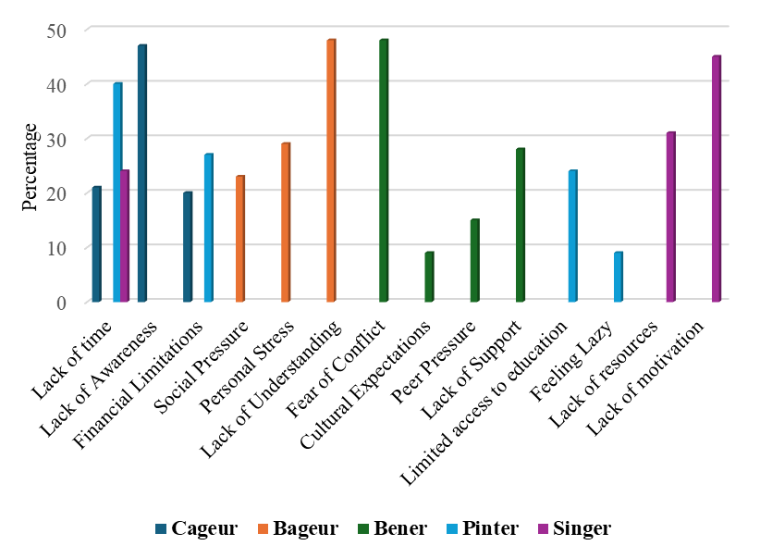
Source: Results of analyses survey, 2024

Figure 1. The challenges in applying Sundanese Indigenous perspective

In the case of Pinter, which refers to the ability to hone intelligent, the biggest challenges were lack of time (40%) and financial problems (27%). Time constraints and financial problems appear to be intertwined, with many individuals feeling they do not have enough time to pursue education or self-development due to concerns about costs. For Singer, which focuses on creativity, the top challenges were lack of motivation (45%) and lack of resources (31%). This suggests that creativity is often hampered by a lack of resources and passion, which are essential to expressing oneself freely. Overall, the biggest challenges faced in applying Cageur, Bageur, Bener, Pinter, and Singer were lack of understanding (48%) and awareness (47%). This creates a significant barrier for individuals to internalize and apply the values ​​contained in the Pancawaluya. If we want to encourage the implementation of these principles, we must first focus on education and raising public awareness to understand the importance of health, positive attitude, honesty, intelligent, and creativity in everyday life. This research result is supported by Nugraha et al., (2021). Furthermore, to simplify the implementation of the data above, a model was created in the form of a quadrant below as presented in Table 5 and Figure 2.

Table 5. Explanation of quadrant coordinates of Sundanese PWB

Quadrant | X | Y | Explanation
Quadrant I  (++) | +  Cageur | +  Bener | Physical and Mental health, stability, honesty, moral values
Quadrant II  (-+) | -  Bageur | +  Pinter | Positive social interaction, generosity, critical, problem solving
Quadrant III  (--) | -  Cageur | -  Singer | Maintaining health for creative input, innovation, originality
Quadrant IV  (+-) | +  Bener | -  Singer | Ethical creativity, following moral values for meaningful innovation
Source: Results of analyses survey, 2024

Quadrant II is where there is a combination of positive Bageur and negative Pinter values. In this case, the Sundanese people have strength in Bageur but the greater challenge is in Pinter. Bageur (Good Attitude, Positive Interaction) means that The Sundanese people have a relatively low challenge score in this aspect, namely in social pressure (23%) and personal stress (29%). This shows that they tend to be good at social interactions, such as kindness, cooperation, and generosity. They have the strength to build positive social relationships with others, and this is their advantage. Positive social relationships (Bageur) show that the Sundanese people have the strength to build a solid community with good social support, as seen from the relatively low challenges in social pressure and personal stress.
Pinter (intelligent, problem-solving) explains that the challenges in this aspect are quite high, namely 40% in lack of time, indicating that the community faces difficulties in implementing values ​​related to intelligent, education, and the ability to solve problems. They may have limitations in mastering technical skills or critical thinking skills. In addition, financial limitations (27%) also indicate economic constraints that hinder the ability to learn and develop. This is an area that needs improvement, especially in terms of how they can better adapt to the challenges of modern life and the increasingly competitive world of work. The community is thought to have difficulty in solving critical problems and needs more resources to increase intelligent and innovation. Hence, based on the existing data, the Sundanese people are in Quadrant II (-+) because they show strength in the Bageur aspect but face major challenges in the Pinter aspect. Further details can be seen in Figure 2.

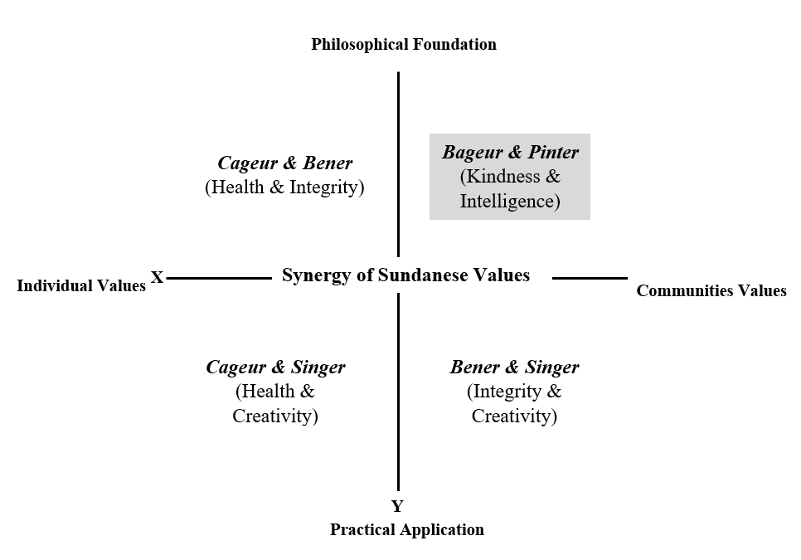
Source: Results of analyses survey, 2024

Figure 2. Quadrant Coordinates of Sundanese PWB

Developing strategies to overcome challenges of applying the Sundanese Indigenous perspective

Facing the challenges in implementing Pancawaluya, especially in the context of Cageur, Bageur, Bener, Pinter, and Singer, an approach is needed that is not only creative but also relevant to current conditions. One unusual proposal is to create a digital-based community that focuses on education and self-development, by utilizing technology and social media as a means to build awareness and knowledge. For example, by creating an online platform or mobile application that provides interactive content about health, positive attitudes, honesty, intelligence, and creativity. That way, knowledge about Cageur and Bener can reach a wider audience, and the community can be involved in a fun and informative learning process. It is important to emphasize the Pinter and Bener aspects because these two values ​​play an important role in creating good mental health. According to Ryff's theory, mental health is not only about feeling happy, but also about having meaning in life, positive relationships, and mastery of the environment. When people understand and practice the Bener values ​​in terms of honesty and openness, they will find it easier to build healthy and supportive relationships. On the other hand, developing Pinter through training that focuses on mastering practical and intelligent skills will help individuals feel more competent in dealing with everyday challenges, which in turn can reduce stress and increase self-confidence. In the highly spiritual context of Pancawaluya, counselors can use culturally and spiritually based counselling approaches to help people understand and integrate the role of spirituality in their well-being.

Integrating Sundanese values for resilience and psychological growth

The integration of Sundanese values ​​in the context of resilience and psychological growth reflects the importance of the relationship between mutually supportive concepts. Cageur (healthy) is connected to self-acceptance, where maintaining physical and mental health is the foundation for better self-acceptance (Utami, 2021). When individuals take care of their health, they feel better about themselves, which in turn increases emotional resilience. This shows that good health is not only physical but also mental and emotional. Then, Bageur (kind) is connected to positive relations, where an emphasis on kindness builds strong interpersonal relationships. Generosity, compassion, and cooperation create trust and meaningful relationships, which are key aspects of well-being. These positive relationships help individuals feel connected to others, which is an important element in social resilience. Figure 3 shows the integration of Sundanese values for resilience and psychological growth.

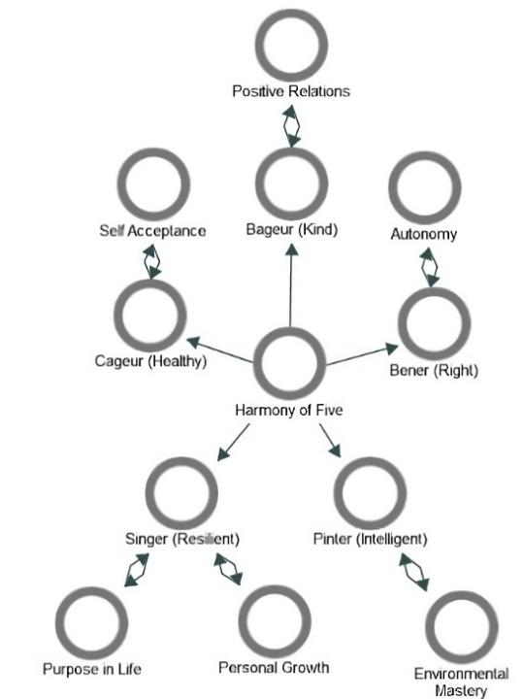
Source: Results of analyses survey, 2024

Figure 3. The integration of Sundanese values for resilience and psychological growth

Bener (right) is connected to autonomy, where integrity and truth allow individuals to make ethical decisions independently, while still respecting the values ​​of their community. This encourages self-determination and a balanced sense of autonomy, which are important for personal and professional development. Pinter (intelligent) and Singer (resilient) are connected to environmental mastery. Wisdom and cultural knowledge enable individuals to face challenges and adapt to their environment. This promotes personal growth and mastery over life circumstances, which in turn empowers resilience in the face of adversity. Lastly, Singer (resilient) is also connected to purpose in life and personal growth. Resilience enables individuals to bounce back from adversity, which fosters a sense of purpose in life. Overcoming challenges not only helps people grow but also improves their perspective on life and find deeper meaning in their experiences.
Here are practical steps to integrate Sundanese values ​​in the context of resilience and psychological growth from Ryffs' theory.

- Community-based programs

Community-based programs that integrate Sundanese values ​​can include various initiatives that support individual health and well-being. First, holding health workshops (Cageur) that promote physical and mental balance following Ryff's PWB theory. In addition, community service activities (Bageur) that encourage togetherness and resource sharing can build positive relationships, supporting a sense of connectedness that is important in PWB. Ethical decision-making training (Bener) will facilitate individual autonomy and integrity, in line with the aspects of freedom and self-control in PWB. Educational programs (Pinter) that increase knowledge about sustainable living and critical thinking contribute to personal growth while resilience-building exercises (Singer) help individuals deal with stress and adapt to change, supporting life goals and growth that are the focus of PWB.

- Digital platforms and media

The use of digital platforms and media can be an effective tool to integrate Sundanese values ​​into everyday life. For example, the development of health and fitness applications (Cageur) will make it easier for individuals to access resources that support physical and mental health. In addition, the use of social media to share stories of kindness (Bageur) can strengthen positive social relationships. Ethics podcasts (Bener) discuss integrity values ​​to help individuals make ethical decisions. Educational content (Pinter) that shares skills and problem-solving can improve individuals' ability to face challenges, while inspirational videos (Singer) about overcoming difficulties can motivate individuals to find meaning in their experiences.

- Integrating traditional wisdom in schools

Integrating Sundanese traditional wisdom into the Education curriculum and adding the role of school counselors in supporting the learning of Sundanese values ​​can help students understand and apply the Pancawaluya values ​​in their academic and social lives while developing social, emotional, and self-management skills.

- Implementation in corporations and institutions

The implementation of Sundanese values ​​in companies and institutions can be done through several programs that support individual welfare and growth. First, employee welfare programs (Cageur), corporate social responsibility (Bageur, Bener), and contributing positively to society, as well as conducting leadership development (Pinter, Singer) through training for leaders to make wise decisions.

- Bringing traditional and modern approaches closer

Making traditional wisdom more understandable and acceptable to different age groups, by encouraging flexibility in the application of Pancawaluya values. The use of modern psychological tools can help individuals understand how these values ​​contribute to personal and collective growth, thereby strengthening all aspects of PWB.

Conclusion

Unlike the Western model that glorifies environmental mastery through control and regulation, in Sundanese culture, well-being lies in harmony with the natural environment, not in mastering it. This creates an ecological balance that is in line with the principles of life that they believe in. The advantage of Sundanese PWB is the simplicity of life that focuses on the values ​​of togetherness and harmony. Well-being in Sundanese culture lies in ecological balance and the values ​​of togetherness. However, there is a gap between theory and practice in implementing the values ​​of Pancawaluya, where the Sundanese people are in Quadrant II, showing strength in the Bageur aspect but facing greater challenges in the Pinter aspect. To overcome these challenges, the Sundanese people need to be involved in educational activities that focus on developing critical thinking skills and innovation. Community-based programs are also needed to increase understanding of Bener values ​​through transparency and integrity. This approach must be in line with the modern context, utilizing technology and digital media to reach various groups. The practical steps to integrate Sundanese values ​​in the context of resilience and psychological growth from Ryffs' theory are 1) Community-based programs; 2) digital platforms, and media; 3) integrating traditional wisdom in schools; 4) implementation in corporations and institutions; 5) and bringing traditional and modern approaches closer together.

Acknowledgement

I would like to express my deepest gratitude to the Education Fund Management Institute (LPDP) for the scholarship support that has been given by the Indonesian government.

References

Arslan, G. (2023). Psychological well-being and mental health in youth: Technical adequacy of the comprehensive inventory of thriving. Children, 10(7), 1-12.
Bastos, A., Monteiro, J., Barbosa, R., Pimentel, H., Silva, S., & Faria, C. (2023). Engagement with life and psychological wellbeing in late adulthood: Findings from community-based programs in Portugal. PLoS ONE, 18, 1-12.
Doery, E., Satyen, L., Paradies, Y., & Toumbourou, J. W. (2023). The relationship between cultural engagement and psychological well-being among Indigenous Adolescents: A systematic review. Journal of Cross-Cultural Psychology, 54(1), 90-113.
Dudgeon, P., Boe, M., & Walker, R. (2020). Addressing inequities in Indigenous mental health and wellbeing through transformative and decolonising research and practice. Research in Health Science, 5(3), p48.
Durmush, G., Craven, R. G., Yeung, A. S., Mooney, J., Horwood, M., Vasconcellos, D., Franklin, A., Duncan, C., & Gillane, R. (2024). Enabling Indigenous wellbeing in higher education: Indigenous Australian youth-devised strategies and solutions. Higher Education, 87(5), 1357–1374.
Gone, J. P., & Kirmayer, L. J. (2020). Advancing Indigenous mental health research: Ethical, conceptual and methodological challenges. Transcultural Psychiatry, 57(2), 235–249.
Hilman, I., Hendriawan, N., & Sunaedi, N. (2019). Culture of local wisdom of Kampung Kuta community in facing climate changes in Ciamis Regency, West Java. IOP Conference Series: Earth and Environmental Science, 338, 1-8.
Ilfiandra, & Saripudin, M. (2023). Ethnopedagogy: Exploring peaceful traditions of Indonesia’s Sundanese Indigenous communities. Educating for Peace through Countering Violence: Strategies in Curriculum and Instruction. Routledge.
Mackean, T., Shakespeare, M., & Fisher, M. (2022). Indigenous and Non-Indigenous theories of wellbeing and their suitability for wellbeing policy. International Journal of Environmental Research and Public Health, 19(18), 1-16.
Martela, F., & Ryan, R. M. (2023). Clarifying eudaimonia and psychological functioning to complement evaluative and experiential well-being: Why basic psychological needs should be measured in national accounts of well-being. Perspectives on Psychological Science, 18(5), 1121-1135.
Ninomiya, M. E. M., Burns, N., Pollock, N. J., Green, N. T. G., Martin, J., Linton, J., Rand, J. R., Brubacher, L. J., Keeling, A., & Latta, A. (2023). Indigenous communities and the mental health impacts of land dispossession related to industrial resource development: A systematic review. The Lancet Planetary Health, 7(6), e501–e517.
Nugraha, A., Sulistiana, D., & Muslim, A. (2021). Overview of the life philosophy of the Sundanese people against the cultural intelligence of students in East Priangan. JOMSIGN: Journal of Multicultural Studies in Guidance and Counseling, 5(2), 31–42.
Nugraha, A., Supriatna, M., Suherman, U., Budiman, N., & Imaddudin, A. (2024). Characteristics of student cultural intelligence in East Priangan and counseling services to facilitate it. Jurnal Konseling Dan Pendidikan, 12(1), 76.
Perceka, M. Z., Fahmi, I., & Kurniadewi, E. (2019). Identitas etnik dan asertivitas mahasiswa Suku Sunda. Jurnal Psikologi Islam Dan Budaya, 2(2), 63–76.
Ponnapalli, A., Fisher, T., & Turner, K. M. T. (2023). Exploring Indigenous community conceptions of parent wellbeing: A qualitative analysis. International Journal of Environmental Research and Public Health, 20(4), 1-21.
Rahman, A. A., Sarbini, Tarsono, Fitriah, E. A., & Mulyana, A. (2018). Studi eksploratif mengenai karakteristik dan faktor pembentuk identitas etnik Sunda. Jurnal Psikologi Islam dan Budaya (JPIB), 1(1), 1-8.
Ryff, C. D., & Soren, A. (2023). Introduction to this special issue on new thinking on psychological health: Find purpose and meaning in life. International Journal of Environmental Research and Public Health, 20(24), 1-9.
Shakespeare, M., Fisher, M., Mackean, T., & Wilson, R. (2021). Theories of Indigenous and non-Indigenous wellbeing in Australian health policies. Health Promotion International, 36(3), 669 679.
Soren, A., & Ryff, C. D. (2023). Meaningful work, well-being, and health: Enacting a Eudaimonic vision. International Journal of Environmental Research and Public Health, 20(16), 1-21.
Sujatmiko, I. G. (2014). Keterwakilan etnis di politik nasional: Kasus etnis Sunda di Republik Indonesia. Masyarakat, Jurnal Sosiologi, 19(1),
Utami, K.S.N. (2021). Representasi Filosofi Cageur, Bageur, Bener, Pinter, tur Singer terhadap upaya penguatan karakter peserta didik dalam pembelajaran sejarah. Historia: Jurnal Pendidik Dan Peneliti Sejarah, 4(2), 115-122.
van Dierendonck, D., & Lam, H. (2023). Interventions to enhance eudaemonic psychological well-being: A meta-analytic review with Ryff’s Scales of Psychological Well-being. Applied Psychology: Health and Well-Being, 15(2), 594-610.
Wissing, M. P. (2022). Beyond the “third wave of positive psychology”: Challenges and opportunities for future research. Frontiers in Psychology, 12, 795067.

