Ecotourism potentials and sustainability challenges of Gua Gajah, Merapoh, Malaysia

Elia Syarafina Abdul Shakur¹, Siti Dina Razman Pahri², Hazman Samsudin³, Akmal Raffi⁴, Norhayati Ab Manaf⁵

1Department of Real Estate, Faculty of Built Environment, Universiti Malaya
2Center for Research in Development, Social and Environment, Faculty of Social Sciences and Humanities, Universiti Kebangsaan Malaysia
3Bachelor of Economics (Natural Resources) Programme, Faculty of Business, Economics, and Social Development, Universiti Malaysia Terengganu
4Plant Science Programme, Faculty of Resource Science and Technology,
Universiti Malaysia Sarawak
5Department of Community Development, Institute of Tropical Biodiversity and Sustainable Development, Universiti Malaysia Terengganu

Correspondence: Siti Dina Razman Pahri (email: sitidina@ukm.edu.my)

Received: 12 November 2024; Accepted: 10 August 2025; Published: 20 August 2025

Abstract

The Pahang National Park in Malaysia is known for its impressive Mount Tahan. Gua Gajah is located in Sungai Relau National Park, Merapoh. Most tourists use the Sungai Relau trail to reach Mount Tahan in Pahang National Park for hiking and bird watching. Gua Gajah is named after the visits by elephants seeking shelter and leaving behind their droppings. The historical values, natural beauty, and rich biodiversity of Gua Gajah have made it a highly potential destination for ecotourism. This paper aims to explore the attractions of Gua Gajah and address the obstacles encountered in developing it into an ecotourism hotspot. This study adopted a qualitative approach, including document analysis, observation, and in-depth interviews. The total number of stakeholders is ten, consisting of two government officers, four community management council members, three nature guides, and one wildlife officer. This study's findings summarised that the main attraction of Gua Gajah is its natural resources of diverse flora and fauna. These valuable natural resources could become a tourist attraction and an essential livelihood source for the Merapoh villagers. The trail to Gua Gajah entails a guide leading visitors to a cave nestled amidst jungle surroundings. However, much of the trail winds through a forest, requiring further study and exploration. This study also highlighted the crucial role of the local community and the Department of Wildlife and National Parks Malaysia (PERHILITAN) cooperation in the success of this ecotourism site. These findings offer guidance for policymakers aiming to develop Gua Gajah, Pahang National Park, into an ecotourism spot that could cultivate the achievement of Sustainable Development Goals (SDG) 8 and 15. It is important to note that the findings are specific to Gua Gajah and may not apply to other ecotourism sites, each with its unique history and attractions.

Keywords: Challenges, ecotourism, Gua Gajah, Merapoh, natural resources
Introduction

Ecotourism in cave areas presents a unique opportunity for conservation and community involvement in promoting sustainable tourism. This balanced integration of socio-economic components, environmental conservation, education empowerment, and optimising natural resources can significantly boost the local economy (Koeshadi et al., 2019; Marlina, 2022). The success of ecotourism is heavily reliant on the active participation and support of the local community, who play a crucial role in preserving the natural beauty and biodiversity of their surroundings. However, conserving ecotourism areas has challenges, including environmental degradation due to development and pollution (Béki et al., 2016; Forje et al., 2021). These challenges, though daunting, can be overcome with strategic management and community involvement. Cave ecotourism is one of the potential ecotourism spots in Malaysia, besides other ecotourism places across diverse environmental elements such as mountains, oceans, rivers, and forests. Merapoh is a small town located in the vicinity of Pahang National Park, Malaysia; it is a strategic location and has the potential to be developed into a one-stop centre and a new city due to its central link between Kelantan and Kuala Lumpur State in Malaysia. As a one-stop centre, it can allow traders to market various agricultural products, food, handicrafts and others (Ali, 2019). Farmers Organization Authority (FOA) aims to make Merapoh a tourism city based on its thriving and competitive ecotourism activities.

Gateway to caving paradise of Merapoh

Merapoh village, according to its history, was opened around 1929 because of the communist colony. Merapoh was also a relic of the gold mine area and the Chinese cultivated tin. However, after the place was declared an emergency site in 1948, the mine area was closed, and even the miners and other Chinese residents moved to Jerkoh village through a resettlement program in the new village. The resettlement caused Chinese villagers to leave Merapoh village permanently. Baumeister and Newman (1994) stated that heritage tourism should consider the original image of the local community as this initiative proves that the community values the potential of heritage as symbolic for their tourism products. The limestone cave symbolises the Merapoh geopark heritage because it comprises various unique limestone caves that have reached the age of hundreds of millions of years and must be preserved and maintained. The Ministry of Tourism, Arts, and Culture Malaysia and the Ministry of Natural Resources and Environmental Sustainability of Malaysia need to take action to highlight this area and the forests around Merapoh as environmentally sensitive and one of the geopark areas in the country.
The caves in the vicinity of Merapoh, often referred to as the Cave Paradise or Gateway to Caving Paradise of Merapoh, showcase features and breathtaking scenery. Nestled within a rainforest environment that has evolved over millennia, these caves remain largely uncharted. Merapoh is hailed for its ecotourism appeal and reputation as a haven for caving enthusiasts, and it holds a wealth of hidden treasures waiting to be unveiled.
In general, the caves in Merapoh can be categorised into show caves, adventure caves and archaeology caves. Showcase is a cave that can be visited by people of all ages (Tahi Bintang Cave, Kalong Cave, Sisik Naga Cave, Bilah Cave, Hantu Menari Cave). Adventure caves are classified as caves with extreme activities that require specialised equipment as well as experienced guides, such as jungle pioneering, hill climbing, crawling on narrow paths, swimming in rivers and boating (Hari Malaysia Cave, Tagang Cave, Rimau Cave, Katak Cave, Air Mata Dayang Cave and Jibik Cave). Archaeology caves generally contain historical and archaeological materials. Among them are (i) ancient paintings (Seribu Cerita Cave, Rimau Cave, Gajah Sendeng Cave, Jambatan Batu Cave, Lima Cave), (ii) Mammal Fossils (Bekong Cave and Jebuk Cave), (iii) Brachiopod Fossils (Tahi Bintang Cave), and (iv) Old Potteries (Hari Malaysia Cave and Rimau Cave)(PLANMalaysia, 2014).
The study only focuses on Gua Gajah (Elephant Cave), one of the prominent tourist locations in Sungai Relau National Park, Merapoh. Gua Gajah is a limestone outcrop that provides elephants shelter during the monsoon. Gua Gajah has a bat chamber where guano and bats are found. The Wildlife and National Parks under the Department of Wildlife and National Parks (PERHILITAN) Peninsular Malaysia protected and conserved this cave site. The dearth of prior research on ecotourism in Gua Gajah, Merapoh, drove it. This article also discusses the attractions and challenges associated with tourist attractions in Gua Gajah, Merapoh.

Method and study area

Data collection

The collection of information has been obtained from planning documents and official documents, visual and documentary content, fiction films, pictures, slides and videos, travelogue, blogs and websites, literature, tourism promotion materials, media commentary, and emails that were sent from the sites; interviews, informal conversations, and time have also been taken to observe the study site (Salazar, 2012; Farrelly, 2019). Once imaginaries are recognised and identified, they are conducted through a combination of methods, including segmentation analysis from in-depth interviews with selected respondents.
Data were collected over two years, including five days during the scientific expedition (UMT-WILDLIFE) on 11-16 September 2019, to understand the phenomenon. Due to the COVID-19 virus, interviews had to be conducted using Webex and Zoom room internet to continue with data collection using effective two-way communication. Purposive sampling was used to interview nine informants from Merapoh’s ecotourism management, and one was a voluntary tourist (see Table 1). The selection criteria for stakeholders include more than three years of work experience, local residency, and valuable knowledge of Merapoh.

Table 1. Stakeholders and host community identified

No | Agency Group | Total informants | Participant composition | Interview
1. | Kuala Lipis District and Land Office | 2 | District Officer  Assistant District Officer | R1  R2
2. | Village Community Management Council | 4 | Village Head  Secretary  Head of Youth, Sports and Non-governmental Organizations  Volunteer Fireman | R3  R4  R5  R6
3. | Nature Guide Organisation | 3 | Travel Agent 1  Travel Agent 2  Volunteer tourist | R7  R8  R9
4. | Wildlife Office | 1 | Wildlife Ranger | R10

The interview focused on how the informants understood their experience while managing Merapoh as an ecotourism place. At the beginning of the interview, informants were asked to recount their experiences or the needs they were expected to have to continue living in Merapoh. Communities and the stakeholders were asked to further comment on the unique elements of their sites, their appreciation of the value of nature and their thoughts on attracting tourists to the place, and an explanation if there are issues involving nature, community, cultural or collective issues. The session consisted of four interviewers who conducted this discussion. The interview data were collected by place, namely, the Merapoh Village Community Management Council (MPKK) hall meeting room, Gua Gajah site, and Merapoh village mosque.

Data analysis

Data were analysed and encoded manually from interviews, conversations and field notes. Open coding was then carried out to identify many themes and sub-themes. The data have been divided into several components and compared with other data. Interview transcripts and notes of over a hundred pages were provided, and the text was to be divided and coded according to themes related to re-imagined Merapoh history and the ecotourism that community groups and stakeholders narrate.

Results

This study discovered a few elements as attractions for Gua Gajah, which are (i) cave exploration, (ii) biodiversity, (iii) natural privilege, (iv) historical site, and (v) nature guide services. As for challenges, a challenging trail for trekking and logging activity was the primary concern that posed a threat to sustainability values.

Gua Gajah’s attractions as an ecotourism site

a. Cave exploration

Gua Gajah is near the Pahang-Kelantan State border in the Sungai Relau National Park, Merapoh. It is an entry point into the greater Pahang National Park area. Most visitors use the Sungai Relau trail to Mount Tahan for hiking or do other activities like bird watching. Merapoh is located directly along Federal Route 8, about 27 kilometres before Gua Musang, Kelantan. Tourists can drive there or take a bus, taxi or train to Merapoh and travel the additional 7 kilometres from Merapoh along a small, sealed road right into Sungai Relau. Gua Gajah is located 5.5 km from Sungai Relau, Merapoh, Pahang National Park.
Most tourists visit Sungai Relau to climb Mount Tahan or do birdwatching. It takes only five days to return. A small sealed road connects Sungai Relau to Kuala Juram, the starting point for the trail up Mount Tahan. Before Mount Tahan, Gua Gajah was one of the cave explorations that needed a nature guide. Guide fees are RM150 per day, and the maximum is 12 people. Every tourist to the National Park needs to acquire a permit from the Department of Wildlife and National Parks (PERHILITAN), which costs RM1 per person and RM5 per camera. National Park provides rental campsite facilities with a fee of RM1.00 for one person/night.

b. Discovering the wonders of biodiversity en route to Gua Gajah

In the case of Gua Gajah, the journey is as important as the destination. As visitors trek for hours, they will be captivated by the diverse biodiversity found within the various natural landscapes of the national park. Some of the species that could be spotted en route to Gua Gajah include the arachnids (e.g. Thelyphonus sp.), birds (e.g. Copsychus saularis), flowering plants (e,g. Ixora sp.), herpetofauna (e.g. Chalcorana megalonesa), insects (e.g. Pyrops sp.) and macrofungi ( e,g. Ramaria sp.) (see Figure 1). Apart from serving as additional attractions, especially the hard ecotourists (Azlizam et al., 2018), the flora and fauna in the national park can be utilised as educational tools to highlight the crucial role of the lowland forest in sustaining high biodiversity, thereby emphasising the need for conservation to the visitors (Ahmad, 2015).

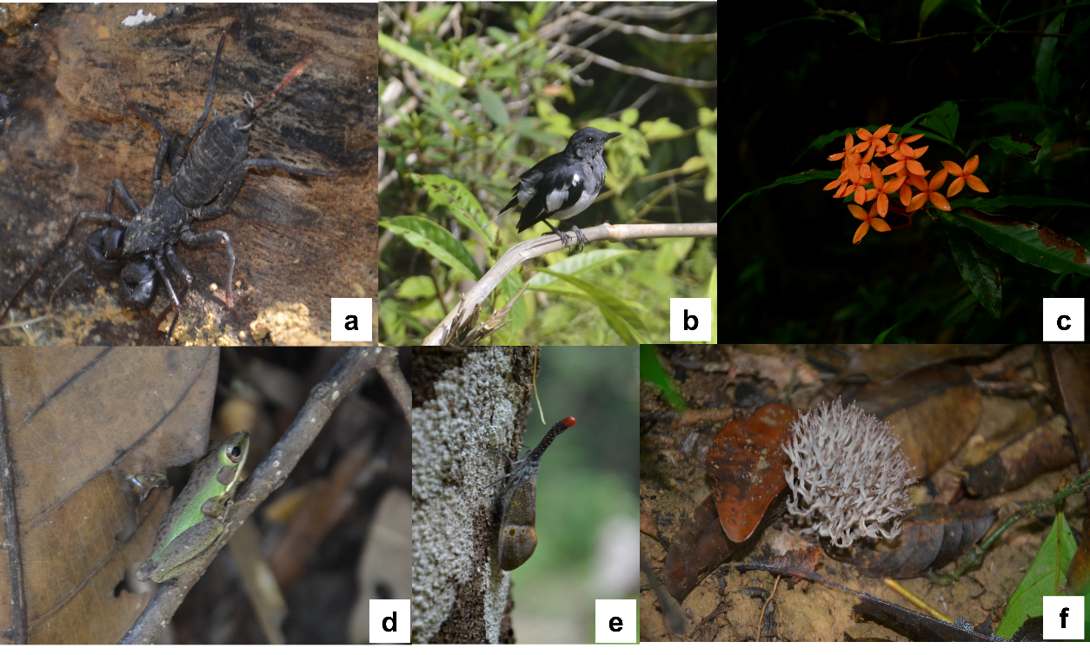
Source: Authors’ work

Figure 1. Biodiversity of Pahang National Park, Sungai Relau, Merapoh. a) Thelyphonus sp., b) Copsychus saularis, c) Ixora sp. , d) Chalcorana megalonesa, e) Pyrops sp. , and f) Ramaria sp.

c. Gua Gajah natural privilege

Gua Gajah is a limestone outcrop with rock art that gives shelter for elephants during the monsoon. Figures 2 and 3 show the outer and inside views of Gua Gajah, respectively. Figure 4 shows the cave entrance that the researchers accessed. It is also a tiny limestone outcrop with many traces of wildlife taking refuge inside. Inside Gua Gajah, there is a bat chamber, the place where guano and bats are discovered. This cave also has a relatively large chamber with some interesting formations. Bats, caves, racers, snakes and frogs may be spotted. The low variety of guests has made National Park, Sungai Relau, a haven for wildlife. Figures 2 and 3 show the views from outside and inside Gua Gajah. Figure 4 shows a dedicated researcher making their way to the entrance of the Gua Gajah.

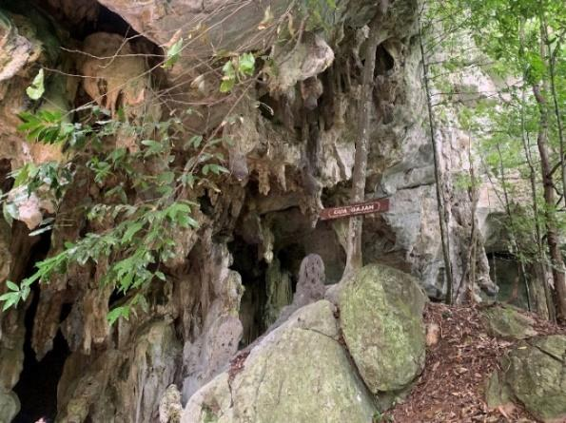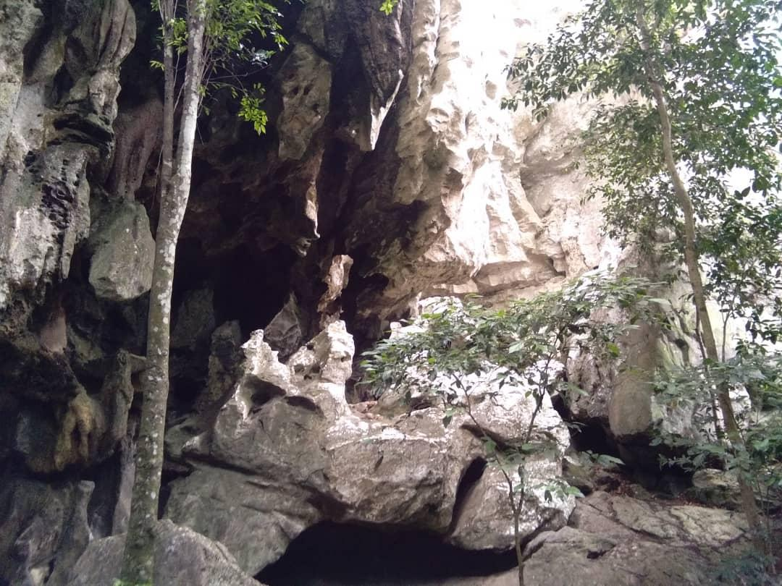
Source: Authors’ work

Figure 2. Outer view at Gua Gajah

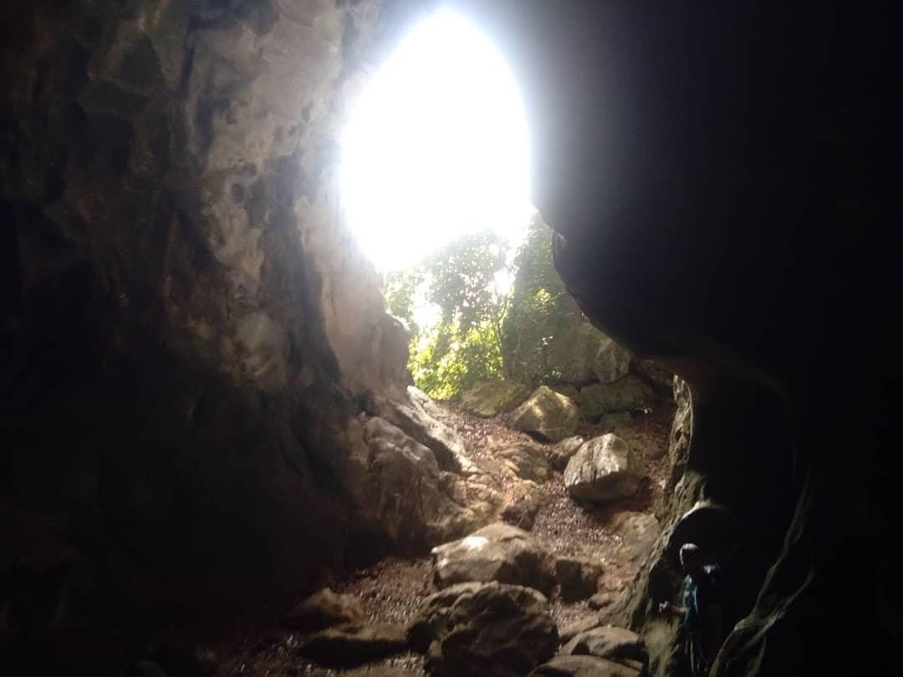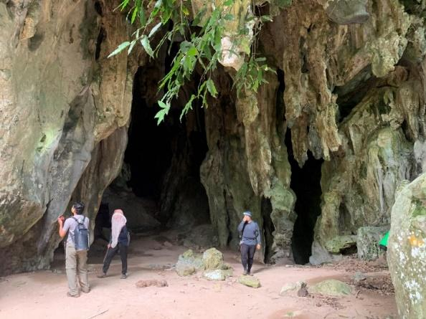
Source: Authors’ work

Figure 3. Inside view at Gua Gajah

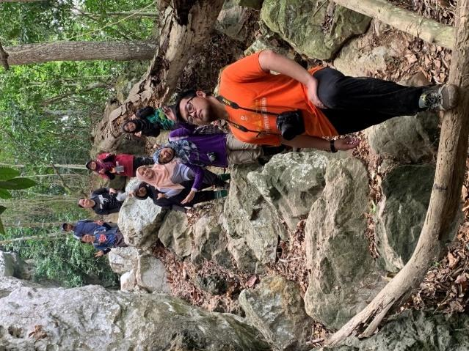
Source: Authors’ work

Figure 4. Entrance to Gua Gajah with researchers

d. History of Gua Gajah

The imaginary story of the communist presence became even more vital when Hamzah shared that the Gua Gajah had become a communist remnant because it was believed to be their hiding place:

"This Gua Gajah does not have much history, but the elders used to say that here is where the communists hid ……. who found a lot of landmines on the outside of Gua Penyenga, there were hardly any remnants of the soldiers …" (R10)

Stakeholders share history, such as Gua Gajah, where the communists came to attack the people and hide in the caves. As part of its history, it can be a culture because the community lives nearby, around the caves, to protect themselves from the war. Other values make them imagine that the place has its unique features.

e. Nature guide services

The Merapoh area, abundant with its unique natural treasures and interesting historical stories, has gained the state government's interest in focusing on the ecotourism sector. The ecotourism sector is a prospect of generating new job opportunities. For tourist attractions, local economic resources in Merapoh can generate income depending on the ability to develop its natural resources, such as forests, caves and Mount Tahan.
It is clear that Podzi is proud that his community has been given priority for the available employment opportunities, which are mainly related to the ecotourism sector. Rosmiati and Hamzah are from Merapoh. Rosmiati states that Merapoh has its nature guide association. Regarding a ranger, Hamzah has explained that every Merapoh guide should possess a green batch, while non-Merapoh rangers must register even if the batch already exists elsewhere. However, priority is still given to the locals of Merapoh to benefit from the economic returns.

"Most of the locals involved in tourism are no doubt from Merapoh" (R8)

"Merapoh local workers such as SGI Outdoor Merapoh Travel" (R2)

"…… Except for nature guides who are working here need to register with the National Park and they need to have a green batch; otherwise, they (PERHILITAN) will not give permission to come and bring in the tourists ..meaning that if the guide comes from Kuala Tahan, it is not allowed…… the guide need to be from Merapoh..you cannot simply come here even with the green batch …… the privilege is only given to Merapoh tourist guides …… because we want to attract the community or the villagers here not to the outsiders …… There is not much here, we also do not allow guides from outside Merapoh …… likewise for mountain climbing, despite there is a request from outsiders we need a guide from the locals here …… the National Park have the enactment, so all of us can decide on something …… " (R10)

Among the nature guide associations that are still active are Merapoh Forest Run, Merapoh Mountain Bike, Jom Hogoh Merapoh Caves, Mt Tahan Climbathon, SGI Travel Agent, and RA Adventure Travel & Tour.
Figure 5 shows the vast attractions of Gua Gajah, consisting of cave exploration, unique biodiversity, natural privilege, historical sites and nature guide service, where all these elements position Gua Gajah as one of the promising ecotourism destinations. Visitors can explore the cave’s unique rock formation and bat chamber while also enjoying activities like bird watching and hiking Mount Tahan nearby. The area is rich in lowland forest flora and fauna, and features striking natural landscapes, including limestone outcrops decorated with ancient rock art. Remnants from the communist era can also be found in the vicinity. Guided nature tours are available, but it is important to note that Merapoh guides should hold a green batch, and non-Merapoh rangers must register before leading visitors.

Gua Gajah’s Attractions as an Ecotourism Site
Cave Exploration | Biodiversity | Natural Privilege | Historical Site | Nature Guide Services
Mount Tahan hiking | Natural Landscapes | Limestone Outcrop with Rock Art | Communist Remnant | Merapoh guide should possess a green batch
Bird Watching | Flora and Fauna | Bat Chamber |  | Non-Merapoh rangers must register
Gua Gajah | Lowland Forest | Large Chamber

Figure 5. Diagram for Gua Gajah’s attractions as an ecotourism site

Gua Gajah’s challenges as ecotourism site

a. A Trek to Gua Gajah from Sungai Relau (Relau River)

A trek to Gua Gajah takes two to three hours each way. Before trekking, researchers must board a four-wheel drive guided by WILDLIFE from Sungai Relau to Gua Gajah. A small, sealed road only fits one vehicle. Before the cave, researchers need to ensure that the supply of food and beverages is adequate, as well as first aid kits and research tools. The road is slippery, and we should be cautious due to discovering fresh former elephant footprints along the route. Figure 6 shows the researcher teams taking a jeep track before using the track route to ‘Gua Gajah Trail’.

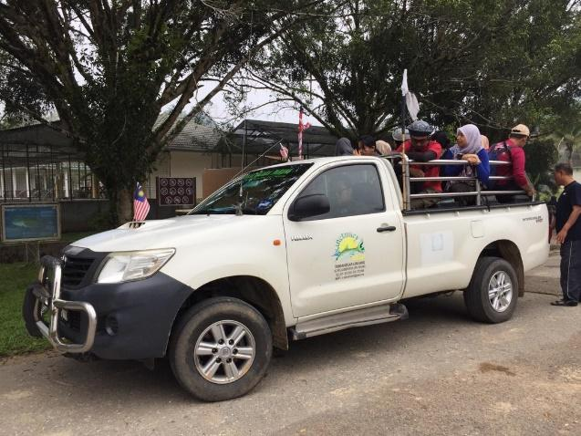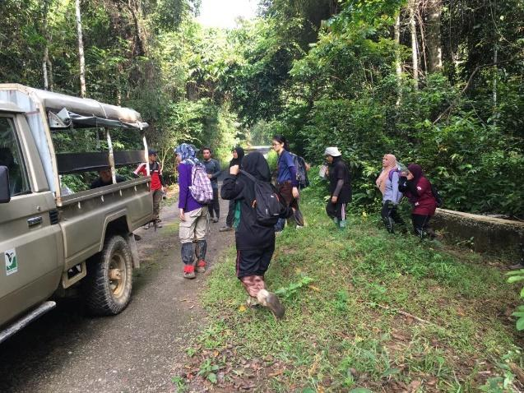
Source: Authors’ work

Figure 6. Take a Jeep Track before using the track route to ‘Gua Gajah Trail’

b. Gua Gajah trail

Gua Gajah Trail is challenging as a tourist site, as shown in Figure 7. This trail needs a nature guide and leads to a reasonably big cave in the middle of the jungle. The cave is so named because elephants often take shelter within it, and its floor is littered with their droppings. A large stretch of the trail passes through a low-stature forest, and it is unclear why. Past logging? Or just plain old nutrient deficiency in the soil? Figure 8 depicts the remarkable coverage of an elephant's foot on the trail.
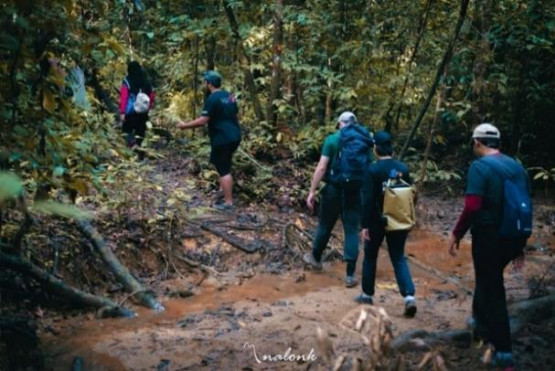
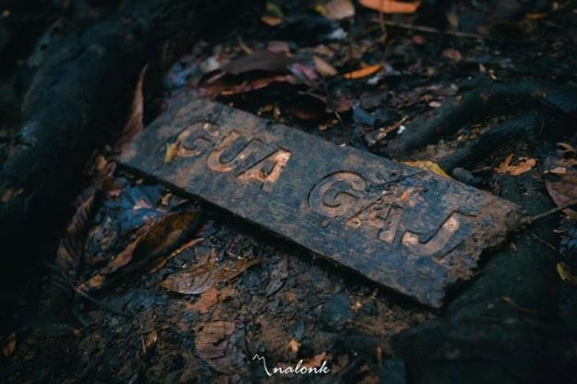
Source: Authors’ work

Figure 7. Track route to Gua Gajah

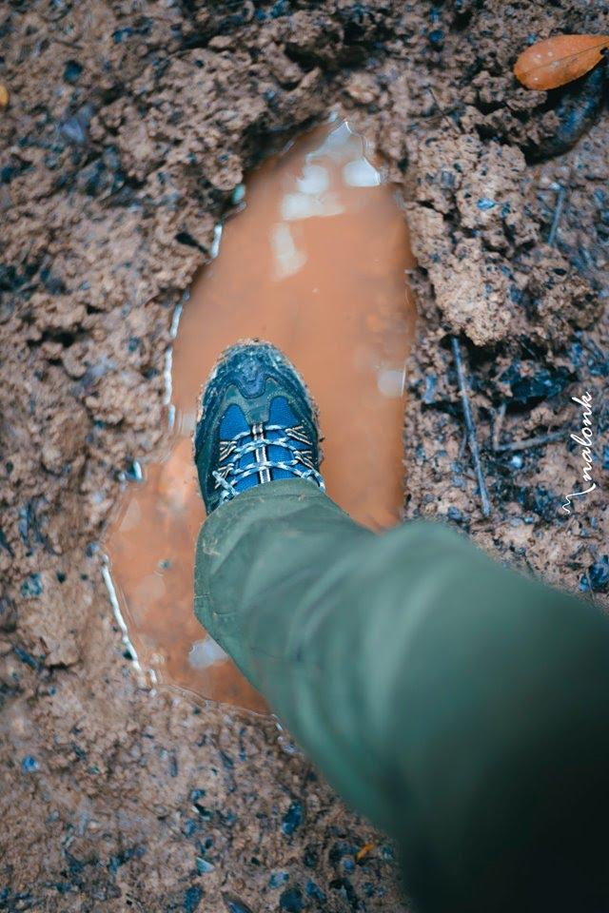
Source: Authors’ work

Figure 8. Differences in the size of adult elephant foot and human foot

c. Logging

There are still challenges to improving the potential sustainable ecotourism in Merapoh's heritage destination. Imaginaries of beauty owned by the Merapoh area may disappear due to logging activities. The uncontrolled logging activity has led to river water pollution, affecting ecotourism destinations in the National Park. The Merapoh River, known for its pure water source for the local community, has turned murky due to pollution. The once calm river environment is now cluttered with fallen trees, blocking the river flow.

Discussion

To understand the uniqueness of tourism in Merapoh, known for its cave paradise, which consists not only of Gua Gajah, the effort to develop this place is minimal, and it still has a long way to go. During the expedition, several perspectives on Merapoh ecotourism were taken down, such as the perspectives from the local communities, local government, the ecological aspects, the natural formation of the limestone and landscape, geographic location and the historical aspects to understand the main attraction of the site, which leads to an exciting find.
The local community must appreciate the potential value of their heritage site as the Gateway to Caving Paradise of Merapoh: Imaginaries or Reality to expand their offer for implementation. The town of Merapoh is famous for the symbolic value of its hundreds of millions of years of limestone caves that are not to be found elsewhere in Malaysia, with waterfalls, bird watching, and mountain climbing at Mount Tahan- the highest mountain in Peninsular Malaysia, which is covered with the oldest tropical rainforest and is located National Park. Merapoh ecotourism products are the main attraction, especially for foreign tourists who love tropical rainforests. Tourist destinations, then, "are cast or spatialised as certain types of places" and become "places for this" and "places for that" (Shields, 2003; Chronis, 2012) through their imaginaries. Hampton (2005) has addressed that identity and community are the determining factors for understanding heritage tourism development, mainly small-scale tourism. This study has also illustrated how this problem can be solved practically. His work generally explains the role of Merapoh’s identity and community in understanding how society functions and the crisis and socio-economic change process.
To fulfil the role of identity and community, Aas et al. (2005) and Ballesteros and Ramírez (2007) have provided two recommendations for identifying and configuring communities to produce relevant symbolics. Among them is participatory tourism planning and management, the most suitable model to ensure accurate knowledge of the heritage tourism environment. Imaginaries can become a reality by providing support with their participation in promoting Merapoh through various activities and programs with the community. Accordingly, it is necessary to learn before supporting any collective' identity status' of heritage tourism initiatives to be transformed into a tourism resource.
The role of the stakeholders is also essential to realise Merapoh’s ecotourism plan towards Sustainable Tourism (ST). ST theory is adopted where there is a need for a 'bottom-up' and 'community-based' approach (Getz & Timur, 2005; Hung, 2013), realising that their views are essential for an effective tourism development strategy in Merapoh. To protect Merapoh's treasures, we should value and preserve the stories about the treasures of nature and cultures, which this study focuses on Gua Gajah. Imaginaries should be promoted as an image of Merapoh engraved with pride for its unique features (Shakur et al., 2025). Moreover, they provide a way to interpret the common historical past and become a conceptual compass for the present.
Merapoh, known for its rich biodiversity and forested areas, has the potential to become an ecotourism destination locally and globally. Hence, the National Ecotourism Master Plan has included it as a potential ecotourism development site. This is parallel with Sustainable Development Goals (SDG) 8, which promotes decent work and economic growth, and SDG 15, which aims to sustainably manage forests, halt land degradation, combat desertification, and stop biodiversity loss.

Conclusion

This paper contributes to the body of knowledge by extending the local communities' imaginaries and interacting shared imaginaries with the stakeholders' imaginaries and views. According to the interview with the community, they are inspired by the place's sense of belonging and Gua Gajah's historical and heritage value. Future monitoring of sensitive species and best practices for eco-friendly infrastructure needs urgent attention in future studies. As a result, these practices must strike a delicate balance between conservation and the demand for ever-more tourism. The construction of access roads, lighting and visitor facilities such as guest houses is not only done without thorough environmental impact assessments but also long-term sustainability planning. Logging should be banned or restricted in the ecologically sensitive zones, particularly in critical ecosystems (e.g. Gua Gajah cave surrounds). This plays a significant role in shaping the living space and the imagination of the local communities and authorities, alongside economic factors. With the 'imaginaries' tourism of the local community and authority coming into conceptualisation, Gua Gajah, specifically and Merapoh, generally, is on the right track to becoming a world ecotourism destination for the coming years. These historical places need to be effectively promoted to speed up the development of a sustainable ecotourism sector. It can be foreseen that more studies need to be carried out to document more potential cave ecotourism sites in Malaysia in cultivating the achievement towards SDG 8 and SDG 15 in a few years.

Acknowledgement

Development, Universiti Malaysia Terengganu (UMT), for their generous funding of the scientific expedition to Taman Negara Pahang, Sungai Relau, Merapoh. Their support has been invaluable in facilitating our research and advancing knowledge in this vital area of biodiversity and social science. Special thanks to WILDLIFE Malaysia for their collaboration and logistical support throughout the expedition, and SK-2024-033 research grant Universiti Kebangsaan Malaysia, for the collective effort underscores the importance of partnerships in advancing scientific understanding and promoting sustainable development.

References

Aas, C., Ladkin, A., & Fletcher, J. (2005). Stakeholder collaboration and heritage management. Annals of Tourism Research, 32(1), 28-48.
Ahmad, A. (2015). Conservation of island biodiversity in Brunei Darussalam: The role of ecotourism in environmental education. International Journal of Ecology & Development, 30(1), 51-63.
Ali, M. (2019, December 6). Merapoh Destinasi Persinggahan. Farmers Organization Authority. http://www.lpp.gov.my/archive/view/merapoh-destinasi-persinggahan
Amanda L. S., Carter A. H., & Lee A. F. (2019). Ecotourism for conservation?. Annual Review on Environment Resources, 44, 229-253.
Azlizam, A., Alias, S. N. H. S., Mazlina, J., Idris, N. H., & Manohar, M. (2018). The attractiveness of Taman Negara National Park, Malaysia as perceived by local visitors. Journal of Wildlife and Parks, 33, 1-13.
Ballesteros, E. R., & Ramirez, M. H. (2007). Identity and community—Reflections on the development of mining heritage tourism in Southern Spain. Tourism Management, 28(3), 677-687.
Baumeister, R. F., & Newman, L. S. (1994). How stories make sense of personal experiences: Motives that shape autobiographical narratives. Personality and Social Psychology Bulletin, 20(6), 676–690.
Béki, P., Metzger, J., & Lasztovicza, D. (2016). Caves, as touristic attractions in Hungary: Adventure, health, culture, ecotourism. Applied Studies in Agribusiness and Commerce, 10(4-5), 51-58.
Chronis, A. (2012). Between place and story: Gettysburg as tourism imaginary. Annals of Tourism Research, 39(4), 1797–1816.
Farrelly, F. (2019). Revealing the memorial experience through the tourist-led construction of imagined communities. Tourism Management, 75, 13-21.
Forje, G. W., Tchamba, M. N., & Eno-Nku, M. (2021). Determinants of ecotourism development in and around protected areas: The case of Campo Ma’an National Park in Cameroon. Scientific African, 11, e00663.
Getz, D., & Timur, S. (2005). Stakeholder Involvement in Sustainable Tourism: Balancing The Voices. In W. F. Theobald (Ed.), Global tourism (pp. 230-247). Routledge.
Hampton, M. (2005). Heritage, local communities and economic development. Annals of Tourism Research, 32, 735-759.
Hung, L. T. (2013). Influence analysis of community resident support for sustainable tourism development. Tourism Management, 34, 37-46.
Koeshadi Sasmito, Agus Wahyudi, Syamsidar Sutan, & Fajar Alam. (2019). Ecotourism potential of Batu Gelap Cave, Kutai Kartanegara, East Kalimantan. Journal of Physics: Conference Series, 1363, 012051.
Marlina, Sumarmi, Astina, I.K., Utomo, D. H., & Kurniawati, E. (2022). Ecotourism management based on local wisdom for optimising the function of cave water resources as a prevention of floods and droughts in Wakatobi regency, Indonesia. GeoJournal of Tourism and Geosites, 44(4), 1222–1232.
PLANMalaysia. (2014). Merapoh gateway to caving paradise of Malaysia. Pelan Tindakan Khas Merapoh, Daerah Lipis, Pahang Darul Makmur.
Salazar, N. B., (2012). Tourism imaginaries: A conceptual approach. Annals of Tourism Research, 39(2), 863–882.
Shakur, E. S. A., Samsudin, H., Halim, M. A. S. A., & Md Razali, M. K. A. (2025). Imagining Merapoh in Malaysia as a world class ecotourism destination. Geojournal, 90(19), 1-16.
Shields, R. (2003). Political tourism: Mapping memory and the future at Que'bec City. In S. P. Hanna & V. J. Del Casino, Jr. (Eds.), Mapping tourism (pp. 1–27). University of Minnesota Press.

