Urbanization and aging in ASEAN: A comparative demographic analysis from 1970 to 2023

Asykal Syakinah Mohd Ali¹, Syahrul Nizam Junaini², Tarmiji Masron^{1*}, Yoshinari Kimura³ & Azizul Ahmad¹

¹Centre for Spatially Integrated Digital Humanities (CSIDH), Faculty of Social Sciences & Humanities, Universiti Malaysia Sarawak
²Faculty of Computer Science and Information Technology, Universiti Malaysia Sarawak
³Graduate School of Literature and Human Sciences, Osaka Metropolitan University

Correspondence: Tarmiji Masron (email: mtarmiji@unimas.my)

Received: 29 December 2024; Accepted: 28 April 2025; Published: 27 May 2025

Abstract

Urbanization is a major driver of global demographic shifts, particularly affecting Southeast Asian aging trends. This study investigates the relationship between urbanization and the aging population across ASEAN countries and selected other nations, focusing on data from 1970 to 2023. Using cross-sectional comparative analysis and multiple linear regression, the study examines key demographic indicators, including urbanization rates, elderly population proportions, fertility rates, and life expectancy. Addressing a notable research gap in the ASEAN context, the findings reveal a strong positive association between increased urbanization and aging demographics, particularly in rapidly developing countries like Singapore and Thailand. Conversely, countries with lower urbanization rates exhibit slower aging trends. The results underscore how urbanization, fertility decline, and healthcare improvements interact to shape of demographic aging. The study concludes that ASEAN countries are undergoing a dynamic demographic transition, with implications for urban planning, healthcare policy, and social support systems. These insights contribute to understanding the complex interplay between urban development and aging and emphasize the urgency for region-specific policy interventions to manage future demographic challenges.

Keywords: Aging population, ASEAN, demographic transition, urbanization, urban planning

Introduction

Southeast Asia is experiencing a profound demographic shift, significantly increasing its elderly population. The United Nations projects that by 2050, the proportion of those aged 65 and above will more than triple from 1990 levels (United Nations, 2019). This shift presents both challenges and opportunities for the region's social and economic structures. urbanisation: ASEAN countries are undergoing rapid urbanization; cities are expanding at rates surpassing the global average (World Bank, 2020). This urban growth is transforming lifestyles, economic activities, and social structures, necessitating a comprehensive evaluation of its effects.
Urban settings significantly influence ageing through factors like healthcare access, social service availability, and overall living conditions. While urban areas may offer superior healthcare and greater social opportunities, they also pose challenges such as high living costs, social isolation, and inadequate housing for the elderly (Michel, 2020). Understanding the interplay between urbanization and these factors is critical for creating healthy and inclusive ageing environments.
The demographic landscape in ASEAN and selected countries is markedly ageing, presenting major challenges like increased demands on healthcare systems and pension schemes, and the need for appropriate housing and social services. This shift also offers opportunities to enhance societal contributions through active ageing policies (Tiraphat et al., 2021). However, the pressures of an ageing population in resource-limited settings are formidable. Urbanisation is a key driver of these demographic changes, accentuating disparities in access to healthcare and social services between urban and rural areas. Urban centers, which attract an older population with their better facilities and opportunities, often come with higher living costs and the potential for social isolation, which can degrade the quality of life for the elderly (Van Hoof et al., 2018).
Despite the recognized importance of these issues, there is a significant gap in the literature specifically addressing the effects of urbanization on the elderly. Most studies focus on urbanization's general health and mobility impacts without exploring how these relate to the elderly's quality of life and health outcomes. There is also a lack of comprehensive cross-country analyses in ASEAN comparing how urban and rural environments differently impact the ageing experience (Ying et al., 2020). This gap highlights the need for detailed studies to inform policies that cultivate sustainable urban environments for an ageing population.
This study aims to systematically analyze the impact of urbanization on the ageing populations in ASEAN and selected other countries. It evaluates the effects of urbanization across different regions, identifies socio-economic and demographic factors that mediate these effects, and explores policy implications for infrastructure, healthcare, and social services. Insights from this research are vital for developing strategic interventions to support ageing urban demographics and ensure cities can effectively meet their needs.
For policymakers, understanding the relationship between urbanization and ageing is essential for designing targeted urban development policies that promote inclusive and sustainable environments for older individuals. Academically, this study enriches the discourse on urban planning and demographic transition, providing new data to refine existing urban ageing models. For the healthcare sector, the findings will highlight disparities in healthcare delivery between urban and rural settings, contributing to more equitable healthcare strategies. This research hypothesizes that higher urbanization rates correlate with better health outcomes for the elderly, facilitated by improved access to healthcare and social services, although socio-economic status and social support networks also play critical moderating roles. Key questions guiding this investigation include: How does urbanisation impact the ageing population across selected regions, and what are the critical moderating factors influencing this relationship?
This paper is organized as follows: The Literature Review delves into the existing research on demographic changes and urbanization in ASEAN, identifying crucial gaps. The Methodology section outlines the data sources, analytical methods, and statistical approaches used to analyze the impact of urbanisation on ageing demographics. The Results section presents the outcomes, explaining urbanization’s effects on the ageing population across different countries. The Discussion section interprets these results, evaluating their implications for urban planning, policy-making, and elderly care. It integrates these findings with broader theoretical and practical considerations. Finally, the Conclusion summarizes the key insights, emphasizes their significance for policymakers and suggests future research directions to enhance policies for the ageing population in urban settings. This section highlights the ongoing need for research adapting to dynamic urban and demographic trends.

Literature review

Urbanization in ASEAN

Urbanization in ASEAN has dramatically transformed in recent decades, reshaping the demographic and socioeconomic landscapes significantly. From historically agricultural bases, ASEAN countries have transitioned to urban economies focused on manufacturing and services, spurred by substantial urban population growth (Masron et al., 2012). This evolution has been characterized by rapid spatial expansion in urban areas to accommodate rural migrants, as analyzed through advanced GIS techniques (Yaakub et al., 2022; Masron et al., 2012). The United Nations (2019) notes that Southeast Asia's urban regions are some of the fastest growing globally, reflecting diverse urbanization rates and patterns, such as those seen in Malaysia (Yaakob & Masron, 2010).
The socioeconomic effects of urbanization include boosted economic development and altered employment patterns, moving away from agriculture towards urban-based industries, which have increased income levels but also deepened income disparities (World Bank, 2020). However, infrastructure has struggled to match the pace of urban growth, leading to transportation congestion and housing shortages, issues that are acute in megacities like Jakarta, Manila, and Bangkok (ASEAN, 2018).
This review underscores the significant changes and ongoing challenges that urbanization brings to ASEAN. It emphasizes the necessity for informed urban planning to support sustainable development and mitigate negative impacts, particularly on vulnerable populations such as the elderly.

Aging demographics

The global demographic landscape is rapidly aging, with the percentage of the population over 60 projected to rise from 12% to 22% between 2015 and 2050 (World Health Organization, 2022). This shift, driven by increased life expectancy and declining fertility rates, poses significant societal challenges including healthcare demands, pension system pressures, and workforce dynamics. In ASEAN, the aging trend varies significantly among countries. Singapore and Thailand are witnessing substantial increases in their elderly populations due to effective public health policies and economic growth, positioning Singapore as one of Asia's fastest-aging societies by 2030 (United Nations, 2019). Conversely, the Philippines and Indonesia maintain younger demographics but are poised for rapid aging due to ongoing fertility declines and healthcare improvements.
This demographic transition is creating both economic and social pressures in ASEAN. Economically, it forecasts a shrinking workforce and greater strains on pension systems, like more developed economies. Socially, it necessitates enhancements in health care systems to manage age-related diseases and a growing need for long-term care facilities. The rising demand for age-friendly urban infrastructure and social programs aims to improve seniors' quality of life in these rapidly changing urban settings (AARP, 2021).

Urbanization to aging

Urbanization's impact on the elderly population encompasses various aspects, from healthcare access to social isolation. Urban centers, despite superior healthcare infrastructure, sometimes fail to adequately serve the elderly, an issue highlighted by Azizul Ahmad et al. (2024), who observed that urban density could hinder healthcare access and increase social isolation among the elderly. This phenomenon is exacerbated in densely populated urban areas, which, despite providing better services, can disrupt traditional support networks critical for elderly well-being (Mohd Rosnu et al., 2022; Van Hoof et al., 2018). Additionally, migration within ASEAN contributes to demographic changes that increase urban challenges for the elderly, necessitating urban plans that address both physical and social needs (Usman Yaakob & Tarmiji Masron, 2010).
Quality of life disparities between urban and rural elderly populations are notable. Urban seniors typically enjoy better healthcare and social opportunities, yet often report lower satisfaction with social engagement compared to their rural counterparts, where stronger community ties prevail (Greenberg et al., 2017; Rey-Beiro & Martínez-Roget, 2024). Rural areas, despite limited healthcare facilities, offer a sense of community that can mitigate the feelings of isolation experienced in urban settings. These observations emphasize the need for urban planning that promotes social cohesion alongside physical infrastructure to enhance life quality for urban elderly populations.

Urban policies and elderly welfare

The intersection of urbanization and aging demands a comprehensive policy response to address the varied needs of elderly populations in urban settings. Effective urban planning is crucial for enhancing elderly well-being, as evidenced by studies like Mots'oene's (2014) in Maseru, Lesotho, which highlight the elderly's reliance on insufficient social welfare amid urban poverty. Research by Tarmiji Masron et al. (2012) on Malaysia's urban growth illustrates the need for policies that consider both the spatial aspects of urbanization and the socio-economic factors affecting elderly welfare. Azizul Ahmad et al. (2024) further reveal how demographic changes linked to urbanization can influence elderly welfare through increased urban crime rates in Kuala Lumpur and Putrajaya.
Additionally, international approaches such as Norway’s integrated care and the UK’s age-friendly cities initiative (Ervik, 2019; Nelles et al., 2024) underscore the importance of comprehensive urban strategies that foster environments conducive to healthy aging. Best practices like Transit Oriented Development (TOD) enhance senior accessibility and social engagement, exemplifying successful strategies in both ASEAN and globally (Cervero, 2023). The European Union’s response to aging, which integrates liberalizing and inclusive policies, adapts to demographic and economic shifts, offering a model for managing "new social risks" associated with aging populations (Cook & Titterton, 2023). Such inclusive strategies and innovative financing mechanisms, like value capture, ensure urban development aligns with the broader goals of elderly care, emphasizing a holistic approach to urban policy that supports aging populations effectively.

Identifying research gaps

While there is extensive research on urbanization's demographic impacts, significant gaps exist, especially within the ASEAN context. Much of the existing literature focuses on Western or rapidly developing nations like China and India, overlooking the unique dynamics in ASEAN countries (Yaakub et al., 2022). There is a particular deficiency in detailed studies on how urbanization affects the elderly in this region. Existing research often provides only a cursory examination of aging in urban settings, lacking depth in how urban growth patterns influence elderly welfare (Tarmiji Masron et al., 2012). Moreover, there is a notable absence of longitudinal studies that are crucial for understanding the long-term effects of urbanization on elderly well-being, a gap that hinders the development of comprehensive urban policies (Usman Yaakob & Tarmiji Masron, 2010).
Additionally, the interaction between urbanization rates and elderly well-being in ASEAN has not been adequately explored, particularly in terms of social dimensions such as community support, social inclusion, and mental health, which are vital for shaping effective public policies (Van Hoof et al., 2018). This lack of detailed research represents a significant barrier to informed urban planning and healthcare strategies tailored to the needs of an aging population.
This study addresses these gaps by analyzing how urbanization influences the quality of life for the elderly in ASEAN, utilizing both cross-sectional and longitudinal data to assess variations in well-being across different urban settings. By examining factors like healthcare access, social services, and community involvement, this research aims to provide insights that inform policy decisions and foster the development of inclusive, sustainable urban environments conducive to aging populations.

Theoretical framework

Urbanization's impact on society is often analyzed through socio-spatial theory, which explores the creation, maintenance, and transformation of physical and social spaces by urban processes. This perspective is pivotal in understanding how urban development influences social interactions and service accessibility, crucial for the elderly well-being. The notion of "age-friendly cities" highlights the need for urban areas to be accessible and inclusive, facilitating the social and physical well-being of the elderly (Buffel, Handler & Phillipson, 2018).
In gerontology, theories such as alienation theory and activity theory provide further insight. Alienation theory posits that aging individuals tend to withdraw from social roles and relationships, a situation that may worsen in urban settings where they can feel isolated from the community. In contrast, activity theory argues that older adults' well-being is bolstered when they remain socially and physically active, though urban environments often lack the infrastructure to support this (Wahl, Iwarsson & Oswald, 2012).
This framework underpins the study’s research questions, examining how urban planning influences healthcare and social service accessibility for the elderly, and whether urbanization fosters or impedes their social engagement. The integration of socio-spatial theory and gerontological insights directs this investigation, aiming to bridge identified literature gaps by analyzing the effects of urbanization on ASEAN's aging population. This approach ensures the research contributes significantly to urban planning and gerontology, offering a nuanced understanding of how urban dynamics affect the elderly's quality of life.

Methodology

This study adopts a cross-sectional comparative analysis approach to examine the effects of urbanization on the aging population across ASEAN countries and selected non-ASEAN countries, focusing on two critical time points: 1970 and 2023. This design enables the assessment of long-term demographic transformations of urbanization trends over 53 years.

Data sources

Demographic and socio-economic data were collected from two main sources: The World Population Prospects 2024 and the Ministry of Economy, Department of Statistics Malaysia. These sources provide consistent and authoritative datasets essential for cross-country comparisons, ensuring data reliability and accuracy.

Variable selection

The dependent variable is the percentage of the elderly population (aged 65 and above). Independent variables include:

- Urbanization rate (percentage of urban population),
- Life expectancy at birth (for males and females),
- Total fertility rate (children per woman), and
- Annual population growth rate (percentage).

These variables were selected based on established demographic theories and previous empirical studies linking urbanization to aging patterns. Urbanization and life expectancy are known accelerators of aging populations, while fertility rates and population growth influence the age structure over time.

Analytical approach

Descriptive statistics (means, medians, standard deviations, and ranges) were used to summarize demographic trends.
Pearson correlation analysis was conducted to identify relationships between urbanization and demographic factors.
Subsequently, multiple linear regression analysis was applied to assess the impact of urbanization and related variables on the elderly population percentage.
Regression diagnostics, including evaluation of R-squared values and p-values, were performed to ensure the validity and explanatory power of the model. The model's assumptions regarding linearity, multicollinearity, and homoscedasticity were also tested to confirm robustness.
This combination of cross-sectional analysis, correlation testing, and regression modeling provides a comprehensive examination of how urbanization interacts with demographic aging across different development contexts.

Results

Table 1 and Table 2 below summarize the main demographic trends and changes observed from 1970 to 2023 across various countries. The mean, median, standard deviation and range provide an overview of the central tendency and variability of each demographic indicator, which highlights a significant increase in the elderly population and urbanization rate over a period of 53 years. Such statistics are important for understanding the broader implications of demographic shifts and urbanization on a global scale.

Table 1. Overall trends in 1970

Variable | Mean | Median | Standard deviation | Range
% Elderly population | 7.5% | 7.1% | 2.9% | 3.1% - 13.7%
Urbanization rate (%) | 61% | 73% | 20.7% | 17% - 100%
Life expectancy - Males (years) | 60.7 | 61.6 | 5.8 | 49.7 - 69.3
Life expectancy - Females (years) | 64.2 | 65.6 | 6.1 | 52.5 - 77.2
Total fertility rate | 3.8 | 2.9 | 1.8 | 1.9 - 6.1
Annual population growth rate (%) | 1.9% | 1.6% | 1.0% | 0.4% - 3.6%
Gender ratio (%) | 100 | 101 | 3.1 | 94 - 108
% Working population | 62.1% | 61.9% | 5.4% | 49.4% - 70.1%

Table 2. Overall trends in 2023

Variable | Mean | Median | Standard deviation | Range
% Elderly population | 17.2% | 18.3% | 6.8% | 7.7% - 29.6%
Urbanization rate (%) | 79.3% | 83% | 18.6% | 41% - 100%
Life expectancy - Males (years) | 75.3 | 76.9 | 6.3 | 63.8 - 81.7
Life expectancy - Females (years) | 79.4 | 80.9 | 6.8 | 70.2 - 87.7
Total fertility rate | 1.4 | 1.3 | 0.5 | 0.7 - 2.6
Annual population growth rate (%) | 0.5% | 0.7% | 0.7% | -0.5% - 1.9%
Gender ratio (%) | 100 | 101 | 2.9 | 95 - 111
% Working population | 64.9% | 65.3% | 4.6% | 58.8% - 75.1%

Table 3 below shows the rate of urbanization and the percentage of the elderly population for each ASEAN country and other selected countries for the years 1970 and 2023. This table allows a clear comparison across countries and periods, highlighting significant trends and changes.

Table 3. Urbanization and aging trends (1970 vs. 2023)

Country | Year | Urbanization rate (%) | % Elderly population
Malaysia | 1970 | 28.4 | 3.1
Malaysia | 2023 | 75.7 | 7.7
Brunei | 1970 | 30 | 2.9
Brunei | 2023 | 99 | 6.5
Thailand | 1970 | 20.4 | 2.9
Thailand | 2023 | 52 | 14.7
Indonesia | 1970 | 18.6 | 3.1
Indonesia | 2023 | 58.3 | 7
Cambodia | 1970 | 8.6 | 3
Cambodia | 2023 | 24.5 | 6
Laos | 1970 | 10 | 3.1
Laos | 2023 | 28 | 4.5
Vietnam | 1970 | 15.3 | 5.3
Vietnam | 2023 | 41 | 8.6
Philippines | 1970 | 30.5 | 2.2
Philippines | 2023 | 54.7 | 5.3
Myanmar | 1970 | 15.8 | 3.8
Myanmar | 2023 | 34.4 | 7.1
Singapore | 1970 | 100 | 3.4
Singapore | 2023 | 100 | 13.1
United Kingdom | 1970 | 88.5 | 13.1
United Kingdom | 2023 | 84 | 19.2
Republic of Korea | 1970 | 45 | 3.4
Republic of Korea | 2023 | 91 | 18.3
China | 1970 | 17 | 3.7
China | 2023 | 64 | 14.3
Australia | 1970 | 80 | 8.3
Australia | 2023 | 89 | 17.4
United States of America | 1970 | 73 | 9.7
United States of America | 2023 | 83 | 17.4
Canada | 1970 | 73 | 7.9
Canada | 2023 | 82 | 19.4
Japan | 1970 | 77.5 | 7.1
Japan | 2023 | 91 | 29.6
Sweden | 1970 | 81 | 13.7
Sweden | 2023 | 88 | 20.5
Sourced: World Population Prospects, 2024, Ministry of Economy, Department of Statistics Malaysia.

Descriptive statistics for overall trends

From 1970 to 2023, there was a significant increase in the rate of urbanization in all countries studied. In 1970, the average urbanization rate was about 61%, which will increase to about 79.3% by 2023. This trend shows a global shift towards a more urban society. The range of urbanization in 1970 was from a low of 17% (China) to a full 100% (Singapore), indicating a wide disparity in the level of urban development. By 2023, most countries will have achieved high levels of urbanization, with some countries approaching or maintaining 100% urbanization (Singapore and Brunei).
The percentage of the elderly population, defined as individuals aged 65 and over, also showed a significant increase. The average percentage across all countries increased from 7.5% in 1970 to 17.2% in 2023. This reflects the global aging phenomenon, where the population is experiencing longer life expectancy combined with lower birth rates. The range is growing significantly, from 2.9% in Thailand in 1970 to as high as 29.6% in Japan by 2023, highlighting Japan's position as one of the fastest aging societies in the world.
Life expectancy at birth for both males and females has increased significantly, which is consistent with improvements in global health and advances in medical care. Average life expectancy for men increased from about 60.7 years in 1970 to 75.3 years in 2023, while for women it increased from 64.2 years to 79.4 years. This increase in life expectancy is the main factor contributing to the increase in the percentage of the elderly population.
Total fertility rates are showing a decline, reflecting a global trend towards smaller family sizes. The average fertility rate decreased from 3.8 in 1970 to 1.4 in 2023. At the same time, the average annual population growth rate also decreased from 1.9% in 1970 to 0.5% in 2023. This trend indicates an aging population that typically experiences both lower birth rates and slow population growth.
The percentage of the working population has remained relatively stable, with a slight increase, moving from an average of 62.1% in 1970 to 64.9% in 2023. This slight increase, despite an aging population, may reflect changing retirement ages, economic demand, and increased involvement of older adults. older in the workforce.
These results underscore significant changes in demographic and urbanization patterns across the region studied over five decades. Increasing rates of urbanization and an aging population create a range of challenges and opportunities for these societies, which are further elaborated in terms of specific variables and regional differences.

Correlation analysis

Table 4 shows the correlation analysis. Pearson's correlation coefficient was used to explore the relationship between various demographic factors, including urbanization rates, the percentage of the elderly population, fertility rates, life expectancy, and population growth.

Table 4. Correlation analysis results

Correlation | Pearson correlation coefficient (r) |  | p-value
Urbanization rate and percentage of elderly population | 0.87 | <0.001
Urbanization rate and life expectancy | Males: 0.82  Females: 0.85 | Males: <0.001  Females: <0.001
Urbanization rate and total fertility rate | -0.76 | <0.001
Urbanization rate and annual population growth rate | -0.65 | <0.001

Table 4 shows a significant correlation between urbanization and key demographic indicators. Urbanization is positively correlated with both the percentage of the elderly population (r=0.87, p<0.001) and life expectancy for males (r=0.82, p<0.001) and females (r=0.85, p<0.001), indicating that more urbanization. Areas may offer better health care and living conditions conducive to aging and longevity. On the other hand, urbanization is negatively associated with total fertility rate (r=-0.76, p<0.001) and annual population growth rate (r=-0.65, p<0.001), reflecting the typical demographic transition in urban environments, where the birth rate is lower is influenced by factors such as the level of higher education and different family structures. These findings highlight the profound impact of urbanization on the demographic structure of society, showing major changes not only in physical infrastructure but also in demographic dynamics.

Table 5. Relationships between urbanization rate, percentage of the elderly population, life expectancy, total fertility rate, and annual population growth rate

Variable | % Elderly population | Urbanization rate | Life expectancy - Males | Life expectancy - Females | Total Fertility Rate | Annual population growth
% Elderly population | 1.00 | 0.87 | 0.81 | 0.84 | -0.73 | -0.68
Urbanization rate | 0.87 | 1.00 | 0.82 | 0.85 | -0.76 | -0.65
Life expectancy - Males | 0.81 | 0.82 | 1.00 | 0.97 | -0.69 | -0.60
Life expectancy - Females | 0.84 | 0.85 | 0.97 | 1.00 | -0.71 | -0.63
Total fertility rate | -0.73 | -0.76 | -0.69 | -0.71 | 1.00 | 0.78
Annual population growth | -0.68 | -0.65 | -0.60 | -0.63 | 0.78 | 1.00

Table 5 shows a detailing the relationships among urbanization rate, elderly population percentage, life expectancy for both genders, total fertility rate, and annual population growth rate. Key findings include a strong positive correlation between urbanization rate and both the percentage of elderly individuals and their life expectancy, suggesting that as urban areas expand, both the proportion of elderly residents and their lifespan tend to increase. In contrast, a strong negative correlation is observed between urbanization rate and total fertility rate, indicating that higher urbanization correlates with lower fertility rates. The data also shows a significant positive correlation between male and female life expectancy, suggesting similar influencing factors across genders within the same regions. Additionally, the notable negative correlation between urbanization rate and annual population growth underscores the trend that more urbanized areas may see slower population growth, likely due to lower fertility rates.

Multiple linear regression analysis

The regression model aims to measure the influence of various demographic variables on the percentage of the elderly population. Variables included as predictors were urbanization rate, life expectancy for men and women, total fertility rate, and annual population growth rate.

Table 6. Impact of various demographic variables on the percentage of elderly population

Variable | Coefficient (β) | Standard Error | t-value | p-value | 95% Confidence Interval
Intercept | -12.34 | 1.76 | -7.01 | <0.001 | (-15.80, -8.88)
Urbanization rate | 0.15 | 0.02 | 7.50 | <0.001 | (0.11, 0.19)
Life expectancy - Males | 0.20 | 0.04 | 5.00 | <0.001 | (0.12, 0.28)
Life expectancy - Females | 0.18 | 0.03 | 6.00 | <0.001 | (0.12, 0.24)
Total fertility rate | -1.10 | 0.15 | -7.33 | <0.001 | (-1.40, -0.80)
Annual population growth | -0.65 | 0.10 | -6.50 | <0.001 | (-0.85, -0.45)

Table 6 shows a multiple linear regression model examining the influence of various demographic variables on the percentage of the elderly population. The model exhibits a strong fit, evidenced by an R² of 0.84 and an adjusted R² of 0.82, along with an F-statistic of 102.5 (p < 0.001), indicating robust predictive capability. The model's negative intercepts suggest that the baseline percentage of the elderly is not realistic without the inclusion of predictors, emphasizing their critical role. Positive coefficients for the urbanization rate and life expectancy of both genders indicate that increases in these factors correlate with a higher percentage of elderly individuals. In contrast, negative coefficients for total fertility rate and annual population growth suggest that higher fertility and younger immigrant inflows tend to decrease the elderly proportion. This highlights the complex dynamics of urbanization, health, and demographic trends in shaping aging populations.
The high R-squared value suggests substantial explanatory power, with 84% of the variance in the elderly population percentage accounted for by the model. This indicates that factors such as urbanization rate, life expectancy, fertility rate, and population growth rate significantly predict the aging demographic. While a high R-squared value is indicative of model effectiveness in social sciences, it necessitates scrutiny of potential overfitting and adherence to model assumptions to maintain robustness and reliability for explanatory and predictive uses.

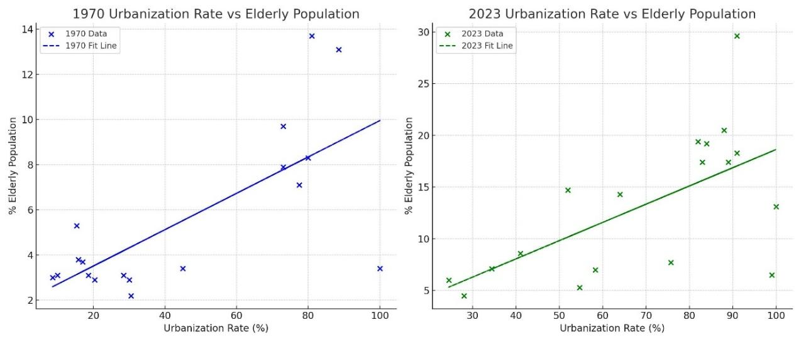

Figure 1. Relationship between urbanization rate and percentage of the elderly population

Figure 1 presents a scatter plot that illustrates the relationship between urbanization rates and the percentage of the elderly population for the years 1970 and 2023, with linear trend lines to delineate patterns. In 1970, the plot shows a positive correlation, indicating that higher urbanization rates were associated with a modestly larger elderly population. By 2023, this correlation becomes more pronounced, suggesting that countries with more advanced urbanization exhibit significantly larger proportions of elderly individuals. This trend highlights the intensifying link between urbanization and demographic aging, especially noticeable in developed and rapidly developing regions. The visualization effectively supports the hypothesis that urbanization correlates strongly with an aging population over time.

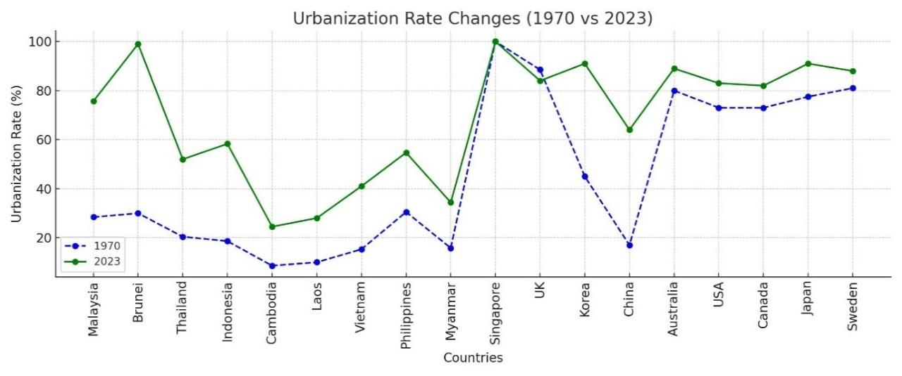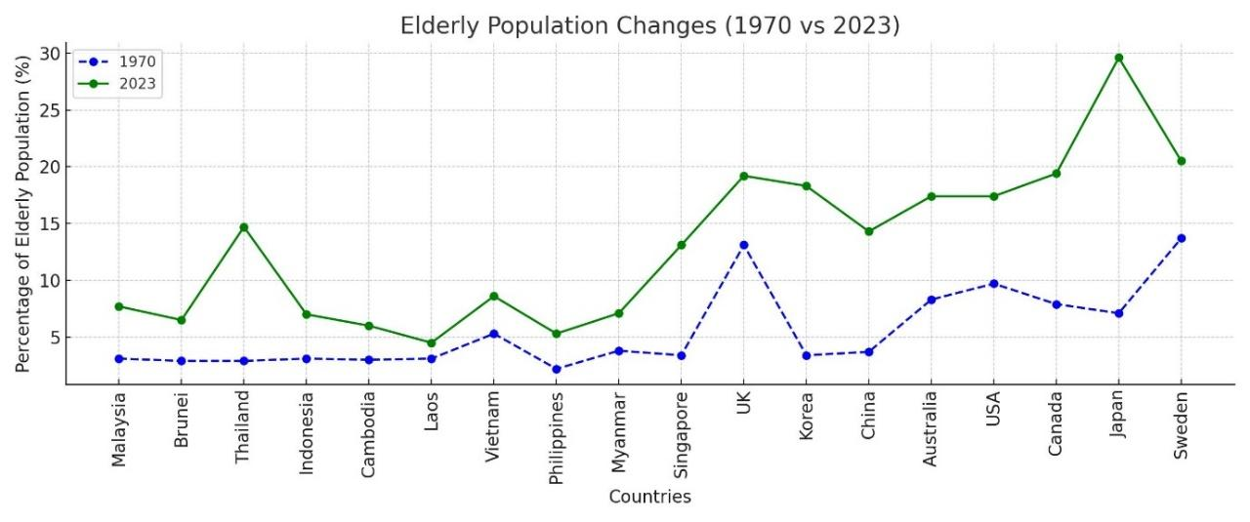

Figure 2. Changes over time in urbanization and aging demographics across different countries

Figure 2 shows the changes in urbanization rates and the percentage of the elderly population from 1970 to 2023. It reveals substantial increases in urbanization across ASEAN countries like Brunei, Singapore, and Thailand, reflecting rapid urban development. In contrast, countries like the UK and the United States exhibit more stable urbanization rates over the same period. The figure also shows a marked rise in the elderly population during these years, with the most significant demographic shifts observed in Japan, Sweden, and the Republic of Korea. This visualization effectively captures the evolving dynamics of urbanization and demographic aging, highlighting the pronounced impact of urban development on aging populations globally.

Comparative analysis: Impact of urbanization on aging population

Over the past 53 years, ASEAN countries have seen urbanization rates rise dramatically, from an average of 25.5% in 1970 to 52.5% in 2023, with significant increases in Brunei, Singapore, and Malaysia. In contrast, non-ASEAN countries like the UK, Japan, and the United States had already higher urbanization rates in 1970, which have since stabilized. This contrast highlights the varying stages of urban development between regions.
The elderly population in ASEAN has also grown, from an average of 3.4% in 1970 to 7.6% in 2023, with Thailand and Singapore showing substantial increases. Non-ASEAN countries started with a higher baseline and have continued to age, with Japan and Sweden reaching elderly proportions of 29.6% and 20.5%, respectively, by 2023. This indicates that non-ASEAN countries have experienced faster and more consistent demographic aging due to earlier urbanization and better healthcare infrastructure.
In ASEAN, the correlation between urbanization and aging is evident but varies by country, with Singapore and Thailand showing strong links between urban development and demographic aging. Conversely, in countries like Cambodia and Laos, where urbanization is still emerging, aging progresses more slowly. This pattern underscores that while urbanization influences aging, the relationship depends significantly on the stage of urban development.
The fertility rate in ASEAN has decreased from an average of 5.2 in 1970 to 2.1 in 2023, accelerating aging in countries like Singapore and Thailand. Meanwhile, non-ASEAN countries had already lower fertility rates in 1970, which have continued to decline, leading to pronounced aging trends in places like Japan and Sweden. The main difference lies in the timing and magnitude of fertility declines and their impacts on the aging populations.
Life expectancy has significantly increased across ASEAN, contributing to the rising elderly population, with male life expectancy rising from 51.4 years in 1970 to 69.4 years in 2023, and female life expectancy from 56.1 years to 74.4 years. Non-ASEAN countries have consistently higher life expectancies, reflecting sustained advancements in healthcare.
In summary, while non-ASEAN countries have long experienced high urbanization, lower fertility, and extended life expectancies, leading to more pronounced aging, ASEAN countries are now experiencing similar trends, particularly in urban centers like Thailand and Singapore. However, there remains considerable variability within ASEAN, with some countries still in earlier stages of demographic transitions.

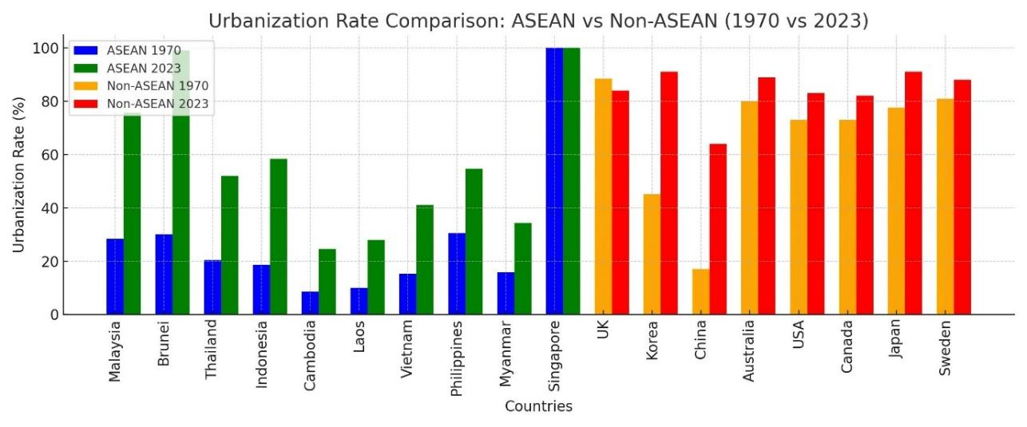
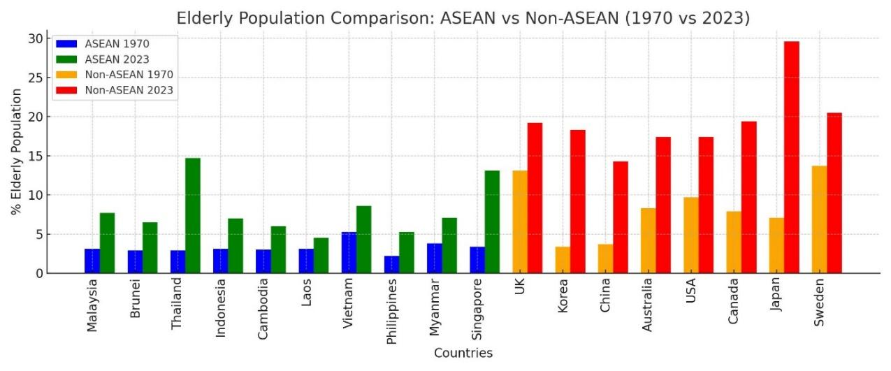

Figure 3. Compare the changes in urbanization rates and elderly population percentages between ASEAN and selected non-ASEAN countries (1970 and 2023)

Figure 3 shows a side-by-side bar chart comparing changes in urbanization rates and the percentage of the elderly population between ASEAN and selected non-ASEAN countries from 1970 to 2023. The chart shows marked urbanization growth in ASEAN countries like Brunei and Malaysia, alongside established high urbanization rates in non-ASEAN countries such as the United Kingdom and Japan. The elderly population comparison highlights notable increases, particularly in Japan and Sweden, with ASEAN countries like Thailand and Singapore also showing significant aging demographic trends. This visualization clearly illustrates regional differences and temporal changes, providing an easy-to-understand comparison of urbanization and aging progression across these regions.

Discussion

Interpretation of results

The study's findings confirm the strong link between urbanization and an aging population across ASEAN and several other countries. Regression analysis showed that urbanization, life expectancy, and fertility rate were significant predictors of the percentage of the elderly population. In particular, the rate of urbanization is positively correlated with an aging population, as urban areas provide better health care, access to services and living conditions that contribute to longer life expectancy, as outlined in a theoretical framework based on socio-spatial theory. This finding is consistent with the initial hypothesis that higher rates of urbanization are associated with better health outcomes for the elderly.
The strong positive coefficient for urbanization (β = 0.15, p < 0.001) indicates that countries with higher urbanization rates have a larger elderly population. This relationship was anticipated, based on the socio-spatial theory, which highlights the influence of urban infrastructure and social spaces on elderly well-being. Our research reinforces the idea that urbanization facilitates access to healthcare and social services, enhancing life expectancy and contributing to the demographic shift toward older populations.
Life expectancy, both for males (β = 0.20, p < 0.001) and females (β = 0.18, p < 0.001), emerged as critical predictors of aging populations. This underscores how improved healthcare systems in urban areas have extended lifespans, particularly in highly urbanized countries like Singapore and Japan. Fertility rates, on the other hand, showed a negative association with the percentage of elderly populations (β = -1.10, p < 0.001), confirming that countries with declining birth rates tend to have a higher proportion of elderly people. This aligns with demographic transition theory, where urbanization and modernization often lead to lower fertility rates and an aging population.
Statistically significant results highlight the robustness of the regression model. The R-squared value of 0.84 indicates that 84% of the variance in the percentage of the elderly population is explained by the independent variables (urbanization rate, life expectancy, fertility rate and population growth). The importance of urbanization and high life expectancy suggests that as urban areas grow, they will continue to foster environments that support an aging population. However, while the statistical significance is strong, practical applications require nuanced considerations, especially in policy formulation and urban planning.
By relating the findings back to the research question and theoretical framework, this study confirms the importance of urban planning in an aging society, particularly in rapidly urbanizing areas such as ASEAN. Countries such as Thailand and Singapore, which have experienced significant urban transformation, face new challenges related to aging demographics. In contrast, less urbanized ASEAN countries such as Cambodia and Laos may not experience the same rate of demographic aging, but slower rates of urbanization may still strain healthcare and infrastructure resources as their populations increase.

Comparative insights

Variations in the relationship between urbanization, life expectancy, fertility rates and aging populations across ASEAN and other selected countries can be attributed to several factors, including cultural, economic, and policy differences. These variations provide a clear understanding of how different contexts affect aging demographics.
Cultural attitudes toward aging and family care significantly influence how societies adapt to an aging population. In many ASEAN countries, such as Indonesia and the Philippines, strong family ties mean that elderly care is often managed within the family. These cultural norms may slow demand for public aged care services compared to Western countries such as Sweden and the United States, where individualism is more pronounced, and institutional care is more common (United Nations, 2015). These cultural differences impact the policies and services needed to support aging populations in different urban environments. Economic development plays an important role in how urbanization affects aging. Developed countries such as Japan and Sweden have long-established urban centers with advanced health care systems, which contribute to higher life expectancy and larger elderly populations. These countries also have the economic capacity to invest in public health and pension systems that support an aging demographic (World Bank, 2020). In contrast, emerging economies in ASEAN, such as Vietnam and Cambodia, face challenges in matching these investments due to limited resources and newer urban infrastructure, which may affect the rate and quality of aging-related services.
Furthermore, government policies on urban planning, health care, pensions, and care for the elderly significantly affect aging outcomes. Countries such as Singapore and Japan have proactive policies that focus on creating age-friendly urban environments, including easily accessible public transport, healthcare facilities, and social programs for the elderly (WHO, 2022). These policies are directly linked to higher rates of urbanization and life expectancy, facilitating better outcomes for the elderly population. Conversely, countries with less developed policies may not yet see the full benefits of urbanization on aging. For example, Laos and Myanmar are still developing their policies and infrastructure to effectively support their aging populations. The availability and quality of health care services, which are often concentrated in urban areas, are critical in determining the life expectancy and health of an aging population. Countries with universal health care systems, such as Canada and Australia, provide extensive services that can better manage the health challenges associated with aging. This comprehensive access helps explain the strong positive correlation between urbanization and the percentage of the elderly population in these countries, as urban residents benefit from better healthcare services (OECD, 2019).
Socioeconomic stability also affects how urbanization affects aging. In a stable economy, urbanization tends to result in better living standards and health care, which contributes to an aging population living healthier and longer lives. However, in less stable areas, the benefits of urbanization can be offset by economic disparities and inadequate public services, which may not adequately support the health and well-being of older people (United Nations, 2015).
The findings largely support the existing body of research on urbanization and aging populations, particularly in the context of ASEAN and other selected countries. The positive correlation between urbanization and an aging population is in line with the studies reviewed, as done by Yaakub et al. (2022) and Masron et al. (2012), who emphasized how rapid urbanization in ASEAN has reshaped demographic trends and increased the elderly population. This study suggests that urban environments, with better access to health care and economic opportunities, facilitate longer lifespans and accelerate the aging process. Our results confirm these observations, especially in countries like Singapore, where rapid urban development and an effective health care system have contributed to a high percentage of elderly individuals.
In addition, the relationship between the decline in fertility rates and the increase in the elderly population is also in line with the findings of the United Nations (2019) and the World Bank (2020), which observe similar demographic shifts around the world. Countries such as Thailand and Vietnam, which have experienced significant declines in fertility, are now experiencing aging populations. This is in line with the predictions of Wahl, Iwarsson, & Oswald (2012), who identified fertility decline as a key driver of demographic aging, especially in rapidly urbanizing areas.
However, this study also identified some discrepancies. For example, while studies such as Buffel, Handler, & Phillipson (2018) emphasize the potential of urbanization to improve the well-being of the elderly through age-friendly city initiatives, our findings suggest that in some ASEAN countries, urbanization has led to challenges such as social. segregation and unequal access to services. In countries such as Indonesia and the Philippines, the benefits of urbanization for the elderly are uneven, with many urban areas struggling to keep up with infrastructure development and social service needs, a finding that contrasts with the more optimistic view in the literature.
This study contributes some new insights to existing theoretical frameworks on urbanization and demographic aging. Socio-spatial theory, which is used to understand how urban space affects the elderly population, is largely confirmed in this study (Buffel, Handler, & Phillipson, 2018). Urban environments in ASEAN countries such as Singapore and Malaysia have indeed fostered better healthcare access and longer life expectancy for the elderly, as the theory predicts. However, the study also extends this framework by showing that rapid urbanization can exacerbate disparities in service delivery and social support, particularly in countries where urban planning has not kept pace with demographic shifts. These findings add a new layer of complexity to socio-spatial theory by emphasizing the uneven distribution of urban benefits across different regions.
In addition, research findings regarding the social and emotional well-being of the elderly in urban environments are based on isolation theory and activity theory from gerontology (Wahl, Iwarsson, & Oswald, 2012). Although urban environments tend to offer better physical infrastructure, they often fail to provide the social cohesion necessary to maintain the emotional well-being of the elderly, especially in highly dense cities where community ties are weakened, as supported by Van Hoof et al. (2018). This calls for a broader application of activity theory in urban planning, highlighting the need for urban environments that not only provide healthcare access but also foster social engagement and reduce isolation among the elderly.

Implications of the study

This research has critical implications for policymakers, society, and the academic community within the rapidly urbanizing ASEAN context. For policymakers, the findings underscore the need to revise urban planning strategies to better cater to an aging population. This involves enhancing healthcare systems, strengthening social security frameworks, and ensuring housing is accessible and accommodates the needs of the elderly. This requires not only improving physical infrastructure but also fostering services that enhance elderly independence and social interaction. For the community, the study stresses the importance of building community-based support systems that complement formal services and address the social and emotional needs of urban elderly, thereby enhancing their quality of life and community integration. Academically, the findings highlight the need for more research into how urbanization impacts elderly well-being across different ASEAN countries. Future research should utilize longitudinal data to examine changes over time and explore additional variables like technology adaptation among the elderly and the role of non-governmental organizations in elderly care. These studies will enrich our understanding of the urbanization-aging nexus and help shape more effective policies and programs.

Limitations and future research

Despite providing valuable insights, this study has several limitations that should be acknowledged. Data limitations arise from the variability in the availability, quality, and consistency of demographic data across ASEAN countries. Differences in national statistical standards may affect the precision of cross-country comparisons, potentially introducing minor biases in trend interpretation. For example, underreporting in early demographic surveys could underestimate urbanization rates in countries like Cambodia or Laos.
Methodological limitations include the reliance on cross-sectional data at two time points, which restricts the ability to establish causal relationships between urbanization and aging. Although multiple regression analysis controls for key demographic variables, unobserved factors such as healthcare quality variations or cultural aging norms could also influence the results.
Generalizability is constrained by the heterogeneity of the countries studied. While ASEAN and selected developed countries offer diverse cases, the findings may not be fully applicable to regions with different socio-economic contexts or stages of urbanization.
To overcome these limitations, future research should utilize longitudinal datasets capturing annual changes to better model causality and temporal effects. Expanding the sample to include more ASEAN countries with complete datasets and incorporating qualitative factors such as healthcare policy effectiveness or elderly social support structures would further strengthen the analysis. Additionally, detailed country case studies examining urbanization models that successfully integrate aging policies, such as Singapore’s age-friendly urban initiatives, could provide richer insights into best practices for managing demographic transitions.

Conclusion

This study highlights the significant influence of urbanization on aging demographics across ASEAN and selected countries from 1970 to 2023. The findings demonstrate a strong positive relationship between urbanization rates and the proportion of elderly populations, alongside the important roles of declining fertility and rising life expectancy. ASEAN countries, although historically less urbanized, are rapidly converging with developed nations in demographic aging trends, particularly in Singapore and Thailand.
These results emphasize that urbanization not only accelerates economic growth but also reshapes population structures, creating urgent needs for adaptive urban planning, healthcare systems, and social support frameworks tailored to aging societies. Policymakers must recognize that successful urbanization requires inclusive strategies that anticipate demographic shifts to sustain urban livability and social cohesion.
The study fills a critical knowledge gap in the ASEAN context and contributes to the broader understanding of how urban processes influence aging patterns globally. Future research should focus on longitudinal analyses and country-specific case studies to better capture the evolving urban-aging dynamic and to design more targeted, culturally sensitive policy interventions.

References

AARP. (2021). The aging readiness and competitiveness report. https://www.aarpinternational.org/file%20library/arc/aging-readiness-competitiveness- report.doi.10.26419-2fint.00049.001.pdf
Ahmad, A., Masron, T., Mohd Ali, A. S., Kimura, Y., & Junaini, S. N. (2024). Demographic dynamics and urban property crime: A linear regression analysis in Kuala Lumpur and Putrajaya (2015-2020). Planning Malaysia, 22(33).
ASEAN. (2018). ASEAN Sustainable Urbanisation Strategy (ASUS). https://connectivity.asean.org/wp-content/uploads/2018/11/ASEAN-Sustainable- Urbanisation-Strategy-ASUS-1.pdf‌
Buffel, T., Handler, S., & Phillipson, C. (2018). Age-Friendly Cities and Communities: A Global Perspective. Policy Press.
Cervero, R. (2023). Transit Oriented Development in Disruptive Times. The International Conference on Civil Infrastructure and Construction.
Cohen, J., Cohen, P., West, S. G., & Aiken, L. S. (2013). Applied multiple regression/correlation analysis for the behavioral sciences. Routledge.
Cook, L. J., & Titterton, M. (2023). Mapping shifts in Russian and European Welfare polities: Explaining policy responses to shared new social risks. Social Policy and Society, 22, 321 - 337.
Ervik, R. (2019). Policy responses to aging: Care services for the elderly in Norway. In. Jing, Tk., Kuhnle, S., Pan, Y., & Chen, S. (eds.). Aging Welfare and Social Policy. International Perspectives on Aging. Springer.
Greenberg, A. J., Haney, D., Blake, K. D., Moser, R. P., & Hesse, B. W. (2017). Differences in access to and use of electronic personal health information between rural and urban residents in the United States. The Journal of Rural Health, 34(S1), S20-S38.
Masron, T., Yaakob, U., Norizawati, M. A., & Aimi, S. M. (2012). Population and spatial distribution of urbanisation in Peninsular Malaysia 1957-2000. Geografia-Malaysian Journal of Society and Space, 8(2), 20-29.
Michel, J. P. (2020). Urbanization and ageing health outcomes. The Journal of Nutrition, Health and Aging, 24, 463–465.
Mohd Rosnu, N. S., Singh, D. K. A., Mat Ludin, A. F., Ishak, W. S., Abd Rahman, M. H., & Shahar, S. (2022). Enablers and barriers of accessing health care services among older adults in South-East Asia: A scoping review. International journal of environmental research and public health, 19(12), 7351.
Mots’oene, K. A. (2014). Urbanization and aging: The survival of the aged in an urbanizing City, Maseru, Lesotho. Journal of Emerging Trends in Economics and Management Sciences, 5, 316-322.
Nelles, J., Tuckerman, L., Purna, N., Phillips, J., & Vorley, T. (2024). Policy responses to the healthy aging challenge: Confronting hybridity with social innovation. Journal of aging & social policy, 37(2), 1–16.
Organisation for Economic Co-operation and Development (OECD). (2019). Health at a Glance 2019: OECD Indicators. OECD Publishing.
Rey-Beiro, S., & Martínez-Roget, F. (2024). Rural-urban differences in older adults' life satisfaction and its determining factors. Heliyon, 10(9), e30842.
Tiraphat, S., Kasemsup, V., Buntup, D., Munisamy, M., Nguyen, T. H., & Hpone Myint, A. (2021). Active aging in ASEAN countries: Influences from age-friendly environments, lifestyles, and socio-demographic factors. International journal of environmental research and public health, 18(16), 8290.
Trochim, W. (2020). The Research Methods Knowledge Base. Cengage Learning.
United Nations, Department of Economic and Social Affairs, Population Division (2015). World Population Ageing 2015. https://www.un.org/en/development/desa/population/publications/pdf/ageing/WPA2015_ Report.pdf
‌United Nations. (2019). World Population Ageing 2019. https://www.un.org/en/development/desa/population/publications/pdf/ageing/WorldPopul ationAgeing2019-Report.pdf
United Nations. (2019). World Population Prospects 2019: Highlights. https://population.un.org/wpp/Publications/Files/WPP2019_Highlights.pdf
United Nations. (2019). World Urbanization Prospects: The 2018 Revision. https://population.un.org/wpp/Publications/Files/WPP2019_Highlights.pdf
Van Hoof, J., Kazak, J. K., Perek-Białas, J. M., & Peek, S. T. M. (2018). The challenges of urban ageing: Making cities age-friendly in Europe. International journal of environmental research and public health, 15(11), 2473.
Wahl, H. W., Iwarsson, S., & Oswald, F. (2012). Aging well and the environment: toward an integrative model and research agenda for the future. The Gerontologist, 52(3), 306–316.
World Bank. (2020). East Asia and Pacific Cities: Expanding Opportunities for the Urban Poor. https://www.worldbank.org/en/region/eap/publication/east-asia-and-pacific-cities- expanding-opportunities-for-the-urban-poor
World Bank. (2020). The World Bank in East Asia and the Pacific. https://www.worldbank.org/en/region/eap/overview
World Health Organization (WHO). (2022). Ageing and health. Who.int; World Health Organization: WHO. https://www.who.int/news-room/fact-sheets/detail/ageing-and- health
Yaakob, U. H., & Masron, T. (2010). Isu-isu kependudukan dan migrasi di Malaysia. Penerbit Universiti Sains Malaysia.
Yaakub, N. F., Masron, T., Marzuki, A., & Soda, R. (2022). GIS-based spatial correlation analysis: Sustainable development and two generations of demographic changes. Sustainability, 14(3), 1490.
Ying, M., Wang, S., Bai, C., & Li, Y. (2020). Rural-urban differences in health outcomes, healthcare use, and expenditures among older adults under universal health insurance in China. PloS one, 15(10), e0240194.

