Rational choices of communities in purchasing housing on the urban fringe of Yogyakarta

Emilia Putri Purnama, Nanda Harda Pratama Meiji

Sociology Education, Faculty of Social Science, State University of Malang

Correspondence: Nanda Harda Pratama Meiji (email: nanda.harda.fis@um.ac.id )

Received: 17 January 2025; Accepted: 7 May 2025; Published: 27 May 2025

Abstract

Yogyakarta has experienced a notable increase in population density due to an influx of migrants from various regions. This demographic growth has led to a surge in land prices across the city. As a result, many young families who do not yet own a house have become increasingly concerned and have chosen to purchase housing on the outskirts. This study aims to examine in greater depth the rational choices made by communities when deciding to purchase housing in peripheral areasi. This research employed a qualitative research design. The subjects in this study are young families who decided to purchase housing in urban fringe areas. The findings indicate that the primary rationale behind this decision is the need to adjust their budgetary allocations, given that residential properties in the urban fringe areas are considerably more affordable than those in the city center. Additional motivations include a preference for a tranquil atmosphere in the countryside, the availability of adequate facilities (although not yet fully comprehensive), and convenient accessibility, despite the considerable distance from the city center of Yogyakarta.

Keywords: Community, housing, rational choice, urban fringe, Yogyakarta, young families

Introduction

Yogyakarta is one of Indonesia’s major tourist destinations and holds the status of a special region under Law Number 13/2012 concerning DIY Privileges, which was passed on August 31, 2012 (Munier, 2016). It attracts both domestic and international tourists with its rich cultural heritage sites, such as sekaten, the Ramayana ballet, Labuhan rituals, and shadow puppets, as well as popular shopping centers such as Malioboro, Beringharjo Market, Bakpia Pathok 25, among others (Kusuma et al., 2020). In addition, Yogyakarta is also known as the City of Students ydue to its numerous higher education institutions that students from all over Indonesia (Yu & Setiyaningrum, 2019). This has increased population density in Yogyakarta City, resulting in increasingly limited vacant land in the city center. Consequently, land prices in the city center of Yogyakarta have increased significantly (Nurwanto, 2023). According to (Prime360, 2023), the land prices in the city center of Yogyakarta have reached IDR 10.000.000/m², while in the suburbs, prices range from 2.200.000 to 3.000.000/m².
The high price of land in urban areas causes anxiety among people who do not own a house, as it relates to the socio-cultural characteristics of Indonesians, who still firmly hold the value of homeownership and land possession (Amrozi et al., 2022). For Indonesians, a house is not only regarded as a place to live, but also as a symbol of social status, future security, and family legacy (Nugroho et al., 2022). This contrasts with patterns in several other countries, where many people choose to live in apartments or flats. In other developing countries such as Brazil, China, India, and Vietnam, living in apartments or flats is increasingly common, especially in big cities facing high population growth and urbanization pressures (Sarkar & Jana, 2023; Al Hibbi et al., 2023).
Therefore, the culture of owning a landed house in Indonesia has led developers to aggressively carry out development in urban fringe areas to reduce production costs and meet the community’s needs for affordable housing (Harniyati, 2021). The urban fringe refers to areas located on the outskirts of the city, marking the boundary between dense urban zones and remote rural regions (Widianto & Keban, 2020). These areas are typically characterized by changes in land use, where agricultural or plantation land is transformed into commercial zones due to increasing urban density (Wayan Candrapraleka Putra et al., 2022). In the Special Region of Yogyakarta, significant development has occurred in the urban fringe areas, as in the map below (Hutapea, 2022).

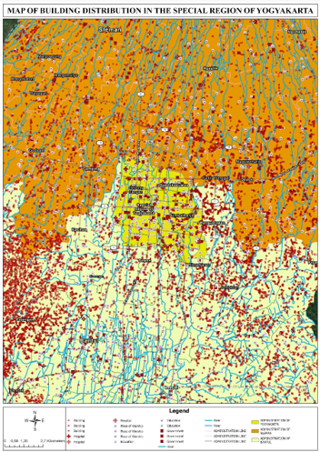
Source: Processed researcher data, 2024

Figure 1. Map of building distribution in the special region of Yogyakarta

The map above illustrates that development in the Special Region of Yogyakarta has extended to urban fringe areas such as Banguntapan, Kasihan, Godean, Sewon, Bangunjiwo, and others. The urgency of development in these areas is getting higher, not only as a solution to limited space in the city center but also as a strategy for more equitable regional development (Rustiadi, 2018). Therefore, understanding the rational choices people make when purchasing housing in the urban fringe areas of Yogyakarta is very important. This understanding can serve as the basis for formulating spatial planning and housing development policies that are adapted to market needs, sustainable, and beneficial to the wider community.

Literature review

Previous studies on developments in urban fringe areas have primarily focused on the impacts resulting from such development. For instance, Hayati (2022) examined the socio-economic impacts of housing development in rural areas of Gresik. (Wira, 2021) explored how residents respond to housing development in rural areas. Meanwhile, Wibisono and Yeni Widowaty (2023) highlighted the legal aspects of food agricultural land protection against land conversion in the Special Region of Yogyakarta. In contrast to these studies. The present research emphasizes how housing development in the urban fringe areas of Yogyakarta can attract people. Specifically, this research focuses on the rational choices made by communities, particularly young families, when deciding to purchase housing in the urban fringe areas of Yogyakarta.
According to the Indonesian Language Dictionary, the word “rational” comes from the word "rasio," which means logical thinking or reasoning that aligns with general human understanding. It can also be interpreted as thinking that is guided by logic and reasonable considerations, consistent with a sound mind and rationality. Thus, “rational” can be defined as an individual's thinking that is based on logical and reasonable considerations. Meanwhile, rational choice refers to a decision based on certain considerations that align with an individual’s logic as a decision maker (Marsh et al., 2021). Rationality emerges when a person is faced with multiple choices and must select the one that is considered most logical. A choice is said to be rational if it is made with a specific goal in mind and produces a certain consequence (Coleman, 1986).
The decision of young families to purchase housing in urban fringe areas involves careful considerations and a range of residential model choices, which can be analyzed through the lens of rational choice theory. Rational choice theory, introduced by James Coleman, seeks to explain macro-level phenomena through micro-level analysis, specifically how the system shapes the orientation of individual actors. Coleman also argues that the reality of the system as a macro phenomenon must be understood through the internal motivations of a prototypical individual. He focuses more attention on individuals because they are key agents of social change. According to Coleman, the substance of social theory should not merely be an academic exercise but must also be able to influence the world or social life through interventions. These interventions are acts of interference carried out by individuals, groups, or even by the state.
Within this framework, individuals play a very important role in the functioning of social systems because their decisions ultimately determine whether a system will run or not. Coleman's rational choice theory is grounded in the idea that every individual acts with a goal in mind. Thus, rational choice theory serves as a tool for thinking logically and rationally when making a decision (Coleman, 1986). In explaining this concept, Coleman draws on economic logic. Suggesting that individuals act in ways that maximize their wants and needs. This happens because individuals are more self-interested in achieving the ultimate goal of the decisions they make. The final decision, then, is aimed at maximizing utility, the outcome that makes them feel happier, better, or more satisfied.
James Coleman also emphasizes that two important factors are essential in making rational choices: Actors and resources. Actors in this context refer to individuals who take action. These actors can organize themselves because they understand what they want and what to do, and are assumed to act in ways that will produce outcomes aligned with their interests. For example, if a person is faced with three choices, let’s say Choice A, Choice B and Choice C, and determines that Choice B is more meaningful or beneficial than the other two, then the actor will choose Choice B. In this way, when actors make decisions, they evaluate multiple choices and select the one considered the most rational (Coleman, 1986).
Every individual is essentially faced with many choices involving a variety of different objects. The same applies when people purchase housing; they are presented with various types of houses, each with its advantages. Although they will ultimately choose only one, that choice is considered rational from their perspective. However, a decision considered rational by one person may not necessarily be considered rational by others. This is because rational choices are subjective and cannot be measured solely from an external point of view. Thus, rational choice can only be measured based on the point of view of the person acting.

Methodology and study area

The location selected for data collection is on the outskirts of the Special Region of Yogyakarta, specifically in Godean. This area was chosen because it is one of the targets of capital investors seeking to develop their property businesses, particularly residential development as land prices are more affordable than in the city center, driven by increasingly dense population growth. The map below shows the research location within one of the housing clusters in Godean District. As shown, housing development has taken place in the urban fringe areas, where the surrounding environment still looks green. Before this development, the area was a hill where the local community extracted clay for brickmaking.

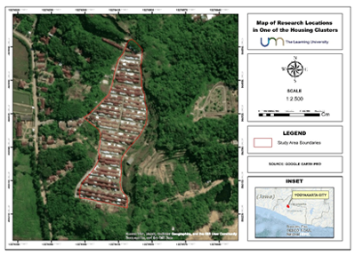
Source: Processed researcher data, 2024

Figure 2. Research location

The research process began with determining the research topic, focusing on the rise of residential purchases in urban fringe areas by young families. The initial step involved reviewing previous studies to identify the novelty of the current research. Following this, the research problems were formulated, centering on the rational choices made by young families when deciding to purchase housing in urban fringe areas. In this research, the researchers employed a qualitative research design. The purpose of using a qualitative design is to gain a deeper understanding of the rational reasons that influence these decisions.
The subjects of this research were young families who had chosen to purchase housing in urban fringe areas. As they dominate the occupation of new housing in these areas. Purposive sampling was used to select informants based on specific criteria by the research topic. The criteria established by the researchers include young families with a marriage duration between 1 and 10 years, young families with an age range of 30-35 years, and permanent residents of urban fringe areas. A total of 7 informants from young families who live in the urban fringe areas of Yogyakarta participated in this study.
After determining the research subjects, the researchers carried out data collection activities. First, an observation was carried out to understand the actual conditions in the field, including both the research location and the characteristics of the informants. Second, unstructured in-depth interviews were conducted to obtain detailed information from informants regarding their perspectives on the rational reasons for choosing to purchase housing in urban fringe areas rather than in urban areas. Third, documentation was conducted by collecting data through photographs, videos, and transcripts of interviews.
The next step taken by the researchers was to analyze the data that had been obtained. The data analysis used in this research followed the framework proposed by Miles and Huberman. According to this framework, there are three stages of data analysis: data condensation, data presentation, and conclusion drawing (Sugiyono, 2020). In this research, data condensation involved simplifying the data obtained and aligning it with the research topic. Furthermore, data presentation was conducted by compiling data that had been simplified previously into a brief description, making it easier to interpret and draw conclusions. The final stage was conclusion drawing, where the researchers verified all the compiled data and formulated the conclusions based on the results, by the research objectives. After analyzing the data, data validation was carried out using source triangulation to ensure the credibility of the findings. Finally, the researchers drafted articles based on data that had been validated.

Results and discussion

Drivers influencing young families in purchasing housing in urban fringe areas

One of the urban fringe areas of Yogyakarta experiencing intensive housing development is the Godean District in Sleman Regency. Over the past 15 years, the Godean Subdistrict has undergone a significant transformation in land use, marked by a sharp increase in residential development. This trend is driven by the growing population density in the Special Region of Yogyakarta, which has created a greater demand for housing opportunities. As a result, residential areas have expanded into the outskirts of the region. As illustrated in the map below, the amount of built-up land in the Godean Subdistrict was minimal in 2004. However, by 2009, there was a notable increase in built-up land. In the subsequent years, culminating in 2023, the green area in the Godean Subdistrict has significantly declined due to extensive housing development.
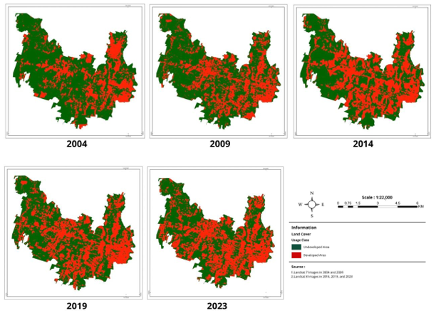
Source: Processed researcher data, 2024

Figure 3. Land use map of Godean Subdistrict

The emergence of capital owners developing housing in urban fringe areas does not necessarily make it easier for people to fulfill their needs for housing. On the contrary, it often creates new problems because the fulfillment of housing needs still requires a relatively large amount of money, even in urban fringe areas. For those who are economically well off, buying a house may not take long. However, for those who are economically disadvantaged, the ability to purchase a house varies significantly, and it can take years for them to fulfill their housing needs (Sugianto, 2020). Therefore, to fulfill the need for housing, people, both in urban areas and in urban fringe areas, make various considerations, which can be seen as rational choices.

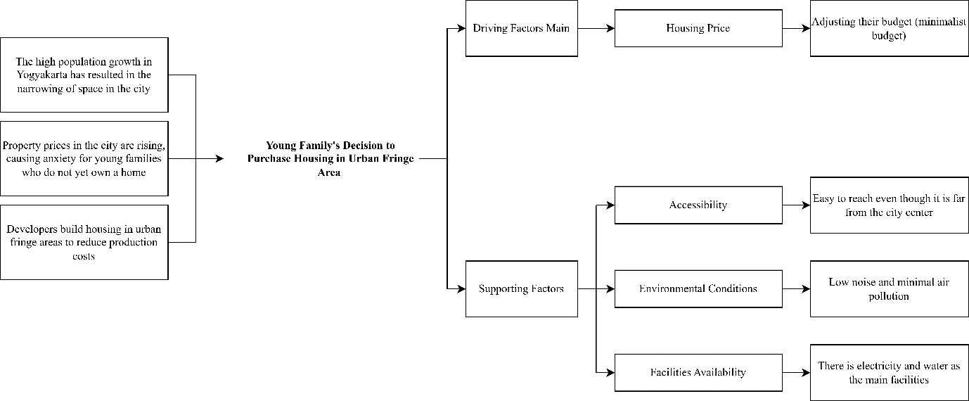
Source: Processed researcher data, 2024

Figure 4. Factors driving young families to purchase housing in urban fringe areas

People make rational choices in response to an event or circumstance that requires them to take appropriate action based on their decisions (Coleman, 1986). Based on the field study, young families tend to purchase housing in urban fringe areas due to anxiety over soaring property prices in the city center of Yogyakarta. This price surge is driven by the limited availability of urban space resulting from high population density. Faced with these conditions, young families decided to purchase housing in the urban fringe areas. However, before making such a decision, they must consider various factors, particularly their available resources. These considerations include the budget they have, the housing environment, the distance between home and work, the availability of facilities, the legal status of the property, and other relevant aspects. The following section outlines the key factors that influence young families to purchase a house in the urban fringe areas of Yogyakarta.

- Housing price

The primary factor influencing the decision of young families to purchase housing in urban fringe areas is the price. They aim to obtain housing that is commensurate with their financial resources. The majority of young families who choose urban fringe areas as a location for purchasing housing have limited financial resources. Thus, the availability of subsidized housing in the urban fringe areas, priced between Rp160,000,000 and Rp175,000,000, presents a significant opportunity for young families to secure a place to live, particularly given the relatively high market prices in the urban area of Yogyakarta. Houses within this price range offer a viable option for those seeking residence through the subsidized mortgage program. This is illustrated by the narrative of Mr. DW below.

" I chose to buy a house here because I didn’t own one, and I heard that the land prices in Jogja are the second highest in Indonesia, even though the minimum wage in Jogja is quite low. So, without subsidies, it would be difficult for residents to afford a house, especially because it’s hard to find jobs that offer a good pay." (Informant Mr. DW, 2023).
- Accessibility

In the context of services or facilities, accessibility refers to the ease with which individuals can access these resources in a financially viable manner. This includes physical, economic, social, and informational access. Despite the considerable distance between housing in urban fringe areas and public facilities, this does not deter prospective buyers from acquiring properties in these locations. They believe that access to the city and essential public facilities remains relatively manageable and not excessively distant, with a typical travel time of approximately 30 to 45 minutes. Consequently, they are still able to commute to the city daily despite the distance between their homes and their workplace.

"The environment here also feels safer because it is not as densely populated as in the city. So, there is less pollution." (Informant Mrs. AN, 2023)

- Housing environment

The residential environment in urban fringe areas is characterized by a notable absence of noise, air pollution, and the urban hustle and bustle that define more densely populated urban centers. This is largely because the development in urban fringe areas is not as dense as that in urban areas. This quieter environment is another factor that influences the decision of young families to purchase housing in urban fringe areas. Moreover, some respondents had previously resided in urban areas and perceived the urban fringe as a more tranquil alternative. This is illustrated by the narrative of Mrs. AN.

"The environment is also safe because it is not dense like in the city. So, there is not too much pollution." (Informant Mrs. AN, 2023)

- Availability of facilities in the residential areas

Facilities are defined as elements that provide the necessary support for the optimal functioning of human activities. It can be argued that facilities play an important role in meeting the needs and ensuring the comfort of the community. Furthermore, the presence and qualities of facilities can influence the value and attractiveness of a residential area. Field data indicates that some housing developments still lack adequate facilities, despite the provisions outlined in the initial site plan. In some cases, the facilities are incomplete, even though the construction of the units has been completed. Some housing developments lack essential facilities, such as places of worship. And in others, the access roads have not been renovated by the developer.
In addition, there was a housing complex that was still under construction, with less than 100% of its units completed. As a result, water availability for the residents was limited because the Regional Drinking Water Company (hereinafter called PDAM) had not yet installed the necessary infrastructure. According to the developer, PDAM services would be installed once the construction of the units is 100% complete. Based on the field data, the researchers often encountered inadequate water supply in housing developments, despite water being a vital necessity. Nevertheless, this issue does not discourage buyers from choosing housing in urban fringe areas because the overall availability of water and electricity is still considered adequate.

“Now, the water and electricity lines are functioning properly. However, until now prayer facility has not yet been built, and the damaged road, which is the easiest access out of the residential neighborhood, has also not been repaired. So far, there has been no response from the developer.” (Informant Mrs. LN, 2023)

Rational decision of young families to purchase housing in the urban fringe area

Based on James Coleman's rational choice theory, two important factors in rational decision-making are actors and resources. In this research, the actors are housing buyers in urban fringe areas who are motivated by the desire to own a house or a place to live. Meanwhile, resources are all the potential that exists or is owned by an individual. Resources here can be in the form of natural resources and human resources. Natural resources refer to elements that are already available in the environment or derived from nature, while human resources refer to potential within a person. In the context of this research, the primary resource in question is the money or budget available to housing buyers in the urban fringe areas. These buyers, as actors, strive to fulfill their goal of owning a place to live, even with a small budget. However, observations in the field show that the actors involved are not only housing buyers but also developers. As actors, the developers possess resources (in this case, capital) that they use to achieve their own goals. Such as acquiring land in the urban fringe areas to build housing. This allows them to reduce production costs because the land prices in central urban areas are very high. The process of buying and selling land naturally involves additional actors, namely, residents who own the land. These residents possess land as their key resource, which can be sold to developers. Their motivation for selling their land is typically financial, as they aim to use the proceeds to achieve other personal goals.
It can be observed that the resources owned by an individual can attract the interest of others who seek to obtain those resources. This occurs because an actor does not always have the resources needed to fulfill their needs. Such a situation is evident in the interaction between residents in the suburbs of Yogyakarta and property developers. Developers, who have financial resources, engage in land transactions with residents in the urban fringe areas, residents who own land, a valuable resource in this context. These transactions, carried out by the two actors, represent a realization of mutual interest, where each actor leverages the resources they possess through the process of buying and selling.
After the transaction process, the developers proceed with housing construction. The houses they build certainly have a relatively cheaper price compared to those in the urban area of Yogyakarta. This ultimately attracts another group of actors, housing buyers who are interested in purchasing housing in the urban fringe areas of Yogyakarta. These buyers typically have limited financial resources but aim to own a house that fits within their budget. Therefore, the massive development of housing at low prices is a breath of fresh air for them to be able to have a place to live. Therefore, the relatively low prices of housing offered by the developers, combined with the option to purchase through a mortgage, serve as the primary motivation behind buyers’ rational decision to purchase housing in the urban fringe areas of Yogyakarta.
This is different from people who choose to purchase housing in the urban fringe areas of Surakarta City. Based on research conducted by Anindita et al. (2021), the main reason people purchase housing in the urban fringe area of Surakarta City is the comfort of the residential environment., In contrast, the price factor does not significantly affect the selection of housing locations. From the perspective of the rational choice theory proposed by James Coleman, the decisions made by housing buyers in the urban fringe areas of Surakarta City may be considered irrational by housing buyers in the urban fringe areas of Yogyakarta, and vice versa. This is because they have contrasting reasons for deciding to purchase housing in the urban fringe areas. However, neither decision is better nor worse. A rational choice must be understood from the point of view of the actor who takes the action and the rational reasons that support their decision.
Therefore, the choices made by housing buyers in the urban fringe areas of Yogyakarta can be considered rational in the context of this study, a rational choices are defined as goal-oriented decisions made by individuals who take action. In this case, the rational choice involves how housing buyers make decisions to purchase housing in the urban fringe areas of Yogyakarta. These decisions are, of course, supported by various considerations because before making a final decision, buyers are typically faced with many housing options. Ultimately, they choose housing in the urban fringe areas of Yogyakarta primarily based on affordability, with other supporting factors such as accessibility, environmental conditions, and availability of facilities also influencing their decision.
However, every decision made by individuals carries consequences, both positive and negative. This also applies to the decision of young families to purchase housing in urban fringe areas, where the main driving factor is limited financial resources. Although it is a rational choice, this decision still carries certain risks. The following illustrates the risks associated with young families' decision to purchase housing in urban fringe areas.
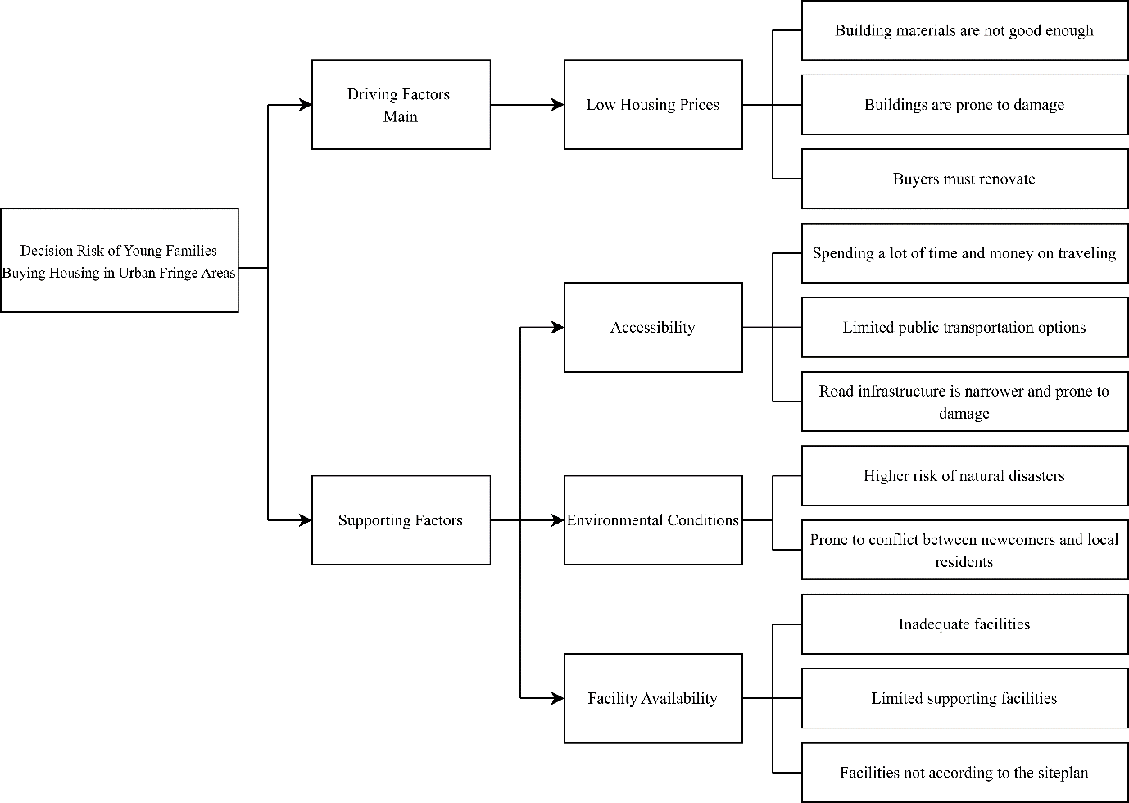
Source: Processed researcher data, 2024

Figure 5. Risks of buying housing in urban fringe areas

Based on the chart above, it can be seen that each driving factor behind the decision of young families to purchase housing in urban fringe areas carries certain risks. First, the main risk stems from the main driving factor, which is the preference for low housing prices. While affordable prices are attractive, they often come at the expense of building quality, as less sturdy structures are often the result of using substandard materials. Based on the field data, many houses have developed wall cracks even though they have only been inhabited for about 3 years, forcing homeowners to undertake renovations. Second, there are risks associated with the accessibility factor. Residents of the urban fringe may face challenges such as increased travel time and higher transportation costs to reach workplaces, schools, shopping centers, hospitals, and other essential services due to the longer distances. In addition, limited public transportation options force residents to rely on private vehicles, which, of course, require higher costs. Narrow, poorly maintained, and damage-prone road infrastructure is another common issue, adding to accessibility challenges.
Third, there are risks associated with housing environmental conditions. Housing developments in urban fringe areas face a higher risk of natural disasters because many are built in hilly regions that are prone to landslides. In addition, from a social environment perspective, there is a risk of conflict between newcomers (housing buyers) and residents due to differences in culture and habits. Fourth, risks also arise from the availability of facilities. Based on the field data, many housing estates lack adequate facilities, both within the housing area and in the surrounding environment. In several cases, the facilities provided do not match the site plan proposed by the developer. Some developments do not places of worship or access roads that remain unrepaired. In addition, there is a lack of supporting facilities around residential areas, such as supermarkets, hospitals, and public transportation.

Conclusion

The decision of the community to purchase housing in urban fringe areas, primarily motivated by the relatively affordable prices compared to houses in urban areas, can be considered a rational choice. According to James Coleman's rational choice theory, two key elements are involved: actors and resources. In this context, the term "actors" refers to those who purchase housing, while the financial resources they possess are regarded as their "resources." These actors play a pivotal role in utilizing their financial resources to achieve the goal of homeownership within a constrained budget. This allocation of resources reflects a rational, goal-oriented decision-making process. However, the acceptance of potential risks and consequences associated with this decision is also a crucial aspect. These risks include substandard construction quality, limited public transportation options, distance from essential public facilities, susceptibility to natural disasters, potential conflicts between newcomers and residents, and inadequate housing facilities. Therefore, this research is expected to serve as a reference for developers, encouraging them to prioritize material standards and building quality without compromising affordability. In addition, the researchers suggest that further research explore the impacts of housing development on local communities in rural or fringe areas.

Acknowledgements

This research was supported by the Department of Sociology, State University of Malang. It was funded by the 2023 PNBP of State University of Malang.

References

Al Hibbi, A., Harsono, D., & Lena Satlita, D. (2023). Analysis of gentrification characteristics in Solo Baru Sukoharjo area: A review of the causes and impacts of physical-space gentrification.
Amrozi, I., Sultansyah, D. R. P., Hidayat, A. M. N. A., & Savirani, A. (2022). Millennials and urban development challenges: Gentrification and commercialization of space in Kota Yogyakarta. Journal of Youth Studies, 10(2), 115.
Anindita, N., Astuti, W., & Hardiana, A. (2021). Housing site selection for the western urban fringe city Surakarta. Village-City, 3(1) 61.
Coleman, J. S. (1986). Micro foundations and macrosocial theory. Approaches To Social Theory, 345-363.
Harniyati, I. (2021). The effect of agricultural land conversion to non-agricultural on food security in Gamping, Mlati, Depok, and Berbah Districts of Sleman Regency. Stpn Repository, 1-23.
Hayati, L. N. (2022). Analysis of the impact of agricultural land conversion to housing on the economic sector in rural areas. Journal Economics and Strategy, 3(2), 79-90.
Hutapea. (2022). Growth Factors of Urban Fringe Areas (Case Study: Banguntapan District, Bantul Regency). 11(0341), 217-224.
I Wayan Candrapraleka Putra W, Ngakan Ketut Acwin Dwijendra, & I Dewa Gede Agung Diasana Putra. (2022). Spatial pattern of residential area growth in Dalung Village. Paduraksa: Civil Engineering Journal of Warmadewa University, 11(1), 15-23.
Kusuma, P., Dharsono, D., Marianto, D., & Guntur, G. (2020). Mascot of Yogyakarta City. Mudra Journal of Cultural Arts, 35(2), 250-255.
Marsh, D., Stoker, G., & Mahadi, H. (2021). Rational Choice Theory: Political Science Theory and Methods Series. Nusamedia.
Munier, S. E. (2016). Analysis of the Determination of Governor and Deputy Governor of Yogyakarta According to Law No. 13/2012 on the Special Region of Yogyakarta [Doctoral dissertation, Universitas Islam Indonesia].
Nugroho, S., Yuliani, E., & Kautsary, J. (2022). Urban Sprawl Phenomenon and Factors of Land Use Change in the Suburbs. Uniplan: Journal of Urban And Regional Planning, 3(1), 1-8.
Nurwanto, I. (2023). Land Prices Are Expensive, Regency Government Has Difficulty Adding Rth. Https://Radarjogja.Jawapos.Com/Sleman/652958131/Harga-Tan-Tan-Mahal-Pemkab-Sulitulit-Ta mbah-Rth
Prime360. (2023). Latest Land Price Update per Meter in Jogja in 2023. https://www.prime360.id/berita-terbaru/update-harga-tanah-per-meter-di-jogja-tahun-2023-terbaru
Rustiadi, E. (2018). Regional Planning and Development. Crestpent Press and Yayasan Pustaka Obor Indonesia, Member of Ikapi Dki Jakarta, 500.
Sarkar, A., & Jana, A. (2023). Interpreting the energy choices and environmental satisfaction determinants in low-income housing typologies: Cases from slums and slum rehabilitation housing of Mumbai, India. Cities, 143, 104576.
Sugianto, R., & Ginting, S. O. (2020). Analysis of the effect of price, product quality, location, facilities and promotion on house purchase decisions at Medan Resort City housing. Jurnal Wira Ekonomi Mikroskil: JWEM, 10(01).
Sugiyono. (2020). Quantitative, Qualitative, and R&D Research Methods. Alfabeta.
Wibisono, G., & Yeni Widowaty. (2023). The Urgency of Food Agricultural Land Protection Against Land Conversion in the Special Region of Yogyakarta. Krtha Bhayangkara, 17(1), 93-106.
Widianto, H. W., & Keban, Y. T. (2020). Gentrification: The Socio-economic impact of hotel development in Malioboro areas, Yogyakarta City, Indonesia. Pks Journal, 19(2), 107-123.
Wira, P. S. (2021). Community Views on the Impact of Subsidized Housing Development Griya Bhina Karya Mojosongo. Journal of Sustainable Development, 4(2), 31-34.
Yu, S., & Setiyaningrum, A. (2019). A study on city branding of Yogyakarta City as a student city in Indonesia. Matrik: Journal of Management, Business Strategy and Entrepreneurship, 13(1), 31-46.

