Integrating Coastal Vulnerability Index (CVI), remote sensing and GIS for tsunami vulnerability assessment in rural Malaysian communities

Nik Ahmad Faris Nik Effendi ¹, Mohd Faisal Abdul Khanan ^{1*}, Suzanna Noor Azmy ²

¹ Geospatial Imaging and Information Research Group, Universiti Teknologi Malaysia
² Geoscience and Digital Earth Centre (INSTEG), Universiti Teknologi Malaysia

Correspondence: Mohd Faisal Abdul Khanan (email: mdfaisal@utm.my)

Received: 25 February 2025; Accepted: 18 May 2025; Published: 20 August 2025

Abstract

The unexpected occurrence of tsunamis in various countries has highlighted their devastating impact on coastal communities. However, detailed assessments of physical vulnerability at the village level, particularly in developing countries, are still lacking. This research aimed to evaluate the level of physical vulnerability to tsunamis by combining the Coastal Vulnerability Index (CVI) with remote sensing and Geographic Information System (GIS) approaches in 12 coastal villages in Kuala Muda, Kedah, based on damage history and individual building characteristics. The results revealed that Kampung Kuala Muda experienced the highest historical damage, with a total of 381 buildings evaluated. About 97 buildings were classified as high vulnerability, 156 as moderate vulnerability and only 44 were in the very low vulnerability category. Overall, villages with a history of moderate to very high damage, such as Kampung Paya and Kampung Masjid, predominantly had moderately vulnerable buildings. This underscores the significance of geographical factors like elevation, proximity and slope in determining vulnerability levels. Furthermore, statistical analysis using multinomial logistic regression on five physical indicators such as elevation, inundation, land use, slope and proximity. The result indicated that slope was the most reliable factor influencing vulnerability. Inundation and elevation followed as significant contributors for high vulnerability, with a p-value of less than 0.05. Additionally, the distance factor demonstrated a significant negative effect, suggesting that locations farther away from major geographic features were at a lower risk. The findings of this research emphasize the need for mitigation strategies tailored to the vulnerability profile of each village, including strengthening building structures.

Keywords: Coastal Vulnerability Index, GIS, Malaysia, MCDM, remote sensing, Tsunami

Introduction

Tsunamis are catastrophic natural events that severely impact coastal communities, infrastructure and the environment (Frankenberg et al., 2020; Jihad et al., 2020; Krichen et al., 2024; Cisternas et al., 2024). These events cause widespread destruction to build environments, such as housing, roads and public facilities, highlighting the importance of assessing physical vulnerability for effective disaster risk management. Physical vulnerability, which refers to the vulnerability of physical structures to tsunami impacts, is essential for understanding potential risks and informing mitigation strategies (Jelínek & Krausmann, 2008; Sumaryono, 2010; Williams et al., 2024). Therefore, Geographic Information Systems (GIS) and remote sensing have emerged as crucial tools in spatially mapping and assessing physical vulnerability with precision, enabling more effective disaster risk reduction strategies ( Ismail et al., 2012; Najihah et al., 2014; Deepak et al., 2020; Skoufias et al., 2020; Sauti et al., 2021; Jundullah & Wijayanto, 2022; Syafiq & Azri, 2023; Kundan et al., 2024).
Kota Kuala Muda, located in Kedah, Malaysia, was heavily impacted by the 2004 Indian Ocean tsunami, resulting in significant loss of life and extensive damage to infrastructure (Asmawi & Ibrahim, 2014; Mustakim et al., 2020; Moon et al., 2022). This area, characterized by low elevation and flat terrain, remains highly vulnerable to future tsunami events (Sauti et al., 2021; Benazir et al., 2023; Xhafaj et al., 2024). While numerous global studies have successfully applied GIS and remote sensing in tsunami vulnerability assessments, micro-scale studies that focus on household-level physical vulnerability in Malaysia remain scarce.
Tsunami disaster research in Malaysia generally addresses disaster management at a broader scale, without incorporating detailed physical indicators that are essential for evaluating tsunami vulnerability (Chong & Kamarudin, 2018; Rosmadi et al., 2023). While tsunamis are rare in Malaysia, their potential impact can be significant if they occur unexpectedly (Ahmadun et al., 2020a; Moon et al., 2022). Critical parameters such as slope, elevation, land use, inundation levels, and proximity to coastlines are often analyzed in isolation, leading to fragmented and incomplete risk assessments (Koroglu et al., 2019). This lack of integration results in insufficient evidence to develop effective, localized risk reduction strategies, particularly for the most vulnerable communities (Schmidt, 2023).
Vulnerability is commonly understood as the interaction between exposure, sensitivity and adaptive capacity. Therefore, the aim of this research is to develop a comprehensive physical vulnerability map for tsunami vulnerabilities in Kota Kuala Muda, Malaysia, by integrating remote sensing data and GIS-based spatial analysis within a CVI framework. In the context of tsunami vulnerability such as exposure and sensitivity, this research identifies and spatially map key physical vulnerability indicators such as elevation, slope, land use, inundation levels and proximity to coastlines using advanced remote sensing and GIS techniques. A Coastal Vulnerability Index (CVI) was constructed through a weighted multi-criteria analysis and the physical vulnerability levels of different areas within Kota Kuala Muda was assessed, with a particular focus on household-scale vulnerability. The results were validated through comparison with historical damage data from the 2004 tsunami event.

Material and methods

Research area

The research area is located in the Kuala Muda district of Kedah, with coordinates at Latitude 5.5360° N and Longitude 100.4490° E. This region consists of 12 villages along the northwest coast of Peninsular Malaysia as shown in Figure 1. These coastal villages exhibit varied population densities and economic activities that rely heavily on natural resources such as fishing, agriculture, and tourism (Asmawi & Ibrahim, 2014; Cha et al., 2017; Ahmadun et al., 2020; Mukaramah Harun et al., 2023). This area is identified as being vulnerable to the threat of tsunamis, largely due to its low geographic profile and the high risk of damage from rising sea levels (Al-Qadami et al., 2024). Kampung Pulai Sayak and Kampung Sungai Meriam are situated close to the coast and engage primarily in fishing activities.

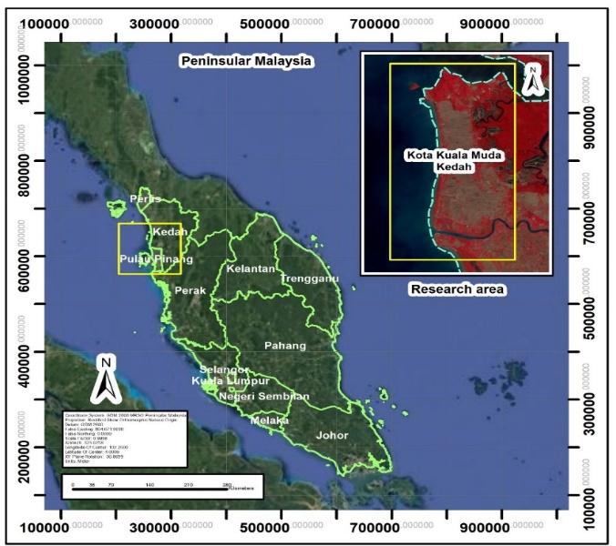

Figure 1. Research area

Kampung Paya, Kampung Masjid and Kampung Kepala Jalan are located slightly inland but remain at risk of flooding due to rising sea levels. Kampung Kuala Muda serves as the center for the main fishing activities in the region. Kampung Tepi Sungai and Kampung Baru Pulai Sayak are near swamps and rivers that are frequently affected by changes in water levels. Lastly, Kampung Sungai Yu, Kampung Hujung Matang and Kampung Padang Salim are further from the coast; however, they are still vulnerable to the impacts of tsunamis due to their proximity to rivers and low-lying areas. The villages mentioned are important for researching tsunami vulnerability because they are at risk not only from tsunami waves but also from floods that can impact low-lying areas near rivers, increasing the potential for damage. Understanding the vulnerability level of each village in the research area is crucial for planning effective disaster mitigation strategies, including population evacuation and the construction of tsunami-resistant infrastructure (Jurnal et al., 2024).

Methodology

The methodology of this research consists of four main interrelated components. First, this research conducts field observations by gathering data through questionnaires and interviews with experts related to tsunami. The selection of experts is critical in determining the weightage and appropriateness of indicators for tsunami vulnerability assessment. Experts were chosen based on their domain expertise, research background and relevance to disaster-related fields. They were drawn from three main sectors: academia, government agencies and NGOs. Academic experts were selected from diverse disciplines such as disaster science, engineering, physics and social sciences with a focus on tsunami-related research. Government experts were identified based on institutional responsibilities related to tsunami management, including agencies such as NADMA, APM, JPS, the Fire and Rescue Department and PLAN Malaysia. Selection emphasized practical experience in disaster preparedness and response rather than rank or designation. NGO representatives were chosen for their direct experience in disaster relief and community engagement, enabling effective future data collection.
Three main selection criteria were applied across all expert groups: (i) subject-matter expertise, (ii) experience in disaster or community engagement and (iii) job relevance. In addition, local experts with individuals from tsunami-affected communities were included for their firsth hand knowledge. These included village leaders, community members, or survivors with clear memories of the event. Criteria for selection included direct experience with the 2004 tsunami, cognitive soundness and appropriate age during the event. However, challenges such as relocation or mortality of tsunami victims necessitated preliminary surveys and reference to official records to identify eligible local experts.
This process is very important to select and validate relevant indicators and sub-indicators using the Relative Importance Index (RII), where only those that meet the established criteria are accepted for further analysis. Second is to determine weights using the Multi-Criteria Decision Making (MCDM) method. This includes pairwise comparisons, consistency checks and score calculations, leading to decisions based on the weighted factors. Third is the process of remote sensing data using Landsat 9 satellite images to extract information such as the Normalized Difference Vegetation Index (NDVI) and various band combinations. This data is employed to classify land and sea categories and establish coastline boundaries.
Additionally, a buffering analysis is conducted to assess the distance of buildings from the beach. Fourth is to develop vector data by extracting building footprints and village boundaries in vector format. These buildings are classified into different categories and a database is created to integrate all the information. Finally, combine the results of all these processes to produce a tsunami vulnerability map using the Coastal Vulnerability Index (CVI). This last step involves using a raster calculator, reclassifying data and converting vector data to raster format to create a comprehensive factor map. This systematic approach ensures that the research produces relevant outputs for tsunami mitigation. More detailed methodology was illustrated in Figure 2.
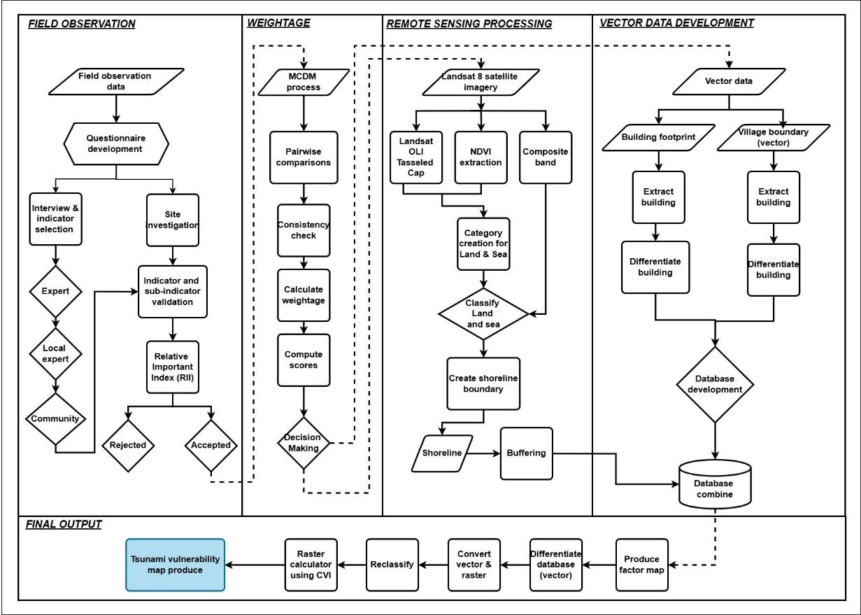

Figure 2. Research methodology

Description of data

This research employs several parameters to evaluate the area's vulnerability to tsunami impacts, including elevation, inundation level, coastal slope, land use and proximity to the coast. The data is measured according to a specific classification scale adapted using multi-criteria decision-making (MCDM) method which is Analytic Hierarchy Process (AHP) and also from previous research that developed by Saaty (1987). The range and important of parameters are based on expert opinion on tsunami disaster from different agencies. Elevation is categorized into five levels, ranging from very low to very high, based on the height of the land above sea level. Areas with low elevations (0-5 meters) are deemed highly vulnerable to tsunamis, as water can easily overflow into these regions. In contrast, areas with high elevations greater than 20 meters are considered very safe. This classification is referenced from a research conducted by Najihah et al. (2014).
Inundation level, which refers to the depth of flooding during a tsunami, is also classified into five levels. Areas with inundation depths less than 0.5 meters are categorized as "very low," while those with inundation depths greater than 3.0 meters are regarded as highly vulnerable. This parameter is based on research by Ismail et al. (2012), which sheds light on the extent and depth of water coverage on land during a tsunami. Coastal slope is another factor used to assess vulnerability. Steeper slopes greater than 1.2% exhibit a low level of vulnerability, as they help mitigate the impact of tsunamis. On the other hand, gentle slopes less than 0.3% are considered very vulnerable because tsunami waves can easily inundate these areas. This information is also sourced from the research by Ismail et al. (2012).
Land use can be categorized into five main types based on the potential effects of a tsunami. Forest areas are considered the safest because they can absorb tsunami energy, whereas urban areas are deemed the most vulnerable due to their high density of infrastructure and population (Primack et al., 1985; EJF report & EJFct, 2006; Spalding et al., 2014; Mikulecký et al., 2023; Benazir et al., 2024). This classification is based on research by Sambah et al. (2018). Additionally, coastal proximity meaning the distance from the coast is used to assess an area's exposure to tsunamis. Areas located less than 100 meters from the coast are at the highest risk, while those situated further away which is 400-500 meters have a lower risk. This categorization is derived from a research by Najihah et al. (2014). Using these parameters allows for a comprehensive understanding of a region's vulnerability to tsunamis, facilitating the creation of more accurate risk maps and more effective mitigation strategies. Table 1 shows the parameter for physical vulnerability assessment used based on previous research.

Table 1. Parameter for physical vulnerability assessment

Parameter | Very low  (1) | Low  (2) | Medium  (3) | High  (4) | Very high  (5) | Reference
Elevation  (m) | >20 | 15-20 | 10-15 | 5-10 | 0-5 | Najihah et al., 2014
Inundation level  (m) | >3.0 | 2.0-3.0 | 1.0-2.0 | 0.5-1.0 | <0.5 | Ismail et al., 2012
Coastal slope  (%) | >1.2 | 1.2-0.9 | 0.9-0.6 | 0.6-0.3 | <0.3 | Ismail et al., 2012
Land use  (type) | Forest | Water | Bare soil | Agriculture | Urban | Sambah et al., 2018
Coastal proximity (m) | 400-500 | 300-400 | 200-300 | 100-200 | <100 | Najihah et al., 2014

Data collection and processing

- Field observation

The primary tool used in this field research is the questionnaire, which is essential for effectively collecting large-scale data, particularly when engaging with the local community. Creating the questionnaire requires careful consideration to ensure clarity for individuals from diverse backgrounds. Experts review the questions to avoid addressing any sensitive issues. The semi-structured questionnaire designed for this research includes both open and closed questions, facilitating the collection of both quantitative and qualitative data. It is strategically aligned with methods such as the Analytical Hierarchy Process (AHP), which involves comparing various indicators and sub-indicators. The questionnaire is divided into three main sections, intended for response by both experts and non-experts. Additionally, a field survey was conducted in the area affected by the tsunami in Kuala Muda to gather data on the impact of the disaster. However, a challenge for this research is that the effects of the tsunami, which occurred 20 years ago, have mostly faded. Only a few locations have been transformed into historical monuments related to the tsunami, which can be referenced for this research, as shown in Figure 3.
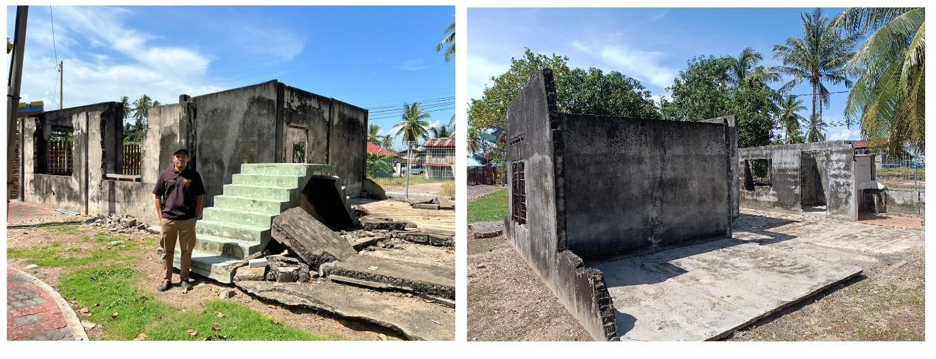

Figure 3. Field observation

- GIS and remote sensing data

This research employs a combined approach using Geographic Information System (GIS) and remote sensing technologies to assess the physical vulnerability in the area of Kota Kuala Muda, Kedah. The primary data utilized in this research includes village boundary vector data, the locations of houses in each village, Landsat 9 satellite imagery from 2024 and Digital Elevation Model (DEM) data obtained from the ALOS mission. The vector data is used to develop a spatial database of physical elements on a micro-scale, particularly focusing on the locations of houses within the research area. Landsat 9 images facilitate land use classification through a supervised classification algorithm, specifically the Maximum Likelihood Classifier (MLC). This classification helps identify different categories such as residential areas, agricultural land, forests and open spaces, as well as determine coastlines using the Normalized Difference Water Index (NDWI) analysis.
Besides, the DEM data is employed to create maps showing slope, elevation and inundation levels. The slope analysis is conducted using the Slope Tool function in GIS, while the inundation levels are modelled by simulating rising water levels with the Raster Calculator. ALOS 30m data, produced by the Japanese space agency (JAXA), is a valuable source of digital elevation model (DEM) data for tsunami vulnerability studies. With a spatial resolution of 30 meters and global coverage, this data is highly effective for identifying low-lying coastal areas at a high risk of tsunami impact. One of the key advantages of ALOS 30m is its relatively accurate land surface elevation information, with a vertical accuracy of approximately ±5 meters. This level of precision is adequate for macro-level mapping of risk zones, such as areas with elevations below 10 or 20 meters above sea level. ALOS 30m offers several benefits for tsunami studies, including its application in tsunami flood simulations (inundation modeling) and spatial analysis to locate settlements, critical infrastructure and populations within risk zones. Additionally, ALOS 30m is particularly valuable for countries like Malaysia, where frequent cloud cover limits the effectiveness of regular optical DEM.
To obtain building data, this research digitizes information from Google Earth, using ArcMap software to access precise coordinates. Each building was represented as both polygon and point geometries, accompanied by relevant information and characteristics regarding the area and its infrastructure. After the digitization process, this research validates each building through site visits and data collection. The WGS 84 coordinate system was used for this research , which has been established prior to the digitization process.

- Data processing

The initial tsunami research included many parameters. However, after evaluation and filtering using the Relative Importance Index (RII) method based on expert judgment, only five parameters were accepted. Experts determined that these parameters are appropriate for the situation in Malaysia, which lacks a triggering factor. Once these preferences are assigned, a consistency check is carried out to ensure that judgments are logical and free from contradictions. This check involves calculating the Consistency Index (CI) as shown in equation 1 and then dividing it by the average random CI value to obtain the Consistency Ratio (CR) as shown in equation 2. Here, λmax represents the largest principal eigenvalue and n denotes the number of elements in the comparison.

$$Consistency Index \left(CI\right)=\frac{λ- n }{n-1} (1)$$

To calculate the consistency ratio (CR), divide the consistency index by the random mean of the CI developed by Saaty (1987). According to Saaty 1980, if the CR value exceeds the acceptable limit, it is crucial to recalculate and repeat the pair-wise step. Saaty 1980 categorized the matrix size based on the random consistency index (RI) value, which ranges from one to nine.
$Consistency Ration \left(CR\right)=\frac{CI }{Mean random CI}$(2)

The analysis process consists of several key steps. First, Landsat 9 data undergoes radiometric and atmospheric corrections to enhance the accuracy of land use classification, which is then assessed using a confusion matrix that references field data. Second, Digital Elevation Model (DEM) data is utilized to extract relevant maps showing slope, elevation and simulated immersion levels for low-lying areas that may be vulnerable to tsunamis. Third, vector data representing house locations and village boundaries is integrated with land use maps, coastlines, slopes, elevations and immersion levels through overlay analysis in Geographic Information Systems (GIS). Vulnerability assessments are conducted at a highly detailed level, analysing each home individually. The vulnerability of each house is evaluated based on its distance from the beach, the surrounding land use, slope, elevation and risk of submergence. This methodology is supported by observations from previous studies, which are incorporated into this research to create a more comprehensive mapping of vulnerability levels.
In general, using Landsat 9 alone is not suitable for analyzing individual buildings due to its relatively low resolution. However, in this research, Landsat 9 is appropriate because the assessment is complemented by fieldwork as a validation method. Each house in the research area is a village house with a yard approximately 30 meters in size, which aligns well with the Landsat pixel resolution. Additionally, this research does not examine infrastructure aspects, such as construction level or type. Instead, it focuses solely on the landform characteristics surrounding the buildings and the types of land use. Therefore, Landsat 9 is highly suitable for land use classification in this research area, particularly due to the availability of various spectral bands that enhance the classification process.
The outcome of this approach is a physical vulnerability map that illustrates the risk level for each house in the research area. This combined method of GIS and remote sensing not only facilitates a more accurate spatial assessment but also serves as a crucial foundation for risk mitigation planning. This includes initiatives such as constructing tsunami-resistant infrastructure or relocating residents to safer areas.

- Data normalization

Before conducting spatial analysis in GIS software, it is essential to normalize all physical parameters, such as elevation, inundation level, coastal slope, land use and coastal proximity. This normalization ensures scale uniformity and allows for comparability among the indicators. For continuous data such as elevation, inundation level, slope and coastal proximity using equation 3:

$$X normalization=\frac{\left(x-x min\right)}{(x- x min⁡) } (3)$$

Normalization method is applied to convert each value to a standard range between 0 and 1. In fuzzy logic, the selection of membership functions depends on the nature of the relationship with vulnerability. For instance, parameters like lower elevation and steeper slopes indicate a higher level of vulnerability, which is addressed by using the fuzzy small function. In contrast, for categorical data such as land use, vulnerability scores are assigned based on existing literature and expert judgment. Each land use class is categorized according to its relative level of vulnerability to tsunami impacts. These normalized values are then utilized in a weighted multi-criteria analysis to generate an empirical and spatially explicit Coastal Vulnerability Index (CVI).

- Coastal vulnerability index (CVI) method

This research employs the Coastal Vulnerability Index (CVI) to assess the physical vulnerability of coastal areas to tsunamis. The CVI concept, introduced by Gornitz (1991), has been widely utilized in studies related to coastal risk. The CVI is a numerical index that integrates several physical parameters to evaluate the vulnerability of a specific area. In this research, parameters such as slope, elevation, proximity to the coast, land use and potential inundation levels were considered. The following equation 4 is used to calculate the CVI value:

$$CVI = \sqrt{\frac{X1 * X2 * X3 *……….Xn}{n}} (4)$$

In this context, X1, X2, X3, ……, Xn represent the values of each normalized parameter, with n indicating the total number of parameters considered. A higher Coastal Vulnerability Index (CVI) value signifies a greater vulnerability to tsunamis. This approach enables the integration of various physical parameters, providing a comprehensive overview of the vulnerability levels in coastal areas. The application of the CVI in this research is instrumental in identifying regions that require immediate attention for risk mitigation and sustainable development planning.
- Evidence-based approach (tsunami event 2004)

The rating scale used to classify the impact of tsunamis along the northwest coast of Peninsular Malaysia measures the impact based on the level of inundation (depth of flooding caused by tsunami waves), which indicates the depth of water that submerges the area during a tsunami event. This scale is divided into five categories, starting from Very Low Impact (1) which occurs when the water level rises by less than 0.5 meters, where the impact is very minimal and only affects coastal areas such as vegetation and beaches without causing major damage to infrastructure or human settlements.
Low Impact (2) occurs when the water level rises between 0.5 and 1.0 meters, which can affect low-lying areas close to the coast, causing minor damage to structures not built to withstand flooding. Moderate Impact (3) occurs when the water depth is between 1 and 2 meters, which will affect a wider area and cause more serious damage to buildings and infrastructure, with a higher risk to the safety of residents and require evacuation efforts. High Impact (4) occurs when the water level rises between 2 to 3 meters, submerging a larger area and causing major damage to structures and utilities, requiring emergency action and evacuation of residents to reduce loss of life.
Finally, Very High Impact (5) occurs when the level of inundation exceeds 3 meters, where almost the entire coastal area was submerged, causing great destruction to buildings, roads and ecosystems and requiring large-scale restoration efforts. This scale is used to assess the level of vulnerability of coastal areas to tsunamis, providing a clear picture of the potential risk and enabling more effective mitigation planning such as the construction of tsunami-resistant infrastructure or the relocation of residents to safer areas. This ranking of impact is based on Ismail et al. (2012) was used as a reference that used in this research was illustrated in Table 2.

Table 2. Ranking scale used for tsunami impact classification for N-W coast of Peninsular Malaysia

Variables | Very low impact  (1) | Low impact  (2) | Moderate impact  (3) | High impact  (4) | Very high impact  (5)
Inundation level  (m) | H < 0.5 m | 0.5 < H <1.0 m | 1.0 < H < 2.0 m | 2.0 < H <3.0 m | H >3.0 m

Result and analysis

Relative Importance Index (RII) and Consistency Ratio evaluate (CR)

In this research, 5 indicators were evaluated by six experts from different professions such as academics, NGOs and the government who were involved in the tsunami disaster. The Relative Importance Index (RII) was used to determine the relevance of each indicator to the research area in Malaysia, which rarely experiences tsunamis. The RII calculation is based on a formula created by other researchers and applied in this research. Initially, 8 respondents were interviewed to establish the weightage for each indicator and sub-indicator. After conducting an expert evaluation based on the established criteria, two respondents didn't meet the criteria and were therefore excluded from the research. As a result, only six experts were considered and used as references in this research.
In the Relative Importance Index (RII) assessment, a value of 0.5 or higher is considered acceptable, while a value below 0.5 is rejected. The RII calculation takes into account the total weight given by respondents (W), the highest weight assigned (A) and the number of respondents (N). The results show that these five indicators are important indicators in the research of vulnerability to tsunamis because they obtained RII values ​​exceeding 0.5 for all indicators assessed by experts. Therefore, these five indicators are accepted and can be continued for the next process.
In AHP analysis, the Consistency Ratio (CR) value is used to assess the consistency of the judgments made in the pairwise comparison matrix. If the CR value is less than 0.1 (10%), then the level of consistency is considered acceptable and the decision can be continued. On the other hand, if the CR value is equal to or greater than 0.1, this indicates that the judgments are inconsistent and the comparison process needs to be reviewed to ensure the validity and reliability of the analysis results.
In this research, the obtained consistency ratio value is 0.2%, which is below the acceptable tolerance level. Therefore, it is considered acceptable to proceed to the next step. Calculating this consistency ratio is crucial to ensure that the weightings are appropriate and relevant for this research, based on the perspectives of experts and previous research. This is because some indicators may only be applicable in certain areas and not suitable for Malaysia.

Land use and land cover classification

Based on Table 3, the classification results using the Maximum Likelihood method show a high performance with an overall accuracy of 89% and a Kappa Coefficient of 0.835, which reflects a very good agreement between the predicted value and the actual value. Water body, bare land, and vegetation achieved a high User's Accuracy of 100%, indicating that all predicted pixels for this category were accurate without any errors. The Producer's Accuracy for water body and urban area are 97.62% and 100% respectively, which shows that almost all the real pixels for this category are successfully detected by the model.
However, the main weakness was found in the urban area category, with a User's Accuracy of only 45%, where many urban pixels were misclassified as vegetation, reflecting the challenge in distinguishing categories with similar spectral characteristics. On the other hand, the vegetation category performed well with a User's Accuracy of 100% and a Producer's Accuracy of 82.93%, although there was some misclassification against other categories. The success of the model in classifying the majority of categories such as water bodies and bare land, which have clear spectral features, shows the effectiveness of this method. Despite the weaknesses in the urban category, the results of this classification still provide a reliable land use map with the potential for improvement for certain categories through the use of additional data or higher resolution parameters. The final output for classification was shown in Figure 4.

Table 3. Accuracy assessment for land use classification

 | Water body | Urban area | Bare land | Vegetation | User's Accuracy (%)
Water body | 26 | 0 | 0 | 0 | 100
Urban area | 0 | 9 | 0 | 11 | 45
Bare land | 0 | 1 | 5 | 0 | 100
Vegetation | 0 | 3 | 0 | 47 | 100
Total | 26 | 13 | 5 | 58
Producer's Accuracy (%) | 97.62 | 100 | 62.5 | 82.93
Overall accuracy (%) | 89%
Kappa Coefficient | 0.835

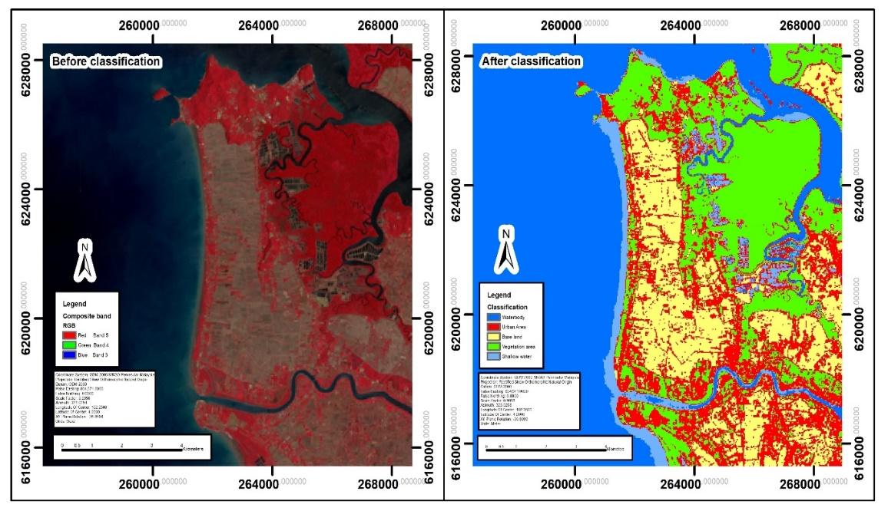

Figure 4. Land use & land cover classification using Maximum Likelihood

Slope, coastal proximity, elevation and inundation level extraction

The results of the map analysis indicate the level of tsunami vulnerability in coastal areas of the research region, based on four main parameters which is slope, proximity to the coast, elevation, and inundation level. The slope map reveals that most coastal areas have low slopes less than 0.5%, indicated in red, which signifies high vulnerability since tsunami waves can easily spread in such areas. Therefore, areas with steep slopes less than 1.0% are marked in orange and red, showing they are more exposed to tsunami risks. Besides, the map illustrating distance from the coast shows that regions within 100 meters of the shore, colored red, are categorized as high-risk zones. As the distance from the coast increases, the risk diminishes, with areas greater than 500 meters represented in green and considered safer.
In the elevation map, coastal areas with low elevation 0–5 meters are marked in yellow, indicating a high vulnerability to tsunamis. In contrast, areas with high elevation above 20 meters are colored blue and are at a lower risk. Most coastal regions in northern Kedah have low elevations, underscoring their vulnerability to tsunami impacts. The inundation level map illustrates tsunami depth, with areas experiencing high inundation levels greater than 5 meters shown in red, while areas with low inundation less than 2 meters are represented in dark blue. Coastal regions recorded significant flooding, while areas further inland experienced less water inundation. Overall, this analysis reveals that regions with low slopes, close proximity to the coast, low elevation and high flood levels are the most vulnerable to tsunami effects. These insights provide a comprehensive understanding of each coastal area's vulnerability and are crucial for informing risk mitigation planning and disaster management strategies moving forward. Figure 5 illustrates the extraction data from DEM at the research area.

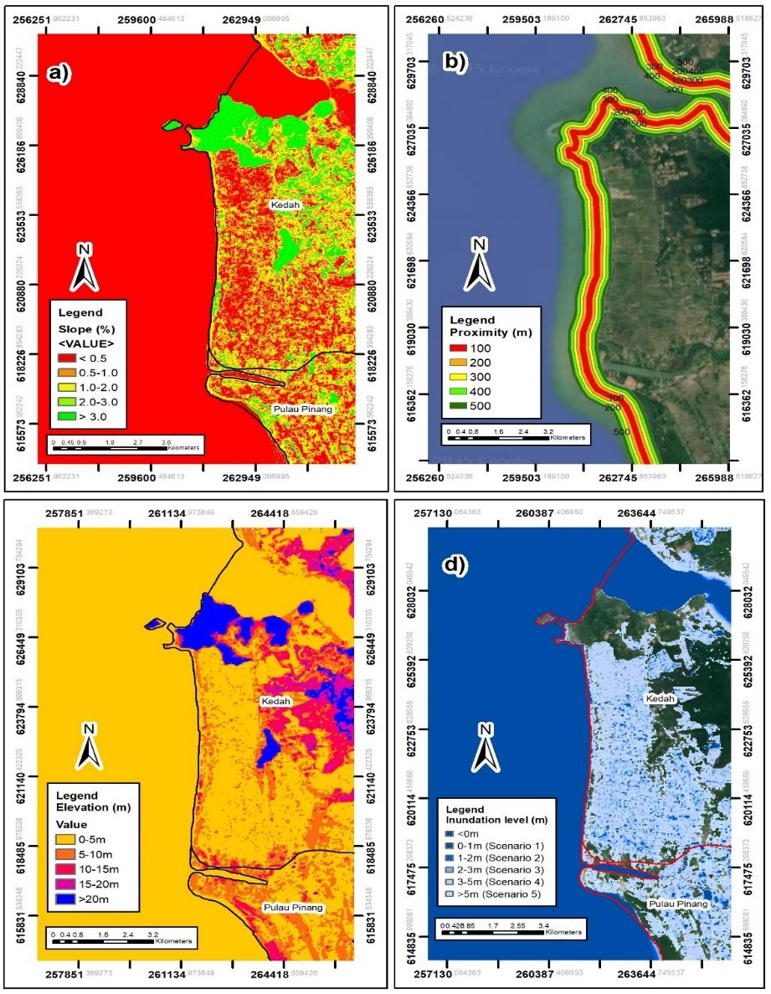

Figure 5. Data extraction from DEM; a) slope, b) Coastal proximity, c) Elevation, d) Inundation level
Physical vulnerability level for every individual building

A research on physical vulnerability levels across 12 coastal villages in Kuala Muda provides a comprehensive overview of vulnerability classifications by village and building type, as illustrated in Figure 6. Kampung Kuala Muda, which has recorded the highest historical damage due to past tsunamis, also contains the largest number of buildings, totalling 381. Of these, 156 buildings fall under the medium vulnerability category, 97 are classified as highly vulnerable and only 44 are categorized as having very low vulnerability. This profile highlights Kampung Kuala Muda as particularly susceptible to tsunami risk, underscoring the urgent need for targeted and immediate mitigation measures. Kampung Paya, which has experienced moderate damage in the past, also comprises a significant number of buildings, with a total of 310. In this village, 127 buildings are classified as having medium vulnerability, 68 as low, 58 as high and 13 as very high vulnerability.

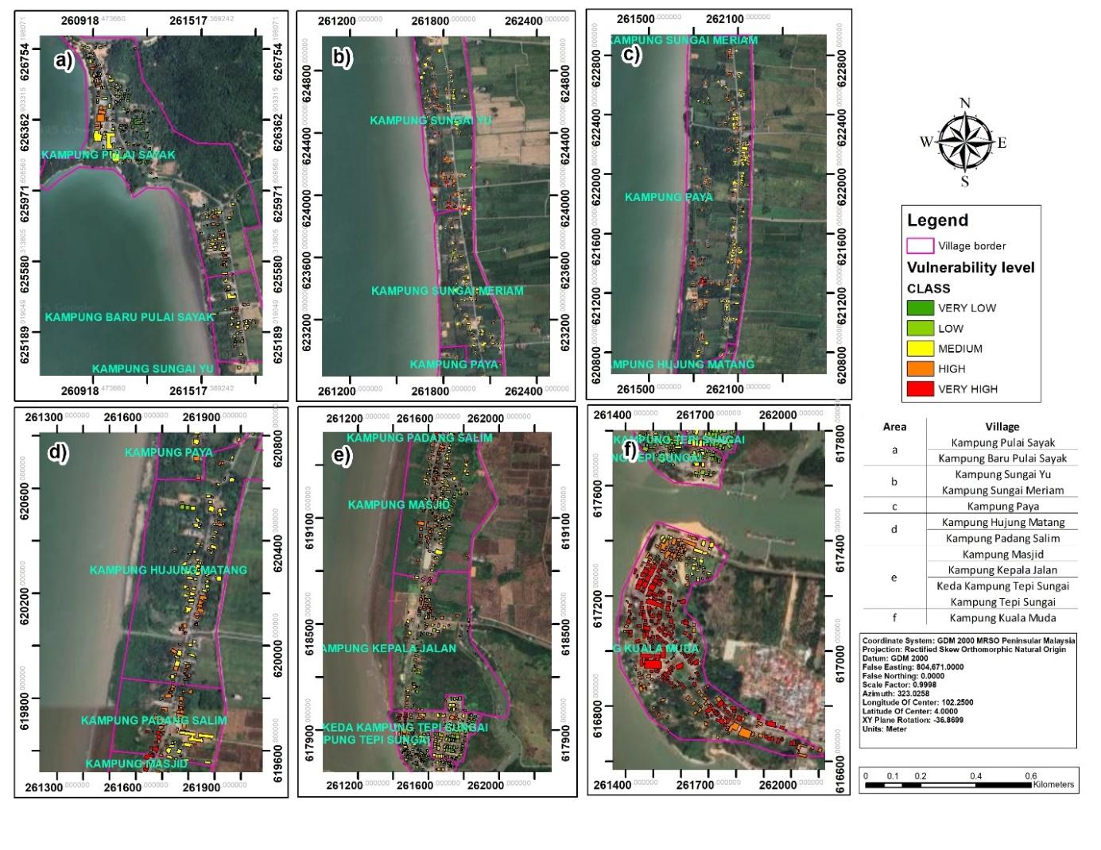

Figure 6. Physical vulnerability map for individual buildings in Kuala Muda, Kedah

While Kampung Paya demonstrates a notable level of vulnerability, it is not as severe as that of Kampung Kuala Muda. On the other hand, villages like Kampung Baru Pulai Sayak, which has a very low history of damage, recorded a much smaller number of buildings 65 in total. Most buildings in this village fall into the low with 21 buildings and medium with 27 buildings vulnerability categories, indicating that the tsunami risk in this area is more manageable compared to others. However, there are still some buildings classified in the high and very high categories, with 7 and 3 buildings, respectively.
In contrast, villages such as Kampung Masjid and Kampung Kepala Jalan, despite having a history of very high damage, exhibit a similar vulnerability pattern. Kampung Masjid has 225 buildings, with the majority about 91 buildings categorized as medium vulnerability. Similarly, Kampung Kepala Jalan, which has 129 buildings, also shows a predominance of medium vulnerability structures about 41 buildings. This pattern suggests that while the history of tsunami damage influences vulnerability levels, other physical factors such as geographic location, elevation and distance from the coast also play crucial roles in determining vulnerability. Overall, most villages exhibit a moderate level of vulnerability, particularly those with a history of moderate to very high damage, such as Kampung Kuala Muda and Kampung Paya.
In contrast, some villages with a history of low damage, like Kampung Sungai Meriam and Kampung Pulai Sayak, have a majority of buildings categorized as low to moderate vulnerability. This analysis enhances our understanding of the variations in tsunami risk in the coastal area of Kuala Muda. The findings also highlight the need for implementing mitigation measures tailored to each village's vulnerability level. These measures may include improving building structures, developing coastal protection infrastructure and planning evacuation procedures for buildings in high and very high vulnerability categories. This research serves as a crucial foundation for more strategic and effective disaster risk planning. For a more detailed explanation about vulnerability level estimation can refer to Figure 7 and Table 4.

Table 4. Tsunami vulnerability estimation for individual village and building

No. | Village | Damage based of history | Estimation vulnerability level |  |  |  |  | Total number of buildings
No. | Village | Damage based of history | (Number of building) |  |  |  |  | Total number of buildings
No. | Village | Damage based of history | Very low | Low | Medium | High | Very high | Total number of buildings
1 | Kampung Pulai Sayak | Very Low | 44 | 63 | 110 | 35 | 8 | 260
2 | Kampung Sungai Meriam | Low | 35 | 14 | 39 | 15 | 7 | 110
3 | Kampung Paya | Moderate | 44 | 68 | 127 | 58 | 13 | 310
4 | Kampung Masjid | Very high | 44 | 50 | 91 | 32 | 8 | 225
5 | Kampung Kepala Jalan | Very high | 44 | 19 | 41 | 17 | 8 | 129
6 | Kampung Kuala Muda | Very high | 44 | 71 | 156 | 97 | 13 | 381
7 | Keda Kampung Tepi Sungai | High | 42 | 18 | 41 | 16 | 8 | 125
8 | Kampung Tepi Sungai | High | 44 | 27 | 62 | 20 | 11 | 164
9 | Kampung Baru Pulai Sayak | Very low | 21 | 7 | 27 | 7 | 3 | 65
10 | Kampung Sungai Yu | Low | 44 | 20 | 50 | 16 | 11 | 141
11 | Kampung Hujung Matang | Moderate | 44 | 20 | 48 | 16 | 11 | 139
12 | Kampung Padang Salim | Moderate | 24 | 34 | 27 | 7 | 4 | 96

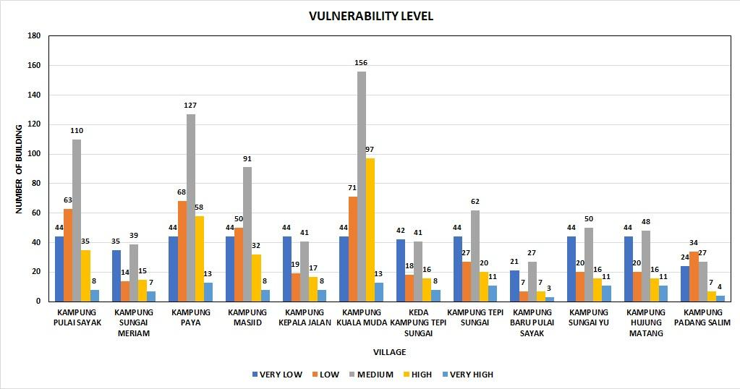

Figure 7. Bar graph diagram based on village area

Statistical test for significant indicators

Multinomial logistic regression was used to analyze the impact of five indicators which is elevation, inundation, land use, slope and proximity as illustrated in Table 5. On vulnerability classification, with Class 2 serving as the reference group. The analysis identified several statistically significant predictors that varied by the comparison category. For the comparison between Class 3 and Class 2, three predictors were found to be statistically significant. Elevation demonstrated a positive association with the likelihood of being classified as Class 3 (B = 0.335, p = 0.016, Exp(B) = 1.398, 95% CI [1.065, 1.836]), indicating that an increase in elevation corresponds to higher odds of belonging to Class 3. Land use was also significant (B = 0.500, p = 0.029, Exp(B) = 1.648, 95% CI [1.053, 2.580]), suggesting that certain land use types contribute to higher vulnerability levels. The most significant predictor was slope (B = 0.366, p < 0.001, Exp(B) = 1.442, 95% CI [1.276, 1.630]), indicating that steeper slopes substantially increase the likelihood of a location being classified as Class 3. In contrast, neither inundation nor proximity showed statistically significant effects in this comparison (p > 0.05).
For the comparison between Class 4 and Class 2, a wider array of variables proved to be highly significant. Elevation continued to be a strong predictor (B = 0.876, p < 0.001, Exp(B) = 2.401, 95% CI [1.796, 3.208]) and inundation history emerged as a dominant factor (B = 1.418, p < 0.001, Exp(B) = 4.127, 95% CI [2.503, 6.806]), indicating that areas with a higher history of inundation are over four times more likely to be classified as Class 4 compared to Class 2. Slope also maintained a significant positive effect (B = 0.600, p < 0.001, Exp(B) = 1.823, 95% CI [1.591, 2.088]). Interestingly, proximity to certain features (such as coastlines and rivers) was negatively associated with Class 4 membership (B = -0.963, p < 0.001, Exp(B) = 0.382, 95% CI [0.309, 0.471]), indicating that locations further away from these features were less likely to be classified in the highest vulnerability category. However, land use was not a significant predictor in this group (p = 0.356). Overall, these findings emphasize that slope is the most consistently influential factor across both vulnerability transitions, while inundation history and elevation are particularly critical for the most severe vulnerability classification. The model supports the incorporation of physical and geographical parameters into vulnerability classification frameworks, with important implications for targeted spatial planning and disaster risk reduction strategies.

Table 5. Multinomial logistic regression test

Parameter Estimates
CLASS ª |  | B | Std. Error | Wald | df | Sig. | Exp(B) | 95% Confidence Interval for Exp(B)
 |  |  |  |  |  |  |  | Lower Bound | Upper Bound
2 | Intercept | 6.371 | 1.572 | 16.429 | 1 | 0.001
2 | elevation | -0.876 | 0.148 | 35.039 | 1 | 0.001 | 0.417 | 0.312 | 0.557
2 | Inundation | -1.418 | 0.255 | 30.869 | 1 | 0.001 | 0.242 | 0.147 | 0.399
2 | Land use | 0.205 | 0.222 | 0.852 | 1 | 0.356 | 1.227 | 0.794 | 1.896
2 | slope | -0.600 | 0.069 | 75.224 | 1 | 0.001 | 0.549 | 0.479 | 0.628
2 | proximity | 0.963 | 0.107 | 80.363 | 1 | 0.001 | 2.620 | 2.122 | 3.233
3 | Intercept | 1.932 | 1.367 | 1.997 | 1 | 0.158
3 | elevation | -0.541 | 0.108 | 24.869 | 1 | 0.001 | 0.582 | 0.471 | 0.720
3 | Inundation | -1.241 | 0.216 | 32.947 | 1 | 0.001 | 0.289 | 0.189 | 0.442
3 | Land use | 0.704 | 0.198 | 12.637 | 1 | 0.002 | 2.023 | 1.372 | 2.983
3 | slope | -0.234 | 0.051 | 20.677 | 1 | 0.001 | 0.791 | 0.715 | 0.875
3 | proximity | 0.927 | 0.083 | 125.485 | 1 | 0.001 | 2.526 | 2.148 | 2.971
a. The reference category is: 4

The findings of this research demonstrate that the utilized approach is highly relevant and has significant potential for application in future tsunami vulnerability modeling. This research focuses on an area that has experienced minimal physical changes, making it a suitable basis for assessing long-term vulnerability. As a result, the findings can potentially be generalized and applied more broadly to other coastal regions with similar geomorphological characteristics, particularly regarding soil structure and landform. This approach aligns with prior studies, such as those by Najihah et al. (2014), which also employed indicators like land use, elevation and distance from the coast. However, this research improves upon previous work by incorporating additional indicators, such as inundation level, which facilitates a more in-depth vulnerability analysis. Moreover, the analysis scale in this research is significantly more detailed, utilizing a 'micro-scale' approach that focuses on the smallest scale to individual building footprints rather than the village scale approach used in earlier studies.
In addition, the results of the statistical analysis in this research indicate that land use indicators may not be ideal as the primary components in a micro-scale context. In contrast, factors such as slope were found to have a more significant impact on determining vulnerability levels. This aligns with the findings of Ismail et al. (2012), who also utilized the CVI index. However, there are notable methodological differences between this research and Ismail et al. (2012) research. While their research assessed vulnerability at the village level in aggregate before breaking it down to the household level, our research began the assessment directly at the household level, using specific indicators. This approach enables a more comprehensive and targeted identification of risk areas, enhancing the clarity and usability of the findings for effective risk mitigation planning.

Conclusion and recommendation

This research provides a comprehensive assessment of coastal areas' vulnerability to tsunamis, aligning with Sustainable Development Goal (SDG) 13. The research evaluates the physical vulnerability of 12 coastal villages in Kuala Muda, Kedah. The findings indicate that Kampung Kuala Muda is the most vulnerable area, with the highest number of buildings which is 381 units, a significant portion of which fall into the moderate to high vulnerability categories. Kampung Paya also exhibits a notable level of vulnerability, with buildings categorized across all vulnerability levels, including 13 buildings classified as very high vulnerability. In contrast, villages such as Kampung Pulai Sayak and Kampung Sungai Meriam have experienced low damage history and have a high percentage of buildings in the low and moderate vulnerability categories. This suggests a more manageable level of risk. However, it is important to note that the presence of buildings in the high and very high vulnerability categories in these villages should not be overlooked, as they still require targeted mitigation efforts. Based on studies and reports regarding the 2004 tsunami, it is evident that most of the buildings affected were located in the villages of Kuala Muda, Kedah (Abdullah et al., 2005; Ahmadun et al., 2020b; Asmawi & Ibrahim, 2014). This demonstrates that this research is highly relevant, supported by accurate reports and is well-suited for further development in Malaysia.
Overall, most villages exhibited moderate vulnerability. This variation was influenced not only by their damage history but also by physical factors such as elevation, inundation, land use, slope, and proximity to the coast. Statistical analysis using multinomial logistic regression revealed that slope was the most significant and consistent factor affecting vulnerability classification. Inundation and elevation also significantly impacted vulnerability, particularly for the highest classification which is class 4. Additionally, proximity to the coast showed a notable negative relationship; areas situated farther from the coastline tended to be less vulnerable. While land use affected vulnerability in Class 3, it did not have a significant impact on Class 4.
Although this research provides detailed physical vulnerability mapping at the individual building level, there are several limitations that need to be acknowledged. First, the scope of this research is limited to physical elements such as elevation, inundation, land use, slope and proximity distance without considering social or economic dimensions that also play an important role in determining the vulnerability level of a community. The historical damage data used is based on records that may not fully reflect changes in the actual impact level at all locations, especially for areas where changes were poorly demonstrated or not well documented during the 2004 tsunami. Third, the approach used in this research is static, which should not be the case as development growth, land use patterns and potential climate impacts on dynamic vulnerability levels.
Therefore, to improve the accuracy and effectiveness of Disaster Risk Reduction (DRR) planning, several suggestions for further research can be considered. First, the integration of socio-economic elements such as household income, age of residents, education level and access to emergency facilities is important to form a more holistic and reflective vulnerability model of the reality of the affected community. Second, the development of dynamic vulnerability models that take into account land use changes, physical development and community adaptive capacity will enable risk assessments that are more responsive to changes over time. Third, the use of advanced technologies such as Geographic Information Systems (GIS), remote sensing and artificial intelligence (AI) should be increased to support real-time risk mapping and accelerate the decision-making process. Furthermore, this study has demonstrated that combining data from open sources with field data yields quality results suitable for rapid execution. To enhance the study's quality further and achieve more specific outcomes, it is recommended to use higher-resolution data, such as LiDAR and Unmanned Aerial Vehicle (UAV) data, to improve clarity and accuracy. Finally, direct field studies through interviews, questionnaires and local community involvement should be implemented to understand risk perceptions and existing adaptive capacity, thus enabling community-based risk mitigation planning to be formulated in a more inclusive and effective manner.

Acknowledgement

This work was funded by the Universiti Teknologi Malaysia (UTM) Digital Infused Research (DIR) grant (Ref: Q.J130000.5152.00L74).

References

Abdullah, K., Tan, K. S., & Ghazali, N. H. M. (2005, July 3-7). No more in the comfort zone – Malaysia’s Response to the december 2004 tsunami [Paper presentation]. International Hydrography and Oceanography Conference and Exhibition, Kuala Lumpur.
Ahmadun, F. R., Wong, M. M. R., & Mat Said, A. (2020a). Consequences of the 2004 Indian Ocean Tsunami in Malaysia. Safety Science, 121, 619–631.
Al-Qadami, E., Razi, M. A. M., Shah, S. M. H., Ideris, M. F. M., & Mahamud, M. (2024). Insight into Kedah State’s Coastal Perils: Tsunamis, floods, and sea level increase. The Journal of The Institution of Engineers Malaysia, 84(2), 32.
Asmawi, M. Z., & Ibrahim, A. N. (2014). The Impacts of tsunami on the well-being of the affected community in Kuala Muda, Kedah, Malaysia. Journal of Clean Energy Technologies, 1(3), 246–250.
Benazir, Syamsidik, Idris, Y., & Putra, N. P. (2023). Connecting community’s perspectives on tsunami risk to anticipated future tsunamis: A reflection from a progress of tsunami preparedness from a coastal community in Aceh-Indonesia after 19 years of the 2004 Indian Ocean Tsunami. Geoenvironmental Disasters, 10, 21.
Benazir, Triatmadja, R., Syamsidik, Nizam, & Warniyati. (2024). Vegetation-based approached for tsunami risk reduction: Insights and challenges. Progress in Disaster Science, 23, 100352.
Cerѐ, G., Rezgui, Y., & Zhao, W. (2017). Critical review of existing built environment resilience frameworks: Directions for future research. International Journal of Disaster Risk Reduction, 25, 173–189.
Cha, L. S., Naraman @ Kamarul Zaman, N. A., Azmi, N. A., & Mohmad Nordin, N. A. (2017). Revitalisasi warisan budaya di Kg. Sg. Emas,Kota Kuala Muda.
Chong, N. O., & Kamarudin, K. H. (2018). Disaster risk management in Malaysia: Issues and challenges from the persepctive of agencies. PLANNING MALAYSIA: Journal of the Malaysian Institute of Planners, 16(1), 105–117.
Cisternas, P. C., Cifuentes, L. A., Bronfman, N. C., Repetto, P. B., & Castañeda, J. V. (2024). Earthquake and tsunami preparedness between residents and tourists in coastal communities. Progress in Disaster Science, 23, 100343.
Deepak, S., Rajan, G., & Jairaj, P. G. (2020). Geospatial approach for assessment of vulnerability to flood in local self governments. Geoenvironmental Disasters, 7, 35.
EJF report, & EJFct. (2006). MANGROVES : Nature’s defence against TSUNAMIS- A report on the impact of mangrove loss and shrimp farm development ono coastal defences. Envrionmental Justice Foundation.
Frankenberg, E., Sumantri, C., & Thomas, D. (2020). Effects of a natural disaster on mortality risks over the longer term. Nature Sustainability, 3, 614–619.
Gornitz, V. (1991). Global coastal hazards from future sea level rise. Palaeogeography, Palaeoclimatology, Palaeoecology, 89(4), 379–398.
Ismail, H., Abd Wahab, A. K., Mohd Amin, M. F., Mohd Yunus, M. Z., Jaffar Sidek, F., & Esfandier J., B. E. (2012). A 3-tier tsunami vulnerability assessment technique for the north-west coast of Peninsular Malaysia. Natural Hazards, 63, 549–573.
Jelínek, R., & Krausmann, E. (2008). Approaches to tsunami risk assessment. JRC Scientific and Technical Reports. http://labtinti4.df.unibo.it/transfer/sites/default/files/adminRoot/documents/deliverables/TRANSFER_D8.2_ANNEX_A8.2.3.pdf
Jihad, A., Muksin, U., Syamsidik, Suppasri, A., Ramli, M., & Banyunegoro, V. H. (2020). Coastal and settlement typologies-based tsunami modeling along the northern Sumatra seismic gap zone for disaster risk reduction action plans. International Journal of Disaster Risk Reduction, 51, 101800.
Jundullah, M. R., & Wijayanto, A. W. (2022). Natural disaster identification and mapping of tsunami and earthquake in Indonesia using satellite imagery analysis (Case research : Aceh, Palu, and Yogyakarta). Preprints.
Jurnal, B., Administrasi, I., Fajria, R., Fajria, R., & Putera, R. E. (2024). Disaster mitigation through the disaster resilient village program in Padang Pariaman District. BISNIS & BIROKRASI: Jurnal Ilmu Administrasi dan Organisasi, 31(1), 16-23.
Koroglu, A., Ranasinghe, R., Jiménez, J. A., & Dastgheib, A. (2019). Comparison of Coastal Vulnerability Index applications for Barcelona Province. Ocean & Coastal Management, 178, 104799.
Krichen, M., Abdalzaher, M. S., Elwekeil, M., & Fouda, M. M. (2024). Managing natural disasters: An analysis of technological advancements, opportunities, and challenges. Internet of Things and Cyber-Physical Systems, 4, 99–109.
Kundan, C., Umank, M., Padam, M., & Omar, J. (2024). Discover geoscience integration of remote sensing data and GIS technologies in river management system. Discover Geoscience, 2, 67.
Mikulecký, P., Punčochářová, A., Babič, F., Bureš, V., Čech, P., Husáková, M., Mls, K., Nacházel, T., Ponce, D., Štekerová, K., Triantafyllou, I., Tučník, P., Sunanda, V., & Zanker, M. (2023). Dealing with risks associated with tsunamis using indigenous knowledge approaches. International Journal of Disaster Risk Reduction, 86, 103534.
Moon, W. C., Sidek, L. M., Lau, T. L., Puay, H. T., Majid, T. A., Wahab, A. K. A., & Teo, F. Y. (2022). A shared vision on the 2004 Indian Ocean Tsunami in Malaysia: Hazard assessments, post-disaster measures and research. Journal of Marine Science and Engineering, 10(8), 1088.
Mukaramah Harun, Zainol, N. A., & Chik, N. (2023). Public expenditures and wellbeing of fishing community in Malaysia: A comprehensive review. Journal of Advanced Zoology, 44(S-53), 406–419.
Mustakim, N. S., Lateh, H., & Razali, M. Z. (2020). Keberkesanan program kesedaran bencana tsunami: Kajian kes di Kota Kuala Muda, Kedah. Geografia-Malaysian Journal of Society and Space, 16(2), 66–79.
Najihah, R., Effendi, D. M., Hairunnisa, M. A., & Masiri, K. (2014). Tsunami vulnerability assessment mapping for the west coast of Peninsular Malaysia using a geographical information system (GIS). IOP Conference Series: Earth and Environmental Science, 18, 012047.
Nakhapakorn, K., Giang, P. Q., Ussawarujikulchai, A., Tantrakarnapa, K., Jirakajohnkool, S., Weerasiri, T., Srichan, N., Maneekul, T., & PhramahaTawee, P. (2022). Geospatial Technology for Estimating the Physical Vulnerability of Building Structures to Natural Hazards. In V. P. Singh., S. Yadav., K. K. Yadav., G. A. Corzo Perez., F. Muñoz-Arriola. & R. N. Yadava (Eds.), Application of Remote Sensing and GIS in Natural Resources and Built Infrastructure Management. Springer.
Nirandjan, S., Koks, E. E., Ye, M., Pant, R., Ginkel, K. C. H. Van, Jeroen, C. J., Aerts, H., & Ward, P. J. (2024). Review article: Physical vulnerability database for critical infrastructure multi-hazard risk assessments – A systematic review and data collection. Natural Hazards and Earth System Sciences, 24(12), 4341-4368.
Primack, R. B., Ashton, P. S., Chai, P., Lee, H. S., & Ashton, P. S. (1985). Growth rates and population structure of Moraceae Trees in Sarawak , East Malaysia. Ecology, 66(2), 577–588.
Rosmadi, H. S., Ahmed, M. F., Mokhtar, M. Bin, & Lim, C. K. (2023). Reviewing Challenges of Flood Risk Management in Malaysia. Water, 15(13), 2390.
Saaty. (1987). The analytic hierarchy process-what and how it is used. Mathematical Modelling, 9(3-5), 161–176.
Sambah, A. B., Miura, F., Guntur, & Fuad. (2018). Spatial multi criteria approach for tsunami risk assessment. IOP Conference Series: Earth and Environmental Science, 162, 012019.
Sauti, N. S., Daud, M. E., Kaamin, M., & Remali, N. (2021). Geospatial technology in potential analysis and mapping of tsunami risk at West Coast Peninsular Malaysia. Sains Malaysiana, 50(4), 929–943.
Schmidt, J. (2023). Mitigating risk of failure in information technology projects: Causes and mechanisms. Project Leadership and Society, 4, 100097.
Skoufias, E., Strobl, E., & Breivik Tveit, T. (2020). Flood and Tsunami damage indices based on remotely sensed data: An application to Indonesia. Natural Hazards Review, 21(4), 04020042.
Spalding, M., McIvor, A., Tonneijck, F., Tol, S., & Eijk, P. van. (2014). Mangroves for coastal defence. Wetlands International and The Nature Conservancy.
Sumaryono. (2010). Assessing building vulnerability to tsunami hazard Using integrative remote sensing and gis approaches [Doctoral dissertation, Universität München].
Syafiq, M., & Azri, S. (2023). A review on the GIS usage in spatio-temporal risk assessment in asset management. IOP Conference Series: Earth and Environmental Science, 1274, 012005.
Usman Kaoje, I., Abdul Rahman, M. Z., Tam, T. H., Mohd Salleh, M. R., Idris, N. H. B., & Omar, A. H. (2021). An indicator-based approach for micro-scale assessment of physical flood vulnerability of individual buildings. International Journal of Built Environment and Sustainability, 8(2), 23–33.
Williams, J. H., Paulik, R., Aránguiz, R., & Wild, A. (2024). Vulnerability of physical infrastructure network components to damage from the 2015 Illapel Tsunami, Coquimbo, Chile. Pure and Applied Geophysics, 181, 2421–2445.
Xhafaj, E., Hassan, H. M., Scaini, C., & Peresan, A. (2024). Simulation of large plausible tsunami scenarios associated with the 2019 Durres (Albania) earthquake source and adjacent seismogenic zones. Mediterranean Geoscience Reviews, 6(3), 197–217.

