ESG disclosure and form performance under transition risk: Evidence from Malaysia’s energy sector

Noraini Moktar¹, Mazlida Mat Deli¹, Tahmina Akhter³, Siti Norliyana Harun⁴

¹Faculty of Business and Communication, Persiaran Perdana BBN
²Graduate School of Business, Universiti Kebangsaan Malaysia
³Faculty of Business and Economics, Universiti Malaya
⁴Centre for Tropical Climate Change System, Institute of Climate Change,
Universiti Kebangsaan Malaysia

Correspondence: Mazzlida Mat Deli (email: mazzlida@ukm.edu.my)

Received: 17 March 2025; Accepted: 28 October 2025; Published: 20 November 2025

Abstract

This study investigates how environmental, social and governance (ESG) disclosure influences firm performance in Malaysia’s energy sector, emphasizing the moderating role of transition risk. Using panel data from 2012–2022 for seven publicly listed energy firms, three performance measures: Tobin’s Q, Return on Assets (ROA) and Sharpe Ratio were analyzed. Results indicate that ESG disclosure quality significantly enhances firm valuation and profitability, though environmental disclosure negatively affects risk-adjusted returns in the short term. Transition risk moderates the ESG–performance relationship, highlighting firms’ capacity to manage policy and technological uncertainties during energy transition. The findings contribute to emerging-market literature by integrating transition risk into the ESG–performance nexus. Policy implications include aligning ESG reporting with Bursa Malaysia and IFRS/ISSB standards, improving investor screening for green finance and encouraging firms to enhance transparent communication strategies to attract sustainable capital.

Keywords: Energy sector, ESG, Malaysian stock’s market, transition risk

Introduction

Malaysia’s energy transition context creates distinctive incentives and constraints for ESG disclosure. The country’s dependence on fossil fuels, alongside its extensive palm-oil biomass industry, places Malaysia in a unique position among emerging economies. Recent initiatives such as the National Energy Transition Roadmap (NETR) and Bursa Malaysia’s Voluntary Carbon Market (VCM), illustrate how policy, regulation and technology collectively shape ESG disclosure expectations for listed energy firms. In this evolving landscape, ESG disclosure quality has become a critical determinant of how investors assess firm resilience and long-term value. High-quality disclosure reduces information asymmetry, enhances investor trust and signals readiness for low-carbon transformation. Yet Malaysian practices remain uneven: some firms align with Global Reporting Initiative (GRI) or Task Force on Climate-Related Financial Disclosures (TCFD) guidelines, while others provide only narrative statements.
Currently, the adoption of palm oil biomass for energy faces challenges in attracting investors due to various unidentified risks associated with the technology (Zamri et al., 2021; Naidu & Moorthi, 2021). This study aims to demonstrate that, concerning environmental concerns, stock market risk should not deter investments. Modern investors are increasingly aware of the transition from fossil fuels to renewable energy sources, including palm oil biomass. In this context, risk will act as a moderating factor in the relationship between ESG disclosure and firm performance. Pedersen et al. (2021) highlight three types of investors ESG-unaware, ESG-aware, and ESG-motivated emphasizing a spectrum of motivations. This differentiation supports the need to study how ESG integration influences investment behavior, particularly as the motivation to prioritize ESG considerations may diminish expected excess returns.
Transition risks arise when firms fail to align their strategies with ESG expectations, leading to potential economic losses. This paper argues that transition risk as a critical variable that moderates the relationship between ESG disclosure and firm performance. This novel focus is supported by the argument that firms neglecting ESG commitments may struggle to satisfy investor expectations, particularly when key stakeholders, like banks, emphasize ESG ratings and disclosures. As Tarmuji et al. (2016) and Raimo et al. (2021) suggest, such transparency mitigates investor uncertainty, bolsters confidence, and encourages sustainable capital allocation. This directly ties to the need for understanding how ESG integration influences perceived and actual investment risks. By examining the moderating role of transition risks, this research contributes to bridging gaps in existing literature on ESG disclosure and firm performance. It also provides actionable insights for investors, firms and policymakers aiming to align sustainable investing practices with market expectations.
Although several Malaysian studies have examined ESG and firm performance, most employ composite ESG performance scores rather than disclosure quality indicators. Few disaggregate environmental (E), social (S) and governance (G) pillars or incorporate the country’s distinctive policy environment, palm-biomass potential and carbon-market developments. Addressing this gap, the present study focuses on the quality of ESG disclosure and its effect on firm performance within the Malaysian energy sector.
Accordingly, this study seeks to answer three questions:
- How does the quality of ESG disclosure influence firm performance among Malaysian energy firms?
- How does transition risk the financial exposure arising from regulatory or technological shifts moderate this relationship?
- What implications arise for policymakers, investors and firms in enhancing ESG transparency?
This study highlights the importance of ESG disclosure in meeting investors' demands in the stock market. By increasing ESG-related information, firms demonstrate their commitment to sustainable business strategies, as emphasized by Terdpoapong et al. (2024) and Moktar et al. (2023). This increased transparency not only builds investor confidence but also enhances the firm’s appeal as a sustainable investment opportunity. For example, even when firms incur high costs for initiatives like palm oil biomass-to-energy projects, robust ESG disclosures can offset these costs by attracting investor interest, thereby securing funding for long-term sustainability goals. Investors, particularly in the energy sector, increasingly prioritize firms with high ESG disclosure as part of a return-driven investment portfolio. Contemporary investment trends show that companies demonstrating strong ESG commitments are favored for inclusion in sustainable portfolios, leading to higher demand and increased stock prices. Such firms offer both financial returns and reputational value, aligning with modern investors' goals. Evidence suggests that high ESG disclosure correlates with greater stock market demand, benefiting investors with both portfolio growth and competitive returns.
In summary, this study aims to examine the direct effect of Environmental, Social and Governance disclosure on firm performance when moderated by risk. The study fills the research gap in emerging economies, especially in the Malaysia emerging market. This study effectively makes findings in two main conclusions. Firstly, each pillar of ESG disclosure has significant positive effect on firm performance (measured by Tobin Q and ROA). However, only the Environmental disclosure is seen to have negative relationship with firm performance (measured by Sharpe ratio), while social and governance disclosure has no effect on Sharpe ratio. These findings highlight that, investors have risk-adjusted tolerance when investing to firm with high environmental disclosure. Secondly, each Environmental, Social and Governance disclosure significantly relate to firm performance negatively when moderated by risk. More importantly, during this transition period, from fossil fuel to renewable energy, findings indicate that even though firms need high challenges to increase their ESG disclosure, investors are showing their risk tolerance for their investment portfolio performance in the case of any strategic activities that related to climate change. Firms are gaining higher firm performance in long term by incorporating higher ESG disclosure.

Literature review

ESG disclosure and firm performance

A key tenet for the effective use of the clean development mechanism is the component of ESG disclosure (Lee et al., 2022). Malaysia's clean development mechanism places a high priority on palm oil biomass as a source of energy that can help achieve significant future reductions in carbon emissions. In addition, biomass from palm oil can generate around 5000 MW of electricity at a 40% efficiency (Zamri et al., 2022). Without a doubt, Malaysia's annual reliance on coal may be reduced by using biomass from palm oil. However, Malaysia is facing high rivals to enable palm oil biomass to energy as the biggest output of renewable energy in present time. The production of palm oil biomass to energy is reducing due to several factors (Zailan et al., 2021; Naidu & Moorthi, 2021; Zamri et al., 2022). One of rivals highlighted is the investment cost to the technology makes the palm oil biomass to energy is unattractive and not sustainable.
Given that it tackles sustainability issues while promoting social and economic advantages, investing in palm oil biomass-to-energy projects naturally conforms to important aspects of Environmental, Social and Governance (ESG) principles. Table 1 shows how the element of environmental, social and governance are related to global sustainability goal.

Table 1. ESG disclosure for palm oil biomass to energy and contribution to global sustainability development goal

ESG disclosure | Contribution to global sustainability development goal
Environmental  (E) | Waste management and Resource utilization:  Palm oil waste, including empty fruit bunches, palm kernel shells, and mesocarp fibers, can be converted into energy through biomass-to-energy initiatives. This mitigates waste and encourages the effective use of byproducts, reducing the palm oil industry's environmental impact.  Cutting Emissions of Greenhouse Gases  reduces emissions by controlling POME methane and substituting fossil fuels.  The production of renewable energy  encourages the use of renewable energy sources.  Preserving of Biodiversity  lessens the need for land expansion, hence contributing to biodiversity preservation.
Social (S) | Creating Jobs and Developing Local Communities  creates jobs in rural regions.  Sources of Energy  supplies underserved areas with dependable, renewable energy.  Enhancements in Health  improves human health by reducing air pollution caused by burning biomass waste.  Engaging the Community  Involves local communities, ensuring equitable benefit-sharing.
Governance (G) | Regulatory Compliance  Ensures compliance with sustainability and environmental restrictions.  Management of a Supply Chain with Ethics  shows a dedication to ethical manufacturing procedures for palm oil.  Stakeholder Collaboration  encourages collaborations for accountability with NGOs, governments, and other organizations.  Reporting and Transparency  offers comprehensive environmental, social, and governance (ESG) disclosures.

Therefore, this paper sheds light to extend the awareness about ESG disclosure as an assistant towards investors demand in the stock market. In this regard, the increases of information related to ESG disclosure by firm in the stock market, investors will acknowledge that firm has put an effort towards a sustainable business strategy (Terdpoapong et al., 2024; Moktar et al., 2023). The increases of ESG disclosure by a firm will increase the attractiveness from investors to put an investment into the firm (Terdpoapong et al., 2024). Therefore, even though firm has put a high cost for palm oil biomass to energy, by holding with high ESG disclosure in the stock market, firm will be gaining demand from investors.
Investors are willing to allocate funds to firms in the energy sector, provided these firms demonstrate strong ESG disclosures in the stock market. They assess companies to build a profitable and sustainable investment portfolio. Currently, both investors and investment managers prioritize firms with high ESG disclosures as part of their sustainable portfolios (Devi et al., 2024; Grishunin et al., 2022; Kiessling, Isaksson & Yasar, 2016; Eccles, Ioannou & Serafeim, 2014). Evidence suggests that companies with strong ESG disclosures experience higher demand in the stock market, leading to increased share prices. As a result, investors benefit from returns on their stock market investments.

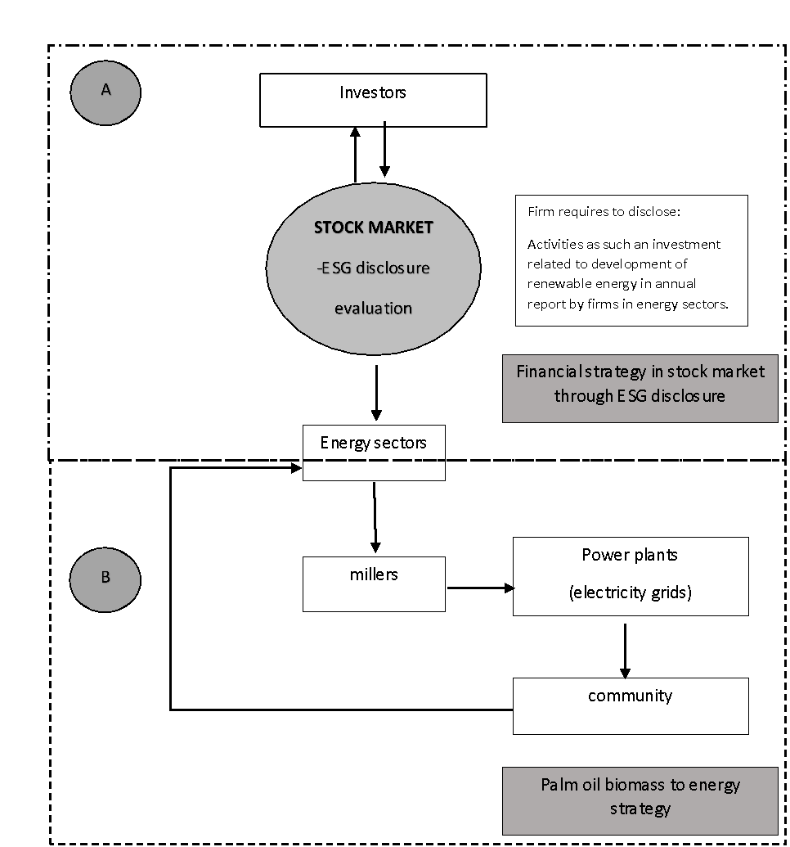

Figure 1. Stock market as an investment strategy for capital cycle

Figure 1 (A) illustrates on how stock market may assist the sustainable financial strategy for pam oil biomass to energy. The process is involving with investors, stock market and energy sectors. At this stage, firms in energy sectors are presenting activities related to environmental, social and governance in annual report. High activities related to environmental, social and governance inside a firm will be replicated to high ESG disclosure. An investment for palm oil biomass to energy itself consists of the high elements of ESG disclosure.
Figure 1 (B) illustrates the involvement of energy sectors, palm oil millers and community nearby power plant by biomass to energy. This process is more technical towards the generation and distribution of energy to the community. At this stage, beside firms in energy sectors experienced high demand in the stock market (increases price by high demand from investors), firms get return from community by the cost of electricity distribution from electricity grids.
Since Malaysia is making advancement towards the circular economy concept through the implementation of biomass-based cogeneration energy systems, the technical feasibility challengers into the technology have been facing positive development (Zailan et al., 2022). Therefore, ESG disclosure may assist the successful palm oil biomass towards sustainable energy resources in future.
ESG disclosures in the stock market play a crucial role in attracting capital for the palm oil biomass-to-energy sector. By aligning their initiatives with sustainability goals, firms can attract ESG-focused investors, enhance their market value and secure funding for growth. These dynamic positions the sector as a key player in the transition to a green economy, fostering a virtuous cycle of sustainability and financial success.
From a broader perspective, numerous studies have attempted to link ESG disclosure to firm performance. ESG initiatives are taken by firms to demonstrate compliance to the market and increase financial returns. The literature is full of contradictory findings and ambiguities, which makes the relationship between ESG and company firm performance still poorly defined (Khan, 2022).
There are huge arguments from past research that leads to ESG disclosure is a relevance information to increase firm performance. Carnini et al. (2022) found that among European firms, there is positive relationship between ESG disclosure and firm performance. Other prior empirical research also stated that the level of ESG disclosure would give significant impact to firm value (Devi et al., 2024; Grishunin et al., 2022; Handoyo & Anas, 2024; Luo et al., 2024; Rahmaniati & Ekawati, 2024; Uyar et al., 2021). Higher or lower return performance is associated with the level of ESG disclosure rating of a firm. It will reflect the high and low demand of the firm with ESG disclosure and increases firm performance. Thus, the following hypotheses are examined:

H₁: The high level of Environmental disclosure is significantly associated with high firm performance.
H₂: The high level of Social disclosure is significantly associated with high firm performance.
H₃: The high level of Governance disclosure is significantly associated with high firm performance.

Transition risk and the ESG-performance relationship

According to prospect theory, the expected return is increases with the increases of risk taken by investors (Sharpe, 1994). In this regard, investors will put their investment according to the level of risk they can absorbed. However, in the early stage of sustainable investment framework been introduced, investors have high uncertainty towards sustainable investment that holding greater E, S and G disclosure. Pedersen et al. (2021) has come out with three types of investors when investors have started to access and evaluated E, S and G information in the market. ESG unaware investors, ESG aware investors and ESG motivated investors. It implies that the growing motivation to invest in shares driven by ESG disclosures has reduced investors expected excess returns. Investors are allocating funds primarily to support environmental initiatives. To provide an investor-oriented perspective, this study employs the Sharpe ratio as an additional performance indicator alongside Tobin’s Q and ROA. The Sharpe ratio measures excess return per unit of volatility, reflecting how investors evaluate compensation for the risks they bear. Incorporating this metric allows the analysis to capture short-term market reactions to ESG information, offering a dynamic, risk-adjusted view of firm performance that complements accounting-based and market-value measures. Unlike previous Malaysian studies that rely on composite ESG performance scores, this research focuses on ESG disclosure quality, the comprehensiveness and credibility of sustainability information disclosed in annual and sustainability reports. Disclosure quality better captures managerial transparency and accountability, offering clearer evidence of how firms communicate their sustainability commitment to investors.
Along the period of 2012 until 2022, such effort in Malaysia stocks Market to support sustainable investment portfolio has given impact to the investors on the awareness that important to include sustainable component inside their investment decision (Capital market Malaysia, 2023). From the global sustainable investing strategies, there are increase of 25% between 2016 to 2020, investors put their investment strategies according to ESG integration (Capital market Malaysia, 2023). In this regard, investors have increased their screening towards ESG integration prior to investment decision being made. Therefore, this research argues that there is moderation factor between ESG integration with the transition risk that investors been taken. The divergence of transition risk associated to ESG integration may accelerate or motivated firm performance, hence create transition risk inside the stock market.
The transition risk that this paper is incorporate is the risk of an economic loss due to the inability to complement the investors’ satisfaction due to lack of evidence of being responsible. At this stage, Investors are more likely to allocate capital to businesses that prioritize Environmental, Social and Governance (ESG) factors if key stakeholders, such as banks and other financial institutions, emphasize ESG ratings in their decision-making. According to the risk theory of management, banks help mitigate the risks associated with information asymmetry by requiring transparent and mandated disclosures (Tarmuji et al., 2016). According to the Task Force on Climate-related Financial Disclosures (TCFD, 2017) and the Network for Greening the Financial System (NGFS, 2021), transition risk refers to the financial exposure that firms face due to regulatory, policy, technological or reputational changes during the shift toward a low-carbon economy. In this study, transition risk is treated as a moderating variable, as different levels of transition exposure can alter how ESG disclosure affects firm performance. When transition risk increases, detailed environmental disclosure may heighten investor concerns about compliance costs, whereas strong social and governance disclosures can mitigate perceived exposure by signalling resilience and transparency. This enhanced transparency reduces information gaps, thereby increasing investor confidence. As the degree of information asymmetry decreases, investors become more willing to provide capital, recognizing the reduced uncertainty and potential for long-term sustainable returns (Raimo et al., 2021).

Theoretical perspectives: Prospect, stakeholder and institutional theories

According to Prospect Theory (Kahneman & Tversky, 1979), investors evaluate outcomes based on perceived gains and losses rather than absolute returns. During periods of policy or technological uncertainty, high ESG transparency may increase perceived risks due to cost and compliance burdens, leading to cautious investor behavior. However, as ESG maturity improves, the same disclosures can enhance trust and long-term performance resilience.
Additionally, Stakeholder Theory (Freeman, 1984) posits that firms engage in sustainability reporting to fulfill the expectations of multiple stakeholders investors, regulators, customers and communities. Transparent ESG disclosure strengthens stakeholder confidence, which, in turn, enhances firm reputation and market valuation.
Institutional Theory (DiMaggio & Powell, 1983) complements this perspective by explaining how regulatory pressures, social norms and professional practices institutionalize ESG disclosure as a legitimacy mechanism. In Malaysia, evolving sustainability reporting standards and Bursa Malaysia’s guidelines act as institutional drivers that compel firms to formalize ESG reporting as part of their strategic communication and compliance processes.

Hypotheses development

Therefore, from the discussion above it is evident that transition risk moderates the relationship between ESG disclosure and firm performance. Hence, hypothesis 4,5,6 is as follow:

H₄ Transition risk moderates the relationship between Environmental disclosure and firm performance.
H₅ Transition risk moderates the relationship between Social disclosure and firm performance
H₆ Transition risk moderates the relationship between Governance disclosure and firm performance.

Figure 2 presents the moderated-effects conceptual framework linking ESG disclosure (E, S, G) to firm performance (Tobin’s Q, ROA and Sharpe Ratio) under varying levels of transition risk (TR). Solid arrows represent direct relationships, while dashed arrows (E×TR, S×TR, G×TR) denote moderating interactions. Control variables - firm size, leverage, age and institutional ownership are included to control for firm heterogeneity, while firm and time fixed effects capture unobserved differences across firms and years.

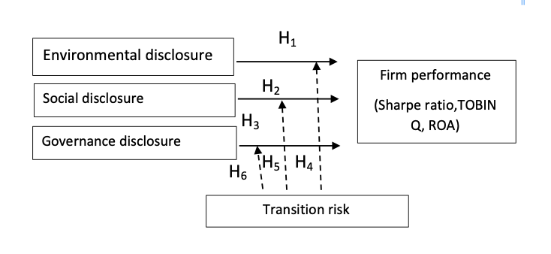
Figure 2. Conceptual Framework

Method and study area

Theoretical underpinning

The methodological approach of this study is grounded in Signaling Theory and Legitimacy Theory. Signaling Theory suggests that firms disclose ESG information to signal reliability, ethical conduct and transparency to investors, thereby reducing information asymmetry and perceived uncertainty in the market. High-quality ESG disclosures send positive signals that can enhance investor confidence and improve firm valuation. Legitimacy Theory posits that companies engage in sustainability disclosure to maintain congruence between organizational behavior and societal norms or regulatory expectations. In the Malaysian context where the government promotes the National Energy Transition Roadmap (NETR) and Bursa Malaysia mandates sustainability reporting firms use ESG disclosure to reinforce legitimacy and compliance with national sustainability goals. These theoretical foundations inform the model design and support the hypothesis that higher ESG disclosure quality positively influences firm performance, moderated by the level of transition risk faced by each firm.

Model derivation

The empirical model applied in this study is directly derived from the conceptual framework (Figure 2), which integrates Signaling Theory and Legitimacy Theory as the theoretical foundation. Based on Signaling Theory, firms disclose ESG information to signal transparency, ethical governance and effective risk management to investors, thereby reducing information asymmetry and improving perceived firm value. Legitimacy Theory complements this by suggesting that firms engage in ESG disclosure to maintain their legitimacy within the regulatory and social environment.
Integrating these two theories, this study models firm performance (FP) as a function of ESG disclosure (E, S, G), transition risk (TR) and their interaction effects. The theoretical relationship is empirically represented by a moderated panel regression structure:

FPit =αi +τt + β1ESGit +β2TRit +β3(ESGit×TRit)+γ′Xit+εit

where FP_{it} denotes firm performance (Tobin’s Q, ROA, or Sharpe Ratio) for firm _{i} in year _{t}; ESG_{it} represents the environmental, social and governance disclosure scores; TR_{it} denotes transition risk; and XitXit​ refers to a set of control variables (firm size, leverage, age and institutional ownership). The interaction term ESG_{it}×TR_{it} captures how transition risk moderates the relationship between ESG disclosure and firm performance. Firm and time fixed effects (α_{i},τ_{t}) are included to account for unobserved heterogeneity across firms and time.

Sample and data

The sample comprises seven Bursa-listed energy firms observed monthly from 2012–2022 (total 672 firm-month observations after outlier treatment). Firm names are masked for confidentiality and comparability, consistent with exchange-level disclosure considerations. We acknowledge that the small firm-level N limits external validity beyond Malaysia’s listed energy segment; however, the high-frequency panel provides substantial within-firm variation to identify effects. We therefore interpret statistical inference cautiously and emphasize pattern consistency across specifications and robustness checks.

ESG disclosure

This study uses Bloomberg’s ESG disclosure scores to measure the effect of transition risk to firm performance. The present research argues that the use of disclosure scores is an unbiased measure of the quantity of information provided by firms because Bloomberg ESG Disclosure Score is not specific performance metrics. Bloomberg ESG Disclosure Score presents the degree to which a company is reporting on ESG information in firms’ annual report (Eccles, Serafeim & Krzus, 2011). In this regard, the present research has overcome the potential bias occurring due to firms imitating their ESG performance without compromising the idea of greater responsibility to society (Mueller 2014).
Secondly, ESG disclosure is a multidimensional concept, which explains the environmental, social and governance disclosure in a bucket. Thus, ESG disclosure can affect one component and may cut out the opposing effects of other components. The present research has shed light to take advantage of disaggregating the environmental, social and governance disclosure.

Firm performance

There is vast literature using Tobin’s Q to proxy firm performance (Atan et al., 2018; Ding et al., 2016; Taylor et al., 2018). Past researchers have used Tobin’s Q to evaluate firm value in the market (Atan et al., 2018; Ding et al., 2016; Taylor et al., 2018). Tobin’s Q is created from the Q theory of investment by Brainard and Tobin (1968). The theory is applied from Keynes’ neoclassical theory of investment in the financial market. In 1969, Tobin’s Q was developed from the extension of the Q theory of investment (Tobin, 1969).
The Q theory of investment states that q denotes the ratio of the market value of a firm in the stock market to the replacement cost of the firm’s physical assets. Q represents the fair firm performance in the stock market. Q denotes the proportion of the market value of a firm’s capital stock to the replacement cost of the firm’s physical assets. It means that in the situation firms need to increase their capital at Q greater than 1, there will be a potential that additional investment will make an accumulation of profit beyond the cost of capital. In contrast, in the situation firms need to decrease their capital stock at Q lower than 1, the firm will absorb burden in terms of additional investment will impact to less than the cost of capital. In this situation, firm experiences with selling off its asset.
Therefore, the ideal Q value is equal to 1. It means that firms have managed the asset in equilibrium with the profit that they make from any investment made. Q ratio signifies to an overall value of a company from book and market performance. The ratio may assist in a variety of choices for business and financial decision. Data is taken from Bloomberg for Tobin’s Q.
Firm performance is not only viewed in the perspective of market valuation but also discussed in the perspective of firm profitability, in terms of the firm’s ability to gain financial profit. Return on Asset (ROA) (Garcia et al., 2017; Mynhardt, 2017). Using ROA may assist in giving more evidence as an alternative proxy for firm performance. (Garcia et al., 2017; Mynhardt, 2017).
From investors perspective, investment performance is important for them to evaluate firm performance (Sharpe, 1994). The Sharpe Ratio is a method used to evaluate investment performance. Investors may assess how much return is being generated per unit of risk taken by using the Sharpe Ratio, which calculates the risk-adjusted return of an investment.
Formula for the Sharpe Ratio:

$$Sharpe Ratio=\frac{\left(Firm^{'}s return-Risk Free Rate\right)}{Standard Deviation of Firm^{'}s return}$$
Transition risk

According to the Task Force on Climate-related Financial Disclosures (TCFD, 2017) and the Network for Greening the Financial System (NGFS, 2021), transition risk refers to potential financial losses that firms may face during the shift to a low-carbon economy. These losses can arise from regulatory tightening (e.g., carbon taxes, emission caps), technological disruptions (e.g., renewable energy substitution), market re-pricing, or reputational pressures related to sustainability performance.
Following previous studies (Battiston et al., 2017; Clark et al., 2022), this study operationalizes transition risk using the standard deviation of monthly stock returns, which reflects the degree of market uncertainty and investor response to regulatory, technological and energy-transition shocks. In emerging markets such as Malaysia, this measure provides a reliable market-based proxy for transition exposure where firm-level data on carbon intensity, regulatory compliance costs, or stranded asset risks are not yet publicly available.
This approach is consistent with the TCFD’s emphasis on the financial materiality of transition drivers, allowing firms’ exposure to decarbonization risk to be captured through observable market volatility. Nonetheless, the study acknowledges that a comprehensive measure of transition risk could, in future, include industry-level indicators such as (i) carbon intensity of operations, (ii) exposure to carbon pricing mechanisms and (iii) policy or regulatory stringency indices. Thus, while the use of standard deviation primarily captures market-perceived risk, it serves as an appropriate and empirically grounded indicator of transition exposure within the data availability constraints of the Malaysian energy sector.
In addition to market-implied volatility, transition exposure can be proxied using policy/regulatory indicators. Practically, this can be implemented via (i) event-window dummies around major Malaysia energy-transition policy announcements or reporting-framework milestones; and/or (ii) a policy stringency index capturing changes in disclosure or carbon-pricing guidance. These indicators interact with ESG pillars (e.g., E×Policy) to capture how policy shocks condition the ESG performance link.
Where accessible, qualitative climate/ESG risk ratings (e.g., transition-risk or management-quality assessments) can be employed as additional proxies. We treat these as sensitivity variables, interacting them with ESG pillars to confirm that our findings are not specific to a single risk measurement approach.

Control variable

Control variables are needed to assess and precisely examine the relationship between the E, S and G disclosure variables, transition risk and firm value. These control variables have been proven, based on the literature, to have a significant relationship with firm value. The present research uses four control variables, which are the leverage, firm size, firm age and institutional investor involvement. Table 2 summaries the control variables used.

Table 2. Summaries the control variables

Symbol | Variables | Reference variables | Unit | Source
LEV | Leverage | Ratio of debt to equity ratio | Ratio | Bloomberg
SIZE | Firm size | Market capitalization to Book value | Ratio | Bloomberg
AGE | Firm age | Age of firm | Year | Annual Report
INST | Institutional ownership involvement | Percentage of institutional ownership | Percentage | Annual Report

Model specification

Model 1 uses equation 3.1 to 3.3. These equations are applied to test hypotheses H₁, H₂, and H₃ respectively, where the main effect of each Environmental, Social and Governance disclosure with firm performance (FP) is explained.

${FP}_{it}=β_{1}{ENV}_{it}+{β_{2}LEV}_{it}+{β_{3}AGE}_{it}+{β_{4}SIZE}_{it}+{β_{5}INST}_{it}+ϵ_{it}$ (3.1)
${FP}_{it}=β_{1}{SOC}_{it}+{β_{2}LEV}_{it}+{β_{3}AGE}_{it}+{β_{4}SIZE}_{it}+{β_{5}INST}_{it}+ϵ_{it}$ (3.2)
${FP}_{it}=β_{1}{GOV}_{it}+{β_{2}LEV}_{it}+{β_{3}AGE}_{it}+{β_{4}SIZE}_{it}+{β_{5}INST}_{it}+ϵ_{it}$ (3.3)

Model 2 is applied to test the interaction effects of each Environmental, Social and Governance disclosure and risk. Equation 3.4, 3.5 and 3.6 use to test hypothesis H₄, H₅ and H₆.

${FP}_{it}=β_{1}{ENV}_{it}+β_{2}({ENV}_{it×}{{{Risk}_{it})+β}_{3}LEV}_{it}+{β_{4}AGE}_{it}+{β_{5}SIZE}_{it}+{β_{6}INST}_{it}+ϵ_{it }$(3.4)
${FP}_{it}=β_{1}SOC+β_{2}({SOC}_{it}{{×{Risk}_{it})+β}_{3}LEV}_{it}+{β_{4}AGE}_{it}+{β_{5}SIZE}_{it}+{β_{6}INST}_{it}+ϵ_{it}$(3.5)
${FP}_{it}=β_{1}{GOV}_{it}+β_{2}({GOV}_{it}{{×{Risk}_{it})+β}_{3}LEV}_{it}+{β_{4}AGE}_{it}+{β_{5}SIZE}_{it}+{β_{6}INST}_{it}+ϵ_{it}$(3.6)

A standard selection sequence has been implemented: Chow test (pooled vs. FE), Breusch–Pagan Lagrange Multiplier (BP-LM) test (pooled vs. RE), and Hausman test (FE vs. RE).The FE/LSDV was adopted when regressors correlate with firm effects and RE otherwise. All models employ heteroskedasticity-robust, firm-clustered standard errors. For transparency, the relevant test statistics and pp-values in each table’s notes were reported, together with R2R2, NN, and the chosen panel specification.

Robustness test

To ensure the reliability of the empirical results, several robustness and sensitivity analyses were conducted. First, all financial and disclosure variables were winsorized at the 1st and 99th percentiles to mitigate the influence of extreme outliers. Second, multicollinearity diagnostics confirmed variance inflation factors (VIF) below the conventional threshold of 10 for all specifications, indicating no multicollinearity issues. Third, models were re-estimated using lagged ESG disclosure values (t–1) to test the stability of results over time. Fourth, alternative measures of transition risk were employed, including market-scaled volatility, policy and regulatory indices and qualitative transition-risk scores, to confirm that findings were not dependent on a single proxy. Fifth, a placebo pillar-swap test randomly reassigned environmental, social and governance labels to verify pillar-specific robustness. Finally, all estimations used firm-clustered robust standard errors to correct for heteroskedasticity and autocorrelation within panels. The results across these checks remained consistent in both sign and statistical significance, demonstrating that the main conclusions are stable under multiple specifications and alternative assumptions.

Moderation testing procedure

The moderation was operationalized by interacting each ESG pillar with transition risk. Steps:
- Mean-center ESG and transition-risk variables;
- Esitmate FPit=αi+τt+β1Zit+β2TRit+β3(Zit×TRit)+γ′Xit+εit, where Z∈{ESG}
- Report and interpret β3;
- Compute simple slopes of Z at low/mean/high TR (e.g., mean ± 1 SD);
- Plot marginal effects ∂FP/∂Z over TR and, where relevant, Johnson–Neyman regions.
- Re-estimate with alternative TR proxies to confirm stability.

Panel data regression

The static panel specifications were adopted to focus on within-firm variation in disclosure and risk at a monthly horizon and to provide a baseline benchmark of disclosure performance relations across firms. As a check, the specifications have been re-estimated using lagged ESG disclosure (t−1) to probe potential short-run dynamics; conclusions are unchanged. From 2012 to 2022, there were 7 firms with ten years of observation. Data is gathering using monthly observation comprising 672 observations after took out some outliers. There are time-invariant and individual invariant factors in the econometric model of 3.1 to 3.12. Each characteristic other than the variables involved in this study on the 7 firms may create a significant influence on firm value. This condition assumes the individual invariant factor has caused an impact on firm value, which falls into the error term,
$ϵ_{it}= v_{i}+u_{it}$ …(3.7)

Furthermore, the time-invariant factor, which explained by the difference in observation years, also influences firm value. The high consistency and persistency effect in the error term $ϵ_{it}$will affect the accuracy of the results.
There are several panel regression analysis techniques, such as Pooled Ordinary Least Square (POLS), Fixed Effect (FE) and Random Effect (RE) models for the static regression model. In line with prior studies on climate-related disclosure, this study employs a static model of analysis. A static model is suitable because the primary objective is to provide a benchmark of current disclosure practices across firms, rather than to examine their dynamic evolution over time. Similar approaches have been adopted in existing TCFD-related studies, where researchers assess the percentage of firms disclosing under each of the four pillars (governance, strategy, risk management, metrics & targets) at a given reporting date. For example, the TCFD Status Report (2022) presents a cross-sectional benchmarking of disclosures without modelling time dynamics. Likewise, Maji and Kalita (2022) applied content analysis of Indian energy firms’ annual reports using TCFD recommendations in a static framework to assess disclosure quality and its association with performance. Similarly, Gao and Saleh (2024) benchmarked Chinese firms’ TCFD-aligned disclosures to evaluate their financial implications. These examples confirm that a static model is appropriate for establishing a baseline of disclosure levels and ensuring comparability across firms and sectors. The selection of models depends on the data distribution and characteristics that most suitable to estimate in the model. In panel regression analysis, the three models have different assumption before the regression analysis is performed. The assumptions are made to estimate the econometric model for hypothesis testing. With the assumptions, the panel data can reduce the multicollinearity and improve the efficiency of the hypothesis testing. The Hausman test will be used to determine whether the data is suitable for the FE model, RE model, or chow test (Park 2011). According to Park (2011), RE model chooses if p value >0.05, meanwhile FE model is chosen if p value <0.05.
Figure 3 shows the steps for panel specification model before panel regression is analyzed. Breusch and Pagan Lagrangian multiplier test and White’s test would assist to justify that data is having a heteroscedasticity issue (p value >0.05) or not (p value <0.05). White’s test is more sensitive to analyze that data is having heteroscedasticity issue (p value >0.05) or not (p value <0.05). If an unrestricted heteroscedasticity exists, sample data carried to test Random Effect (RE) and Fixed Effect (FE). The heteroscedasticity issue has been taken out when RE or FE model is used. Data involving the FE model was analyzed using least square dummy variable (LSDV). In LSDV, any firm specific characteristic has been put into consideration. This condition means that any firm with unique characteristics that influenced the dependent variable may give significant relationship in beta value. In the result, dummy variable for the firm is significant to dependent variable. Therefore, LSDV is believed to show more accurately compared to FE because we can minimize any invisible effect that is not included in the model.

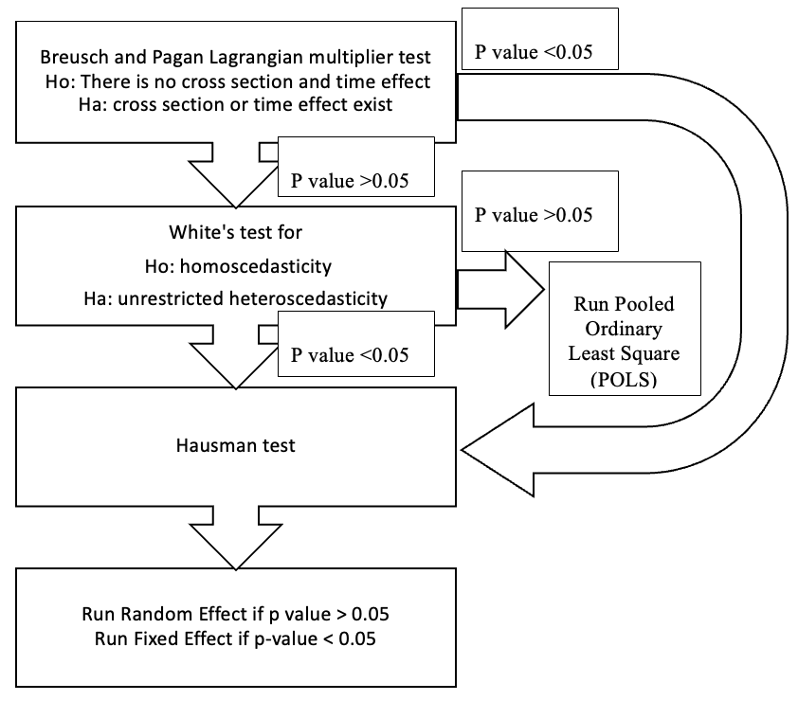

Figure 3. Steps for panel specification test

All the regression used the Stata “regress” command, including a “robust” option, to give the best estimation results. Robust option may assist in minimizing any concern to meet all the assumptions for panel regression. Besides that, any outliers are considered out by using the “robust” option.

Results and discussion

The empirical results are presented in three parts. Table 2 provides the descriptive statistics for all variables, including the mean, minimum, maximum and standard deviation for firm performance (Sharpe Ratio, Tobin’s Q, ROA) and ESG disclosure indicators (Environmental, Social, Governance), together with firm-level controls. Table 3 presents the baseline panel regression results for Models (3.1–3.3), showing the main effects of ESG disclosure pillars on firm performance. Table 4 summarizes the results for Models (3.4–3.6), which incorporate the moderating effect of transition risk on ESG performance relationships. Finally, Table 5 reports robustness tests and alternative model specifications. Each table includes coefficient estimates, t-statistics (in parentheses) and significance levels denoted by ***, ** and * for 1%, 5% and 10% significance, respectively. All models were estimated using firm-clustered robust standard errors to control for heteroscedasticity and serial correlation. The appropriate panel model (FE/RE/LSDV) was selected based on Chow, LM and Hausman tests and the chosen specification is reported in each table. To facilitate interpretation, results are presented by performance measure first Tobin’s Q (market-based), then ROA (accounting-based) and finally Sharpe Ratio (risk-adjusted). This structure allows comparison between long-term firm value, profitability and investor sentiment perspectives.
The following subsections discuss the results for each model in sequence, highlighting coefficient directions, statistical significance and theoretical implications.

Descriptive statistic

Table 2 presents the descriptive statistics Sharpe Ratio, Tobin Q, return on asset, E, S and G disclosure factors, age, size, leverage institutional ownership and risk for the firms in the energy sector.

Table 2. Descriptive statistic shows minimum, maximum, mean and standard deviation

Variables | Minimum | Maximum | Mean | Standard deviation
Sharpe Ratio | -2.64x10¹⁴ | 0.2603782 | -5.73x10¹² | 1.23x10¹⁴
Tobin Q | 0.7221 | 3.8571 | 1.682947 | 0.9466856
ROA | -13.3976 | 16.98218 | 4.77563 | 4.998764
Environmental disclosure | 0.0000 | 77.0040 | 10.2180 | 13.3603
Social disclosure | 0.0000 | 65.5672 | 28.9270 | 25.0260
Governance disclosure | 0.0000 | 56.9000 | 21.0920 | 19.3150
Size | 0.7221 | 3.8571 | 1.6847 | 0.9467
Leverage | -13.3976 | 16.9822 | 4.7816 | 5.0016
Institutional ownership | 1.2580 | 6.0247 | 2.9105 | 1.3175
Age | 0.2644 | 6.5206 | 2.1807 | 1.6685
Risk | 17.0000 | 111.0000 | 47.5057 | 26.2142

ESG and investment performance (Sharpe ratio)

Figures 3 illustrate the relationship between risk and investment performance for firms in the energy sector of the Malaysian stock market. The analysis, investment performance using the Sharpe ratio as a measure, indicates a consistent trend where investment performance increases alongside rising risk, reflecting a risk-return tradeoff favorable to investors. Despite some negative Sharpe ratio values, where the risk-free rate exceeds the expected return, investors may still view these investments as viable, as the performance aligns with the broader risk absorption capacity of the market.
The negative Sharpe ratios highlight that the energy sector underperformed relative to the risk-free rate during the observed period. However, from an investor’s perspective, such scenarios can still be acceptable if they fit within broader portfolio strategies. As per Sharpe (1994), the ratio remains a useful tool for assessing risk-adjusted returns, even when performance is negative, as it provides critical insights into the alignment of risk and reward in each market segment.

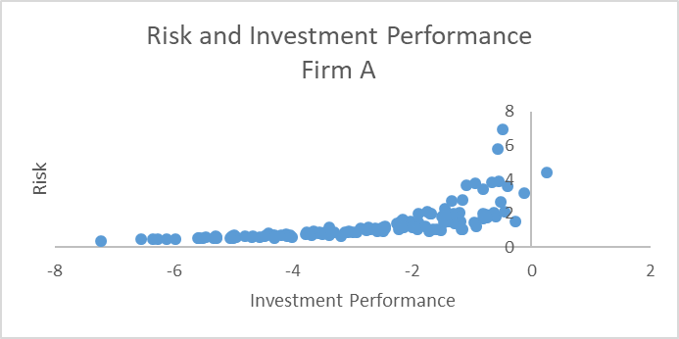 | 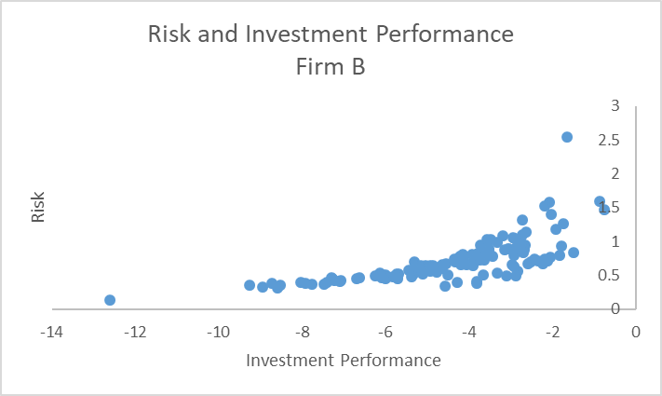
(a) | (b)
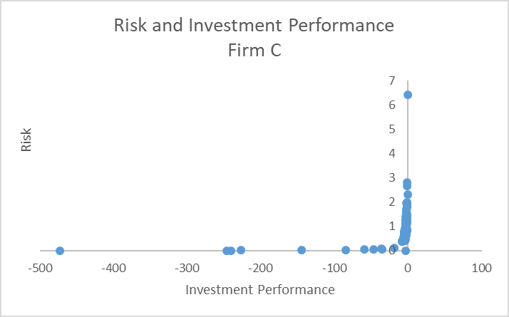 | 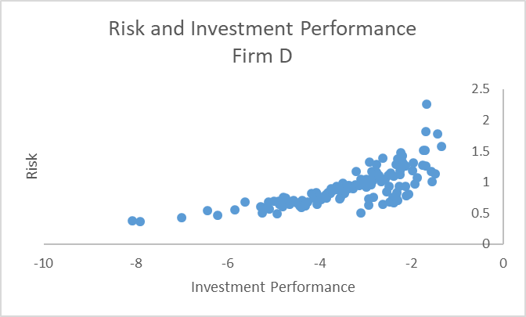
(c) | (d)
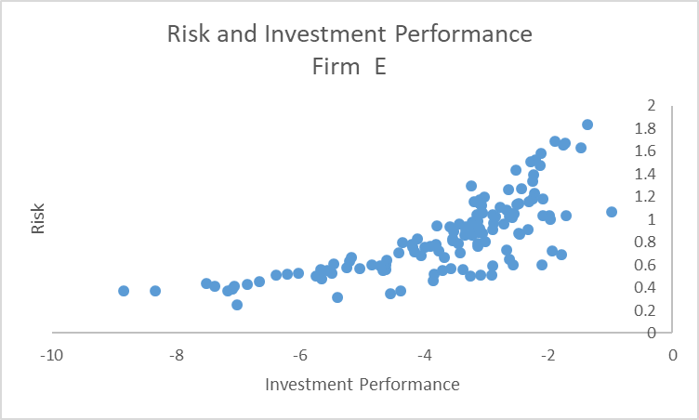 | 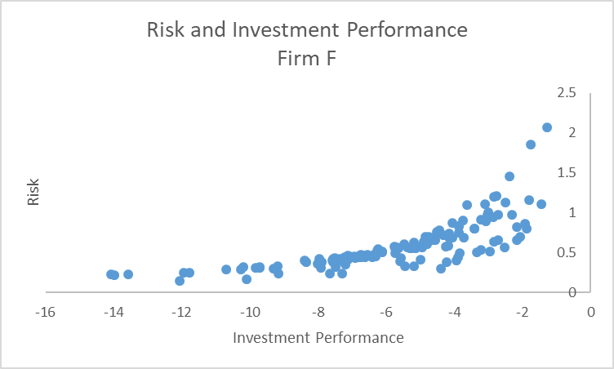
(e) | (f)
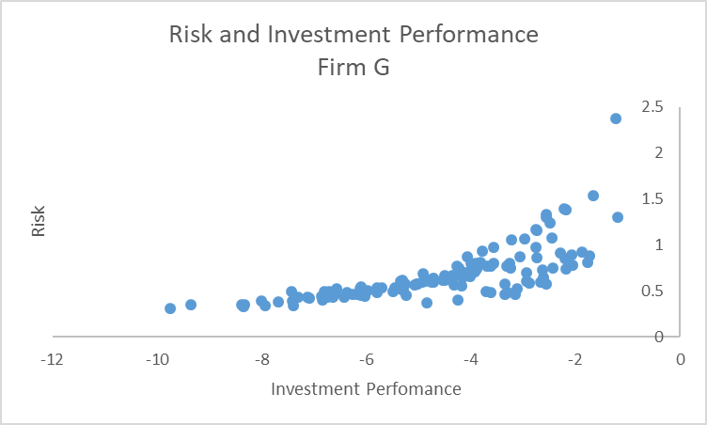
(g)
Figure 2. Figure 3(a) to (g) presents correlation between risk and investment performance (Sharpe ratio)

Impact of ESG Disclosures on TOBIN Q, ROA and Sharpe ratio

Table 3 reports the results of the baseline panel regression assessing the impact of Environmental, Social and Governance (ESG) disclosures on firm value measured by Tobin’s Q. Environmental disclosure shows a positive and statistically significant association with Tobin’s Q (β = 0.028, p < 0.01), indicating that enhanced transparency on environmental practices improves investors’ valuation of energy firms. Similarly, social disclosure exerts a strong positive effect (β = 0.062, p < 0.01), implying that active social engagement, such as employee welfare and community programs—contributes to higher market value. Governance disclosure also demonstrates a positive and significant coefficient (β = 0.008, p < 0.05), underscoring the importance of internal oversight and accountability in sustaining firm reputation. Collectively, these results confirm that all three ESG pillars enhance firm value, supporting H1–H3. Control variables behave as expected: firm size positively influences Tobin’s Q, while leverage has a negative effect, consistent with standard capital-structure theory.

Table 3. Relationship between ESG disclosure and firm performance (TOBIN Q)

Variables |  | TOBIN Q
Environmental disclosure | [0.0280432] (2.42)***
Social disclosure |  | [0.0624659]  (10.24)***
Governance disclosure |  |  | [0.0080019]  (2.07)**
Size | [0.4950149] (60.51)*** | [0.4827519]  (43.39)*** | [0.4836197]  (41.44)***
Leverage | [-0.0270942]  (-5.95)*** | [-0.0535908]  (-4.98)*** | [-0.0292703]  (-2.91)***
Institutional ownership | [0.0011246]  (1.25) | [-0.0050275]  (-1.94)* | [-0.0003589]  (-0.15)
Age | [0.0004278]  (1.83)* | [-0.0322353]  (-5.68)*** | [0.0004241]  (0.17)
Intercept | [0.4627437]  (5.96)*** | [2.581246]  (6.23)*** | [0.7084448]  (2.81)***
R-squared | 0.97 | 0.67 | 0.78
Prob>F | 0.00 | 0.00 | 0.00
Observation | 672 | 672 | 672
Panel model appropriate | LSDV | FE | RE
[ ] beta coefficient panel data regression LSDV/FE/RE model; ( ) t- statistic;
* indicates 1% significant, ** indicates 5% significant, * indicates 10% significant.

Table 4 presents the fixed-effects panel regression results examining the relationship between ESG disclosure and accounting-based performance (ROA). All three ESG dimensions exhibit positive and statistically significant effects. Environmental disclosure enhances profitability (β = 1.147, p < 0.01), suggesting that environmentally responsible operations contribute to operational efficiency and long-term cost savings. Social disclosure also improves ROA (β = 0.720, p < 0.01), reflecting the productivity gains and stakeholder goodwill arising from strong social practices. Governance disclosure is positively related to ROA (β = 0.299, p < 0.01), implying that effective governance mechanisms support sustainable financial performance. Control variables such as leverage remain negatively significant, while institutional ownership shows a positive relationship, consistent with the notion that institutional investors reward well-governed firms. These findings reinforce H1–H3 for the accounting-based measure.

Table 4. Relationship between ESG disclosure and firm performance (ROA)

Variables |  | ROA
Environmental disclosure | [1.471134]  (7.54)***
Social disclosure |  | [0.7202447]  (7.66)***
Governance disclosure |  |  | [0.2990012]  (3.85)***
Size | [1.214018]  (7.06) | [1.28213]  (7.47)*** | [1.384003]  (7.75)***
Leverage | [-1.408583]  (-8.65)*** | [-1.505566]  (-9.07)*** | [-1.335081]  (-7.71)***
Institutional ownership | [0.1818338]  (4.59)*** | [0.1615335]  (4.05)*** | [0.217275]  (5.36)***
Age | [-0.6173647]  (-7.65)*** | [0.6987317]  (-7.99)*** | [-0.459251]  (-5.14)***
Intercept | [18.63]  (3.07) *** | [23.91943]  (3.74)*** | [8.099873]  (1.30)
R-squared | 0.40 | 0.40 | 0.36
Prob>F | 0.00 | 0.00 | 0.00
Observation | 672 | 672 | 672
Panel model appropriate | FE | FE | FE
[ ] beta coefficient panel data regression FE model; ( ) t- statistic;
* Indicates 1% significant, ** indicates 5% significant, * indicates 10% significant.

Table 5 evaluates the influence of ESG disclosures on risk-adjusted investment performance measured by the Sharpe Ratio. The results show that Environmental disclosure exerts a negative and weakly significant effect (β = –0.223, p < 0.10), implying that markets may perceive environmental investments as cost-intensive and uncertain in the short run. In contrast, Social disclosure has no significant effect on the Sharpe ratio (β = -0.099, p > 0.10) and Governance disclosure also shows no significant relationship (β = -0.062, p > 0.10). These results indicate that Social and Governance disclosures do not influence the Sharpe ratio. Consequently, H₁ is accepted, while H₂ and H₃ are rejected.
Higher levels of Environmental disclosure are associated with a decrease in firm performance, implying that investors perceive a negative investment value during the study period. This finding is suggesting a negative correlation between risk-adjusted corporate performance and increased environmental transparency. This implies that environmental projects are seen by investors as expensive and containing more risks than benefits right away. Long-term benefits, higher compliance costs, or doubts about the true significance of such disclosures could all contribute to this unfavorable impression. Investors that are focused on short-term gains may therefore penalize companies that make substantial environmental disclosures.
The finding that environmental disclosure negatively affects short-term investor sentiment, as reflected by the Sharpe Ratio, can be explained by several mechanisms. First, cost-related concerns environmental initiatives often require substantial upfront investment in cleaner technologies or renewable transitions, which can temporarily reduce profitability. Second, greenwashing fears investors may question the authenticity of environmental claims, especially in markets where ESG assurance and verification frameworks are still maturing (Kotsantonis & Pinney, 2022). Third, regulatory uncertainty the evolving landscape of Malaysia’s sustainability reporting and carbon-market regulations can create ambiguity about future compliance costs and policy risks. These short-term deterrents may overshadow long-term benefits, leading risk-averse investors to adjust their portfolios away from firms with high environmental expenditure in the short term.
Social disclosure, which frequently encompasses programs like community involvement or diversity, may not have an immediate, clear effect on financial success. In the same manner, governance disclosures can be seen as mostly driven by compliance and provide less opportunity for corporate distinction. Investors might place more importance on other operational and financial aspects; thus these disclosures have no noticeable effect on risk-adjusted returns.

Table 5. Relationship between ESG disclosure and firm performance (Sharpe ratio)

Variables |  | Sharpe ratio
Environmental disclosure | [-0.2229844]  (-1.69)*
Social disclosure |  | [-0.0987324]  (-1.54)
Governance disclosure |  |  | [-0.0618152]  (-1.06)
Size | 0.3413033  (1.83) | 0.3290367  (2.64)*** | [0.31440000]  (2.47)**
Leverage | -0.15072  (-1.30) | [-0.1453403]  (-1.23) | [-0.1409566]  (-1.15)
Institutional ownership | -0.0723881  (-2.50) *** | -0.0050275  (-1.94) * | [-0.0765739)  (-2.65)*
Age | 0.1172614  (1.83) * | -0.0322353  (-5.68) *** | 0.1115594  (1.63)
Intercept | -5.901451  (-1.03) | 2.581246  (6.23) *** | -5.231028  (-0.90)
R-squared | 0.28 | 0.28 | 0.27
Prob>F | 0.00 | 0.00 | 0.00
Observation | 584 | 584 | 584
Panel model appropriate | LSDV | LSDV | LSDV
[ ] beta coefficient panel data regression FE model; ( ) t- statistic;
* Indicates 1% significant, ** indicates 5% significant, * indicates 10% significant.

Moderating effects of transition risk

Table 6 presents the moderating effects of transition risk on the relationships between ESG disclosures and firm performance. The firms in the oil industry, which have higher exposure to transition risk may view ESG disclosures as a strategic tool to signal their risk preparedness and sustainability to investors (Hahn & Schiemann, 2015).

Table 6. Moderation effects of transition risk on the relationship between ESG disclosure and firm performance

Variables | TOBIN Q | ROA | Sharpe Ratio
Environmental disclosure | [0.0506636]  (2.65)*** | [1.764379]  (4.67)*** | [-0.5235588]  (-3.40)***
Transition Risk X Environmental disclosure | [-6.912122]  (-2.10)** | [-275.9913]  (-4.12)*** | [80.03669]  (2.76)***
Social disclosure | [0.0471921]  (5.56)*** | [0.5020479]  (3.00)*** | [-1.4698691]  (-1.54)
Transition Risk X Social disclosure | [0.0184645]  (2.58)*** | [-0.4525372]  (-2.5)** | [0.06106921]  (0.85)
Governance disclosure | [0.0028849]  (0.62) | [0.4405312]  (4.80)*** | [-0.0802656]  (-1.15)
Transition Risk X Governance disclosure | [0.0120597]  (3.47)*** | [-0.1817392]  (-2.85)*** | [0.0244544]  (0.63)
[ ] beta coefficient panel data regression LSDV model; ( ) t- statistic;
* Indicates 1% significant, ** indicates 5% significant, * indicates 10% significant,

The interaction effect of transition risk on the relationship between environmental disclosure and firm valuation (expressed by TOBIN Q) is negative. Since the strength and direction of this relationship depends on contextual factors, namely: region and industry to which the firms belong to, (Firede et al., 2015) the relationship between environmental disclosure and firm value can be negatively influenced by high costs and risks of transition in the energy sector (Plumlee et al., 2015).
On the other hand, carbon-intensive industries, for example: energy, mining etc., tend to have stronger positive influence on firm valuation from social and governance disclosures, due to regulatory and societal pressures. Past studies (Eccles et al., 2014) suggest that by combining governance and social transparency, firms often outperform peers in managing transition risks. The empirical evidence of this study also confirms that the transition risk positively influences firms’ valuations with social and governance disclosures, which the stakeholders may consider as a firm’s means of managing and communicating strategic oversights and community concerns for navigating through the challenges of low carbon transition (Schmiedeknecht, 2023).
The positive moderating role of transition risk on the relationship between social and governance disclosure and firm performance suggests that firms exposed to higher transition uncertainty benefit more from transparent governance and strong stakeholder engagement. This finding can be interpreted through stakeholder-trust and regulatory-signaling mechanisms. Under greater policy or technological uncertainty, firms that demonstrate credible governance and social responsibility signal resilience and adaptability to investors. Governance transparency such as clear board oversight, anti-corruption measures and stakeholder dialogue reduces perceived regulatory and reputational risks (Li et al., 2023). Similarly, robust social initiatives, including workforce reskilling or community engagement, enhance long-term legitimacy, cushioning firms from the adverse market perception of transition risk. Together, these factors explain why transition risk positively moderates the effects of social and governance disclosure on firm performance in the Malaysian energy sector.
Firms that strategically manage their ESG disclosures can improve financial performance by reducing risks, enhancing efficiency and building trust with stakeholders (Eccles et al., 2014). However, the findings of this study reveal that transition risk negatively moderates the relationship between ESG disclosures and firm performance (measured by ROA). Transition risks often require substantial investments in compliance, technology, or restructuring for transition to adoption of low-carbon processes. These costs can erode the financial benefits of ESG disclosures, reducing ROA (Hawn & Ioannou, 2016). Additionally, firms in high-transition-risk sectors, like- energy sector, may face frequent policy changes, higher compliance costs, or market disruptions (Clark et al., 2015). The financial strain of adapting to these pressures can offset the performance gains typically associated with ESG transparency.
Furthermore, by lowering transition risks and boosting operational resilience, investments in Social and Governance disclosures improve a firm's ability to manage its assets efficiently. Better alignment with long-term sustainability objectives, market expectations, and regulatory requirements results in this risk reduction. Reduced transition risks indicate that businesses are less vulnerable to problems with their finances and reputation, which boosts their return on assets (ROA). Firms can attain greater returns on their investments when Social and Governance disclosure complement strategic asset usage, which reflects enhanced firm performance.
Social and Governance disclosure and Tobin's Q have contradictory finding. Although sustainability objectives and Governance disclosure commonly attract investors (Uyar et al., 2021), the relationship is not always easily understood. When transition risks are thought to increase, investors may expect better returns since firms that invest in Social and Governance disclosure are frequently viewed as good management and able to reduce risks in the future. Additionally, Bashar et al. (2023) and Abdullah et al. (2023) point out that investor views and behavior in their investment are greatly influenced by behavioral factors such as media influence, environmental concerns and society standards. The wider advantages of Governance disclosure and practices in boosting market valuation and investor confidence are highlighted by these aspects.
Increasing green investments also requires attracting investors and removing financial obstacles particularly for the challenging development of biomass to energy technology. In this context, improving the finance structures would guarantee that sufficient funds are accessible throughout the whole technological feasibility and commercial viability process. Given the significant upfront costs and the requirement for technical support from public institutions, funding for the ideation, research and development stage should primarily come from the government and public-private partnerships. Because of the longer gestation and greater risk-return trade-off, equity-based and alternative financing are more successful during the growth stage. Lastly, in order to maintain corporate continuity, traditional financing usually plays a bigger role throughout the mature phase.
In order to build investor trust and release funds for renewable energy projects, ESG disclosure is an essential instrument. By comprehending the dynamic connections between financial results with ESG disclosure and practices, this study highlights how investors and firms may work together to accelerate the shift to a sustainable energy system.
Strengthening ESG disclosure practices in Malaysia requires a structured policy approach that integrates regulatory enforcement, financial incentives, and market alignment. First, ESG reporting should be made mandatory across all public-listed companies, fully aligned with Bursa Malaysia’s Sustainability Reporting Guidelines, the Task Force on Climate-related Financial Disclosures (TCFD) and the upcoming IFRS S1 and S2 standards. Second, the government can promote compliance by offering tax deductions or green investment allowances for firms that obtain independent assurance on their ESG reports or adopt verifiable carbon-reduction initiatives. Third, regulators such as the Securities Commission Malaysia and Bank Negara Malaysia could incorporate ESG reporting quality into credit risk assessments and green-finance eligibility, ensuring that firms with credible disclosures receive preferential access to sustainability-linked loans or lower financing rates. Such measures would not only enhance disclosure quality but also incentivize corporate Malaysia to integrate sustainability performance into strategic decision-making.
The study’s findings also have practical implications for investors and financial institutions. High-quality ESG disclosure can serve as a screening mechanism for identifying firms with lower transition risk and stronger long-term resilience. Investors may incorporate ESG transparency into portfolio selection, risk diversification and ESG index inclusion criteria. Financial institutions can also integrate ESG performance into green bond eligibility assessments and sustainability-linked loan pricing, ensuring that capital is directed toward credible and transparent firms. In Malaysia, the Bank Negara Malaysia Climate Change and Principle-based Taxonomy (CCPT) offers a foundation for aligning ESG disclosure with financing decisions. Firms demonstrating measurable progress in climate-related risk management can benefit from improved credit ratings and access to green finance instruments. Therefore, enhancing ESG disclosure quality is not only a matter of regulatory compliance but also a strategic approach to attract sustainable investments and lower financing costs.
In addition to policy and investor-level interventions, firms themselves play a critical role in strengthening ESG communication to attract investment and mitigate perceived risk. Companies should adopt transparent, data-driven sustainability reporting, ensuring that environmental strategies such as carbon reduction, energy transition, or circular-economy initiatives, are supported by measurable targets and verified outcomes. Consistent and authentic ESG narratives across annual, sustainability and investor-relations reports reduce skepticism of greenwashing and build investor confidence. Firms may further enhance credibility through third-party assurance, ESG rating verification, and public disclosure of progress against net-zero targets. Such communication strategies not only strengthen investor trust but also position firms as proactive, reliable actors in Malaysia’s transition toward a low-carbon economy.

Conclusion

This study explores the relationship between Environmental, Social, and Governance (ESG) disclosures and firm performance in Malaysia's energy sector. The findings of this study reveals that adopting ESG disclosures positively influences firm performance, supporting previous research on the benefits of sustainable and socially responsible strategies. These results confirm the first hypothesis of this study. Firm performance is measured by using Tobin's Q. The robustness test conducted by replacing Tobin's Q with Return on Assets (ROA) also demonstrates a significant positive relationship between ESG disclosure and firm performance.
These findings emphasize the significance of ESG disclosure in the energy sector for building trust among consumers and investors. By showing that ESG investments can yield strong financial returns and strengthen investment portfolios, the study highlights the potential of ESG practices to support successful investments in renewable energy projects.
Given Malaysia's current energy transition, this study explains significant implications for investors, policymakers and business leaders. Firstly, by enhancing adherence to the Task Force on Climate-related Financial Disclosures (TCFD), the International Sustainability Standards Board (ISSB) and Bursa Malaysia's Sustainability Reporting Guidelines, governments should require and standardize ESG disclosure frameworks. Investors must be able to discern between meaningful sustainability performance or greenwashed disclosure in order to reduce information asymmetry. Second, it is critical to encourage the integration of ESG and finance by offering specific incentives, such as tax incentives, subsidies, or recognition programs, to companies who exhibit confirmed environmental transparency, particularly those transitioning to renewable energy. With these steps, environmental reporting would no longer be seen as a financial burden but as a strategic investment.
Third, by including ESG disclosure indicators into products like green sukuk, sustainability-linked loans and climate-focused investment funds, financial institutions may strengthen green finance and hedging tools. By integrating these metrics, which address emission reduction goals, the use of renewable energy and governance quality, investors may evaluate how well firms are aligned with low-carbon transitions while reducing financial risks associated with climate change. Financial products that incorporate ESG disclosure not only facilitate sustainable investment flows but also improve portfolio resilience, risk diversification and investor confidence in the energy transition. This helps to close the gap between capital market results and corporate sustainability initiatives.
Fourth, firms need to create and convey trustworthy, data-driven transition scenarios that incorporate risk reduction techniques, plans for renewable diversification and precise emission objectives. Open communication may reduce market turbulence, boost investor trust and draw in sustainability-focused funding. Finally, to ensure that valuation frameworks reward companies dedicated to long-term environmental transformation rather than those focused on short-term cost considerations, investor education and screening procedures should be reinforced to reflect transition risk sensitivity. When taken as a whole, these legislative actions can close the gap between capital market reactions and firm-level ESG initiatives, fostering a more robust and sustainable energy financing ecosystem in Malaysia. Additional from this findings, to include stakeholder trust and regulatory compliance signaling should empirically investigate as mediating factors in future study, could improve theoretical knowledge and strengthen this findings.

Acknowledgement

The authors gratefully acknowledge the financial support provided by Universiti Kebangsaan Malaysia (UKM) under the Geran Universiti Penyelidikan (GUP-2024-043), and Geran Galakan Penyelidik Muda (GGPM-2024-011). The authors also wish to express their sincere appreciation to the Siti Hasmah Digital Library, Multimedia University, for providing access to Bloomberg data essential for this research.

References

Abdullah S. I. N. W., Sriganeshvarun, Fong, K. T., Thanam, S., & Mustafa, A. Z. M. (2023). Going green: The impact of green initiative events on environmental practice intentions. Journal of Sustainability Science and Management, 18(8), 1-23.
Almansour, B., Elkrghli, S., & Almansour, A. Y. (2023). Behavioral finance factors and investment decisions: A mediating role of risk perception. Cogent Economics & Finance, 11(2).
Atan, R., Alam, M. M., Said, J., & Zamri, M. (2018). The impacts of environmental, social, and governance factors on firm performance: Panel study of Malaysian companies. Management of Environmental Quality: An International Journal, 29(2), 182–194.
Brainard, W. C., & Tobin, J. (1968) Pitfalls in financial model-building. American Economic Review, 58(244), 99-122.
Carnini Pulino, S., Ciaburri, M., Magnanelli, B. S., & Nasta, L. (2022). Does ESG disclosure influence firm performance?. Sustainability, 14(13), 7595.
Clark, G. L., Feiner, A., & Viehs, M. (2015). From the stockholder to the stakeholder: How sustainability can drive financial outperformance.
Devi, L. V., Ariefianto, M. D., & Juliana, R. (2024). ESG, country governance indicators and company value: Evidence from Asia. Journal of Infrastructure, Policy and Development, 8(14), 9195.
Ding, D. K., Ferreira, C., & Wongchoti, U. (2016). Does it pay to be different? Relative CSR and its impact on firm value. International Review of Financial Analysis, 47, 86–98.
Eccles, R. G., Ioannou, I., & Serafeim, G. (2014). The impact of corporate sustainability on organizational processes and performance. Management science, 60(11), 2835-2857.
Eccles, R. G., Serafeim, G., & Krzus, M. P. (2011). Market interest in non financial information. Journal of Applied Corporate Finance, 23(4), 113–128.
Friede, G., Busch, T., & Bassen, A. (2015). ESG and financial performance: aggregated evidence from more than 2000 empirical studies. Journal of Sustainable Finance & Investment, 5(4), 210-233.
Garcia, A. S., Mendes-Da-Silva, W., & Orsato, R. (2017). Sensitive industries produce better ESG performance: Evidence from emerging markets. Journal of Cleaner Production, 150, 135–147.
Grishunin, S., Naumova, E., Burova, E., Suloeva, S., & Nekrasova, T. (2022). The impact of sustainability disclosures on value of companies following digital transformation strategies. International Journal of Technology, 13(7), 1432-1441.
Hahn, R., Reimsbach, D., & Schiemann, F. (2015). Organizations, climate change, and transparency: Reviewing the literature on carbon disclosure. Organization & environment, 28(1), 80-102.
Handoyo, S., & Anas, S. (2024). The effect of Environmental, Social, and Governance (ESG) on firm performance: The moderating role of country regulatory quality and government effectiveness in ASEAN. Cogent Business & Management, 11(1).
Hawn, O., & Ioannou, I. (2016). Mind the gap: The interplay between external and internal actions in the case of corporate social responsibility. Strategic management journal, 37(13), 2569-2588.
Khan M. A. (2022). ESG disclosure and Firm performance: A bibliometric and meta analysis. Research in International Business and Finance, 61, 101668.
Kiessling, T., Isaksson, L., & Yasar, B. (2016). Market Orientation and CSR: Performance Implications. Journal of Business Ethics, 137(2), 269–284.
Lee, S. K., Choi, G., Roh, T., Lee, S. Y., & Um, D. (2022). Exploring the impact of environmental, social, and governance on clean development mechanism implementation through an institutional approach. Frontiers in Psychology, 13, 890524.
Luo, Z., Li, Y., Nguyen, L. T., Jo, I., & Zhao, J. (2024). The moderating role of country governance in the link between ESG and financial performance: A study of listed companies in 58 countries. Sustainability, 16, 5410.
Muaz, M. F., Milano, J., Shamsuddin A. H., Roslan, E., Fatihah, S., Abd Rahman, A., Bahru, R., Fattah, I. M. R., & mahlia, T. M. I. (2022). An overview of palm oil biomass for power generation sector decarbonization in Malaysia: Progress, challenges, and prospects. WIREs Energy and Environement, 11(4).
Mynhardt, H., Makarenko, I., & Plastun, A.(2017). Market efficiency of traditional stock market indices and social responsible indices: The role of sustainability reporting. Investment Management and Financial Innovations, 14(2), 94–106.
Naidu, L., & Moorthy, R. (2021). A Review of key sustainability issues in Malaysian Palm Oil Industry. Sustainability, 13, 10839.
Noraini Moktar, Mazzlida Mat Deli, Ummu Ajirah Abdul Rauf, Fazli Idris, Astri Ayu Purwati. (2023). ESG disclosure: The extent of investors’ confidence in stock market. International Journal of Academic Research in Progressive Education and Development, 12(3), 1005-1024.
Park, H. M. (2011). Practical Guides To Panel Data Modeling: A Step-by-step Analysis Using Stata. Tutorial Working Paper. Graduate School of International Relations, International University of Japan.
Pederson, L. J., Fitzgibbons, S., & Pomorski, L. (2021). Responsible investing: The ESG-efficient frontier. Journal of Financial Economics, 142(2), 572-597.
Plumlee, M., Brown, D., Hayes, R. M., & Marshall, R. S. (2015). Voluntary environmental disclosure quality and firm value: Further evidence. Journal of accounting and public policy, 34(4), 336-361.
Prommin, P., Jumreornvong, S., Jiraporn, P., & Tong, S. (2016). Liquidity, ownership concentration, corporate governance, and fi rm value: Evidence from Thailand. Global Finance Journal, 31, 1–15.
Rahmaniati, N. P. G., & Ekawati, E. (2024). The role of Indonesian regulators on the effectiveness of ESG implementation in improving firms’ non-financial performance. Cogent Business & Management, 11(1), 2293302.
Raimo N., Caragnano A., Zito M., Vitolla F., & Mariani, M. (2021). Extending the benefits of ESG disclosure: The effect on the cost of debt financing. Corporate Social Responsibility and Environmental Management, 28(4), 1412-1421.
Schmiedeknecht, M. H. (2023). UN Principles for Responsible Investments (PRI). In Encyclopedia of sustainable management (pp. 3807-3814). Springer International Publishing.
Sharpe, W. F. (1994) The Sharpe Ratio. The Journal of Portfolio Management, 21, 49-58.
Tarmuji, I., Maelah, R., & Tarmuji, N. H. (2016). The Impact of Environmental, Social and Governance Practices (ESG) on Economic Performance: Evidence from ESG Score. International Journal of Trade, Economics and Finance, 7(3), 67–74.
Taylor, J., Vithayathil, J., & Yim, D. (2018). Are corporate social responsibility (CSR) initiatives such as sustainable development and environmental policies value enhancing or window dressing?. Corporate Social Responsibility and Environmental Management, 25(5), 971-980.
Terdpaopong, K., Wegmann, G., Kraiwanit, T., Limma, P., & Rafiyya, A. (2024). Unveiling the influence of ESG disclosures on corporate profitability: Insights from Thailand’s publicly listed companies. Journal of Infrastructure, Policy and Development, 8(7), 4787.
Tobin, J. (1969) A general equilibrium approach to monetary theory. Journal of Money, Credit & Banking, 1, 15-29.
Uyar, A., Kilic, M., Koseoglu, M. A., Kuzey, C., & Karaman, A. S. (2020). The link among board characteristics, corporate social responsibility performance, and financial performance: Evidence from the hospitality and tourism industry. Tourism Management Perspectives, 35, 100714.
Zailan, R., Lim, J. S., Manan, Z. A., Wan Alwi, S. R., Mohammadi-ivatloo, B., & Jamaluddin, K. (2021). Malaysia scenario of biomass supply chain-cogeneration system and optimization modeling development: A review. Renewable and Sustainable Energy Reviews, 148, 111289.

