Developing a strategic framework for the educational development of Rohingya refugees in Malaysia: An ISM-MICMAC approach

Mashitah Sabdin¹, Mohd Ikhwan Izzat Zulkefli², Farrah Ilyani Che Jamaludin², Syaaibah Zulkipli²

¹Faculty of Science, Management & Computing, Universiti Teknologi PETRONAS
²Department of Management, Universiti Teknologi PETRONAS

Correspondence: Mashitah Sabdin (email: mashitah_sabdin@utp.edu.my)

Received: 9 June 2025; Accepted: 13 July 2025; Published: 20 November 2025

Abstract

Since 2010, the Rohingya community in Myanmar has been subjected to ethnic cleansing and genocide, prompting many to flee and seek refuge in neighbouring countries such as Malaysia, Bangladesh and Thailand. However, refugees residing in countries such as Malaysia, which has not ratified the Refugee Convention, face significant challenges in accessing formal education. Limited educational opportunities often result in high dropout rates among refugee children, which previous studies have linked to increased crime and social problems. Thus, this study aims to develop a framework for the educational development of Rohingya refugees in Malaysia. The study engaged 12 experts to develop the framework using Interpretive Structural Modeling (ISM) and MICMAC analysis to prioritize and categorize the main contributing factors. The results showed that 11 factors were identified for inclusion in the framework. Further analysis highlighted several critical factors, including ‘Awareness and Cooperation Among the Rohingya Community on the Importance of Children’s Education,’ ‘Sustainability of Funds for School Development,’ ‘Fund Management,’ ‘Integrated Curriculum and Syllabus’ and ‘Teaching Staff.’ Among these factors, ‘Awareness and Cooperation Among the Rohingya Community on the Importance of Children’s Education’ emerged as the most critical in promoting sustainable educational development. Hence, the framework is designed to serve as a practical guide for relevant stakeholders, such as local authorities and non-governmental organizations (NGOs), to help them better coordinate their efforts and provide accessible and continuous educational opportunities for Rohingya refugee children in Malaysia.

Keywords: Educational development, Interpretive Structural Modeling (ISM), Malaysia, MICMAC, Rohingya refugees, strategic framework

Introduction

Malaysia is one of the primary host countries for refugees, particularly the Rohingya, due to its strategic geographic location, accessible entry points and shared Islamic faith (Ehmer & Kothari, 2021). As of April 2025, approximately 198,430 refugees and asylum seekers were registered with the United Nations High Commissioner for Refugees (UNHCR) in Malaysia. Of these, 177,110 individuals were from Myanmar, including around 116,020 Rohingya, alongside 29,450 Chin and 31,640 from other ethnic groups fleeing conflict or persecution (UNHCR, 2025). The Rohingya, a Muslim minority in Myanmar, have faced systemic ethnic cleansing and genocide since 2010 (O’Brien & Hoffstaedter, 2020). Myanmar’s discriminatory citizenship laws have rendered nearly all of them stateless, making the Rohingya the largest stateless ethnic group in the world (Haque et al., 2023). Despite not being a signatory to the 1951 Refugee Convention or its 1967 Protocol, Malaysia continues to serve as a major destination for Rohingya refugees (Yusoff et al., 2022). However, in the absence of legal recognition and protection under Malaysian law, these refugees, particularly children, face significant vulnerabilities, including limited access to basic education.
Although Rohingya refugee children in Malaysia are continuously denied access to formal education, they receive non-formal education through learning centres operated by the UN Refugee Agency and local non-governmental organizations (NGOs) (Lee & Hoque, 2024). The educational situation is complex due to their lack of legal recognition, which excludes them from public schooling and forces reliance on community-based and NGO-supported programs (Haque et al., 2025). According to UNHCR, approximately 80 percent of Rohingya children do not attend public schools due to systemic segregation within the education system (Pazil, 2020). Only a small proportion of children receive informal education through NGOs, unregistered community schools, religious institutions or private tutoring centres. This limited access is resulting in a generation of Rohingya who remain illiterate and face a bleak, uncertain future. In the absence of proper schools for the community, the informal education provided by NGOs is insufficient to adequately prepare students for higher education, including university studies (Togoo & Ismail, 2021). Moreover, the lack of a national policy on refugee education in Malaysia has resulted in a fragmented system, leaving many children with poor-quality learning experiences.
Education is a life-saving, life-sustaining and life-transforming process that serves as the foundation for a child’s future. It equips children with the knowledge, understanding and skills needed to build better lives for themselves and their communities (Shohel, 2022). Its importance is further underscored by studies indicating that school dropout among refugee children can lead to long-term social issues, including rising crime rates in Malaysia (Samsudin & Ismail, 2021). Reports reveal that some refugee children, unable to attend school, become involved in criminal activities such as theft and begging. The presence of begging syndicates in areas like Penang and Klang has been partly attributed to this lack of educational opportunity (Pazil, 2020). Granting educational rights to refugee children can protect them from exploitation, including child labour and can reduce the growing dropout rates among refugee and stateless children. Without intervention, the continued denial of access to quality education threatens to exacerbate the cycle of poverty, marginalization and social exclusion among Rohingya refugees in Malaysia, with long-term implications for national cohesion and human development.
In addition, existing literature emphasizes that, in the absence of formal access, alternative educational programmes serve as the main avenue for refugee education in Malaysia. UNHCR, NGOs, community-based organizations and madrassas operate more than 130 community learning centres under a non-formal parallel education system (Palik, 2020; Todd et al., 2019). These centres rely heavily on donations and international aid and are often managed by NGOs, charities and the refugee community itself. As such, they face significant operational challenges, including funding shortages, staff retention, communication issues with Rohingya children and internal cultural and social tensions within the Rohingya community (Samsudin & Ismail, 2022). These institutions do not receive financial support from the government. For example, while the UNHCR office in Malaysia attempts to allocate some funds, it must also support other learning centres across the country (Khairi et al., 2023). Community schools managed by the Rohingya Community Organization (RCO) similarly face financial and staffing constraints. One such school employs only three paid teachers (receiving RM1,000–RM1,200 monthly from UNHCR) and three unpaid volunteers to serve 84 students (Farzana et al., 2020). These are common challenges faced by community schools in delivering education to Rohingya children, highlighting the need for coordinated stakeholder collaboration to improve access. Additionally, most existing studies focus on describing the challenges faced by Rohingya refugees without proposing a strategic, evidence-based educational development framework tailored to the Malaysian context.
Despite the urgent need for educational reform, existing programmes for Rohingya refugees in Malaysia remain largely unsustainable due to short-term funding and a lack of stakeholder coordination. These limitations hinder efforts to achieve Sustainable Development Goal (SDG) 4, which focuses on ensuring inclusive and equitable quality education and promoting lifelong learning opportunities for all, particularly vulnerable groups (Shohel, 2022) such as Rohingya refugee children. Therefore, there is a critical research gap in identifying practical and long-term solutions that can strengthen educational access and outcomes for Rohingya children. In response to these challenges, this study aims to develop a strategic framework for the educational development of Rohingya refugees in Malaysia. By addressing this gap, the study contributes not only to academic understanding but also offers practical recommendations to inform future refugee education policy, inter-agency coordination and sustainable educational planning. This framework is expected to guide relevant stakeholders in building a more sustainable, inclusive and coordinated educational system that meets the unique needs of Rohingya refugee children in Malaysia.

Method

This study employed Interpretive Structural Modelling (ISM) to develop a framework for the educational development of Rohingya refugees in Malaysia, analysing the factors that influence their educational progress. Introduced by Warfield (1973), ISM is a computer-aided modeling technique designed to solve complex problems by structuring expert knowledge and forming a hierarchy of elements (Jamaludin et al., 2025). It applies the principles of graph theory to construct network representations that capture complex contextual relationships using theoretical, conceptual and computational resources (Abdullah, 2014). ISM integrates word, mathematical and graphical; and uses expert knowledge to establish interrelationships among elements in a specific domain (Ahmad & Qahmash, 2021). Through pairwise comparisons, it generates a structural model that visually represents the relationships between factors in the form of a hierarchy (Zulkefli et al., 2024). This hierarchy not only identifies the driving and dependent factors but also ranks them according to their influence, thus providing a better understanding of the structure and relative importance of factors contributing to the educational development of Rohingya refugees in Malaysia.

Sampling and data collection

This study used purposive sampling to select 12 participants who served as an expert panel. According to Janes (1988), the ISM method is most effective with the participation of 8 to 15 experts, making the chosen sample size appropriate for this study. The experts consisted of policymakers, academics, representatives of non-governmental organizations (NGOs) and community leaders from the Rohingya community. The selection of experts was guided by criteria adapted from Zulkefli et al. (2025), which included: (i) holding at least a bachelor’s degree, with academics required to hold a doctoral degree; (ii) possessing knowledge relevant to the study; (iii) having a minimum of five years of experience in their respective fields; (iv) demonstrating strong communication skills; and (v) demonstrating a commitment to the duration of the study. The profiles of the experts who participated in the study are summarised and presented in Table 1.

Table 1. Profile of the experts

Category of experts | No. of experts | Working experience (Years)
Policy makers | 2 | 10-20 and above
Academicians | 3 | 10-20 and above
Non-Governmental Organisation (NGO) | 5 | 10-20 and above
Rohingya community leaders | 2 | 10-20 and above

Data analysis

The framework for this study was developed using Interpretive Structural Modeling (ISM) with the aid of Concept Star software (Zulkefli et al., 2024). The ISM analysis generated a structural map illustrating the hierarchical relationships between factors influencing educational development. Thus, the ISM steps are as follows:

Step 1: Identifying the factors of educational development

The first step was to identify factors relevant to educational development using the Nominal Group Technique (NGT) through expert group discussions. NGT is a structured small group discussion method designed to achieve consensus among experts (Vahedian-Shahroodi et al., 2023). It facilitates the collection of ideas from experts and allows them to make informed suggestions regarding the research under study (Zulkefli et al., 2023). Based on the NGT method, this study identified a preliminary list of 11 factors to be used in developing the framework, as shown in Table 2.

Table 2. Preliminary list of factors of educational development

No. | Factors
1. | Infrastructure
2. | Teaching staff
3. | Integrated curriculum and syllabus
4. | Governance of the school system
5. | Cooperation and approval from the authority
6. | Awareness and cooperation among the Rohingya community on the importance of children’s education
7. | Local community awareness and support
8. | Establishment of Parent and Teacher Association (PIBG) in Rohingya schools
9. | Internal affairs management within the Rohingya community
10. | Fund management
11. | Sustainability of funds for school development

Step 2: Determining the contextual and relation phrase

This step was to establish the contextual relationships between the identified factors of educational development. It clarifies how these factors should be logically connected in the framework development. The relationships between factors were determined by expert consensus, with the panel providing advice on appropriate contextual relationships and relational expressions, which define how factors interconnect and influence each other within the framework (Jamaludin et al., 2025).

Step 3: Constructing a structural self-interaction matrix (SSIM) using the ISM software

In this step, a SSIM was constructed to determine the relationship between the different factors influencing educational development. To facilitate this process, the study used the ISM software called Concept Star. This software presents the factors in pairs to the experts and invites them to vote on the relationship between each pair before moving on the next (Abdullah et al., 2017). The procedure is repeated until all factors are matched and the relationships are established.

Step 4: Generating an ISM model

Once the factor pairing process was completed, the ISM software generated the initial structural model. This model was developed using pairwise comparisons and the application of transitive logic (Zulkefli et al., 2022). Transitive logic postulates that if three elements (A, B and C) have the following relationships: A → B and B → C, then A is also related to C (A → C or A → B → C). In addition, the generated ISM model then underwent an expert review process. During this step, the expert panel reviewed the model to identify any conceptual inconsistencies and recommended necessary changes (Zulkefli et al., 2024). However, only minor adjustments were allowed, as the model was developed through a rigorous and systematic process based on expert discussion and consensus (Jamaludin et al., 2025).

Step 5: Evaluating the ISM model using MICMAC analysis

The final step was to evaluate the ISM model using the Matrix of Cross-Impact Multiplications Applied to Classification (MICMAC) analysis method (Jamaludin et al., 2025). MICMAC was applied to analyse and classify the factors identified through ISM based on their driving power and dependence power (Zulkefli et al., 2024). This method classifies the factors into four groups: (i) Independent factors: strong driving power but weak dependence power, (ii) Linkage factors: both strong driving and strong dependence power, (iii) Autonomous factors: weak driving power and weak dependence power and (iv) Dependent factors: weak driving power but strong dependence power (Zulkefli et al., 2024). In this study, MICMAC analysis was used to analyse the degree of interrelationships between the factors in developing the educational development framework.

Results

The proposed framework, presented in Figure 1, is based on the results of an ISM session with a panel of experts. It illustrates the interdependence of different factors influencing the educational development of Rohingya refugees, with the aim of supporting the creation of a sustainable education system in Malaysia. The arrows in the framework represent the sequence or flow from one factor to another, forming a structured map describing how these factors interact within an overall system. In addition, the model shows which factors need to be addressed first before moving on to others. Based on the findings, some of the critical factors that should be prioritised include ‘Awareness and Cooperation Among the Rohingya Community on the Importance of Children’s Education’, ‘Sustainability of Funds for School Development’, ‘Fund Management’, ‘Integrated Curriculum and Syllabus’ and ‘Teaching Staff’. Among these, ‘Awareness and Cooperation Among the Rohingya Community on the Importance of Children’s Education’ is located at the top of the ISM hierarchy. This suggests it is the most crucial factor to address first. Once this factor is properly managed, it can support the implementation of other related factors.

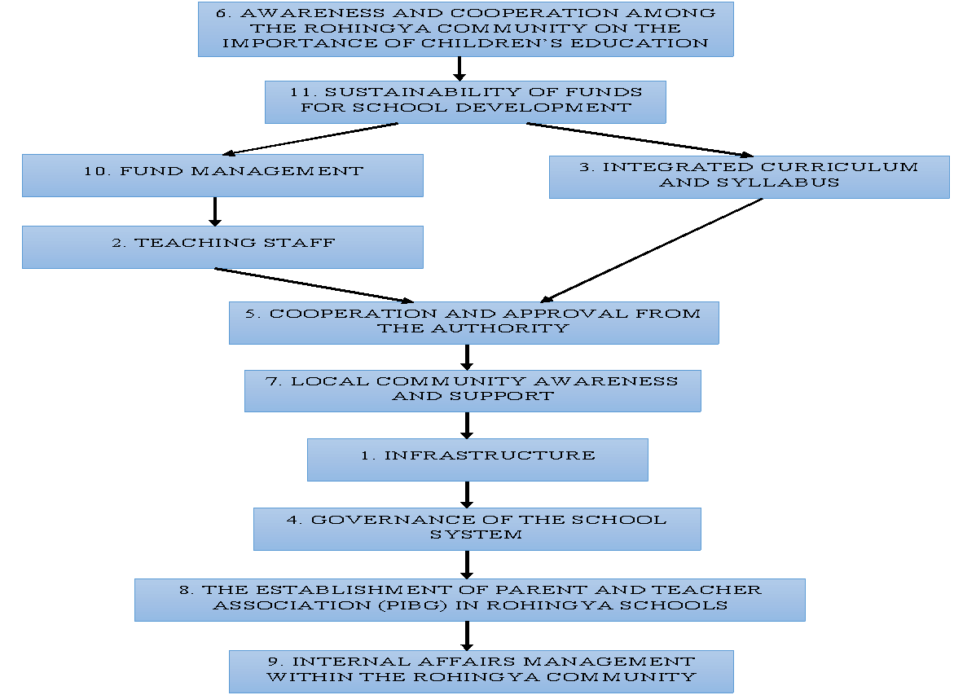

Figure 1. Strategic framework for educational development of Rohingya refugees in Malaysia

In this study, the factors within framework for educational development of Rohingya refugees were categorized into three main groups based on their driving and dependent power. As illustrated in Figure 2 and detailed in Table 3, the framework groups the factors into: (i) Independent factors, (ii) Autonomous factors and (iii) Dependent factors.
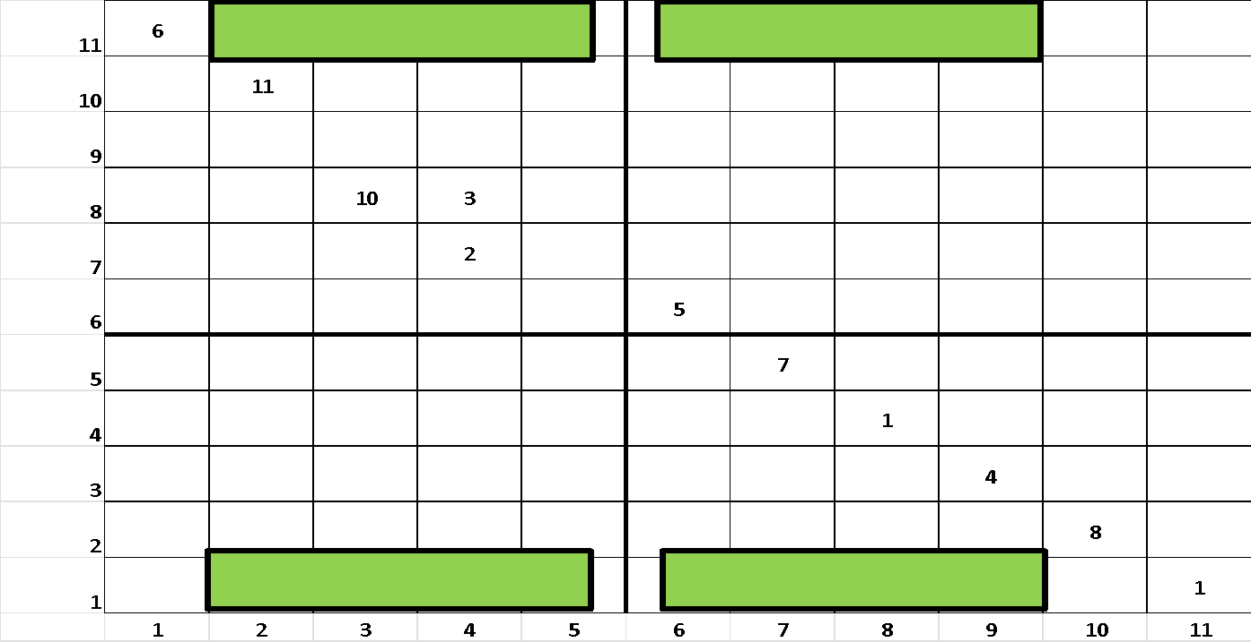

Figure 2. Conica matrix of the educational development of Rohingya refugees

The categorization of educational development factors is essential for building a sustainable education framework for the Rohingya community in Malaysia. As illustrated in Figure 2, the Driver-Dependency Matrix categorizes these factors based on their driving and dependence power. The first group (independent factor) includes ‘Awareness and Cooperation Among the Rohingya Community on the Importance of Children’s Education’, ‘Sustainability of Funds for School Development’, ‘Fund Management’ and ‘Integrated Curriculum and Syllabus’. These factors form the foundation of educational development as they strongly influence the system and must be prioritized. The second group (linkage factor) includes only one factor: ‘Cooperation and Approval from the Authority’, highlighting their vital role in connecting with other factors.
The third group (dependent factors) includes ‘Infrastructure’, ‘Governance of the School System’, ‘Local Community Awareness and Support’, ‘The Establishment of Parent and Teacher Association (PIBG) in Rohingya Schools’ and Internal Affairs Management within the Rohingya Community’. These factors are important, but they depend on other factors. Finally, the fourth group (autonomous factors) was not represented in this study. Based on these groupings, the framework is divided into three phases: initiation (independent group), intervening (linkage group) and sustaining (dependent group), as shown in the framework in Figure 1.

Table 3. Summary of educational development categories for Rohingya refugees based on MICMAC analysis

No. | Group | Characteristics | Factors
1. | Independent factor | Important factors that need to be addressed before others due to their high driving power | 2,3,6,10,11
2. | Linkage factor | Factors that serve as a link between independent and dependent factors | 5
3. | Autonomous factor | Factors with low driving and dependence power; less connected to the other factors | None
4. | Dependent factor | Factors with low driving power but high dependence; influenced by other factors | 1,4,7,8,9

Discussion

The framework (Figure 1) illustrates that Factor 6 ‘Awareness and Cooperation Among the Rohingya Community on the Importance of Children’s Education’, is the most significant driver of educational development and the most influential in affecting other related factors. Positioned at the top of the framework, this factor should be prioritized by relevant stakeholders to provide education for Rohingya refugee children in Malaysia. This finding aligns with the MICMAC analysis (Figure 2), which identifies Factor 6 as the most influential independent factor, indicating its strong impact on the other elements within the framework. According to Wati and Sahid (2022), parents’ awareness of the importance of education significantly influences their decisions regarding their children’s schooling. When parents and community members understand the value of education for their children’s future, they are more likely to support it by enrolling their children in school, encouraging their learning and promoting better educational opportunities. However, several factors continue to hinder refugee children’s access to education, such as parents’ limited awareness, especially concerning girls’ education and economic hardship that forces families to withdraw their children from school and push them into the labour force (Palik, 2020). As such, long-term educational development depends on a bottom-up approach in which the community itself recognizes the benefits of education, not only for their children but also for the society and nation.
In addition, the framework suggests that after addressing Factor 6, attention should be given to Factor 11, ‘Sustainability of Funds for School Development,’ as it plays a critical role in educational development. Sustainability of funds is not merely a financial concern but a foundational requirement for the long-term success of refugee education. Stable and continuous funding ensures that educational initiatives, infrastructure and daily operations can proceed without disruption, while insufficient funding often leads to the lack of essential facilities, equipment and learning materials (Akinyemi et al., 2022). To support this, effective fund management, as highlighted in Factor 10, ‘Fund Management,’ is essential. Even when funds are available, poor administrative practices such as weak budgeting, ineffective record-keeping and lack of accountability can hinder progress (Olaifa et al., 2024). Furthermore, the framework highlights that once funding sustainability is achieved, attention should shift to Factor 3, ‘Integrated Curriculum and Syllabus,’ where the introduction of an integrated curriculum in Rohingya community schools can provide a more systematic and holistic education. As Rahman and Husain (2022) emphasize, integrated curricula allow students to make connections between subjects, thereby enhancing their critical thinking and problem-solving abilities. The introduction of such curricula can help build foundational knowledge for Rohingya refugee children. Additionally, the framework indicates that once Factor 10, ‘Fund Management,’ is addressed, attention should be directed to Factor 2, ‘Teaching Staff,’ as a critical component of educational development. Teachers play a central role in promoting both the intellectual and social development of students (Hee et al., 2019). They are considered the backbone of educational development, as they directly shape the quality of instruction, influence student outcomes and contribute to long-term societal progress.
After the independent factors such as Factors 6, 11, 10, 3 and 2 are addressed, the framework highlights that, in order to provide education for refugee children, stakeholders must focus on Factor 5, ‘Cooperation and Approval from the Authority.’ This implies that once basic educational needs are in place, obtaining approval from government or local authorities becomes essential to legitimize refugee education institutions. Without such approval, schools may operate informally, thereby limiting access to public support and financial assistance. In the Malaysian context, the establishment of a private school requires approval from the relevant authorities. As highlighted by Umar and Hussin (2009), this process involves various levels of review and endorsement before a school can be officially established and operated. This ensures that institutions comply with the guidelines and regulations set by the government to maintain the quality of education provided in accordance with national standards. According to the National Education Policy book, all Alternative Learning Centres (ALCs) must consistently adhere to existing regulations through regular supervision, inspections and enforcement related to governance, curriculum and educational programs to ensure the delivery of quality education services (Palik, 2020).
The final group in the framework consists of dependent factors that include Factor 7, ‘Local Community Awareness and Support’; Factor 1, ‘Infrastructure’; Factor 4, ‘Governance of the School System’; Factor 8, ‘The Establishment of Parent and Teacher Association (PIBG) in Rohingya Schools’; and Factor 9, ‘Internal Affairs Management within the Rohingya Community.’ These are identified as subsequent elements that need to be addressed to support sustainable educational development for Rohingya refugees. After receiving approval from the authorities (Factor 5), stakeholders must focus on managing Factor 7, as local community acceptance is crucial to preventing discrimination and social exclusion. Negative perceptions of refugees, often portrayed as burdens or threats, can lead to hostility from host communities (Lee, 2023). When the local community accepts the presence of Rohingya refugees, it opens opportunities for collaborative support, such as providing educational resources and organizing community fundraising to sustain refugee schooling.
Following this, the framework recommends addressing Factor 1, which concerns the development of school infrastructure. Creating a conducive learning environment with adequate classrooms, basic furniture, electricity and sanitation enables both students and teachers to focus on education. According to UNHCR (2016),poor infrastructure and low-quality education are significant barriers to school enrollment and retention among refugee children. Thus, establishing the physical foundation of Rohingya community schools is essential before formal operations begin. Additionally, Factor 4, which highlights the importance of good governance, must also be managed to ensure proper administrative leadership (Kadir, 2019). Good governance promotes innovation in curriculum development, teacher training and teaching resources, ultimately enhancing the quality of education and student performance. It also supports transparency, accountability and ongoing institutional improvement, which are necessary for the long-term sustainability of educational services for refugee communities.
Moreover, Factor 8 emphasizes the need to establish PIBGs in Rohingya schools. Refugee families often face challenges such as language barriers, financial constraint and unfamiliarity with the local education system. PIBGs offer a platform for collaboration between parents and teachers to overcome these barriers and strengthen student support. As noted by Okafor et al. (2022), PIBGs help parents engage with modern educational practices and community trends. Onderi and Makori (2013) also affirm that PIBGs are instrumental in guiding curriculum decisions, facilitating communication, raising school funds and advocating for educational policy. Finally, the framework highlights Factor 9, internal affairs within the Rohingya community. Cultural norms, such as expectations for girls to manage household duties or marry young, often hinder their educational participation (Samsudin & Ismail, 2022). Addressing internal challenges such as cultural restrictions, disputes and conflicts allows children to focus on learning in a safe and stable environment. Without managing these internal affairs, even well-governed and well-equipped schools may struggle with student dropout and disrupted learning. Resolving these issues is therefore essential for fostering both academic success and social development among Rohingya refugee children.

Conclusion

In conclusion, the development of a strategic framework for the educational development of Rohingya refugees in Malaysia represents an important step in addressing the major challenges faced by refugee children in accessing education. This study identified 11 factors, two of which were found to be critical: ‘Awareness and Cooperation Among the Rohingya Community on the Importance of Children’s Education’ and ‘Sustainability of Funds for School Development’. These two elements form the foundation for improving access to quality education and ensuring the long-term sustainability of educational development for Rohingya refugees. However, two main limitations should be noted. First, the study relied primarily on expert opinions, which may not fully capture the experiences of the refugee community. Future research should incorporate broader community perspectives, including those of Rohingya parents, students and educators, to validate the proposed framework. Second, the study focused specifically on the Malaysian context and caution should be exercised when generalising its findings to other settings. Comparative research across different states within Malaysia or other countries would be useful to examine the reliability and adaptability of the framework in various refugee education settings.
In addition, this study makes a significant contribution to both knowledge development and government policy. It contributes to the body of knowledge by developing a framework for the educational development of Rohingya refugees in Malaysia. The study addresses a notable gap in the existing literature, where refugee education strategies are often generic and fail to account for the political, legal and cultural context of Malaysia. Through the involvement of diverse stakeholders and the use of the ISM method, the study provides empirical evidence and presents a framework tailored to the Malaysian context. Furthermore, this research contributes to policymaking by proposing a framework that can inform policymakers and support the revision of existing refugee education policies. It highlights the importance of collaboration between governments, NGOs and local communities, demonstrating how policies can integrate these actors to create more sustainable educational opportunities for refugees. The framework provides policymakers with robust recommendations to improve access to education for refugee children, not only in Malaysia but also in other countries hosting similar refugee populations.

References

Abdullah, M. R. T. L. (2014). Development of Activity-Based mLearning Implementation Model for Undergraduate English Language Learning [Thesis dissertation, University of Malaya].
Abdullah, M. R. T. L., Al-Amin, M. N., Ur-Rahman, A., Baharuddin, A., & Ahmad, Z. (2017). Sustainable socio-religious harmony development in Malaysia: An interpretive structural modelling for multi-religious society. Journal of Al-Tamaddun, 12(1), 53-64.
Ahmad, N., & Qahmash, A. (2021). SmartISM: Implementation and assessment of interpretive structural modeling. Sustainability, 13(16), 8801.
Akinyemi, I. A., Amaechi, L. I., & Etoh, L. C. (2022). Digitalization of education in Nigerian secondary schools: Benefits & challenges. Journal of Education & Humanities Research (JEHR), 13(1), 34-42.
Ehmer, E., & Kothari, A. (2021). Malaysia and the Rohingya: Media, migration and politics. Journal of Immigrant & Refugee Studies, 19(4), 378-392.
Farzana, K. F., Pero, S. D. M., & Othman, M. F. (2020). The dream’s door: Educational marginalization of Rohingya children in Malaysia. South Asian Journal of Business and Management Cases, 9(2), 237-246.
Haque, M. M., Nasir, N. H., & Saleh, N. Z. (2025). Challenges of non-formal education for Rohingya children in Malaysia. Asian Affairs: An American Review, 52(2-3), 48-67.
Haque, M. M., Othman, Z., & Mat, B. B. (2023). Rohingya refugees and their right to work in Malaysia. Asian Affairs: An American Review, 50(2), 95-119.
Hee, O. C., Shukor, M. F. A., Ping, L. L., Kowang, T. O., & Fei, G. C. (2019). Factors influencing teacher job satisfaction in Malaysia. International Journal of Academic Research in Business and Social Sciences, 9(1), 1166–1174.
Jamaludin, F. I. C., Abdullah, M. R. T. L., Endut, M. N. A. A., Saifuddeen, S. M., Hamimi, K. A., & Harun, S. (2025). Developing a shariah-compliant medical services framework in Malaysia: An Expert system approach using Fuzzy Delphi Method and interpretive structural modelling. BMJ Open, 15(1), E082263.
Janes, F. (1988). Interpretive structural modelling: A methodology for structuring complex issues. Transactions of The Institute of Measurement and Control, 10(3), 145-154.
Kadir, A. N. J. (2019). Good governance issues in education system and management of secondary schools in Kwara State, Nigeria. Ejournal Of Education Policy, 1-14.
Khairi, A., Ahmad, I., & Zainal, S. (2023). Sustainable Development Goals (SDGs) and education for Rohingya refugees in Malaysia. Environment and Social Psychology, 8(2), 1-9.
Lee, C. (2023). Narratives of resistance towards stigmatised refugee identities in Malaysia. International Journal of Asia-Pacific Studies, 19(2), 81-108.
Lee, H., & Hoque, M. M. (2024). Rohingya refugee education in Malaysia: An analysis of current standards and challenges. Asian Journal of Education and Social Studies, 50(7), 416-437.
O’Brien, M., & Hoffstaedter, G. (2020). There we are nothing, Here we are nothing!”-The enduring effects of the Rohingya genocide. Social Sciences, 9(11), 209.
Okafor, S. O., Izueke, E. M., Okoye, E. O., Chuke, N. U., Kekeocha-Christopher, I. C., Okezi, O., Abdulrouf, I., & Udenze, C. (2022). Knowledge and perception of school social eork services among Parents Teachers Association (PTA) and its implication to community and Sustainable Development South-East Nigeria. Italian Journal of Sociology of Education, 14(2), 174-200.
Olaifa, A. S., Ajala, S., Olaifa, E. O., Medupin, A. J., & Adeoye, M. A. (2024). Principals’ fund management strategies and school administrative effectiveness. Indonesian Journal of Educational Research and Review, 7(1), 107-115.
Onderi, H., & Makori, A. (2013). Training needs of BoG and PTA on school leadership and management in Kenya’s secondary education: A study of a district in the Kisii county of Kenya. Global Advanced Research Journal of Social Science 2(3), 64-77.
Palik, J. (2020). Education for Rohingya refugee children in Malaysia. Peace Research Institute Oslo (PRIO) Policy Brief, 2.
Pazil, N. F. A. (2020). Aplikasi enam dimensi kelompok minoriti berdasarkan pendekatan kinloch: Perubahan sosio-politik minoriti Rohingya. Geografia-Malaysian Journal of Society and Space, 16(4), 311-325.
Rahman, M. M., & Husain, T. (2022). Structural barriers to providing basic education to Rohingya children in the Kutupalong Refugee Camp, Cox's Bazar, Bangladesh. International Journal of Educational Research Open, 3, 100159.
Samsudin, A. Z., & Ismail, N. K. (2021). Pendidikan kanak-kanak muslim Rohingya: Kajian kes di Rohingya Intellectual Skills And Excellence (RISE), Kajang, Selangor. Sains Insani, 6(3), 67-76
Samsudin, A. Z., & Ismail, N. K. (2022). Dilema Pendidikan Kanak-Kanak rohingya di Malaysia: Satu tinjauan awal. MANU Jurnal Pusat Penataran Ilmu dan Bahasa (PPIB), 33(1), 79-105.
Shohel, M. M. C. (2022). Education in emergencies: Challenges of providing education for Rohingya children living in refugee camps in Bangladesh. Education Inquiry, 13(1), 104-126.
Todd, L., Amirullah, A., & Wan, Y. S. (2019). The Economic Impact of Granting Refugees in Malaysia The Right to Work. Institute For Democracy And Economic Affairs (IDEAS).
Togoo, R. R., & Ismail, F. H. B. M. (2021). Security dilemma of Rohingya refugees in Malaysia. Open Journal of Political Science, 11, 12-20.
Umar, A., & Hussin, S. (2009). Pendaftaran sekolah agama rakyat sebagai sekolah bantuan kerajaan: Kajian implikasinya ke atas Perlembagaan Persekutuan dan Akta Pendidikan 1996. International Conference on Islamic Research in Islamic Laws Jabatan Syariah dan Undang-Undang, Akademi Pengajian Islam, Universiti Malaya.
UNHCR. (2016). Education For Refugees: Priority Activities and Requirements Supporting Enrolment and Retention.
UNHCR. (2025). Figures at a Glance in Malaysia.
Vahedian-Shahroodi, M., Mansourzadeh, A., Shariat Moghani, S., & Saeidi, M. (2023). Using the nominal group technique in group decision-making: A review. Medical Education Bulletin, 4(4), 837-845.
Warfield, J. N. (1973). Binary matrices in system modeling. IEEE Transactions on Systems, Man and Cybernetics(5), 441-449.
Wati, A. P., & Sahid, S. (2022). Factors Influencing parents’ awareness of children’ education investment: A systematic review. Sustainability, 14(8326), 1-13.
Yusoff, S. M. B., Salleh, M. A. B., & Haque, M. M. (2022). Malaysian and Indonesian law and policy on Rohingya refugees: A comparative review. Indonesian Comparative Law Review, 4(2), 59–71.
Zulkefli, A. U., Abdullah, M. R. T. L., & Endut, M. (2022). Co-Creation on redefining consumer well-being needs among youth through self-potential development model. Frontiers in Psychology, 13, 1-15.
Zulkefli, M. I. I., Endut, M. N. A.-A., & Abdullah, M. R. T. L. (2023). Application of The Nominal Group Technique (NGT) in Identifying The Components of The Islamic Affairs Index Instrument. International Conference On Environmental, Social and Governance, Kuching, Sarawak.
Zulkefli, M. I. I., Endut, M. N. A.-A., & Abdullah, M. R. T. L. (2024). Exploring factors affecting the sustainability of islamic affairs in Malaysia: An Interpretive Structural Modeling (ISM) approach. International Journal of Sustainable Development & Planning, 19(2), 703-713.
Zulkefli, M. I. I., Endut, M. N. A.-A., Abdullah, M. R. T. L., Jamaludin, F. I. C., & Zulkipli, S. (2025). Development and validation of indicators for the Islamic Affairs Management Index in Malaysia: A Fuzzy Delphi method approach. Geografia-Malaysian Journal Of Society And Space, 21(2), 187-198.

