The living heritage site Kudus Kulon: A case study on muslim community and cultural continuity in Indonesia

Astari Wulandari¹², Atik Suprapti¹, Agung Budi Sardjono¹

¹Diponegoro University
²University of 17 Agustus 1945 Semarang

Correspondence: Astari Wulandari (email: astari@untagsmg.ac.id)

Received: 21 June 2025; Accepted: 29 October 2025; Published: 20 November 2025

Abstract

This study explores how the Muslim community in Kudus Kulon responds to urban planning pressures, commercialization of heritage spaces and shifting demographics. Cultural continuity is sustained through regular religious events, preservation of historic architecture and strong emotional ties to inherited traditions. These practices reinforce the community’s identity and support Kudus Kulon’s status as a living heritage site It focuses on how the community-oriented initiatives play an important role in the area's identity as a "living heritage" site, where religious and cultural events keep pace with the rapid movement of change that is sweeping through this cityscape. The research design takes a qualitative approach since the tool for gathering detailed data concerning the community's roles in preserving tangible and intangible heritage will be in-depth interviews, focus group discussion and direct observations that involve 32 informants. The data reveal the dynamic heritage preservation process in which social, spatial and psychological dimensions interlink and is driven by religious and cultural caretakers, local foundation and residents through active participation. Examples of cultural continuity include the annual Buka Luwur Sunan Kudus ritual, preservation of the historic Menara Kudus Mosque and communal gatherings such as kenduri and pengajian kampung. These practices reflect the community’s commitment to sustaining heritage through religious devotion, spatial preservation and intergenerational transmission. This study brings into perspective the importance of the core community for sustaining cultural traditions in the process of modernization, which can give a nuanced understanding of how Islamic heritage keeps alive in Kudus Kulon. The insight gained from this investigation gives wider discourse on the sustainability of living heritage districts and the ongoing dialogue between tradition and change which accordance to the sustainable development goals 11 aims to make urban areas inclusive, safe, resilient and sustainable.

Keywords: Community participation, cultural continuity, islamic heritage, living heritage, muslim community

Introduction

The understanding of heritage preservation has evolved over the past two decades from "change management to "managing changes" (Ripp & Rodwell, 2015) then, more recently to "continuity management and compatible changes" in the scholarly literature (Khalaf, 2021). This study draws on key concepts in heritage management, including the Krakow Charter 2000, which emphasizes managing change in historic urban areas through adaptive strategies. Rather than resisting development, the Charter advocates for preserving cultural significance while allowing transformation. The concept of managing change refers to balancing preservation with modernization, especially in living heritage contexts. Meanwhile, continuity management focuses on sustaining cultural practices and values across generations despite environmental and social shifts. These concepts are applied directly to the case of Kudus Kulon, where community-led efforts maintain religious and cultural traditions amid urban pressures. For example, in Melaka, Malaysia, the Portuguese Settlement preserves its heritage through annual festivals and traditional housing, supported by local policies. Similarly, in Singapore, colonial buildings are adaptively reused as galleries and public spaces, showing how physical heritage can evolve without losing meaning. These cases illustrate how Kudus Kulon’s community through rituals, mosque preservation and spatial stewardship actively sustains its Islamic identity as a living heritage site.
The basic idea is not only to maintain the significance of heritage places, but also to accommodate and harmoniously integrate contemporary interventions that have no or minimal adverse impact on significance attributes that are aspects of heritage places that convey value. They can be tangible or intangible such as materials, forms, designs, arrangements, functions, techniques and traditions. This alternative conceptual and operational framework places heritage between continuity and change over time recognizing that "Cultural heritage, like natural heritage, is an evolving process, not a forced heritage to complete" (Holtorf, 2017). Continuity and change are necessary for heritage to remain relevant to people, but proposed changes such as new building projects must be compatible to prevent negative impacts (Khalaf, 2020).
Living heritage is recognized globally as a functional framework for conservation. It emphasizes the continuity of spatial functions, cultural traditions and community life (Smith et al., 2017; Wijesuriya, 2016). This approach values heritage not as static monuments, but as evolving practices embedded in daily life. However, modern heritage management often disrupts this continuity. Communities may become disconnected from their heritage due to top-down restoration efforts, commercialization or exclusion from decision-making processes (Hanafiah et al., 2020; Jamaludin et al., 2021). Living heritage sites are also vulnerable to environmental, social, economic and political pressures. These changes can erode cultural meaning and weaken community ties. Therefore, managing both change and continuity is essential. It requires linking past traditions with present realities through adaptive practices (Poulios, 2011; Veldpaus et al., 2013). Continuity is not only about preserving original functions, but also about maintaining social relevance and emotional connection. This underscores the central role of communities in sustaining heritage.
In Indonesia, this dynamic is evident in Kudus Kulon, a historic Islamic district where religious rituals, spatial preservation and communal events actively maintain cultural identity. The case of Kudus Kulon illustrates how community-led efforts can balance tradition and transformation, offering a localized model of living heritage conservation. The global understanding of living heritage finds a tangible expression in the local context of Indonesia, particularly in Kudus Kulon, where community-based practices actively sustain cultural continuity. Kudus Kulon district is one of the right examples where community connections are seen in their daily lives, the implementation of their cultural traditionsand the preservation of their cultural heritage. These cultural practices are reflected in religious and communal activities at various levels from neighborhood to district and regional scales. Examples include Qur’anic study gatherings (pengajian), pilgrimage to ancestral graves (ziarah makam) and the ritual cleaning of heirlooms (jamas pusaka), which are often held in conjunction with Islamic commemorative events. Kudus Kulon is a mosaic of living (Suprapti, 2014), religious education (Akhwan et al., 2010; Falaq, 2022) and economic activities (Anisa, 2018; Hana, 2018; Marsono et al., 2018) that form a rich and dynamic community, deeply bound by deep heritage and values (Indrahti, 2012; Khotimah, 2018; Pujiyanto et al., 2019). As a historical area (Wikantari, 1995), Kudus Kulon has the potential for cultural heritage, both tangible and intangible. Kudus Kulon is the name of the old city, which is the embryo of the Kudus Urban area, one of the regencies in the province of Central Java.
The development of Kudus Kulon as an Islamic historic district was influenced by the presence of Jaffar Sidiq (well known as Sunan Kudus) as missionaries, one of religious leaders Wali Songo who spread Islamic teaching in Java Island at fourteenth century (Halim et al., 2022). Wali Songo had a significant role in the process of Islamization in Java, a unique approach through local art and culture. The method applies a pattern of continuity in various aspects of people's lives, combining elements of local culture with Islamic teachings (Rosyadi et al., 2021). Thus, a new belief and social system. From here the concept of Islam Nusantara developed. This concept is a typical Indonesian interpretation of Islam that promotes religious understanding through a cultural lens that emphasizes the importance of plurality, tolerance, moderation (Qomar, 2019), supporting inclusivity and respecting cultural and religious differences (Muhammad & Duderija, 2022).
The Muslim community's understanding of the importance of collaborating cultural heritage preservation with international law in the preservation of cultural and religious heritage in facing urban challenges, globalization and technological change is evident in the Islamic Declaration on Cultural Diversity (Alshehaby, 2020). Islamic teachings explicitly make no mention of cultural heritage and there is no single method or general agreement prevailing in preserving cultural heritage within the scope of Islam (Rico, 2017). An understanding of heritage preservation practices within Muslim communities is important to do in their own way rather than through a Eurocentric lens (Khan, 2015; Rico, 2019). This is evident in various contexts. In Fez, Morocco, historic madrasas and mosques are preserved through community-driven efforts that integrate education, architecture and spirituality (Salam, 2024). In Istanbul, Ottoman-era mosques and Sufi lodges are restored through collaboration between civil society and religious groups, reactivating heritage as a living tradition. In Malaysia, Kampung Hulu Mosque in Melaka and Kapitan Keling Mosque in Penang exemplify how religious values and local identity shape conservation practices that sustain both spiritual function and cultural continuity (Ismail et al., 2016; Abdul-Hadi et al., 2016).This is a research opportunity when considering the diversity of characters in every Muslim community in the world, especially in Indonesia as one of the countries that represent the multifaceted and colourful nature of religious voyages and destinations in the Muslim world (Luz, 2020).
In Kudus Kulon, the concept of living heritage is embodied in everyday religious and communal practices that reflect how the community sustains cultural continuity through ritual, space and social ties. These practices demonstrate that heritage in Kudus Kulon is not merely preserved but actively lived and adapted across generation. Based on the above arguments, it raises the question how does the Muslim community in Kudus Kulon preserve its cultural heritage? How cultural heritage of Kudus Kulon continue over time? This research aims to explore Kudus Kulon as a living heritage site where the Muslim community plays an important role in its continuity. This research will provide new local knowledge on how communities contribute to the continuity of cultural heritage in Kudus Kulon. This study complements previous research on Islamic cities on the North Coast of Java Island which reviewed the potential of Kudus Kulon district as a partial living heritage (Suprapti, 2021). The previous research did not formulate the concept of living heritage in Kudus Kulon as a unique case. Thus, through this research Kudus Kulon has the potential to be proposed as a formal living heritage site and can develop as a "living laboratory" for multidisciplinary research. Theoretically, the study contributes to the discourse on living heritage by integrating it with the notion of Islam Nusantara, highlighting how religious practices, local traditions and spatial continuity interact in sustaining heritage. By articulating this relationship, the research provides a localized theoretical framework that can enrich discussions on the dynamics of living heritage in Muslim societies, particularly within the Indonesian–Islamic cultural landscape.

Method

This study employs a qualitative research methodology, specifically utilizing a case study approach, focusing on Kudus Kulon district as single case to explore the subject matter in depth. Kudus Kulon was deliberately chosen as the research locus because of its distinctive historical and socio-religious setting. The district represents one of the few surviving Islamic urban fabrics in Java that has continuously maintained its traditional spatial order, community rituals and economic activities since the 16th century. The local Muslim community still practices religious and social traditions inherited from the Wali period, which makes Kudus Kulon an exemplary site for examining how living heritage operates in everyday life. The case study approach is particularly useful for exploratory research where the goal is to gain an in-depth understanding of a particular case or to generate new hypotheses (Saunders et al., 2009). Case studies can also be used to test or refine existing theories, as well as to provide empirical evidence to support or challenge existing claims (Yin, 2018). The case study strategy was also used in several previous studies that reviewed cultural aspects in Kudus Kulon, such as research on the influence of historical buildings and their sustainability (Anisa & Lissimia, 2020), continuity and change in urban heritage (Wulandari et al., 2024) and spatial arrangement of traditional dwelling (Anisa et al., 2022).

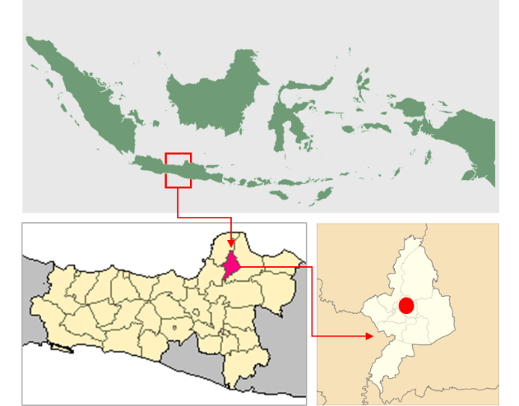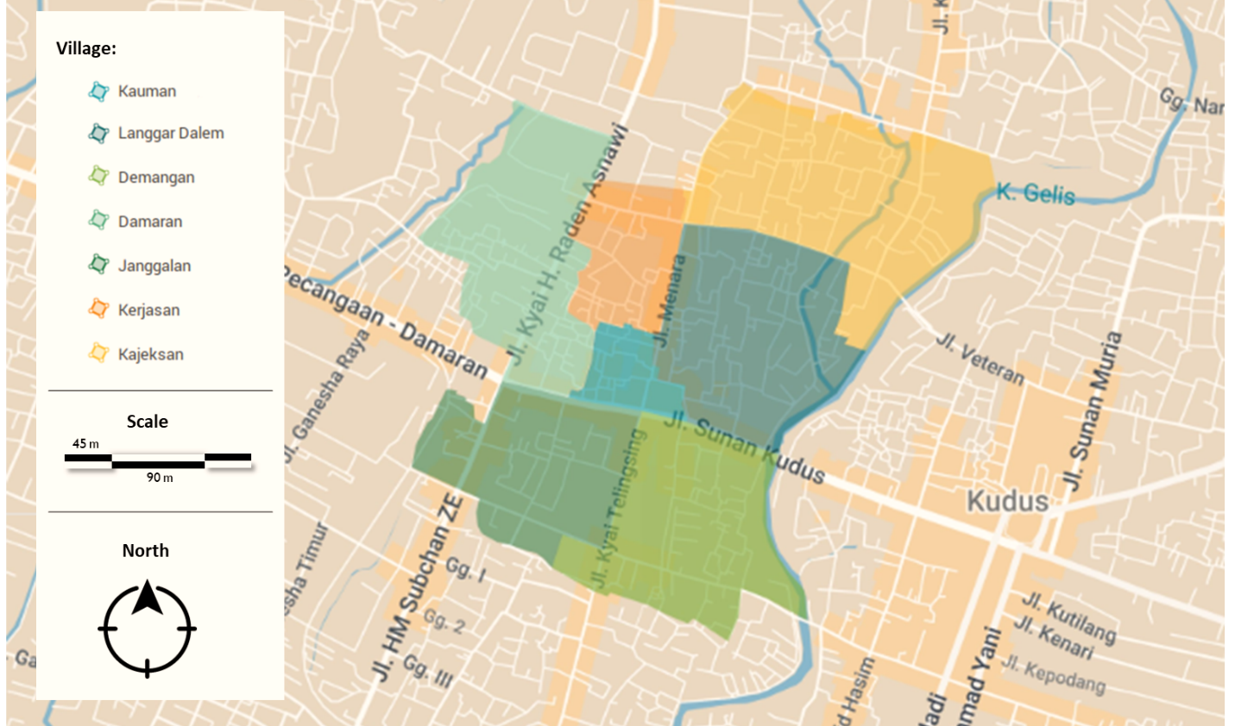
Source: Develop by author from Google Maps, 2024

Figure 1. Research location, Kudus Kulon administrative districts

Kudus Kulon’s rich historical narrative as a central site in the spread of Islam across Southeast Asia, coupled with its demonstrated cultural resilience in adapting traditions to contemporary challenges, exemplifies successful preservation efforts. These characteristics make it a standout case study for exploring the potential of living heritage conservation in historically rich Islamic districts. As a research location, Kudus Kulon covers several seven administrative village areas namely Kauman, Langgardalem, Demangan, Damaran, Janggalan, Kerjasan and Kajeksan (Figure 1). All of these areas are in Kudus urban areas with relatively flat topography. The type of land use is dominated by buildings with residential and commercial functions. Despite being situated in a dense and modern urban setting, Kudus Kulon demonstrates cultural resilience through the sustained practice of intangible heritage. This is evident in annual traditions such as Dandangan, the Buka Luwur ceremony for Sunan Kudus, Jamas Pusaka rituals and pilgrimage to ancestral graves, which continue to reinforce communal identity and spiritual continuity.
Field observations are used to gain an in-depth understanding of Kudus Kulon, especially regarding the physical conditions of the environment, procedures for implementing cultural traditions, as well as the characteristics of the places where these traditions take place. This observation process involves observation, field notes, audio recording, grouping data and reflection. Another data collection strategy is interviewing various backgrounds key informants who understood Kudus Kulon and were actively involved in cultural heritage preservation (see Table 1). The interviews are investigating how the community is involved in cultural heritage preservation with certain criteria. Key informants in the category of public figures and community; one informant for each village. Meanwhile, local governments and non-governmental organizations are selected based on their roles and understandings of cultural heritage preservation. This method is in line with the mixed-methods approach developed by Ramli et al. (2024), which demonstrated the effectiveness of integrating in-depth interviews and field observations.

Table. 1 Key informant

Informant category | Criteria | Number of informants
Public figures | - Religious care takers | 7 people
 | - Cultural agent | 7 people
People and community | - Inhabitant | 7 people
 | - Local community | 7 people
Local government | - Department of Tourism and Culture | 1 people
 | - Cultural council | 1 people
Non Govermental Organization (NGO) | - YM3SK - Sunan Kudus foundation (Yayasan Masjid Menara dan Makam Sunan Kudus) | 1 people
 | - Komunitas cerita Kudus Tuwa (An independent cultural walking tour community) | 1 people
Total key informant |  | 32 people
Source: Author, 2024

The selection of 32 respondents is considered sufficient to achieve data saturation, as it encompasses diverse stakeholder groups including community leaders, local residents, government representatives and NGOs who are directly involved in cultural heritage preservation. Saturation was reached when recurring themes, practices and perspectives consistently emerged across villages, with no significant new information arising in the final interviews. This aligns with qualitative research standards, where saturation is typically achieved within 20–30 interviews depending on the complexity and heterogeneity of the topic (Guest et al., 2006).
This article is qualitative exploratory research that seeks to uncover new insights, solve problems and provide a deep understanding of a complex social phenomenon in Islamic historic district Kudus Kulon. Explorative research could establish relationships between theoretical frameworks and real-world phenomena, especially when the understanding of a social issue is considered unclear (Aithal & Aithal, 2023). Based on this, exploratory is increasingly recommended on new research themes and approaches problems from a fresh perspective (Mason et al., 2010). Figure 2 below presents the research design for this article

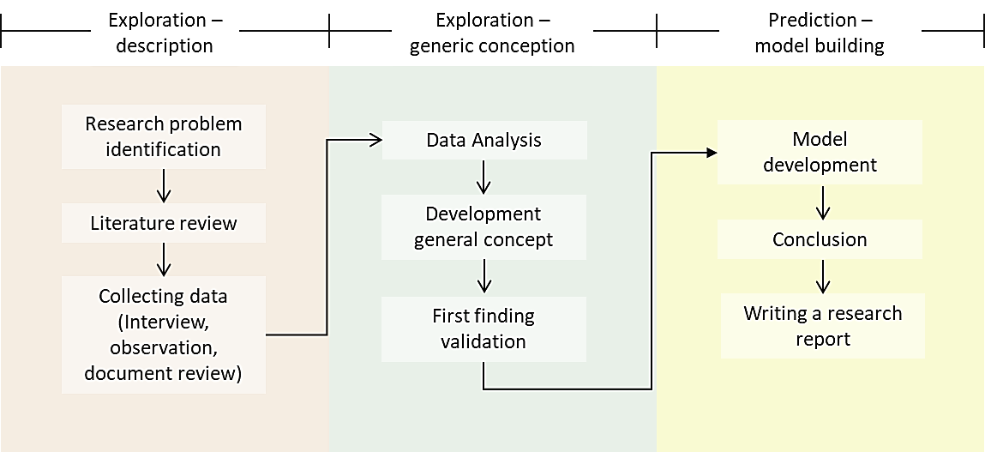
Source: Developed by author from Stebbins, 2001

Figure 2. The research design

This research begins with the process of identifying phenomena or problems related to human interaction, their activities and cultural heritage practice in Kudus Kulon. Literature review is taken at the next stage as the researcher's background knowledge and confirms the novelty of the research, particularly in linking cultural resilience with urban heritage dynamics. As expressed by (Stebbins, 2001) in exploratory research, literature reviews serve to justify an exploratory approach that is more open and not bound by previous theories or findings. In this study, semi-structured observation was conducted during local rituals such as Dandangan and Buka Luwur Sunan Kudus. Document analysis included archival records and visual documentation of heritage sites. Data were analyzed qualitatively to identify recurring patterns in spatial use and cultural continuity. A categorization analysis was employed to classify cultural heritage items in Kudus Kulon based on their form and continuity status. This matrix-based approach enabled the identification of patterns and gaps in heritage preservation, which informed the development of a community-centered living heritage concept. The interpretation of findings led to the formulation preliminary hypothesis regarding the role of heritage in sustaining community identity amid urban transformation. This is in accordance with the nature of the exploratory research that guide further inquiry into the reliability of observed associations.

Results and discussion

An overview of tangible and intangible Kudus Kulon cultural heritage

The interconnectedness of tangible and intangible heritage is fundamental to strengthening the identity of Kudus Kulon. Tangible cultural heritage, such as monuments, buildings and objects, is closely related to intangible cultural heritage, which includes traditions, practices and knowledge. This interconnection is essential for understanding the cultural landscape and local identity, emphasizing the need for a comprehensive assessment of both tangible and intangible heritage (Daly, 2014; Indera & Yahaya, 2016). Based on this, tangible and intangible heritage in Kudus Kulon in this study is considered the main research variable that can direct researchers in exploring the role of the Muslim community and its cultural continuity. The analysis in this study will focus on Kudus Kulon's cultural heritage which has been registered as a national and regional heritage as presented in Table 2 below.

Table 2. Tangible and intangible heritage of Kudus Kulon

Name of heritage | Brief description
Joglo Pencu – (traditional skill and wood carving of Kudus Traditional House)
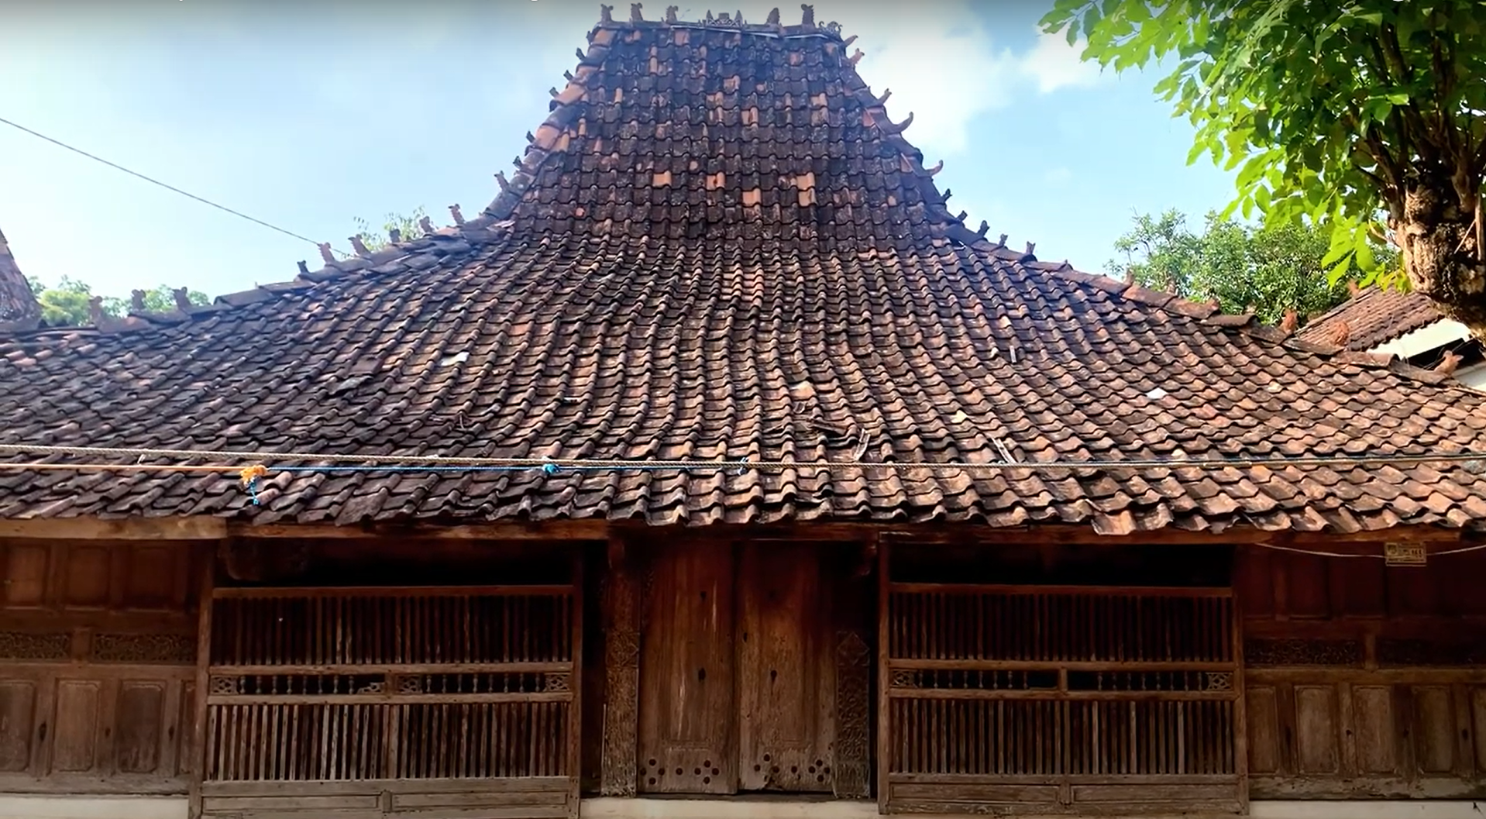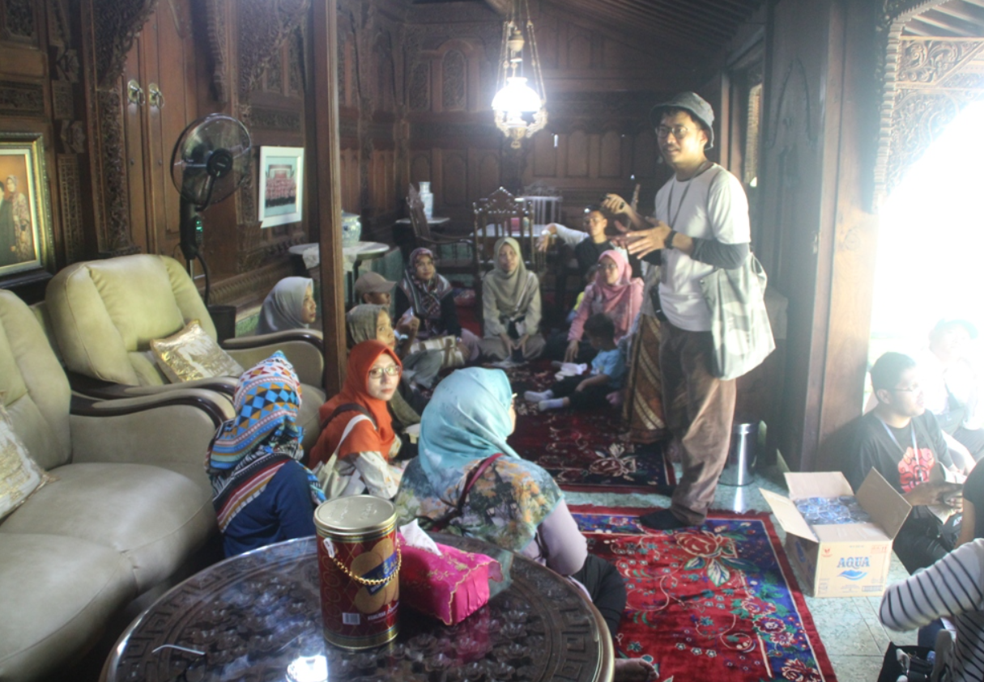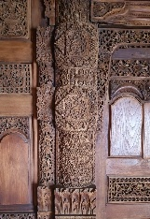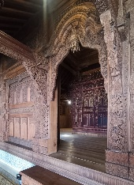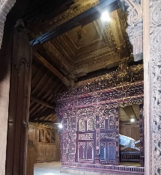
Type of heritage | Joglo Pencu falls into two categories of heritage, both tangible and intangible heritage. The traditional skill and wood carving of Kudus Traditional House was registered as National Intangible heritage with the number REK/WBTB/2016/01/00070. Meanwhile, the traditional house building is designated as an intangible heritage. One of the Joglo Pencu belonging to the Fathkawati Family is registered as a cultural heritage building legally stipulated through the decree of the Regent of Kudus number 432.2/220/2023 concerning the determination of district-level cultural heritage buildings
Function | The main function of this building is as a residence that has been inhabited by several generations. Due to its status as a cultural heritage building, this house attracts the attention of many visitors and researchers. Despite being private property, homeowners are open to research activities and knowledge sharing
Frequency | All the time
Actor | Building owner, researcher, community
Threat | Building maintenance is carried out independently by the owner, both in terms of financing and the preservation methods applied. The government's involvement is limited to the process of determining the status of buildings as cultural heritage
Ta’sis Menara Celebration
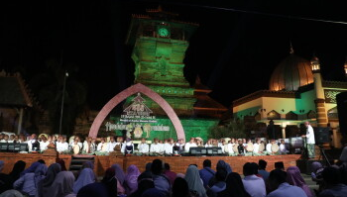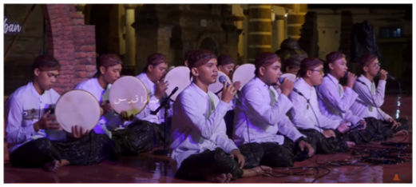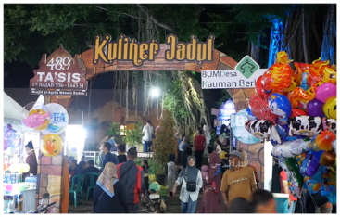
Type of heritage | Although it is listed in the Decree of the Sacred Regent number 32 of 2023 as an intangible cultural heritage, the Ta'sis Menara Celebration does not meet the requirements to be submitted as a national intangible cultural heritage
Function | This event sequence consists of traditional food bazar, khatam (the practice of completing the recitation) Al-Qur’an (the main religious text of Islam), punden (an area where tomb/tombs Kudus religious figure has placed) and belik (a source of spring water that is considered sacred by the local community), calligraphy and macapat (traditional form of Javanese poetry, often presented as songs or chants) competition, colossal tambourine performance, public religious forum, Indonesian mosque council forum and international cultural and religious performance
Frequency | Annual - five consecutive days
Actor | YM3SK (Sunan Kudus Foundation)
Threat | Although it is not rooted in the teachings of Sunan Kudus in the past, this annual celebration is a momentum that has become the agenda of the Kudus Kulon community which is a symbol of togetherness and collective identity that accommodates the potential of the local economy as well as an intellectual and spiritual discussion forum
Buka Luwur ceremony
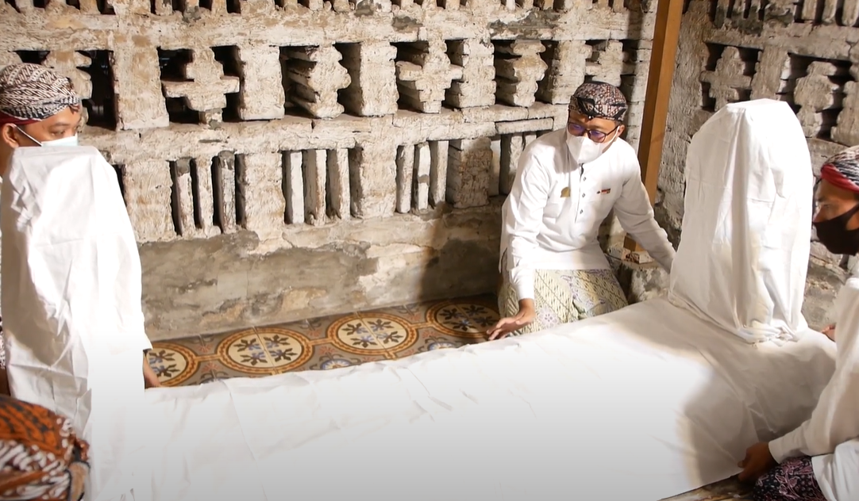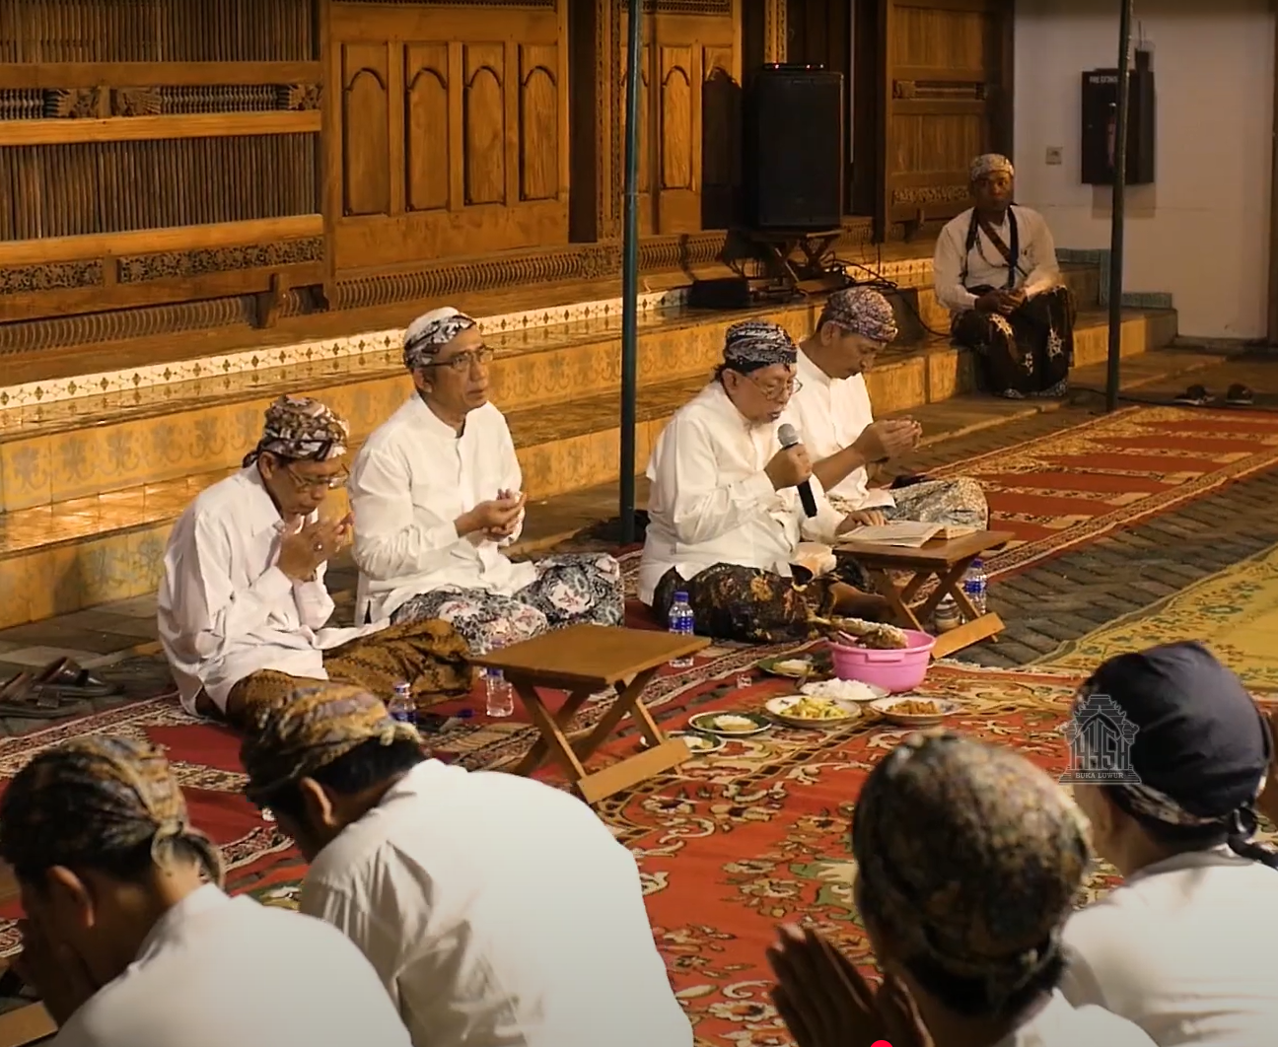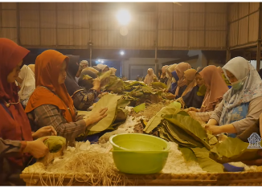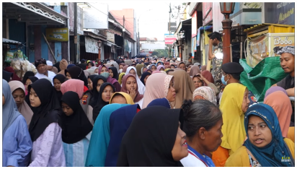
Type of heritage | Buka Luwur ceremony registered as national intangible heritage by Indonesian Cultural Minister’s Decree No 414/P/2022 that consisted of various activities that contained high social, cultural and religious values. Such as the process of replacing luwur and the process of preparing thousand packs of sego jangkrik, Sunan Kudus favourite dish that consists of white rice and some slices traditionally cooked buffalo meat. Those two cultural events involve collaboration and unwritten knowledge sharing among generations and compliance with tradition
Function | The ceremony, which was driven by YM3SK, involved more than 500 people (based on interview) who were volunteers consisting of the community and communities based on crowd funding as a charity from the private sector and peoples. The Buka Luwur ceremony shows the great potential of community participation in supporting intangible heritage preservation activities that create a new model where charity and philanthropy become part of tradition
Frequency | Annual – ten consecutive days
Actor | YM3SK, community, inhabitant, local government, privat sector as event sponsor, Islamic figure, visitor, pilgrims and volunteers
Threat | The Buka Luwur ceremony shows the great potential of community participation in supporting intangible heritage preservation activities that create a new model where charity and philanthropy become part of tradition. But this intangible heritage faced a significant threat. The increasing number of visitors and business actors during the event has the potential to shift the focus from spiritual values to economic aspects
Jamasan Keris Cinthoko
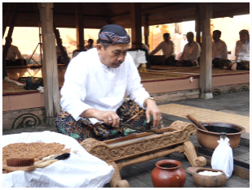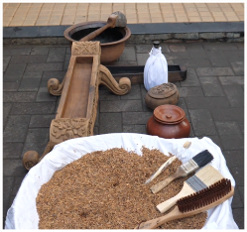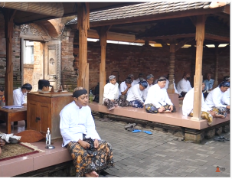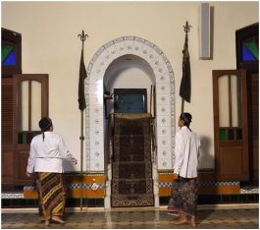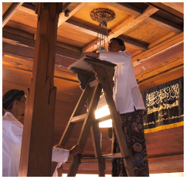
Type of heritage | Jamasan Pusaka Keris Cinthoko registered as national intangible heritage based on Indonesian Cultural Minister’s Decree No 372/M/2021. Jamasan is a javanese sacred ritual to clean up the heirloom. Keris cinthoko is a called for a traditional weapon from Kudus Kulon that believed has owned by Sunan Kudus. This ritual is held every year as a part of Buka Luwur Sunan Kudus ceremony and will be led by cultural care takers where it takes place in Sunan Kudus tomb area
Function | The main function of this tradition is to preserve the heirloom from corrotion. There was no significance change on every step on this sacred procession that attended by social figure, community representatives, local governments, religious figure and caretakes and local business owner who lives near Menara Mosque
Frequency | Annual – 1 Muharam (Month in Islamic calendar)
Actor | Heirloom care taker, YM3SK, social figure, community representatives, local governments, religious figure and caretakes and local business owner who lives near Menara Mosque
Threat | There was no significance change on every step on this sacred procession. Only male representatives and committee will be allowed join to this sacred ritual. This condition shows the male symbolics role in Javanese cultural tradition and cross sectoral collaboration in preserving authenticity of tradition which will lead to the resilience of the cultural identity of the Kudus community. In traditional Javanese cosmology, male figures are often associated with authority, protection and spiritual guardianship, especially in rituals involving sacred heirlooms (pusaka) and ancestral veneration. While men dominate the ritualistic and symbolic space, women may still play supporting roles in preparation, hospitality and community coordination though these contributions are often less visible or formally acknowledged
Dandangan cultural festival
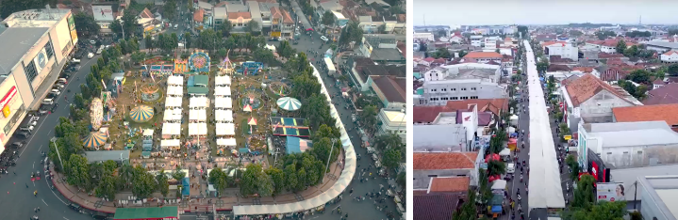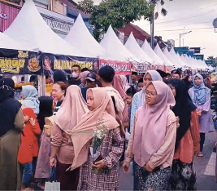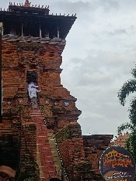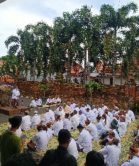
Type of heritage | Dandangan cultural festival is registered as national intangible heritage number REK/WBTB/2021/01/00165. The rituals that take place in Menara Mouse complex. The socio-cultural festival takes place in Menara Park, every night during the festival. The night market placed along Sunan Kudus Road
Function | The tradition of beating bedug (a traditional drum made of animal skin and wooden frame) of Menara Mosque is a method established by Sunan Kudus to inform people about the first day of Ramadhan (a holy month for Muslim do to fasting in a whole month). The bedug that beat in the last day in the Dandangan event sequence is starts with a ritual, communal praying at Sunan Kudus tomb, having traditional meal together (regent, religious figure, religious caretaker, community figure, head village, community representatives and inhabitant who lives near Menara Mosque)
Frequency | Annual – during 10 days before 1 Ramadhan
Actor | Kudus District Govement, Industrial and Tradding Department, Cultural and Tourism Department, Transportation Department, Police Department, YM3SK, local community, local artist
Threat | Based on the record of Industrial and Tradding Department of Kudus District, in 2023 Dandangan involved 620 traders at the night market which was held on a 2 km protocol road that was converted into a trading area from 4 pm – midnight). This is a challenge for the local government to make several adjustments such as modifying traffic flow, using pedestrian lanes for trading and traffic congestion. Dandangan has evolved from cultural tradition into yearly momentum to maintain Kudus Kulon cultural identity, local economy and facing the challenges of modernization in a unique way
Menara Kudus Mosque and Sunan Kudus Tomb Complex
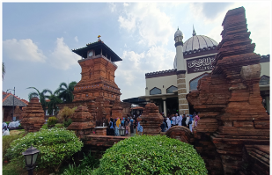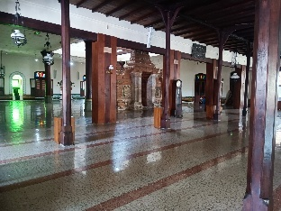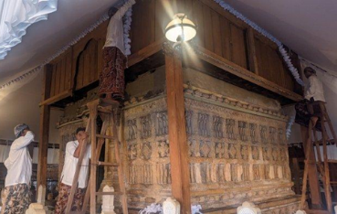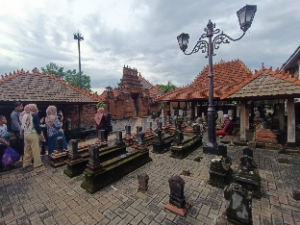
Type of heritage | Menara Kudus Mosque and Sunan Kudus Tomb Complex was registered as national intangible heritage site number CB.5050.19700101.00427. An ancient mosque built in 1549 combining Javanese and Islamic architectural styles, symbolizing Kudus' history where Sunan Kudus tomb and other religious figure (which are Sunan Kudus student) tombs located. From the old town centre to the main pilgrimage destination in Kudus City as a form of respect for Sunan Kudus as a religious figure
Function | The main functions of this heritage site are places of worship and religious tourist destinations. However, various social activities such as compensation for orphans, islamic studies, reciting Al-Quran, commemoration of Islamic holidays (Hijri New Year, Maulid Nabi, Eid al-Fitr, Eid al-Adha
Frequency | All the time
Actor | Mosque care taker, Sunan Kudus tomb complex care taker, YM3SK, Moslem community, pilgrims, inhabitant, local government.
Threat | The heritage site has evolved, developed and is at risk of changing its spatial character due to capitalism and modernization. This area becomes “a main stage” of social, cultural and religious event. spatial transformation, cultural preservation and religious identity for Kudus Kulon community. The main threat of this heritage site is spatial transformation and commercial encroachment that caused by capitalist development pressures such as tourism infrastructure and retail expansion that reshaping the physical layout of Kudus Kulon
Langgar Bubrah
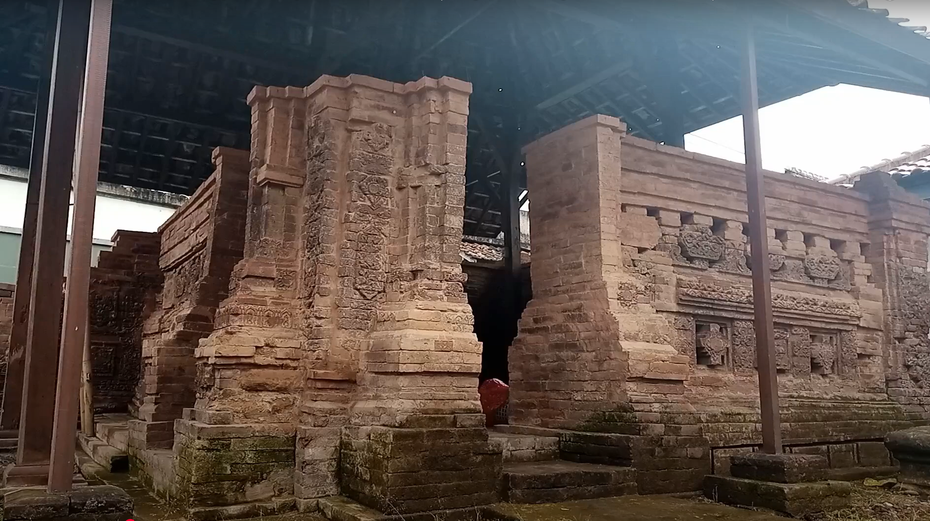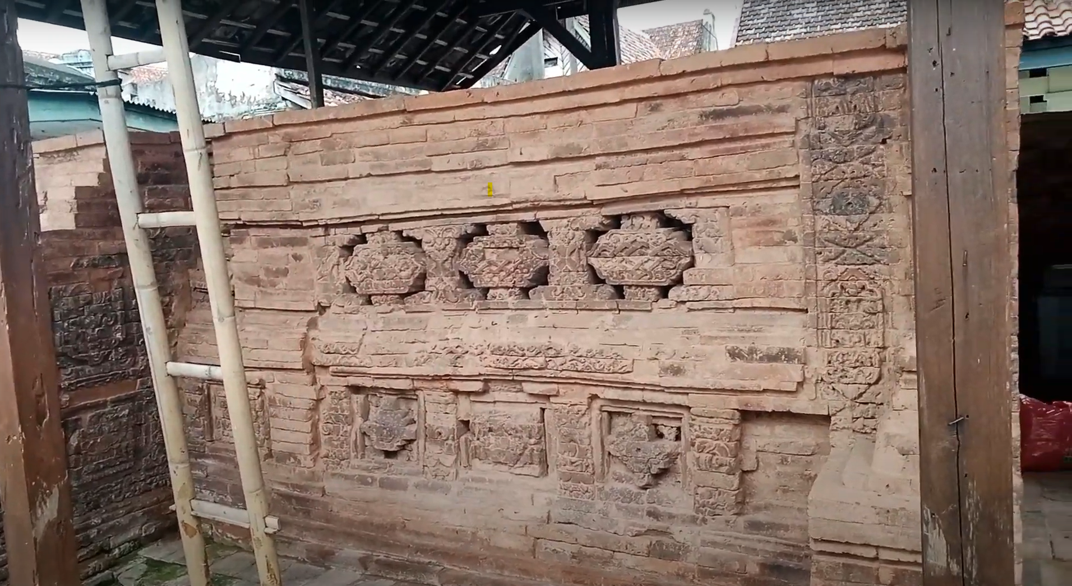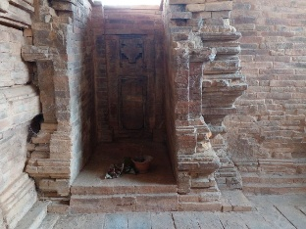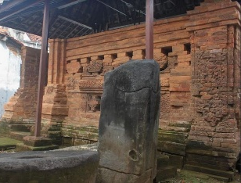
Type of heritage | Langgar Bubrah is a megalithic artefact that was built before Sunan Kudus era in 15 centuries. This historical structure, part of the rich Islamic heritage in Kudus registered as heritage structure at province level by Center for Preservation and Management of Archaeological Heritage, Central Java, decree no 988/02.SP/BP3/P.IX/2006
Function | Based on interviews and observations of the shape and location of the building, Langgar Bubrah is strongly suspected to be a relic of a place of worship or a worship building belonging to the Hindu community that had settled in the Kudus area before the entry of Islam. As the local Islamic tradition developed, this building then underwent a process of adaptation and reinterpretation, so that it became part of the spiritual narrative of the Islamic community in Kudus. The structure was not used to perform worship for Muslims either in the past or today
Frequency | All the time
Actor | Local goverment
Threat | Langgar Bubrah, which was once believed to be part of the early traces of the spirituality of the holy people, now faces the threat of weathering its meaning due to no longer being actively functioned in religious and social life. Without community involvement, the site slowly turned into a passive monument visited by only a handful of people, risking becoming a silent artifact that lost relevance in the collective memory
Langgardalem Mosque
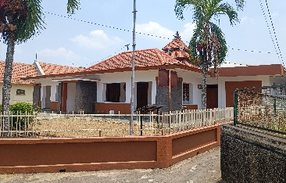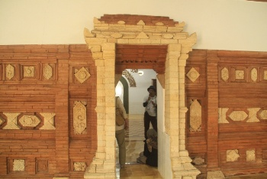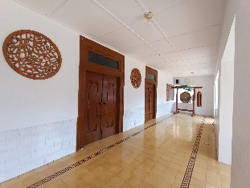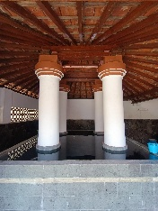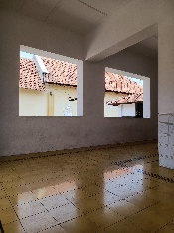
Type of heritage | Langgardalem Mosque was registered as heritage building at provice level with numbers CB.6060.1970.0101.01538 that representing traditional Islamic architecture. Local community belief this building was Sunan Kudus previous place to stay and a private mosque that located the middle of neighbourhood and 200 meters from Menara Mosque
Function | This mosque was built in 1480 and still use as a worship place, socio-cultural space for community to do religious activity or discuss issue in contemporary world casually. This mosque has undergone several changes in the physical shape of its building in the past and now 95 percent of its authenticity has been successfully preserved
Frequency | All the time – The inner prayer room is always locked and only open at certain times according to the five-time prayer schedule
Actor | Mosque care taker, inhabitant
Threat | The inner prayer room that is always locked and only opened during prayer time can create an impression of exclusivity and reduce the emotional connection of the community with the sacred space

The results of the analysis of each of the above cultural heritage implicitly show the existence of a hierarchy, namely at the regional and local levels, which reflects the functional and symbolic relationship between various tangible and intangible elements that form the social, religious and cultural identity of the Kudus Kulon Community. The hierarchy is defined according to the dimensions of spiritual significance, heritage continuity and social participation. As a cultural heritage, the Mosque Tower and the Tomb of Sunan Kudus occupy the top of the hierarchy based on its role as a spiritual center, Islamic History in Kudus and the main symbol of the spread of Islam. Spatially, the complex is the main space for social and religious activities in Kudus Kulon. Intangible heritage such as the iftar ceremony and the Ta'sis celebration of the Menara strengthens the position of the Menara Mosque which creates a space for collaboration and dialogue across generations that strengthens the aspect of spirituality that supports social interaction and knowledge transfer. On the other hand, the dandangan festival occupies an important position for its role in strengthening local social and economic cohesion through a communal event that unites the community while maintaining religious traditions. The following table summarizes the relative positions of these heritage elements within the cultural hierarchy, based on their symbolic, functional and participatory significance.

Table 3. The visitors and heritage preservation budget source

Site / Event | Visitor number | Budget source
Menara Mosque and Sunan Kudus tomb complex | ±1,500 visitors per week; daily and Friday prayers. The peak visitor on cultural and religious event | Sponsorship, charity, national budget, regional budget, foundation budget
Joglo Pencu traditional hourse | 6 residents; 1 – 20/visit by permit | Personal funding
Langgardalem Mosque | ± 50 whorshipers/day; | Sponsorship, charity, regional budget
Langgar Bubrah | Limited visit (mostly researcher, heritage tours) | Regional budget
Buka Luwur Ceremony | ± 5000 participants annually | Sponsorship, charity, foundation budget
Dandangan Festival | ± 8000 participants annually | Regional budget, sponsorship
Jamasan Ketis Cinthoko Ritual | ± 500 participants annually | Sponsorship, charity, foundation budget
Ta’sis Menara Celebration | ± 3000 participants annually | Sponsorship, charity, foundation budget
Traditional Craftsmanship Skill (Joglo Pencu Construction) | <10 active craftsmen; occasional restoration works | Personal funding
Source: Interview, 2025

In local level, tangible heritage Langgar Dalem Mosque play an important role as a neighborhood-scale place for daily worship and a center for the community. Although its activities are realtively modest and primarily serve nearby household for daily prayes, the mosque remains an integral part of the local religious favric. Most large-scale gathering and public religious teaching, however, are concentrated at The Menara Mosque that located 300 meters away. his spatial proximity reflects a complementary relationship between the two, where the Langgar Dalem functions as a familiar and intimate spiritual space that sustains everyday worship, while the Menara Mosque serves as the main locus of communal devotion and broader religious identity in Kudus Kulon
It is different with Jamasan Keris Cinthoko, although it focuses on spiritual and physical care of Sunan Kudus' heritage. Traditional skill and wood carving of Kudus Kulon traditional house as intangible heritage also has significance in preserving local wisdom that is full of philosophy, even though it is threatened by modernization and capitalism. The Joglo Pencu traditional house, along with its associated wood-carving skills, faces a visible decline as modernization and market pressures reduce the number of skilled craftsmen. One local artisan explained that “young people prefer factory jobs; carving is too slow to earn a living,” illustrating the tension between cultural continuity and economic survival.
Despite these challenges, the traditional craftsmanship still embodies deep philosophical values of patience, harmony and devotion embedded in Kudus Kulon’s local wisdom. To sustain this heritage, practical interventions such as training programs for young artisans, local government subsidies for restoration projects and the development of heritage branding for Kudus’s woodcraft could strengthen both cultural resilience and creative economy. Importantly, women’s participation in religious events and community education programs highlights an inclusive dimension of cultural life, ensuring that heritage transmission remains collective and intergenerational. As an interconnected whole, these tangible and intangible elements form a living network that keeps the spiritual and cultural identity of Kudus Kulon alive amid rapid change.
As a holistic unit, each element of cultural heritage forms an integrated and mutually supportive network that holds the cultural and spiritual identity of Kudus Kulon alive and relevant in the middle of rapid change. The strong connection between the Kudus Kulon community and the Menara Mosque Tomb complex reflects not only a historical bond but also a deeply rooted spiritual relationship that continues to shape local identity. The site functions as a sacred center where daily worship and pilgrimage intersect, embodying a sense of devotion that binds people to both their faith and their shared past. Within this space, the Menara Mosque represents the living presence of belief in everyday life, while the Tomb of Sunan Kudus serves as a locus of remembrance that links personal piety with collective memory. This encounter between worship, history and heritage turns the complex into a space of mediation between humans and the Divinean enduring symbol of how spirituality sustains social continuity and cultural meaning (Eliade, 1959; Smith et al., 2017). In this sense, the heritage value of the complex transcends its architectural form, evolving instead through the lived experiences and rituals that reaffirm the community’s faith and sense of belonging (Harrison, 2012).

The dialogue between tangible and intangible heritage of Kudus Kulon

Heritage – the cultural heritage that has been reviewed in the previous section is classified in four quadrants according to their character and places the aspect of continuity as a key analytical variable. This pers[ective follows the living heritage approach proposed by (Poulios, 2015), which emphasizes the ongoing relationship between people and heritage rather than static preservation of material form. Continuity of living heritage is interpreted through this dimensions: he continuity of original function (the sustained religious or social use of heritage), the continuity of community connection (the active participation of local communities in maintaining meaning and use), the continuity of spatial and cultural expression (the evolving yet recognizable form of rituals and spaces) and the continuity of care or maintenance systems (the community-based practices that ensure heritage survival over time).
The classification of cultural heritage in Kudus Kulon shows (see figure 3) the unique conservation dynamics between tangible heritage and intangible heritage that describe the challenges and opportunities in each quadrant. Each heritage was placed within the quadrants based on field observation, interview evidence and indicator of ritual frequency, stakeholder involvement and intergenerational transmission. This framework provides a strong and comprehensive perspective in understanding how the living heritage of Kudus Kulon continues to adapt while preserving its spiritual and cultural essence.

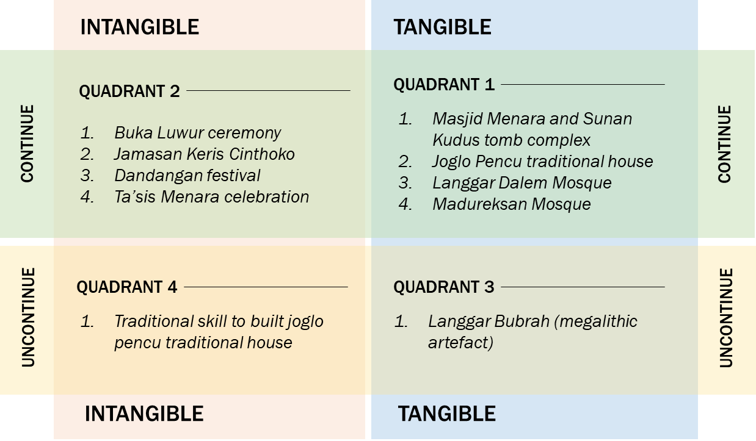
Source: Authors, 2025

Figure 3. The heritage classification of Kudus Kulon

Through analysis for each quadrant, specific themes that can serve as a foundation in developing the concept of living heritage and preservation of cultural heritage in the Kudus Kulon area emerge.
- Quadrant 1. The 'living' tangible heritage such as the Menara Mosque and Sunan Kudus Tomb complex -acts as a social link between the community, local communities, NGOs, the government and the private sector through communal activities, traditional celebrations, ceremonies and worship. The living term is related to the livable condition, continuity on its function and maintenance. These sites have high spatial value as symbolic and spiritual spaces that are well maintained with spatial dimensions that are still utilized and relevant to the contemporary world. In addition, a strong emotional bond between the community and heritage sites can enhance identity and foster local pride based on Islamic values, socio-cultural values. Based on interview, Menara Mosque hosts daily, weekly, monthly and annual religious gatherings with consistent participatioan across generation.
- Quadrant 2. The continuity of intangible traditions sucg as the Dandangan Festival, Buka Luwur, Ta’sis Menara Celebration strengthens social cohesion through the collective participation of the community through annual ritual. The tradition is held in flexible open spaces that can adjust to the needs of the celebration of activities. Public spaces will be transformed into centers of celebration and social spaces. The key informant mentioned that more than 2000 people attend that annual event which coordinated by local committees. Thus, the spaces where the tradition is held are dynamic that strengthen social interaction that builds social solidarity and strengthens the sense of togetherness between the Muslim and non-Muslim communities. These traditions create a sense of emotional and spiritual unity among the community.
- Quadrant 3. Tangible heritage artefact such as the Langgar Bubrah is slowly losing its relevance in society due to the disconnection of social ties with heritage because heritage is not used as a center for socio-cultural activities. The site location near active public areas leadks to the concentration of activities elsewhere, while the heritage structure itself functions only as a secondary visual element. Local informants express that the site is rarely visited except during heritage tour, school excursions or preservation prooject. This quadrant represent heritage at risk of functional obsolescence, requiring signage improvement and awareness campaigns to reactivate public interest.
- Quadrant 4. Intangible heritage such as the traditional skill of Joglo Pencu house building and wood carving faces significant decline. The younger generation uninterested to learn this crafts, partly due to limited spatial context and the lack of practice space. The gradual disappearance of this knowledge indicates a serious intergenerational gap. Senior artisans express concern that “once the old masters are gone, the skill will die with them.” To counter this, apprenticeships, documentation and market-based incentives are essential to ensure the continuity of craftsmanship as part of Kudus Kulon’s living heritage.
In summary, each quadrant implies a distinct conservation priority: protection and stewardship for living tangibles (Q1); event governance and anti-commodification measures for public traditions (Q2); adaptive reuse and awareness campaigns for underused tangibles (Q3); and apprenticeships, documentation and market incentives for at-risk intangible skills (Q4). Integrating these tailored strategies within a living heritage framework ensures that both tangible and intangible elements remain interdependent, sustaining Kudus Kulon’s cultural identity in a balanced and resilient way.
The description above shows that the preservation of cultural heritage in Kudus Kulon faces challenges in the contemporary world, especially in the spatial, social and psychological dimensions. The dynamics of heritage preservation above show that the continuity of heritage depends on social involvement, space utilization and psychological attachment of the community. In this study, the psychological dimension was identified qualitatively through field observations and intervews that captured people’s emotional engagement and voluntary participation. Indicators include the consistent attendance of residents at annual religious or cultural events, the involvement of local volunteers in organizing and maintaining ceremonies without financial incentives and expressions of pride and belonging associated with heritage sites. These behavioral manifestations are understood as forms of psychological continuity, showing that people’s attachment is sustained through active participation and shared experience rather than verbal declarations alone. Maintaining these three dimensions in a balanced way means preserving heritage to remail alive in the contemporary world. On the other hand, an endangered heritage refers to heritage that begin to lose their social relevance, spatial function and psychological resonance within the community.

The living heritage concept of Kudus Kulon district

The dynamics of preserving the tangible and intangible heritage of Kudus Kulon demonstrate that the living dimension of heritage has an important role to ensuring the continuity of cultural life within historically significant districts. The living dimension underscores the importance of community involvement in the preservation and transmission of cultural practices and values over time. Living heritage, which includes both tangible and intangible cultural elements, evolves trough the active participation and adaptation of the community that maintain and reinterprets theis traditions across generation. This perspective is in line with the concept of living heritage proposed by previous researchers that community and continuity are the defining keywords (Poulios, 2015; Stovel et al., 2005; Wijesuriya, 2016), which emphasize community and continuity as defining principles. However, the Kudus Kulon model enriches the global concept of living heritage – originally framed by UNESCO for World Heritage contexts by grounding it within a localized, community based Islamic setting. The model introduces three interrelated dimensions of cultural continuity that reflect how the Muslim community experiences and sustains its heritage in daily life:
- Social dimension, expressed through social cohesion, collective participation, cross-generational regeneration and knowledge transfer;
- Spatial dimension, manifested in the use and revitalization of ritual and symbolic spaces that support communal interaction and worship; and
- Psychological dimension, observed through emotional attachment, spiritual meaning and a sense of pride and belonging.
In this study, continuity across these dimensions was identified through ethnographic observation and interviews evident in community attendance at annual religious events, voluntary participation in heritage maintenance and the continued use of sacred spaces for social interaction. This operationalization emphasizes that heritage remains “living” not merely through preservation of form, but through the sustained and evolving relationship between people, place and belief.
Visually, figure 4 captures the concept of community-centered living heritage framework integrating three dimensions: social, spatial dan psychological within a layered system of engagement. These dimensions are built based on the socio-cultural values of Muslim community and the socio-economic realities of heritage practice in the district. The Complex of the Menara Mosque and the Tomb of Sunan kudus serves as a core heritage site is a heart of Kudus Kulon. This core embodies tangible heritage as a spatial anchor for cultural practice, while intangible heritage which bring life and meaning to these spaces. This core is surrounded by three concentric layers of community engagement.
- The inner layer reflects heritage protection, encompassing the daily activities of caretakers (abdi dalem), mosque officials and local artisans who ensure the physical and ritual maintenance of the site.
- The middle layer denotes functional interaction, where residents, merchants and visitors participate in socio-economic and religious activities such as the Dandangan Festival or Friday market that sustain community life.
- The outer layer represents sustaining tradition, including cultural organizations, local foundation and educational institutions that promote intergenerational learning, craft training and public awareness.
The flows between layers, illustrated in Figure 4, signify the observable exchanges of participation, resources and decision-making that connect different community groups. These flows were identified through field observation and interviews evident in shared management meetings, volunteer mobilization and collaborative event organization.In line with the previous living heritage concept, core community is attached to the core heritage site (Poulios, 2011), but the difference is the component of core community. In Kudus Kulon case, core community is group of Muslims consisting of inhabitant, religious and cultural care takers and the foundation namely Menara Mosque and Sunan Kudus Tomb Foundation (Yayasan Masjid Menara dan Makam Sunan Kudus – YM3SK) that have active role in both preserving and living the heritage. The foundation collaborates with the local government on spatial regulation and tourism coordination, while local residents contribute labor and religious participation. This structure creates a hybrid governance model where community leadership remains central but receives institutional support.

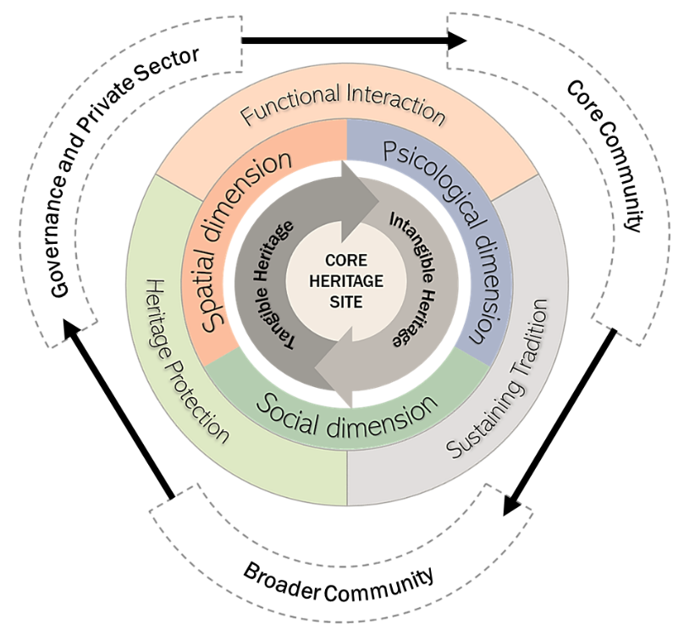
Source: Authors, 2025

Figure 4. The concept of community-centered living heritage

Even though the Dynamic Model of Community-Centered Living Heritage was developed from the experience of the Muslim community in north coastal Java, Indonesia, its conceptual insight may be relevant to other districts t where cohesion is found between the core community and a broader community that is supported actively by governance and the private sector participation. However, as a single case study, this model’s transferability remains context-dependent. Its applicability presupposes several enabling conditions: the presence of a faith -based or culturally cohesive community, a semi formal organizational structure (like local foundation), supportive heritage policies and a balanced local economy that allows voluntary participation in preservation practices. This concept complements previous work on the concept of continuity and change in Kudus Kulon (Wulandari et al., 2024) that extends the understanding of living heritage by introducing the idea of continuous and circular interaction between three dimensions as an integrated approach to understand the engagement between communities and heritage emotionally and socially.
The psychological dimension introduced in this model provides recognition of the inheritance's attachment to the practice of preservation, about maintaining physical space while fostering a sense of belonging, identity and emotional connection. This provides an explanation for why certain traditions can survive even if their environment changes because they have deep psychological and emotional meaning for peoples. Another ability of this model lies in the aspect that the functional interactions will articulate better the different generations and communities collaborated in tangible ways, through regular events, rituals, communal traditions and cooperative governance to sustain their cultural heritage as emphasized by a number of researchers about the importance of the framework of cultural sustainability in the context of living heritage (Idris et al., 2021). Field observation also recorded continuity indicators such as consistent ritual attendance, stabel volunteer participation and ongoing transmission of cultural heritage knowledge.
Neverthless, the model’s scope is not without limitations. Its strength in explaining community-led continuity may not hold in context with weak social cohesion, fragmented religious authority or heavy dependence on external funding. Moreover, the process of formalizing heritage management through organization and events carries inherent risks; commercialization pressures, selective participation and gradual shift in meaning that mau redure rituals to performative displays. Recognizing these challenges positions the model not as a universal template but as a reflective tool for understanding how living heritage can succed or struggle under different socio cultural and governance conditions. Heritage preservation is not only limited to the practice of protecting artifacts, but also about maintaining the community's relationship with its cultural roots. This relational processm shaped by community aspirations and adaptive governance, makes the model dynamic yet contingent sustainable where participation is genuine, but vullnerable where meaning become commodified.

Conclusion

The model of community-centered living heritage developed in this study offers and integrated understanding of how social, spatial and psychological dimensions interact to sustain cultural heritage in Kudus Kulon’s Islamic historic district. Developed upon ethnographic observation, interviews and participatory mapping, the model demonstrates that social continuity is maintained throught collective rituals and intergenerational involvement. Spatial continuity is sustained by adaptive use of sacred and public spaces. Psychological continuity emerges from emotional attachment, pridem and spiritual meaning that conect people to place. The findings highlight how the core community (religious caretakers, local residents and the local foundation YM3SK) act as cultural custodian that bridges daily life and sacred heritage. Their cooperation reflects the values of Islam Nusantara, where faith, lacality and cultural adaptation intertwine to keep traditions relevant within modern urban life. Policy impications include the need for collaborative governance platforms that strengthen the institusional role of community foundation as mediators between local residents, government and other statkeholders. Rather than introducing new training or managerial interventions, policy support should focus on facilitating the continuity of establish tradition through spatial, financial and regulatory protection. This approach respects the semi-closed nature of the Kudus Kulon community in ritual practice, acknowledging that sustainability is best achived when the community remains the primary custodian and decision maker of its own cultural expressions. While the concept provides a useful framewordk to interpret continuity in Kudus Kulon, its application remains limited to single case study. Comparative research with other Muslim heritage districts in Java or Southeast Asia would help test its transferability and refine its indicators for broader use. I essence, the dynamic interaction observed in Kudus Kulon reveal that heritage endures not solely through physucal preservation, but through the lived practices, shared spaces and affective bonds that keep it alive and evolving amid urban transformation.

Acknowledgement

My sincere appreciation goes to Kudus Kulon local foundation namely YM3SK, Cultural and Education Board for Kudus district, Cerita Kudus Tuwa community, Kauman village administrative office, who generously shared their insights and knowledge of local heritage, enabling me to gain a deeper understanding of the rich cultural legacy in Kudus Kulon.

References

Aithal, P. S., & Aithal, S. (2023). New Research Models under Exploratory Research Method. In P. K. Paul et al. (Eds.), Emergence and Research in Interdisciplinary Management and Information Technology (Chapter 7, pp. 109-110). New Delhi Publishers.

Akhwan, M., Suyanto, S., & Purwanto, M. R. (2010). Pendidikan moral masyarakat Jawa (Studi nilai-nilai pendidikan moral dalam tradisi Ruwatan). Millah: Journal of Religious Studies, 9(2), 207–226.

Alshehaby, F. (2020). Cultural heritage protection in islamic tradition. International Journal of Cultural Property, 27(3), 291–322.

Anisa, A. (2018, Oktober 17). Kaitan antara Fungsi Ekonomi dengan Bentuk Fisik Lingkungan Disekitar Kompleks Masjid, Makan dan Menara Kudus Jawa Tengah. Prosiding Nasional Sains dan Teknologi (SEMNASTEK), Fakultas Teknik Universitas Muhammadiyah Jakarta.

Anisa, A., Ashadi, A., Lissimia, F., & Bimatukmaru, R. F. (2022). Exploration of spatial arrangement changes as a form of spatial sustainability in dwelling. Case study: Kilungan House in Kudus Old City, Indonesia. International Journal of Built Environment and Scientific Research, 6(2), 127-138.

Anisa, A., & Lissimia, F. (2020). The influence of historic buildings existence on economic development and regional arrangement: A case study of Menara kudus area, Indonesia. IOP Conference Series: Earth and Environmental Science, 452, 012018.

Daly, C. (2014). A framework for assessing the vulnerability of archaeological sites to climate change: Theory, development and application. Conservation and Management of Archaeological Sites, 16(3), 268–282.

Eliade, M. (1959). The Sacred and the Profane: The Nature of Religion (W. R. Trask, Trans.). Houghton Mifflin Harcourt.

Falaq, Y. (2022). The value of traditional social education “Bukak Luwur Sunan Kudus.” QALAMUNA: Jurnal Pendidikan, Sosial,dan Agama, 14(2), 299–310.

Guest, G., Bunce, A., & Johnson, L. (2006). How many interviews are enough?: An experiment with data saturation and variability. Field Methods, 18(1), 59–82.

Halim, V., Afini, N. A., Rahayu, P., & Septemuryantoro, S. A. (2022). Cultural acculluration in the architecture of the Kudus tower mosque. STRUKTURAL (Seminar on Translation, Applied Linguistics, Literature and Cultural Studies), 1(1), 395-399.

Hana, M. Y. (2018). Dinamika sosio-ekonomi pedagang santri dalam mengembangkan industri kretek di Kudus, 1912-1930. JUSPI (Jurnal Sejarah Peradaban Islam), 2(1), 15-35.

Hanafiah, M. H., Jamaluddin, M. R., & Riyadi, A. (2020). Local community support, attitude and perceived benefits in the UNESCO World Heritage Site. Journal of Cultural Heritage Management and Sustainable Development, 11(1), 95–108.

Harrison, R. (2012). Heritage: Critical Approaches. Routledge.

Holtorf, C. (2017, March 13). Conservation and Heritage as Future-Making. A contemporary provocation: reconstructions as tools of future-making, Paris.

Idris, N., Suzila, T. I., & Mohammad, L. M. (2021). The preservation of provincial identity in baroque influenced artistic architectural structure at Kampung Cina, Terengganu. Geografia-Malaysian Journal of Society and Space, 17(2), 432-446.

Indera, S. M. R., & Yahaya, A. (2016). Assessing cultural heritage potential: A framework to incorporate incentives programme into heritage management strategies. The Social Sciences, 11(12), 2916–2921.

Indrahti, S. (2012). Kudus dan Islam: Nilai-Nilai Budaya Lokal dan Industri Wisata Ziarah. CV. Madina.

Jamaludin, I. S., Seow, T. W., Mat Radzuan, I. S., Mohamed, S., & Abas, M. A. (2021). Conserving living heritage site in Portuguese settlement, Melaka world heritage site: Issues and conservation elements. IOP Conference Series: Earth and Environmental Science, 842(1), 012056.

Khalaf, R. W. (2020). The implementation of the UNESCO World Heritage Convention: continuity and compatibility as qualifying conditions of integrity. Heritage, 3(2), 384–401.

Khalaf, R. W. (2021). Continuity: A fundamental yet overlooked concept in World Heritage policy and practice. International Journal of Cultural Policy, 27(1), 102–116.

Khan, H.-U. (2015). Architectural conservation as a tool for culural continuity: A focus on the built environment of islam. ArchNet-IJAR: nternational Journal of Architectural Research, 9(1), 1-17.

Khotimah, N. (2018). Enkulturasi nilai-nilai kesejarahan Sunan Kudus pada masyarakat di daerah Kudus Kulon. Historia Pedagogia, 7(2), 120–128.

Luz, N. (2020). Pilgrimage and religious tourism in islam. Annals of Tourism Research, 82, 102915.

Marsono, Prihantara, F., Irawan, P., & Sari, Y. K. (2018). Dampak Pariwisata Religi Kawasan Masjid Sunan Kudus terhadap Ekonomi, Lingkungan dan Sosial-Budaya. UGM PRESS.

Muhammad, C. L., & Duderija, A. (2022). Understanding the context and concept of Islam Nusantara. ICR Journal, 13(1), 92–111.

Poulios, I. (2011). Is every heritage site a “Living” One? Linking Conservation to communities’ association with sites. The Historic Environment: Policy & Practice, 2(2), 144–156.

Poulios, I. (2015). The Past in the Present: A Living Heritage Approach - Meteora, Greece (1st ed., Vol. 17). Ubiquity Press Ltd.

Pujiyanto, M., Wasino, M., Astuti, T. M. P., & Utomo, C. B. (2019). Gusjigang: The entrepreneurship philosophy from Sunan Kudus. Proceedings of the International Conference on Rural Studies in Asia (ICoRSIA).

Qomar, M. (2019). Islam nusantara. Epistemé: Jurnal Pengembangan Ilmu Keislaman, 14(1), 131–150.

Ramli, R. R., Kamal, N. A., & ZafikK, N. N. K. (2024). The assessment of Royal Belum State Park as a World Heritage Site. Geografia-Malaysian Journal of Society and Space, 20(2), 82-94.

Rico, T. (Ed.). (2017). The Making of Islamic Heritage: Muslim Pasts and Heritage Presents. Springer Singapore.

Rico, T. (2019). Islam, heritage and preservation: An untidy tradition. Material Religion, 15(2), 148–163.

Ripp, M., & Rodwell, D. (2015). The geography of urban heritage. The Historic Environment: Policy & Practice, 6(3), 240–276.

Rosyadi, Z., Wafa, K., Muttaqin, A., & Nurngaini, I. (2021). Peran dan periodisasi Wali Songo dalam pengembangan budaya islam di Nusantara. SINDA: Comprehensive Journal of Islamic Social Studies, 1(3), 191–197.

Salam, F. A. (2024). To Whom does a living heritage belong? : Negotiations over the preservation of the ottoman legacy in Istanbul. Journal of the Council for Research on Religion, 5(1), 29–51.

Saunders, M., Lewis, P., & Thornhill, A. (2009). Research methods for business students (5th ed.). Financial Times Prentice Hall.

Smith, G. S., Messenger, P. M., & Soderland, H. A. (2017). Heritage Values in Contemporary Society. Routledge.

Stebbins, R. A. (2001). Exploratory Research in the Social Sciences (Volume 48). Sage Publications, Inc.

Stovel, H., Stanley-Price, N., & Killick, R. (2005). Conservation of living religious heritage. ICCROM 2003 Forum on Living Religious Heritage: conserving the sacred. ICCROM.

Suprapti. (2014). The Tradition of living muslim community Kudus Kulon. Journal of Social Sciences, 10(2), 63–73.

Suprapti, A. (2021). A living heritage approach toward sustainability of islamic city in the Northern Coastal of Java, Indonesia. Journal of Architectural Design and Urbanism, 4(1), 61–78.

Veldpaus, L., Pereira Roders, A. R., & Colenbrander, B. J. F. (2013). Urban heritage: Putting the past into the future. The Historic Environment: Policy & Practice, 4(1), 3–18.

Wijesuriya, G. (2016). Conserving living Taonga: The concept of continuity. In Decolonizing Conservation (1st ed., p. 11). Routledge.

Wikantari, R. R. (1995). Safeguarding a Living Heritage: A Model for the architectural Conservation of an historic Islamic district of Kudus, Indonesia [Unpublished thesis, University of Tasmania].

Wulandari, A., Suprapti, A., & Sardjono, A. B. (2024). Cultural continuity and change in Kudus Kulon: The urban heritage trialogue. Journal of City: Branding and Authenticity, 1(2).

Yin, R. K. (2018). Case study research and applications: Design and methods (6th ed.). SAGE publishing.

