Flood mitigation as social investment: Leveraging SROI for sustainable disaster management in Sungai Muda, Kedah

Dona Raihana Don Ramli, Kadaruddin Aiyub, Azahan Awang, Sarina Yusoff,
Mohamad Xazaquan Mansor Ali

Pusat Kajian Pembangunan, Sosial dan Persekitaran, Fakulti Sains Sosial dan Kemanusiaan, Universiti Kebangsaan Malaysia

Correspondence: Dona Raihana Don Ramli (email: donaraihana@ukm.edu.my)

Received: 12 July 2025; Accepted: 5 October 2025; Published: 20 November 2025

Abstract

Evaluating the value generated from the flood mitigation projects is crucial in assessing the effectiveness, efficiency and sustainability. The current economic landscapes have faced significant challenges, primarily due to resource scarcity coupled with escalating demands. This scenario has intensified pressure on disaster management, impacting both for-profit and nonprofit sectors. A significant obstacle in securing funding for these projects is the challenge of demonstrating their value, return on investment, particularly since the outcomes often pertain to "soft outcomes" or "intangible value," which are inherently difficult to quantify. Therefore, there is an increasing recognition to incorporate the three pillars of sustainability social, economic and environmental elements into every investment decision related to flood disaster management. This approach not only supports resilience and long-term impact but also aligns with Sustainable Development Goals (SDGs). This article investigates the Sungai Muda Flood Mitigation Project as a case study to evaluate the application of the Social Return on Investment (SROI) methodology. The findings markedly positive net social benefit, quantified as a social return value of RM4,892,641,540.00, indicating that the program generates RM4.88 in social benefits for every ringgit invested which consists of social, economic and environmental elements. This positions the project as a substantial social investment that yields significant measurable social value for individuals, communities and society at large. Consequently, the SROI framework emerges as an invaluable tool for stakeholders including government agencies, project managers, investors and corporate social responsibility initiatives seeking to assess sustainability from a financial approach. By fostering a holistic understanding of value in flood disaster management, stakeholders can make informed decisions that strengthen the performance and sustainability of their investments.

Keywords: Flood disaster management, flood mitigation projects, social investment, Social Return on Investment (SROI), three pillars of sustainability

Introduction

In the contemporary landscape, characterized by a heightened focus on flood mitigation projects, the Social Return on Investment (SROI) methodology emerges as a comprehensive approach for demonstrating value, aligning closely with the principles of the Sustainable Development Goals (SDGs) and the foundational three pillars of sustainability. The tripartite framework of sustainability, encompassing social, economic and environmental elements, symbolized by the intersecting circles model with overarching sustainability at its core, underscores the interconnected nature of sustainable development (Purvis et al., 2019). Internationally acknowledged as a stakeholder-driven approach, SROI evaluates the value generated by social programs, including flood mitigation efforts, by capturing the social value reflected in the changes stakeholders experience in their lives (Patil, 2023). Compared to conventional evaluations that focus on financial benefits, SROI offers a more comprehensive approach by integrating the assessment of social and environmental value generated from the investment (Pawley, 2023; Jenkins et al., 2017). Flooding in Malaysia has become increasingly frequent and destructive, with 836 flood events recorded in 2024 (JPS, 2024), resulting in total flood-related losses of RM933.4 million (NADMA, 2025) and affecting approximately 123,729 people (AstroAwani, 2024). These statistics underscore the urgency of developing effective and sustainable flood mitigation strategies.
The SROI framework is grounded in a comprehensive value perspective, aiming to address inequalities, mitigate environmental degradation and enhance overall well-being by considering the associated social, environmental and economic costs and benefits (Hyatt et al., 2022). Despite its growing use globally, empirical applications of SROI in flood mitigation within Southeast Asia and Malaysia remain limited. Addressing this gap, the present study aims to evaluate the social returns of flood mitigation projects in Malaysia using the SROI framework. Specifically, the study seeks to identify the elements and indicators involved in evaluating the social return obtained from flood mitigation project investments and assess the returns of these investments across social, economic and environmental dimensions. Within this framework, it is essential to develop evidence-based evaluation tools to assess social returns and enhance the sustainability of flood disaster management initiatives. While further investment in disaster management may initially appear as a cost, it is crucial to emphasize that the long-term savings resulting from avoided damages can yield substantial benefits in the future.
The literature on SROI has expanded from its origins in the voluntary sector to applications in both public and private domains. A fundamental aspect of this approach is its broad value perspective, defining social value as “the value that stakeholders experience through changes to their lives” (Social Value International, 2015). This framework is driven by a mission to reduce inequality and environmental degradation while improving well-being by incorporating social, environmental and economic costs and benefits (Nicholls et al., 2012). SROI comprises a set of principles that guide thought processes and develop standards for behavior in social investment contexts (United Nations, 2016). The application of SROI in flood mitigation programs provides deeper insights into how organizational activities impact individuals and facilitates improved resource allocation decisions (Merino et al., 2022). Decision-makers benefit from SROI by incorporating broader impacts into their choices, thereby enhancing their capacity to account for social, economic and environmental effects (Hermansyah, 2023). Ultimately, the SROI framework is designed to empower decision-makers to incorporate these considerations into their choices, promoting more informed and effective investments in flood mitigation as a form of social investment for sustainable disaster management.

Literature review

Leveraging the principles of Social Return on Investment (SROI) to enhance sustainable disaster resilience

Social Return on Investment (SROI) offers a comprehensive instrument for quantifying the value of social investments, aligning seamlessly with the SDGs by integrating social, economic and environmental dimensions. SROI has been characterized as a framework for the quantification and accounting of a more expansive notion of value (Corvo et al., 2022). This holistic approach allows for a deeper understanding of impacts that extend beyond mere financial returns. Initially developed by the Roberts Enterprise Development Foundation (REDF) in San Francisco, USA, in 1996, SROI was later adapted by the New Economics Foundation in the United Kingdom in 2008 (Banke-Thomas et al., 2015; Classen, 2015; Hall et al., 2015; Mertens et al., 2015). While SROI is grounded in established economic evaluation frameworks such as cost-benefit analysis (Gibson et al., 2011; King, 2014; Pathak & Dattani, 2014), it distinguishes itself by adopting a more inclusive perspective that encompasses the entirety of social impacts, including multiplier effects (Banke-Thomas et al., 2015; Krlev et al., 2013; Pathak & Dattani, 2014). Moreover, SROI emphasizes robust stakeholder engagement, ensuring that the voices of those affected by interventions are integral to the assessment process (King, 2014; Krlev et al., 2013; Mertens et al., 2015). SROI analysis can be integrated at any stage of the project cycle, making it a valuable tool for governments, investors, corporations and organizations, both for-profit and nonprofit seeking to maximize the returns on their social investments. It can be utilized during initial program planning as well as mid-term and final evaluations, producing "one-off snapshots" that capture value over specific time periods (Context, 2010; Gibbon & Dey, 2011) (see Figure 1).

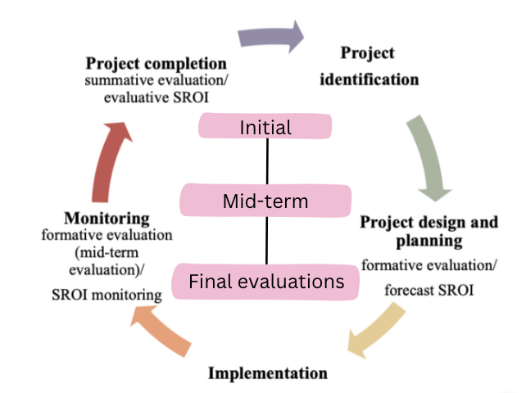
Source: Adapted from Context, 2010

Figure 1. Integrating SROI analysis and evaluation into project cycle
Applications of SROI in disaster management

Incorporating SROI within sustainability practices is essential for assessing the long-term impacts and viability of interventions. This approach highlights the necessity of aligning organizational objectives with stakeholder expectations to enhance social impact. By converting social outcomes into financial proxies, SROI enables organizations to comprehensively assess the benefits derived from their investments in terms of time, money and resources (Banke-Thomas et al., 2015). SROI can be applied at multiple levels: individual (micro), organizational (meso) and societal (macro) (Krlev et al., 2013), offering valuable insights for impact assessment and empowering stakeholders to make informed resource allocation decisions. The SROI framework is founded on seven principles designed to facilitate effective communication with funders and stakeholders (see Figure 2).

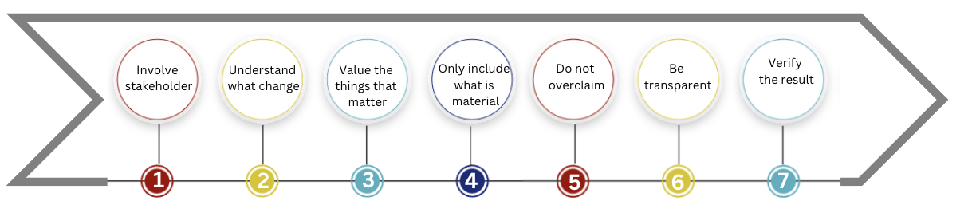
Source: Nicholls et al., 2009

Figure 2. Principles of SROI

Underpinned by concepts such as the theory of change and logic model, SROI analysis draws from traditional economic evaluations (Easterling et al., 2023). The value generated from investments is significantly influenced by the active engagement of stakeholders at various levels, whether they are directly or indirectly affected by the project. In brief, conducting an SROI analysis involves six key stages (Kadel et al., 2022) (see Figure 3), which collectively enhance the effectiveness of disaster resilience strategies and foster sustainable social investments.

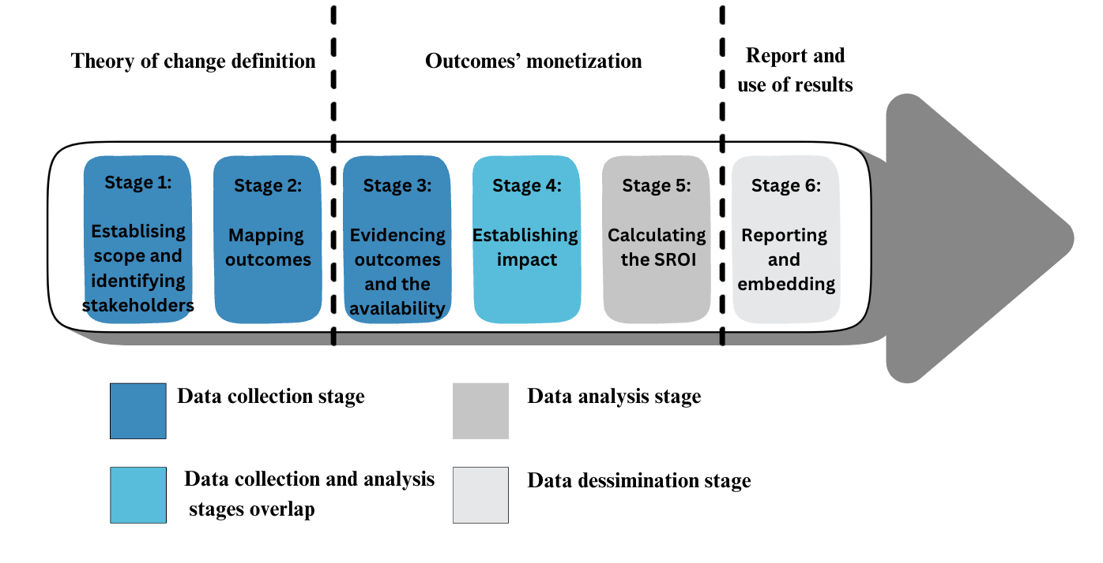
Source: Own elaboration based on Context, 2010; Nicholls et al., 2009

Figure 3. Stages of the SROI process
Limitations of SROI

Despite its utility, SROI analysis has several limitations. The process can be time-consuming and resource-intensive due to extensive data collection and stakeholder engagement. Assigning financial proxies to social outcomes is often challenging, particularly for intangible benefits such as well-being or community cohesion and may involve subjective judgments that affect comparability. Additionally, there is a risk of double counting overlapping outcomes. Methodological variations across studies and potential stakeholder biases further limit the standardization and generalizability of findings. Addressing these limitations is crucial to enhance the reliability and credibility of SROI as a tool for evaluating social investments, including in disaster management contexts.

Method and study area

This study adopts the Social Return on Investment (SROI) framework to evaluate the social, economic and environmental outcomes of flood mitigation programs in Sungai Muda, Kedah (Nicholls et al., 2009; Banke-Thomas et al., 2015). The SROI approach allows for a comprehensive assessment of social value by translating outcomes into monetary terms and capturing stakeholder perspectives across the project lifecycle (Krlev et al., 2013; Kadel et al., 2022). This study employs a quantitative approach, administering a survey to 380 household heads, specifically targeting farmers residing in flood-prone areas (floodplains) classified as high-risk and directly impacted by the Sungai Muda Flood Mitigation Project. A combination of purposive and quota sampling techniques were used to ensure representativeness. Household heads engaged in agricultural activities along the Sungai Muda were selected from ten villages, with 10 percent of the population from each village (equivalent to 38 respondents per village) included in the sample. The selected respondents shared common characteristics, including cultivating within the floodplain area located within a 1 km radius of the riverbank an area considered highly vulnerable with significant potential impacts during flooding events and residing in similar single-storey village houses constructed from a combination of wood and concrete. To minimize selection bias and strengthen the validity of the findings, random number assignment was applied within each village quota to objectively select respondents.
A questionnaire survey was employed to collect data from affected households heads. The questionnaire was designed to align with the study objectives and included both open- and close-ended questions, covering demographic and socio-economic information, flood experiences, damages and losses and perceptions of flood mitigation programs (Patton, 2015; Creswell & Creswell, 2018). The questionnaire, comprising open and closed-ended questions, was designed to meet the study objectives and included six sections (A–F). Section A covered demographic and socio-economic information, including household size, farming activities, secondary occupations, income and number of school-going children. Section B examined flood experiences, including frequency, duration, causes, coping strategies and impacts. Section C addressed flood damages, assistance received and involved agencies. Section D explored individual, community and government participation in flood management. Section E assessed perceptions of the flood mitigation program, including its effects on quality of life, health, employment, income, flood frequency and the local economy. Section F gathered suggestions for future development and flood management initiatives. A pilot test with 30 participants and adjustments were made based on feedback (Presser et al., 2004).
The rationale for selecting the Sungai Muda Flood Mitigation Project (PTB) is that the Sungai Muda area is one of the regions experiencing floods almost every year. Flood events in Kedah have not only caused economic losses but have also resulted in loss of lives. The Sungai Muda, located within the borders of Kedah and Pulau Pinang, encompasses a catchment area of 4,210 km² and extends approximately 180 km in length, originating from the Muda Dam and traversing the districts of Baling, Sik and Kuala Muda. This river catchment serves as a vital water source for agricultural, industrial and domestic sectors in both Penang and Kedah. The region is prone to annual flooding during the rainy seasons, which typically occur from April to May and September to November. The increasing frequency and intensity of flooding have exacerbated numerous challenges, including riverbank erosion, water pollution and the depletion of water resources.
Drawing on the Social Return on Investment framework applied to the Sungai Muda Flood Mitigation Project, this research underscores the foundational pillars of sustainability: social, economic and environmental elements (refer to Figure 4). The instrument of SROI comprises three primary pillars and 19 indicators; however, this study has selected only seven indicators pertinent to the Sungai Muda Flood Mitigation Project, aligning them with the specific research objectives and contextual requirements. It is essential to acknowledge that the selection of indicators may vary based on the context and timeframe of the study. Despite variations in specific indicators across different cases, the core pillars of sustainability; social, economic and environmental remain consistently applicable.

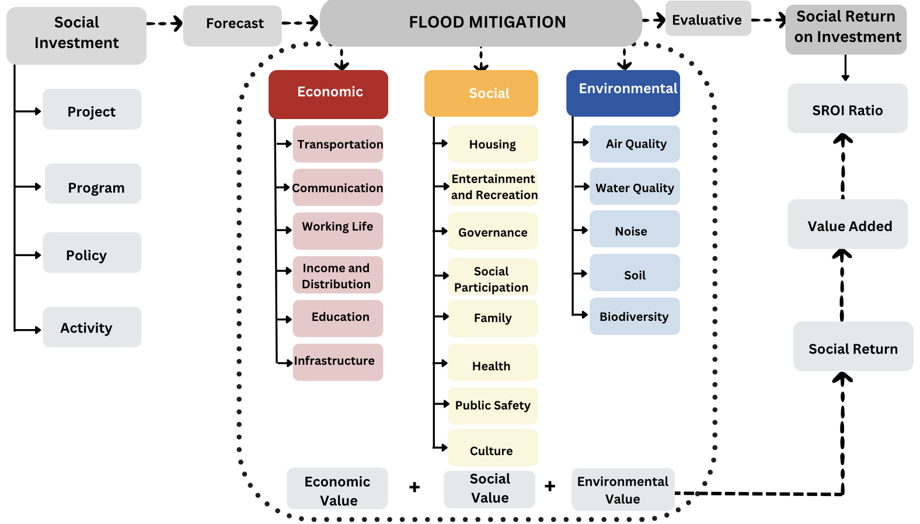
Source: Own elaboration

Figure 4. Instrument of SROI

Subsequently, a monetary valuation will be ascribed to each indicator to quantify its significance within the assessment framework. For example, within the social pillar, a health indicator was employed. The monetary value for this health indicator was determined by analyzing the cost savings associated with hospital treatments incurred by farmers. As a result, the overall value of each pillar will be derived from the aggregated values of the respective indicators, as detailed in Figure 5.

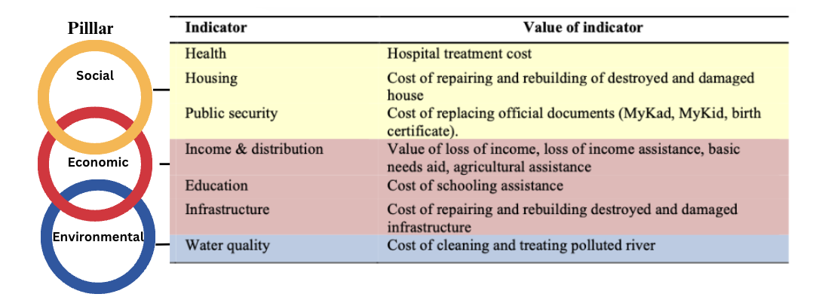
Source: Own elaboration

Figure 5. The value of indicator and pillar of SROI

The valuation of each indicator within every pillar will be customized to reflect the specific circumstances of the study. This flexibility allows the indicators to align closely with the research objectives and requirements. Consequently, not all indicators will be uniformly applied, nor will they possess identical values across different scenarios due to varying contextual factors. The SROI analysis provides a comprehensive overview of the total net present value impact, value added and SROI ratio for each investment made in activities, policies, projects or programs, as illustrated in Figure 6.

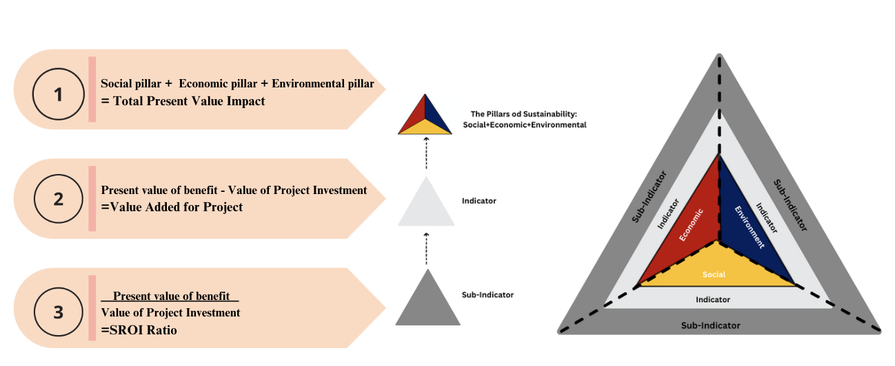
Source: Own elaboration based on Ramli et al., 2019

Figure 6. Social return on investment
Results and discussion

Integrating SROI in quantifying the Sungai Muda flood mitigation project

SROI analysis effectively captures changes across the entire spectrum of the theory of change, from inputs to impacts, while providing a monetized ratio (Rotheroe & Richards, 2007; Emerson, 2003; Zappala & Lyons, 2009). While SROI serves as a valuable tool in various contexts, its application in the Flood Mitigation Project in Sungai Muda, Kedah is particularly pertinent. Engaging with intended beneficiaries as a key stakeholder group can not only help mitigate the impacts of flooding and enhance quality of life but also uncover insights and potential unintended consequences that might otherwise remain hidden. Furthermore, examining the pillars of sustainability: social, economic and environmental within the SROI framework is essential for comprehensively understanding the costs and benefits of the holistic approach promoted by the Sungai Muda Flood Mitigation Project.
The social value derived from the Sungai Muda Flood Mitigation Project encompasses the interrelated social, economic and environmental pillars, each reflecting the value derived from the indicators outlined in the Malaysia Well-being Index Report 2022 (Department of Statistics Malaysia, 2024). The findings reveal that the project positively influences shared values across these pillars: economic (41.4%), environmental (40.6%) and social (18%). Through the SROI analysis, the total net present value impact of the project is calculated at RM4,892,641,540.00, encompassing social indicators (health, housing, public security), economic indicators (income distribution, education, infrastructure) and an environmental indicator (water quality). The total investment cost for the project is RM1,001,760,000.00 (JPS 2016), indicating that the flood mitigation initiative has generated a value added of RM3,890,881,540.00. The SROI ratio of 4.88:1 reflects the shared values across the social, economic and environmental pillars (refer to Figure 7), signifying that each ringgit invested in the project yields an additional RM3.88 in social impact value. Figure 7 shows that the economic pillar contributed the largest share of social value, driven by factors such as loss of income, income assistance, basic needs aid and agricultural support (income and distribution), cost of schooling assistance (education) and cost of repairing and rebuilding destroyed or damaged infrastructure (infrastructure). In contrast, the social pillar generated relatively smaller benefits, reflecting costs related to hospital treatment (health), replacing official documents (public security) and repairing or rebuilding damaged homes (housing). The environmental pillar accounted for the smallest proportion but remains critical, including expenses for cleaning and treating polluted rivers (water quality) and supporting long-term resilience. This breakdown illustrates that while economic returns represent the majority of measured impacts, social and environmental outcomes are essential for achieving a balanced, sustainable and inclusive approach to disaster management.
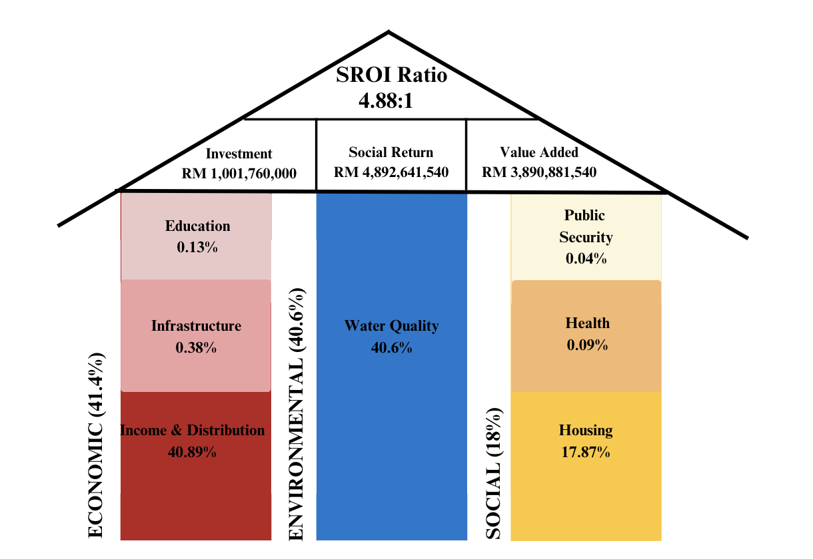
Source: Own elaboration

Figure 7. The shared value of Sungai Muda flood mitigation project

The SROI analysis highlights the substantial social value generated by the Sungai Muda Flood Mitigation Project. The SROI ratio of 4.88:1 indicates that the project is effectively contributing to positive social, economic and environmental outcomes, aligning closely with the SDGs (see Figure 8). The flood mitigation initiatives not only enhance security and provide a sense of comfort but also generate significant cost savings by preventing economic, social and environmental losses. This cost saving is comparable to other international studies in disaster management. For instance, a study by the National Institute of Building Sciences finds $6 saved for every dollar invested in mitigation activities to reduce risk and disaster losses. While in the case of riverine flood, the savings are a $7-to-$1 benefit for proactive mitigation steps (Lighttbody & Fuchs, 2018). In the Nature Based Infrastructure (NBI) scenario, for every ZAR 1 invested, between ZAR 1 and 5 could be returned over a 25-year period, amounting to net benefits of up to ZAR 600 million (USD 34.2 million). The environmental, social and economic benefits of NBI in Drakenstein include avoided flood damages, the value of recreational areas, job creation and reduced mental health impacts (Contor et al., 2025). This high return across diverse outcome areas underscores the project’s capacity to drive meaningful impact while advancing SDG objectives, reflecting its value as a socially responsible and sustainable investment.

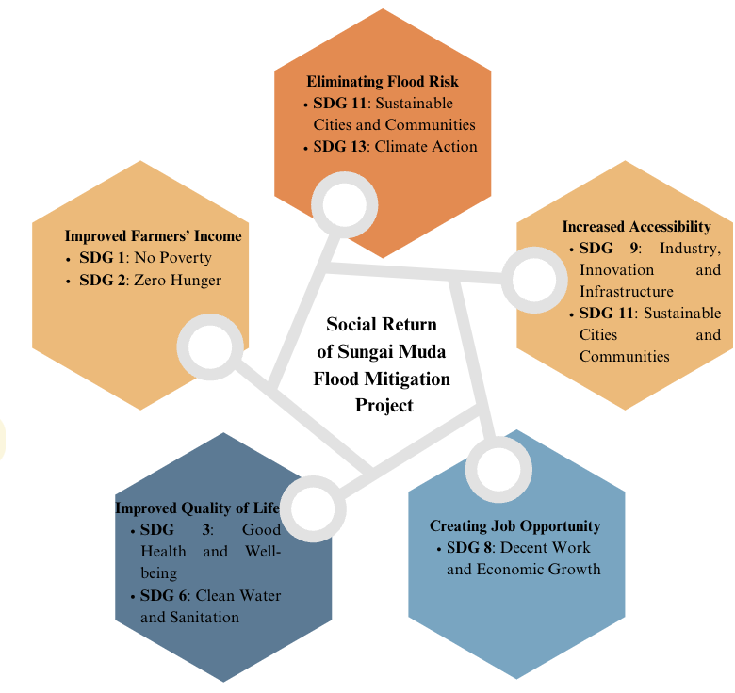
Source: Own elaboration

Figure 8. Impacts of Sungai Muda, Kedah Flood mitigation project

The SROI methodology is centered on quantifying the value of changes across social, economic and environmental elements by translating these changes into monetary terms whenever possible. Thus, conducting an SROI analysis effectively illustrates the value of social investments aimed at enhancing societal well-being, striving to measure the real impact of these investments accurately. Social value is generated through changes in the conditions that affect individuals, communities and society at large, encompassing various dimensions of life.

Conclusion

The convergence of sustainability and social investment in flood mitigation projects is essential for addressing contemporary economic challenges. The Flood Mitigation Project in Kedah exemplifies the potential of sustainable investment to deliver substantial social benefits in the realm of flood disaster management. In the current economic landscape, demonstrating the viability of social investments requires a clear articulation of their value proposition, which encompasses both financial effectiveness and social responsibility. The SROI methodology emerges as a robust and persuasive approach for conveying the efficiency and impact of social investments. By quantifying social value, SROI not only identifies potential cost-saving opportunities but also facilitates a comprehensive assessment and management of value. These findings carry significant policy implications for Malaysia, highlighting the importance of integrating SROI evaluation into national disaster management (flood mitigation) frameworks. Such integration can help in prioritising funding, initiatives, while fostering collaboration between government agencies and other stakeholders. Embedding SROI in policy planning can improve resource allocation, strengthen decision-making based on evidence and ensure that future flood mitigation investments help build long-term resilience and meet sustainable development goals. This framework represents a paradigm shift in understanding value creation, allowing for a wider range of impacts and ultimately supporting a more sustainable future for Malaysia.

References

Banke-Thomas, A. O., Madaj, B., Charles, A., & van den Broek, N. (2015). Social return on investment (SROI) methodology to account for value for money public health interventions: a systematic review. BMC Public Health, 15, 582.
Brouwers, J., Prins E., & Salverda, S. (2010). Social return on investment: A practical guide for the development cooperation sector.
Classens, M. (2015). What’s in it for the volunteers? An SROI approach to volunteers’ return on investment in the Good Food Markets. Non-profit Management and Leadership, 26(2), 145-156.
Contor, H., Bechauf, R., & Guzzetti, M. (2025, February 12). Sustainable Asset Valuation of Nature-Based Flood Mitigation Infrastructure in Drakenstein, South Africa. International Institute for Sustainable Development.
Corvo, L., Pastore, L., Mastrodascio, M., & Cepiku, D. (2022). The social return on investment model: A systematic literature review. Meditari Accountancy Research, 30(7), 49–86.
Creswell, J. W., & Creswell, J. D. (2018). Research Design: Qualitative, Quantitative and Mixed Methods Approaches (5th ed.). Sage Publications.
Department of Statistics Malaysia, DSOM. (2024). Malaysia Well-being Index Report 2022.
Department of Statistics Malaysia. (2024). Malaysia Well-being Index Report 2022.
Easterling. D., Jacob, R. R., Brownson, RC., Haire‐Joshu, D., Daniel A. Gundersen, D. A., Angier, H., DeVoe, J. E., Likumahuwa-Ackman, S., Vu, T., Glasgow, R. E., & Schnoll, R. (2023). Participatory logic modeling in a multi-site initiative to advance implementation science. Implementation Science Communications, 4, 106.
Emerson, J. (2003). The nature of returns: A framework for analyzing the performance of social enterprises. California Management Review, 45(3), 36-51.
Gibbon, J., & Dey, C. (2011). Developments in social impact measurement in the third sector: scaling up or dumbing down? Social and Environmental Accountability Journal, 31(1), 63-72.
Gibson, J., Jones, A., Travers, H., & Hunter, E. (2011). Performative evaluation and social return on investment: Potential in innovative health promotion interventions. The Royal Australian and New Zealand College of Psychiatrists, 19, 553-557.
Hall, M., Millo, Y., & Barman, E. (2015). Who and what really counts? Stakeholder prioritization and accounting for social value. Journal of Management Studies, 52(7), 907-934.
Hermansyah, A. (2023). Decision-makers benefit from SROI by considering broader impacts in their choices, enhancing their ability to account for social, economic and environmental effects. Journal of Economic Impact Analysis, 4, 112–125.
Hyatt, D., Anderson, R., & Miller, J. (2022). Demonstrating broader social value: The role of SROI in engaging stakeholders. Journal of Social Impact and Evaluation, 18(4), 55–70.
Jabatan Pengairan dan Saliran Malaysia, JPS (2024). Status Terkini Banjir Seluruh Negara Tahun 2024 https://www.facebook.com/jpsmalaysiaofficial/posts/status-terkini-banjir-seluruh-negara-tahun-2024dari-tempoh-1-januari-hingga-10-o/959825226184421/
Jabatan Pengairan dan Saliran, JPS. (2016). Maklumat Asas Pengurusan Lembangan Sungai Muda.
Jenkins, K., Surminski, S., Hall, J., & Crick, F. (2017). Assessing surface water flood risk and management strategies under future climate change: Insights from an agent-based model. The Science of the Total Environment, 595, 159-168.
Kadel, R., Khedher, N. B., & Imbeau, D. (2022). The six stages of Social Return on Investment (SROI) analysis. Journal of Social Impact and Sustainability, 14(1), 45-67.
King, N. (2014). Making the case for sport and recreation services: The utility of Social Return on Investment (SROI) analysis. International Journal of Public Sector Management, 27(2), 152-164.
Krlev, G., Munscher, R., & Mulbert, K. (2013). Social Return on Investment (SROI): state-of-the-art and perspectives - a meta-analysis of practice in Social Return on Investment (SROI) studies published 2002-2012.
Lightbody, L., & Fuchs, M. (2018, January 11). Every $1 invested in disaster mitigation saves $6: Spending to reduce risk saves lives and creates jobs, key study finds. The Pew Charitable Trusts https://www.pewtrusts.org/en/research-and-analysis/articles/2018/01/11/every-1-invested-in-disaster-mitigation-saves
Merino, M., Garcia, M., & Johnson, L. (2022). Understanding the impact of organizational activities: A methodological approach for improved resource allocation. Journal of Strategic Management, 29(3), 112–130.
Mertens, S., Xhauflair, V., & Marée, M. (2015). Questioning the Social Return On Investment (SROI). SOCENT Publication, Interuniversity Attraction Pole on Social Enterprise.
National Disaster Management Agency, NADMA. (2025, March 20). Jumlah Kerugian Akibat Banjir 2024 Cecah RM933.4J https://www.nadma.gov.my/bi/media-en/news/3253-jumlah-kerugian-akibat-banjir-2024-cecah-rm933-4j
Nicholls, J. (2017). The Landscape of Social Impact Measurement: Trends and Debates. In Social Impact Measurement: Theory and Practice. Routledge.
Nicholls, J., Lawlor, E., Neitzert, E., & Goodspeed, T. (2012). A guide to social return on investment: The SROI network.
Nicholls, J., Lawlor, E., Neizert, E. (2009). Seven principles for measuring what matters: a guide to effective public policy-making. The New Economics Foundation.
Pathak, P., & Dattani, P. (2014). Social return on investment: Three technical challenges. Social Enterprise Journal, 10(2), 91-104.
Patil, A. (2023). SROI measures the value created by social programs by defining social value as the changes experienced by stakeholders in their lives. Journal of Social Impact Assessment, 4, 112–125.
Patton, M. Q. (2015). Qualitative Research & Evaluation Methods (4th ed.). Sage Publications.
Pawley, A., Moldoff, D., Brown, J., & Freed, S. (2023). Reducing flood risk and improving system resiliency in Sacramento. California: overcoming obstacles and emerging solutions. Frontiers in Water, 5, 1-26.
Presser, S., Couper, M. P., Lessler, J. T., Martin, E., Martin, J., Rothgeb, J. M., & Singer, E. (2004). Methods for testing and evaluating survey questions. Public Opinion Quarterly, 68(1), 109–130.
Purvis, B., Mao, Y., & Robinson, D. (2019). Three pillars of sustainability: In search of conceptual origins. Sustainability Science, 14(3), 681-695.
Ramli, D. R. D., Aiyub, A., & Arifin, K. (2019). Nilai Pulangan Sosial Pelaburan. Penerbit UKM.
Rotheroe, N., & Richards, A. (2007). Social return on investment and social enterprise: transparent accountability for sustainable development. Social Enterprise Journal, 3(1), 31-48.
Sinar Harian (2024, November 30). Banjir memburuk, cecah 123,729 mangsa seluruh negara. Astro Awani https://www.astroawani.com/berita-malaysia/banjir-memburuk-cecah-123729-mangsa-seluruh-negara-498666
Social Value International. (2015). Social Return on Investment (SROI) Network Guide.
The New Economics Foundation. (2008). Measuring value: A guide to Social Return on Investment (SROI).
United Nations. (2016). Transforming Our World: The 2030 Agenda for Sustainable Development.
Zappala, G., & Lyons, M. (2009). Recent approaches to measuring social impact in the third sector: An overview. CSI Background Paper No. 6.

