
JABATAN SURGERI, FAKULTI PERUBATAN • SURGERY DEPARTMENT, FACULTY OF MEDICINE

20th February, 2025.

Professor Dr. Lim Pei San,
The Chief Editor,
Journal of Surgical Academia. Dear Professor,
RE: Cover letter to the Journal of Surgical Academia

Manuscript title: The Submammary-Evert (Sub-E) Technique For Excision Of Benign Breast Lumps In Underdeveloped And Developing Countries– A Case Series

This is to declare that all authors have contributed to the study. No part of the manuscript has been sent for consideration elsewhere or published in any International or National Journal. The authors clearly certify that there is no aspect of plagiarism. All the conflicts of interest have been clearly defined and the source of grant disclosed. Due ethical permission/consent has been obtained for carrying out the study. In case of any dispute, the authors will be held fully responsible for the statement disclosed in the cover letter. The authors are also aware of the copyright rules and also declare that they will not reproduce any published text without due permission from the journal.

Name of author Signature Date signed

- Norlia Abdullah 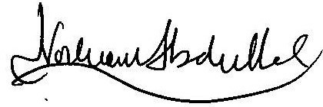 20.02.2025

- Tan Kok Liang 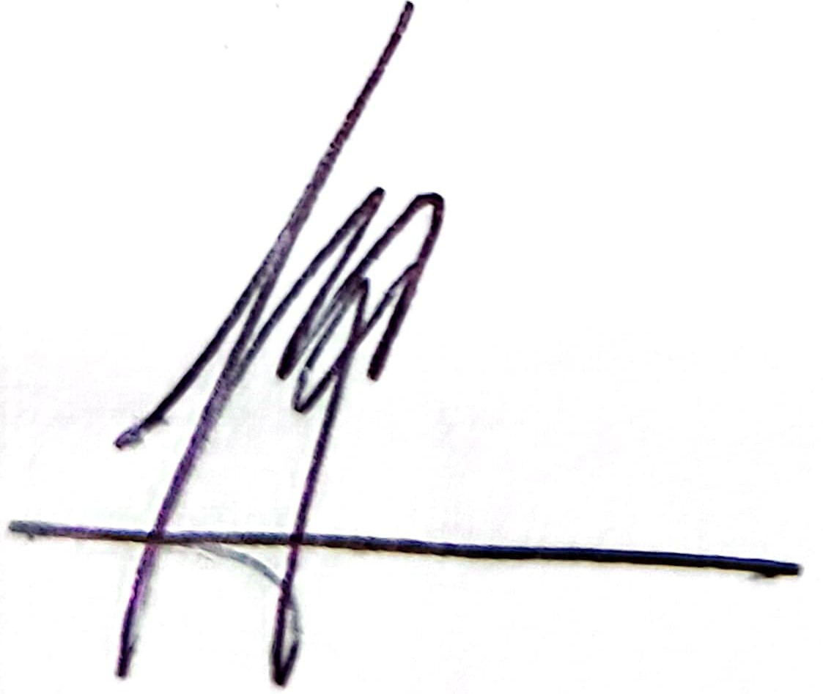 20.2.2025


- Kanmani Murugesu 20.2.2025


- Adi Syazni Muhammed
21.2.2025

  - Scientific value
    - It describes an innovative surgical technique that is easy to learn with no added instruments required; thus saving cost.
    - It may be performed by surgical trainees & general surgeons even in underdeveloped countries.
    - It is suitable for excising benign breast lumps; a very common condition.
    - This surgery uses a single well hidden scar which can be used even for multiple breast lumps. This is important especially in non Caucasian communities that have increased risk to develop keloidal scars.
    - It avoids damage to the lactiferous ducts, especially important in women of childbearing age who are the majority with benign breast lumps such as fibroadenomas.
    - It avoids damage to the sensorineural nerves around the nipple areolar complex which are important for pleasurable sensation.

  - Copyright
The Submammary Evert (Sub-E) Technique obtained copyright on the 2.3.2022 (LY2022E00743).

Here’s thanking you in anticipation. We look forward to hearing a positive response from you.

Yours sincerely,
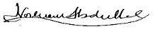

Professor Norlia Abdullah MBBS, Dr. Surg (UKM), FAMM
Senior Consultant Breast Surgeon,
The Department of Surgery, Faculty of Medicine UKM, HCTM.

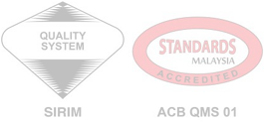
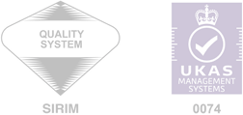
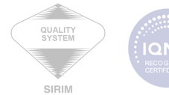

CERTIFIED TO ISO 9001:2015 CERT. NO. QMS 01100

JABATAN SURGERI/SURGERY DEPARTMENT
Tingkat 8 Bangunan Klinikal, Hospital Canselor Tuanku Muhriz
Kampus Kuala Lumpur,Jalan Yaacob Latif, Bandar Tun Razak, 56000 Cheras, Kuala Lumpur, Malaysia.
Telefon:+603-9145 6201/6202/ 8220/ 8299 Laman Web: http://www.ukm.my/medicine/

ILMU, MUTU DAN BUDI

