HYPERCALCAEMIC PARANEOPLASTIC SYNDROME IN A YOUNG WOMAN WITH MALIGNANT PHYLLODES OF THE BREAST :
A CASE REPORT
Abstract

Paraneoplastic syndromes, though uncommon, present systemic effects secondary to primary malignancies or metastases. We present a case of a 25-year-old nullipara with a left breast malignant phyllodes. Pre-operative investigations revealed hypercalcaemia. Her staging CT scan did not demonstrate any enlarged parathyroid gland. Her serum intact parathyroid hormone level was not raised. After correction with saline hydration, she underwent a left mastectomy, axillary dissection and a supercharged bipedicle TRAM flap. The following day, due to flap congestion, she underwent flap exploration but unfortunately, the flap necrosed. She required temporary coverage with a split-skin graft to allow her post operative sepsis to resolve. She underwent a delayed extended latissimus dorsi myocutaneous pedicled flap for chest wall closure. The cause of hypercalcemia was attributed to be a paraneoplastic syndrome which has not been reported previously in a malignant phyllodes tumor. The hypercalcaemia is postulated to have caused the thrombosis leading to flap failure.
Keywords: hypercalcaemia, paraneoplastic syndrome, malignant phyllodes, breast, thrombosis
Short running title: Hypercalcaemic paraneoplastic syndrome in malignant phyllodes

Introduction
Paraneoplastic syndromes are disorders caused by systemic effects from primary malignancy or metastasis. The involved systems are neurology, endocrine, haematology and rheumatology. The most common malignancy associated with paraneoplastic syndrome are non-small cell lung cancer, lymphoproliferative disorders, gynaecologic carcinoma and breast carcinoma. We report a case of malignant phyllodes of the breast with the endocrine aspect of paraneoplastic syndrome in the form of hypercalcaemia in a young nullipara.

Phyllodes tumours, also named cystosarcoma phyllodes (1) are rare and make up less than 1% of primary breast tumours. Another rarity in this case is the development of malignant phyllodes in a young woman, as the majority occur between 35-45 years of age (2). However, literature review has reported a case even in a 20 year old (3).

Case Report

A 25-year-old nullipara with underlying bipolar disorder, presented with a painless breast lump for 4 months duration. It rapidly increased in size to occupy the entire left breast. Triple assessment confirmed the lesion to be a malignant phyllodes tumour. She was a non-smoker, but was overweight with a body mass index of 25kg/m2.

She was scheduled to undergo a left mastectomy, axillary dissection and immediate breast reconstruction. On admission, she was incidentally found to be hypercalcaemic with a corrected calcium level of 3.48 mmol/L (2.2-2.6 mmol/L). Her serum intact parathyroid hormone (i-PTH) level was not raised 0.641 pmol/L (1.6-6.9 pmol/L). Ultrasound of the neck did not reveal any abnormalities of the parathyroid and thyroid glands. She was given intravenous infusion of 10 pints of crystalloids resulting in her calcium level to decrease to 2.6 mmol/L (2.2-2.6 mmol/L) within 24 hours.

She underwent immediate breast reconstruction consisting of a pedicled transversus rectus abdominis myocutaneous (TRAM) flap. The flap was isolated and raised by detaching its bilateral superficial and deep inferior epigastric arteries and was supercharged by two anastomoses. The 1st anastomosis was between the right deep inferior epigastric artery to the left superficial circumflex iliac artery. The 2nd anastomosis was between the left deep inferior epigastric artery to the left pectoral branch of the thoraco-acromial artery. Venous anastomoses was between the inferior epigastric veins to the superior epigastric veins.

However, less than 24 hours, post-operatively, the flap appeared congested. Intra-operatively, it was found that a thrombus had formed in the superior epigastric vein.
Despite removal of the thrombus, the congestion did not improve and resulted in flap necrosis (Figures 1 a-d). She required temporary wound coverage with a split skin graft. Her hypercalcaemia resolved after surgery.

Figures 1a - d: The pre-operative and post-operative photos of the patient.
a: Ulcerated malignant phyllodes tumour at the lower pole of the left breast (arrowed)
b: The TRAM flap reconstructed breast appeared congested post-operatively.
c: The colour worsened within 24 hours with resultant total flap necrosis.
d: The LD flap breast reconstruction with its medial side allowed to heal by granulation.

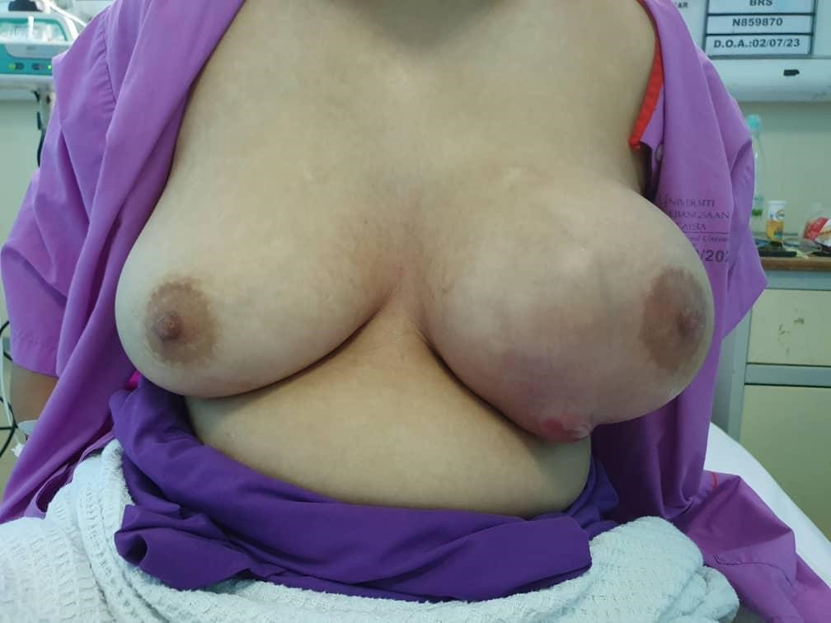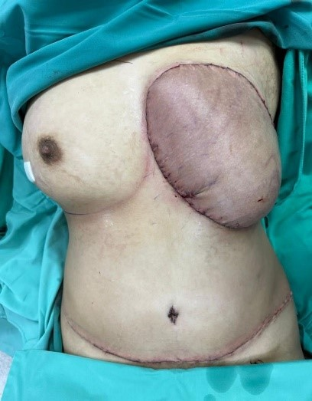
b
a
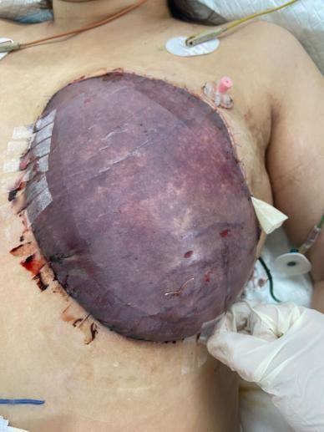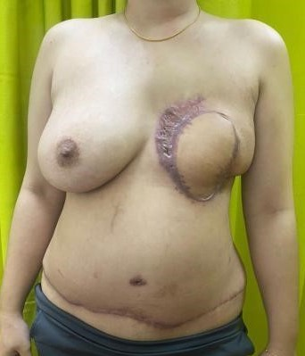
d
c

Post-operatively, CT staging was done whereby no other pathology was identified that could have caused the hypercalcaemia (Figures 2 a & b).

Figures 2a & b: Reconstructed sagittal (a) and coronal images (b) of the thyroid gland. No nodule or mass was detected at the region surrounding or adjacent to the thyroid gland (blue arrows).

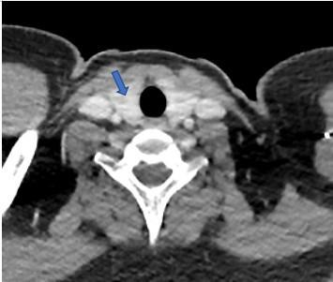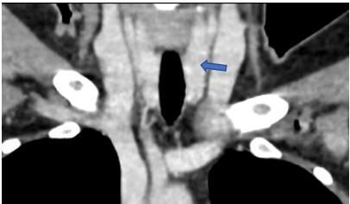
a
b

The tumour was reported to have malignant features consisting of overgrowth of stromal components, areas of tumour necrosis with poorly differentiated cells with marked nuclear pleomorphism, prominent nucleoli and frequent mitosis (Figures 3A -D).

Figures 3A-D: Histopathological slides of the left breast malignant phyllodes tumour.

A. The malignant tumour with infiltrative border, composed of overgrowth of stromal components with increased cellularity arranged in a diffuse cellular sheet pattern.
(H&E, 20x).
B. Areas of tumour necrosis (asterisk) were present (H&E, 20x).
C. Benign breast ducts were seen within the tumour (arrowheads) displaying reactive nuclear atypia (H&E, 100x).
D. The tumour was composed of poorly differentiated ovoid to spindle-shaped cells with marked nuclear pleomorphism and prominent nucleoli. Mitosis (circled) were frequently observed (H&E, 400x).

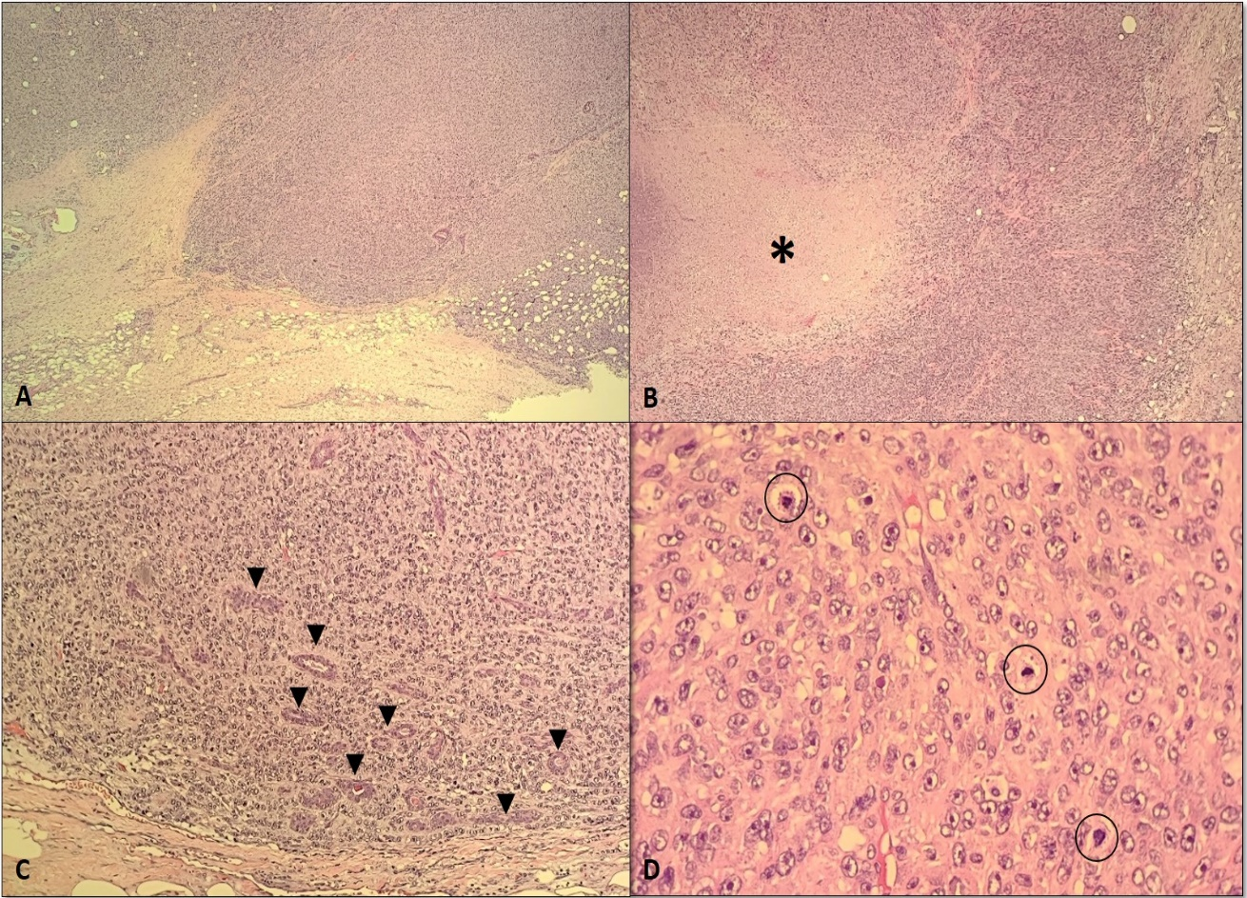

At the breast multidisciplinary team meeting, it was decided that she required adjuvant radiotherapy. She underwent a left extended latissimus dorsi myocutaneous pedicled flap for wound coverage successfully and completed adjuvant radiotherapy.

Discussion

The TRAM flap has traditionally been either pedicled or free. The vascular supply of the pedicled flap relies on the superior epigastric artery. However, the free flap depends on the inferior epigastric artery micro-anastomosed to the internal mammary artery. A recent development has been to supercharge the TRAM flap. In these cases, the pedicled flap undergoes added microvascular augmentation with anastomosis of the inferior epigastric artery to the internal mammary artery, thoracodorsal artery or perforator vessel. This is often done is cases with increased risks such as in overweight or obese women (4). As this woman was overweight and the area needed coverage was large, the plastic surgeon decided to supercharge the pedicled TRAM flap as according to Hartrampf’s Zone of Perfusion, zone IV will be likely to receive the least blood perfusion (5). Unfortunately in this case, the supercharged-pedicled flap failed resulting in total flap loss.

Paraneoplastic endocrine syndromes generally result from tumour production of hormones or peptides that lead to metabolic derangements. Thus, excision of these underlying tumours often improves these conditions (6). Most paraneoplastic syndromes are associated with neurological disorders that present in either known cancer cases or those with occult tumours (7).
Malignant phyllodes tumours are associated with a high risk of local recurrence, particularly when adverse histopathological features are present such as stromal overgrowth, high mitotic activity and close or involved margins. Radiation is indicated when margins are less than 1cm, tumour size larger than 5 cm and in those with long life expectancy.
Studies have shown that adjuvant radiotherapy significantly reduces local recurrence in malignant phyllodes tumours. Yu et al (2022) reported that adjuvant radiotherapy was associated with a statistically significant reduction in recurrence in malignant phyllodes (P = 0.034) but not in borderline or benign tumours (8). Boutrus et al (2021) demonstrated a 5-year local recurrence-free survival (LRFS) of 90% in patients with borderline/malignant phyllodes who received adjuvant radiotherapy, compared to 42% in those who did not (9). The benefit was most notable in those who had breast-conserving surgery, though benefit was also observed post-mastectomy.
In our case, adjuvant radiotherapy was recommended and completed following the mastectomy and flap reconstruction due to the large tumour size and malignant features. There is no established role for adjuvant chemotherapy in malignant phyllodes tumours. Chemotherapy is reserved for metastatic or unresectable disease, with extrapolation from soft tissue sarcoma regimens.
Hypercalcaemia has been reported to occur in 20-30 percent of those with cancer (10). When the hypercalcaemia is associated with a hormone, the condition is called humoral hypercalcaemia of malignancy (HHM). This appears to be the first reported case of HHM in a malignant phyllodes breast tumour. However, there have been a few cases reported of HHM associated in breast carcinoma (11,12). Hypercalcaemia is commonly mediated via parathyroid hormone related protein (PTHrP) in squamous cell carcinomas and renal cell carcinoma. Given her normal intact parathyroid hormone (iPTH) and no skeletal metastases, PTHrP secretion is the most likely aetiology in her as well.

In normal homeostasis, free ionized calcium is needed for the initial steps of platelet plug formation in the extrinsic pathway, where together with factor Va, it will be bound by factor Xa, to generate a prothrombinase complex. This complex will cleave prothrombin into thrombin. Thrombin has a procoagulant role in activating platelet, hence leading to thrombus formation. Calcium ions, combined with thrombin also acts on fibrinogen to form fibrin monomers, the aggregation of which will form a final insoluble fibrin clot.

The link between hypercalcaemia and thrombosis is still not completely understood. The proposed mechanism is that calcium triggers vascular smooth muscle leading to vasoconstriction (13), activates the coagulation cascade and results in fibrin clot formation. Algethamy et al 11 (14) reported that there was a correlation between severe hypercalcaemia and an increased risk of thrombosis formation. Hypercalcaemia also disturbs the renal reabsorption of sodium and water. Nausea and anorexia which commonly occur in hypercalcaemia, but were absent in this patient, could lead to uncompensated polyuria resulting in dehydration and hypercoagulability. Additionally, elevated calcium concentration has cytotoxic effects that stimulate cell death and result in thrombosis (15).

In this case, CT scan did not show any other pathology that could have contributed to her hypercalcemia. Her serum intact parathyroid hormone (i-PTH) level was not raised, hence primary hyperparathyroidism is unlikely. The theory is that the hypercalcaemia, although corrected pre-operatively, had induced thrombosis in the superior epigastric vein of the rectus abdominis muscle pedicle. Post-mastectomy, the hypercalcaemia resolved. Her medication for bipolar disorder (Quetiapien) has not been known to cause hypercalcaemia.

.

Conclusion

This case, we believe, is the first reported occurrence of paraneoplastic syndrome presenting as hypercalcemia in a young woman with a malignant phyllodes tumour of the breast. Despite the absence of symptoms, the hypercalcemia pre-operatively warranted correction. Due to her rapidly corrected calcium level, she may not have achieved a stable generalized systemic condition. Thus, this may have led to the development of the intravascular thrombus resulting in the flap necrosis. Further research is warranted to study if this complication could have been avoided peri-operatively.

Ethics Statement
Written informed consent was obtained from the individual for the publication of any potentially identifiable images or data.

Funding
Funding will be provided by the Medical Faculty, Universiti Kebangsaan Malaysia, if required

Conflict of Interest
The authors declare that there was no conflict of interest.

References

- Lester J, Stout AP. Cystosarcoma phyllodes. Cancer 1954; 7:335–53.
- Ostapenko E, Burneckis A, Ostapenko A, Skaisgirytė A, Ostapenko V. Malignant phyllodes tumor of the breast with metastases to the lungs: A case report and literature review. Radiol Case Rep 2022; 18 (17):4006–12. - PMC - PubMed
- Balachandran NR, Abdullah N, Ismail MI, Wong YP & Azmi MI. Recurrent and transformation of borderline to malignant phyllodes tumour with osteoid differentiation: a case report and literature review. Frontiers in oncology 2024; 14. 1377074. https://doi.org/10.3389/fonc.2024.1377074
- Wu LC, Iteld L & Song DH. Supercharging the transverse rectus abdominis musculocutaneous flap: breast reconstruction for the overweight and obese population. Annals of plastic surgery 2008; 60(6), 609–613. https://doi.org/10.1097/SAP.0b013e318156625b
5. Vosburg RW, White MJ, Heckler FR. Supercharging of delayed pedicled
transverse rectus abdominis myocutaneous flaps, is it a viable option?
Microsurgery 2015; 35 (3), 204–206.
https://doi.org/10.1002/MICR.22301
6. Pelosof LC, Gerber DE. Paraneoplastic Syndromes: An Approach to Diagnosis
and Treatment. Mayo Clin Proc 2010; 85(9): 838-54.

7. Darnell RB, Posner JB. Paraneoplastic syndromes involving the nervous
system. N Engl J Med 2003; 349(16): 1543-54.
8. Yu CY, Huang TW, Tam KW. Management of phyllodes tumor: A systematic review and meta-analysis of real-world evidence. Int J Surg. 2022;107:106969.
9. Boutrus RR, Khair S, Abdelazim Y, et al. Phyllodes tumors of the breast: Adjuvant radiation therapy revisited. Breast. 2021;58:1–5.
10. Stewart AF. Hypercalcaemia associated with cancer. N Engl J Med 2005;
352(4): 373-9.
11. Ahmed MS, Nor Faezan AR, Rohaizak M. Parathyroid Hormone Secreting
Metaplastic Breast Carcinoma: A Case Report of Paraneoplastic Syndrome.
Journal of Surgical Academia 2016; 6(2): 46-49.
https://doi.org/10.17576/JSA.2016.0602.12.
12. Mavligit GM, Cohen JL, Sherwood LM. Ectopic production of parathyroid
hormone by carcinoma of the breast. N Engl J Med 1971; 285(3): 154-156.
13.Yarnell PR, Caplan LR. Basilar artery narrowing and hyperparathyroidism:
illustrative case. Stroke 1986;17(5):1022–4. doi:
10.1161/01.str.17.5.1022. [DOI] [PubMed] [Google Scholar]
14. Algethamy HM, Shikdar YA, Alansari TA. A case of severe hypercalcemia with
arterial and venous thrombosis. Anaesth pain intensive care 2020;24(1):111 -
114.DOI: https://doi.org/10.35975/apic.v24i1.1235
15. Koufakis T, Antonopoulou V, Grammatiki M et al. The Relationship between
Primary Hyperparathyroidism and Thrombotic Events: Report of Three Cases
and a Review of Potential Mechanisms. Int J Hematol Oncol Stem Cell Res.
2018;12(3):175-180. PMID: 30595818; PMCID: PMC6305263.

