DUAL PATHOLOGY BREAST CARCINOMA : A CASE SERIES
Mohd Saufee Al-Firdaus Mohd Ismail¹, Norlia Abdullah¹, Suria Hayati Md Pauzi²,
Tan Geok Chin², Fuad Ismail³

¹Department of Surgery, Faculty of Medicine, Hospital Canselor Tuanku Muhriz,
Universiti Kebangsaan Malaysia..
²Department of Pathology, Faculty of Medicine, Hospital Canselor Tuanku Muhriz,
Universiti Kebangsaan Malaysia.
³Department of Oncology, Faculty of Medicine, Hospital Canselor Tuanku Muhriz,
Universiti Kebangsaan Malaysia.

Corresponding author:
Dr. Norlia Abdullah,
Senior Consultant Breast Surgeon, Department of Surgery, Faculty of Medicine,
Hospital Canselor Tuanku Muhriz, Universiti Kebangsaan Malaysia,
Jalan Yaacob Latiff, Bandar Tun Razak, 56000 Cheras, Kuala Lumpur.
E-mail: norlia@hctm.ukm.edu.my, norliapermata@gmail.com
ORCID : 0000-0003-2024-7353
Telephone: 03-91455795/6201. Fax: 03-91456684

1481 words

Abstract
Dual pathology breast carcinoma, whether unifocal, multifocal or multicentric may significantly impact patient prognosis. Certain histological combinations are associated with favourable outcomes, while others may indicate a more aggressive disease. We present a series of two women with different pathological combinations. The first case had multicentric cancers of the left breast. She underwent neoadjuvant chemotherapy, then nipple-sparing mastectomy with axillary dissection and immediate TRAM breast reconstruction. Histopathological assessment revealed a combination of metaplastic carcinoma and invasive micropapillary carcinoma; both aggressive subtypes. Post adjuvant radiotherapy, she remained disease-free for five years. The second case had a unifocal right breast cancer managed with breast-conserving surgery and sentinel lymph node biopsy. Histopathology revealed a combination of invasive carcinoma of no special type (NST) and invasive papillary carcinoma. These subtypes are associated with a more favourable prognosis. Post radiotherapy and on endocrine therapy, this patient remains well at 2 years follow-up. These cases demonstrate the prognostic variability in dual histopathology breast cancers and highlights the importance of individualized treatment.
Keywords :
Dual pathology, multifocal, multicentric, breast cancer, micropapillary, papillary, metaplastic, carcinoma,
Short running title: Dual pathology breast carcinoma

Introduction
Dual pathological malignant subtypes within the same breast may significantly influence one’s prognosis. This is because certain histological combinations are associated with either favourable or poor clinical outcomes (1). Breast cancer can present as a unifocal or multifocal disease, whereby multiple tumours are located in the same quadrant. Multicentric disease refers to tumours located in different quadrants of the same breast. Contemporary classification often group multifocal and multicentric presentations under the collective term Multifocal Multicentric Breast Carcinoma (MMBC), recognizing their shared clinical features and implications.

MMBC has been identified as an independent factor associated with more aggressive disease behaviour, including increased recurrence risk and reduced disease-free survival (DFS) and overall survival (OS), when compared to unifocal breast cancer (2,3).

This case series reports breast cancer cases involving two distinct histopathological subtypes, occurring in both MMBC and unifocal disease. Our aim is to contribute to the limited literature on these rare presentations and their clinical outcome.

Case reports
Case 1
A 40 year-old Para 4 presented with a lump in her left breast for 3 months duration. Clinical examination revealed a 6.5 x 7.5 cm mass involving the upper two quadrants of the left breast with a palpable axillary lymph node. Bedside ultrasound found this mass to be irregular with a left axillary lymph node that had loss of fatty hilum (size 1.04 cm x 1.26 cm). The contralateral breast and axilla were normal. Her mammogram image showed a BIRADS 4B lesion. The core biopsy confirmed an invasive ductal carcinoma of no special type; oestrogen receptor (ER) and progesterone receptor (PR) were both negative while HER2 receptor was positive (3+). Computer tomography (CT) staging of the thorax, abdomen and pelvis (TAP) was clear of any distant metastasis. She was staged as cT3N1aM0, indicative of locally advanced breast cancer (Stage IIIA). The patient received six cycles of neoadjuvant chemotherapy; initially with 5-Fluorouracil, Epirubicin and Cyclophosphamide (FEC) for 3 cycles followed by docetaxel from the fourth to sixth cycle. The tumour showed a good response and the patient subsequently underwent a left nipple-sparing mastectomy, axillary dissection and reconstruction with a unipedicled ipsilateral Transverse Rectus Abdominis Myocutaneous (TRAM) flap surgery. Post-mastectomy histopathology revealed two distinct cancer types in the different quadrants of the same breast. The upper outer quadrant (UOQ) lesion which measured 21mm was a Bloom and Richardson grade 3 had features of metaplastic breast carcinoma (Figures 1 A-D). However, the upper inner quadrant (UIQ) lesion which measured 6mm was a Bloom and Richardson grade 2 invasive micropapillary carcinoma (Figures 2 A-D). All lymph nodes were negative for malignancy (0/8).

Figure 1 : Histopathology of Case 1; the UOQ lesion.
(A) The larger tumour is composed of sheets and clusters of neoplastic cells without tubule formation (H&E, 10x).
(B) The tumour cells are polygonal in shape, with pleomorphic vesicular nuclei and abundant eosinophilic cytoplasm. No obvious intracellular keratinization or intercellular bridge are observed (H&E, 20x).
(C) The tumour cells show positive expression for squamous marker, p63 (IHC, 20x).
(D) The tumour cells show positive expression for CK5/6 (IHC, 20x).
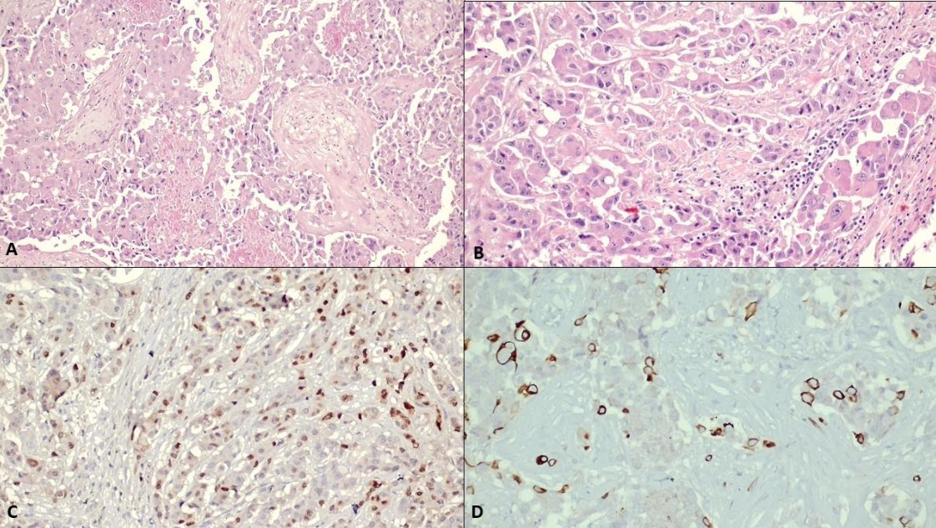
D
A
B
C

Figure 2 : Histopathology of Case 1; the UIQ lesion.
(A) A separate tumour nodule in the upper inner quadrant of breast (H&E x 10).
(B) The tumour forms aggregates with papillary-like patterns devoid of central fibrovascular cores
(H&E X 20).
(C) Oestrogen receptor is negative (IHC x 20)
(D) HER2 protein expression is positive (IHC x 20)

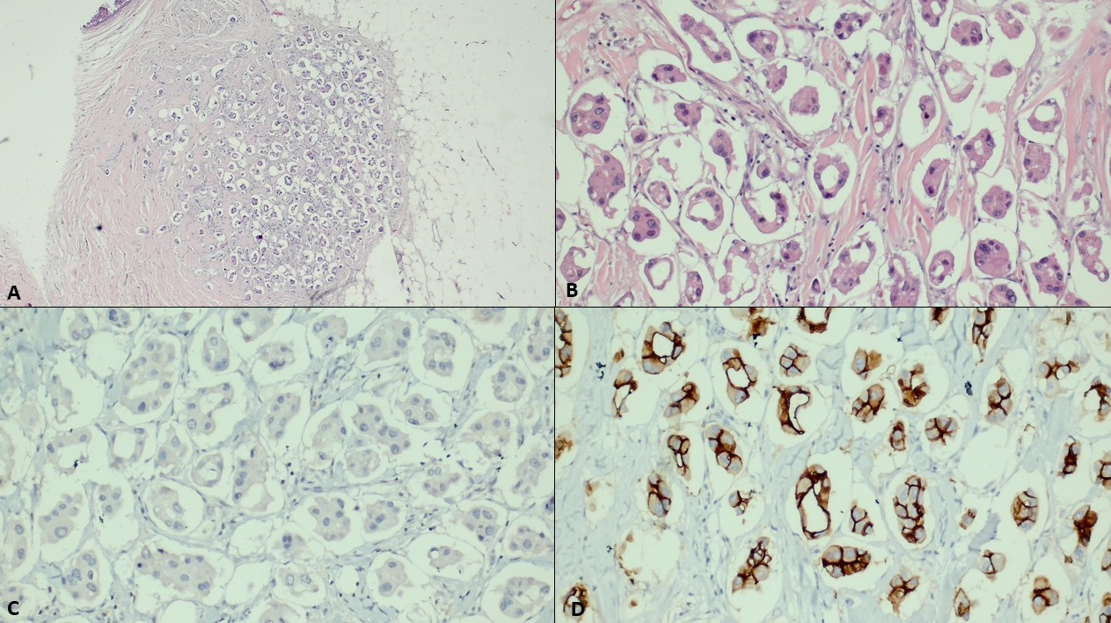
D
C
B
A

The patient subsequently completed 15 fractions of adjuvant radiotherapy (40 Gy) and was planned for targeted therapy (Trastuzumab ; Trade name Herceptin). However, she defaulted follow up for 10 months. When she returned, Herceptin could not be prescribed. This is because the recommendation for Herceptin as adjuvant therapy is to be started within 3 months of surgery or 3 weeks post adjuvant chemotherapy. After 5 years follow-up in our centre, the patient remained disease free but requested for a transfer of care to another centre due to logistical reasons.

Case 2
A 67 year-old woman presented with a painless right breast lump. She had no other local or constitutional symptoms . Thirty years ago, she had received hormonal therapy to treat recurrent miscarriages. The treatment consisted of Dydrogesterone and subsequently changed to Medroxyprogesterone, for a total of 3 years. However, she still failed to conceive till term and remained nulliparous.

Breast examination revealed a mass in the upper outer quadrant, with no palpable axillary lymph nodes. Bedside ultrasound of the lump was 1.2 x 1.8 x 1.3 cm. An ultrasound guided core needle biopsy of the lesion confirmed it to be an invasive breast carcinoma, Bloom and Richardson grade 2, ER-positive (strong, >95%), PR-negative and HER2-negative. Staging scans (ultrasonography of abdomen and chest radiograph) showed no distant metastases. The patient underwent surgery; a right breast wide local excision and sentinel lymph node biopsy (SLNB). Histopathology revealed 2 different cancer pathologies within the same lesion which consisted of 70% invasive papillary carcinoma and 30% invasive carcinoma of no special type (Figures 3 A-D). All lymph nodes were negative for malignancy (0/8 lymph nodes; 6 sentinel lymph nodes with 2 para sentinel lymph nodes). The final staging was pT1N0M0.

Figure 3. Histopathology of Case 2.
(A). The smaller part of the tumour is composed of invasive carcinoma of no special type
(H&E x 20).
(B). The larger part of the tumour is composed of invasive papillary carcinoma (H&E x 10).
(C). The papillary component demonstrates neoplastic cells arranged in papillary architecture with
central fibrovascular core (arrowed) (H&E x 40).
(D). The neoplastic cells are negative for P63 immunohistochemistry (arrowed) (H&E x 20).

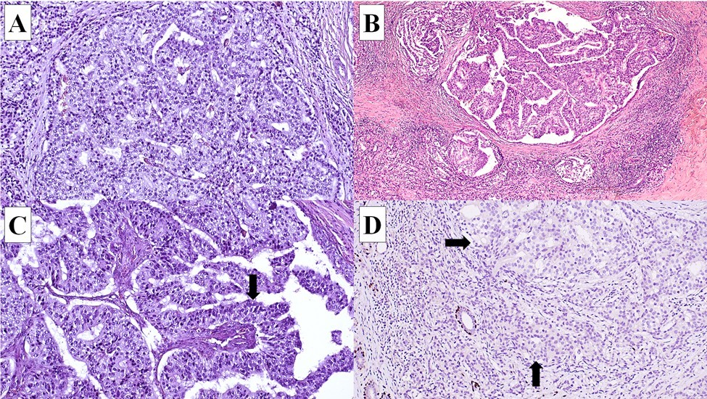

Postoperatively, the patient was started on endocrine therapy (T. Tamoxifen 20 mg once daily) and completed 40 Gy of adjuvant radiotherapy in 15 fractions to the right breast. Upon follow-up for the past 2 years, the patient remained well, with no signs of recurrence.

Discussion
Multifocal Multicentric Breast Carcinoma (MMBC) may present as either a single or mixed histopathological subtype, each carrying distinct prognostic implications. Previous studies by Budzik et al. (1) and Guan et al. (2) have demonstrated that single breast cancer pathology, especially pure mucinous carcinoma is associated with a more favourable prognosis compared to mixed variants Among the latter, combinations such as Invasive Ductal Carcinoma (IDC) with Invasive Micropapillary Carcinoma (IMPC) are linked to poorer outcomes than IDC alone or IDC with Ductal Carcinoma In Situ (DCIS) (3,4). In Case 1, two rare and aggressive histological subtypes; Metaplastic Breast Carcinoma (MBC) and IMPC were identified concurrently within the same breast. MBC and IMPC are individually uncommon, with reported incidences of 0.2–2% and 3–6%, respectively (5,6). To our knowledge, this represents the first documented case of MMBC with MBC and IMPC within the same breast, and current literature offers no prognostic data on this unique combination.

Both MBC and IMPC are aggressive, with high recurrence and metastatic rates (7,8). Despite this, the patient remained disease-free at five years post-treatment, likely due to effective neoadjuvant chemotherapy, surgery and radiotherapy, despite not having had targeted therapy. Chemotherapy resulted in complete resolution of nodal involvement and clear surgical margins; factors known to significantly improve disease-free survival (DFS) and overall survival (OS). This outcome is consistent with existing data reporting five-year survival rates of 71% for MBC and 87.5% for IMPC (8,9).

Interestingly, the IDC in the case above was initially identified on core biopsy but was absent in the final surgical specimen. This discrepancy may be explained by several factors: chemotherapy-induced histological transformation, the biopsy which removed 6 cores may have removed the small area involved or a differential response to chemotherapy where the IDC component was eradicated while MBC and IMPC persisted (10,11).

Surgical excision with clear margins remains the cornerstone of MMBC management. While both mastectomy and breast-conserving surgery are acceptable, achieving negative margins is critical in reducing recurrence risk and improving long-term outcomes (12,13). In Case 1, the patient has had 5 years of disease free survival, after radiotherapy, despite the absence of targeted therapy.

Malignant papillary neoplasms consist of papillary Ductal Carcinoma In Situ (DCIS), encapsulated papillary carcinoma , solid papillary carcinoma and invasive papillary carcinoma (IPC). IPC is the most rare amongst these, forming 13-20% of papillary neoplasms and 0.5% of invasive breast cancer. IPC, commonly occurs in postmenopausal women and is often associated with invasive breast cancer of a non-specific type or papillary DCIS, as in Case 2. IPC is characterized by positive oestrogen and progesterone receptors with no amplification of the HER2 gene and a low Ki-67 proliferation index. Although IPC has malignant histological features similar to those of IDC, it has a favourable prognosis (14). Patient number 2 remained in remission post surgery, radiotherapy and on endocrine therapy after follow-up of 2 years.

Conclusion
The prognosis of dual breast cancer histopathology is influenced by various factors. Based on our literature review, Case 1 is the first reported case of MMBC with MBC and IMPC within the same breast. Given the rarity of dual pathology breast carcinomas, further studies are warranted to explore their biological behaviour and treatment response. To maximise clinical outcome, in cases of mixed lesions, treatment decisions should be based on the type of lesion with the higher/highest degree of malignancy (14).

Ethical consideration / consent
Informed consent was obtained from the patients for publication of this case series.

Author contribution
MSAMI: Initial draft & Data acquisition
NA: Main clinician, Conceptualization & Final editing
SHMP: Preparation, reporting of pathological slides of Case 1 and editing
TGC: Preparation & reporting of pathological slides of Case 2 and editing
FI: Oncological treatment and editing

Funding statement
The article processing fee will be funded by the Faculty of Medicine, Universiti Kebangsaan Malaysia, if required.

Conflict of interest
The authors declare no conflict of interest.

References
- Budzik MP, Fudalej MM, Badowska-Kozakiewicz AM. Histopathological analysis of mucinous breast cancer subtypes and comparison with invasive carcinoma of no special type. Scientific Reports 2021; 11(1), 5770. https://doi.org/10.1038/s41598-021-85309-z
- Guan X, Xu G, Shi A et al. Comparison of clinicopathological characteristics and prognosis among patients with pure invasive ductal carcinoma, invasive ductal carcinoma coexisted with invasive micropapillary carcinoma, and invasive ductal carcinoma coexisted with ductal carcinoma in situ. Medicine 2020; 99(50), e23487. https://doi.org/10.1097/MD.0000000000023487
- Lang Z, Wu Y, Li C, Li X, Wang X, Qu G. Multifocal and multicentric breast carcinoma:
a significantly more aggressive tumor than unifocal breast cancer. Anticancer Res. 2017;
37:4593‐4598. doi: 10.21873/anticanres.11858 [DOI] [PubMed] [Google Scholar]
4. Tabár L, Dean PB, Tucker FL et al. Multifocal and diffusely infiltrating breast
cancers are highly fatal subgroups needing further improvement in diagnostic and
therapeutic strategies. European Journal of Radiology 2023; 164, 110854.
https://doi.org/10.1016/j.ejrad.2023.110854
5. Ye F, Yu P, Li N et al. Prognosis of invasive micropapillary carcinoma compared
with invasive ductal carcinoma in breast: A meta-analysis of PSM studies. The Breast
2020; 51: 11–20. https://doi.org/10.1016/j.breast.2020.01.041
6. Rajan R, Abdullah N, Abdullah NMA, Mohd Kassim AY. Metaplastic breast
carcinoma with upper limb gangrene. Breast Cancer: Targets and Therapy 2017; 9: 297–
299. https://doi.org/10.2147/BCTT.S126909
7. Lee JH, Ryu JM, Lee SK et al. Clinical Characteristics and Prognosis of Metaplastic
Breast Cancer Compared with Invasive Ductal Carcinoma: A Propensity-Matched Analysis.
Cancers 2023; 15(5): 1556. https://doi.org/10.3390/cancers15051556
8. Lewis GD, Xing Y, Haque W et al. Prognosis of lymphotropic invasive
micropapillary breast carcinoma analyzed by using data from the National Cancer Database.
Cancer Communications 2019; 39(1): 1–9. https://doi.org/10.1186/s40880-019-0406-4
9. Yang YL, Liu BB, Zhang X, Fu L. Invasive Micropapillary Carcinoma of the Breast:
An Update. Archives of Pathology & Laboratory Medicine 2016; 140(8): 799–805.
https://doi.org/10.5858/arpa.2016-0040-RA
10. Abdullah N, Rizuana IH, Goh JHL, Lee QZ, Md Isa N, Md Pauzi,SH. Bilateral
metachronous breast malignancies: Malignant phylloides and invasive breast carcinoma—
a case report. Frontiers in Oncology 2023; 13. https://doi.org/10.3389/fonc.2023.1034556
11. Bhatia, S. Therapy-Related Myelodysplasia and Acute Myeloid Leukemia. Seminars in
Oncology 2013; 40(6), 666–675. https://doi.org/10.1053/j.seminoncol.2013.09.013

12. Kuan L, Tiong LU, Parkyn R, Walters D, Lai C, Walsh D. Disease recurrence and
survival in patients with multifocal breast cancer: a follow‐up study with 7‐year results.
ANZ Journal of Surgery 2017; 87(10). https://doi.org/10.1111/ans.13193
13. Zhang Y, Liu F, Gao Q et al. Comparing the outcome between multicentric/multifocal
breast cancer and unifocal breast cancer: A systematic review and meta-analysis. Frontiers
in Oncology 2022; 12. https://doi.org/10.3389/fonc.2022.1042789
14. Wang S, Zhang Q, Mao X. Invasive papillary carcinoma of the breast. Front. Oncol.
2024; 14:1374091. doi: 10.3389/fonc.2024.1374091

Recommended Reviewers

1. Dr. Maya Mazuwin
Consultant Breast & Endocrine Surgeon, USM
E-mail: mazuwin@usm.my
Telephone:019-9877140

2. Professor Nur Aishah Md Taib
Senior Consultant Breast Surgeon, UMMC.
E-mail: nuraish@gmail.com
Telephone: 019-2405856

