20th April, 2025.

Professor Dr. Lim Pei San,
The Chief Editor,
Journal of Surgical Academia.

Dear Professor,
RE: Cover letter to the Journal of Surgical Academia

Manuscript title: DUAL PATHOLOGY BREAST CARCINOMA : A CASE SERIESThis is to declare that all authors have contributed to the study. No part of the manuscript has been sent for consideration elsewhere or published in any International or National Journal. The authors clearly certify that there is no aspect of plagiarism. All the conflicts of interest have been clearly defined and the source of grant disclosed. Due ethical permission/consent has been obtained for carrying out the study. In case of any dispute, the authors will be held fully responsible for the statement disclosed in the cover letter. The authors are also aware of the copyright rules and also declare that they will not reproduce any published text without due permission from the journal.

Name of author Signature Date signed

1. Mohd Saufee Al-Firdaus Mohd Ismail 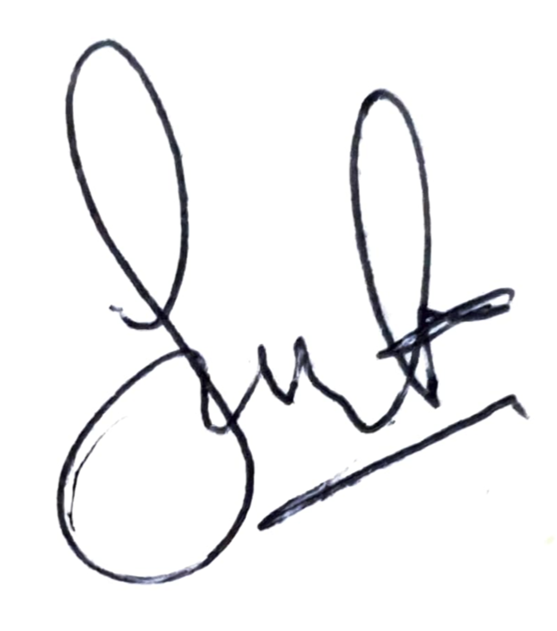 20.4.2025
2. Norlia Abdullah 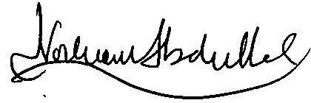 20.4.2025
3. Suria Hayati Md Pauzi 20.4.2025
4. Tan Geok Chin geokchin 21.4.2025
5. Fuad Ismail 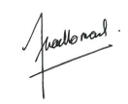 21.04.25

The scientific value of this case series is discussion of the rare finding of dual breast cancer
histopathology in the same breast, management and outcome in two cases that were treated
in our institution.

a. It describes the first reported case of a dual pathology breast carcinoma consisting of metaplastic
and micropapillary in the same breast.
b It discusses the histological types of dual pathology breast carcinoma and possible prognosis.

Here’s thanking you in anticipation. We look forward to hearing a positive response from you.

Yours sincerely,
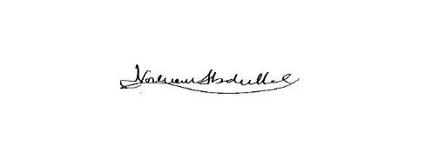
Professor Dr. Norlia Abdullah
MBBS, Dr. Surg (UKM), FAMM
Senior Consultant Breast Surgeon,
The Department of Surgery, Faculty of Medicine UKM, HCTM.

