Table 1: Learning objectives, contents, and media used.
Learning Objectives | Contents | Media
Students will be able to identify the anatomical structures and to explain its function in swallowing. | - Salivary glands  - Lips  - Mandible  - Teeth  - Tongue  - Oral Cavity  - Cheeks  - Pharynx  - Larynx  - Valleculae and pyriform sinuses  - Esophagus | - Coloured Graphic  - Audio narration  - Text
Students will be able to identify the muscles involved in swallowing and to describe the functions of the muscles and its innervation. | - Muscles of the lips  - Muscles of mastication  - Intrinsic and extrinsic muscles of the tongue  - Muscle of the cheeks  - Pharyngeal muscles  - Intrinsic and extrinsic muscles of the larynx  - Muscles of the esophagus | - Coloured Graphic  - Audio narration  - Text
Students will be able to describe the events in the phases of swallowing. | - Pre-oral anticipatory phase  - Oral phase  - Oral transit phase  - Pharyngeal phase  - Crico-esophageal phase  - Velopharyngeal closure  - Pharyngeal constriction and shortening  - Hyolaryngeal excursion | - 3D animation  - Audio narration
Students will be able to explain the coordination of respiration and swallowing. | - Coordination of respiration and swallowing | - 3D animation  - Audio narration

Table 2: Materials produced (images and animations with audio narration).
Media Type | Contents
Coloured images with audio narrations | - salivary glands  - lips  - muscles of the face and lips  - mandible  - temporalis and masseter muscles  - lateral and medial pterygoid muscles  - teeth  - tongue  - taste and general sensations of the tongue (innervation map)  - intrinsic muscles of the tongue  (frontal section)  - intrinsic muscles of the tongue  (lateral view)  - extrinsic muscles of the tongue  - oral cavity  - buccinator muscles  - pharynx (sagittal section)  - pharyngeal muscles  - larynx (bone and cartilages)  - hyoid bone  - thyroid cartilage  - intrinsic muscles of the larynx  - extrinsic muscles of the larynx  - hyolaryngeal excursion  - valleculae and pyriform sinuses  (posterior view)  - valleculae and pyriform sinuses  (superior view)  - esophagus  - esophageal muscles
Animations with audio narrations | - overview of a swallowing process  - pre-oral anticipatory phase  - oral phase  - oral transit phase  - pharyngeal phase  - crico-esophageal phase  - velopharyngeal closure  - pharyngeal constriction and shortening  - hyolaryngeal excursion  - coordination of respiration and swallowing

Table 3: Mean and standard deviation of each 7-point rating scale item.
 | Questions | Mean | S.D.
1  2  3  4  5  6  7  8 | Part I: Usefulness  It helps me be more effective in learning.  It helps me be more productive.  It is useful.  It helps me to understand the subject better.  It makes learning easier.  It saves me time when I use it.  It meets my needs in learning.  It provides me adequate information. | 6.70  6.30  6.63  6.89  6.63  6.41  6.52  6.56 | 0.61  0.67  0.49  0.32  0.49  0.69  0.58  0.58
9  10  11  12  13  14  15  16  17  18  19  20  21 | Part II: Ease of use  It is easy to use.  It is simple to use.  It is user friendly.  It is easy to move from one part to another.  It is flexible.  Using it is effortless.  I can use it without written instructions.  I don't notice any inconsistencies as I use it.  I believe users would like it.  I learned to use it quickly.  I easily remember how to use it.  It is easy to learn to use it.  I quickly became skilful with it. | 6.63  6.52  6.26  6.04  6.11  6.15  6.07  6.11  6.52  6.67  6.81  6.59  6.56 | 0.57  0.89  0.90  1.02  0.80  0.77  1.11  0.75  0.51  0.48  0.40  0.50  0.51
22  23  24  25  26  27  28 | Part III: Satisfaction  I am satisfied with it.  I would recommend it to a friend.  It is fun to use.  It works the way I want it to work.  It has an attractive presentation.  I feel I need to have it.  It is pleasant to use. | 6.44  6.56  6.48  6.37  6.56  6.59  6.63 | 0.58  0.64  0.80  0.88  0.70  0.80  0.57

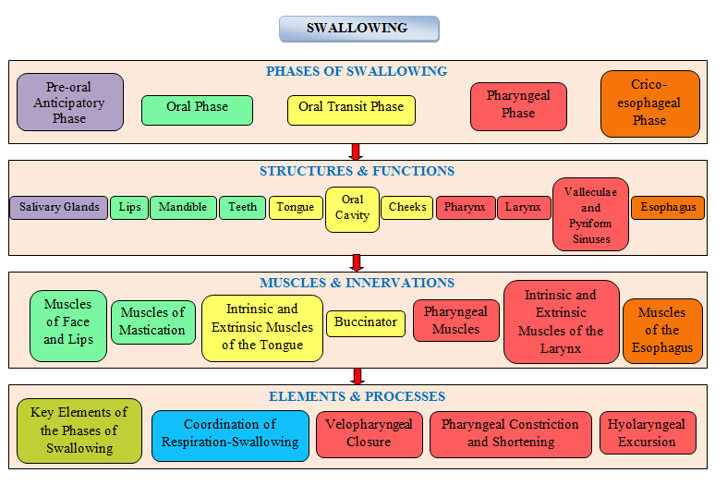
Figure 1: Contents in the courseware were organized according to the phases of swallowing. Topics on each anatomical structure and its functions were organized under the swallowing phase(s) which the structure is involved in, followed by topics on muscles and nerve innervations of the anatomical structure. Topics on key elements of each phase of swallowing and topics on specific processes were organized under the swallowing phase which it is related to.

Figure 2: A sample of image used in the courseware – anterior view of the oral cavity.

Figure 3 Sample of a content page showing animation of the oral phase of swallowing. Links to topics on anatomical structures involved in the phase placed under the animation video - provides easy navigation and direction to related topics to aid understanding of relation between the physiological functions and the anatomical structures and muscles involved.

