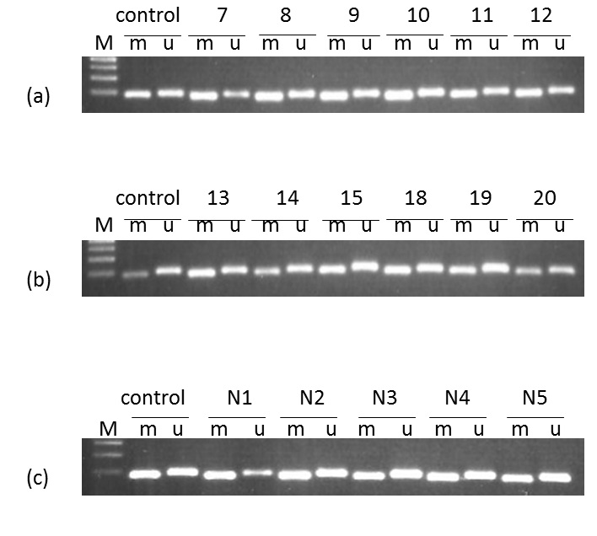
FIGURE 1. Representative MSP results for MGMT
(a) Sample 7, 8, 9, 10, 11 and 12 = methylated
(b) Sample 13, 14, 15, 18, 19 and 20 = methylated
(c) Reactive lymph nodes, N1, N2, N3, N4 and N5 = methylated
Abbreviations: M = marker; m = methylated, u = unmethylated; N = reactive lymph nodes.

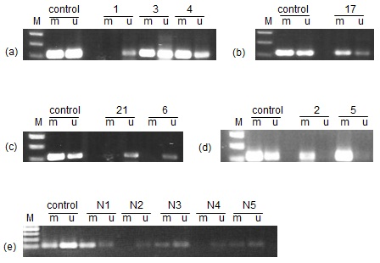
FIGURE 2. Representative MSP results for SPOCK2
(a) Sample 1 = unmethylated, sample 3 and 4 = methylated
(b) Sample 17 = methylated
(c) Sample 21 and 6 = unmethylated
(d) Sample 2 and 5 = methylated
(e) Reactive lymph nodes, N1, N3 and N5 = methylated, N2 and N5 = unmethylated
Abbreviations: M = marker; m = methylated, u = unmethylated; N = reactive lymph nodes.

