Table 1: Mean (SD), range and p-values of spinal morphological attributes in young adults
Variables | Gender | Mean (SD) | Range | p-value
Right LUMBAR EXTENSORS MUSCLE fiber angle | Males | 11.76 (4.99) | 3.00- 20.26 | 0.12
Right LUMBAR EXTENSORS MUSCLE fiber angle | Females | 9.62 (4.08) | 0.30- 18.85 | 0.12
Left LUMBAR EXTENSORS MUSCLE fiber angle | Males | 7.96 (5.11) | 0.70- 18.01 | 0.89
Left LUMBAR EXTENSORS MUSCLE fiber angle | Females | 7.77 (3.93) | 1.79- 16.84 | 0.89
LUMBAR EXTENSORS MUSCLE thickness | Males | 2.44 (0.28) | 1.74- 2.98 | < 0.05
 | Females | 1.97 (0.30) | 1.22- 2.55
LUMBAR EXTENSORS MUSCLE endurance | Males | 138.37 (54.59) | 66.00- 240.00 | 0.46
LUMBAR EXTENSORS MUSCLE endurance | Females | 126.50 (50.31) | 44.00- 240.00 | 0.46
Thoracic curvature | Males | 32.51 (9.19) | 13.98- 46.85 | 0.76
Thoracic curvature | Females | 31.60 (10.12) | 8.81- 51.34 | 0.76
Lumbar curvature | Males | 40.84 (11.94) | 21.51- 64.18 | 0.06
Lumbar curvature | Females | 46.66 (8.31) | 26.68- 59.56 | 0.06

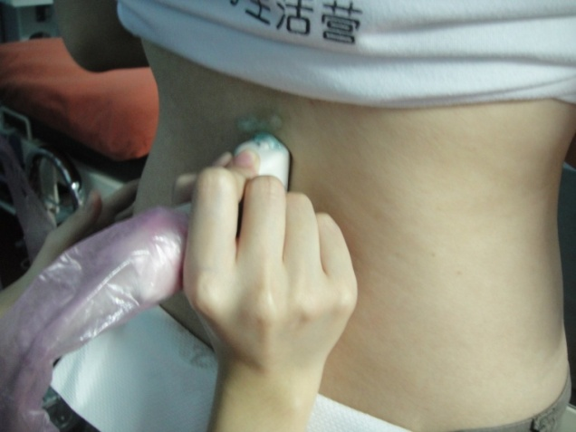
Figure 1a : Ultrasound imaging of lumbar extensor muscle at the 3rd lumbar spinal vertebral level
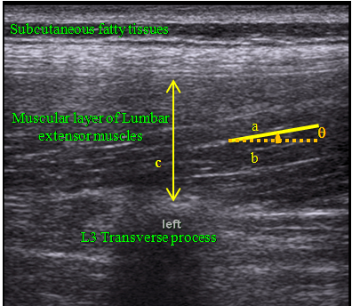
Figure 1. Image of left lumbar extensor muscles
a= fiber nearest to midpoint of lumbar extensor muscles
b= line parallel to inner skin layer
c= thickness of lumbar extensor muscles.
θ= fiber angle of lumbar extensor muscles.
Inner aponeurosis
Figure 1b : An ultrasound image of lumbar extensor muscle

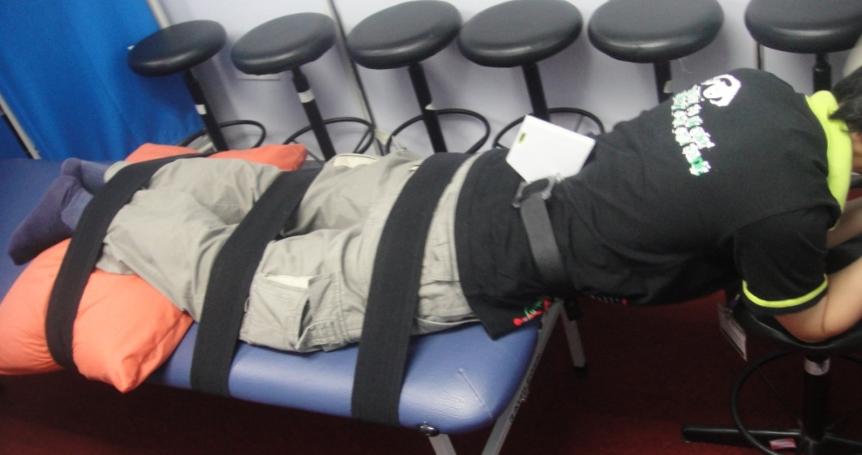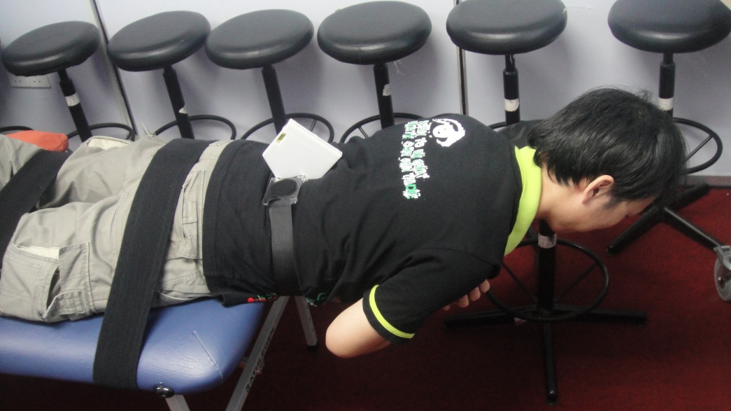
Figure 2: Measurements of Lumbar extensor muscle endurance using Sorenson’s test

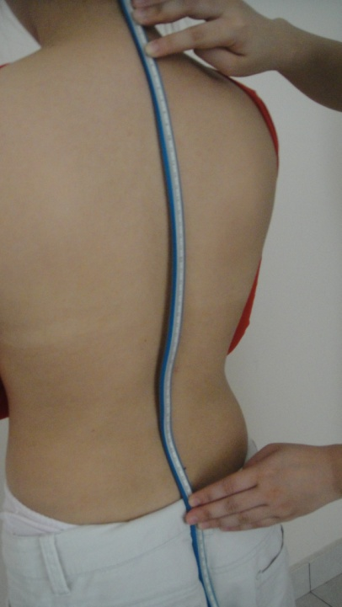
Figure 3a: Measurements of the degree of the kyphosis and lumbar lordosis using a flexible ruler
L₂

H₂

H₁

S2
L₁
T12
C7

Fig 3b. An illustration of thoracolumbar curvature measurement performed in the study. L₁: representation of total length of thoracic kyphosis curvature; L₂: representation of total length of lumbar lordosis curvature; H₁: representation of maximum width of thoracic kyphosis curvature; H₂: representation of maximum width of lumbar lordosis curvature.

