Table 1: High Performance Liquid Chromatography elution gradient used in fractionation and detection of ergosterol
Time Minutes | Solvent A Water % | Solvent B  Methanol % | Flow Rate  ml per minute
0 | 40 | 60 | 1.5
10 | 0 | 100 | 1.5
16.5 | 0 | 100 | 1.5
17 | 40 | 60 | 1.5
19 | 40 | 60 | 1.5

Figure 1: Calibration curve of ergosterol standard

Table 2: HPLC results for ergosterol standard
Ergosterol  concentration  (µg/mL) | HPLC RT* (minutes) | HPLC peak area | HPLC Peak height
1000 | 13.032 | 29694650 | 2285723
800 | 13.026 | 27051242 | 2197821
500 | 13.026 | 16089992 | 1496168
300 | 13.016 | 10758018 | 975950
100 | 13.001 | 2958753 | 258676
50 | 13.005 | 1312314 | 115258
40 | 12.998 | 1221806 | 107711
25 | 12.994 | 626850 | 55205
10 | 12.991 | 269223 | 23596
*RT = retention time

Table 3: Ergosterol content of fungal and bacterial isolates determined by HPLC
Sample no. | Isolate | HPLC result | HPLC RT (minutes) | Ergosterol conc.  (µg/ml) | Ergosterol content in mycelia*  (µg/mg)
1-Af | Aspergillus fumigatus | positive | 13.003 | 359.59 | 10.7877
2-An | Aspergillus niger | positive | 12.969 | 153.89 | 4.6167
3-Ca | Candida albicans | positive | 12.998 | 209.58 | 6.2874
4-Ct | Candida tropicalis | positive | 12.975 | 761.25 | 22.8375
5-Crg | Cryptococcus gattii | positive | 12.980 | 419.86 | 12.5958
6-Crn | Cryptococcus neoformans | positive | 13.007 | 235.99 | 7.0797
7-Fs | Fusarium solani | positive | 13.009 | 313.36 | 9.4008
8-Mu | Mucor | positive | 13.016 | 360.72 | 10.8216
9-Pe | Penicillium | positive | 13.032 | 379.21 | 11.3763
10-Rh | Rhizopus | positive | 13.009 | 446.53 | 13.3959
11-Bs | Bacillus subtilis | Negative | - | 0 | -
12-Ec | Escherichia coli | Negative | - | 0 | -
13-Pse | Pseudomonas aeruginosa | Negative | - | 0 | -
14-Ste | Staphylococcus aureus | Negative | - | 0 | -
*Ergosterol concentration calculated per mg dry mycelial weight

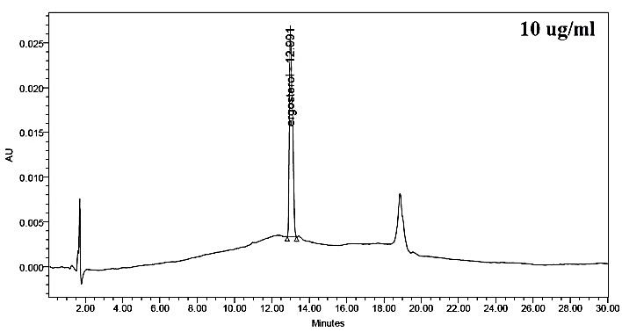 | 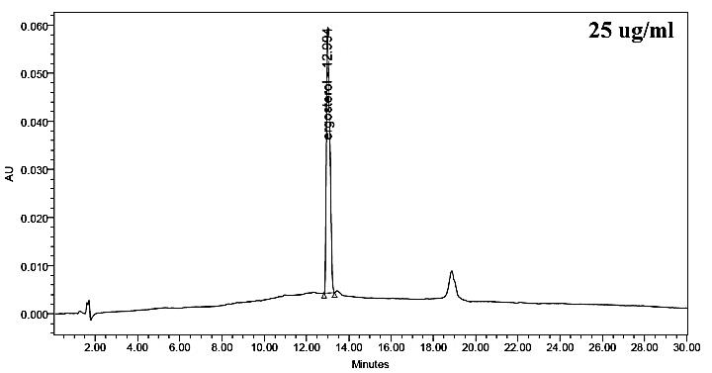
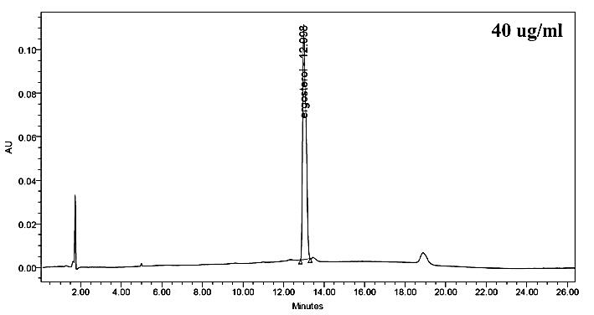 | 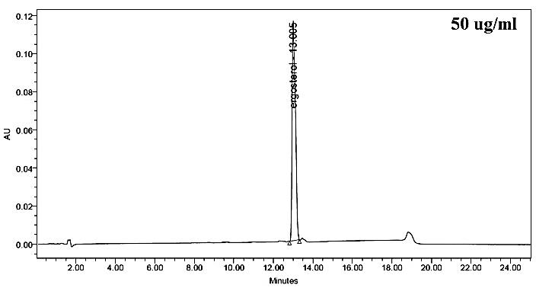
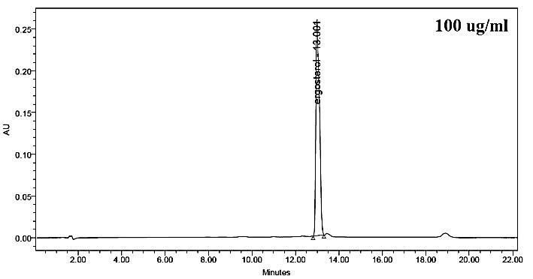 | 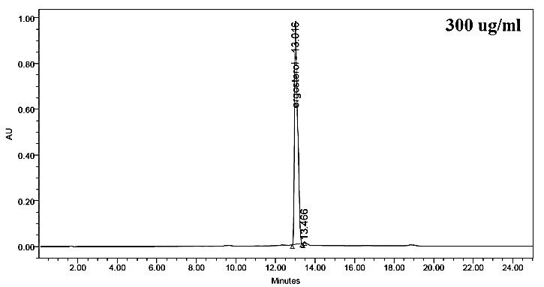
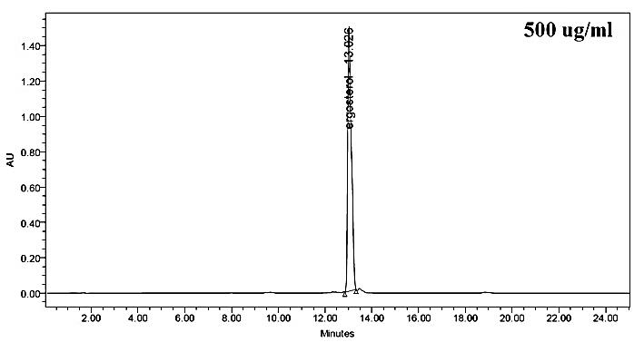 | 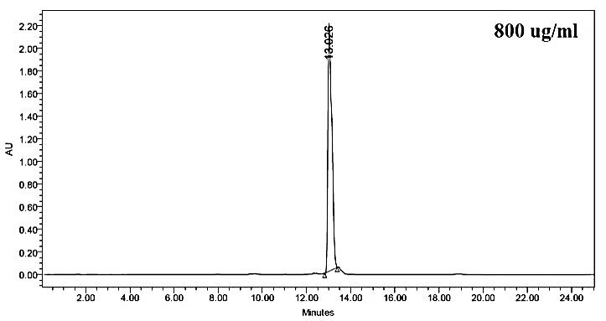
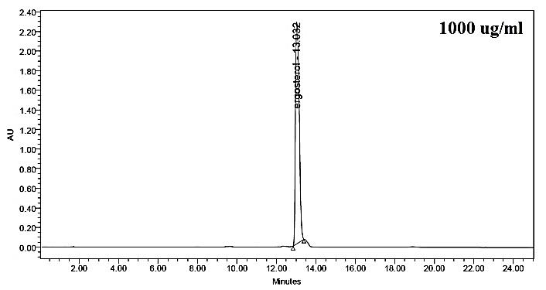

Figure 2: Chromatograms of ergosterol standard at varying concentrations

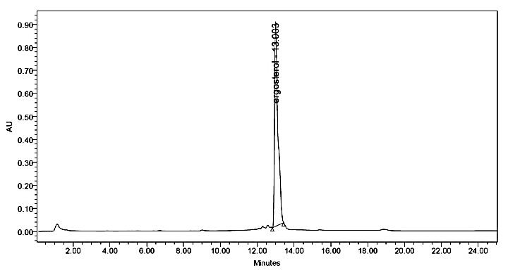  Af | 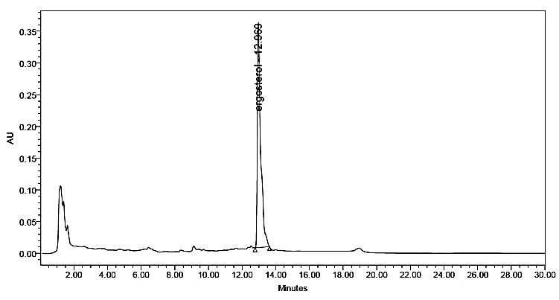  An
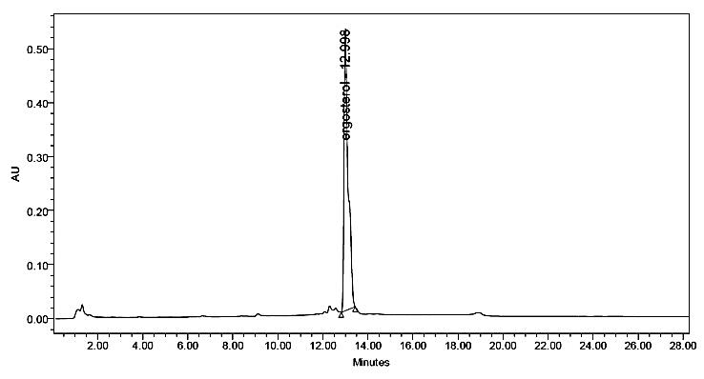  Ca | 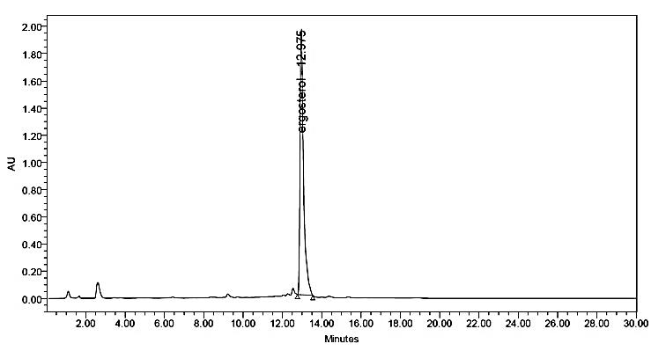  Ct
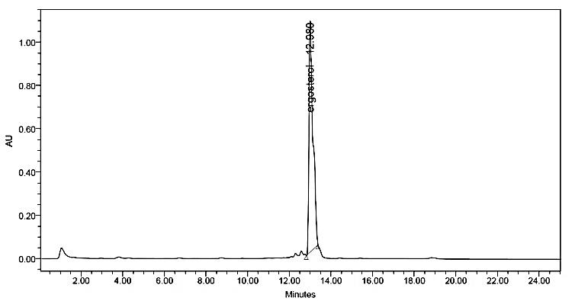  Crg | 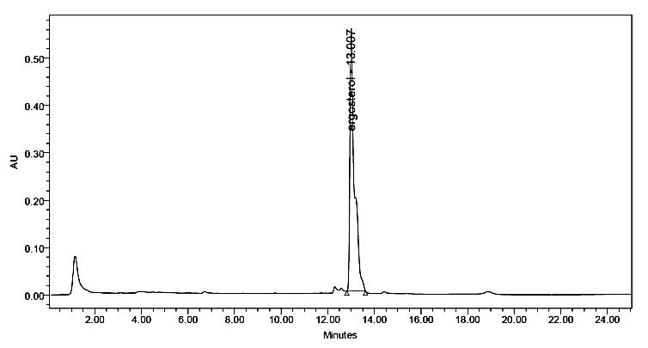  Crn
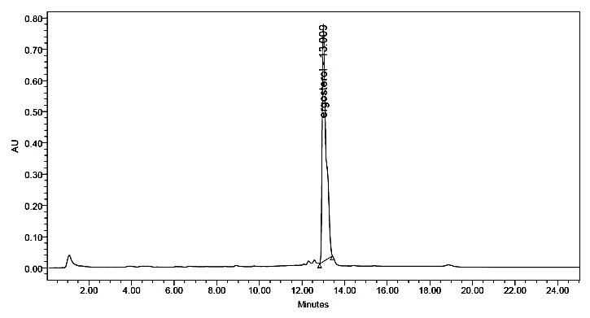  Fs | 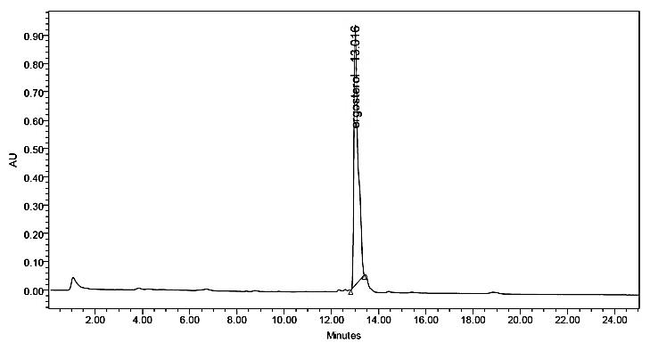  Mu
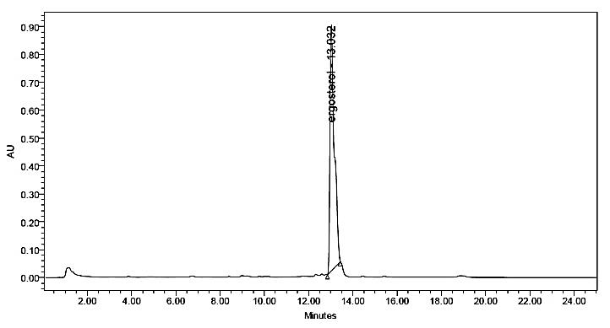  Pe | 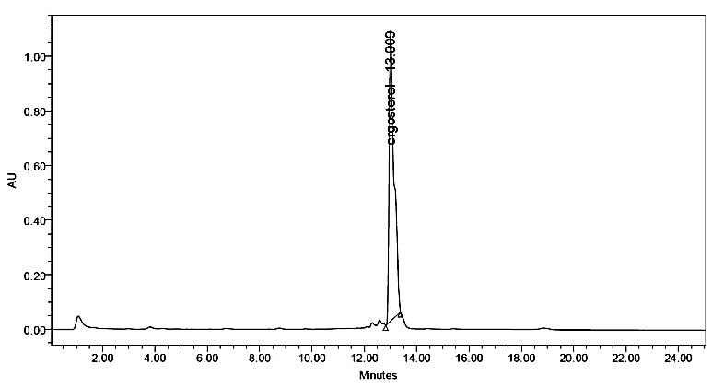  Rh
Figure 3: Chromatograms of ergosterol in pathogenic fungal isolates studied

