Dear editor,

The following are the potential reviewers:

1. PM. Dr. Ahmad Nazlim Yusoff
Fakulti Sains Kesihatan. UKM KL
nazlimtrw@ukm.edu.my

2. Dr. Mazly Farina Mohammad
Fakulti Sains Kesihatan. UKM KL
mazlyfarina@ukm.edu.my

Thank you.

Best regards,
Hanani

Title: Observation of Auditory Perceptual and Visual-Spatial Characteristic of Patient with Occipital Lobe Tumour: A Magnetoencephalography study.

Abstract

The present study discussed functional reorganization and alteration in respond to the slow-growing tumour, hemangiopericytoma in the occipital cortex. Visual evoked field (VEF) and auditory evoked field (AEF) using magnetoencephalography (MEG) was used to evaluate the source localization and brain activity of the participant. Results of VEF source localization show a atypical brain wave. Brain activation demonstrates low activation of the occipital lobe in the ipsilateral to the tumour while contralateral hemisphere activated with high intensity and bigger activation volume. AEF result shows an identical source localization and both side of the temporal lobe are activated. This result provide evidence that slow-growing tumour can induce functional reorganization and alteration to the brain.

Keywords: Visual evoked field (VEF), auditory evoked field (AEF), magnetoencephalography (MEG), hemangiopericytoma, occipital cortex

Pemerhatian Persepsi dan Visual-ruang Pesakit dengan Tumor pada Lobus Ocipital: Satu Kajian Magnetoencephalography (MEG).

Abstrak

Kajian ini membincangkan terdapatnya proses penyusunan semula dan perubahan kefungsian bagi tindak balas terhadap tumor yang lambat membesar, hemangiopericytoma pada bahagian korteks osipital. Kajian ini menggunakan bidang visual yang ditimbulkan (VEF) dan bidang auditori yang ditimbulkan (AEF) menggunakan magnetoencephalography (MEG) untuk menilai penyetempatan sumber dan pengaktifan otak peserta. Hasil penyetempatan sumber VEF menunjukkan gelombang otak yang tidak sejajar diantara kedua-dua belah hemisfera. Pengaktifan otak menunjukkan pengaktifan yang rendah pada lobus oksipital di ipsilateral tumor manakala hemisfera kontralateral diaktifkan dengan intensiti tinggi dan jumlah pengaktifan yang lebih besar. Hasil AEF menunjukkan penyetempatan sumber yang sama pada kedua-dua belah hemisfera dan kedua-dua belah lobus temporal diaktifkan. Hasil ini menunjukkan bahawa tumor yang lambat membesar dapat mendorong penyusunan semula dan menyebabkan perubahan pada fungsi otak.

Keywords: bidang visual yang ditimbulkan (VEF), bidang auditori yang ditimbulkan (AEF), magnetoencephalography (MEG), hemangiopericytoma, Korteks Osipital

Abbreviation

MEG: Magnetoencephalography
MRI: Magnetic Resonance Imaging
VEF: Visual Evoked Field
AEF Auditory Evoked Field
BESA: Brain Electrical Source Analysis

Introduction

Visual cortex is a part of the cerebral cortex that processes visual information and it is located in the occipital lobe. Damage to visual cortex is a common incidence in cases of brain tumour, stroke or trauma [1]. This brain damage of the visual cortex can cause alteration in the brain function and lead to the changes of vision abilities [2]. In the case of brain tumour, as a tumour grows, it puts pressure on surrounding tissue therefore, affecting the function, process or part of the cortex that is controlled by that area of the brain. In slow-growing tumour e.g. hemangiopericytoma, functional reorganization can occur [3]. During the process of the functional brain reorganization new cortical regions can be recruited to participate in the visual cortex network, aiding in the recovery of function of the visual areas [4].

The finding of the functional reorganization and changes in visual cortex alteration induced by tumour growth might be limited to an early critical period of development [5-7] led to a common assumption that all cortical connections in the adult visual cortex are fixed [8]. However, this assumption has been challenged by evidence of plasticity in early visual cortex evoked by changes in normal experience [9, 10] and by damage to peripheral visual pathways [10, 11]. However, the endpoint of functional reorganization and alteration is not always beneficial and can lead to significant maladaptive outcomes [12]. The effects is of course are related to the nature and extent of the neuropathogenic process. The stage of neurodevelopment during which the insult occurs is also play an important roles [13]

The present study will discuss the functional reorganization and alteration of the brain in respond to the hemangiopericytoma in the occipital cortex. Hemangiopericytoma is an uncommon tumor that only accounts for 1% of all central nervous system tumor [14]. It is characterised by histopathological finding of abnormal pericytes around the capillaries. The mass effect from this lesion can manifest as a gradual increase in intracranial pressure, or more localized symptoms such as hemiparesis, aphasia, gait unsteadiness and loss of vision [15]. The purpose of the present study is to observe and report the functional and structural reorganization that has been made by the brain in response to the tumour growth.

The present study recorded visual evoked field (VEF) and auditory evoked field (AEF) of magnetoencephalography (MEG) in order to evaluate the function of auditory and visual processing. The tumour not only invades the occipital area but also extended to the posterior temporal lobe. The observation of the tumour induced reorganization in structural and functional will be discussed based on the MEG assessment in term of peak and latency of VEF and AEF.

Materials and Methods

Participants
A 30-year-old, right handed male participant complaining of worsening headaches, tinnitus and bilateral blurring of vision for 2 months. The participant had an uneventful medical and social history, There is no previous seizure, recurrent vomiting or trauma. On clinical examination, the participant was fully conscious but impaired visual acuity. Fundoscopy examination found bilateral papilloedema with optic atrophy. MRI of the brain showed lobulated extra-axial lesion measuring 6x5x7 cm at left occipital region crossing to the right, attached to falx. The lesion was hypointense in T1 view, hyperintense in T2 view, and vividly enhanced by contrast. No hydrocephalus was seen. Histopathological examination from the lesion sample showed closely packed moderately pleomorphic cells interlacing with blood vessels exhibiting staghorn pattern, oval to round nuclei, fine chromatin pattern and indistinct cell borders which was consistent with Anaplastic Hemangiopericytoma (WHO Grade III). The patient was administered dexamethasone but no improvement of symptoms was noted. After full explanation of the nature and risks of the study, informed consent was obtained according to the protocol approved by the Institutional Ethics Committee (IEC) of Universiti Sains Malaysia.

Magnetoencephalography and data processing
Magnetoencephalogram (MEG) data were recorded continuously during the performance of a visual (checkerboard pattern) and auditory (two and three syllabus words presented) stimulus, as shown in Fig. 1 A, B and C. MEG data were collected using a 306-channel Vectorview system (ElektaNeuromag, Helsinki) in a light Elekta-Neuromag magnetically-shielded room. A magnetometer and two orthogonal planar gradiometers were located at each of 102 positions. Vertical and horizontal eye movements were recorded using paired EOG electrodes. Four head position indicator (HPI) coils were used to monitor the head position. A 3D digitizer (Fastrak Polhemus Inc., Colchester, VA) was used to record the three-dimensional locations of the HPI coils and approximately 200 ‘head points’ across the scalp, and three anatomical fiducials (the nasion and left and right pre-auricular points). Data were sampled 1000 Hz and pre-processed using Max Filter software (Elekta-Neuromag, Helsinki) with movement compensation. Software Brain Electrical Source Analysis (BESA version 6.0, GmbH, Graefelfing, Germany) was used to process for source analysis of the waveforms of the visual processing area. An MRI image was also collected using 3-tesla magnetic resonance imaging (MRI) (Philips Achieva 3.0T X-series, Philips, Netherlands).

Source Analysis of Visual Evoked Field (VEF) and Auditory Evoked Field (AEF)
In order to provide the precise spatial localizations compared to distributed source models for both visual evoked field (VEF) and auditory evoked field (AEF), for example minimum norm approaches, equivalent current dipole approach was used. For the starting point of the dipoles, in order to maximize the explained spatial variance of the scalp-recorded potentials using maximization algorithm (EM), the algorithm iteratively shift dipole sources at the at specific brain location with a specific dipole orientation. The source dipole solutions for the N100 component were determined.

Data were filtered using high pass filter (>1 Hz, Butterworth filter 6 dB/oct with no added padding) and the artefact rejection threshold was set to 2500 fT for magnetometers and 900 fT for gradiometers. Using adaptive artefact correction, eye-blinks were corrected and modelled in the source analysis with one fixed source. Epochs were low pass filtered to 200 Hz (Butterworth filter 24 dB/oct), time locked to the tone onset, baseline corrected (- 50 to 200 ms). Source analysis of evoked responses from the gradiometer MEG channels, was performed on the visual and auditory processing response. The forward model topography (leadfield) was estimated using a realistic head model, co-registered by fiducial and digitised scalp loci. The inverse of this leadfield matrix was applied to the gradiometer data to estimate the source waveforms, varying source location and orientation iteratively until the residual difference between scalp and model waveforms was minimized. The data were fitted to two bilateral equivalent current dipoles (regional sources). The fits were constrained by imposing symmetry on the two sources, but not constrained by location or orientation, and with regularisation constant 1% to stabilise source fitting in the presence of noise.

For the N100 (50 –150 ms) produced in a two source solution that was most likely fundamental the generation of scalp recorded potential in these time windows. Two source dipoles were fitted distinctly with the constraint of having symmetrical sources in each hemisphere. Using different starting locations, these symmetric dipoles were allocated consistently to the occipital cortex for VEF and temporal cortex for AEF for the N100. Dipoles were fit sequentially in the right and left occipital and temporal activation and fit over 50–150 ms.

Results

Fig. 2A and B demonstrate a sagittal and transverse view of MRI brain depicting a solid tumour at the bilateral occipital region, in the red circle. MRI result indicate the tumour mass are greater in the left hemisphere. The tumour not only invades the occipital area but also extended to the posterior temporal lobe. Fig. 2C shows the brain wave of source analysis including amplitude and latency using BESA. Comparing between right and left hemisphere of N100 visual evoked field (VEF) signal, right hemisphere component of N100 is corresponding in time whilst the left hemisphere, ipsilateral to the tumour signal shows prolonged in N100 latency and the signal peak is in the opposite direction. Furthermore, left hemisphere brain wave shows lower wave amplitude which might indicate a dysfunction of the visual pathway. Fig. 2D shows 3D images and transverse view of source localization. Results indicate that both hemisphere is activated but the left hemisphere (ipsilateral to the tumour) activated with low intensity and small activation volume.

Fig. 3A demonstrate N100 auditory evoked field (AEF) wave signal comparing between right and left hemisphere. For both hemispheres, the component of N100 is corresponding in time to the AEF. However, result indicates that the left hemisphere shows lower wave amplitude. The auditory task used activated both temporal area of the brain, as in Fig. 3B. Comparing between hemispheres, left hemisphere (ipsilateral to the tumour) shows higher activation intensity. Source activity results demonstrate that both source localization and brain activity is matched.

Discussion

In the present study, we observed tumour-induced functional reorganization and changes in the brain particularly in the occipital area. Temporal area was also included as a region of interest, this is due to the tumour have also occupied a small area in the posterior part of the left temporal lobe. Brain activation and source localization were used to measure the functional localization during both visual (VEF) and auditory (AEF) tasks. As a result, we found that atypical N100 VEF wave signal and brain activation. However, for N100 AEF, the wave signals are corresponding in time and brain activation is identical with previous published study [16, 17].

N100 VEF
The present data on continuous prolonged recording of VEF suggest that complaints of visual disturbances are associated with marked labiality and prolonged in N100 VEF latency in the ipsilateral hemisphere to the tumour. The present study further suggests that the present symptoms are also associated with atypical wave signal, the amplitude of the brain wave are in the opposite direction to the N100 amplitude. Our observation finding are in agreement with the previous study which report that brain tumour interfere with normal brain wave and function by disrupting their wave signal of the brain network [18, 19]. Comparing between hemispheres, left hemisphere brain wave shows lower wave amplitude which might indicate a dysfunction of the visual pathway. This present study proposed that the tumour has suppressed the functional visual processing areas. Therefore, disrupt the propagation of the brain wave. This situation is expected as the tumour provoking loss of associated fibers or changes in synaptic efficiency. This may alter the communication between neuronal networks and may underlie neurological disturbances [20-22].
t has been shown that patients with brain tumor
experience cognitive deficits.
21–25
These cognitive def
-
icits are probably primarily due to the tumor itself, and
not to adverse effects of radiotherapy because only high
fraction doses (exceeding 2Gy) are likely to affect cog-
nition.
26
Patients experience attention deficits, working
memory problems, reduced psychomotor speed, and
problems with executive functions.
27
The origin of the
cognitive deficits in low-grade glioma patients is in-
completely understood. One might expect that th

A brain activation result reveals that bilateral hemispheres of occipital areas are activated. However, result demonstrates that left hemisphere (ipsilateral to the tumour) activated with low intensity and smaller activation volume compared to the right hemisphere.The present observation proposed that the contralateral area of the functional lesion-visual would take place in response to the brain insult (in this case brain tumour), with increased contralateral and reduced ipsilateral activity. Similar pattern of brain behaviour was also found in a previous study where a series of activation shifts took place involving an early recruitment of contralesional homologous brain regions after a brain insult [23]. Similar pattern of results was found in stroke-induced aphasia suggesting an increased activation in the contralateral area of the lesion-language network, followed by re-shifting of main activation to left hemisphere language areas [24]. The present result is also supported by the source localization analysis, the component of N100 in the left hemisphere is not corresponding in time to those of the VEP are identified and the recording of VEP shows the localization of the two dipoles is in the right occipital region. Therefore, we proposed that the cortical reorganization occurs in brain and right occipital area take over the functional processing that previously performed by the left hemisphere of the brain in response to the brain insult.

N100 AEF
AEF examination was performed to the patient in order to observe the effect of the tumour to the auditory processing.The latency and the location of equivalent current dipole of N100 AEF for both hemispheres are match. However, the brain wave signal in the ipsilateral to the tumour shows lower in amplitude but higher in brain activation intensity.This result indicates that there are alterations and changes in the brain wave and activation intensity eventhought the posterior part of the temporal lobe involved is small. This brain alterations and changes are proposed to be related to the mechanism of survival of the tumour tissues. Previous studies suggest that the phenomenon of higher brain activity and intensity in the tumour area is due to the high metabolism rate[25]. This is a common phenomenon for the tumour tissue to have higher activity compared to normal cells. This phenomenon is known as Warburg Effect, which postulated the changes in metabolism is the fundamental cause of cancer[26] .

In summary, the neuroimaging result of the VEF and AEF demonstrate a brain changes and alteration. This changes and alteration to the brain anatomy and function are due to the brain tumours that invade the functional areas of the brain. The present study suggests that the mechanisms of the tumour-induced plasticity are based on the intrinsic reorganisation within the lesion area. Consequently, this mechanism leads to the recruitment of other regions implicated in the original functional network, which is contralateral area to the tumour.

Conclusion

In the present study, we observed the effect of a local brain lesion (brain tumour) in the occipital area to the source localization and brain activity using VEF and AEF of MEG signals. The main observations were that patient with brain tumors have atypical brain wave and activation ipsilateral to the tumour. This interference in the brain signals and activation were not only confined to the tumour areas but also areas close to the tumour. We also observed that the contralateral hemisphere activated with high intensity and bigger activation volume, we proposed that this mechanism are in respond to neural plasticity. The concept of neural plasticity is certainly appealing. However, unequivocal proofs that plastic changes following the changes of environmental (due to the tumour) better adaptation remain to be provided. Thus, future study related to this issue is needed.

Acknowledgements

The authors wish to thank Hazim Omar for data acquisition from Department of Neurosciences, Health Campus Universiti Sains Malaysia.

References
1. Young, J.M., et al., Cortical reorganization consistent with spike timing-but not correlation-dependent plasticity. Nat Neurosci, 2007. 10(7): p. 887-95.
2. Lau, J.C., et al., Functional Magnetic Resonance Imaging for Preoperative Planning in Brain Tumour Surgery. Can J Neurol Sci, 2017. 44(1): p. 59-68.
3. Restani, L. and M. Caleo, Reorganization of Visual Callosal Connections Following Alterations of Retinal Input and Brain Damage. Front Syst Neurosci, 2016. 10: p. 86.
4. Boldt, R., et al., Spatial variability of functional brain networks in early-blind and sighted subjects. Neuroimage, 2014. 95: p. 208-16.
5. Hubel, D.H. and T.N. Wiesel, Brain mechanisms of vision. Sci Am, 1979. 241(3): p. 150-62.
6. Hubel, D.H. and T.N. Wiesel, Early exploration of the visual cortex. Neuron, 1998. 20(3): p. 401-12.
7. Hubel, D.H. and T.N. Wiesel, Visual area of the lateral suprasylvian gyrus (Clare-Bishop area) of the cat. J Physiol, 1969. 202(1): p. 251-60.
8. Hubel, D.H., T.N. Wiesel, and S. LeVay, Plasticity of ocular dominance columns in monkey striate cortex. Philos Trans R Soc Lond B Biol Sci, 1977. 278(961): p. 377-409.
9. Liang, H., et al., Interactions between feedback and lateral connections in the primary visual cortex. Proc Natl Acad Sci U S A, 2017.
10. Abe, H., et al., Adult cortical plasticity studied with chronically implanted electrode arrays. J Neurosci, 2015. 35(6): p. 2778-90.
11. Gilbert, C.D. and W. Li, Adult visual cortical plasticity. Neuron, 2012. 75(2): p. 250-64.
12. Schumacher, E.H., et al., Reorganization of visual processing is related to eccentric viewing in patients with macular degeneration. Restor Neurol Neurosci, 2008. 26(4-5): p. 391-402.
13. Sabbah, N., et al., Reorganization of early visual cortex functional connectivity following selective peripheral and central visual loss. Sci Rep, 2017. 7: p. 43223.
14. Joo, M.S., et al., Metastatic Intracranial Hemangiopericytoma to the Spinal Column: A Case Report. Brain Tumor Res Treat, 2016. 4(2): p. 128-132.
15. Zweckberger, K., et al., Hemangiopericytomas grade II are not benign tumors. Acta Neurochir (Wien), 2011. 153(2): p. 385-94.
16. Kim, K., et al., Multi-channel atomic magnetometer for magnetoencephalography: a configuration study. NeuroImage, 2014. 89: p. 143-51.
17. Korostenskaja, M., et al., Magnetoencephalography reveals altered auditory information processing in youth with obsessive-compulsive disorder. Psychiatry Res, 2013. 212(2): p. 132-40.
18. Morrison, M.A., et al., Reliability of Task-Based fMRI for Preoperative Planning: A Test-Retest Study in Brain Tumor Patients and Healthy Controls. PLoS One, 2016. 11(2): p. e0149547.
19. Inoue, T., et al., Combined three-dimensional anisotropy contrast imaging and magnetoencephalography guidance to preserve visual function in a patient with an occipital lobe tumor. Minim Invasive Neurosurg, 2004. 47(4): p. 249-52.
20. Jutzeler, C.R., A. Curt, and J.L. Kramer, Relationship between chronic pain and brain reorganization after deafferentation: A systematic review of functional MRI findings. Neuroimage Clin, 2015. 9: p. 599-606.
21. Jarosiewicz, B., et al., Functional network reorganization during learning in a brain-computer interface paradigm. Proc Natl Acad Sci U S A, 2008. 105(49): p. 19486-91.
22. Manan, H.A., et al., The effects of aging on the brain activation pattern during a speech perception task: an fMRI study. Aging Clin Exp Res, 2015. 27(1): p. 27-36.
23. Chen, H., J. Epstein, and E. Stern, Neural plasticity after acquired brain injury: evidence from functional neuroimaging. PM R, 2010. 2(12 Suppl 2): p. S306-12.
24. Duffau, H., Lessons from brain mapping in surgery for low-grade glioma: insights into associations between tumour and brain plasticity. Lancet Neurol, 2005. 4(8): p. 476-86.
25. Sontheimer, H., Brain cancer: Tumour cells on neighbourhood watch. Nature, 2015. 528(7580): p. 49-50.
26. Weber, G.F., Metabolism in cancer metastasis. International Journal of Cancer, 2016. 138(9): p. 2061-2066.

Figure and Figure Captions
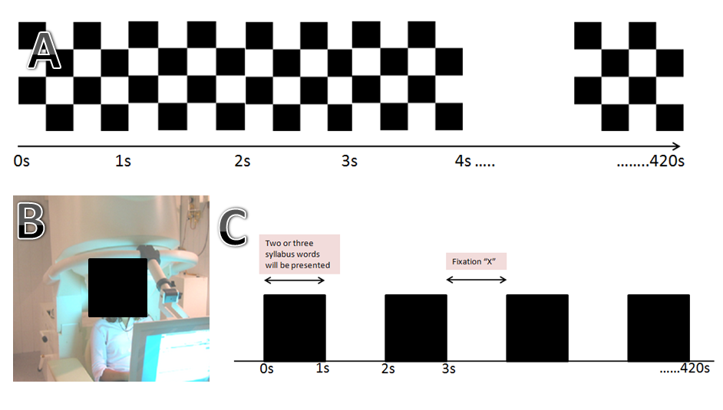
Figure 1: (A) Sequence of checkerboard used during the study. The stimulus is presented continuously for about 7 minutes. Participant need to focus to the stimulus presented, not to think about anything, to stay awake and must not fall asleep during the scan. (B): How participant is position during the study. The screen will be position in front of the participant. (C) Auditory stimulus used in the study, the stimulus was presented using earphone which are compatible with MEG. The stimulus is presented for 7 minutes.

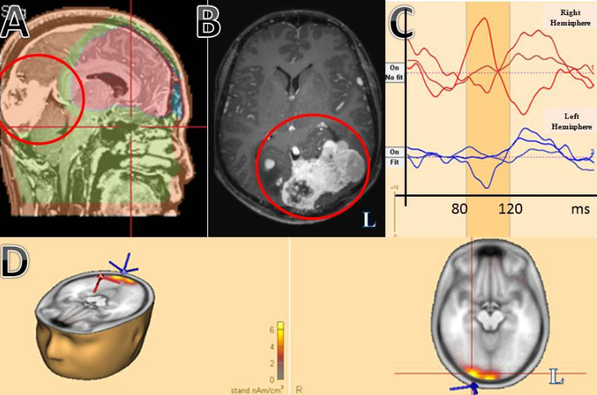

Figure 2.(A) Sagittal and (B) transverse view of MRI brain depicting a solid tumour at the bilateral occipital region (red circle).MRI result indicate the tumour mass are greater in the left hemisphere. (C) Comparing between right and left hemisphere of N100 VEF signal, right hemisphere component of N100 is corresponding in time whilst the left hemisphere signal shows prolonged in N100 latency and lower wave amplitude which might indicate a dysfunction of the visual pathway. (D) Shows source localization analysed using BESA source analysis. It shows activation on the both side of occipital region but with low activation intensity in the left. R: right side of brain; L:left side of the brain.

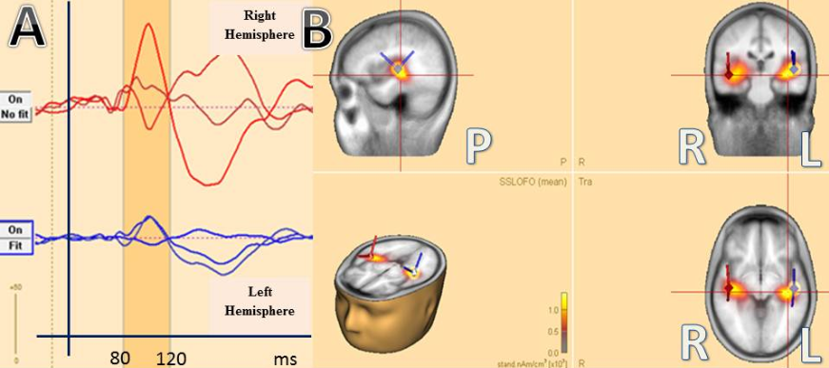

Figure 3.(A) N100 wave signal of AEF comparing between right and left hemisphere. Both hemisphere component of N100 is corresponding in time to the AEF. Comparing to the right, left hemisphere shows lower wave amplitude. (B) Shows source localization analysed using BESA source analysis. Both side of the brain are activated but with different intensity. R: right side of brain; L: left side of the brain.

