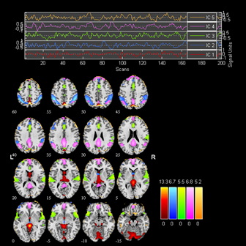
(a)
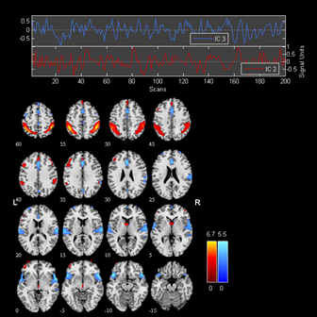
(b)
FIGURE 4 (a) Five independent components (IC) with their temporal response differentiated by colors as obtained from GIFT. (b) IPL (red) and ITG (blue) are the two of the ICs

