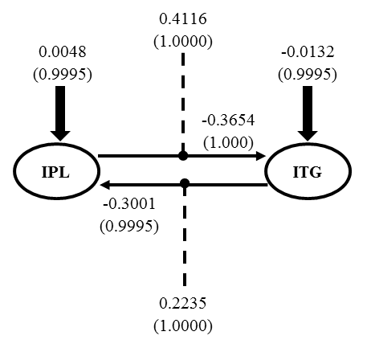

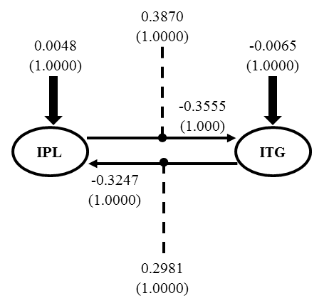

Fig. 6 DCM for right (top) and left (bottom) hemisphere effective connectivity between IPL and ITG

