Figure 1: Flow diagram of the search strategy
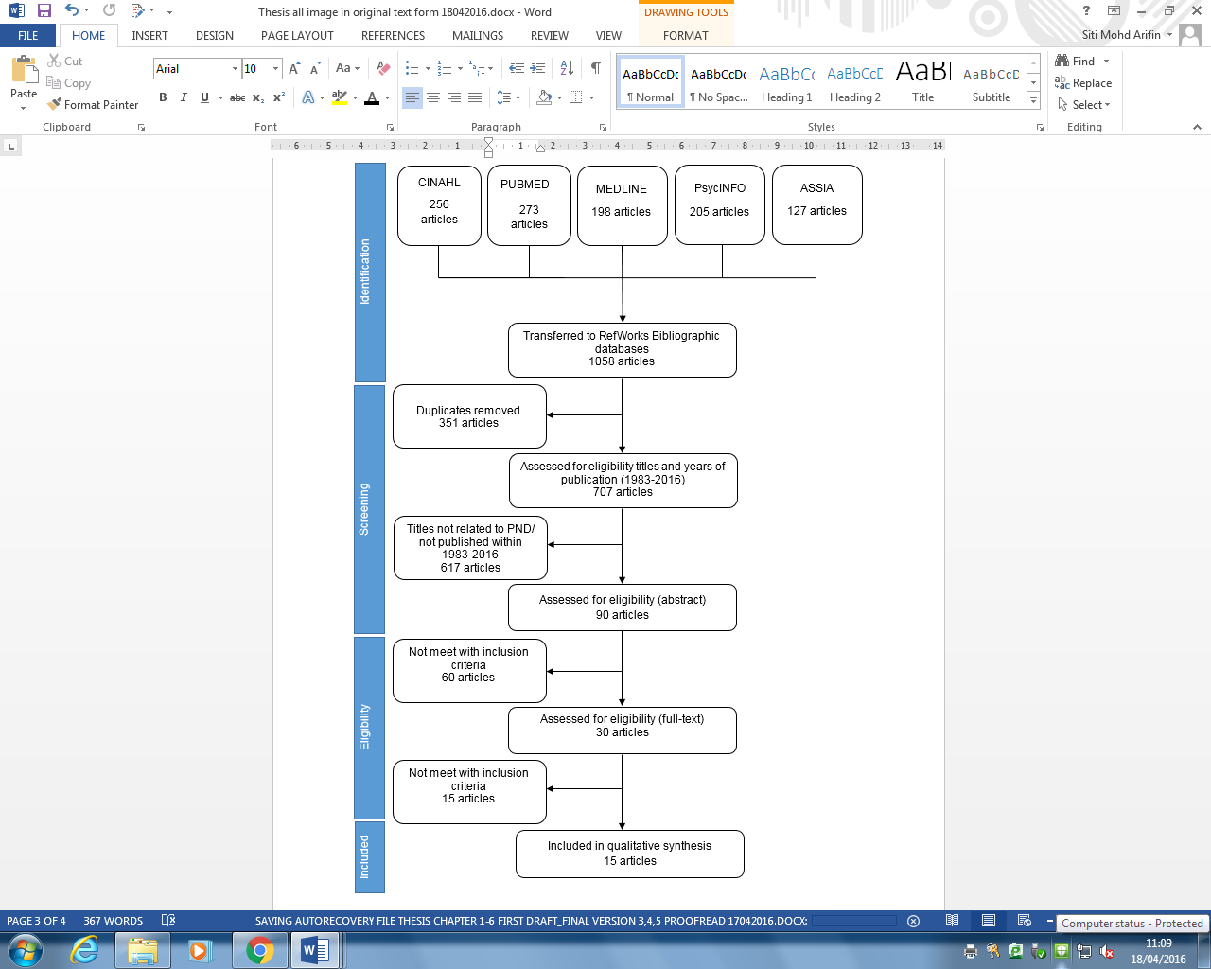

Table 1: Inclusion and exclusion criteria of the selected articles.
Inclusion criteria | Exclusion criteria
Described HCPs’ experiences in caring for women with PND | Not peer reviewed papers
Were carried out among HCPs (e.g. midwives, nurses, health visitors, doctors, general practitioners, and paediatricians) | Not published in English/Malay
Used qualitative methods of data collection and analysis (either a stand-alone study or a discrete part of a larger mixed method study)
Have been peer reviewed
Published in English/Malay in academic journals between 1983 and 2016

Table 2: Quality appraisal outcome using Critical Appraisal Skills Programme
Authors (Year) | Was there a clear statement of the aims of the research? | Is a qualitative methodology appropriate? | Was the research design appropriate to address the aims of the research? | Was the recruitment strategy appropriate to the aims of the research? | Was the data collected in a way that addressed the research issue? | Has the relationship between the researcher and participants been adequately considered? | Have ethical issues been taken into consideration? | Was the data analysis sufficiently rigorous? | Is there a clear statement of findings? | How valuable is the research? | Quality rating  Meets all the criteria/  Meets most/  Meets few
Tong and Chamberlain (1999) | Yes | Yes | Yes | Yes | Yes | No | Yes | Yes | Yes | Yes | Most
Lloyd and Hawe (2003) | Yes | Yes | Yes | Yes | Yes | No | No | Yes | Yes | Can’t tell | Most
Bilszta (2010) | Yes | Yes | Can’t tell | Yes | Yes | No | Yes | Yes | Yes | Yes | Most
Rush (2012) | Yes | Yes | Yes | Yes | Can’t tell | No | Yes | Yes | Yes | Yes | Most
Belle and Willis (2013) | Yes | Yes | Yes | Yes | Yes | No | Yes | Yes | Yes | Yes | Most
McConnel (2005) | Yes | Yes | Yes | Yes | Yes | No | Yes | Yes | Yes | Can’t tell | Most
Authors (Year) | Was there a clear statement of the aims of the research? | Is a qualitative methodology appropriate? | Was the research design appropriate to address the aims of the research? | Was the recruitment strategy appropriate to the aims of the research? | Was the data collected in a way that addressed the research issue? | Has the relationship between the researcher and participants been adequately considered? | Have ethical issues been taken into consideration? | Was the data analysis sufficiently rigorous? | Is there a clear statement of findings? | How valuable is the research? | Quality rating  Meets all the criteria/  Meets most/  Meets few
Brown and Ruth (2006) | Yes | Yes | Yes | Yes | Yes | No | Yes | Can’t tell | Can’t tell | Yes | Most
Chew-Graham et al (2008) | Yes | Yes | Can’t tell | Yes | Yes | No | No | Yes | Yes | Yes | Most
Junior et al.(2013) | Yes | Yes | Yes | Yes | Yes | Can’t tell | Yes | Yes | Yes | Yes | Most
Teng et al. (2007) | Yes | Yes | Yes | Yes | Yes | No | Yes | Yes | Yes | Yes | Most
Agapidaki et al. (2014) | Yes | Yes | Can’t tell | Yes | Yes | No | Can’t tell | Yes | Yes | Yes | Most
Place et al. (2015) | Yes | Yes | Yes | Yes | Yes | Yes | Yes | Yes | Yes | Yes | All
Mivšek et al. (2008) | Yes | Yes | Yes | Yes | Can’t tell | No | Yes | Can’t tell | Yes | Yes | Most

Table 3: Characteristics of the included studies
Country | Authors | Objectives | Research design | Data collection | Qualitative analysis
USA | Heneghan et al. (2007) | To assess the paediatricians’ beliefs about discussing maternal depressive symptoms during a paediatric visit; and to determine the methods used by the paediatricians to identify mothers with depressive symptoms. | Qualitative approach | Open-ended interviews with ten nurses and seven physicians; observations and ﬁeld diary records. | Inductive content analysis
USA | Abrams et al. (2009) | To investigate the barriers to formal help-seeking for PPD symptoms among the low-income ethnic minority mothers in the United States. | Grounded theory approach | Two focus groups: 12 medical setting service providers and social workers (also involved focus groups and individual interviews with 14 mothers with PPD symptoms and 11 community key informants. | Constant comparison
Brazil | Junior et al.  (2013 | To explore the experiences of Brazilian physicians and nurses caring for women with postpartum depression in the primary healthcare settings. | Qualitative approach | Semi-structured telephone interviews:  18 participants. | Content analysis
Canada | Teng et al. (2007) | To identify the potential barriers to care that recent immigrant women may encounter as perceived by the healthcare workers; and to identify challenges healthcare workers felt that they faced as providers of care to this population. | Qualitative approach | Semi structured interview:  16 key informants from various disciplines employed by healthcare agencies providing care to postpartum immigrant women in Toronto. | Constant comparison
Mexico | Place et al. (2015) | To describe the knowledge frameworks to conceptualize postpartum depression. | Grounded theory approach | Semi structured interviews: 61 physicians, nurses, social workers, and psychologists from five public-sector health care facilities. | Grounded theory analysis
UK | McConnel (2005) | To examine how health visitors understand and make sense of PND. | Qualitative approach | Semi structured interviews: eight health visitors. | Grounded theory analysis
UK | Brown and Ruth (2006) | To determine how health visitors identify PND and the implications this may have for practice. | Qualitative approach | Semi structured interviews: six health visitors. | Thematic analysis
UK | Chew-Graham et al (2008) | To explore the views of GPs and health visitors on the diagnosis and management of PND. | A qualitative study nested within a multicentre randomised controlled trial | In-depth interviews: 19 GPs and 14 health visitors in nine primary care trusts in Bristol, Manchester, and London. | Qualitative analysis
Greek | Agapidaki et al. (2014) | To investigate, identify, and interpret the views of paediatric primary healthcare providers on the recognition and management of maternal depression in the context of a weak primary healthcare system. | Qualitative approach | Face to face in-depth interviews: 26 paediatricians and health visitors. | Framework analysis
Slovenia | Mivšek et al. (2008) | To explore the knowledge and attitude of Slovenian midwives and nurses in relation to postnatal mood disorders. | Qualitative approach | Two focus groups: ten HCPs working in the maternity hospital and in the community centre. | Qualitative analysis
Australia | Tong and Chamberlain (1999) | To investigate the midwife’s knowledge of PND and awareness of risk factors. | Phenomenology | Semi structured interviews: seven midwives. | Colaizzi’s phenomeno-logical approach
Australia | Lloyd and Hawe (2003) | To investigate the different ways in which PND is framed and to give clues to alternative approaches in solving the problem of PND. | Qualitative approach | A series of one-to-one semi structured interviews were conducted among ten professionals who were academics, clinicians, and bureaucrats in two Australian cities. | Framing analysis
Australia | Bilszta (2010) | To gain insight into the experiences, beliefs, attitudes, and personal views of postnatal emotional distress, from the perspective of the HCPs. | Qualitative approach | Two focus groups:  16 HCPs | Qualitative analysis
Australia | Rush (2012) | To improve the understanding of the experience of MCH nurses responding to women at risk of PPD. | Phenomenology | Interview:  8 MCH nurses (two were sought from each of the four councils). | Phenomenological method
Australia | Belle and Willis (2013) | To explore the extent to which Child and Family Health Nurses (CHNs) exercise autonomy as specialist HCPs within the community health setting. | Qualitative approach | Semi structured interviews: 10 community nurses. | Thematic analysis

