Tables
Table 1. Criteria of Word Selection for Test Categories in Mandarin Paediatric Speech Perception Test in Malaysia
Category | Structure
1 (Speech Pattern Perception Test) | Consists of 12 words grouped according to the number of syllable (monosyllables, disyllabic trochees, disyllabic spondees and trisyllables)
2 (Spondee Perception Test) | Consists of 12 disyllabic spondees divided into three columns and grouped according to the tone of the syllables
3 (Vowel Perception Test) | Consists of 12 monosyllables that are divided into four columns with similar consonant and tone but different vowels
4 (Consonant Perception Test) | The structure is similar to VPT but the monosyllables have similar vowel and tone but different initial consonants
5 (Tone Perception Test) | Six tone combinations are formed from four Mandarin tones (Tone 1-2, 1-3, 1-4, 2-3, 2-4, and 3-4). Each tonal pair is constructed by four pairs of minimally contrastive words

Figures
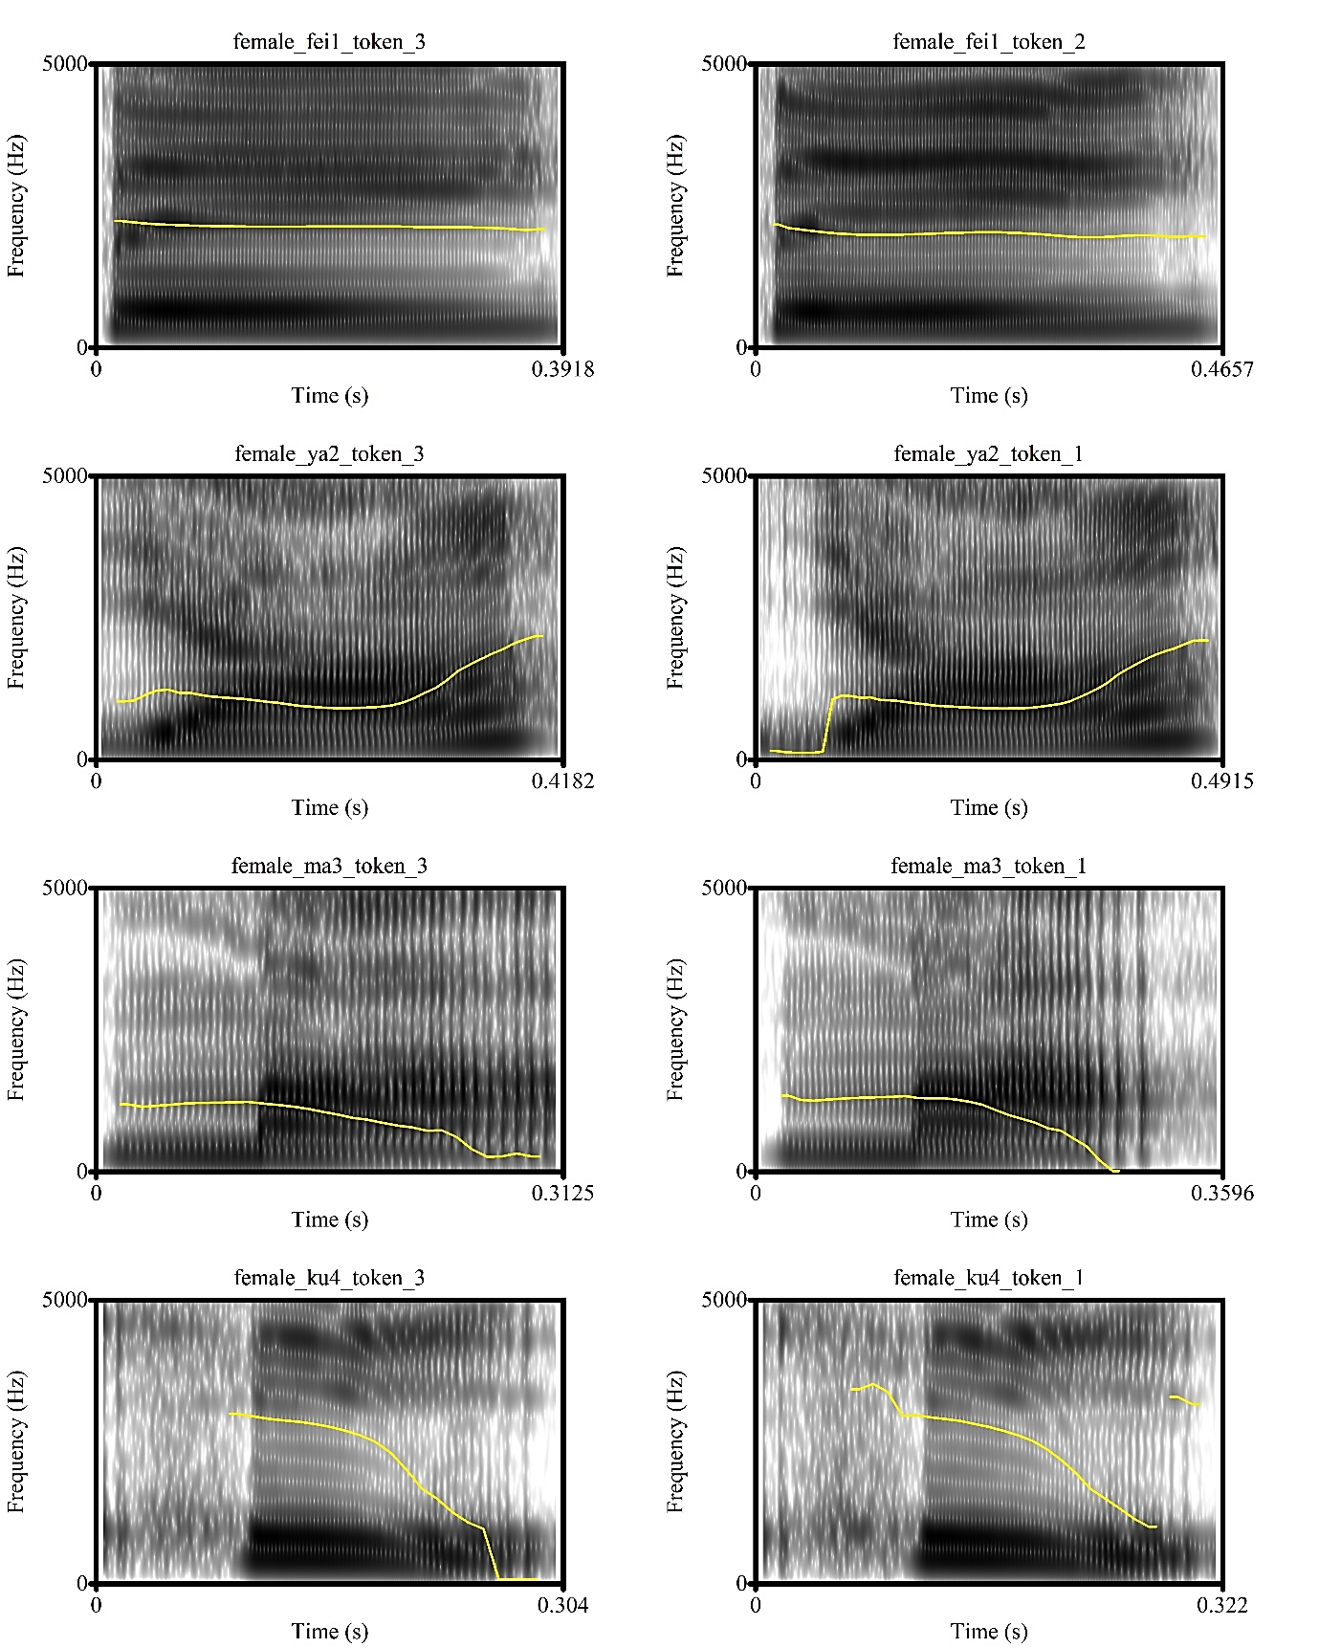
Figure 1: Examples of Female Token Pitch Contours that Fulfilled (Left Panel) & Did Not Fulfil (Right Panel) Mandarin Tones Criteria

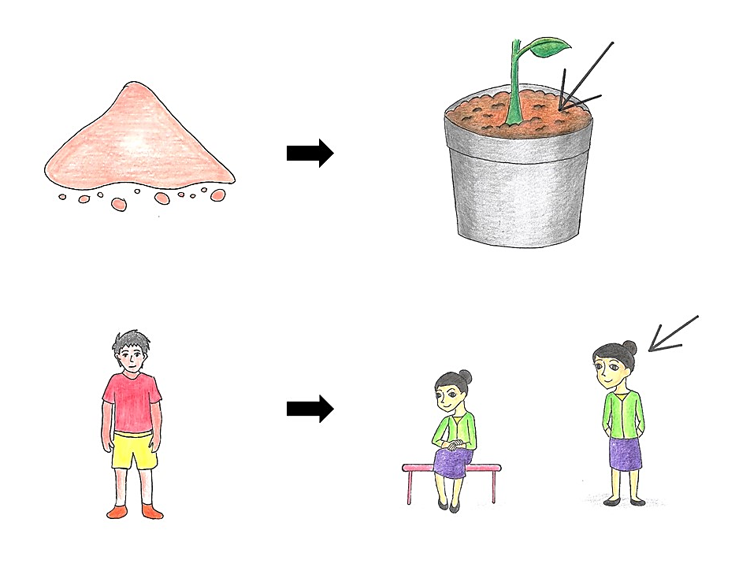
Figure 2: Picture Modification Process on Two Test Item Pictures

