DEVELOPMENT OF A PARENT-LED INTERACTIVE BOARD GAME FOR ARTICULATION THERAPY IN CHILDREN WITH CLEFT LIP AND PALATE (CLP)

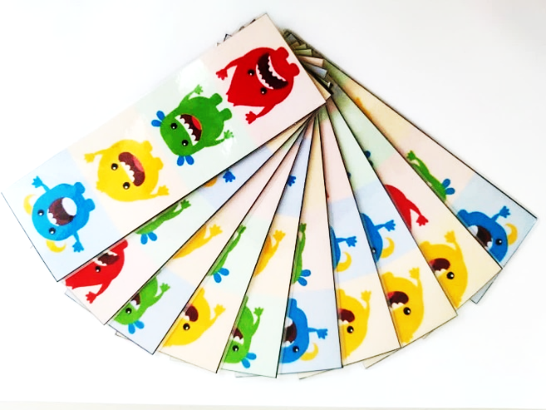  Figure 1 : Monstack Draw Sticks | 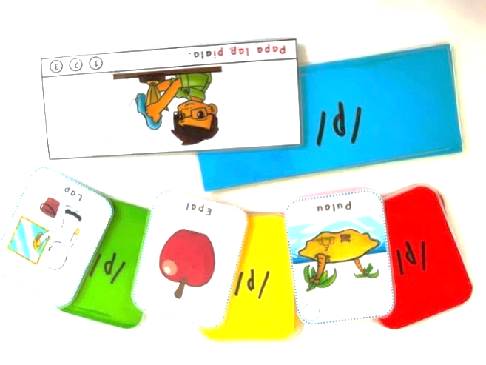  Figure 2 : Words & Sentences Stimuli
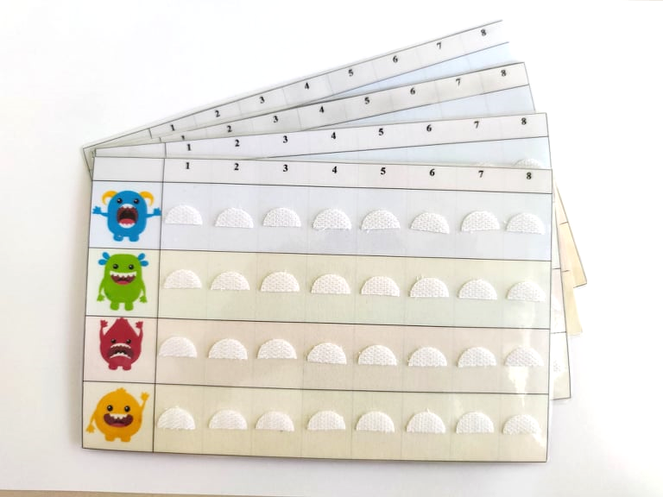  Figure 3 : Monstack Scoring Board | 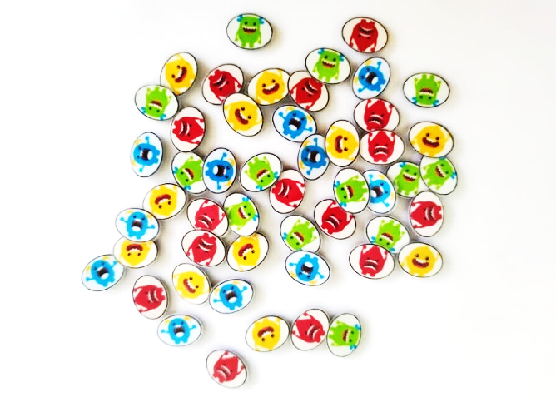  Figure 4 : Monstack Tokens
Figure 1-4: The Monstack Board Game Kit

TABLE 1. Demographic Data of Participants for Board Game Prototype Trial.
No. | Participant | Age of child, | Diagnosis of child
 | Parent | 3;11 | SSD
 | Parent | 4;00 | Cleft
 | Parent | 4;00 | Cleft
 | Speech-Language Pathologist | 4;07 | SSD
 | Parent | 4;07 | Cleft
 | Parent | 4;11 | SSD
 | Speech-Language Pathologist | 5;01 | SSD
 | Speech-Language Pathologist | 5;02 | Cleft
 | Speech-Language Pathologist | 5;09 | SSD
 | Speech-Language Pathologist | 5;09 | SSD
 | Parent | 5;09 | SSD
 | Parent | 6;02 | SSD
 | Speech-Language Pathologist | 6;07 | SSD
 | Speech-Language Pathologist | 6;07 | Cleft
 | Parent | 6;09 | Cleft
 | Parent | 6;11 | Cleft
 | Parent | 7;05 | Cleft
 | Speech-Language Pathologist | 7;11 | SSD
 | Parent | 8;02 | SSD

GRAPH 1. Evaluation on The Components of Monstack Board Game.

TABLE 2. Recommendations on Interactive Board Game as Articulation Therapy Tool.
Questions | Responses
Scoring System | - To reduce the number of columns (Five columns instead of eight.)  - Some of the stickers did not stick well.  - Bigger laminated token picture and grid for scoring board for easier manipulation.
Word/Sentence Stimuli | - To prepare a word list in a document to be used during a session.  - Some of the words were not used by Malay-speaking children.  - Label the word stimuli or with ‘PinYin’ for Chinese characters.  - To prepare two sets of different pictures and sentences for each sound as a child got bored after a few times playing as the words or sentence is repeated.  - Can use colour paper to make the cards more appealing and easier to recognize.  - The words or sentences may be overused and should be refreshed with new ones.
Draw cards | - Some of the cards did not stick well.  - There are circumstances where no matching of monsters occurs even after turning the card around.
General | - Prepare a board, fixed for every stimulus to be more organized, especially for new user  - The velcro straps easy to peel off, can try using magnetic board or like the puzzle board eg. If the project goes electronic, can try inserting the sound of the words

TABLE 3. Evaluation on Usability of Monstack Board Game (N = 19) [N (%)].
Statement | Disagree  n (%) | Neutral  n (%) | Agree  n (%)
Usefulness
My child can pronounce the sounds at word or sentence level easily and correctly after using the board game. | 1 (5.3) | 7 (36.8) | 11 (57.9)
The board game makes the articulation therapy much  easier to be accomplished. | 0 | 1 (5.3) | 18 (94.8)
The board game is fun. | 0 | 2 (10.5) | 17 (89.4)
The duration of the board game is sufficient. | 0 | 5 (26.3) | 14 (73.7)
Ease of Use
The board game is user friendly. | 1 (5.3) | 3 (15.8) | 15 (78.9)
The instructions to play the board game is easily  understood. | 2 (10.5) | 1 (5.3) | 16 (84.2)
This board game can be used to do the articulation  therapy work easily and correctly. | 1 (5.3) | 0 | 18 (94.8)
Ease of Learning
The pictures are clear to recognize. | 1 (5.3) | 1 (5.3) | 17 (89.5)
We quickly become skilful with the board game. | 2 (10.5) | 3 (15.8) | 14 (73.7)
Children are highly motivated to play the board game  as articulation therapy. | 0 | 3 (15.8) | 16 (84.2)
Satisfaction
I am satisfied with the board game. | 1 (5.3) | 0 | 18 (94.7)
I would recommend using the board game to do  articulation therapy. | 0 | 1 (5.3) | 18 (94.7)
My child wants to play the board game again. | 1 (5.3) | 4 (21.1) | 14 (73.6)
I feel I want to have it. | 0 | 1 (5.3) | 18 (94.7)

TABLE 4: Evaluation on Usability of Monstack Between SLP and Parents.
Statement | Mean | SD | 95% CI | P-valueª
Usefulness
SLP^{b} | 16.00 | 2.45 | 13.95 – 18.05 | 0.968
Parents | 16.18 | 1.78 | 14.99 – 17.38
CLP^{c} | 15.63 | 1.41 | 14.45 – 16.80 | 0.351
SSD^{d} | 16.45 | 2.38 | 14.85 – 18.05
Ease of Use
SLP^{b} | 11.88 | 1.46 | 10.66 – 13.09 | 0.545
Parents | 12.00 | 2.19 | 10.53 – 13.47
CLP^{c} | 11.38 | 2.26 | 9.48 – 13.27 | 0.395
SSD^{d} | 12.36 | 1.50 | 11.35 – 13.37
Ease of Learning
SLP^{b} | 12.00 | 1.93 | 10.39 – 13.61 | 0.904
Parents | 12.18 | 1.83 | 10.95 – 13. 41
CLP^{c} | 11.38 | 1.77 | 9.90 – 12.85 | 0.206
SSD^{d} | 12.64 | 1.75 | 11.46 – 13.81
Satisfaction
SLP^{b} | 16.63 | 2.00 | 14.96 – 18.29 | 0.717
Parents | 17.09 | 2.17 | 15.64 – 18.55
CLP^{c} | 16.63 | 2.13 | 14.84 – 18.41 | 0.657
SSD^{d} | 17.09 | 2.07 | 15.70 – 18.48

ªMann-Whitney U Test
^{b}SLP : Speech-Language Pathologist
^{c}CLP : Cleft Lip and Palate
^{d}SSD : Speech Sound Disorder

TABLE 5. SLPs and Parents’ Comments Towards Content and Usability of Monstack.
Comments | - Good  - The visuals are nice, but as commented before, trials can be reduced, Keep it up. Believe it would be a great game after alterations.  - My child can easily get more repetitions during articulation therapy using the board game.  - Good design, easy to use.  - Benefits for older children.  - Good for kids with good sitting behaviour and long attention span.  - Overall, very creative and well thought out game especially with matching monsters.  - I feel the game is useful in helping my child to learn to pronounce more words. I appreciate the therapist coming to guide us to prompt the child to pronounce the words a few times. And the instruction video gives me a clearer picture of how to play the game.  - It's practical (except sometimes the choice of vocabularies are quite rare like ‘peria’), easy to use, less time consumed and it has a great reinforcement system.  - Very fun and interesting game.  - Quite interactive.  - Cards may need to be refreshed after some time but it did achieve the purpose of fun and correcting articulation of words.  - YN had fun playing with the game but she is easier to be distracted by other things.  - Overall excellent.  - It will help the parent if can include a graphical guidance on how to pronounce the alphabets/ making the sounds (the tongue and mouth placement/movement, how to blow the air etc)

The age and diagnosis of child is by which the Monstack board game is used with.
The age of child listed under SLP is the patient which the Monstack board game is trialed on.

