Cover letter

Editor-in-Chief
Jurnal Sains Kesihatan Malaysia (Malaysian Journal of Health Sciences)
June, 2022

Coronavirus disease 2019 (COVID-19) has caused significantly impact to the numerous sectors of economy including dental fraternity due to nationwide lockdown following the pandemic. This paper describes the factors affecting dental practice during national lockdown and its perception towards provisional Covid-19 guidelines in dental practice. Our finding suggest that COVID-19 pandemic had an impact on the practice of dentistry and majority of dental practitioners in Malaysia have complied to the provisional guideline imposed by the health bodies
The manuscript content is original work and has not been published elsewhere. The submission is made on behalf of all authors. I confirm that I have read and understood the journal’s guidelines on matters pertaining to copyright, authorship as well as ethical and legal requirements of the study. The authors report no declarations of interest.
We believe that the findings of this study are relevance to the dental fraternity and we hope that you find this manuscript interesting and worthy of publication in Jurnal Sains Kesihatan Malaysia (Malaysian Journal of Health Sciences).

Yours sincerely,
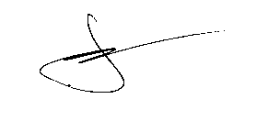
DR. NOR FAHARINA ABDUL HAMID
Universiti Teknologi MARA Malaysia

