.List of Figures
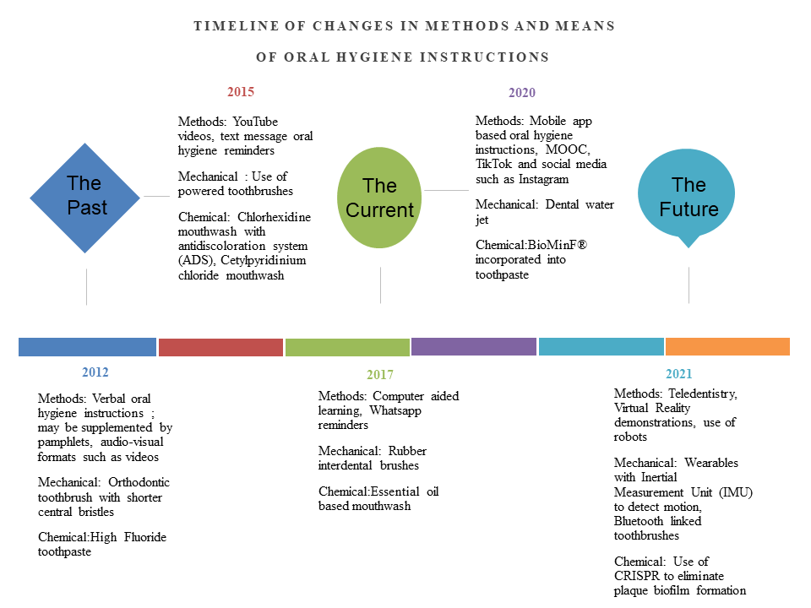 Figure 1: Timeline of changes in the methods and means of oral hygiene instructions

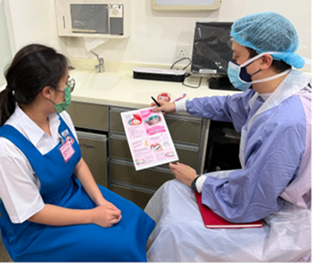

Figure 2: Patient receiving verbal oral hygiene instruction supplemented by pamphlet and model demonstration

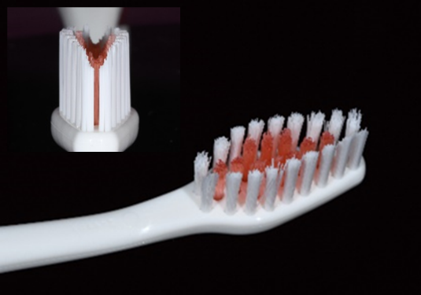
Figure 3: Orthodontic toothbrush head with a central trough

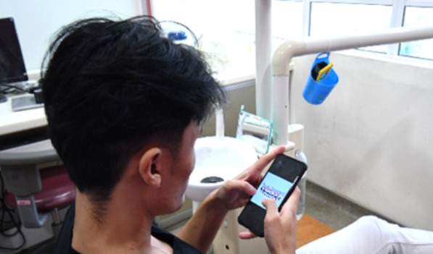
Figure 4: Patient receiving mobile app-based oral hygiene instructions

