TABLES
Table 1. Content validity index (CVI) of the MFA Nonsense Word Test user manual.
Domains | Items | Expert in agreement | I-CVI
Content | The manual explains the purpose and benefits of the MFA Nonsense Word Test. | 5 | 0.83
Content | The manual emphasizes knowledge/skills aimed at helping readers in conducting the MFA Nonsense Word Test. | 6 | 1
Content | The scope of the manual covers essential information directly related to the MFA Nonsense Word Test. | 6 | 1
Visual | The visuals are culturally relevant and sensitive. | 6 | 1
Visual | The visuals are easy for readers to follow and understand. | 6 | 1
Visual | The visuals appear professional and appropriate for an adult audience. | 6 | 1
Visual | The visuals are free of distracting details that take away from the main idea. | 6 | 1
Visual | All graphics complement the text. | 6 | 1
Visual | There are step-by-step directions, with examples provided that will build comprehension and self-efficacy to conduct the MFA Nonsense Word Test. | 6 | 1
Typography and layout | The font size is at least 12 pt. | 6 | 1
Typography and layout | The font is easy-to-read font (no fancy script or lettering). | 6 | 1
Typography and layout | Bold and underline are used instead of all caps and italics to emphasize important items. | 5 | 0.83
Typography and layout | Colours are used to promote easy reading (Dark fonts on light backgrounds are best.). | 6 | 1
Typography and layout | Layout and sequence of information are consistent, making it easy to predict the flow of information. | 6 | 1
Typography and layout | Use of colour supports and is not distracting to the information. | 6 | 1
Typography and layout | There is a lot of white space (no dense text). | 5 | 0.83
Typography and layout | The organization of the paragraphs and sentences is conducive to easy reading. | 5 | 0.83
Typography and layout | Instructions are broken into easy-to-read parts. | 6 | 1
Literacy demand | Common words are used all the time. | 6 | 1
Literacy demand | Short sentences not exceeding 20 words per sentence are used. | 6 | 1
S-CVI/Ave |  |  | 0.97
S-CVI/UA |  |  | 0.80

Table 2. Feedback by experts and action taken to improvise the MFA Nonsense Word Test user manual.
Feedback from audiologists | Actions taken
- The manual only explains on how the test is developed and performed. Reader should know what the score represents, how can it help in terms of counselling or hearing aid fine tuning | Added further explanation on what does the score represent and how can it help in terms of counselling or hearing aid fine tuning in section 6.0 “Interpretations of Results”
- Recommend when and why to carry out the test | Added the function of the test in introduction section
- White space is needed to ease readability | Added space in some pages in between sentences
- Layout of table of contents can be improved. Suggest to use different colour for heading and point | Use bold font for the main topics
- There’s a typo at page 7, item no. 3 under the “IMPORTANT” subheading. The word “safe" should be saved” | Changed the word “safe” to “saved”
- The symbols used to remark the scoring sheet “#This patient’s…”, would be better if change to an asterisk | Changed the symbol # to an asterisk

Table 3. Summary of the demographic background of the participants (n=34).
Description | Percentage, % (n)
Gender
• Female | 85.3 (n=29)
• Male | 14.7 (n=5)
Race
• Malay | 73.5 (n=25)
• Chinese | 20.6 (n=7)
• Indian | 2.9 (n=1)
• Kadazan | 2.9 (n=1)
Year of Study
• Year 3 | 58.8 (n=20)
• Year 4 | 41.2 (n=14)
Native Language
• Malay | 73.5 (n=25)
• Mandarin | 17.6 (n=6)
• English | 2.9 (n=1)
• Tamil | 2.9 (n=1)
• Kadazan | 2.9 (n=1)
Language Most Often Used at Home
• Malay | 76.5 (n=26)
• Mandarin | 20.6 (n=7)
• Tamil | 2.9 (n=1)
Language Most Often Used in University*
• Malay | 70.6 (n=24)
• English | 38.2 (n=13)
• Mandarin | 2.9 (n=1)
Mandarin proficiency Level
• No proficiency | 64.7 (n=22)
• Elementary proficiency | 11.8 (n=4)
• Limited working proficiency | 2.9 (n=1)
• Professional working proficiency | 0.0 (n=0)
• Full professional proficiency | 8.8 (n=3)
• Native proficiency | 11.8 (n=4)
Note: *Some participants chose more than one language, therefore, the total no. of responses = 38.

Table 4. Reason(s) for not being able to perform speech tests on the adult population in the clinic.
Reason(s) for not being able to perform speech tests on the adult population in the clinic | No. of responses | % of responses per 34 participants
It is not crucial as I can use other measures to assess the patient's performance or verify hearing aid (e.g. Aided PTA) | 18 | 53%
Lack of skills in conducting speech test | 17 | 50%
Lack of speech test materials that are suitable | 13 | 38%
I am not familiar with the procedures in conducting a speech test | 12 | 35%
Time constraint | 12 | 35%
It is not a standard practice done to assess functional hearing performance or verify hearing aids in my clinic | 6 | 18%
Speech test for the adult population is not available in my clinic | 2 | 6%
Total | 80
Note: The participants were allowed to choose more than one option. Therefore, the total number of responses = 80.
Table 5. Summary of understandability score for the training videos.
Domain and Items | Agree | Disagree | Percentage of agreement (%)
Topic: Content
- The MFA Nonsense Word Test training videos make their purposes completely evident. | 34 | 0 | 100
Topic: Word choice and style
- The MFA Nonsense Word Test training videos use common, everyday language. | 34 | 0 | 100
- The MFA Nonsense Word Test Training Videos use the active voice. | 33 | 1 | 97.1
Topic: Organization
- The MFA Nonsense Word Test Demonstration Videos break or “chunk” information into short sections. | 34 | 0 | 100
- The MFA Nonsense Word Test Demonstration Videos' sections have informative headers. | 34 | 0 | 100
- The MFA Nonsense Word Test Demonstration Videos present information in a logical sequence. | 33 | 1 | 97.1
Topic: Layout and design
- Text on the screen is easy to read. | 33 | 1 | 100
- The MFA Nonsense Word Test Demonstration Videos allow the user to hear the words clearly (e.g., not too fast, not garbled). | 34 | 0 | 97.1
Topic: Use of visual aids
- The MFA Nonsense Word Test Demonstration Videos use illustrations and photographs that are clear and uncluttered. | 33 | 1 | 97.1
Mean understandability score (SD) |  |  | 98.7 (4.5)

Table 6 Participants’ confidence and perception ratings towards using the MFA Nonsense Word Test.
Domains | Median ± IQR
Confidence | Pre-workshop | Pre-practical | Post-workshop
- I am able to conduct the MFA Nonsense Word Test with confidence. | 2.00 ± 2.00 | 3.00 ± 1.00 | 5.00 ± 1.00
- I am able to explain and demonstrate the procedures to conduct the MFA Nonsense Word Test to someone who has no experience with the test. | 2.00 ± 2.00 | 3.00 ± 2.00 | 5.00 ± 1.00
- I am confident to score a patient’s responses. | 2.00 ± 2.00 | 3.00 ± 1.00 | 5.00 ± 0.00
Perception
- The MFA Nonsense Word Test is an effective tool in accessing the speech perception ability in Mandarin-speaking adult patient. | 3.50 ± 1.00 | 4.00 ± 2.00 | 5.00 ± 1.00
- If the test is available at my workplace, I will conduct the MFA nonsense word test to Mandarin-speaking adult patients. | 3.00 ± 2.00 | 4.00 ± 1.00 | 5.00 ± 0.00
- I will recommend this MFA nonsense word test to be implemented in my clinic/workplace. | 3.00 ± 2.00 | 4.00 ± 2.00 | 5.00 ± 0.00
- I will recommend this MFA nonsense word test with user manual and videos to other colleagues. | 3.00 ± 2.00 | 4.00 ± 2.00 | 5.00 ± 0.00
Note: IQR = interquartile range

FIGURES

Figure 1. Participants' clinical experience.

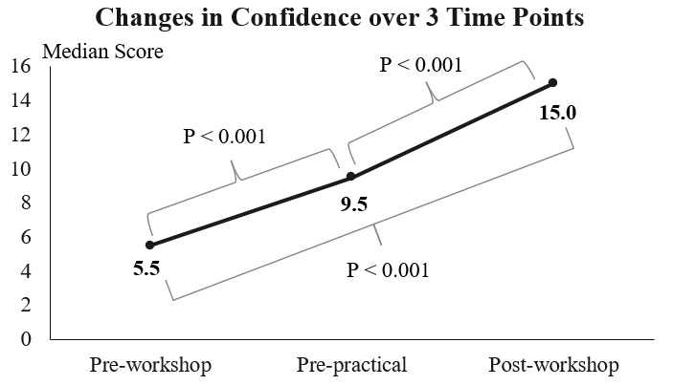
Figure 2 Changes in perception of the participants over three time points (pre-workshop, pre-practical and post-workshop).

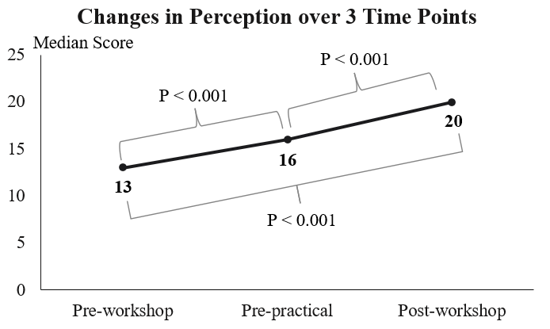
Figure 3. Changes in perception of the participants over three time points (pre-workshop, pre-practical and post-workshop).

