Department of Family Oral Health
Faculty of Dentistry
National University of Malaysia (UKM)
Jalan Raja Muda Abd Aziz
50300, Kuala Lumpur
Malaysia

20th November 2023

Editor-in-Chief,
Jurnal Sains Kesihatan Malaysia
Dear Sir,
SUBMISSION OF MANUSCRIPT FOR PUBLICATION
Thank you for reviewing our original research article titled ‘Knowledge and Awareness of Avulsed Tooth Management Among Dental Surgery Assistants at A Dental Institute’ in your prestigious journal.

We want to declare that this article has never been published in any journals or proceedings. There is also no conflict of interest issue, and no funding or grant was made available for this research work.

We hereby transfer, assign, or otherwise convey all copyright ownership, including all rights, to the journal if the journal publishes such work.

I hope the article gets due consideration from your respectable editorial team.

Thank you.

Yours sincerely,
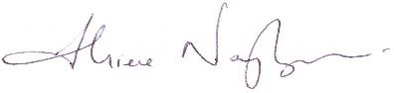
DR. S. NAGARAJAN M.P. SOCKALINGAM
Lecturer and Paediatric Dental Specialist

