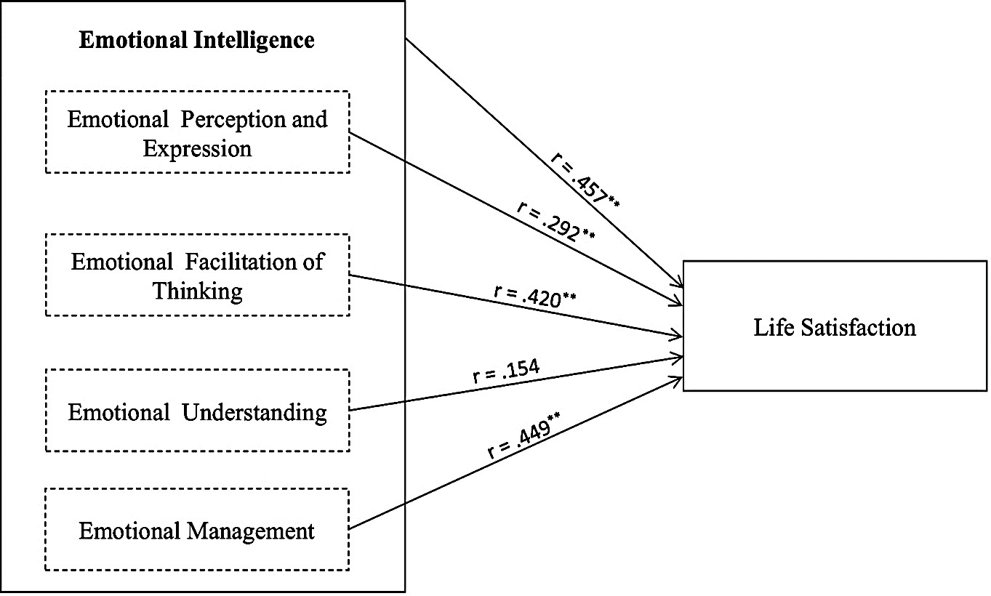

Figure 1 The correlation between emotional intelligence (including four domains) and life satisfaction
**Correlation is significant at the 0.01 level

