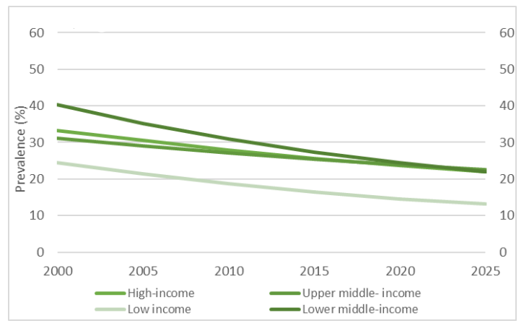
Figure 1. Trends in current tobacco use among people aged ≥15 years (WHO global report on trends in prevalence of tobacco use 2000-2025 third edition) https://apps.who.int/iris/bitstream/handle/10665/330221/9789240000032-eng.pdf
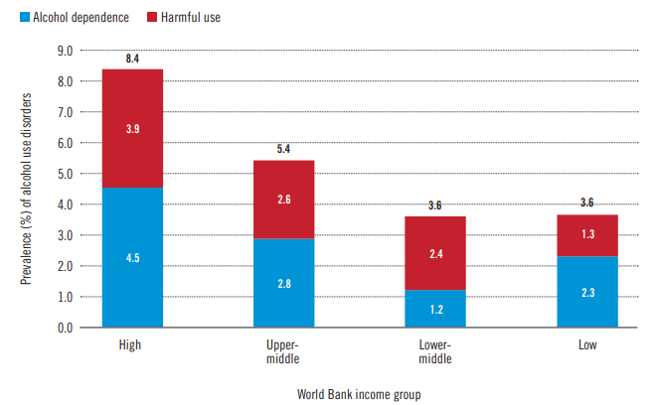
Figure 2. Prevalence (in %) of alcohol use disorders (AUDs), by income group, 2016 (Global status report on alcohol and health 2018) https://apps.who.int/iris/bitstream/handle/10665/274603/9789241565639-eng.pdf

