FREQUENCIES VARIABLES=types_of__newsstories VAR00001 VAR00002 VAR00003 VAR00004 VAR00005
/FORMAT=NOTABLE
/STATISTICS=SKEWNESS SESKEW KURTOSIS SEKURT

/HISTOGRAM NORMAL
/ORDER=ANALYSIS.

Frequencies
Notes
Output Created |  | 20-APRIL-2020 11:23:48
Comments
Input | Data | C:\Users\pc\Desktop\spss collections\level of acceptance spss.sav
Input | Active Dataset | DataSet1
Input | Filter | <none>
Input | Weight | <none>
Input | Split File | <none>
Input | N of Rows in Working Data File | 583
Missing Value Handling | Definition of Missing | User-defined missing values are treated as missing.
Missing Value Handling | Cases Used | Statistics are based on all cases with valid data.
Syntax |  | FREQUENCIES VARIABLES=types_of__newsstories VAR00001 VAR00002 VAR00003 VAR00004 VAR00005  /FORMAT=NOTABLE  /STATISTICS=SKEWNESS SESKEW KURTOSIS SEKURT  /HISTOGRAM NORMAL  /ORDER=ANALYSIS.
Resources | Processor Time | 00:00:00.87
Resources | Elapsed Time | 00:00:00.86

[DataSet1] C:\Users\pc\Desktop\spss collections\level of acceptance spss.sav

Statistics
 |  | Political News Stories | Religious News Stories | News Stories on Health | Entertainment News Stories | News Stories on Lifestyles | News Stories on Arts/Culture
N | Valid | 583 | 583 | 583 | 583 | 583 | 583
N | Missing | 0 | 0 | 0 | 0 | 0 | 0
Skewness |  | -.240 | -.897 | -1.163 | -1.409 | -.781 | .087
Std. Error of Skewness |  | .101 | .101 | .101 | .101 | .101 | .101
Kurtosis |  | -.614 | .040 | 1.247 | 1.794 | .210 | -.414
Std. Error of Kurtosis |  | .202 | .202 | .202 | .202 | .202 | .202

Histogram

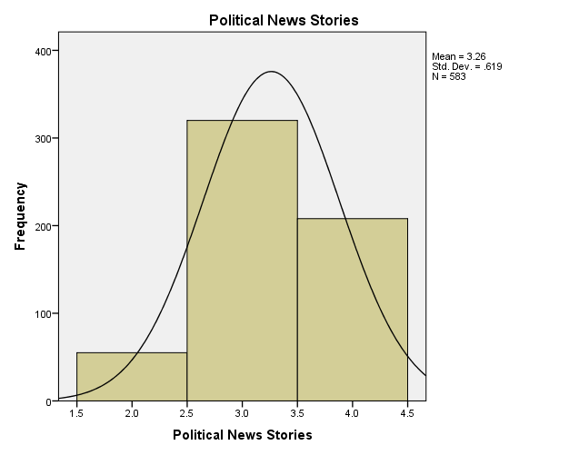

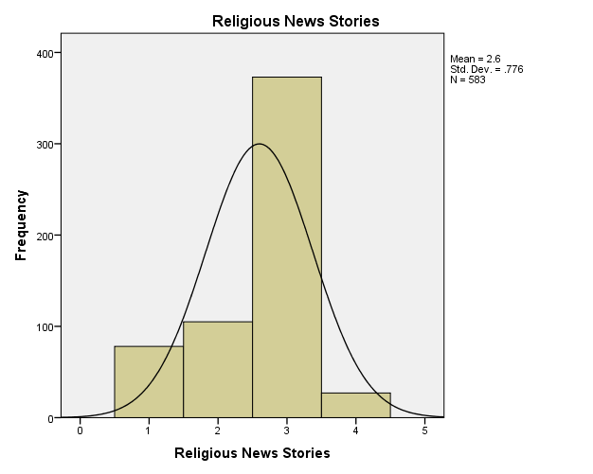

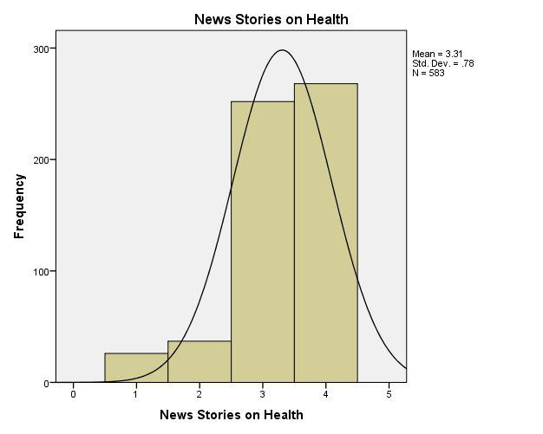

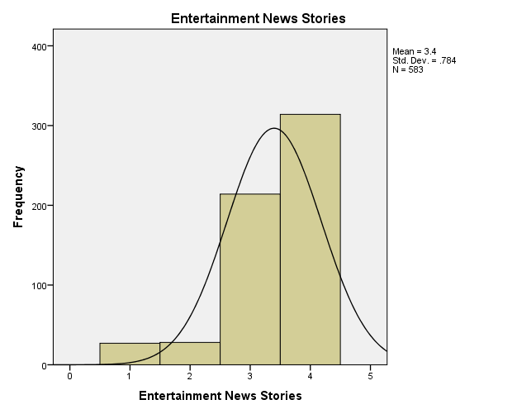

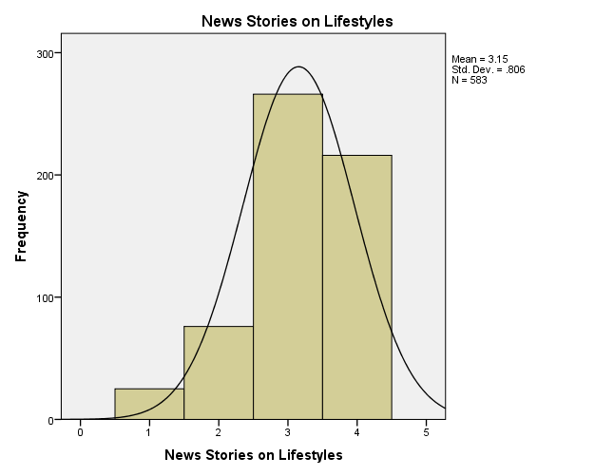

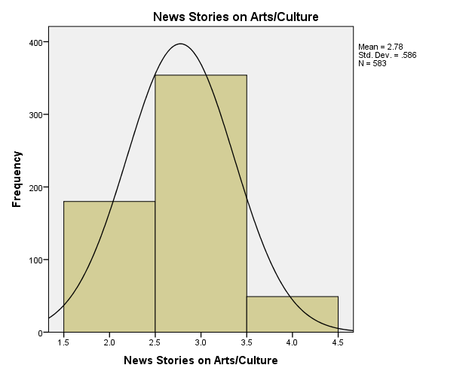

FREQUENCIES VARIABLES=you_to_not_accept VAR00037 VAR00006 VAR00007 VAR00008 VAR00038 VAR00009 VAR00010 VAR00011 VAR00012 types_of_social_media VAR00015
/STATISTICS=SKEWNESS SESKEW KURTOSIS SEKURT
/HISTOGRAM NORMAL
/ORDER=ANALYSIS.

Frequencies

Notes
Output Created |  | 20-APRIL-2020 11:27:06
Comments
Input | Data | C:\Users\pc\Desktop\spss collections\level of acceptance spss.sav
Input | Active Dataset | DataSet1
Input | Filter | <none>
Input | Weight | <none>
Input | Split File | <none>
Input | N of Rows in Working Data File | 583
Missing Value Handling | Definition of Missing | User-defined missing values are treated as missing.
Missing Value Handling | Cases Used | Statistics are based on all cases with valid data.
Syntax |  | FREQUENCIES VARIABLES=you_to_not_accept VAR00037 VAR00006 VAR00007 VAR00008 VAR00038 VAR00009 VAR00010 VAR00011 VAR00012 types_of_social_media VAR00015  /STATISTICS=SKEWNESS SESKEW KURTOSIS SEKURT  /HISTOGRAM NORMAL  /ORDER=ANALYSIS.
Resources | Processor Time | 00:00:01.69
Resources | Elapsed Time | 00:00:01.69

[DataSet1] C:\Users\pc\Desktop\spss collections\level of acceptance spss.sav

Statistics
 |  | religious news | political news | news on same sex | business stories | entertainment/Celebrity news | Lifestyle news | sports news | news on health | fashion | Arts/cultrue | Facebook | Mainstream media social media platforms
N | Valid | 583 | 583 | 583 | 583 | 583 | 583 | 583 | 583 | 583 | 583 | 583 | 583
N | Missing | 0 | 0 | 0 | 0 | 0 | 0 | 0 | 0 | 0 | 0 | 0 | 0
Skewness |  | .592 | 1.299 | 2.531 | 2.503 | 2.560 | 1.639 | 2.073 | 2.503 | 2.716 | 2.503 | 2.093 | 1.974
Std. Error of Skewness |  | .101 | .101 | .101 | .101 | .101 | .101 | .101 | .101 | .101 | .101 | .101 | .101
Kurtosis |  | -1.656 | -.313 | 4.423 | 4.280 | 4.572 | .690 | 2.303 | 4.280 | 5.393 | 4.280 | 2.390 | 1.903
Std. Error of Kurtosis |  | .202 | .202 | .202 | .202 | .202 | .202 | .202 | .202 | .202 | .202 | .202 | .202

religious news
 |  | Frequency | Percent | Valid Percent | Cumulative Percent
Valid | No | 374 | 64.2 | 64.2 | 64.2
Valid | Yes | 209 | 35.8 | 35.8 | 100.0
Valid | Total | 583 | 100.0 | 100.0

political news
 |  | Frequency | Percent | Valid Percent | Cumulative Percent
Valid | No | 450 | 77.2 | 77.2 | 77.2
Valid | Yes | 133 | 22.8 | 22.8 | 100.0
Valid | Total | 583 | 100.0 | 100.0

news on same sex
 |  | Frequency | Percent | Valid Percent | Cumulative Percent
Valid | No | 520 | 89.2 | 89.2 | 89.2
Valid | Yes | 63 | 10.8 | 10.8 | 100.0
Valid | Total | 583 | 100.0 | 100.0

business stories
 |  | Frequency | Percent | Valid Percent | Cumulative Percent
Valid | No | 519 | 89.0 | 89.0 | 89.0
Valid | Yes | 64 | 11.0 | 11.0 | 100.0
Valid | Total | 583 | 100.0 | 100.0

entertainment/Celebrity news
 |  | Frequency | Percent | Valid Percent | Cumulative Percent
Valid | No | 521 | 89.4 | 89.4 | 89.4
Valid | Yes | 62 | 10.6 | 10.6 | 100.0
Valid | Total | 583 | 100.0 | 100.0

Lifestyle news
 |  | Frequency | Percent | Valid Percent | Cumulative Percent
Valid | No | 476 | 81.6 | 81.6 | 81.6
Valid | Yes | 107 | 18.4 | 18.4 | 100.0
Valid | Total | 583 | 100.0 | 100.0

sports news
 |  | Frequency | Percent | Valid Percent | Cumulative Percent
Valid | No | 501 | 85.9 | 85.9 | 85.9
Valid | Yes | 82 | 14.1 | 14.1 | 100.0
Valid | Total | 583 | 100.0 | 100.0

news on health
 |  | Frequency | Percent | Valid Percent | Cumulative Percent
Valid | No | 519 | 89.0 | 89.0 | 89.0
Valid | Yes | 64 | 11.0 | 11.0 | 100.0
Valid | Total | 583 | 100.0 | 100.0

Fashion
 |  | Frequency | Percent | Valid Percent | Cumulative Percent
Valid | No | 526 | 90.2 | 90.2 | 90.2
Valid | Yes | 57 | 9.8 | 9.8 | 100.0
Valid | Total | 583 | 100.0 | 100.0

Arts/culture
 |  | Frequency | Percent | Valid Percent | Cumulative Percent
Valid | No | 519 | 89.0 | 89.0 | 89.0
Valid | Yes | 64 | 11.0 | 11.0 | 100.0
Valid | Total | 583 | 100.0 | 100.0

Facebook
 |  | Frequency | Percent | Valid Percent | Cumulative Percent
Valid | No | 502 | 86.1 | 86.1 | 86.1
Valid | Yes | 81 | 13.9 | 13.9 | 100.0
Valid | Total | 583 | 100.0 | 100.0

Mainstream media social media platforms
 |  | Frequency | Percent | Valid Percent | Cumulative Percent
Valid | No | 496 | 85.1 | 85.1 | 85.1
Valid | Yes | 87 | 14.9 | 14.9 | 100.0
Valid | Total | 583 | 100.0 | 100.0

Histogram

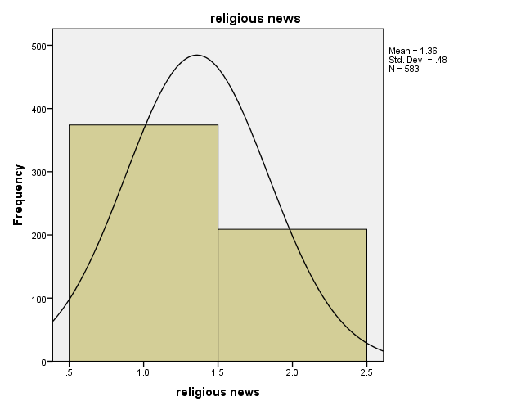

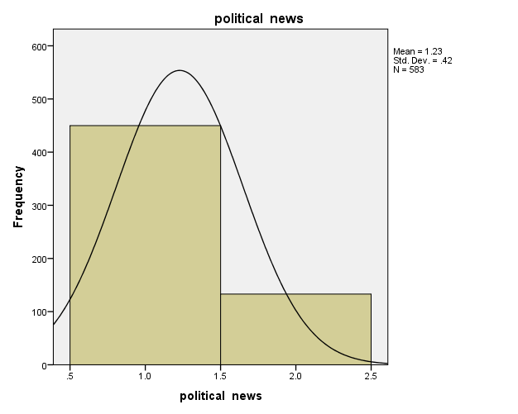

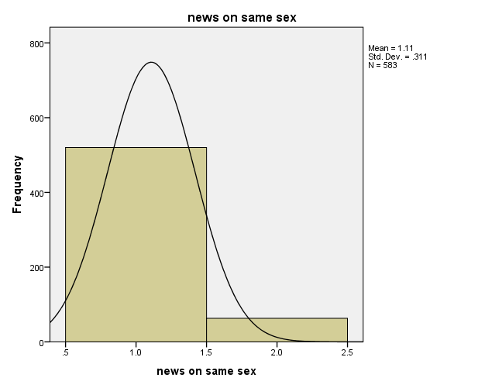

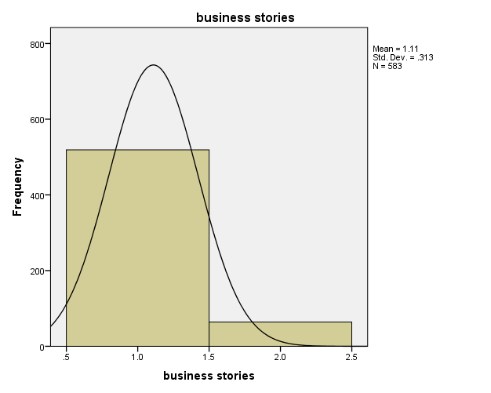

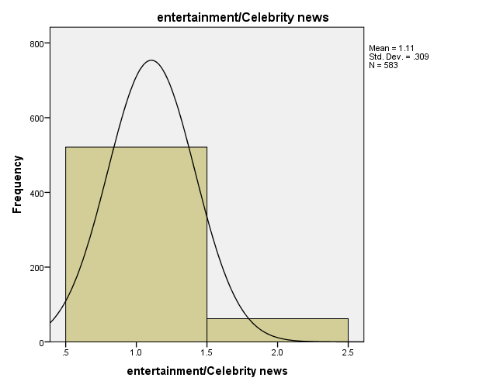

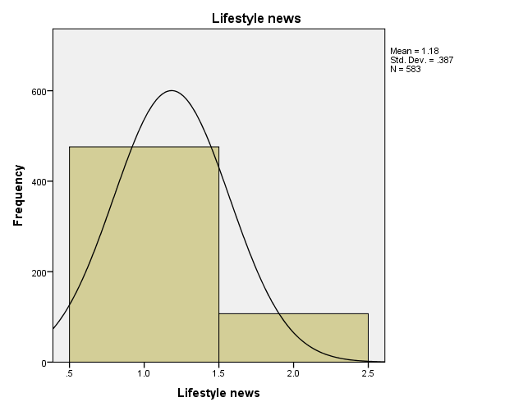

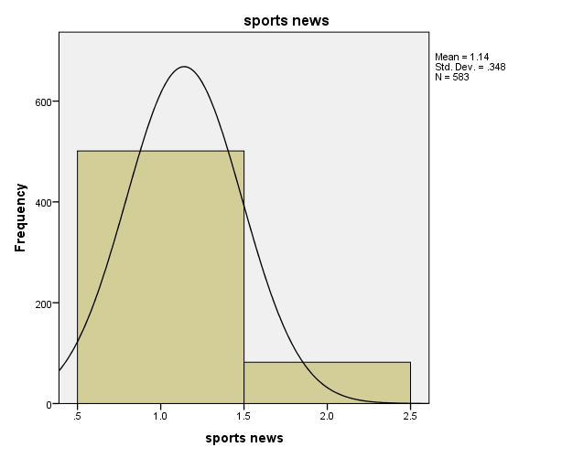

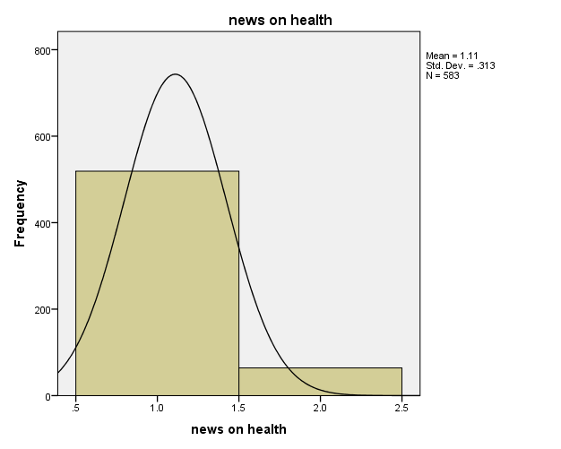

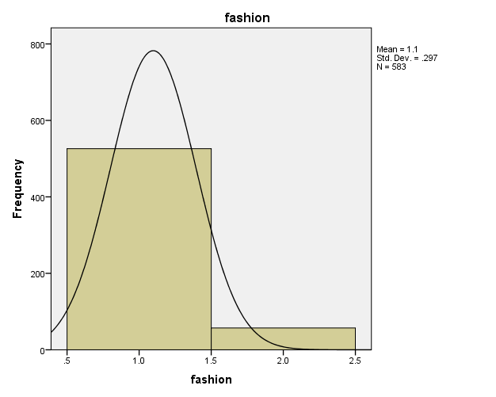

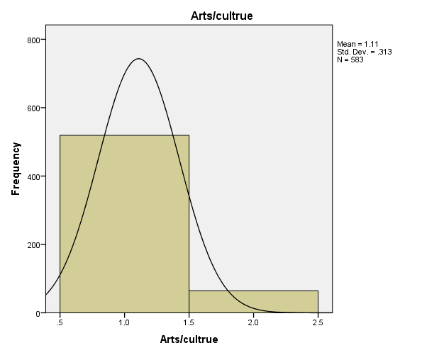

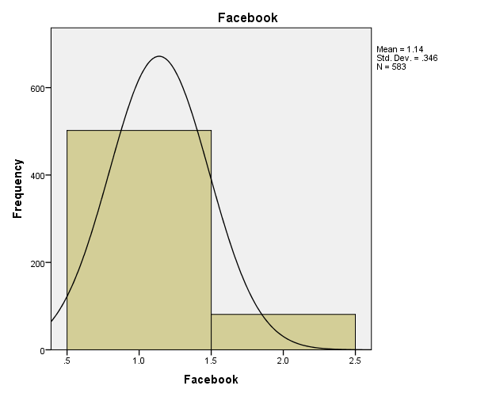

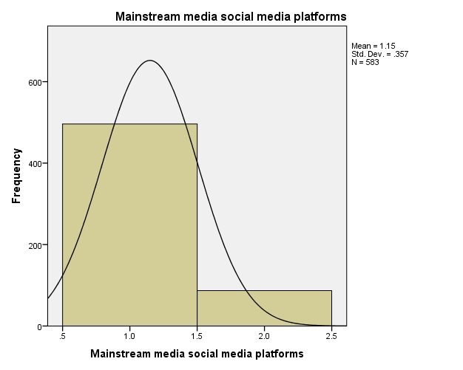

FREQUENCIES VARIABLES=VAR00017 VAR00019 VAR00021 VAR00023 VAR00025 VAR00027
/STATISTICS=SKEWNESS SESKEW KURTOSIS SEKURT
/HISTOGRAM NORMAL
/ORDER=ANALYSIS.

FREQUENCIES VARIABLES=VAR00017 Level_of_acceptance VAR00029 VAR00030 VAR00031 VAR00032 VAR00033 VAR00034 VAR00036
/STATISTICS=SKEWNESS SESKEW KURTOSIS SEKURT
/HISTOGRAM NORMAL
/ORDER=ANALYSIS.

Frequencies

Notes
Output Created |  | 20-APRIL-2020 11:32:09
Comments
Input | Data | C:\Users\pc\Desktop\spss collections\level of acceptance spss.sav
Input | Active Dataset | DataSet1
Input | Filter | <none>
Input | Weight | <none>
Input | Split File | <none>
Input | N of Rows in Working Data File | 583
Missing Value Handling | Definition of Missing | User-defined missing values are treated as missing.
Missing Value Handling | Cases Used | Statistics are based on all cases with valid data.
Syntax |  | FREQUENCIES VARIABLES=VAR00017 Level_of_acceptance VAR00029 VAR00030 VAR00031 VAR00032 VAR00033 VAR00034 VAR00036  /STATISTICS=SKEWNESS SESKEW KURTOSIS SEKURT  /HISTOGRAM NORMAL  /ORDER=ANALYSIS.
Resources | Processor Time | 00:00:01.28
Resources | Elapsed Time | 00:00:01.29

[DataSet1] C:\Users\pc\Desktop\spss collections\level of acceptance spss.sav

Statistics
 |  | Twitter | You usually believe news stories on social media platforms | You like to read more news stories on social media platforms | You consider news stories on social media platforms true | News stories on social media platforms are satisfying to you | You usually share/recommend news stories on social media platforms to friends/colleagues/family members | You consider news stories on social media platforms as fake news | You are addicted to news stories on social media platforms | VAR00036
N | Valid | 583 | 583 | 583 | 583 | 583 | 583 | 583 | 583 | 583
N | Missing | 0 | 0 | 0 | 0 | 0 | 0 | 0 | 0 | 0
Skewness |  | -.045 | -.092 | -.672 | -.176 | -.568 | -.634 | .081 | .228 | -.145
Std. Error of Skewness |  | .101 | .101 | .101 | .101 | .101 | .101 | .101 | .101 | .101
Kurtosis |  | -2.005 | -1.143 | -.753 | -.734 | -.114 | .883 | -.220 | -1.122 | -.827
Std. Error of Kurtosis |  | .202 | .202 | .202 | .202 | .202 | .202 | .202 | .202 | .202

Frequency Table

Twitter
 |  | Frequency | Percent | Valid Percent | Cumulative Percent
Valid | No | 285 | 48.9 | 48.9 | 48.9
Valid | Yes | 298 | 51.1 | 51.1 | 100.0
Valid | Total | 583 | 100.0 | 100.0

You usually believe news stories on social media platforms
 |  | Frequency | Percent | Valid Percent | Cumulative Percent
Valid | strongly disagree | 157 | 26.9 | 26.9 | 26.9
Valid | disagree | 159 | 27.3 | 27.3 | 54.2
Valid | agree | 239 | 41.0 | 41.0 | 95.2
Valid | Strongly agree | 28 | 4.8 | 4.8 | 100.0
Valid | Total | 583 | 100.0 | 100.0

You like to read more news stories on social media platforms
 |  | Frequency | Percent | Valid Percent | Cumulative Percent
Valid | disagree | 76 | 13.0 | 13.0 | 13.0
Valid | agree | 213 | 36.5 | 36.5 | 49.6
Valid | Strongly agree | 294 | 50.4 | 50.4 | 100.0
Valid | Total | 583 | 100.0 | 100.0

You consider news stories on social media platforms true
 |  | Frequency | Percent | Valid Percent | Cumulative Percent
Valid | strongly disagree | 101 | 17.3 | 17.3 | 17.3
Valid | disagree | 211 | 36.2 | 36.2 | 53.5
Valid | agree | 244 | 41.9 | 41.9 | 95.4
Valid | Strongly agree | 27 | 4.6 | 4.6 | 100.0
Valid | Total | 583 | 100.0 | 100.0

News stories on social media platforms are satisfying to you
 |  | Frequency | Percent | Valid Percent | Cumulative Percent
Valid | strongly disagree | 53 | 9.1 | 9.1 | 9.1
Valid | disagree | 183 | 31.4 | 31.4 | 40.5
Valid | agree | 323 | 55.4 | 55.4 | 95.9
Valid | Strongly agree | 24 | 4.1 | 4.1 | 100.0
Valid | Total | 583 | 100.0 | 100.0

You usually share/recommend news stories on social media platforms to friends/colleagues/family members
 |  | Frequency | Percent | Valid Percent | Cumulative Percent
Valid | strongly disagree | 25 | 4.3 | 4.3 | 4.3
Valid | disagree | 106 | 18.2 | 18.2 | 22.5
Valid | agree | 376 | 64.5 | 64.5 | 87.0
Valid | Strongly agree | 76 | 13.0 | 13.0 | 100.0
Valid | Total | 583 | 100.0 | 100.0

You consider news stories on social media platforms as fake news
 |  | Frequency | Percent | Valid Percent | Cumulative Percent
Valid | strongly disagree | 54 | 9.3 | 9.3 | 9.3
Valid | disagree | 290 | 49.7 | 49.7 | 59.0
Valid | agree | 214 | 36.7 | 36.7 | 95.7
Valid | Strongly agree | 25 | 4.3 | 4.3 | 100.0
Valid | Total | 583 | 100.0 | 100.0

You are addicted to news stories on social media platforms
 |  | Frequency | Percent | Valid Percent | Cumulative Percent
Valid | strongly disagree | 132 | 22.6 | 22.6 | 22.6
Valid | disagree | 209 | 35.8 | 35.8 | 58.5
Valid | agree | 126 | 21.6 | 21.6 | 80.1
Valid | Strongly agree | 116 | 19.9 | 19.9 | 100.0
Valid | Total | 583 | 100.0 | 100.0

VAR00036
 |  | Frequency | Percent | Valid Percent | Cumulative Percent
Valid | 1 | 25 | 4.3 | 4.3 | 4.3
Valid | 2 | 182 | 31.2 | 31.2 | 35.5
Valid | 3 | 229 | 39.3 | 39.3 | 74.8
Valid | 4 | 147 | 25.2 | 25.2 | 100.0
Valid | Total | 583 | 100.0 | 100.0

Histogram

