
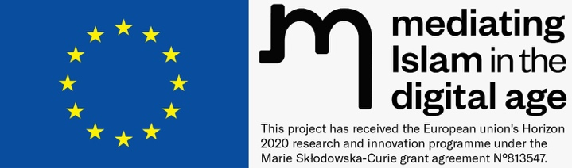

Dear Editor,

Please find enclosed our manuscript entitled “The Web of Hate: Fragmentation of Media Authority and its Link to Right-Wing Populism and Cyber Islamophobia” which we would like to submit the manuscript for consideration of publication in Jurnal Komunikasi: Malaysian Journal of Communication.

In this paper we show that there is a fragmentation of authority of mass media as sensemaker after the advent and wide usage of social media, which can be seen especially well after terror attacks. The increased usage and wide accessibility of social media is allowing more people to feel connected globally after terror attacks and is leading to the creation of mediascapes by defining in-groups of like-minded people against Islam, as a common enemy, which leads to a drastic increase in online hate against Islam and Muslims.

We confirm that this work is original and that it has not been published elsewhere, nor is it under consideration for publication elsewhere. However, the paper is part of a project called ITN-MIDA, which has received funding from the European Union. Within that framework, each project must ensure open access (green or gold) to all peer-reviewed scientific publications as well as conference proceedings relating to its results. We would like to know your policy regarding that issue: Will it be a breach of your copyright policy if ITN-MIDA provides open access to the paper and deposits it in an open-access repository like Zenodo?

Sincerely,

Prof. Dr. Albrecht Fuess,
Department of Islamic Studies,
Philipps University Marburg,
Centrum für Nah- und Mitteloststudien/ Islamwissenschaft
Deutschhausstraße 12
35032 Marburg
albrecht.fuess@staff.uni-marburg.de

