Artworks of the participants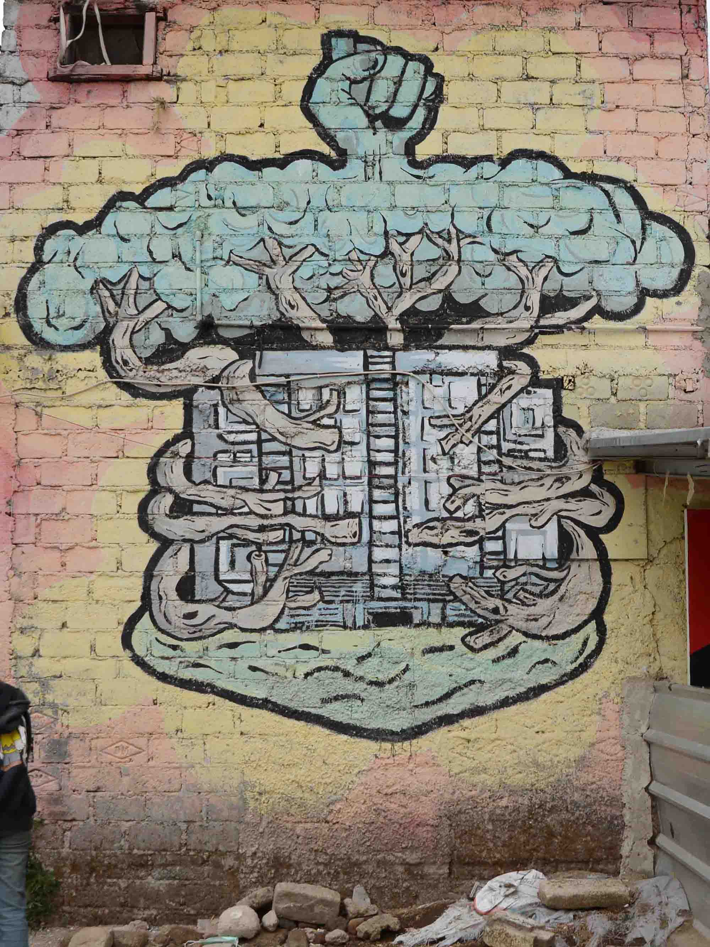
Figure 1: Artwork 1 (A1)

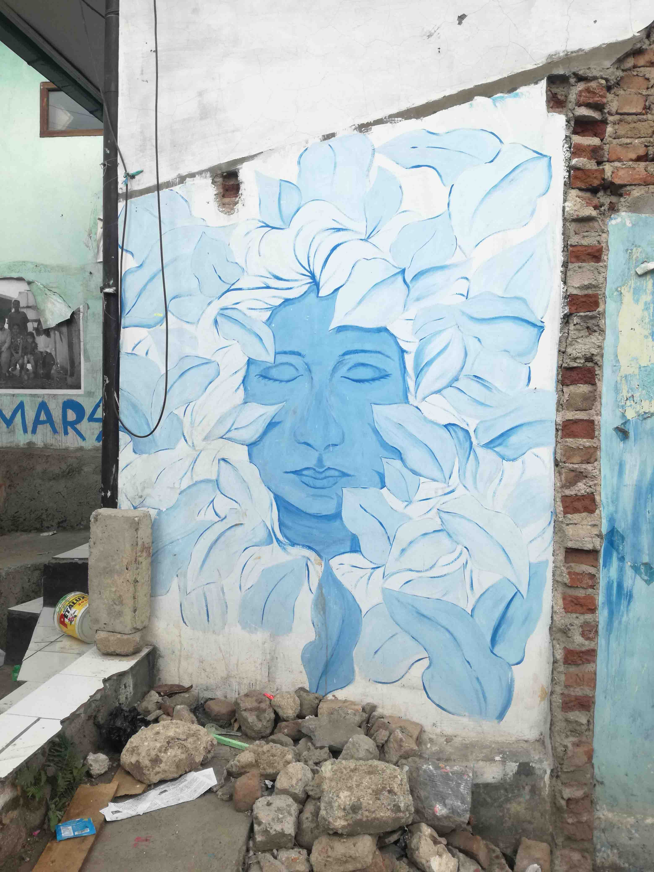
Figure 2: Artwork 3 (A3)

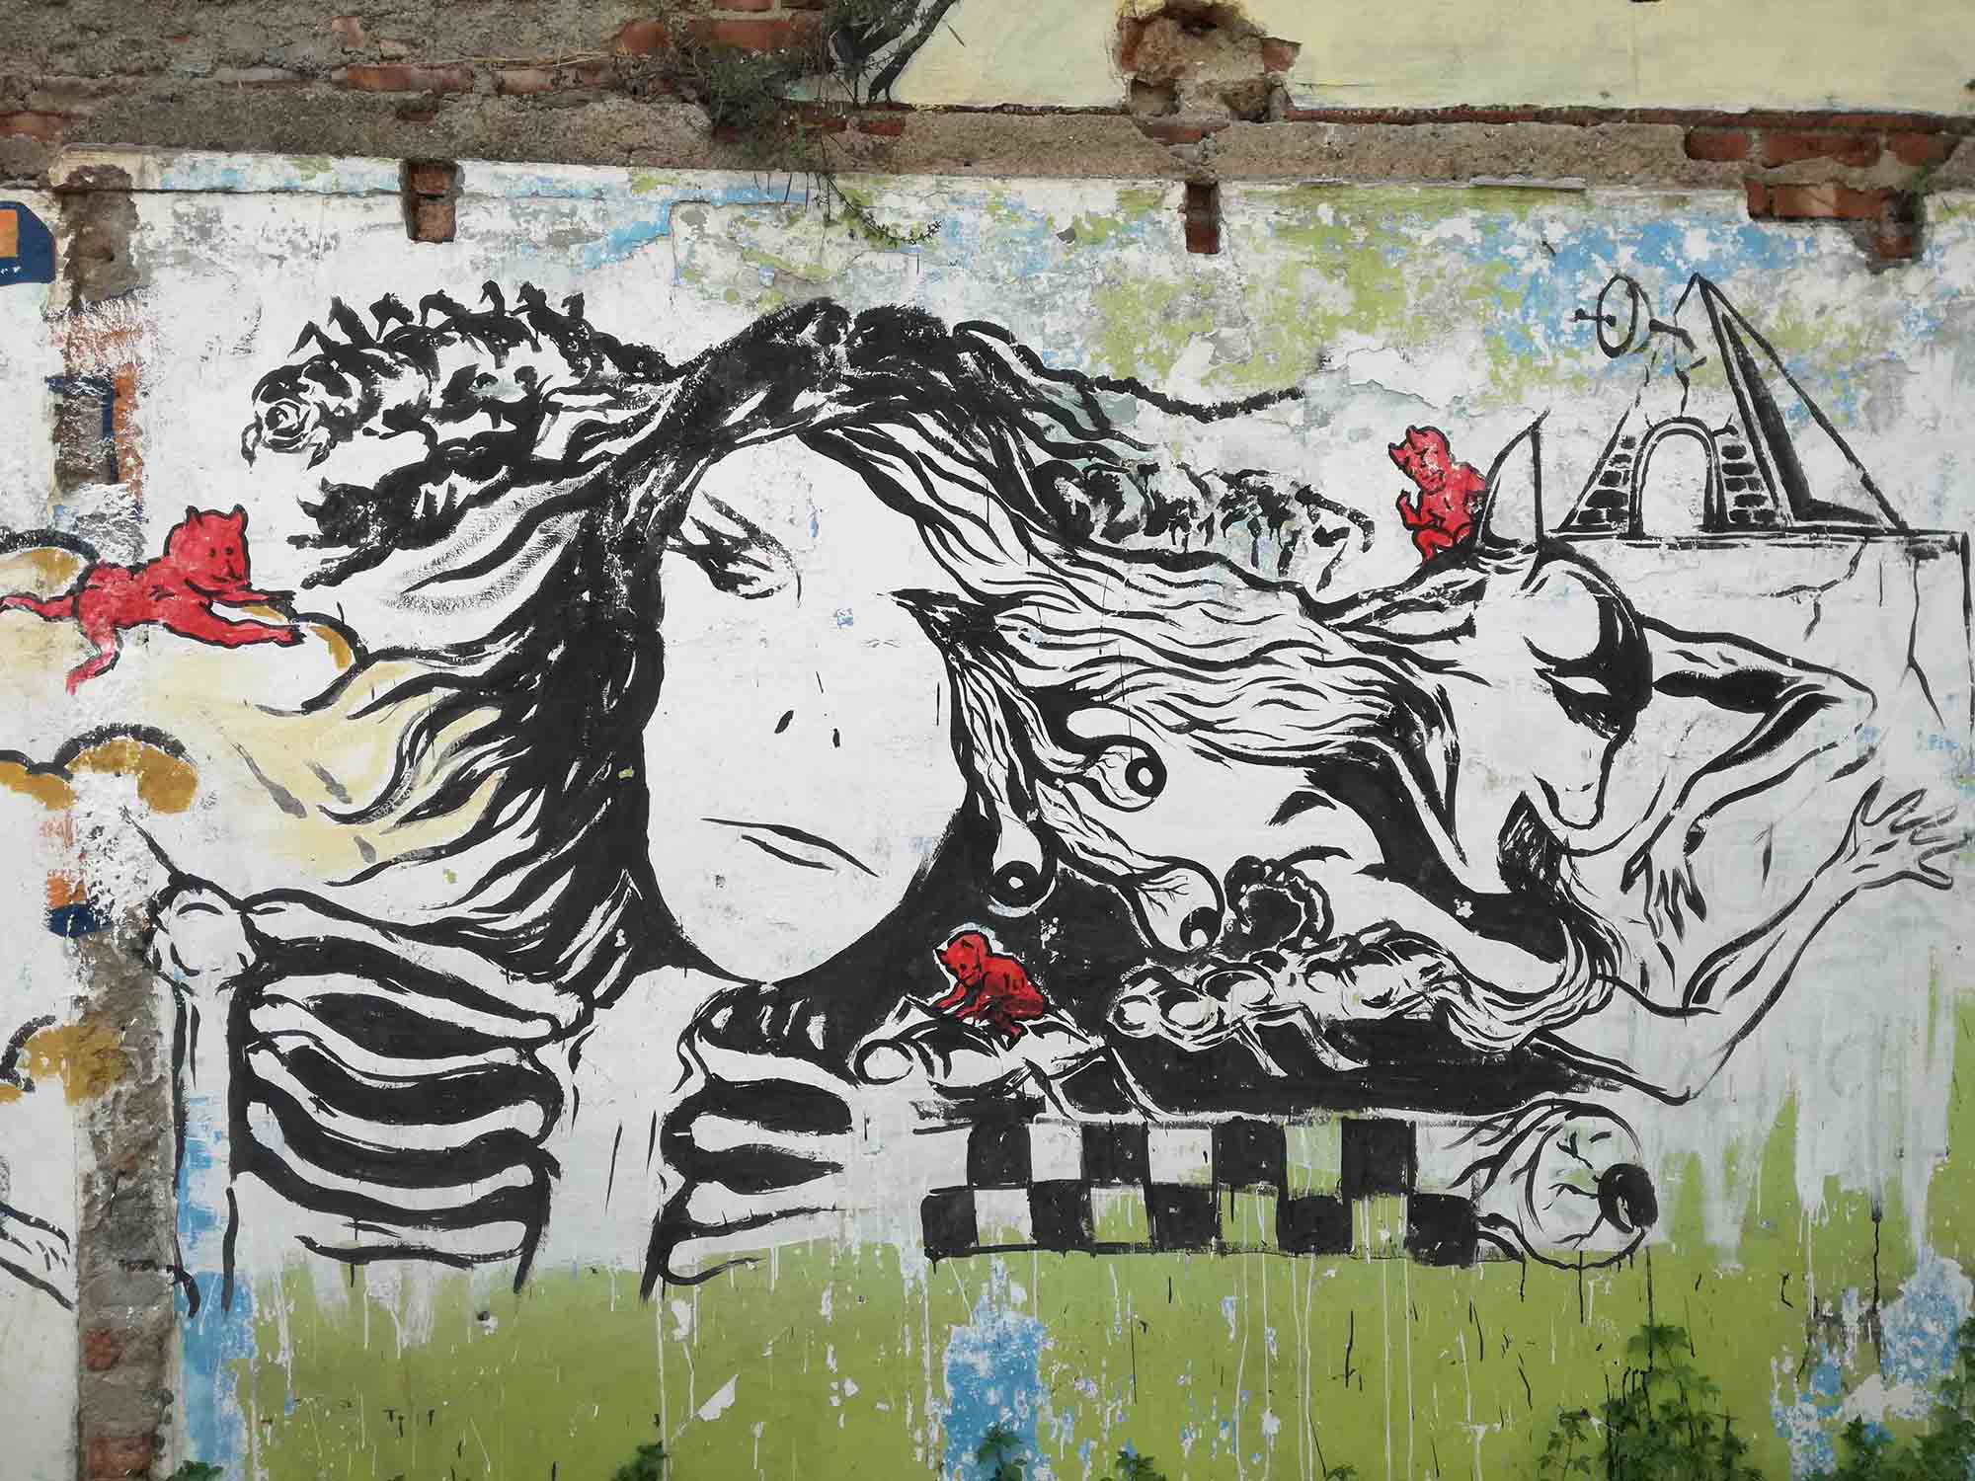
Figure 3: Artwork 4 (A4)

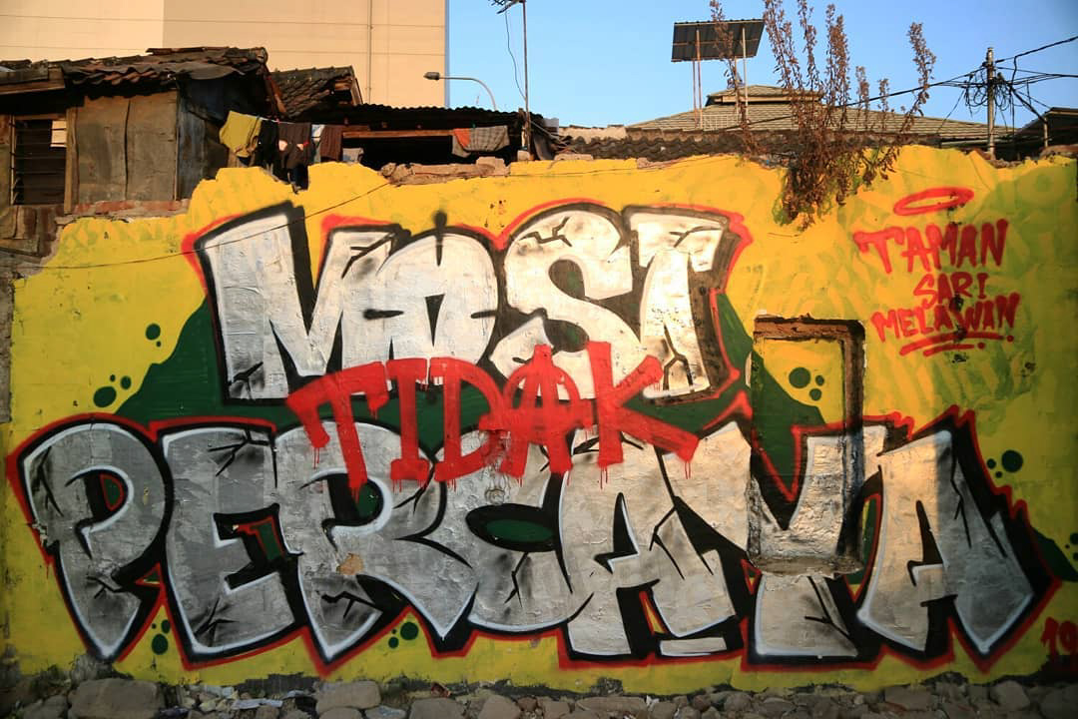
Figure 4: Artwork 5 (A5)

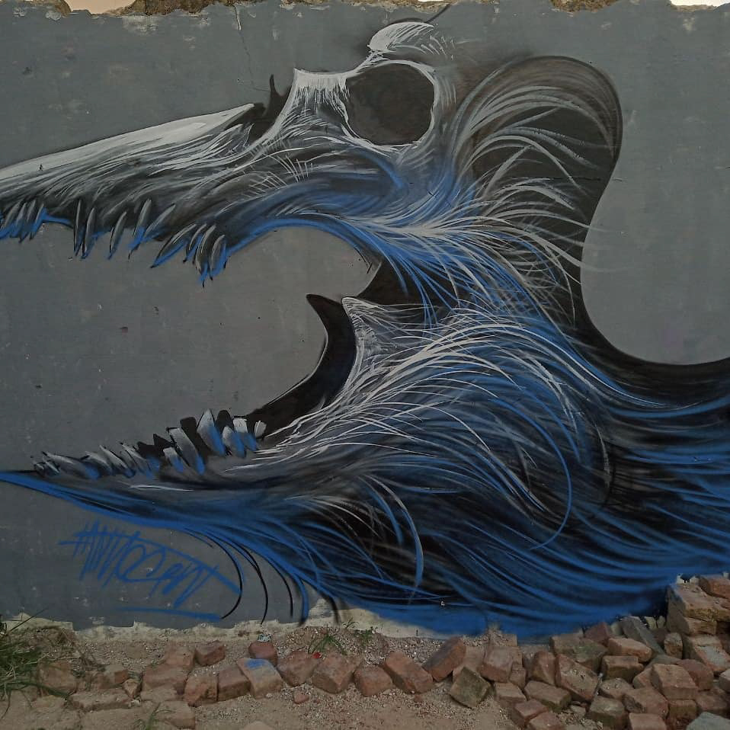
Figure 5: Artwork 6 (A6)

