Figures in the forms of charts
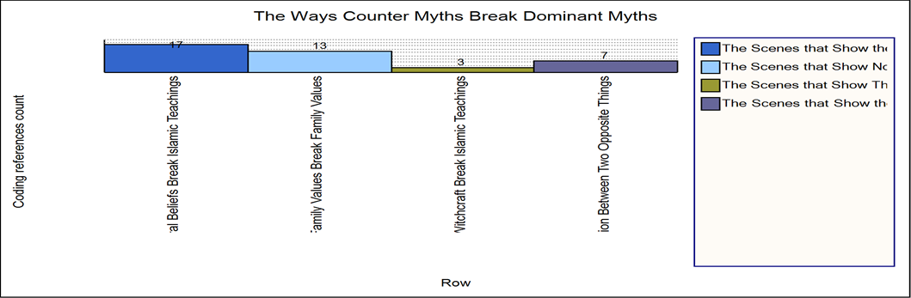
Figure 9 (page 9)

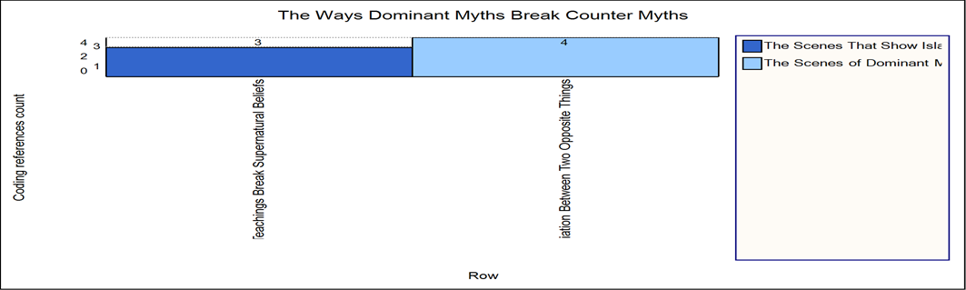
Figure 14 (page 12)
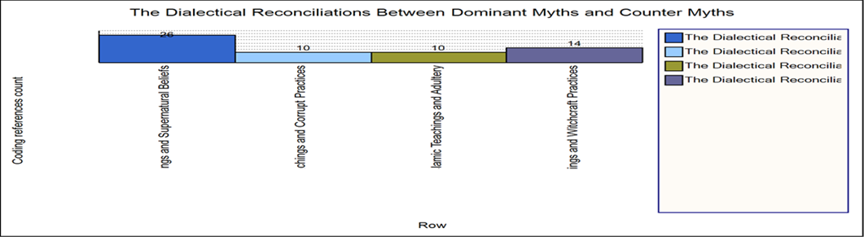
Figure 15 (page 13)

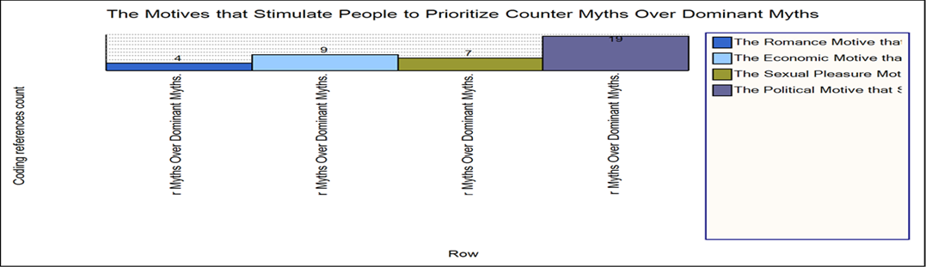
Figure 16 (page 15)
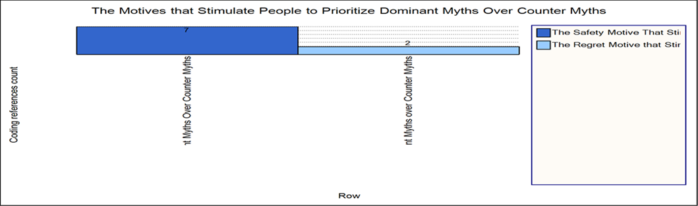
Figure 17 (page 15)

