APPENDIX

Table 1. The results of quality appraisal
Studies | Research design | Q1 | Q2 | Q3 | Q4 | Q5 | No. criteria | Inclusion review
(Razif et al., 2020) | QT | Yes | Yes | Yes | Yes | Yes | 5/5 | Yes
(Asvial et al., 2021) | QT | Yes | Yes | Yes | Yes | Yes | 5/5 | Yes
(Rahi et al., 2021) | QT | Yes | Yes | Yes | Yes | Yes | 5/5 | Yes
(Wu et al., 2021) | QT | Yes | Yes | Yes | Yes | Yes | 5/5 | Yes
(Maphosa et al., 2020) | QT | Yes | Yes | Yes | Yes | Yes | 5/5 | Yes
(J. Cao et al., 2021) | QT | Yes | Yes | Yes | Yes | Yes | 5/5 | Yes
(Prasetyo et al., 2021) | QT | Yes | Yes | Yes | Yes | Yes | 5/5 | Yes
(Khan et al., 2021) | QT | Yes | Yes | Yes | Yes | Yes | 5/5 | Yes
(Oluyinka et al., 2021) | QT | Yes | Yes | Yes | Yes | Yes | 5/5 | Yes
(Alharbi, 2021) | QT | Yes | Yes | Yes | Yes | Yes | 5/5 | Yes
(Khalid et al., 2021) | QT | Yes | Yes | Yes | Yes | Yes | 5/5 | Yes
(Zanetta et al., 2021) | QT | Yes | Yes | Yes | Yes | Yes | 5/5 | Yes
(Sitar-Taut & Mican, 2021) | QT | Yes | Yes | Yes | Yes | Yes | 5/5 | Yes
(Sakka & Namaziandost, 2022) | QT | Yes | Yes | Yes | Yes | Yes | 5/5 | Yes
(Oktavia et al., 2022) | QT | Yes | Yes | Yes | Yes | Yes | 5/5 | Yes
(Acharjya & Das, 2022) | QT | Yes | Yes | Yes | Yes | Yes | 5/5 | Yes
(Al-Harazneh et al., 2022) | QT | Yes | Yes | Yes | Yes | Yes | 5/5 | Yes
(Shoheib & Abu-Shanab, 2022) | QT | Yes | Yes | Yes | Yes | Yes | 5/5 | Yes
(Jevsikova et al., 2021) | QT | Yes | Yes | Yes | Yes | Yes | 5/5 | Yes
(Muangmee et al., 2021) | QT | Yes | Yes | Yes | Yes | Yes | 5/5 | Yes
(Mussa & Sazalli, 2021) | QT | Yes | Yes | Yes | Yes | Yes | 5/5 | Yes
(Zulherman et al., 2021) | QT | Yes | Yes | Yes | Yes | Yes | 5/5 | Yes
(Azizan et al., 2022) | QT | Yes | Yes | Yes | Yes | Yes | 5/5 | Yes
(Latip et al., 2022) | QT | Yes | Yes | Yes | Yes | Yes | 5/5 | Yes
(Puriwat & Tripopsakul, 2021) | QT | Yes | Yes | Yes | Yes | Yes | 5/5 | Yes
(Ardiansyahmiraja et al., 2021) | QT | Yes | Yes | Yes | Yes | Yes | 5/5 | Yes
(Cruz et al., 2022) | QT | Yes | Yes | Yes | Yes | Yes | 5/5 | Yes
(Sora et al., 2021) | QT | Yes | Yes | Yes | Yes | Yes | 5/5 | Yes
(Tomczyk et al., 2021) | QT | Yes | Yes | Yes | Yes | Yes | 5/5 | Yes
(Dindar et al., 2021) | QT | Yes | Yes | Yes | Yes | Yes | 5/5 | Yes
(Park & Ahn, 2021) | QT | Yes | Yes | Yes | Yes | Yes | 5/5 | Yes
(Chaveesuk et al., 2021) | QT | Yes | Yes | Yes | Yes | Yes | 5/5 | Yes
(Yoelianto & Tjhin, 2022) | QT | Yes | Yes | Yes | Yes | Yes | 5/5 | Yes
(Eneizan et al., 2022) | QT | Yes | Yes | Yes | Yes | Yes | 5/5 | Yes
(Alhadid et al., 2022) | QT | Yes | Yes | Yes | Yes | Yes | 5/5 | Yes
(Alshami et al., 2022) | QT | Yes | Yes | Yes | Yes | Yes | 5/5 | Yes
(Lutfi et al., 2022) | QT | Yes | Yes | Yes | Yes | Yes | 5/5 | Yes
(Gumasing et al., 2022) | QT | Yes | Yes | Yes | Yes | Yes | 5/5 | Yes
(Yuduang et al., 2022) | QT | Yes | Yes | Yes | Yes | Yes | 5/5 | Yes
(Habib & Hamadneh, 2021) | QT | Yes | Yes | Yes | Yes | Yes | 5/5 | Yes
(Shao & Lee, 2020) | QT | Yes | Yes | Yes | Yes | Yes | 5/5 | Yes
(Chotigo & Kadono, 2021) | QT | Yes | Yes | Yes | Yes | Yes | 5/5 | Yes
(Yunus et al., 2021) | QT | Yes | Yes | Yes | Yes | Yes | 5/5 | Yes
(Zhao & Bacao, 2021) | QT | Yes | Yes | Yes | Yes | Yes | 5/5 | Yes
(Walrave et al., 2021) | QT | Yes | Yes | Yes | Yes | Yes | 5/5 | Yes
(Santosa et al., 2021) | QT | Yes | Yes | Yes | Yes | Yes | 5/5 | Yes
(Butt et al., 2022) | QT | Yes | Yes | Yes | Yes | Yes | 5/5 | Yes
(Chaveesuk et al., 2022) | QT | Yes | Yes | Yes | Yes | Yes | 5/5 | Yes
(Shiferaw et al., 2021) | QT | Yes | Yes | Yes | Yes | Yes | 5/5 | Yes
(T. M. Cao & Nguyen, 2022) | QT | Yes | Yes | Yes | Yes | Yes | 5/5 | Yes
(Musyaffi et al., 2021) | QT | Yes | Yes | Yes | Yes | Yes | 5/5 | Yes
(Raza et al., 2021) | QT | Yes | Yes | Yes | Yes | Yes | 5/5 | Yes
(Nguyen & Nguyen, 2022) | QT | Yes | Yes | Yes | Yes | Yes | 5/5 | Yes
(Badwelan & Bahaddad, 2021) | QT | Yes | Yes | Yes | Yes | Yes | 5/5 | Yes
(Kharma et al., 2021) | QT | Yes | Yes | Yes | Yes | Yes | 5/5 | Yes
(Muthuraman & Abdullah, 2022) | QT | Yes | Yes | Yes | Yes | Yes | 5/5 | Yes
(Zacharis & Nikolopoulou, 2022) | QT | Yes | Yes | Yes | Yes | Yes | 5/5 | Yes
(Osei et al., 2022) | QT | Yes | Yes | Yes | Yes | Yes | 5/5 | Yes
(Nguyen, 2022) | QT | Yes | Yes | Yes | Yes | Yes | 5/5 | Yes
(Zhou et al., 2022) | QT | Yes | Yes | Yes | Yes | Yes | 5/5 | Yes
(Alghamdi et al., 2022) | QT | Yes | Yes | Yes | Yes | Yes | 5/5 | Yes
(Bamoallem & Altarteer, 2022) | QT | Yes | Yes | Yes | Yes | Yes | 5/5 | Yes
(Alvi, 2021) | QT | Yes | Yes | Yes | Yes | Yes | 5/5 | Yes
(Abbad, 2021) | QT | Yes | Yes | Yes | Yes | Yes | 5/5 | Yes
(Nikou & Aavakare, 2021) | QT | Yes | Yes | Yes | Yes | Yes | 5/5 | Yes
(Yan et al., 2021) | MM | Yes | Yes | Yes | Yes | Yes | 5/5 | Yes
(Pagaling et al., 2022) | QT | Yes | Yes | Yes | Yes | Yes | 5/5 | Yes
(El-Sofany & El-Seoud, 2022) | QT | Yes | Yes | Yes | Yes | Yes | 5/5 | Yes
(Kader et al., 2022) | QT | Yes | Yes | Yes | Yes | Yes | 5/5 | Yes
(Ahmed et al., 2021) | QT | Yes | Yes | Yes | Yes | Yes | 5/5 | Yes
Quantitative (QT), Mixed Methods (MM)

Table 2 Main Contexts, Sample Size, and Respondent Population
Research Context | Sample Size | Respondent Population
Work From Home (WFH) technology | 172 | WFH workers who use WFH technology in various regions in Indonesia
Distance learning | 50 | Middle school students in Jakarta and Tangerang, Indonesia
Telemedicine | 354 | Patients taking medical care from various hospitals in Pakistan
Cross-Border Payments | 786 | Travelers using Mobile cross-border payments to Korea (Chinese citizens)
Study online on WA | 82 | Undergraduate and postgraduate students of the academic year 2019/2020 at Lupane State University, Zimbabwe
Online Tutoring Platforms | 1133 | Educators and students from universities all over mainland China
e-Learning Platforms | 360 | Volunteer of medical students in the Philippines
Mobile Finance Sevice | 839 | MFS app users from different locations in Bangladesh
Canva Online | 789 | Students using the Canvas App at Universities in the Philippines
Digital Health Care | 249 | Health consumers using digital health platforms in Saudi Arabia
Massive Open Online Courses | 1003 | Respondents from Thailand and Pakistan
Food Delivery Application | 950 | FDA users in four regions of Brazil
M-Learning | 311 | College students using M-Learning in Romania
Distance learning | 178 | College student in Amman, Jordan
Video Conference | 212 | WFH workers who use Video Conference in Jakarta, Indonesia
E-learning | 411 | Undergraduate students in Andhra Pradesh, India
E-Learning System | 411 | Undergraduate students in Jordan
Social Commerce (SC) | 463 | Qatari citizens who are actively using the internet and have at least one account on a social media website
Distance learning | 550 | Elementary School Teachers in Lithuania
E-Learning Tools | 1493 | Students across Thai higher education institutions
M-Learning | 163 | English Foreign Language (EFL) teachers in Iraq
Zoom Cloud Meeting | 175 | Lecturers, students, and teachers from universities in Indonesia
Distance learning | 119 | Students from three disciplines at the University of Singapore
E-Learning System | 414 | Undergraduate and postgraduate students in Malaysia
Food Delivery Application | 223 | FDA users in Thailand
Distance learning | 156 | High school students and university students who interact with distance learning in Indonesia,
App Mobile Smart Care System (mSCS) | 60 | Healthcare assistants using the mSCS in Canada
Telepsychology | 514 | -
Covid-19 Contact Tracking App | 349 | COVID-19 contact tracing app users in Germany
Learning Management Study (LMS) | 196 | K-12 teachers in Finland
Retail management strategy | 200 | High-speed rail consumers in South Korea
Digital Payment | 467 | Residents of Bangkok Province, Thailand who use digital payment applications
Subscription Video on Demand (SVOD) | 140 | SCOD application users (Netflix, Disney+ Hotstar, HBO GO, or Viu) in Indonesia
Online Shooping | 274 | Jordanians who use online shopping apps
SANAD service App | 442 | SANAD app users in Jordan
Covid-19 Contact Tracking (MySejahtera) App | 150 | Malaysians using the Mysejahtera app
Distance learning | 384 | King Faisal students, Saudi Arabia
Online Grocery App | 373 | Residents who use the online Sembako application in the Philippines
Risk Assessment App "Morchana" | 907 | Morchana app users in Thailand
Online Grocery App | 443 | Consumers of online grocery app users in India
Social Virtual Reality | 114 | Elderly in Taipei
Food Delivery App | 470 | Customers using the FDA app in Thailand
Study online | 169 | Postgraduate students at public universities in Malaysia
Mobile Payment | 739 | Smartphone users accessing M-Payment in China
Contact Tracing Technology | 1500 | Belgian Residents
Digital Payment | 320 | Digital payment users in Indonesia
Online Learning | 404 | Public and private college students in Punjab, Pakistan
Massive Open Online Course (MOOCs) | 1458 | MOOC app users from Poland, Thailand, and Pakistan
Telemedicine | 319 | Healthcare providers in Ethiopia
Mobile Learning Platform | 831 | Students from Vietnam University
Digital Payment | 204 | Digital payment users in Indonesia
Learning Management System (LMS) | 516 | Karachi state college students, Pakistan
Contact Tracing App | 224 | -
M-Learning App | 539 | Students using m-learning applications in Saudi Arabia
Online Learning | 462 | Students of Al-Ahliyya University Amman, Jordan
Distance learning | 504 | Undergraduate students in Penang
E-Learning | 314 | Students from various universities in Greece
E-Learning | 1024 | College students in Ghana
Digital Detox App | 263 | -
Study Virtual | 301 | Smartphone users accessing M-Payment in China
E-Training | 397 | Field training course students at Imam Abdulrahman Bin Faisal University Saudi Arabia
Distance learning | 115 | Undergraduate student majoring in design at Saudi University
Social Network Tools | 305 | Students at engineering institutes in the State of Rajasthan, India.
E-Learning | 370 | Students in Jordan
Digital technology for college information and literacy | 249 | University Staff and Students in Finland
Pintech App | 227 | MFS users in Bangladesh
Teleneurology | 287 | Adult and pediatric neurologists in the Philippines
Ubiquitous Learning Technology | 600 | Bachelor of Computer Science in Saudi Arabia
Study online | 212 | Diploma Students of MARA University Pahang Malaysia
Learning Management System (LMS) | 1875 | Students from Pakistan, India, South Korea, Malaysia, and Bangladesh.

Table 3 Influential constructs
Studies | Adoption | PE→  BI/other | EE→  BI/other | SI→  BI/other | FC→  BI/other
(Razif et al., 2020) | WFH technology | Yes | No | Yes | Yes
(Asvial et al., 2021) | Distance learning | No | No | Yes | No
(Rahi et al., 2021) | Telemedicine | Yes | No | No | No
(Wu et al., 2021) | Cross-Border Payments | Yes | Yes | No | Yes
(Maphosa et al., 2020) | Study online on WA | Yes | Yes | Yes | Yes
(J. Cao et al., 2021) | Online Tutoring Platforms | Yes | Yes | No | No
(Prasetyo et al., 2021) | e-Learning Platforms | Yes | No | No | No
(Khan et al., 2021) | Mobile Finance Sevice | Yes | Yes | Yes | Yes
(Oluyinka et al., 2021) | Canva Online | Yes | Yes | No | Yes
(Alharbi, 2021) | Digital Health Care | No | No | No | Yes
(Khalid et al., 2021) | Massive Open Online Courses | Yes | No | Yes | Yes
(Zanetta et al., 2021) | Food Delivery Application | Yes | No | Yes | No
(Sitar-Taut & Mican, 2021) | M-Learning | Yes | No | No | No
(Sakka & Namaziandost, 2022) | Distance learning | No | No | No | No
(Oktavia et al., 2022) | Video Conference | Yes | Yes | Yes | Yes
(Acharjya & Das, 2022) | E-learning | Yes | No | Yes | Yes
(Al-Harazneh et al., 2022) | E-Learning System | Yes | No | No | Yes
(Shoheib & Abu-Shanab, 2022) | Social Commerce (SC) | No | No | No | Yes
(Jevsikova et al., 2021) | Distance learning | Yes | Yes | Yes | No
(Muangmee et al., 2021) | E-Learning Tools | Yes | Yes | Yes | Yes
(Mussa & Sazalli, 2021) | M-Learning | Yes | Yes | Yes | Yes
(Zulherman et al., 2021) | Zoom Cloud Meeting | No | No | No | No
(Azizan et al., 2022) | Distance learning | No | No | No | No
(Latip et al., 2022) | E-Learning System | Yes | No | Yes | No
(Puriwat & Tripopsakul, 2021) | Food Delivery Application | Yes | Yes | Yes | No
(Ardiansyahmiraja et al., 2021) | Distance learning | No | Yes | No | No
(Cruz et al., 2022) | App Mobile Smart Care System | Yes | No | No | No
(Sora et al., 2021) | Telepsychology | No | No | No | No
(Tomczyk et al., 2021) | Covid-19 Contact Tracking App | No | No | No | No
(Dindar et al., 2021) | Learning Management Study (LMS) | Yes | Yes | No | No
(Park & Ahn, 2021) | Retail management strategy | Yes | No | Yes | No
(Chaveesuk et al., 2021) | Digital Payment | Yes | No | No | Yes
(Yoelianto & Tjhin, 2022) | Subscription Video on Demand (SVOD) | No | Yes | Yes | Yes
(Eneizan et al., 2022) | Online Shopping | Yes | Yes | Yes | Yes
(Alhadid et al., 2022) | SANAD service App | Yes | Yes | Yes | Yes
(Alshami et al., 2022) | Covid-19 Contact Tracking (MySejahtera) App | Yes | Yes | Yes | Yes
(Lutfi et al., 2022) | Distance learning | Yes | Yes | No | Yes
(Gumasing et al., 2022) | Online Grocery App | Yes | No | No | No
(Yuduang et al., 2022) | Risk Assessment App "Morchana" | Yes | Yes | Yes | Yes
(Habib & Hamadneh, 2021) | Online Grocery App | No | No | No | Yes
(Shao & Lee, 2020) | Social Virtual Reality | Yes | No | Yes | No
(Chotigo & Kadono, 2021) | Food Delivery App | No | No | Yes | No
(Yunus et al., 2021) | Study online | Yes | Yes | Yes | Yes
(Zhao & Bacao, 2021) | Mobil Payment | Yes | No | Yes | No
(Walrave et al., 2021) | Contact Tracing Technology | Yes | No | Yes | Yes
(Santosa et al., 2021) | Digital Payment | Yes | Yes | Yes | Yes
(Butt et al., 2022) | Online Learning | No | No | No | No
(Chaveesuk et al., 2022) | Massive Open Online Courses (MOOCs) | No | Yes | No | Yes
(Shiferaw et al., 2021) | Telemedicine | No | Yes | No | No
(T. M. Cao & Nguyen, 2022) | Mobile Learning Platform | No | Yes | No | No
(Musyaffi et al., 2021) | Digital Payment | Yes | No | No | No
(Raza et al., 2021) | Learning Management System (LMS) | Yes | Yes | Yes | No
(Nguyen & Nguyen, 2022) | Contact Tracing App | Yes | No | No | No
(Badwelan & Bahaddad, 2021) | M-Learning App | Yes | Yes | No | No
(Kharma et al., 2021) | Online Learning | No | No | Yes | No
(Muthuraman & Abdullah, 2022) | Distance learning | No | No | No | No
(Zacharis & Nikolopoulou, 2022) | E-Learning | Yes | No | Yes | No
(Osei et al., 2022) | E-Learning | Yes | Yes | No | Yes
(Nguyen, 2022) | Digital Detox App | Yes | Yes | Yes | No
(Zhou et al., 2022) | Study Virtual | Yes | Yes | Yes | No
(Alghamdi et al., 2022) | E-Training | Yes | Yes | Yes | Yes
(Bamoallem & Altarteer, 2022) | Distance learning | No | Yes | No | Yes
(Alvi, 2021) | Social Network Tools | Yes | Yes | Yes | No
(Abbad, 2021) | E-Learning | Yes | Yes | No | Yes
(Nikou & Aavakare, 2021) | Digital technology for college information and literacy | No | No | No | No
(Yan et al., 2021) | Pintech App | No | No | Yes | No
(Pagaling et al., 2022) | Teleneurology | Yes | Yes | Yes | Yes
(El-Sofany & El-Seoud, 2022) | Ubiquitous Learning Technology | Yes | Yes | No | Yes
(Kader et al., 2022) | Study online | No | No | No | Yes
(Ahmed et al., 2021) | Learning Management System (LMS) | Yes | Yes | Yes | Yes

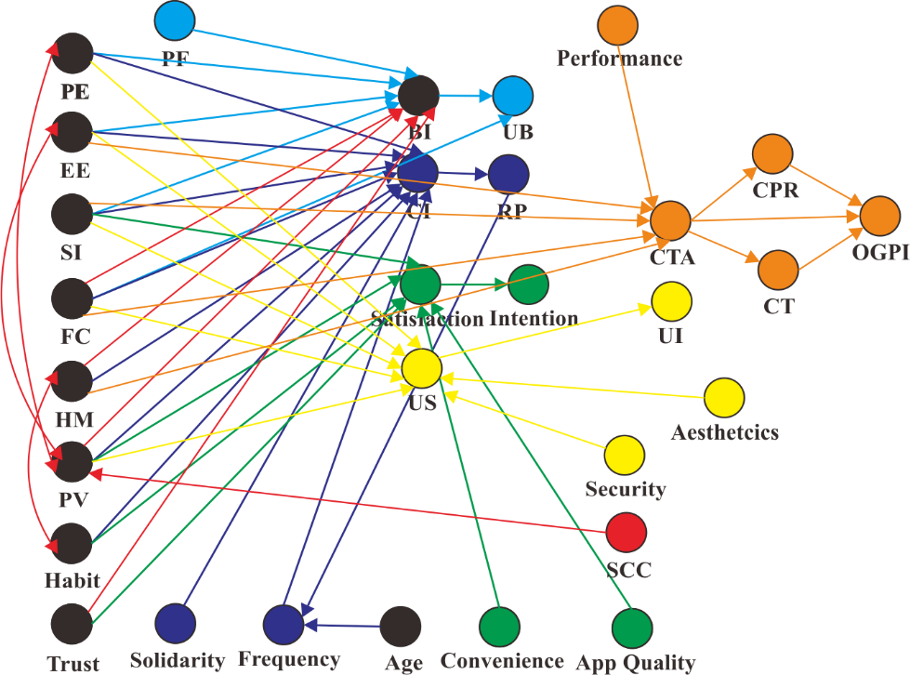
UTAUT/UTAUT2 Existing
(Zanetta et al., 2021)
(Puriwat & Tripopsakul, 2021)
(Chotigo & Kadono, 2021)
(Shoheib & Abu-Shanab, 2022)
(Park & Ahn, 2021)
(Habib & Hamadneh, 2021)

Figure 1 UTAUT combination of business fields
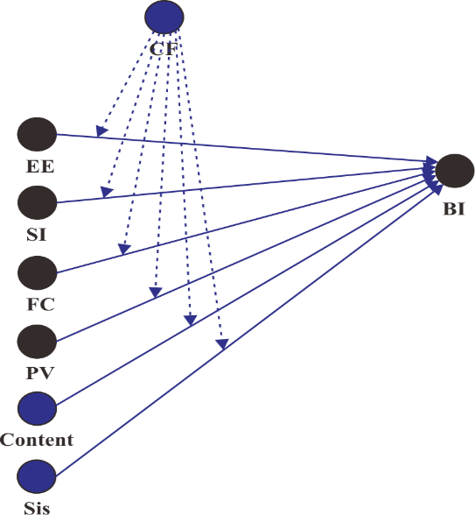
UTAUT/UTAUT2 Existing
(Yoelianto & Tjhin, 2022)

Figure 2 Appendix Fig 2 UTAUT combination of entertainment fields
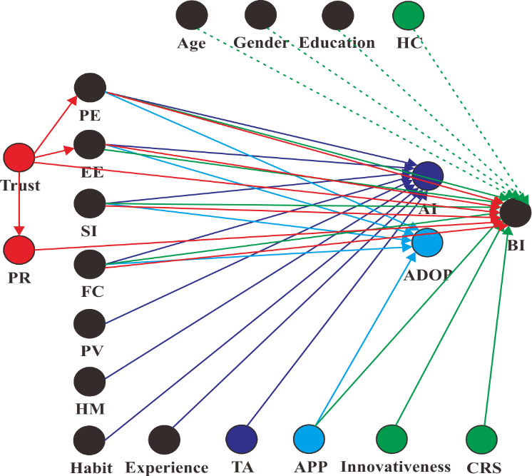

UTAUT/UTAUT2 Existing
(Tomczyk et al., 2021)
(Alshami et al., 2022)
(Walrave et al., 2021)
(Nguyen & Nguyen, 2022)

Figure 3 UTAUT combination of health fields
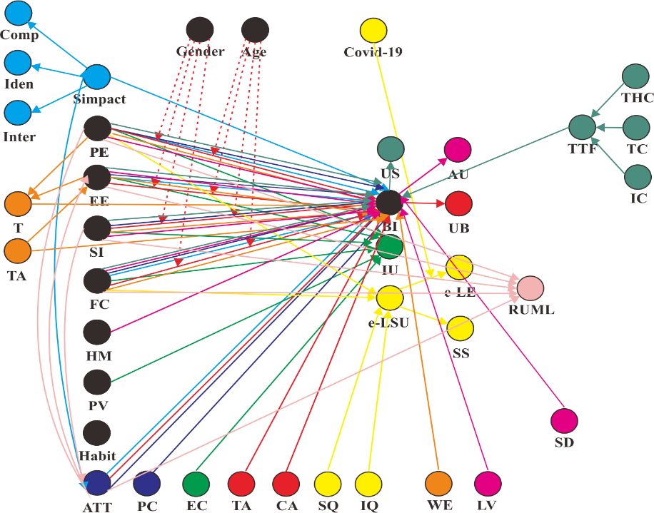
UTAUT/UTAUT2 Existing
(Asvial et al., 2021)
(J. Cao et al., 2021)
(Sakka & Namaziandost, 2022)
(Acharjya & Das, 2022)
(Al-Harazneh et al., 2022)
(Jevsikova et al., 2021)
(Muangmee et al., 2021)
(Mussa & Sazalli, 2021)
(Azizan et al., 2022)

Figure 4 UTAUT combination of education fields (part 1)
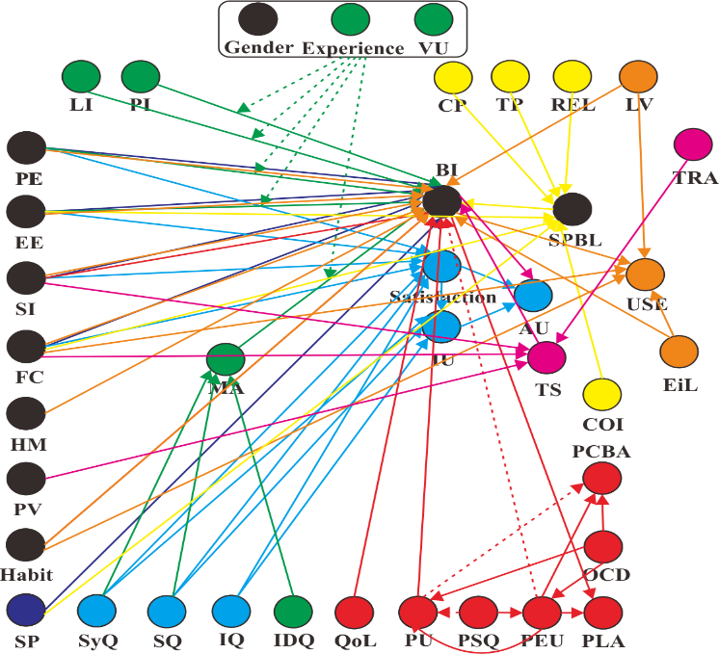

UTAUT/UTAUT2 Existing
(Ardiansyahmiraja et al., 2021)
(Lutfi et al., 2022)
(Badwelan & Bahaddad, 2021)
(Kharma et al., 2021)
(Bamoallem & Altarteer, 2022)
(Zacharis & Nikolopoulou, 2022)
(Kader et al., 2022)

Figure 5 UTAUT combination of education fields (part 2)
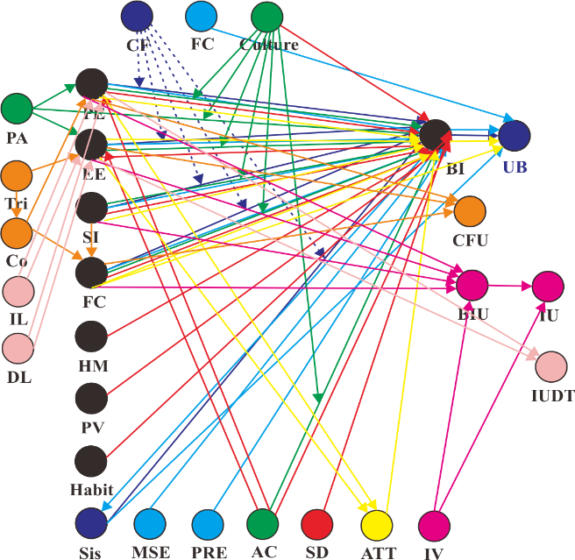

UTAUT/UTAUT2 Existing
(Raza et al., 2021)
(Ahmed et al., 2021)
(Khalid et al., 2021)
(Chaveesuk et al., 2022)
(Maphosa et al., 2020)
(Oluyinka et al., 2021)
(Alvi, 2021)
(Nikou & Aavakare, 2021)

Figure 6 UTAUT combination of education fields (part 3)
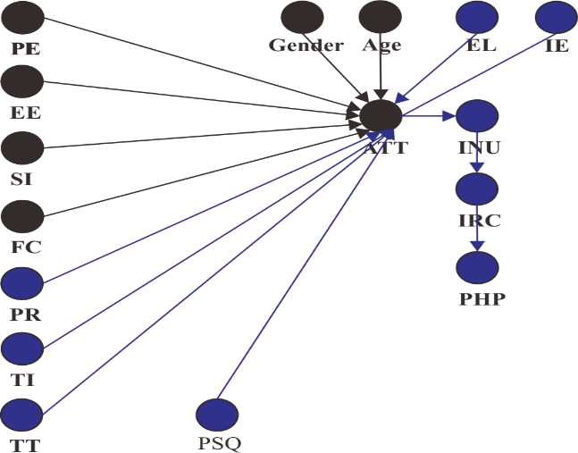
UTAUT Existing
Study (Alhadid et al., 2022)

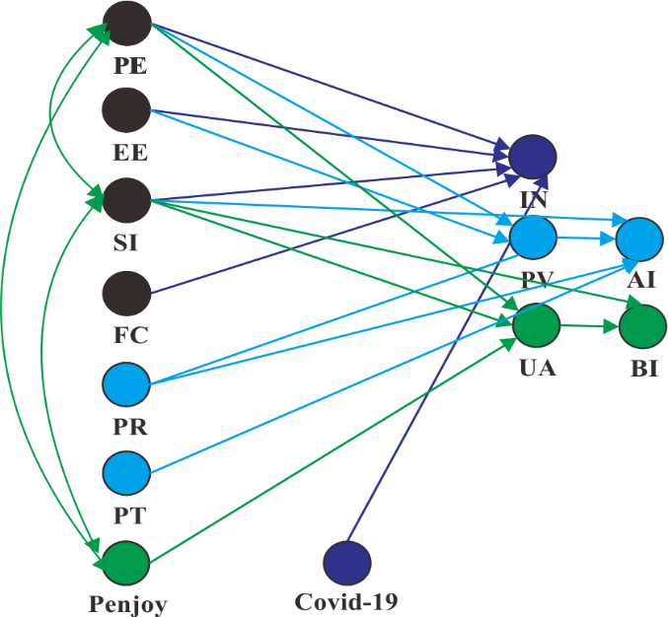
Figure 7 UTAUT combination in the government fields

UTAUT Existing
(Eneizan et al., 2022)
(Yan et al., 2021)
(Shao & Lee, 2020)

Figure 8 UTAUT combination in the economy and social fields
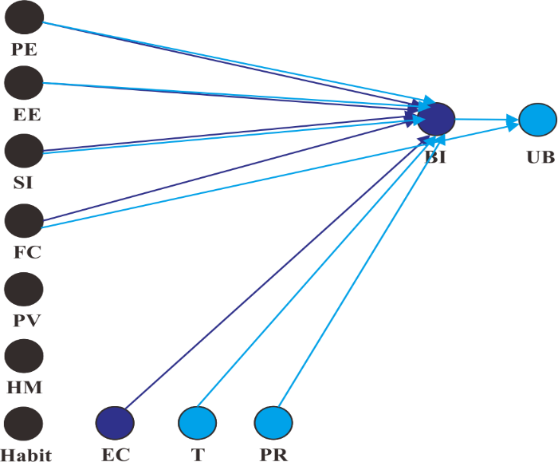
UTAUT Existing
(Razif et al., 2020)
(Oktavia et al., 2022)

Figure 9 UTAUT combination in corporate environment fields
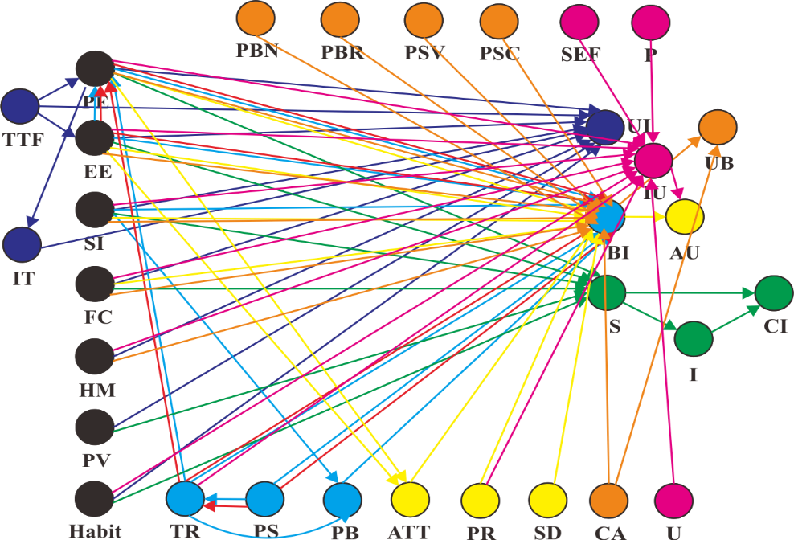
UTAUT/UTAUT2 Existing
(Wu et al., 2021)
(Zhao & Bacao, 2021)
(Santosa et al., 2021)
(Musyaffi et al., 2021)
(Chaveesuk et al., 2021)
(Gumasing et al., 2022)
(Yuduang et al., 2022)

Figure 10 UTAUT combination of mobile technology fields

